***Solution Section* 2.7 – Rational Functions**

***Exercise***

Determine all asymptotes of the function: 

***Solution***

***VA***:  ***HA***: 

***Hole***:  ***Oblique asymptote***: 

***Exercise***

Determine all asymptotes of the function: 

***Solution***

***VA***:   ***HA***: 

***Hole***:  ***Oblique asymptote***: 

***Exercise***

Determine all asymptotes of the function: 

***Solution***





***VA***:  ***HA***: 

***Hole***:  ***Oblique asymptote***: 

***Exercise***

Determine all asymptotes of the function: 

***Solution***

***VA***: *x* = 5 ***HA***: *y* = 0

***Hole***:  ***Oblique asymptote***: 

***Exercise***

Determine all asymptotes of the function: 

***Solution***

|  |  |
| --- | --- |
| ***VA***: *none*  ***HA***: *none*  ***Hole***:  ***Oblique asymptote***: |  |

***Exercise***

Determine all asymptotes of the function: 

***Solution***

|  |  |
| --- | --- |
| ***VA***:  ***HA***:  ***Hole***:  ***Oblique asymptote***: |  |

***Exercise***

Determine all asymptotes of the function: 

***Solution***



***VA***:  ***HA***: 

***Hole***:  ***Oblique asymptote***: 

***Exercise***

Determine all asymptotes of the function: 

***Solution***







***VA***:  ***HA***: 

***Hole***:  ***Oblique asymptote***: 

***Exercise***

Determine all asymptotes of the function: 

***Solution***





***VA***:  ***HA***: 

***Hole***:  ***Oblique asymptote***: 

***Exercise***

Determine all asymptotes of the function: 

***Solution***

***VA***:  ***HA***: 

***Hole***:  ***Oblique asymptote***: 

***Exercise***

Determine all asymptotes of the function: 

***Solution***

***VA***:  ***HA***: 

***Hole***:  ***Oblique asymptote***: 

***Exercise***

Determine all asymptotes of the function: 

***Solution***





***VA***:  ***HA***: 

***Hole***:  ***Oblique asymptote***: 

***Exercise***

Determine all asymptotes of the function: 

***Solution***

***VA***:  ***HA***: 

***Hole***:  ***Oblique asymptote***: 

***Exercise***

Determine all asymptotes of the function 

***Solution***



***Domain***: 





***VA***:  ***HA***: 

***Hole***:  ***Oblique asymptote***: 

***Exercise***

Determine all asymptotes of the function 

***Solution***

***VA***:  ***HA***: 

***Hole***:  ***Oblique asymptote***: 

***Exercise***

Determine all asymptotes of the function 

***Solution***









***VA***:  ***HA***: 

***Hole***:  ***Oblique asymptote***: 

***Exercise***

Determine all asymptotes of the function 

***Solution***



***Domain***: 

***VA***:  ***HA***: 

***Hole***:  ***Oblique asymptote***: 

***Exercise***

Determine all asymptotes of the function 

***Solution***



***Domain***: 

***VA***:  ***HA***: 

***Hole***:  ***Oblique asymptote***: 

***Exercise***

Determine all asymptotes of the function 

***Solution***

|  |  |
| --- | --- |
| ***VA***:  ***HA***:  ***Hole***:  ***Oblique asymptote***: |  |

***Exercise***

Determine all asymptotes of the function 

***Solution***



***Domain***: 





***VA***: 

***HA***: N/A

***Hole***: N/A

***Oblique asymptote***: 

***Exercise***

Determine all asymptotes of the function 

***Solution***



***Domain***: 





|  |  |
| --- | --- |
| ***VA***:  ***HA***:  ***Hole***:  ***Oblique asymptote***: |  |

***Exercise***

Determine all asymptotes of the function 

***Solution***

 ***Domain***: 



***VA***:  ***HA***: 

***Hole***: 

***Oblique asymptote***: 

***Exercise***

Determine all asymptotes of the function 

***Solution***

***Domain***: 

***VA***:  ***HA***: 

***Hole***:  ***Oblique asymptote***: 

***Exercise***

Determine all asymptotes of the function 

***Solution***



***Domain***: 



***VA***:  ***HA***: 

***Hole***: 

***Oblique asymptote***: 

***Exercise***

Determine all asymptotes of the function 

***Solution***

 ***Domain***: 

***VA***:  ***HA***: 

***Hole***:  ***Oblique asymptote***: 

***Exercise***

Determine all asymptotes of the function 

***Solution***

 ***Domain***: 

***VA***:  ***HA***: 

***Hole***:  ***Oblique asymptote***: 

***Exercise***

Determine all asymptotes of the function 

***Solution***

 ***Domain***: 





***VA***:  ***HA***: 

***Hole***:  ***Oblique asymptote***: 

***Exercise***

Determine all asymptotes of the function 

***Solution***

 ***Domain***: 

|  |  |
| --- | --- |
|  | ***VA***:  ***HA***: N/A  ***Hole***: N/A  ***Oblique asymptote***: |

***Exercise***

Determine all asymptotes of the function 

***Solution***



***Domain***: 

|  |  |
| --- | --- |
|  | ***VA***:  ***HA***: N/A  ***Hole***: N/A  ***Oblique asymptote***: |

***Exercise***

Determine all asymptotes (if any) (*Vertical Asymptote, Horizontal Asymptote*; *Hole*; *Oblique Asymptote*) and sketch the graph of



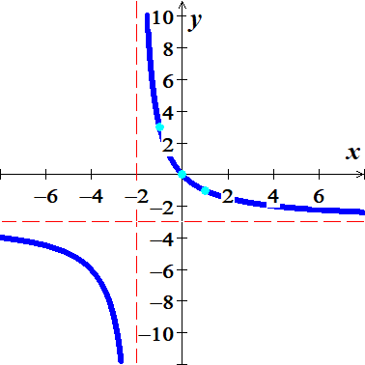***Solution***

***VA***:  ***HA***: 

***Hole***:  ***OA***: 

|  |  |
| --- | --- |
| ***x*** | ***y*** |
| 0 | 0 |
| 1 | −1 |
| −1 | 3 |

***Exercise***

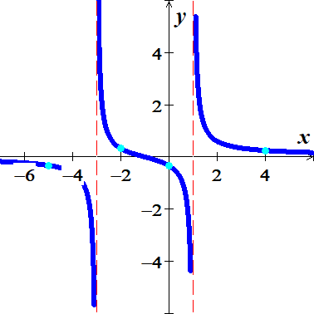Determine all asymptotes (if any) (*Vertical Asymptote, Horizontal Asymptote*; *Hole*; *Oblique Asymptote*) and sketch the graph of



***Solution***

***VA***:  ***HA***: 

***Hole***:  ***Oblique asymptote***: 



***Exercise***

Determine all asymptotes (if any) (*Vertical Asymptote, Horizontal Asymptote*; *Hole*; *Oblique Asymptote*) and sketch the graph of

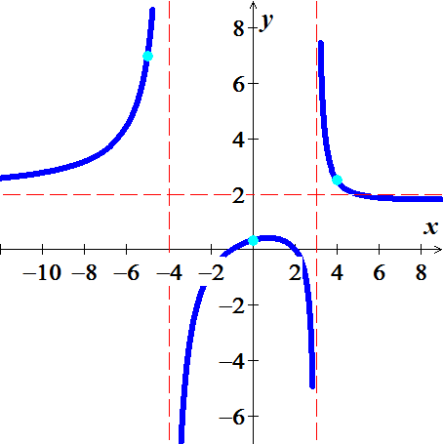 

***Solution***

***VA***:  ***HA***: 

***Hole***:  ***OA***: 



***Exercise***

Determine all asymptotes (if any) (*Vertical Asymptote, Horizontal Asymptote*; *Hole*; *Oblique Asymptote*) and sketch the graph



***Solution***

***VA***:  ***HA***: 

***Hole***:  ***OA***: 

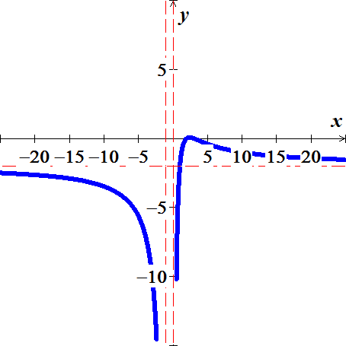 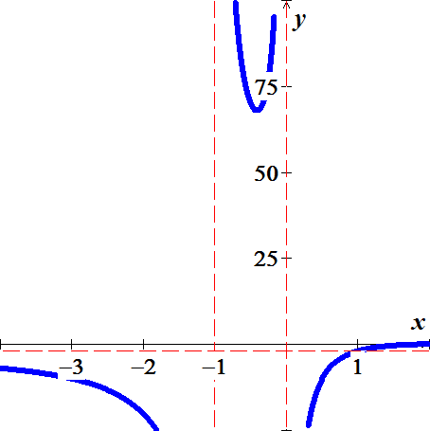

***Exercise***

Determine all asymptotes (if any) (*Vertical Asymptote, Horizontal Asymptote*; *Hole*; *Oblique Asymptote*) and sketch the graph

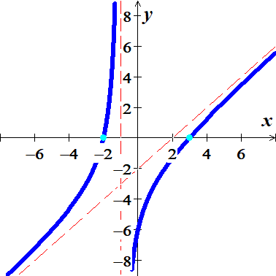 

***Solution***



***VA***:  ***HA***: 

***Hole***:  ***OA***: 

|  |  |
| --- | --- |
| ***x*** | ***y*** |
| 2 | 0 |
| −2 | 0 |
| 0 | −6 |

***Exercise***

Determine all asymptotes (if any) (*Vertical Asymptote, Horizontal Asymptote*; *Hole*; *Oblique Asymptote*) and sketch the graph

 

***Solution***



***VA***:  ***HA***: 

***Hole***:  ***OA***: 

***Exercise***

Determine all asymptotes (if any) (*Vertical Asymptote, Horizontal Asymptote*; *Hole*; *Oblique Asymptote*) and sketch the graph

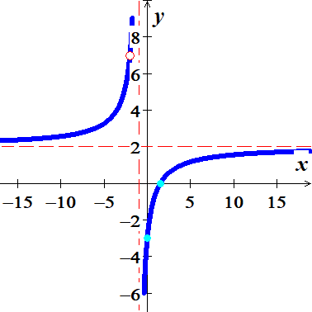 

***Solution***





***VA***:  ***HA***: 

***Hole***:  ***OA***: 

|  |  |
| --- | --- |
| ***x*** | ***y*** |
| 0 | −3 |
|  | 0 |

***Exercise***

Determine all asymptotes (if any) (*Vertical Asymptote, Horizontal Asymptote*; *Hole*; *Oblique Asymptote*) and sketch the graph

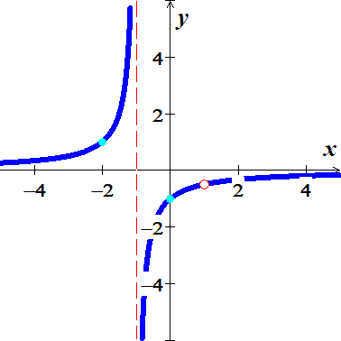

***Solution***





***VA***:  ***HA***: 

***Hole***:  ***OA***: 

|  |  |
| --- | --- |
| ***x*** | ***y*** |
| 0 | −1 |
|  | 1 |

***Exercise***

Determine all asymptotes (if any) (*Vertical Asymptote, Horizontal Asymptote*; *Hole*; *Oblique Asymptote*) and sketch the graph

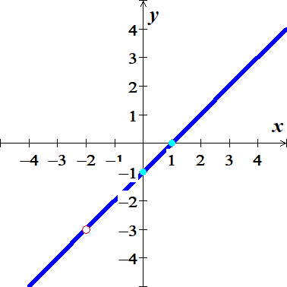

***Solution***





***VA***:  ***HA***: 

***Hole***:  ***OA***: 

|  |  |
| --- | --- |
| ***x*** | ***y*** |
| 0 | −1 |
|  | 0 |

***Exercise***

Determine all asymptotes (if any) (*Vertical Asymptote, Horizontal Asymptote*; *Hole*; *Oblique Asymptote*) and sketch the graph

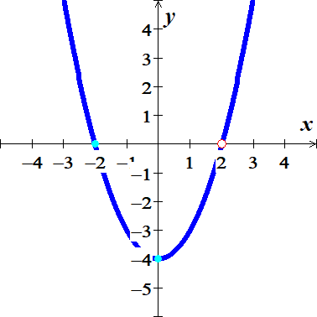 

***Solution***





***VA***:  ***HA***: 

***Hole***:  ***OA***: 

|  |  |
| --- | --- |
| ***x*** | ***y*** |
| 0 | −4 |
|  | 0 |

***Exercise***

Determine all asymptotes (if any) (*Vertical Asymptote, Horizontal Asymptote*; *Hole*; *Oblique Asymptote*) and sketch the graph

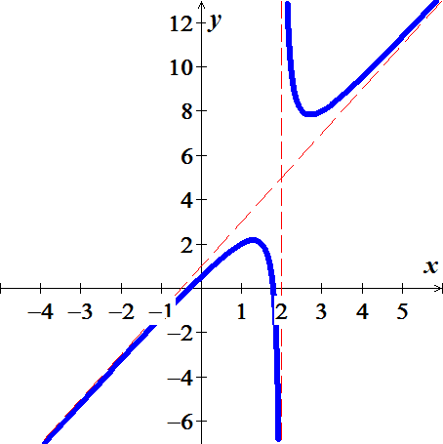

***Solution***







***VA***:  ***HA***: 

***Hole***:  ***OA***: 

***Exercise***

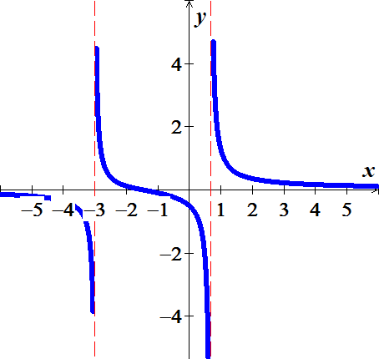Determine all asymptotes (if any) (*Vertical Asymptote, Horizontal Asymptote*; *Hole*; *Oblique Asymptote*) and sketch the graph



***Solution***



***VA***: 

***HA***: 

***Hole***: 

***OA: ***

***Exercise***

Determine all asymptotes (if any) (*Vertical Asymptote, Horizontal Asymptote*; *Hole*; *Oblique Asymptote*) and sketch the graph



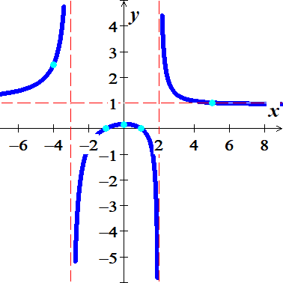***Solution***



***VA***:  ***HA***: 

***Hole***:  ***OA: ***







|  |  |
| --- | --- |
| ***x*** | ***y*** |
| 0 |  |
|  | 1 |
|  | 0 |
| −4 |  |

***Exercise***

Determine all asymptotes (if any) (*Vertical Asymptote, Horizontal Asymptote*; *Hole*; *Oblique Asymptote*) and sketch the graph of



***Solution***

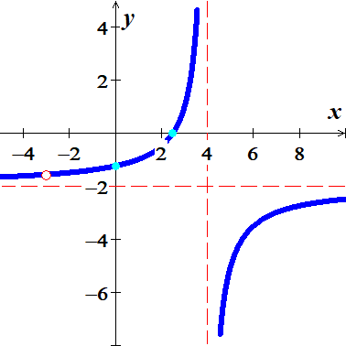

***Domain***: 





***VA***:  ***HA***: 

***Hole***:  ***OA: ***

|  |  |
| --- | --- |
| ***x*** | ***y*** |
| 0 |  |
|  | 0 |

***Exercise***

Determine all asymptotes (if any) (*Vertical Asymptote, Horizontal Asymptote*; *Hole*; *Oblique Asymptote*) and sketch the graph of

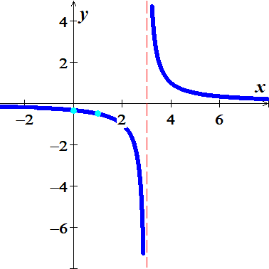

***Solution***

***VA***:  ***HA***: 

***Hole***:  ***OA: ***

|  |  |
| --- | --- |
| ***x*** | ***y*** |
| 0 |  |
|  |  |

***Exercise***

Determine all asymptotes (if any) (*Vertical Asymptote, Horizontal Asymptote*; *Hole*; *Oblique Asymptote*) and sketch the graph of

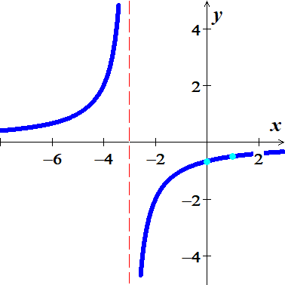

***Solution***

***VA***:  ***HA***: 

***Hole***:  ***OA: ***

|  |  |
| --- | --- |
| ***x*** | ***y*** |
| 0 |  |
|  |  |

***Exercise***

Determine all asymptotes (if any) (*Vertical Asymptote, Horizontal Asymptote*; *Hole*; *Oblique Asymptote*) and sketch the graph of

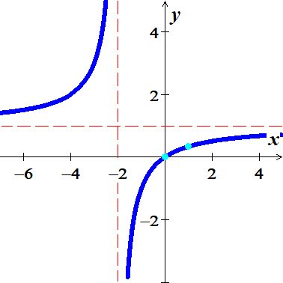

***Solution***

***VA***:  ***HA***: 

***Hole***:  ***OA: ***

|  |  |
| --- | --- |
| ***x*** | ***y*** |
| 0 |  |
|  |  |

***Exercise***

Determine all asymptotes (if any) (*Vertical Asymptote, Horizontal Asymptote*; *Hole*; *Oblique Asymptote*) and sketch the graph of



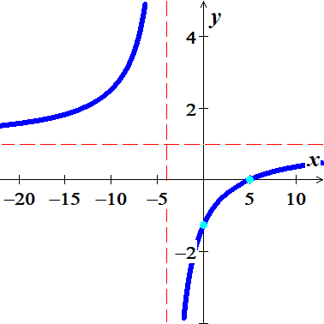***Solution***

***VA***:  ***HA***: 

***Hole***:  ***OA: ***

|  |  |
| --- | --- |
| ***x*** | ***y*** |
| 0 |  |
| 5 | 0 |

***Exercise***

Determine all asymptotes (if any) (*Vertical Asymptote, Horizontal Asymptote*; *Hole*; *Oblique Asymptote*) and sketch the graph of

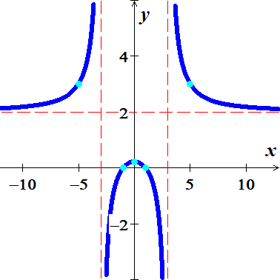

***Solution***



***VA***:  ***HA***: 

***Hole***:  ***OA: ***

|  |  |
| --- | --- |
| ***x*** | ***y*** |
| 0 |  |
|  | 0 |
|  |  |

***Exercise***

Determine all asymptotes (if any) (*Vertical Asymptote, Horizontal Asymptote*; *Hole*; *Oblique Asymptote*) and sketch the graph of

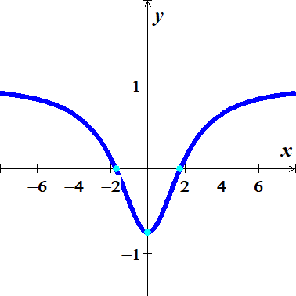

***Solution***

***VA***:  ***HA***: 

***Hole***:  ***OA: ***

|  |  |
| --- | --- |
| ***x*** | ***y*** |
| 0 |  |
|  | 0 |

***Exercise***

Determine all asymptotes (if any) (*Vertical Asymptote, Horizontal Asymptote*; *Hole*; *Oblique Asymptote*) and sketch the graph of

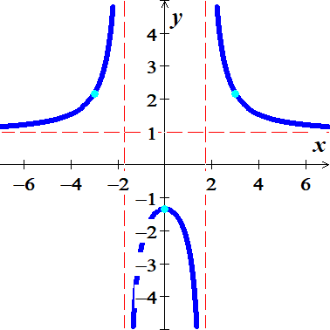

***Solution***



***VA***:  ***HA***: 

***Hole***:  ***OA: ***

|  |  |
| --- | --- |
| ***x*** | ***y*** |
| 0 |  |
|  |  |

***Exercise***

Determine all asymptotes (if any) (*Vertical Asymptote, Horizontal Asymptote*; *Hole*; *Oblique Asymptote*) and sketch the graph of

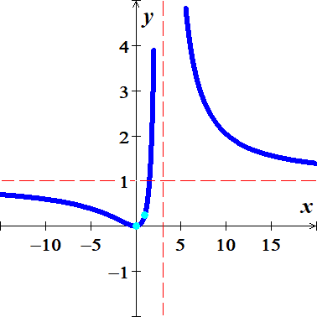

***Solution***



***VA***:  ***HA***: 

***Hole***:  ***OA: ***

|  |  |
| --- | --- |
| ***x*** | ***y*** |
| 0 | 0 |
| 1 |  |

***Exercise***

Determine all asymptotes (if any) (*Vertical Asymptote, Horizontal Asymptote*; *Hole*; *Oblique Asymptote*) and sketch the graph of



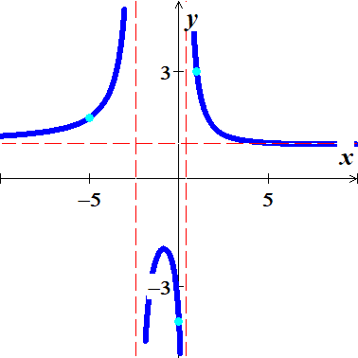***Solution***







***VA***:  ***HA***: 

***Hole***:  ***OA: ***

|  |  |
| --- | --- |
| ***x*** | ***y*** |
| 0 |  |
|  | 3 |
|  |  |

***Exercise***

Determine all asymptotes (if any) (*Vertical Asymptote, Horizontal Asymptote*; *Hole*; *Oblique Asymptote*) and sketch the graph of

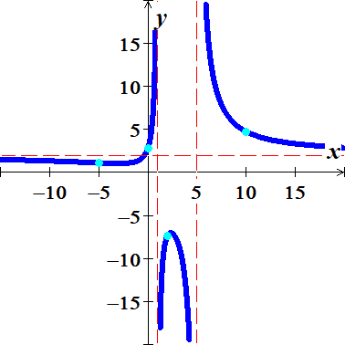

***Solution***

***VA***:  ***HA***: 

***Hole***:  ***OA: ***

|  |  |
| --- | --- |
| ***x*** | ***y*** |
| 0 |  |
|  |  |
|  |  |
| 10 |  |

***Exercise***

Determine all asymptotes (if any) (*Vertical Asymptote, Horizontal Asymptote*; *Hole*; *Oblique Asymptote*) and sketch the graph of

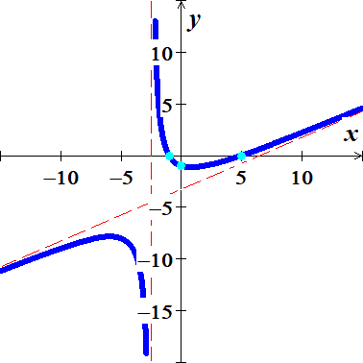

***Solution***



***VA***:  ***HA***: 

***Hole***:  ***OA:*** 

|  |  |
| --- | --- |
| ***x*** | ***y*** |
| 0 |  |
|  | 0 |

***Exercise***

Determine all asymptotes (if any) (*Vertical Asymptote, Horizontal Asymptote*; *Hole*; *Oblique Asymptote*) and sketch the graph of

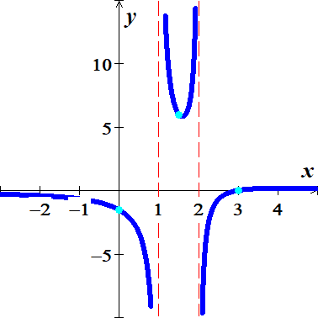

***Solution***



***VA***:  ***HA***: 

***Hole***:  ***OA: ***

|  |  |
| --- | --- |
| ***x*** | ***y*** |
| 0 |  |
| 3 | 0 |
|  |  |

***Exercise***

Determine all asymptotes (if any) (*Vertical Asymptote, Horizontal Asymptote*; *Hole*; *Oblique Asymptote*) and sketch the graph of

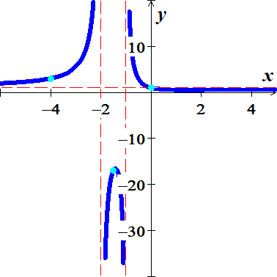

***Solution***



***VA***:  ***HA***: 

***Hole***:  ***OA: ***

|  |  |
| --- | --- |
| ***x*** | ***y*** |
| 0 | 1 |
|  |  |
|  |  |

***Exercise***

Determine all asymptotes (if any) (*Vertical Asymptote, Horizontal Asymptote*; *Hole*; *Oblique Asymptote*) and sketch the graph of

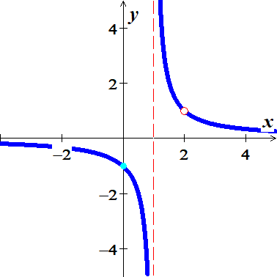

***Solution***







***VA***:  ***HA***: 

***Hole***:  ***OA: ***

|  |  |
| --- | --- |
| ***x*** | ***y*** |
| 0 |  |

***Exercise***

Determine all asymptotes (if any) (*Vertical Asymptote, Horizontal Asymptote*; *Hole*; *Oblique Asymptote*) and sketch the graph of

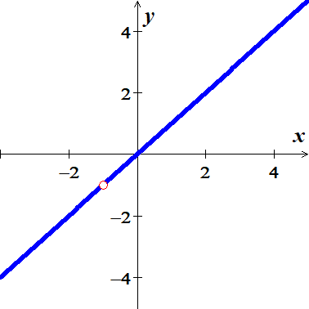

***Solution***





***VA***:  ***HA***: 

***Hole***:  ***OA: ***

***Hole***:  ***OA: ***

|  |  |
| --- | --- |
| ***x*** | ***y*** |
| 0 | 0 |

***Exercise***

Determine all asymptotes (if any) (*Vertical Asymptote, Horizontal Asymptote*; *Hole*; *Oblique Asymptote*) and sketch the graph of

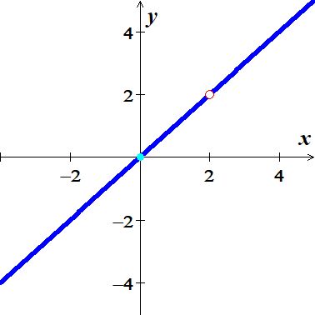

***Solution***





***VA***:  ***HA***: 

***Hole***:  ***OA: ***

***Hole***:  ***OA: ***

|  |  |
| --- | --- |
| ***x*** | ***y*** |
| 0 | 0 |

***Exercise***

Determine all asymptotes (if any) (*Vertical Asymptote, Horizontal Asymptote*; *Hole*; *Oblique Asymptote*) and sketch the graph of

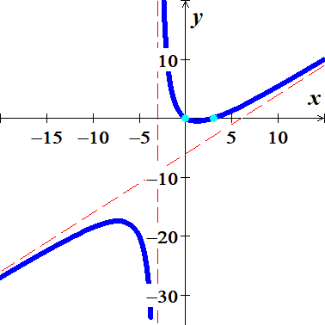

***Solution***



***VA***:  ***HA***: 

***Hole***:  ***OA:*** 

|  |  |
| --- | --- |
| ***x*** | ***y*** |
| 0 | 0 |
| 3 | 0 |

***Exercise***

Determine all asymptotes (if any) (*Vertical Asymptote, Horizontal Asymptote*; *Hole*; *Oblique Asymptote*) and sketch the graph of



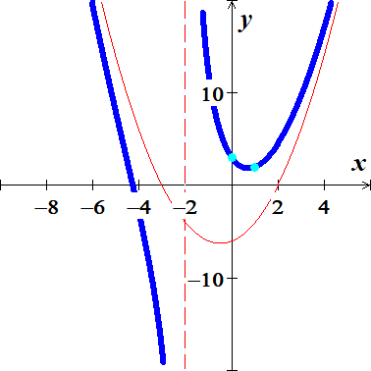***Solution***



***VA***:  ***HA***: 

***Hole***:  ***OA:*** 

|  |  |
| --- | --- |
| ***x*** | ***y*** |
| 0 | 3 |
| 1 | 2 |

***Exercise***

Find an equation of a rational function  that satisfies the given conditions



***Solution***

***Vertical Asymptote***: 

***Horizontal Asymptote***: 

***x-intercept***: 



***Exercise***

Find an equation of a rational function  that satisfies the given conditions



***Solution***

***Vertical Asymptote***: 

***Horizontal Asymptote***: 

***x-intercept***: 









***Exercise***

Find an equation of a rational function  that satisfies the given conditions



***Solution***

***Vertical Asymptote***: 

***x-intercept*** : 

***Horizontal Asymptote***: 



***Exercise***

Find an equation of a rational function  that satisfies the given conditions



***Solution***

***Vertical Asymptote***: 

***x-intercept*** : 

***Horizontal Asymptote***: 





***Exercise***

Find an equation of a rational function  that satisfies the given conditions



***Solution***

***Vertical Asymptote***: 

***x-intercept*** : 

***Horizontal Asymptote***: 



***Hole at *:** 



***Exercise***

Find an equation of a rational function  that satisfies the given conditions



***Solution***

***Vertical Asymptote***: 

***Horizontal Asymptote***: 

***x-intercept*** : 

***Hole at *:** 

