To access your math course website: [www.galveston.mylabsplus.com](http://www.galveston.mylabsplus.com)

After you access the website, please add it to your favorite (see the picture below), *so you do not have to retype the website again at home or work*. (**It will not save it on the campus**)

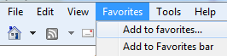

The website:

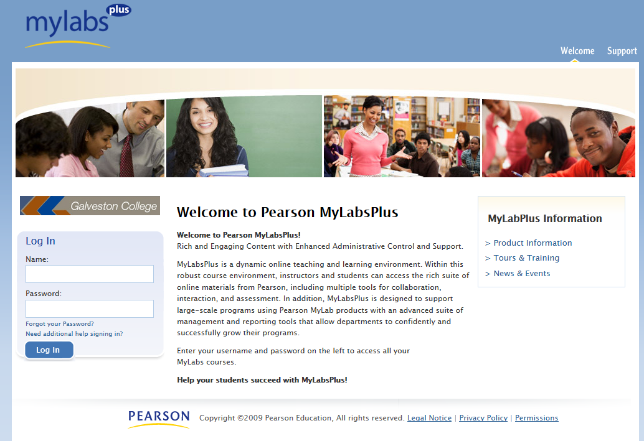

**GC0123456 (1)**

**(3)**

**ican (2)**

To login, under:

1. ***Name***: Enter your GC ID numbers (**GC0123456**).
2. ***Password***: type **ican**.
3. Click on the toggle ***“Log In***” to enter next page.

After you log in, please click on “My Profile” **(4)** to change your password and email address (***one that you check periodically***)

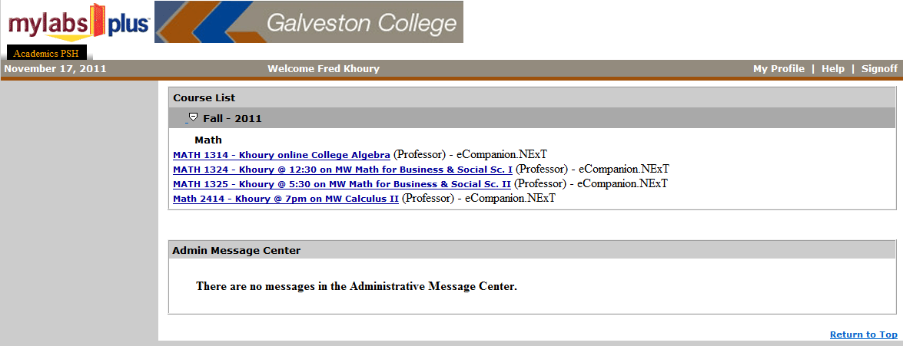

**(4)**

A new page will appear, see below

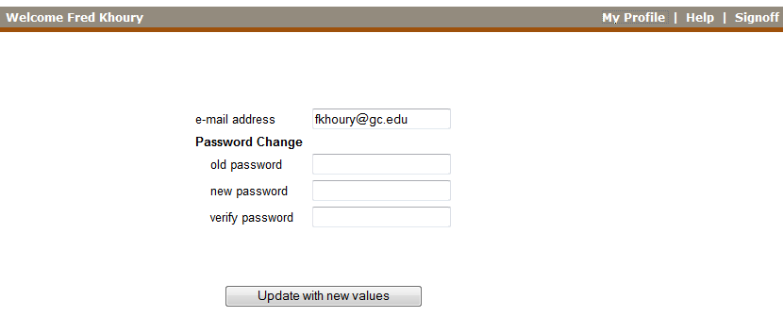

**(9)**

**(8)**

**(7)**

**(6)**

**(5)**

1. ***E-mail address***: You must change your email address to an email that you use and check it periodically. This is the only communication between you and your instructor. ***A default one is created***.
2. ***Old password***: type “ican”
3. ***New password***: enter a new password that you don’t forget
4. ***Verify password***: re-type your new password.
5. ***Update with new values***: click on the toggle to update the changes that you made.

After the updates, log off than log on to check on the updates that you made.

Click on the math course that you are enrolled in.

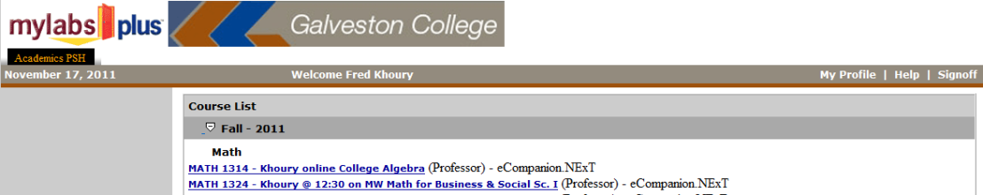

**Temporary Access Code**

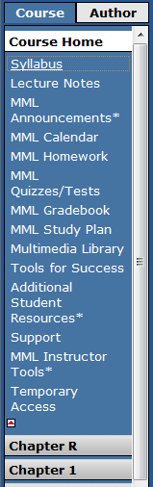 **Click on temporary Access for 3 weeks *free* access**

**Accept the agreement**

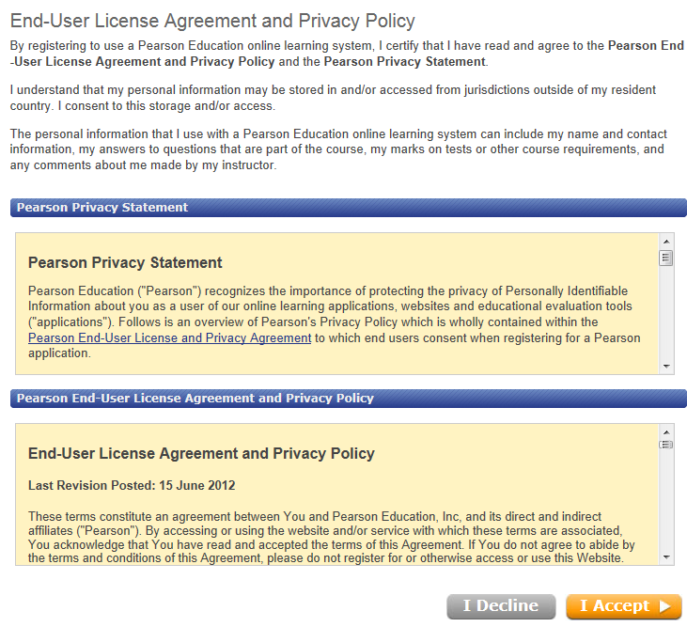

A window will be opened “**Temporary Access**”

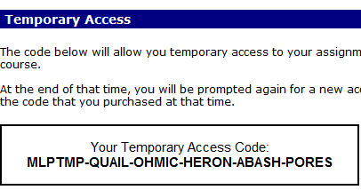

Highlight the code (**bold letter**) then right click to **copy** the code.

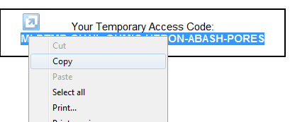

Click on any left toggle (MML homework, …).

A window will be opened.

1. For free or have the access code, check “Access Code” first option.
2. If you want to buy the code through the internet, select the second option.

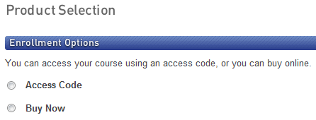

When you click on “Access Code”, click on line below to combine the boxes

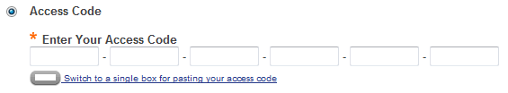

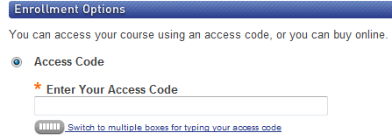

Right click to paste the code