  

 

|  |  |
| --- | --- |
|  |  |



























*y* – *axis* Line

(- , +) (+ , +)

Quadrant Quadrant Rise

II I

Run

Origin

*x* - *axis*

Q - III Q - IV

(- , -) (+ , -)



Equation of a line:  (***b****:* *y* - intercept)

 (*Given:* **slope and one point**)

 (*Given:* **2 points**)

Two slopes m1 and m2 are: Parallel (**//**) if 

Perpendicular (**⊥**) 

***Right Triangle:***

Pythagorean Theorem: 

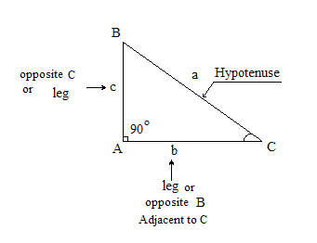

Two points  and 

Distance between 2 points: d = 

Midpoint = 

Equation of a circle with a center (*h*, *k*) and radius *r*:



(Diameter = 2.*r*)



*Reflected across* *x-axis* 

***y* = - *a* *f*(- *c* (*x* ± *b*)) ± *d***

*Reflected across* *y-axis*  

 

e0 = 1 e1 = 2.7183

 

 

 





 







***Formula***

Exponential Growth / Decay:

Growth Rate and Doubling Time:   

Logistic Function:

 

 

 

 

 

    

  

*y* = *x*3  *y* = |*x*|