Math 1314 − College Algebra ***Exam* 1 *Review***

*Professor*: Fred Khoury

1. Solve the following equations:
2. 
3. 25 – [2 + 5*y* – 3(*y* + 2)] = −3(2*y* – 5) – [5(*y* − 1) – 3*y* + 3]

|  |  |
| --- | --- |
|  |  |

1. Solve for *t*: 
2. Solve for *c*: 
3. Solve for *x*: 
4. Solve the following inequalities and express the solutions in interval notation.

|  |  |  |
| --- | --- | --- |
|  |  |  |

1. A student bought a new car for a total of $21,492, including sales tax. If the sales tax rate is 8%, then what amount of tax did she pay?
2. The length of a rectangle is 2 feet longer than three times its width. If the perimeter of the rectangle is 92 feet, find the length and width of the rectangle.
3. Sybil is having her yard landscaped. She obtained an estimate from two landscaping companies. Company ***A*** gave an estimate of $190 for materials and equipment rental plus $45 per hour for labor. Company ***B*** gave an estimate of $280 for materials and equipment rental plus $30 per hour for labor. Determine how many hours of labor will be required for the two companies to cost the same.
4. Kevin has $15,000 to invest. He invested some of the money in corporate bonds that pay 12% and the rest in government-backed Treasury bonds paying 4%. If he earned $1350 interest in one year, how much did he place in each investment?
5. The length of a rectangle is 4 inches shorter than twice the width. Its area is 96 square inches. Find its dimensions.
6. The height of a projectile fired upward from the ground with an initial velocity of 128 *ft./s* is given by , where *s* is the height in feet and *t* is the time in seconds. Find the times at which the projectile will be 192 feet above the ground.
7. The diagonal of a rectangle is 30 inches. If the width is 6 inches less than the length, find the dimensions of the rectangle.
8. A rectangular piece of metal is 10 *in*. longer than it is wide. Squares with sides 2 *in*. long are cut from the four corners, and the flaps folded upward to form an open box. If the volume of the box is 832 , what were the original dimensions of the piece of metal?
9. An open box is made from a 10-*cm* by 20-*cm* piece of tin by cutting a square from each corner and folding up the edges. The area of the resulting base is 96 *cm*2. What is the length of the sides of the squares

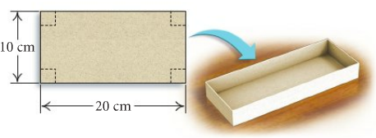

1. The hypotenuse of a right triangle is 50 *ft.* One leg is 10 *ft*. longer than the other. What are the lengths of the legs?

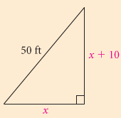

1. The frame on a picture is 8 *in*. by 10 *in*. outside and is uniform width. What is the width of the frame if 48 *in*2 of the picture shows?

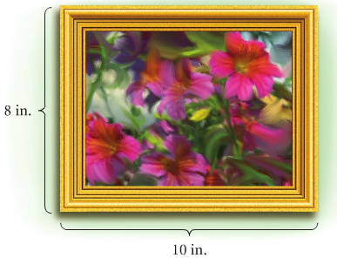

***Solution***

1. 
2. *y* = –2
3. 
4. 
5. 
6. 
7. 
8. 
9. 
10. 
11. 
12. 
13. 
14. 
15. 
16. 
17. 
18. 
19. 
20. 
21. 
22. 

|  |  |  |
| --- | --- | --- |
|  |  |  |

1. $1592
2. Length 35 ft and width 11 ft.
3. 6 hrs.
4. $9375 in 12% and $5625 4%.
5. The length 12 in. and the width 8 in.
6. *t* = 2 and 6 sec. height 192 ft
7. Length 24 in. and width 18 in.
8. Length 30 in. and width 20 in.
9. 
10. 
11. 