Math 1314 ***Homework*** *Sec*−2.1 ***Name***:

1.  **Find**: 
2. Determine any ***relative maximum*** or ***minimum*** of the function, determine the intervals on which the function ***increasing*** or ***decreasing***, and then find the ***domain*** and the ***range***.



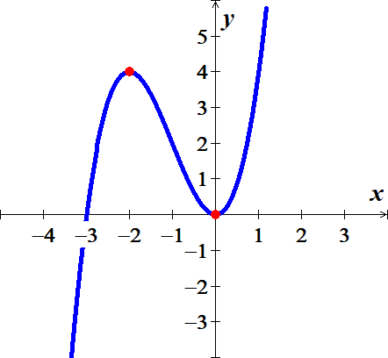

1. An airplane is flying at an altitude of 3800 *feet*. The slanted distance directly to the airport is *d* *feet*. Express the horizontal distance *x* as a function of *d*.

