**Appendix**

**Appendix *A***

***Derivatives***

|  |  |  |  |
| --- | --- | --- | --- |
| ***Constant Rule*** | | , c is a constant | |
| ***Constant Multiple Rule*** | | , *c* is a constant | |
| ***Sum and Difference Rules*** | |  | |
| ***Product Rule*** | |  | |
| ***Quotient Rule*** | |  | |
| ***Power Rules*** | |  | |
| ***Chain Rule*** | |  | |
|  |  | |  |
|  |  | |  |











|  |  |  |
| --- | --- | --- |
| ***Trigonometric*** | | |
|  |  |  |
|  |  |  |
| ***Inverse Trigonometric*** | | |
|  |  |  |
|  |  |  |
| ***Hyperbolic*** | | |
|  |  |  |
|  |  |  |
| ***Inverse Hyperbolic*** | | |
|  |  |  |
|  |  |  |
| ***Exponential Rule*** | | |
|  |  |  |
| ***Derivative of Natural Log* (*ln*)** | | |
|  |  |  |

**Appendix *B***

***Differential Equations***

|  |  |  |
| --- | --- | --- |
|  |  | ***Solution*** |
| Bernoulli’s Equation |  |  |
| Bessel's Equation |  |  |
| Euler - Cauchy Equation |  |  |
| Exact Equation |  |  |
| Homogeneous |  |  |
|  | (where *v = xy*) |
| Legendre’s Eq. |  |  |
| Linear First Order Equation |  |  |

|  |  |  |
| --- | --- | --- |
| Linear , Homogeneous Second Order  Equation |  |  |
| Linear , nonhomogeneous Second Order  Equation |  |  |
| Separation of Variables |  |  |

**Appendix *C***

***Electrical (Basic)***

There are two types of circuits – direct current (***dc***) and alternating current (***ac***) circuits.

***DC* −** circuits are the circuits where the voltage (current) is constant in time. Capacitor is an open circuit, like it’s not there

***Transient***: A circuit changes from one *DC* configuration to another *DC* configuration (a source value changes or a switch flips).

Determine the *DC* state (current, voltages, etc.) before the change.

Then determine what happens after the change. Over time, the circuit will settle into a new *DC* state, where the capacitors are again open-circuits.

In between will be an interval during which currents and voltages are changing as the capacitors charge or discharges. Since these lasts for only a ***short time***, this is known as a ***transient*** effect.

***AC*** − circuits are circuits where the voltage (current) varies with time typically like a sine and cosine. Currents and voltage are changing continuously, sop capacitors are charging and discharging continuously.

A ***source*** is a device that converts non-electrical energy to electrical energy are a battery which converts chemical energy to electrical energy and a generator which converts mechanical energy to electrical energy.

The circuit symbol for a *dc* source is



|  |  |
| --- | --- |
| ***Voltage Source*** |  |
| ***Resistor*** |  |
| ***Switch*** |  |

An ***electromotive force*** (***emf***) of a source is defined to be the amount of work done per a unit charge by the source in transferring a charge from one terminal to the other



*Ε* → Electromotive force (*𝜀mf*) of a source

 Work done by the source in carrying a charge from one terminal to the other.

Unit of measurement of *𝜀mf* is Joules/Coulomb which is the Volt (*V*).

Any source has an internal resistance is represented as

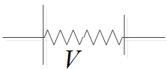

***Alternating Current Circuits***

An alternating current circuit (***ac***) is a circuit where the voltage and the current vary with time typically like a sine or a cosine. A typical ac signal may be given as



*v* is the voltage at a given instant of time and is called ***instantaneous*** voltage.

*V* is the maximum value of the voltage and is called the ***amplitude*** of the voltage.

*ω* is the number of radians executed per second and is called the ***angular frequency*** of the voltage.

It is related with

Frequency (*f*) as *ω = 2πf*

Period (*T*) as *ω = 2π ⁄ T*.

*β* is called the phase angle of the voltage.

Its effect is to shift the graph of  either to the right (if negative) or to the left (if negative).

Phase angle of signal 2 minus the phase angle of signal 1 is called the ***phase shift*** of signal 2 with respect to signal 1.

The one with a bigger phase angle is said to be leading the other and the one with a smaller phase angle is said to be lagging from the other.

If 

***Current***

***Current***: is defined to be amount of charge that crosses a cross-sectional per a unit time.

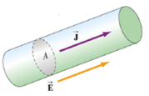



 Current (*average*)

*Q*: Amount of charge that crosses a cross sectional area in time interval Δ*t*

Instantaneous current is defined to be amount of charge  that crosses a cross-sectional area in infinitesimal time interval .



Unit of current is coulomb/second which is defined to be the Ampere abbreviated as *A*.

**Drift Velocity of Electrons**

Normally the electrons are normally colliding with each other. If there is no electric field, the net velocity of the electrons with zero. But if there is a net electric field, the electrons will have a net velocity opposite to the directions of the electrons. This velocity is called the drift velocity of electrons. Even though the carriers of charges are negative charges (electrons), conventionally it is assumed that the carriers of charge are positive charges.

Thus, the direction of current density is taken to be the direction of movement of positive charges which is the same as the directions of the electric field.

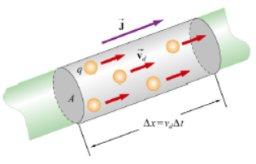

Consider carriers of charge of charge *q* crossing a cross-sectional area with a drift velocity . Suppose the charges travel a distance Δ*x* in a time interval Δ*t*. .

Let *n* represent the number of charges per unit volume.

Therefore, the total amount of charge that crosses the cross-sectional is in time interval Δ*t* is  (where  is the volume of the cylinder of base  and height Δ*x*)







But 





*n*: Number of charges per a unit volume

*q*: Charge of one charge carrier

 Drift velocity

 Cross-sectional area

***Ohm’s Law***

States that the current density and the electric field in metals are directly proportional.



*J*: Current density

E: Electric field

*σ* : A material constant called the conductivity of the materials

***Resistance*** (*R*)

Resistance of a material is defined to be the ratio between the potential difference across its terminals and the current flowing through it.



Unit if resistance is ***volt/ampere*** which is defined to be the ***Ohm*** abbreviated as Ω.

Circuit symbol for resistance is

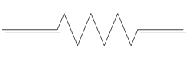 

**Resistance of a Wire of Length** l **and Cross-Sectional Area *A***

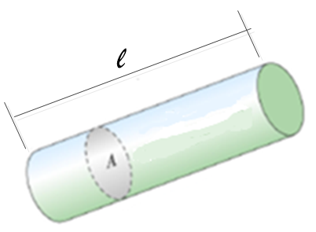



If the electric field in the wire is *E*, then



(Assuming the electric field is constant.)









 (the inverse of the conductivity of the material) is defined to be the resistivity (*ρ*) of the material







*R*: resistance of a wire

l: length of the wire

*A*: cross-sectional area

Therefore; it follows that the resistance of a wire is directly proportional to its length and inversely proportional to its cross-sectional area unit measurement for resistivity is Ω*m*.

**Series Connection of resistors**

Resistors are said to be connected in series if they are connected in a line as shown

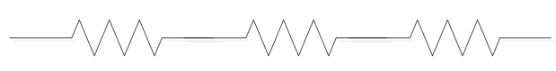

Consider a series connection of resistors  connected to a potential difference .

The current through all the resistors will be the same because they are connected in a single line.



Where *I* is the total current.

The total potential difference is equal to the sum of the potential drops across the individual resistors



**Equivalent Resistance**

Equivalent Resistance of a combination of resistors is defined to be the ratio between the potential drop across the combination  & the current across the combination.



→ Equivalent resistance

→ Total potential difference

→ Current

For series combination 

& 





→ Equivalent resistance of a series combination

**Parallel Connection of Resistors**

Resistors are said to be connected in parallel if they are connected in branches as shown

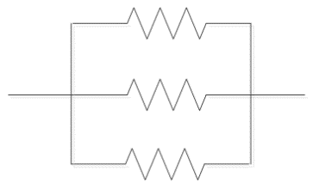

Resistors connected in parallel have the same potential difference across their terminals



Where  is the total potential difference across the combination.

The total current across the combination is equal to the sum of the currents across the resistors



Where ** is the total current across the combination.

Also 

**



Equivalent resistance of parallel combination

***Capacitance and Dielectric***

A Capacitor is two conductors (*or more*) separated by an insulator. A capacitor is used to store charges or electrical energy. The circuit symbol of a capacitor is



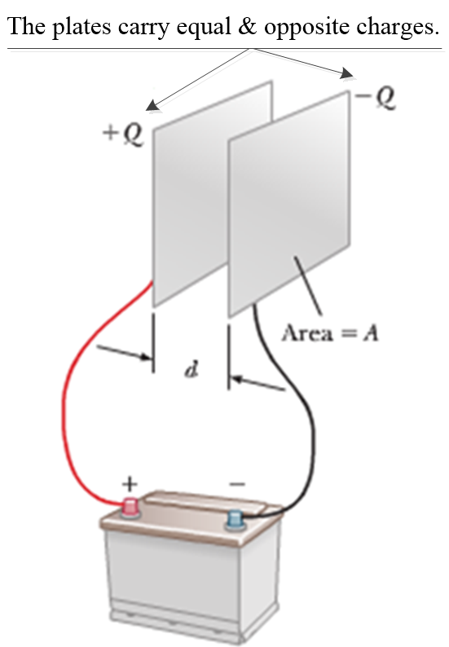

When a capacitor is connected to a potential difference (*such as a battery*), charges are transferred from one of the conductors to the other conductor, and both conductors acquire equal but opposite charge. The charge accumulated is directly proportional to the potential difference between the conductors. That is



Where *Q* is charge accumulated by the conductors and Δ*V* is the potential difference between the conductors. The constant of proportionality is called the capacitance of the capacitor and denoted by *C*.



or



The unit of measurement for capacitance is ***coulomb/volt*** which is defined to be the ***Fared*** abbreviated as ***F***.

**Parallel Plate Capacitor**

Two parallel plates separated by an insulator. From symmetry, the electric field is uniform and perpendicular to the plate inside (*between*) the plates and approximately zero outside the plates.

If the charge density is δ, an expression for the electric field can be obtained by using Gauss’s law by taking the Gaussian surface to be the cylindrical surface shown.

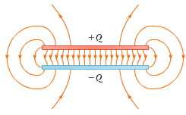

The electric flux crossing part of the cylinder outside the plates is zero because the electric field outside the plates is approximately zero. The electric flux on the curved surface inside plates is zero because the area vector and the electric field perpendicular to each other. The only contribution to the electric flux comes from the end face inside the plates. If the area of the end face is *A* then



where is the magnitude of the electric field inside. From Gauss’s law



where *q* is the charge enclosed by the Gaussian surface.







Coulomb’s constant *k* is related with another constant called ***electrical permittivity*** in ***vacuum*** (*denoted by * ) as

**



*E*: Electric field inside parallel plate capacitor

*δ*: Charge density of the plates

**: Electrical permittivity of vacuum **

Now that we have an expression for the electric field inside, we can also obtain an expression for the potential difference between the plates. Since the electric field is a constant





The capacitance of the capacitor is the ratio between the charge and the potential difference.



(where *A is the area of one of the plates*)





*Capacitance of a parallel plate capacitor of area A and separation d,* (*if they are separated by vacuum or air*)

**Parallel Combination of Capacitors**

Capacitors are said to be connected in parallel if they are connected in a branched connection as shown

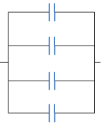

Capacitors connected in parallel have the same potential difference because the conductors on the same side are connected by conductors and are at the same potential but the charge will be divided among the capacitors according to their capacitances. So the total charge is equal to the sum of the charges of each capacitor.

If capacitors  are connected in parallel and then connected to a potential difference ΔV, then



*And*



Where *Q* is the total charge.

**The Equivalent Capacitance**

The equivalent capacitance of a group of capacitors is defined to be the ratio between the total charge (*Q*) and the total potential difference (Δ*V*)



For parallel combination



But 









The equivalent capacitance of capacitors connected parallel is obtained by adding the individual capacitors.

**Series Combination of Capacitors**

Capacitors are said to be connected in series when they are connected in one line.



When capacitors are connected in series are connected to a potential difference, electrons are taken from one of the outermost conductors and taken to the outermost conductor on the other side. All the conductors in between are charges by induction.

Thus, in a series combination all of the capacitor will acquire the same charge which is also equal to the total charge acquired by the capacitors.

The total potential difference across the combination will be divided into the capacitors according to their capacitance.

If capacitors  are connected in series and then connected to a potential difference 

 *Q*: is the total charge



The equivalent capacitance of the combination is defined to be the ratio between the total charge & the total potential difference.













Equivalent capacitance of capacitors connected in series

**Energy Density of a parallel plate capacitor**

If the area of the plates is *A* and the separation between the plates is *d*, then the volume of the parallel plate capacitor is .

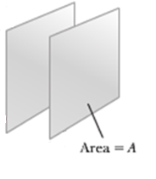 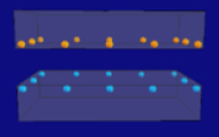

The energy density  is given by



For a parallel plate capacitor

 Where *E* is the electric field strength

& 





 Energy density of a parallel plate capacitor.

**Capacitors with Dielectrics**

A dielectric is an insulator placed between the conductors of a capacitor. A dielectric is used to increase the capacitance of a capacitor consider the parallel plate capacitor shown

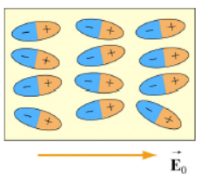 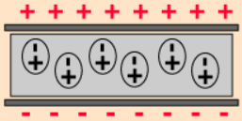

The charges in the plates of the capacitor will set up an electric field directed from the positive plate towards the negative plate. Let the strength of this field be .

This is also the field between the capacitors when the plates are separated by vacuum (or air). This electric field will exert force on the modules of the dielectric. The negative part of a molecule will be pulled towards the positive plate and the positive part of the molecule will be pulled towards the negative plate.

Thus, the molecules of the dielectric will set up their own electric field directed from their positive end towards their negative and which is opposite to the electric field set up by the charges on the plates. The net electric field between the plates is the field due to the charges in the plates minus the field due to the molecules of the dielectric.

Thus, the electric field strength with a dielectric is less than the field strength without a dielectric. The ratio between the field strength without a dielectric  and the field strength with a dielectric is defined to be dielectric constant  of the dielectric



: Dielectric constant

: Electric field without the dielectric

*E*: Electric field with the dielectric



The potential difference between the plates  when there is to dielectric (i.e. vacuum) is given by

 Where *d* is the separation between the plates

& the potential difference  with the dielectric is given by

 





 The potential difference with a dielectric of dielectric constant 

 The potential difference without a dielectric

The capacitance of the capacitor without a dielectric is given by

 Where *Q* is the charge on the plates

& the capacitance with a dielectric of dielectric constant  is

  (the charge remains the same)





 Capacitance with a dielectric of dielectric constant 

 Capacitance without a dielectric

When a dielectric is inserted between the conductors of a capacitor, the electric field decreases by a factor of , the potential difference decreases by a factor of  and the capacitance increases by a factor of .

***Inductance***

**Self-Induced  of an inductor**

An inductor is a coil. The circuit symbol for an inductor is



When an inductor is connected to a source, current will flow through it and this current will produce magnetic field inside the coil. That is there is magnetic flux crossing the loops of the coil due to its own magnetic field.

If the current changes with time, then the magnetic field inside the coil will change with time which implies the magnetic flux crossing the coil will change with time. According to Faraday’s law, this change in magnetic flux will produce induced  in the coil. This kind of induced  is called self induced  because it is caused by the current in the coil itself.

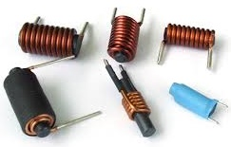 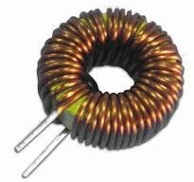 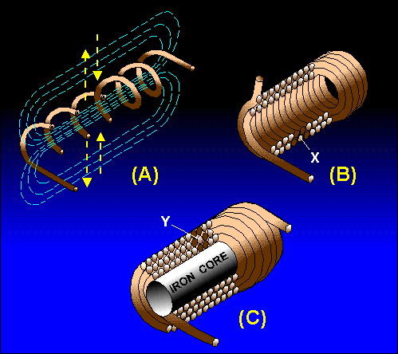

Self-induced  is directly proportional to the rate of change of current in the coil. The constant of proportional between the self induced  and the rate of change of current in the coil is called ***inductance*** (*L*) of the coil.



→ self induced 

*L* → Inductance , rate of change of current with time.

The negative sign indicates that the polarity of the self-induced  is in such a way aas to oppose the cause for the change in flux which is the rate of change of current with time. (It essentially represents Lenz’s rule)

The unit of measurement for inductance is *volt/(Ampere/second)* which is defined to be the Henry, abreviated as ***H***.

The average induced  in a given time interval  can be obtained by integrating  with time in a time interval  & then dividing by 











→ Average induced in a time interval 

→ Change in current in a time interval 

Using Faraday’s law, the inductance of a coil can be expresses in terms of the crossing the coil and the current in the coil

Faraday’s law 

Where *N* is the number of turns & *φ* is magentic flux per turn. Thus







The constant can be replaced without loss of generality because the physical theory depends on derivatives. Therfore the inductance can also be given as



*N* → Number of turns

 → Magnetic flux per turns

*I* → Current in the coil

**Inductance of a Solenoid in terms of its geometry**

The inductance of an inductor depends on the geometry of the coil only. Consider a solenoid of length , radius *R* and number of turns *N*.

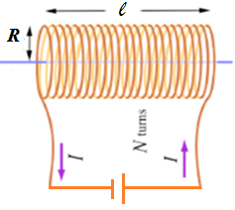

The magnetic flux crossing a single coil due its own current is  inside the solenoid the field is approximately parallel to its axis. But

 & 

Thus 



 Inductance of a solenoid in terms of its geometry

*N* → Number of turns

*R* → Radius of solenoid

 → Length of solenoid



***Kirchhoff’s Rules***

Kirchhoff’s Rules are rules used to solve complex circuits.

A ***junction*** in a circuit is a point where two or more wires meet.

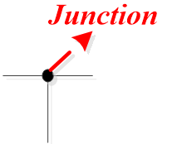

A ***simple loop*** is a non-intersecting loop or a loop that is not divided into more than one loop

|  |  |
| --- | --- |
|  |  |
| *Simple loop* | *Not a simple loop* |

***Kirchhoff’s junction rules*** states that the sum of all the currents in a junction is zero



***Kirchhoff’s loop rules***states that the sum of all the potential differences in a loop is zero



**Sign Convention**

Currents directed towards the junction are taken to be positive while currents directed away from the junction are taken to be negative. It is easier to treat the variables as positive & represent a negative as the negative of the variable (***for example***, if a current I is negative it will be written as –*I*)

The potential difference across a battery (source) is taken to be positive if transversed from its negative to its positive terminal & is taken to be negative if transversed from its positive terminal towards its negative terminal

|  |  |
| --- | --- |
|  |  |
| *Simple loop* | *Not a simple loop* |

The potential difference across a resistor is taken to be negative if transversed in the direction of the current and positive if transversed opposite to the direction of the current

|  |  |
| --- | --- |
|  |  |

**Applying Kirchhoff’s loop**

1. Assign variables & directions to the currents in all the wires of the circuit. Direction is assigned arbitrarily. If after solving the problem the current turns out to be positive, then the assigned direction is the correct direction. If the current turns out to be negative than the actual direction is opposite to the assigned direction.
2. Assign transverse directions (*i.e*., clockwise or counterclockwise) to all of the simple loops of the circuit. Choice of a transverse direction is arbitrary. It is the direction in which Kirchhoff’s loop rule is to be applied.
3. If there are *n* junctions, apply Kirchhoff’s junction will not result in an independent equation.
4. Apply Kirchhoff’s loop rule to all of the simple loops of the circuit.
5. Solve the resulting system of linear equations.

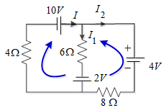

***Examples***

***Solving a circuit with transient changes***

1. Determine the *DC* voltages on the capacitors before the change occurs. These may be given, or you may have to solve for them from the original configuration.
2. Let the change occur instantaneously at time . The capacitors will maintain their voltages into the ***instant*** just after the change. (Recall: capacitor voltage cannot change instantaneously.)
3. Analyze the circuit using standard methods (node-voltage, mesh-current, etc.) Since capacitor currents depend on , the result will be a differential equation.
4. Solve the differential equation, using the capacitor voltages from before the change as the initial conditions.
5. The resulting equation will describe the charging (or discharging) of the capacitor voltage during the transient and give the final *DC* value once the capacitor is fully charged (or discharged).

***Example***

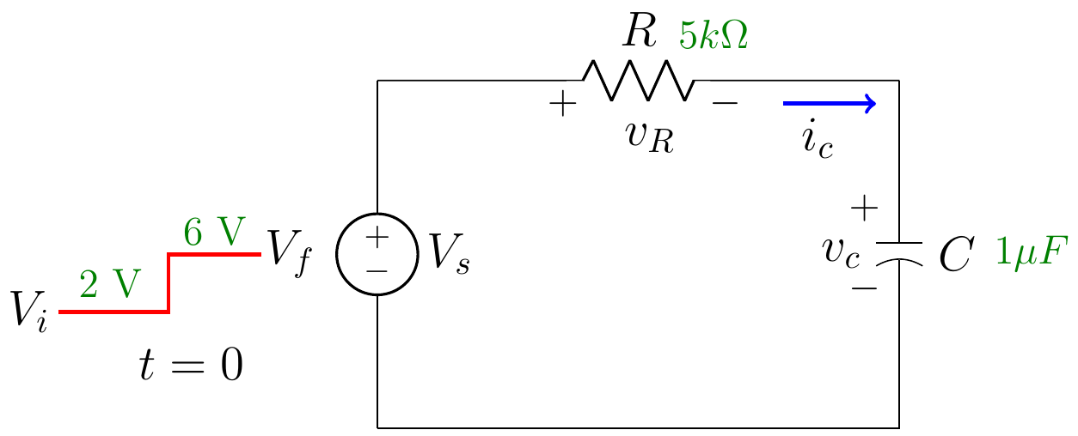

In the circuit,  abruptly changes value from  to  at . Assume that the source was at  for a ***very long time*** before .

1. For ,  and 
2. At ,  changes,  (still), but  jumps abruptly:







 Capacitor begins to charge.

1. For , as the capacitor charges,  will increase. As increases,  will decrease.
2. After a s***ufficiently long time***,  will charge to . The current drops to zero.

The transient is complete.













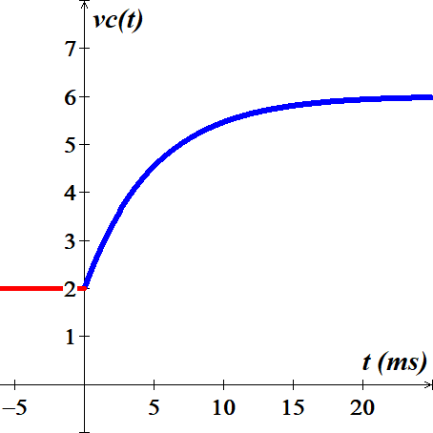







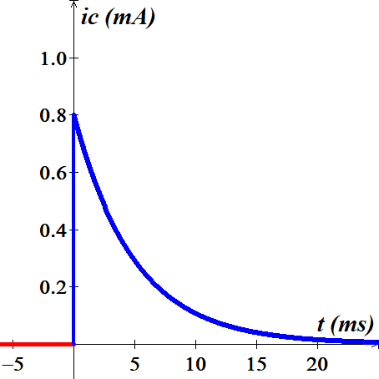 

At  ***√***









At  ***√***

**Appendix *D***

***Factorial***

The Factorial of a non-negative integer *n* is denoted by . The factorial notation  was introduced by Christian Kramp in 1808.

Factorial on any number is the product of positive less than or equal to that number (*n*).





***Example***: 



***Double* Factorial**

The product of all odd integers up to some odd positive integer *n* is called the double factorial of *n*, denoted by .







***Example***: 



For even positive integer *n* the double factorial is







***Example***: 



***Triple* Factorial**

|  |  |
| --- | --- |
|  |  |
| 1 | 1 |
| 2 | 2 |
| 3 | 3 |
| 4 | 4 |
| 5 | 10 |
| 6 | 18 |
| 7 | 28 |
| 8 | 80 |
| 9 | 162 |
| 10 | 280 |

The product of all odd integers up to some odd positive integer *n* is called the triple factorial of *n*, denoted by .



***Example***: 







**Multifactorial**

A common related notation is to use multiple exclamation points to denote a multifactorial, the product of integers in steps of two , three 

 

 



**Appendix *E***

***Integrals***

|  |  |
| --- | --- |
| *General Power Rule* |  |
| *Simple Exponential Rule* |  |
| *General Exponential Rule* |  |
| *Simple Logarithmic Rule* |  |
| *General Logarithmic Rule* |  |
| *Area* |  |
| *Integration by Parts* |  |

|  |  |  |  |  |
| --- | --- | --- | --- | --- |
|  | | |  | |
|  | | |  | |
|  | | | |  | | |
|  | | | |  | | |
|  | | | |  | | |
|  | | | |  | | |
|  | | | |  | | |
|  | | | |  | | |
|  | | | |  | | |
|  | | | |  | | |
|  | | | |  | | |
|  | | | |  | | |
|  | | | |  | | |
|  | | | |  | | |
|  | | | |  | | |
|  | | | |  | | |
|  | | | |  | | |
|  | | | |  | | |
|  | | | |  | | |
|  | | | | | | |
|  | | | | |  | |
|  | | | | |  | |
|  | | | | |  | |
|  | | | | |  | |
|  | | | | |  | |
|  | | | | |  | |
|  | | | | | | |
|  | | | | | | |
|  | | | | |  | |
|  | | | | |  | |
|  | | | | |  | |
|  | | | | |  | |
|  | | | | |  | |
|  | | | | |  | |
|  | | | | |  | |
|  | | | | | | |
|  | | | | |  | |
|  | | | | | | |
|  | | | | |  | |
|  | | | | |  | |
|  | | | | |  | |
|  | | | | | | |
|  | | | | | | |
|  | | | | | | |
|  | | | | | | |
|  | | | | | | |
|  | | | | | | |
|  | | | | | | |
|  | | | | | | |
|  | | | | | | |
|  | | | | | | |
|  | | | | | | |
|  | | | | | | |
|  | | | | |  | |
|  | | | | |  | |
|  | | | | |  | |
|  | | | | |  | |
|  | | | | | | |
|  | | | | | | |
|  | | | | |  | |
|  | | | | |  | |
|  | | | | | | |
|  | | | | | | |
|  | | | | | | |
|  | | | | | | |
|  | | | | |  | |
|  | | | | |  | |
|  | | | | |  | |
|  | | | | |  | |
|  | | | | | | |
|  | | | | | | |
|  | | |  | | | |
|  | | | | | | |
|  | | | | | | |
|  | | | | | | |
|  | | | | | | |
|  | | | | | | |
|  | | | | | | |
|  | | | | | | |
|  | | | | |  | |
|  | | | | |  | |
|  | | | | |  | |
|  | | | | | | |
|  | | | | | | |
|  | | | | |  | |
|  | | | | |  | |
|  | | | | | | |
|  | | | | | | |
|  | | | | |  | |
|  | | | | |  | |
|  | | | | |  | |
|  | | | | |  | |
|  | | | | | | |
|  | | | | | | |
|  | | | | |  | |
|  | | | | |  | |
|  | | | | | | |
|  | | | | | | |
|  | | | | | | |
|  | | | | |  | |
|  | | | | |  | |
|  | | | | | | |
|  | | | | |  | |
|  | | | | |  | |
|  | | | | | | |
|  | | | | |  | |
|  | | | | | | |
|  | | | | | | |
|  | | | | | | |
|  | | | | | | |
|  | | | | |  | |
|  | | | | |  | |
|  | | | | |  | |
|  | | | | |  | |
|  | | | | | | |
|  | | | | | | |
|  | | | | |  | |
|  | | | | | | |
|  | | | | | | |
|  | | | | |  | |
|  | | | | |  | |
|  | | | | | | |
|  | | | | | | |
|  | | | | |  | |
|  | | | | |  | |
|  | | | | | | |
|  | | | | | | |
|  | | | | | | |
|  | | | | | | |
|  | | | | | | |
|  | | | | | | |
|  | |  | | | | |
|  | | | | | | |



**Appendix *F***

## *Laplace Transform*

|  |  |  |  |  |  |
| --- | --- | --- | --- | --- | --- |
| ***Time Function*** | ***Laplace Transform*** | | ***Time Function*** | | ***Laplace Transform*** |
| Unit impulse | 1 | |  | |  |
| Unit step |  | |  | |  |
| *t* |  | |  | |  |
|  |  | |  | |  |
|  |  | |  | |  |
|  |  | |  | |  |
|  |  | |  | |  |
|  |  | |  | |  |
|  |  | |  | |  |
|  |  | |  | |  |
|  |  | |  | |  |
|  |  | |  | |  |
|  |  | |  | |  |
|  |  | |  | |  |
|  |  | |  | |  |
|  | |  |  |  | |
|  | |  |  |  | |
|  | |  |  |  | |
|  | |  |  |  | |
|  | |  |  |  | |
|  | |  |  |  | |
|  | |  |  |  | |
|  | |  |  |  | |
|  | |  |  |  | |
|  | |  |  |  | |
|  | |  |  |  | |
|  | |  |  |  | |
|  | |  |  |  | |
|  | |  |  |  | |
|  | |  |  |  | |

|  |  |
| --- | --- |
|  |  |



**Appendix *G***

***Proofs***

*Derivative*: Rational Function to Power ‘***n***’ in the form 

 

***Proof***



 







*Derivative*: Rational Function to Power ‘***n***’ in the form 



***Proof***



 







*Derivative*: in the form 











I**ntegration by Part**

Evaluate 

|  |  |  |
| --- | --- | --- |
|  |  |  |
| **+** |  |  |
| **−** |  |  |
| **+** |  |  |
| **−** |  |  |
|  |  |  |





***Jose’s Method***

Evaluate 

|  |  |  |
| --- | --- | --- |
|  |  |  |
| **+** |  |  |
| **−** |  |  |
| **+** |  |  |







**Appendix *H***

***Series***



***Arithmetic***





***Geometric***

















































***Legendre Polynomial***



