***Lecture One* – First Order Equations**

***Section* 1.1 – Differential Equations & Solutions**

In the mathematical, engineering and sciences models are devolped to assist in the understanding of physical phenomena. These models often yield an equation that contains some derivvatives of an unknown function. Such an equation is called a ***differential equation***. We introduce few major methods ***geometrical***, ***analytical*** and ***numerical*** for getting the solutions of these problems.

Differential equations all about solving equations involving  .

**1.1-1 Ordinary Differential Equations**

Ordinary differential equations ivolve an unknown function of a single variable with one or more of its derivatives.



*y*: is unknown function

*t*: independent variable

Some other examples:











∴ The order of a differential equation is the order of the highest derivative that occurs in the equation.

 *second order*

 is not an ODE (*ω* is dependent on *x* and *t*)

This equation is called a ***partial differential equation***.

**1.1-2 *Definition***

A first-order differential equation of the form  is said to be in normal form.

 is said to be in normal form.

 is a given function of two variables *t* & *y* (***rate function***).

**1.1-3 Solutions**

A solution of the first-order, ordinary differential equation  is a differentiable function  such that  for all *t* in the interval where  is defined.

1. Can be found in explicit and implicit form by applying manipulation (integration)
2. No real solution.

***Example*** **1**

Show that  is a solution of the first-order equation 

***Solution***





 True; it is a solution

is called the ***general solution***.

The solutions from the graph are called ***solution curves***.

***Example*** **2**

Is the function  a solution to the differential equation

***Solution***







*False*; it is not a solution.

***Exercises Section* 1.1 – Differential Equations & Solutions**

1. Show that  is a solution of the first-order equation 
2. Show that  is a solution of the first- order equation 
3. Show that  is a solution of  for 
4. A general solution  may fail to produce all solutions of a differential equation . Show that  is a solution of the differential equation, but no value of *C* in the given general solution will produce this solution.
5. Use the given general solution to find a solution of the differential equation having the given initial condition.
6. Show that  is a solution of the first-order equation 
7. Use the given general solution to find a solution of the differential equation having the given initial condition. 
8. Use the given general solution to find a solution of the differential equation having the given initial condition. 
9. Use the given general solution to find a solution of the differential equation having the given initial condition. 
10. Find the values of ***m*** so that the function  is a solution of the given differential equation

|  |  |
| --- | --- |
|  |  |

1. Let  is 2-parameter family solutions of the second order differential equation of . Find a solution of the second-order consisting of this differential equation and the given initial conditions.

|  |  |
| --- | --- |
|  |  |

1. Find values of *r* such that  is a solution of 

(**13 – 14**) Solve the differential equation:

|  |  |
| --- | --- |
|  |  |

1. Given the differential equation, is the given equation a solution?

|  |  |
| --- | --- |
|  |  |

***Section* 1.2 – Separable Equations**

**1.2-1 *Separable* Equation**

A simple class of first-order differential equations using a class of ***separable equations.*** These equations can be written with its variables separated and then easily solved.

If is independent of *y* ⇒

 *Integrate both sides*



**1.2-2 *Definition***

A first-order differential equation of the form is said to be separable or to have separable variables.





 *not separable*

***Example* 1**

At time *t* the sample contains radioactive nuclei and is given by the differential equation:



This is called the ***exponential equation***.



 *Separable equation*

 *Integrate both sides*



 *Convert to exponential*







 

***Example* 2**

Solve the differential equation 

***Solution***



 *Integrate both sides*





 *Cross multiplication*





***General Method***

1. Separate the variables
2. Integrate both sides
3. Solve for the solution , if possible

**1.2-3 Newton's Law of Cooling**

Newton's Law of Cooling states that the rate of change of an object's temperature (***T***) is proportional to the difference between its temperature and the ambient temperature (***A***) (i.e. the temperature of its surroundings).



***Example* 3**

A can of beer at 40° *F* is placed into a room when the temperature is 70° *F*. After 10 *minutes* the temperature of the beer is 50° *F*. What is the temperature of the beer as a function of time? What is the temperature of the beer 30 *minutes* after the beer was placed into the room?

***Solution***

By Newton's Law of cooling: The rate of change of an object's temperature (***T***) is proportional to the difference between its temperature and the ambient temperature (***A***).



 *Integrate both sides*







 *Quotient Rule*



⇒ 

*Given*: 











 







**1.2-4 *Losing a solution***

When we use separate variables, the variable divisors could be zero at a point.

***Example* 4**

Find a general solution to 

***Solution***



  C*ritical points*



















If 







⇒ 

If 











**1.2-5 *Implicitly Defined Solutions***

***Example* 5**

Find the solutions of the equation , having initial conditions  and 

***Solution***











 *Quadratic Formula*

 *Implicit*























 , but it never it will be.

*Explicit Solutions*: 

*Implicit solutions*: 

***Example* 6**

Find the solutions to the differential equation , having 

***Solution***











For 







We can't solve for 

⇒ This solution is defined as implicit.

For 







Since the initial condition < 0, then:



For 

 *True statement*

 is a solution

***Exercises Section* 1.2 – Solutions to Separable Equations**

(**1 – 56**) Find the general solution of the differential equation.

|  |  |
| --- | --- |
|  |  |

|  |  |
| --- | --- |
|  |  |

(**57 – 116**) Find the exact solution of the initial value problem. Indicate the interval of existence.

|  |  |
| --- | --- |
|  |  |

|  |  |
| --- | --- |
|  |  |

1. A thermometer reading 100°*F* is placed in a medium having a constant temperature of 70°*F*. After 6 *min*, the thermometer reads 80°*F*. What is the reading after 20 *min*?
2. Blood plasma is stored at 40°*F*. Before the plasma can be used, it must be at 90°*F*. When the plasma is placed in an oven at 120°*F*, it takes 45 *min* for the plasma to warm to 90°*F*. How long will it take for the plasma to warm to 90°*F* if the oven temperature is set at:
3. 100°*F*.
4. 140°*F*.
5. 80°*F*.
6. A pot of boiling water at 100°*C* is removed from a stove at time  and left to cool in the kitchen. After 5 *min*, the water temperature has decreased to 80°*C*, and another 5 *min* later it has dropped to 65°*C*. Assuming Newton’s Law for cooling, determine the (constant) temperature of the kitchen.
7. A murder victim is discovered at midnight and the temperature of the body is recorded at 31°*C*. One hour later, the temperature of the body is 29°*C*. Assume that the surrounding air temperature remains constant at 21°*C*. Use Newton’s Law of cooling to calculate the victim’s time of death. *Note*: The normal temperature of a living human being is approximately 37°*C*.
8. Suppose a cold beer at 40°*F* is placed into a warn room at 70°*F*. suppose 10 *minutes* later, the temperature of the beer is 48°*F*. Use Newton’s Law of cooling to find the temperature 25 *minutes* after the beer was placed into the room.
9. A thermometer is removed from a room where the temperature is  and is taken outside, where the air temperature is . After one-half minute the thermometer reads .
10. What is the reading of the thermometer at ?
11. How long will it take for the thermometer to reach ?
12. A thermometer is taken from an inside room to the outside, where the air temperature is . After 1 *minute* the thermometer reads , and after 5 *minutes* the thermometer reads . What is the initial temperature of the inside room?
13. The temperature inside a house is . A thermometer is taken outside after being inside the house for enough time for it to read . The outside air temperature is . After three *minutes* the thermometer reading is found to be . Find the reading on the thermometer as a function of time.
14. A metal bar at a temperature of  is placed in a room at a constant temperature of . If after 20 minutes the temperature of the bar is .
15. Find the time it will take the bar to reach a temperature of 
16. Find the temperature of the bar after 10 *minutes*.
17. A small metal bar, whose initial temperature was , is dropped into a large container of boiling water.
18. How long will it take the bar to reach  if it is known that its temperature increases  in 1 *second*?
19. How long will it take the bar to reach 
20. Two large containers ***A*** and ***B*** of the same size are filled with different fluids. The fluids in containers ***A*** and ***B*** are maintained at  and , respectively. A small metal bar, whose initial temperature is , is lowered into container ***A***. After 1 *minute* the temperature of the bar is . After 2 *minutes* the bar is removed and instantly transferred to the other container. After 1 *minute* in container ***B*** the temperature of the bar rises . How long, measured from the start of the entire process, will it take the bar to reach ?
21. A thermometer reading  is placed in an oven preheated to a constant temperature. Through a glass window in the oven door, an observer records that the thermometer reads  after  *minute* and  after 1 *minute*. How hot is the oven?
22. At  a sealed test tube containing a chemical is immersed in a liquid bath. The initial temperature of the chemical in the test tube is 80° *F*. the liquid bath has a controlled temperature given by , , where *t* is measured in *minutes*.
23. Assume that , describe in words what you expect the temperature  of the chemical to be like in the short term. In the long term.
24. Solve the initial-value problem.
25. Graph .
26. The mathematical model for the shape of a flexible cable strung between two vertical supports is given by



Where *W* denotes the portion of the total vertical load between the points  and 

The model is separable under the following conditions that describe a suspension bridge.

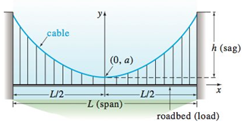

Let assume that the *x-*axis runs along the horizontal roadbed, and the *y-*axis passes through , which is the lowest point on one cable over the span of the bridge, coinciding with the interval .

In the case of a suspension bridge, the usual assumption is that the vertical load in the given equation is only a uniform roadbed, distributed along the horizontal axis. In other words, it is assumed that the weight of all cables is negligible in comparison to the weight of the roadbed and that the weight per unit length of the roadbed  is a constant *ρ*. Use this information to set up and solve an appropriate initial-value problem from which the shape (a curve with equation ) of each of the two cables in a suspension bridge is determined.

Express the solution of the IVP in terms of the sag *h* and span *L*.

1. The Brentano-Stevens Law in psychology models the way that a subject reacts to a stimulus. It states that if *R* represents the reaction to an amount *S* of stimulus, then the relative rates of increase are proportional:



Where *k* is a positive constant. Find *R* as a function of *S*.

1. Barbara weighs 60 *kg* and is on a diet of 1600 *calories* per day, of which 850 are used automatically by basal metabolism. She spends about 15 *cal/kg/day* times her weight doing exercises. If 1 *kg* of fat contains 10,000 *cal*. and we assume that the storage of calories in the form of fat is 100% efficient, formulate a differential equation and solve it to find her weight as a function of time. Does her weight ultimately approach an equilibrium weight?
2. When a chicken is removed from an oven, its temperature is measured at 300° *F*. Three minutes later its temperature is 200° *F*. How long will it take for the chicken to cool off to a room temperature of 70° *F*.
3. Suppose that a corpse was discovered in a motel room at midnight and its temperature was  . The temperature of the room is kept constant at . Two hours later the temperature of the corpse dropped to . Find the time of death.
4. Suppose that a corpse was discovered at 10 PM and its temperature was  . Two hours later, its temperature is . If the ambient temperature is . Estimate the time of death.

***Section* 1.3 – Models of Motions**

In mathematics, the rate at which a quantity changes is the derivative of that quantity.

The 2nd way of computing the rate of change comes from the application itself and is different from on application to another.

***Mechanics***

**1.3-1 Law of mechanics – Newton’s Second Law** (1665-1671)

The accerleration of an object as produced by a net force is directly proportional to the magnitude of the net force, in the same direction as the net force, and inversely proportional to the mass of the object.

The force acting on a mass is equal to the rate of change of momentum with respect to time. Momentum is defined as the product of mass and velocity (*m.v*).

The force is equal to the derivative of the momentum



***Position***: 

**1.3-2 *Universal Law of gravitation***

Anybody with mass *M* attacks any other body with mass *m* directly toward the mass *M*, with a magnitude proportional to the product of the 2 masses and inversely proportional to the square of the distance separating them.



Acceleation: 

Force: 

Gravity: 

Motion ball: 



**1.3-3 *Air Resistance***

The application of force on an object causes an acceleration of that object. A force is not the only factor in the movement, or acceleration of an object. ***Air resistance*** involves movement through the air.  Air resistance is a significant factor in how fast an object falls, according to this law.



***R***: resistance force (*has sign opposite of the velocity*)

***r***: is a function that is always nonnegative

* *when a ball is falling from a high altitude, the density of the air has to be taken into account.*









 Integratre both sides











When  (*Terminal Velocity*)

 (*A*: is a constant)

***Example* 1**

Suppose you drop a brick from the top of a building that is 250 *m* high. The brick has a mass of 2 *kg*, and the resistance force is given by . How long will it take the brick to reach the ground? what will be its velocity at that time?

***Solution***













 ***Integrate both sides***















 (*Using software to solve it*)





**1.3-4 *Finding the displacement***





















***Example* 2**

A ball of mass is protected from the surface of the earth, with velocity . Assume that the force of air resistance is given by , where . What is the maximum height reached by the ball?

***Solution***



 ***Integrate both sides***

 













**1.3-5 *Torricelli’s Law***

Suppose that a water tank has a ***hole with area*** ***a*** at its bottom, from which water is leaking.

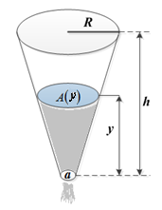

Denote by  the depth of water in the tank at time *t*, and by  the volume of water in the tank then. It is plausible – and true, under ideal conditions – that the velocity of water exiting through the hole is



Which is the velocity a drop of water would acquire in falling freely from the surface of the water to the hole. One can derive this formula beginning with the assumption that the sum of the kinetic and potential energy of the system remains constant. Under real conditions, taking into account the construction of a water jet from an orifice, , where *c* is an empirical constant between 0 and 1 (usually about 0.6 for a small continuous stream of water). For simplicity, we take  in the following discussion.





This is a statement of *Torricelli’s* Law for a draining tank.

Let  denote the horizontal cross-sectional area of the tank at height *y*. Then, applied to a thin horizontal slice of water at height  with area  and thickness , the integral method of cross sections gives



The fundamental theorem of calculus therefore implies that  and hence that





 (An alternative form of *Torricelli’s* Law)



Where  and  are the cross-sectional areas of the water and the hole.

***Example* 3**

A tank is shaped like a vertical cylinder; it initially contains water to a depth of 9 *ft.*, and a bottom plug is removed at time *t* = 0 (*hours*). After 1 *hr*. the depth of the water has dropped to 4 *ft*. how long does it take for all the water to drain from the tank?

***Solution***



 *Integrate both sides*





With initial condition 



















It will take 3 *hours* for the tank to empty.

***Exercises Section* 1.3 – Models of Motions**

1. A body of mass *m* falls from rest subject to gravity in a medium offering resistance proportional to the square of the velocity. Determine the velocity and position of the body at *t seconds.*
2. A body of mass *m*, with initial velocity , falls vertically. If the initial position is denoted . Determine the velocity and position of the body at *t* seconds.

Assume the body acted upon by gravity alone and the air resistance proportional to the square of the velocity.

1. A body falls from a height of 300 *ft*. What distance has it traveled after 4 *sec*. if subject to *g*, the earth’s acceleration?
2. A body falls from an initial velocity of . What distance has it traveled after 3 *sec*. if subject to, the earth’s acceleration?
3. A projectile is fired straight upwards with an initial velocity of . What is its velocity at . 
4. A projectile is fired straight upwards with an initial velocity of . What is its velocity at . 
5. An 8 *lbs*. weight falls from rest toward earth. Assuming that the weight is acted upon by air resistance, numerically equal to , but measured in pounds, find the velocity and distance fallen after *t* seconds. (The variable *v* represents the velocity measured in *ft./sec*.)
6. A stone is released from rest and dropped into a deep well. Eight seconds later, the sound of the stone splashing into the water at the bottom of the well returns to the ear of the person who released the stone. How long does it take the stone to drop to the bottom of the well? How deep is the well? Ignore air resistance. The speed of sound is 340 *m/s*.
7. A rocket is fired vertically and ascends with constant acceleration  for 1.0 *min*. At that point, the rocket motor shuts off and the rocket continues upward under the influence of gravity. Find the maximum altitude acquired by the rocket and the total time elapsed from the take-off until the rocket returns to the earth. *Ignore air resistance*.
8. A ball having mass  falls from rest under the influence of gravity in a medium that provides a resistance that is proportional to its velocity. For a velocity of the force due to the resistance of the medium is −1 *N*. Find the terminal velocity of the ball.

1 *N* is the force required to accelerate a 1 *kg* mass at a rate of : 

1. A ball is projected vertically upward with initial velocity from ground level. Ignore air resistance.
2. What is the maximum height acquired by the ball?
3. How long does it take the ball to reach its maximum height? How long does it take the ball to return to the ground? Are these times identical?
4. What is the speed of the ball when it impacts with the ground on its return?
5. An object having mass 70 *kg* falls from rest under the influence of gravity. The terminal velocity of the object is . Assume that the air resistance is proportional to the velocity.
6. Find the velocity and distance traveled at the end of 2 seconds.
7. How long does it take the object to reach 80% of its terminal velocity?
8. A lunar lander is falling freely toward the surface of the moon at a speed of 450 *m/s*. Its retrorockets, when fired, provide a constant deceleration of 2.5  (the gravitational acceleration produced by the moon is assumed to be included in the given acceleration). At What height above the lunar surface should the retrorockets be activated to ensure a “soft touchdown? (*v* = 0 at impact)?

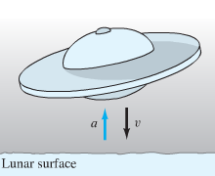

1. 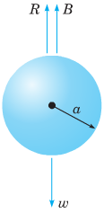A body falling in a relatively dense fluid, oil for example, is acted on by three forces: a resistance force *R,* a buoyant force *B,* and its weight *w* due to gravity. The buoyant force is equal to the weight of the fluid displaced by the object. For a slowly moving spherical body of radius a, the resistive force is given by Stokes’s Law , where *v* is the velocity of the body, and *μ* is the coefficient of viscosity of the surrounding fluid?
2. Find the limiting velocity of a solid sphere of radius *a* and density *ρ* falling freely in a medium of density  and coefficient of viscosity μ.
3. In 1910 R. A. Millikan studied the motion of tiny droplets of oil falling in an electric field. A field of strength *E* exerts a force on a droplet with charge *e*. Assume that *E* has been adjusted so the droplet is held stationary  and that *w* and *B* are as given. Find an expression for *e*.
4. Suppose that the tank has a radius of 3 *ft*. and that its bottom hole is circular with radius 1 *in*. How long will it take the water (initially 9 *ft*. deep) to drain completely?
5. A hemispherical bowl has top radius of 4 *ft*. and at time *t* = 0 is full of water. At that moment a circular hole with diameter 1 *in*. is opened in the bottom of the tank. How long will it take for all the water to drain from the tank?

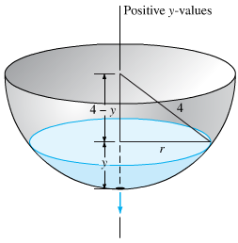

1. The clepsydra, or water clock – A 12*-hr* water clock is to be designed with the dimensions, shaped like the surface obtained by revolving the curve  around the *y-*axis. What should be this curve, and what should be the radius of the circular bottom hole, in order that the water level will fall at the constant rate of 4 *inches per hour*?

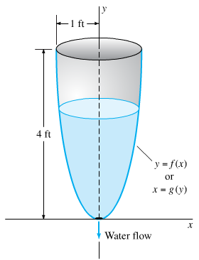

1. At time *t* = 0 the bottom plug (at the vertex) of a full conical water tank 16 *feet* high is removed. After 1 *hr.* the water in the tank is 9 *feet* deep. When will the tank be empty?
2. Suppose that a cylindrical tank initially containing  gallons of water drains (through a bottom hole) in *T* minutes. Use Torricelli’s Law to show that the volume of water in the tank after  minutes is 
3. One of the famous problems in the history of mathematics is the brachistochrone problem: to find the curve along which a particle will slide without friction in the minimum time from one given point *P* to another point *Q*, the second point being lower than the first but not directly beneath it.

This problem was posed by Johann Bernoulli in 1696 as a challenge problem to the mathematicians of his day. Correct solutions were found by Johann Bernoulli and his brother Jakob Bernoulli and by Isaac Newton, Gottfried Leibniz, and the Marquis de L’Hospital. The brachistochrone problem is important in the development of mathematics as one of the forerunners of the calculus of variations.

In solving this problem, it is convenient to take the origin as the upper point *P* and to orient the axes as shown. The lower point *Q* has coordinates . It is then possible to show that the curve of minimum time is given by a function  that satisfies the differential equation



Where  is a certain positive constant to be determined later

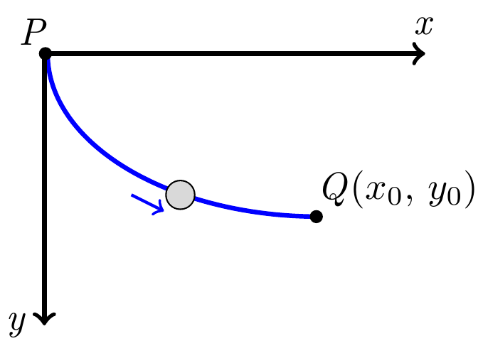

1. Solve the equation  for  . Why is it necessary to choose the positive square root?
2. Introduce the new variable t by the relation



Show that the equation found in part (a) then takes the form



1. Letting , show that the solution of  for which *x* = 0 when *y* = 0 is given by



Equations (*iv*) are parametric equations of the solution of (eq. *i*) that passes through (0, 0). The graph of Eqs. (*iv*) is called a cycloid.

1. If we make a proper choice of the constant *k*, then the cycloid also passes through the point  and is the solution of the brachistochrone problem. Find *k* if  and 
2. Many chemical reactions are the result of the interaction of 2 molecules that undergo a change to produce a new product. The rate of the reaction typically depends on the concentrations of the two kinds of molecules. If *a* is the amount of substance *A* and *b* is the substance *B* at time *t* = 0, and if *x* is the amount of product at time *t*, then the rate of formation of *x* may be given by the differential equation



Where *k* is a constant for the reaction. Integrate both sides of this equation to obtain a relation between *x* and *t*.

1. If 
2. If 

Assume in each case that  when 

1. An open cylindrical tank initially filled with water drains through a hole in the bottom of the tank according to Torricelli’s Law. If  is the depth of water in the tank for , then Torricelli’s Law implies  , where *k* is a constant that includes the acceleration due to gravity, the radius of the tank, and the radius of the drain. Assume that the initial depth of the water is 

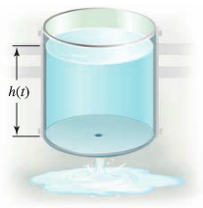

1. Find the solution of the initial value problem.
2. Find the solution in the case that  and .
3. In general, how long does it take the tank to drain in terms of *k* and *H*?
4. An object in free fall may be modeled by assuming that the only forces at work are the gravitational force and resistance (friction due to the medium in which the objects falls). By Newton’s second Law (mass × acceleration = the sum of the external forces), the velocity of the object satisfies the differential equation



Where  is a function that models the resistance and the positive direction is downward. One common assumption (often used for motion in air) is that , where  is a drag coefficient.

1. Show that the equation can be written in the form  where 
2. For what (positive) value of *v* is  (This equilibrium solution is called the ***terminal velocity***.)
3. Find the solution of this separable equation assuming  for 
4. Graph the solution found in part (***c***) with , and verify the terminal velocity agrees with the value found in part (***b***).
5. Suppose a small cannonball weighing 16 *pounds* is shot vertically upward, with an initial velocity 

The answer to the question “How high does the cannonball go?” depends on whether we take air resistance into account.

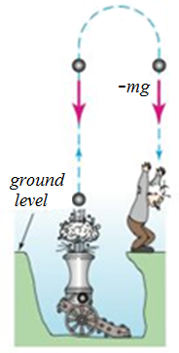

1. Suppose air resistance is ignored. If the positive direction is upward, then a model for the state of the cannonball is given by . Since  the last differential equation is the same as , where we take . Find the velocity  of the cannonball at time *t*.
2. Use the result in part (*a*) to determine the height  of the cannonball measured from ground level. Find the maximum height attained by the cannonball.
3. Two chemicals *A* and *B* are combined to form a chemical *C*. The resulting reaction between the two chemicals is such that for each *gram* of *A*, 4 *grams* of *B* is used. It is observed that 30 *grams* of the compound *C* is formed in 10 *minutes*.
4. Determine the amount of *C* at time *t* if the rate of the reaction is proportional to the amounts of *A* and *B* remaining and if initially there are 50 *grams* of *A* and 32 *grams* of *B*.
5. How much of the compound *C* is present at 15 *minutes*.
6. Interpret the solution as 
7. Two chemicals *A* and *B* are combined to form a chemical *C*. The rate, or velocity, of the reaction is proportional to the product of the instantaneous amounts of *A* and *B* not converted to chemical *C*. Initially, there are 40 *grams* of *A* and 50 *grams* of *B*, and each gram of *B*, 2 *grams* of *A* is used. It is observed that 10 *grams* of *C* is formed in 5 *minutes*.
8. How much is formed in 20 *minutes*?
9. What is the limiting amount of *C* after a long time?
10. How much of chemicals *A* and *B* remains after a long time?
11. If 100 *grams* of chemical *A* is present initially, at what time is chemical *C* half-formed?
12. A skydiver weighs 125 *pounds*, and her parachute and equipment combined weigh another 35 *pounds*. After exiting from a plane at an altitude of 15,000 *feet*, she waits 15 *seconds* and opens her parachute. Assume that the constant of proportionality has the value  during free fall and  after the parachute is opened.

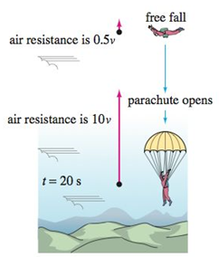

Assume that her initial velocity on leaving the plane is *zero*.

1. What is her velocity and how far has she traveled 20 *seconds* after leaving the plane?
2. How does her velocity at 20 *seconds* compare with her terminal velocity?
3. How long does it take her to reach the ground?
4. A tank in the form of a right-circular cylinder standing on end is leaking water through a circular hole in its bottom. When friction and contraction of water at the hole are ignored, the height *h* of water in the tank is described by



Where  and  are the cross-sectional areas of the water and the hole, respectively.

1. Find  if the initial height of the water is *H*.
2. Sketch the graph  and give the interval *I* of definition in terms of the symbols , , and *H*.
3. Suppose the tank is 10 *feet* high and has radius 2 *feet* and the circular hole has radius  *inch*. If the tank is initially full, how long will it take to empty?
4. A tank in the form of a right-circular cylinder cone standing on end, vertex down, is leaking water through a circular hole in its bottom.
5. Suppose the tank is 20 *feet* high and has radius 8 *inches*. Show that the differential equation governing the height *h* of water leaking from a tank is



In this model, friction and contraction of the water at the hole were taken into account with  and . If the tank is initially full, how long will it take the tank to empty?

1. Suppose the tank has a vertex angle of 60° and the circular hole has radius 2 *inches*. Determine the differential equation governing the height *h* of water. Use  and .
2. If the height of the water is initially 9 *feet*, how long will it take the tank to empty?
3. Suppose that the conical tank is inverted and that water leaks out a circular hole of radius 2 *inches* in the center of its circular base. Is the time it takes to empty a full tank the same as for the tank with vertex down?

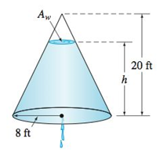

Take the friction/contraction coefficient to be  and 

1. A differential equation for the velocity *v* of a falling mass m subjected to air resistance proportional to the square of the instantaneous velocity is



Where  is a constant of proportionality. The positive direction is downward.

1. Solve the equation subject to the initial condition .
2. Use the solution in part (*a*) to determine the limiting, or terminal, velocity of the mass.
3. If the distance *s*, measured from the point where the mass was released above the ground, is related to velocity *v* by , find an explicit expression for  if 
4. An object is dropped from altitude 
5. Determine the impact velocity if the drag force is proportional to the square of velocity, with drag coefficient .
6. If the terminal velocity is known to −120 *mph* and the impact velocity was −90 *mph*, what was the initial altitude ?
7. An object is dropped from altitude 
8. Assume that the drag force is proportional to the velocity, with drag coefficient . Obtain an implicit solution relating velocity and altitude.
9. If the terminal velocity is known to −120 *mph* and the impact velocity was −90 *mph*, what was the initial altitude ?
10. An object of mass 3 *kg* is released from rest 500 *m* above the ground and allowed to fall under the influence of gravity. Assume the gravitational force constant, with , and the force due to air resistance is proportional to the velocity of the object with proportionality constant . Determine when the object will hit the ground.
11. A parachutist whose mass is 75 *kg* drops from helicopter hovering 4000 *m* above the ground and falls toward the earth under the influence of gravity. Assume the gravitational force is constant. Assume also that the force due to air resistance is proportional to the velocity of the parachutist, with the proportionality constant  when the chute is closed and with constant  when the chute is open. If the chute does not open until 1 *min* after the parachutist leaves the helicopter, after how many *seconds* will he reach the ground?
12. A parachutist whose mass is 75 *kg* drops from helicopter hovering 2000 *m* above the ground and falls toward the earth under the influence of gravity. Assume the gravitational force is constant. Assume also that the force due to air resistance is proportional to the velocity of the parachutist, with the proportionality constant  when the chute is closed and with constant  when the chute is open. If the chute does not open until the velocity of the parachutist reaches , after how many seconds will he reach the ground?
13. An object of mass 5 *kg* is released from rest 1000 *m* above the ground and allowed to fall under the influence of gravity. Assume the gravitational force constant, with , and the force due to air resistance is proportional to the velocity of the object with proportionality constant . Determine when the object will hit the ground.
14. An object of mass 500 *kg* is released from rest 1000 *m* above the ground and allowed to fall under the influence of gravity. Assume the gravitational force constant, with , and the force due to air resistance is proportional to the velocity of the object with proportionality constant . Determine when the object will hit the ground.
15. A 400-*lbs* object is released from rest 500 *ft.* above the ground and allowed to fall under the influence of gravity. Assuming that the force in pounds due to air resistance is , where *v* is the velocity of the object in , determine the equation of motion of the object. When will the object hit the ground?
16. An object of mass 8 *kg* is given an upward initial velocity of  and then allowed to fall under the influence of gravity. Assume that the force in Newton due to air resistance is , where *v* is the velocity of the object in .
17. Determine the equation of motion of the object.
18. If the object is initially 100 *m* above the ground, determine when the object will hit the ground.
19. An object of mass 5 *kg* is given a downward initial velocity of  and then allowed to fall under the influence of gravity. Assume that the force in Newton due to air resistance is , where *v* is the velocity of the object in .
20. Determine the equation of motion of the object.
21. If the object is initially 100 *m* above the ground, determine when the object will hit the ground.
22. A shell of mass 2 *kg* is shot upward with an initial velocity of . The magnitude of the force on the shell due to air resistance is .
23. When will the shell reach its maximum height above the ground?
24. What is the maximum height?
25. We need to design a ballistics chamber to decelerate test projectiles fired into it. Assume the resistive force encountered by the projectile is proportional to the square of its velocity and neglect gravity.

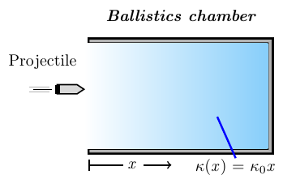

The chamber is to be constructed so that the coefficient  associated with this resistive force is not constant but is, in fact, a linearly increasing function of distance into the chamber:

Let , where  is a constant; the resistive force then has the form .

If we use time *t* as the independent variable, Newton’s Law of motion leads us to the differential equation



1. Adopt distance *x* into the chamber as the new independent variable and rewrite the given differential equation as a first order equation in terms of the new independent variable.
2. Determine the value  needed if the chamber is to reduce projectile velocity to 1% of its incoming value within *d* *units* of distance.
3. When the velocity *v* of an object is very large, the magnitude of the force due to air resistance is proportional to  with the force acting in opposition to the motion of the object. A shell of mass 3 *kg* is hot upward from the ground with an initial velocity of 500 . If the magnitude of the force due to air resistance is .
4. When will the shell reach its maximum height above the ground?
5. What is the maximum height?
6. A sailboat has been running (on a straight course) under a light wind at . Suddenly the wind picks up, blowing hard enough to apply a constant force of 600 *N* to the sailboat. The only other force acting on the boat is water resistance that is proportional to the velocity of the boat. If the proportionality constant for water resistance is  and the mass of the sailboat is 50 *kg*.
7. Find the equation of motion of the sailboat.
8. What is the limiting velocity of the sailboat under this wind?
9. When the velocity of the sailboat reaches , the boat begins to rise out of the water and plane. When this happens, the proportionality constant for the water resistance drop to . Find the equation of motion of the sailboat.
10. What is the limiting velocity of the sailboat under this wind as it is planning?
11. According to Newton’s Law of gravitation, the attractive force between two objects varies inversely as the square of the distances between them. That is, 

Where  and  are the masses of the objects, *r* is the distance between them (center to center), is the attractive force, and *G* is the constant of proportionality.

Consider ta projectile of constant mass *m* being fired vertically from Earth.

Let *t* represent time and *v* the velocity of the projectile.

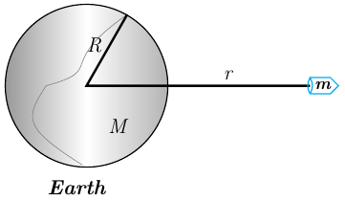

1. Show that the motion of the projectile, under Earth’s gravitational force, is governed by the equation



Where *r* is the distance between the projectile and the center of Earth, *R* is the radius of Earth, *M* is the mass of Earth, and .

1. Use the fact the  to obtain 
2. If the projectile leaves Earth’s surface with velocity , show that



1. Use the result of part (*c*) to how that the velocity of the projectile remains positive if and only if . The velocity  is called the escape velocity?
2. If  and  for Earth, what is Earth’s escape velocity?
3. If the acceleration due to gravity for the Moon is  and the radius of the Moon is , what is the escape velocity of the Moon?
4. A 180*-lb* skydiver drops from a hot-air balloon. After 10 *sec* of free fall, a parachute is opened. The parachute immediately introduces a drag force proportional to velocity. After an additional 4 *sec*, the parachutist reaches the ground. Assume that air resistance is negligible during free fall and that the parachute is designed so that a 200-*lb* person will reach a terminal velocity of −10 *mph*.
5. What is the speed of the skydiver immediately before the parachute is opened?
6. What is the parachutist’s impact velocity?
7. At what altitude was the parachute opened?
8. What is the balloon’s altitude?
9. Suppose water is leaking from a tank through a circular hole of area  at its bottom. When water leaks through a hole, friction and contraction of the stream near the hole reduce the volume of water leaving the tank per second to , where *c*  is an empirical constant.

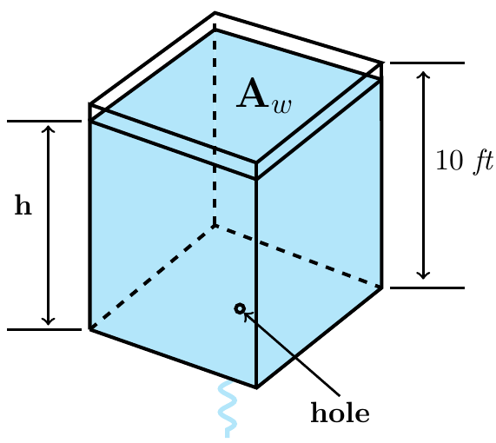

Determine a differential equation for the height *h* of water at time *t* for the cubical tank. The radius of the hole is 2 *in*., , and the friction/contraction factor is 

1. The right-circular tank loses water out of a circular hole at its bottom.

The radius of the hole is 2 *in*., and , and the friction/contraction factor is .

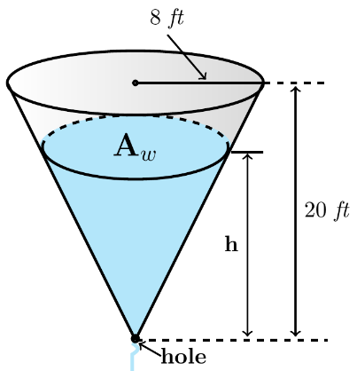

1. Determine a differential equation for the height *h* of water at time *t* for the cubical tank.
2. Find the height in function of time.
3. In meteorology, the term virga refers to falling rain drops or ice particles that evaporate before they reach the ground. Assume that a typical raindrop is spherical. Starting at some time, which we can designate as , the raindrop of radius  falls from rest from a cloud and begins to evaporate.
4. If it is assumed that a raindrop evaporates in such a manner that its shape remains spherical, then it also makes sense to assume that the rate at which the raindrop evaporates − that is, the rate at which it loses mass − is proportional to its surface area, Show that this latter assumption implies that the rate at which the radius *r* of the raindrop decreases is a constant. Find .
5. If the positive direction is downward, construct a mathematical model for the velocity *v* of the falling raindrop at time . Ignore air resistance.
6. A horizontal cylindrical tank of length , and radius , is filled with oil. At  a plug at the lowest point of the tank is removed and a flow results.

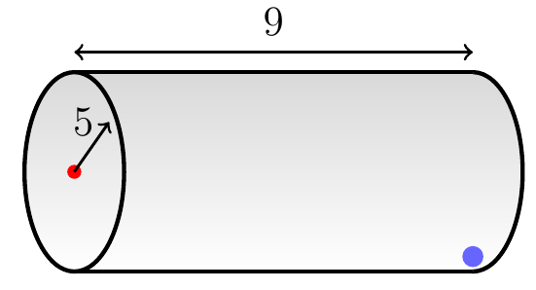

Find *y* the depth of the oil in the tank at any time *t* while the tank is draining. The constriction coefficient is 