***Section* 1.4 – Linear Equations**

***Definition***

A first order linear equation is given by the form:



Is said toe be a linear equation in the variable *y* and where  and  are functions of *x* and called the coefficients

If .

This linear equation is said to be ***homogeneous***. (Otherwise it is ***nonhomogeneous or inhomogeneous***).

|  |  |
| --- | --- |
| ***Linear*** | ***Non-linear*** |
|  |  |
|  |  |
|  |  |

It is possible for a differential equation to have no solutions.

**1.4-1 *Solution of the homogeneous equation***





 *Convert to exponential form*

 



***Example* 1**

Solve: 

***Solution***







*Second method*











**1.4-2 Solving a linear first-order Equation (*Properties*)**

1. Put a linear equation into a standard form 
2. Identify  then find 
3. Multiply the standard form by 
4. Integrate both sides

***Solution of the Inhomogeneous Equation*** 









***Example* 2**Find the general solution to: 

***Solution***















**1.4-3 *Solution of the Nonhomogeneous Equation*** 

Let assume:  

The homogeneous equation is given by 













 *Since* 















 

 

***Example* 3**

Find the general solution of  and the particular solution that satisfies.

***Solution***

 





 









***Example* 4**

Find the general solution of  and the particular solution that satisfies.

***Solution***

 















***Notes***

1. Integrating an expression that is not the differential of any elementary function is called non-elementary.

  

   

1. In math some important functions are defined in terms of non-elementary integrals. Two such functions are the error function and the complementary error function.

 

***Exercises Section* 1.4 – Linear Equations**

(**1 – 90**) Find the general solution of the first-order, linear equation.

|  |  |
| --- | --- |
|  |  |

|  |  |
| --- | --- |
|  |  |

(**91 – 168**) Find the solution of the initial value problem

|  |  |
| --- | --- |
|  |  |

|  |  |
| --- | --- |
|  |  |

|  |  |
| --- | --- |
|  |  |

(**169 – 172**) Find a solution to the initial value problem that is continuous on the given interval 

1.   
2.   
3.   
4.   

Find the solution of the initial value problem. Discuss the interval of existence and provide a sketch of your solution

|  |  |
| --- | --- |
|  |  |

1. The following system of differential equations is encountered in the study of the decay of a special type of radioactive series of elements

 

Where  are constants.

Discuss how to solve this system subject to 

1. Let  be the performance level of someone learning a skill as a function of the training time *t*. The graph of *P* is called a ***learning curve***. We proposed the differential equation



As a reasonable model for learning, where *k* is a positive constant. Solve it as a linear differential equation and use your solution to graph the learning curve.

1. A differential equation describing the velocity *v* of a falling mass subject to air resistance proportional to the instantaneous velocity is



Where  is a constant of proportionality. The positive direction is downward.

1. Solve the equation subject to the initial condition 
2. Use the solution in part (*a*) to determine the limiting, or terminal, velocity of the mass.
3. If the distance *s*, measured from the point where the mass was released above ground, is related to velocity *v* by , find an explicit expression for  if 
4. As a raindrop falls, it evaporates while retaining its spherical shape. If we make the further assumptions that the rate at which the raindrop evaporates is proportional to its surface and that air resistance is negligible, then a model for the velocity  of the raindrop is



Here  is the density of water,  is the radius of the raindrop at ,  is the constant of proportionality, and downward direction is taken to be the positive direction.

1. Solve for  if the raindrop falls from rest.
2. Show that the radius of the raindrop at time *t* is .
3. If  and  10 *seconds* after the raindrop falls from a cloud, determine the time at which the raindrop has evaporated completely.
4. A model that describes the population of a fishery in which harvesting takes place at a constant rate is given by



Where *k* and *h* are positive constants.

1. Solve  given the initial value 
2. Describe the behavior of the population  for increasing time in three cases , , and 
3. Use the results from part (*b*) to determine whether the fish population will ever go extinct in finite time, that is, whether there exists a time  such that . If the population goes extinct then find *T*.
4. A certain body weighing , is heated to a temperature of . Then at  it is plunged into  of water at a temperature of . Given that the specific heat of the body is , find the formula for the temperature *T* of the body during its cooling.

***Section* 1.5 – Mixing Problems**

A typical mixing problem investigates the behavior of a mixed solution of some substance. Typically, the solution is being mixed in a tank. A solution of a given concentration enters the mixture at some fixed rate and is thoroughly mixed in the tank. The tank is also being drained at some fixed rate.

The physical representation of the rate of change:

*rate of change*

*= rate in* − *rate out*

This is referred to as a ***balance law***.

The rate in and out is given by:

*Rate* = Volume Rate (*gal/min*) *x* Concentration (*lb/gal*)

***Example* 1**

The tank initially holds 100 *gal* of pure water. At time , a solution containing 2 *lb* of salt per *gallon* begins to enter the tank at the rate of 3 *gallons* per *minute*. At the same time a drain is opened at the bottom of the tank so that the volume of solution in the tank remains constant.

How much salt is in the tank after 60 *min*?

What will be the eventual salt content in the tank?

***Solution***

number of pounds of salt in the tank after *t* min.

Volume: 

Concentration at time *t*: 

Rate in = Volume Rate *x* Concentration





Rate out = Volume Rate *x* Concentration





rate of change

= rate in − rate out













Since there was no salt present in the tank initially, the initial condition is 









After 60 *min*:





As  then 

 



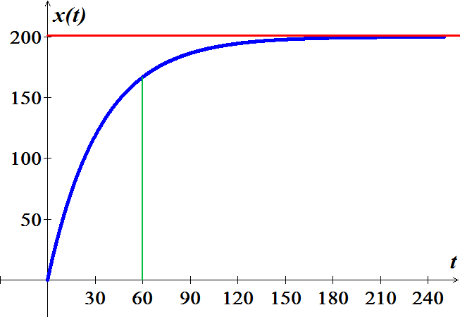

***Example* 2**

The 600-*gal* tank is filled with 300 *gal* of pure water. A spigot is opened above the tank and a salt solution containing 1.5 *lb*. of salt per gallon of solution begins flowing into the tank at the rate of 3 *gal/min*. simultaneously, a drain is opened at the bottom of the tank allowing the solution to leave tank at a rate of 1 *gal/min*. What will be the salt content in the tank at the precise moment that the volume of solution in the tank is equal to the tank's capacity (600 *gal*)?

***Solution***







Rate in 



Rate out 







 



















  














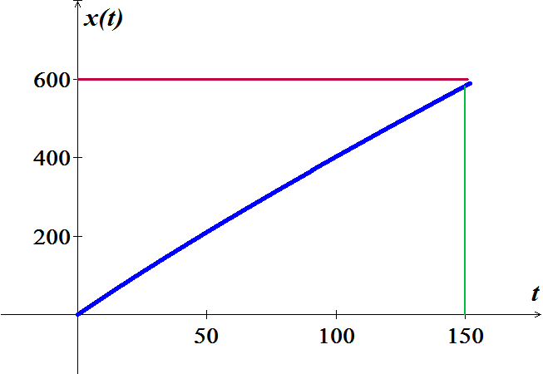

***Exercises Section* 1.5 – Mixing Problems**

1. Consider two tanks, label tank ***A*** and tank ***B*** for reference. Tank ***A*** contains 100 *gal* of solution in which is dissolved 20 *lb.* of salt. Tank ***B*** contains 200 *gal* of solution which is dissolved 40 *lbs.* of salt. Pure water flows into the tank ***A*** at rate of 5 *gal/s*. There is a drain at the bottom of tank ***A***. The solution leaves tank ***A*** via the drain at a rate of 5 *gal/s* and flows immediately into tank ***B*** at the same rate. A drain at the bottom of tank ***B*** allows the solution to leave tank ***B*** at a rate of 2.5 *gal/s*. What is the salt content in tank ***B*** at the precise moment that tank ***B*** contains 250 *gal* of solution?
2. A tank contains 100 *gal* of pure water. At time zero, a sugar-water solution containing 0.2 *lb.* of sugar per gal enters the tank at a rate of 3 *gal/min*. Simultaneously, a drain is opened at the bottom of the tank allowing the sugar solution to leave the tank at 3 *gal/min*. Assume that the solution in the tank is kept perfectly mixed at all times.
3. What will be the sugar content in the tank after 20 *minutes*?
4. How long will it take the sugar content in the tank to reach 15 *lbs.*?
5. What will be the eventual sugar content in the tank?
6. A tank initially contains 50 *gal* of sugar water having a concentration of 2 *lb*. of sugar for each gal of water. At time zero, pure water begins pouring into the tank at a rate of 2 *gal* per *minute*. Simultaneously, a drain is opened at the bottom of the tank so that the volume of sugar-water solution in the tank remains constant.
7. How much sugar is in the tank after 10 *minutes*?
8. How long will it take the sugar content in the tank to dip below 20 *lbs*.?
9. What will be the eventual sugar content in the tank?
10. A 50-*gal* tank initially contains 20 *gal* of pure water. Salt-water solution containing 0.5 *lb.* of salt for each gallon of water begins entering the tank at a rate of 4 *gal/min.* simultaneously; a drain is opened at the bottom of the tank, allowing the salt-water solution to leave the tank at a rate of 2 *gal/min*. What is the salt content (*lb.*) in the tank at the precise moment that the tank is full of salt-water solution?
11. A tank contains 500 *gal* of a salt-water solution containing 0.05 *lb.* of salt per gallon of water. Pure water is poured into the tank and a drain at the bottom of the tank is adjusted so as to keep the volume of solution in the tank constant. At what rate (*gal/min*) should the water be poured into the tank to lower the salt concentration to 0.01 *lb./gal* of water in less than one hour?
12. Suppose that a large tank initially holds 300 *gallons* of water in which 50 *pounds* of salt have been dissolved. Pure water is pumped into the tank at a rate of 3 *gal/min*, and when the solution is well stirred, it is then pumped out at the same rate. Determine a differential equation for the amount of salt  in the tank at time .
13. Suppose that a large mixing tank initially holds 300 *gallons* of water is which 50 *pounds* of salt have been dissolved. Another brine solution is pumped into the tank at a rate of 3 *gal/min*, and when the solution is well stirred, it is then pumped out at a slower rate if 2 *gal/min*. If the concentration of the solution entering is 2 *lb./gal*, determine a differential equation for the amount of salt  in the tank at time 
14. Suppose that a large mixing tank initially holds 300 *gallons* of water is which 50 *pounds* of salt have been dissolved. Another brine solution is pumped into the tank at a rate of 3 *gal/min*, and when the solution is well stirred, it is then pumped out at a faster rate if 3.5 *gal/min*. If the concentration of the solution entering is 2 *lbs./gal*, determine a differential equation for the amount of salt  in the tank at time .
15. A tank contains 100 *gal* of fresh water. A solution containing 1 *lb./gal* of soluble lawn fertilizer runs into the tank at the rate of 1 *gal/min*, and the mixture is pumped out of the tank at a rate of 3 *gal/min*. Find the maximum amount of fertilizer in the tank and the time required to reach the maximum.
16. A 200-*gal* tank is half full of distilled water. At time *t* = 0, a solution containing 0.5 *lb./gal* of concentrate enters the tank at the rate of 5 *gal/min*, and the well-stirred mixture is withdrawn at the rate of 3 *gal/min*.
17. At what time will the tank be full?
18. At the time the tank is full, how many pounds of concentrate will it contain?
19. A 1500 *gallon* tank initially contains 600 *gallon* of water with 5 *lbs*. of salt dissolved in it. Water enters the tank at a rate of 9 *gal/hr.* and the water entering the tank at a rate has a salt concentration of  *lbs./gal*. If a well-mixed solution leaves the tank at a rate of 6 *gal/hr.*, how much salt is in the tank when it overflows?
20. Suppose that an Iowa class battleship has mass 51,000 metric tons (51,000,000 *kg*) and . Assume that the ship loses power when it is moving at a speed of 9 *m/sec*.
21. About how far will the ship coast before it is dead in the water?
22. About how long will it take the ship’s speed to drop to 1 m/sec?
23. A 66-*kg* cyclist on a 7-*kg* bicycle starts coasting on level ground at 9 *m/sec*. The 
24. About how far will the cyclist coast before reaching a complete stop?
25. How long will it take the cyclist’s speed to drop to 1 *m/sec*?
26. An Executive conference room of a corporation contains 4500  of air initially free of carbon monoxide. Starting at time *t* = 0, cigarette smoke containing 4% carbon monoxide is blown into the room at the rate of 0.3 . A ceiling fan keeps the air in the room well circulated and the air leaves the room at the same rate of 0.3 .

Find the time when the concentration of carbon monoxide in the room reaches 0.01%.

1. 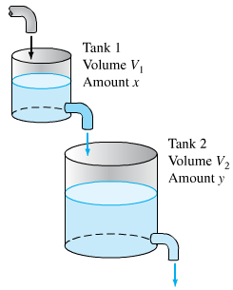Consider the cascade of 2 tanks with  and  the volumes of brine in the 2 tanks. Each tank also initially contains 50 *lb*s. of salt. The three flow rates indicated in the figure are each 5 *gal/min*, with pure water flowing into tank.
2. Find the amount  of salt in tank 1 at time *t*.
3. Suppose that  is the amount of salt in tank 2 at time *t*. Show first that 

And then solve for , using the function  found in part (*a*).

1. Finally, find the maximum amount of salt ever in tank 2.
2. Suppose that in the cascade tank 1 initially 100 *gal* of pure ethanol and tank 2 initially contains 100 *gal* of pure water. Pure water flows into tank 1 at 10 *gal/min*, and the other two flow rates are also 10 *gal/min*.
3. Find the amounts  and  of ethanol in the two tanks at time  .
4. Find the maximum amount of ethanol ever in tank 2.
5. A multiple cascade is shown in the figure. At time *t* = 0, tank 0 contains 1 *gal* of ethanol and 1 *gal* of water; all the remaining tanks contain 2 *gal* of pure water each. Pure water is pumped into tank 0 at 1 *gal/.min*, and the varying mixture in each tank is pumped into the one below it at the same rate. Assume, as usual, that the mixtures are kept perfectly uniform by stirring. Let  denote the amount of ethanol in tank *n* at time *t*.
6. Show that 
7. Show that the maximum value of  for *n* > 0 is 
8. Assume that Lake Erie has a volume of 480  and that its rate of inflow (from Lake Huron) and outflow (to Lake Ontario) are both 350  per year. Suppose that at the time *t* = 0 (*years*), the pollutant concentration of Lake Erie – caused by past industrial pollution that has now been ordered to cease – is 5 times that of Lake Huron. If the outflow henceforth is perfectly mixed lake water, how long will it take to reduce the pollution concentration in Lake Erie to twice that of Lake Huron?
9. A 120 *gal* tank initially contains 90 *lbs*. of salt dissolved in 90 *gal* of water. Brine containing 2 *lb./gal* of salt flows into the tank at rate of 4 *gal/min*, and the well-stirred mixture flows out the tank at the rate of 3 *gal/min*. How much salt does the tank contain when it is full?
10. A 1000 *gallon* holding tank that catches runoff from some chemical process initially has 800 *gallons* of water with 2 *ounces* of pollution dissolved in it. Polluted water flows into the tank at a rate of 3 *gal/hr*. and contains 5 *ounces/gal* of pollution in it. A well-mixed solution leaves the tank at 3 *gal/hr*. as well. When the amount of pollution in the holding tank reaches 500 *ounces* the inflow of polluted water is cut off and fresh water will enter the tank at a decreased rate of 2 *gallons* while the outflow is increased to 4 *gal/hr*. Determine the amount of pollution in the tank at time *t*.
11. A tank contains 50 *gallons* of a solution composed of 90% water and 10% alcohol. A second solution containing 50% water and 50% alcohol is added to the tank at the rate of . As the second solution is being added, the tank is being drained at a rate of . The solution in the tank is stirred constantly. How much alcohol is in the tank after 10 *minutes*?



1. A 200-*gallon* tank is half full of distilled water. At time , a concentrate solution containing  enters the tank at the rate of , and well-stirred mixture is withdrawn at the rate of .



1. At what time will the tank be full?
2. At the time the tank is full, how many pounds of concentrate will it contain?
3. A 200-*gallon* tank is half full of distilled water. At time , a concentrate solution containing  enters the tank at the rate of , and well-stirred mixture is withdrawn at the rate of .



1. At what time will the tank be full?
2. At the time the tank is full, how many pounds of concentrate will it contain?
3. A 200-*gallon* tank is full of a concentrate solution containing . Starting at time , distilled water is admitted to the tank at the rate of , and well-stirred mixture is withdrawn at the same rate.



1. Find the amount of concentrate in the solution as a function of *t*.
2. Find the time at which the amount of concentrate in the tank reaches 15 *pounds*.
3. Find the quantity of the concentrate in the solution as .
4. A 500-*gallon* tank is full of a concentrate solution containing . Starting at time , distilled water is admitted to the tank at the rate of , and well-stirred mixture is withdrawn at the rate .



1. At what time will the tank be empty?
2. Find the amount of concentrate in the solution as a function of *t*.
3. A tank contains 300 *liters* of fluid in which 20 *grams* of salt is dissolved. Brine containing 1 *g* of salt per *liter* is then pumped into the tank at a rate of 4 *L/min*; the well-mixed solution is pumped out at the same rate. Find the number  of grams of salt in the tank at time *t*.



1. A 100-*gallon* tank is full of a concentrate solution containing . Starting at time , Brine containing  is then pumped into the tank at a rate of , and well-stirred mixture is withdrawn at the rate.



Find the amount of concentrate in the solution as a function of *t*.

1. A 10-*gallon* tank is full of a concentrate solution containing . Starting at time , Brine containing  is then pumped into the tank at a rate of , and well-stirred mixture is withdrawn at the rate.



1. Find the amount of concentrate in the solution as a function of *t*.
2. Find the quantity of the concentrate in the solution as .
3. A tank contains 200 *liters* of fluid in which 30 *grams* of salt is dissolved. Brine containing 1 *gram* of salt per liter is then pumped into the tank at a rate of 4 *L/min*; the well-mixed solution is pumped out at the same rate.
4. Find the number  of grams of salt in the tank at time *t*.
5. Solve by assuming that pure water is pumped into the tank.
6. A large tank is filled to capacity with 500 *gallons* of pure water. Brine containing 2 *pounds* of salt per gallon is pumped into the tank at a rate of 5 *gal/min*. The well-mixed solution is pumped out at the same rate.
7. Find the number  of grams of salt in the tank at time *t*.
8. What is the concentration  of the salt in the tank at time *t*? At time ?
9. What is the concentration of the salt in the tank after a long time, that is, as ?
10. What is the concentration of the salt in the tank equal to one-half this limiting value?
11. Solve under assumption that the solution is pumped out at a faster rate of 10 *gal/min*. when tis the tank empty?
12. A large tank is filled to capacity with 100 *gallons* of fluid in which 10 *pounds* of salt is dissolved. Brine containing  *pound* of salt per gallon is pumped into the tank at a rate of 6 *gal/min*. The well-mixed solution is pumped out at the slower rate of 4 *gal/min*. Find the number of pounds of salt in the tank after 30 *minutes*.
13. A 5000-*gal* tank is maintained with a pumping system that passes 100 *gal* of water per minute through the tank. To treat a certain fish malady, a soluble antibiotic is introduced into the inflow system. Assume that the inflow concentration of medicine is  *mg/gal*, where *t* is measured in *minutes*. The well-stirred mixture flows out of the tank at the same rate.
14. Solve for the amount of medicine in the tank as function of time.
15. What is the maximum concentration of medicine achieved by this dosing and when does it occur?
16. For the antibiotic to be effective, its concentration must exceed 100 *mg/gal* for a minimum of 60 *min*. was the dosing effective?
17. A tank initially contains 400 *gal* of fresh water. At time , a brine solution with a concentration of 0.1 *lb*. of salt per gallon enters the tank at a rate of 1 *gal/min* and the well-stirred mixture flows out at a rate of 2 *gal/min*.
18. How long does it take for the tank to become empty?
19. How much salt is present when the tank contains 100 *gal* of brine?
20. What is the maximum amount of salt present in the tank during the time interval found in part (*a*)?
21. When is the maximum achieved?
22. A tank, having a capacity of 700 *gal*, initially contains 10 *lb*. of salt dissolved in 100 *gal* of water. At time , a solution containing 0.5 *lb*. of salt per gallon flows into the tank at a rate of 3 *gal/min* and the well-stirred mixture flows out of the tank at a rate of 2 *gal/min*.
23. How much time will elapse before the tank is filled to capacity?
24. What is the salt concentration in the tank when it contains 400 *gal* of solution?
25. What is the salt concentration at the instant the tank is filled to capacity?
26. A 500-*gal* aquarium is cleansed by the recirculating filter system schematically shown in the figure.

Water containing impurities is pumped out at a rate of 15 *gal/min*, filtered, and returned to the aquarium at the same rate. Assume that passing through the filter reduces the concentration of impurities by a fractional amount *α*. In the other words, if the impurity concentration upon entering the filter is , the exit concentration is , where .

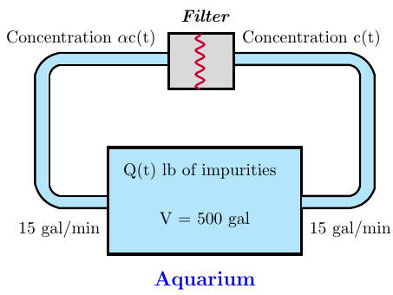

1. Apply the basic conservation principle  to obtain a differential equation for the amount of impurities present in the aquarium at time *t*. Assume that filtering occurs instantaneously. If the outflow concentration at any time is , assume that the inflow concentration at that same instant is .
2. What value of filtering constant *α*. will reduce impurity levels to 1% of their original values in a period of 3 *hr.*?
3. A mixing chamber initially contains 2 *gal* of a clear fluid. Clear fluid flows into the chamber at a rate of 10 *gal/min*. A dye solution having a concentration of 4  is injected into the mixing chamber at a rate of *r* *gal/min*. When the mixing process is started, the well-mixed mixture is pumped from the chamber at a rate .

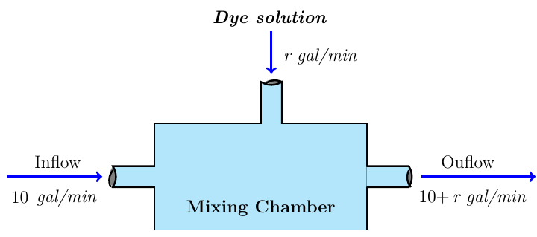

1. Develop a mathematical model for the mixing process.
2. The objective is to obtain a dye concentration in the outflow mixture of 1 . What injection rate *r* is required to achieve this equilibrium solution? Would this equilibrium value of *r* be different if the fluid in the chamber at time  contained some dye?
3. Assume the mixing chamber contains 2 *gal* of clear fluid at time . How long will it take for the outflow concentration to rise to within 1% of the desired concentration?
4. Suppose a brine containing 0.2 *kg* of salt per liter runs into a tank initially filled with 500 *L* of water containing 5 *kg* of salt The brine enter the tank at a rate of . The mixture, kept uniform by stirring, is flowing out at the rate at the same rate.

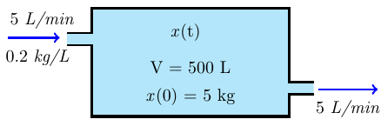

1. Find the concentration, in , of salt in the tank after 10 *min*.
2. After 10 *min*, a leak develops in the tank and an additional liter per minute of mixture flows out of the tank. What will be the concentration, in , of salt in the tank 20 *min* after the leak develops?

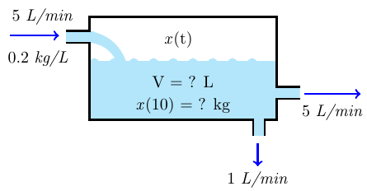

1. A tank of 100-*gallon* capacity is initially full of water. Pure water is allowed to run into the tank at the rate of , and at the same time brine containing  of salt per gallon flows into the tank also at the rate of . The mixture flows out at the rate of .

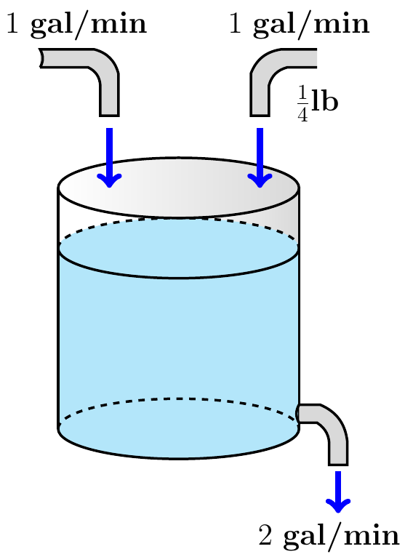

1. Find the amount of salt in the tank after *t* *minutes*.
2. How much salt is present at the end of 25 *minutes*?
3. How much salt is present after a long time?
4. A tank of 50-*gallon* capacity is initially full of pure water. Starting at time  brine containing  of salt per gallon flows into the tank also at the rate of . The mixture flows out at the rate of .



1. Find the amount of salt in the tank after *t* *minutes*.
2. How much salt is present at the end of 25 *minutes*?
3. How much salt is present after a long time?

***Section* 1.6 – Exact Differential Equations**

A class of equations known as exact equations for which there is also a well-defined method of solution

The expression  is called an exact differential form.

**1.6-1 *Theorem***

Let the function *M*, *N*, , where are partial derivatives, be continuous in the rectangular region  then



Is an exact differential equation in *R*, *iff* 

At each point in *R*. That is, there exists a function  satisfying

 *Iff* 



***Example* 1**

Solve the differential equation: 

***Solution***









 ***Integrate*** 







***Example* 2**

Solve the differential equation: 

***Solution***

















***Example* 3**

Solve the differential equation: 

***Solution***







Can be solved by this procedure.

**1.6-2 Integrating Factors**

It is sometimes possible to convert a differential equation that is not exact equation by multiplying the equation by a suitable integrating factor.

**1.6-3 *Definition***

An integrating factor for the differential equation  is a function  such that the form  is exact.





Assuming that *µ* is a function of *x* only, we have















***Example* 4**

Find an integrating factor for the equation , and then solve the equation.

***Solution***















 





**1.6-4 *Bernoulli* Equations**

An equation of the form  is called a ***Bernoulli equation***.

If  First order linear differential equation

If   Separable equation.

For ; the Bernoulli equation can be written as 

Let 





 Which is first-order linear differential equation.

***Example* 5**

Find the general solution 

***Solution***



Let 







 ***Divide by*** 













***Example* 6**

Find the general solution 

***Solution***



Let 





 ***Multiply both sides by*** 













**1.6-5 Homogeneous Equations** 

The form of a homogeneous equation suggests that it may be simplified by using a variable denoted by , to represent the ratio of *y* to *x*. This



Let assume that *v* is a function of *x*, then



The most significant fact about this equation is that the variables *x* & *v* can always be separated, regardless of the form of the function *F*.



Solving this equation and then replacing *v* by  gives the solution of the original equation.

***Example* 7**

Solve the differential equation 

***Solution***



 





















***Example* 8**

Find the general solution 

***Solution***

Let 







 ***Integrate both sides***











**1.6-6 Equations with Linear Coefficients**

For equations with linear coefficients in the form:

The general case: 

Let consider: 

If  



In this case by letting 

If , we let 

 has a solution



***Example* 9**

Solve 

***Solution***











Let 





















 



***Exercises Section* 1.6 – Exact Differential Equations**

(**1 – 61**) Solve the differential equation

|  |  |
| --- | --- |
|  |  |

|  |  |
| --- | --- |
|  |  |

1. 
2. 
3. 
4. 
5. 
6. 

(**62 – 68**) The given equation is not exact. However, if you multiply by the given integrating factor, then it becomes exact. Then solve the equation

1. 
2. 
3. 
4. 
5. 
6. 
7. 

(**69 – 71**) Find the general solution of each homogeneous equation

|  |  |
| --- | --- |
|  |  |

(**72 – 81**) Find an integrating factor and solve the given equation

|  |  |
| --- | --- |
|  |  |

(**82 – 114**) Solve the given initial-value problem

|  |  |
| --- | --- |
|  |  |

1. 
2. 
3. 
4. 
5. 
6. 
7. 
8. 
9. 
10. 
11. 

(**115 – 117**) Find an integrating factor of the form  and solve the equation

|  |  |
| --- | --- |
|  |  |

(**118 – 123**) Find the general solution by using Bernoulli

|  |  |
| --- | --- |
|  |  |

(**124 – 128**) Find the general solution by using homogeneous equations.

|  |  |
| --- | --- |
|  |  |

(**129 – 132**) Find the general solution by using Equation with Linear Coefficients

|  |  |
| --- | --- |
|  |  |

1. Prove that  has an integrating factor that depends only on the sum  if and only if the expression

 depends only on 

Use the prove to solve the equation 

1. A portion of a uniform chain of length 8 *feet* is loosely coiled around a peg at the edge of a high horizontal platform, and the remaining portion of the chain hangs at rest over the edge of the platform.

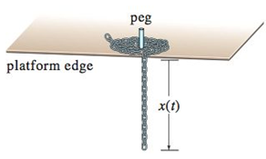

Suppose the length of the overhanging chain is 3 *feet*, that the chain weighs 2 , and that the positive direction is downward. Starting at  seconds, the weight of the overhanging portion causes the chain on the table to uncoil smoothly and to fall to the floor. If  denotes the length of the chain overhanging the table at time , then  is its velocity. When all resistive forces are ignored, it can be shown that a mathematical model relating *v* to *x* is given by



1. Rewrite this model in differential form and solve the *DE* for *v* in terms of *x* by finding am appropriate integrating factor. Find an explicit solution .
2. Determine the velocity with which the chain leaves the platform.

***Section* 1.7 - Modeling Population Growth**

**1.7-1 Modeling Population Growth**

The mathematical model of the growth of a population is given by:



Where ***r***: reproductive rate.

The natural of the predictions of the model depend on the nature of the reproductive rate *r*.

**1.7-2 Malthusian Method**

Since *r* is a constant because the birth or death rates do not depend on time or on the size.

Therefore, the solution to  is given by:





The population at time  is .

***Example* 1**

A biologist starts with 10 *cells* in a culture. Exactly 24 *hrs.* later he counts 25. Assuming a Malthusian model, what the reproductive rate? What will be the number of cells of the end of 10 *days*?

***Solution***





 **24 *hrs. =* 1 *day P =* 25**















***Example* 2**

A certain radioactive material is decaying at a rate proportional to the amount present. If a sample of 50 *grams* of the material was present initially and after 2 *hours* the sample lost 10% of its mass, find:

1. An expression for the mass of the material remaining at any time.
2. The mass of the material after 4 *hours*.
3. How long will it take for 75% of the material to decay?
4. The half-life of the material.

***Solution***

***Given***:  

1. 



 ***Convert to logarithm***









1. 



1. 











1. 



***Note***

We can this formula to solve most of the questions 

**1.7-3 Logistic Model of Growth**

***Logistic population growth*** occurs when the ***growth*** rate decreases as the population reaches carrying capacity. Carrying capacity is the maximum number of individuals in a population that the environment can support.

Suppose an environment is capable of sustaining no more than a fixed number *K* of individuals in its populations. The quantity *K* is called the ***carrying capacity*** of the environment. In reality this model in unrealistic because environments impose limitations to population growth.

The logistic equation is given by:

 

The logistic equation can be solved by separation of variables



 



























***Example* 3**

Suppose we start at time  with a sample of 1000 *cells*. One day later we see that the population has doubled, and sometime later we notice that the population has stabilized at 100,000.

***Solution***

***Given***:  























**1.7-4 Pollution**

Consider a lake that has a volume of , it is fed by an input river, and there is another river which is fed by the lake at a rate that keeps the volume of the lake constant.

The input rate: 

The maximum flow into the lake occurs when 

In addition, there is a factory on the lake that introduces a pollutant into the lake at the rate of 2 . Let  denote the total amount of pollution in the lake at time *t*. If we make the assumption that the pollutant is rapidly mixed throughout the lake, then



***Exercises Section* 1.7 - Modeling Population Growth**

1. The rate of growth of bacteria in a petri dish is proportional to the number of bacteria in the dish.
2. The rate of growth of a population of field mice is inversely proportional to the square root of the population.
3. A biologist starts with 100 *cells* in a culture. After 24 *hrs.,* he counts 300. Assuming a Malthusian model, what the reproductive rate? What will be the number of cells of the end of 5 *days*?
4. A biologist prepares a culture. After 1 *day* of growth, the biologist counts 1000 *cells*. After 2*days,* he counts 3000. Assuming a Malthusian model, what the reproductive rate and how many cells were present initially?
5. A population of bacteria is growing according to the Malthusian model. If the population is triples in 10 *hrs.*, what is the reproduction rate? How often does the population double itself?
6. Consider a lake that is stocked with walleye pike and that the population of pike is governed by the logistic equation



Where time is measured in days and *P* in *thousands* of fish. Suppose that fishing is started in this lake and that 100 *fish* are removed each day.

1. Modify the logistic model to account for the fishing.
2. Find and classify the equilibrium points for your model.
3. Use qualitative analysis to completely discuss the fate of the fish population with this model. In particular, if the initial fish population is 1000, what happens to the fish as time passes? What will happen to an initial population having 2000 fish?
4. Suppose that in 1885 the population of a certain country was 50 million and was growing at the rate of 750,000 people per year at that time. Suppose also that in 1940 its population was 100 million and was then growing at the rate of 1 million per year. Assume that this population satisfies the logistic equation. Determine both the limiting population *M* and the predicted population for the year 2000.
5. The time rate of change of a rabbit population *P* is proportional to the square root of *P*. At time  (months) the population numbers 100 rabbits and is increasing at the rate of 20 rabbits per month. How many rabbits will there be one year later?
6. Suppose that the fish population  in a lake is attacked by a disease at time , with the result that the fish cease to reproduce (so that the birth rate is ) and the death rate *δ* (deaths per week per fish) is thereafter proportional to . If there were initially 900 fish in the lake and 441 were left after 6 weeks, how long did it take all the fish in the lake to die?
7. Suppose that when a certain lake is stocked with fish, the birth and death rates *β* and *δ* are both inversely proportional to 
8. Show that , where *k* is a constant.
9. If  and after 6 months there are 169 fish in the lake, how many will there be after 1 year?
10. The time rate of change of an alligator population *P* in a swamp is proportional to the square of *P*. The swamp contained a dozen alligators in 1988, two dozen in 1998.
11. When will there be four dozen alligators in the swamp?
12. What happens thereafter?
13. Consider a prolific breed of rabbits whose birth and death rates, *β* and *δ*, are each proportional to the rabbit population , with 
14. Show that 

Note that . This is doomsday

1. Suppose that  and that there are nine rabbits after ten months. When does doomsday occur?
2. With , repeat part (*a*)
3. What now happens to the rabbit population in the long run?
4. Consider a population  satisfying the logistic equation , where  is the time rate at which births occur and  is the rate at which deaths occur.
5. If the initial population is , and  births per month and  deaths per month are occurring at time , show that the limiting population is .
6. If the initial population is 120 rabbits and there are 8 births per month and 6 deaths per month occurring at time , how many months does it take for  to reach 95% of the limiting population *M*?
7. If the initial population is 240 rabbits and there are 9 births per month and 12 deaths per month occurring at time , how many months does it take for  to reach 105% of the limiting population *M*?
8. The amount of drug in the blood of a patient (in *mg*) due to an intravenous line is governed by the initial value problem



Where *t* is measured in hours

1. Find and graph the solution of the initial value problem.
2. What is the steady-state level of the drug?
3. When does the drug level reach 90% of the steady-state value?
4. A fish hatchery has 500 *fish* at time , when harvesting begins at a rate of *b* *fish/yr*. where . The fish population is modeled by the initial value problem.



Where *t* is measured in years.

1. Find the fish population for  in terms of the harvesting rate *b*.
2. Graph the solution in the case that . Describe the solution.
3. Graph the solution in the case that . Describe the solution.
4. A community of hares on an island has a population of 50 when observations begin at . The population for  is modeled by the initial value problem.



1. Find the solution of the initial value problem.
2. What is the steady-state population?
3. When an infected person is introduced into a closed and otherwise healthy community, the number of people who become infected with the disease (in the absence of any intervention) may be modeled by the logistic equation



Where *k* is a positive infection rate, *A* is the number of people in the community, and  is the number of infected people at . The model assumes no recovery or intervention.

1. Find the solution of the initial value problem in terms of *k*, *A*, and .
2. Graph the solution in the case that  .
3. For fixed values of *k* and *A*, describe the long-term behavior of the solutions for any  with 
4. The reaction of chemical compounds can often be modeled by differential equations. Let  be the concentration of a substance in reaction for  (typical units of *y* are *moles/L*). The change in the concentration of a substance, under appropriate conditions, is , where  is a rate constant and the positive integer *n* is the order of the reaction.
5. Show that for a first-order reaction , the concentration obeys an exponential decay law.
6. Solve the initial value problem for a second-order reaction  assuming 
7. Graph and compare the concentration for a first-order and second-order reaction with  and 
8. The growth of cancer turmors may be modeled by the Gomperts growth equation. Let  be the mass of the tumor for . The relevant intial value problem is



Where *a* and *K* are positive constants and 

1. Graph the growth rate function  assuming  and . For what values of *M* is the growth rate positive? For what values of *M* is maximum?
2. Solve the initial value problem and graph the solution for , , and . Describe the growth pattern of the tumor. Is the growth unbounded? If not, what is the limiting size of the tumor?
3. In the general equation, what is the meaning of *K*?
4. The halibut fishery has been modeled by the differential equation



Where  is the biomass (the total mass of the members of the population) in kilograms at time *t* (measured in years), the carrying capacity is estimated to be  and .

1. If , find the biomass a year later.
2. How long will it take for the biomass to reach .
3. Suppose a population  satisfies , where *t* is measured in years.
4. What is the carrying capacity?
5. What is ?
6. When will the population reach 50% of the carrying capacity?
7. The board of directors of a corporation is calculating the price to pay for a business that is forecast to yield a continuous flow of profit of $500,000 per *year*. The money will earn a nominal rate of 5% per year compounded continuously. What is the present value of the business?
8. For 20 *years*?
9. Forever (in perpetuity)?
10. The population of a community is known to increase at a rate proportional to the number of people present at a time *t*. If the population has doubled in 6 *years*, how long it will take to triple?
11. Let population of country be decreasing at the rate proportional to its population. If the population has decreased to 25% in 10 *years*, how long will it take to be half?
12. Suppose that we have an artifact, say a piece of fossilized wood, and measurements show that the ratio of *C*−14 to carbon in the sample is 37% of the current ratio. Let us assume that the wood died at time 0, then compute the time *T* it would take for one gram of the radioactive carbon to decay this amount.
13. A certain radioactive material is known to decay at a rate proportional to the amount present. If initially there is  of the material present and after of its original mass, find
14. An expression for the mass of the material remaining at any time *t*.
15. The mass of the material after 4 *hours*
16. The time at which the material has decayed to one half of its initial mass.
17. The rate at which radioactive nuclei decay is proportional to the number of such nuclei that are present in given sample. Half of the original number of radioactive nuclei have undergone disintegration in a period of 1,500 *years*.
18. What percentage of the original radioactive nuclei will remain after 4,500 *years*?
19. In how many years will only one-tenth of the original number remain?

***Section* 1.8 – Basic Electrical Circuit**

An ***electric circuit*** is a path in which electrons from a voltage or current source flow. The point where those electrons enter an ***electrical circuit*** is called the "source" of electrons.

**1.8-1 *Resistor*:** (**O**hm’s **L**aw)

A ***resistor*** is a component of a circuit that resists the flow of electrical current. It has two terminals across which electricity must pass, and it is designed to drop the voltage of the current as it flows from one terminal to the other. Resistors are primarily used to create and maintain known safe currents within electrical components.

A voltage  across the terminals of a resistor is proportional to the current  in it. The constant proportional ***R*** is called the resistance of the resistor in **V**olt/**A**mpere or **O**hms (Ω), and is given by the equation:





For series resistors, the equivalent resistor is:





Then: 

For resistors in parallels:



Then: 

**1.8-2 *Inductor*:** (**F**araday’s **L**aw)

When a current in a circuit is changing, then the magnetic flux is linking the same circuit changes. This change in flux causes an *emf* ***v*** to be induced in the circuit.

***Inductance*** is symbolized by letter ***L***, is measured in ***h*enrys** (***H***), and is represented graphically as a coiled wire – a reminder that inductance is a consequence of a conductor linking a magnetic field.



The voltage  is proportional to the time rate of change of the current, and is given by:

 and 

For series inductors, the equivalent inductor is:





For inductors in parallels:





**1.8-3 *Capacitance*:** (**C**oulomb’s **L**aw)

The circuit parameter of ***capacitance*** is represented by letter ***C***, is measured in ***f****arads* (***F***), and is symbolized graphically by two short parallel conductive plates.



The farad is an extremely large quantity of capacitance, practical capacitor values usually lie in the picofarad (*pF*) to microfarad (*μF*) range.

The graphic symbol for a capacitor is a reminder that capacitance occurs whenever electrical conductors are separated by a dielectric, or insulating, material. This condition implies that electric charge is not transported through the capacitor. Although applying a voltage to the terminals of the capacitor cannot move a charge through the dielectric, it can displace a charge within the dielectric. As the voltage varies with time, the displacement of charge also varies with time, causing what is known as the displacement current.

The potential ***v*** between the terminals of a capacitor is proportional to the charge *q* on it.





 *C* is **C**oulombs/**V**olts or farads.

For capacitances in series, the equivalent capacitance is given by:

|  |  |
| --- | --- |
|  |  |

For capacitances in parallels:

|  |  |
| --- | --- |
|  |  |

**1.8-4 *RLC circuit***

*RLC* circuit is a basic building block in electrical circuits and networks. A second order linear differential equations with constant coefficients is their use as a model of the flow of electric current in the simple series circuit

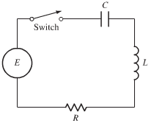

|  |  |  |  |  |  |  |  |  |  |
| --- | --- | --- | --- | --- | --- | --- | --- | --- | --- |
| The current *I*, measured in amperes (***A***), is a function of time *t*.  A ***resistor*** with a resistance of *R* *ohms* (**Ω**)  An ***inductor*** with an inductance of *L henries* (***H***)  A ***capacitor*** with a capacitance of *C farads* (***F***)  The impressed ***voltage*** *E* in volts (***V***) is a given function of time. | |  |  | | --- | --- | | ***Circuit Element*** | ***Voltage Drop*** | | Inductor |  | | Resistor |  | | Capacitor |  | |

In series with a source of electromotive force (such as a battery or a generator) that supplies a voltage of  volts at time *t*. If the switch shown in the circuit is closed, this results in a current of  *amperes* in the circuit and a charge of  *coulombs* on the capacitor at time *t*. The relation between the functions *Q* and the current *I* is



We use ***mks*** electric units, in which time is measured in seconds.

According to elementary principles of electricity, the voltage drops across the three circuit elements.

Kirchhoff's Current Law (***KCL***) (also known as Kirchhoff's ***First Law***)

***The algebraic sum of all the currents at any node in a circuit equals to zero.***

***Current is distributed when it reaches a junction: the amount of current entering a junction must equal the amount of current leaving that junction.***

Kirchhoff's Voltage Law (***KVL***) (also known as Kirchhoff's ***Second Law***)

***The algebraic sum of all the voltages around any closed path in a circuit equals to zero.***

***In a closed circuit the impressed voltage is equal to the sum of the voltage drops in the rest of the circuit.***

According to the elementary laws of electricity, we know that

The voltage drop across the resistor is *IR*.

The voltage drop across the capacitor is .

The voltage drop across the inductor is .

* When the switch is open, no current flows in the circuit; when the switch is closed, there is a current  and a charge  on the capacitor.

The current and charge in the simple *RLC* circuit satisfy the basic electrical equation



The units for voltage, resistance, current, charge, capacitance, inductance, and time are all related:





Since , we can get the second-order linear differential equation



For the charge , under the assumption that the voltage is known.

It is the current, in most problems, rather than the charge *Q* that us of primary interest, so we differentiate both sides and substitute *I* for  to obtain



With initial conditions are











Hence  is also determined by the initial charge and current, which are physically measurable quantities.

* The most important conclusion is that the flow of current in the circuit is precisely the same form as the one that describes the motion of a spring-mass system.

**1.8-5 *Summary***

In *RLC* circuit:

 

In terms of current: 



***Without capacitor*** 

Where  is the change on the capacitor and  is the applied voltage.

**1.8-6 Communication Channel**

The *RC*-circuit consists of a voltage source, a resistor and a capacitor.

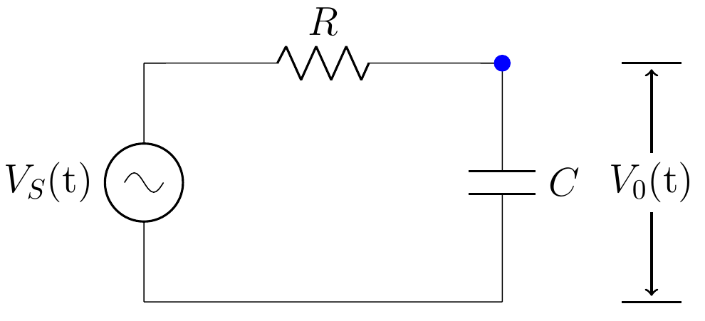

The source voltage  is the message sent and the output voltage  is the message received.

*Kirchoff’s Voltage Law*: the source voltage  is the sum of the voltage drops across the other two circuit elements.

Voltage drop across the resistor 

The current through the resistor, which by Ohm’s Law,





Therefore, the model *RC* circuit *ODE*:





***Example* 1**

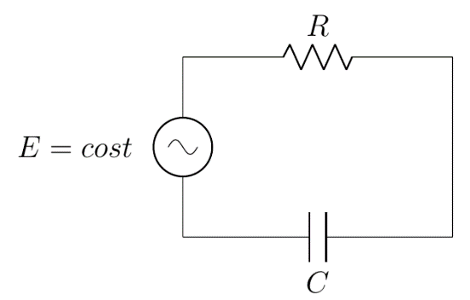Suppose the electrical circuit has a resistor of  and a capacitor of . Assume the voltage source is .

If the initial current is 0 *A*, find the resulting current.

***Solution***

 → 





|  |  |  |
| --- | --- | --- |
|  |  |  |
| + |  |  |
| − |  |  |
| + |  |  |

















## 1.8-7 *Example*

The electrical analog of a carriage on wheels, coupled to the wall through a spring.



***a*)** Mechanical system. ***b*)** Electrical analog.

***A mechanical system with a one coordinates movement.***

In the case of the electrical network, the equation was obtained by applying Kirchhoff's current law at the node ***v***, and is seen to be identical to the equation that would have been obtained by applying D'Alembert's principle to the mechanical system.

The differential equation for both systems is:



In particular, if one uses the force current analogy (or force-torque for a rational system). The topology of the electrical analog is very similar to that of the mechanical system.

## *Example* 2: Alternating Circuit

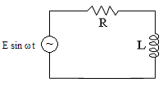

*Alternating Circuit*

Translating the circuit into differential equation:









|  |  |  |
| --- | --- | --- |
|  |  |  |
| + |  |  |
| − |  |  |
| + |  |  |











At 









***Exercises Section* 1.8 - Basic Electrical Circuit**

1. Sum the currents at each node in the circuit

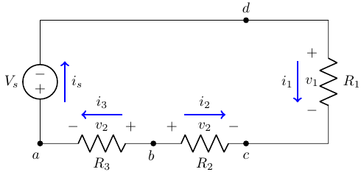

1. Sum the currents at each node in the circuit

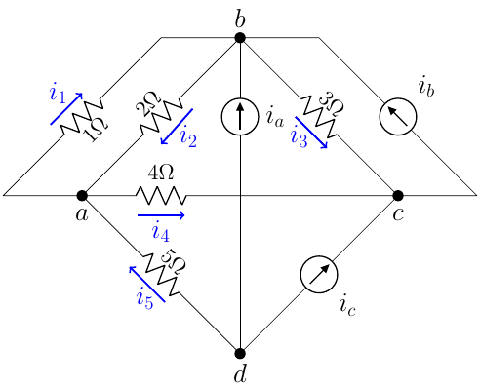

1. Sum the voltges around rach designated path in the circuit

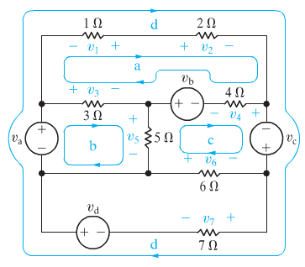

(**4 – 7**) A resistor and a capacitor of are joined in series with an electronic force (*emf*)  and no charge on the capacitor at . Find the ensuing charge on the capacitor at time *t* for the given:

|  |  |  |
| --- | --- | --- |
|  |  |  |

(**8 – 10**) An inductor and a resistor are joined in series with an electronic force (*emf*)  and no charge on the capacitor at . Find the ensuing current in the current at time *t* for the given:

|  |  |  |
| --- | --- | --- |
|  |  |  |

1. An *RL* circuit with a  resistor and a  inductor is driven by a voltage . If the initial inductor current is zero, determine the subsequence resistor and inductor current and the voltages.
2. An *RL* circuit with a  resistor and a  inductor is driven by a voltage . If the initial inductor current is zero, determine the subsequence resistor and inductor current and the voltages.
3. An *RL* circuit with a  resistor and a  inductor is driven by a voltage . If the initial inductor current is 1 *A*, determine the subsequence resistor and inductor current and the voltages.
4. An *RC* circuit with a  resistor and a  capacitor is driven by a voltage . If the initial capacitor current is zero, determine the subsequence resistor and capacitor current and the voltages.
5. Solve the general initial value problem modeling the *RC* circuit



Where *E* is a constant source of *emf*

1. Solve the general initial value problem modeling the *LR* circuit



Where *E* is a constant source of *emf*

1. For the given *RL*−circuit

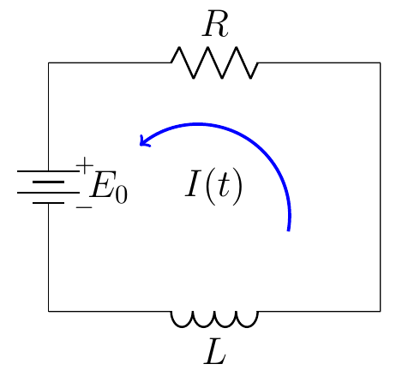

Where  is a constant source of *emf* at time .

Find the current  flowing in the circuit.

1. For the given *RL*−circuit

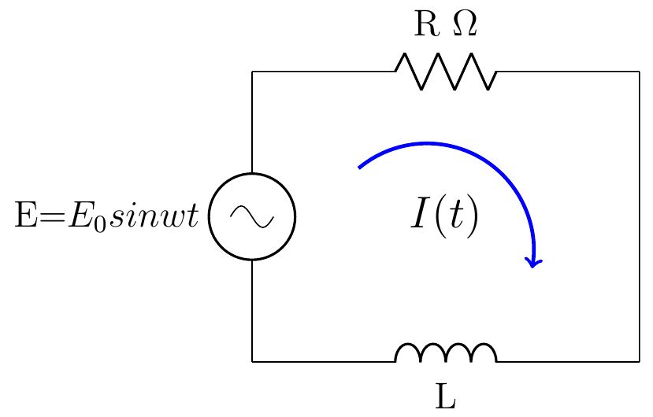

Where  is the impressed voltage.

Find the current  flowing in the circuit.

1. For the given *RL*−circuit

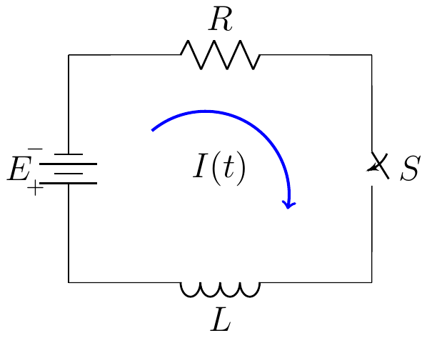

Which has a constant impressed voltage *E*, a resistor of resistance *R*, and a coil of impedance *L*.

Find the current  flowing in the circuit.

1. For the given *RL*−circuit

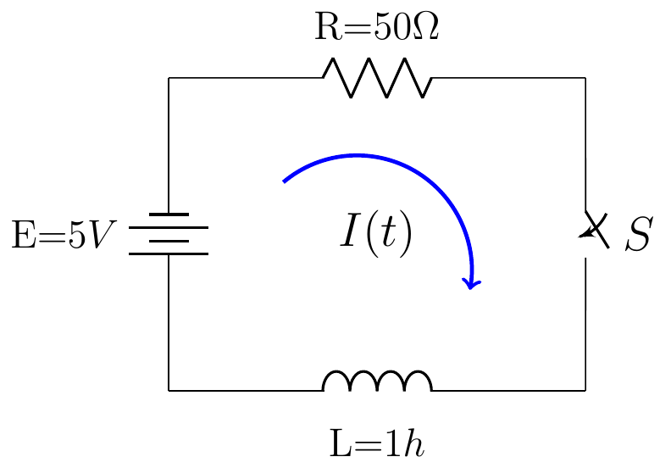

Which has a constant impressed voltage *E*, a resistor of resistance *R*, and a coil of impedance *L*.

Find the current  flowing in the circuit.

1. Consider the circuit shown and let , , and  be the currents through the capacitor, resistor, and inductor, respectively. Let , , and  be the corresponding voltage drops. The arrows denote the arbitrary chosen directions in which currents and voltage drops will be taken to be positive.

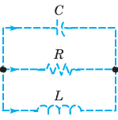

1. Applying Kirchhoff’s second Law to the upper loop in the circuit, show that 
2. Applying Kirchhoff’s first Law to either node in the circuit, show that



1. Use the current-voltage relation through each element in the circuit to obtain the equations



1. Eliminate , ,  and to obtain 
2. Consider the circuit. Use the method outlined to show that the current *I* through the inductor and the voltage *V* across the capacitor satisfy the system of differential equations.

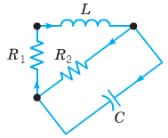



1. Consider an electric circuit containing a capacitor, resistor, and battery.

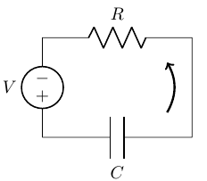The charge  on the capacitor satisfies the equation



Where *R* is the resistance, *C* is the capacitance, and *V* is the constant voltage supplied by the battery.

1. If , find  at time *t*.
2. Find the limiting value  that approaches after a long time.
3. Suppose that  and that at time  the battery is removed and the circuit is closed again. Find  for .
4. 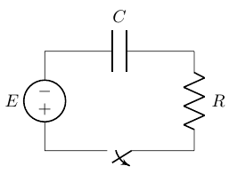A circuit containing an electromotive force, a capacitor with a capacitance of *C* farads (*F*), and a resistor with a resistance of *R* ohms . The voltage drop across the capacitor is , where *Q* is the charge (in coulombs), so in this case ***Kirchhoff’s Law*** gives



But , so we have 

Find the charge and the current at time *t*

1. Suppose the resistance is , the capacitance is 0.05 *F*, a battery gives voltage of 60 *V* and initial charge is 
2. Suppose the resistance is , the capacitance is 0.01 *F*,  and initial charge is 
3. A heart pacemaker consists of a switch, a battery voltage , a capacitor with constant capacitance *C*, and the heart as a resistor with constant resistance *R*. When the switch is closed, the capacitor charges; when the switch is open, the capacitor discharges, sending an electrical stimulus to the heart. During the time the heart is being stimulated, the voltage *E* across the heart satisfies the linear differential equation



Solve the *DE*, subject to 

1. A 30−volt electromotive force is applied to an *LR*-series circuit in which the inductance is 0.1 *henry* and the resistance is 50 *ohms*.
2. Find the current  if 
3. Determine the current as 
4. Solve the equation when  and 
5. A 100−volt electromotive force is applied to an *RC*-series circuit in which the resistance is 200 *ohms* and the capacitance is  *farad*.
6. Find the charge  if 
7. Find the current as 
8. A 200−volt electromotive force is applied to an *RC*-series circuit in which the resistance is 1000 *ohms* and the capacitance is  *farad*.
9. Find the charge  if 
10. Determine the charge as 
11. An electromotive force



Is applied to an *LR*-series circuit in which the inductance is 20 *henries* and resistance is 2 *ohms*. Find the current  if 

1. Suppose an *RC*-series circuit has a variable resistor. If the resistance at time *t* is given by  where  and  are known positive constants, then



If  and , where  and  are constants, show that



1. A heart pacemaker, consists of a switch, a battery, a capacitor, and the heart as a resistor.

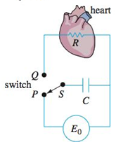

When the switch *S* is at *P*, the capacitor charges; when *S* is at *Q*, the capacitor discharges, sending an electrical stimulus to the heart. The electrical stimulus is being applied to the heart, the voltage *E* across the heart satisfies the linear DE.



1. Let assume that over the time interval of length , , the switch *S* is at position *P* and the capacitor is being charges. When the switch is moved to position *Q* at time  the capacitor discharges, sending an impulse to the heart over the time interval of length : . Thus, over the initial charging/discharging interval the voltage to the heart is actually modeled by the piecewise-defined differential equation



By moving *S* between *P* and *Q*, the charging and discharging over time intervals of lengths  and  is repeated indefinitely. Suppose , . , and , , , , , and so on.

Solve for  for 

1. Suppose for the sake of illustration that . Graph the solution in part (*a*) for 

***Section* 1.9 - Existence and Uniqueness of Solutions**

Existence and uniqueness theorem is the tool which makes it possible for us to conclude that there exists only one solution to a first order differential equation which satisfies a given initial condition

The questions of existence and uniqueness

* When can we be sure that a solution exists**?**
* How many different solutions are there
* ***Existence***: Under what conditions does the Initial Value Problem (**IVP**) have at least one solution?
* ***Uniqueness***: Under what conditions does the **IVP** have at most one solution?
* ***Extension and Long-Term Behavior***: How far ahead into the future and back into the past does a solution extend? How does a solution behave as *t* gets large?
* ***Continuity***: Suppose the data *f* and  change. Can the corresponding change in solution be limited by limiting the change in the data *f* and .
* ***Description***: How can a solution and its behavior be described?

**1.9-1 Existence of Solutions**

***Example* 1**

Consider the initial value problem:  with 

***Solution***

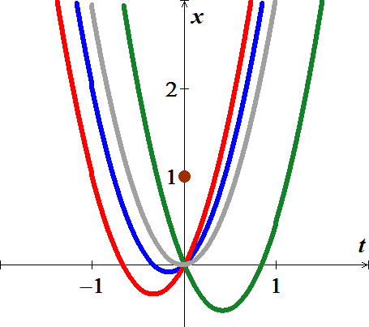

 

There is ***no solution*** to the given initial value













**1.9-2 *Theorem:* Existence of Solutions**

Suppose the function is defined and continuous on the rectangle ***R*** in the *tx*-plane. Then given any point , the initial value problem



has a solution  defined in an interval containing . Furthermore, the solution will be defined at least until the solution curve  leaves the rectangle ***R***.

**1.9-3 Interval of Existence of a Solution**

***Example* 2**

Consider the initial value problem  with . Find the solution and its interval of existence.

***Solution***

The right-hand side is  which is continuous on the entire *tx*-plane.

The solution to the initial value problem is:











 is discontinuous at .

Hence the solution to the initial value problem is defined only for .

The interval: 

**1.9-4 *Theorem*: Existence of a Unique Solution**

Let ***R*** be a rectangular region in the *xy-*plane defined by  that contains the point  in its interior. If  and  are continuous on ***R***, then there exists some interval , contained in [*a, b*], and a unique function , defined on  that is a solution of the initial*-*value problem (IVP)



**1.9-5 Mathematics & Theorems**

Any theorem is a logical statement which has hypotheses (when it's true) and conclusions (true)

***The Hypotheses of the Uniqueness of Solutions Theorem***

1. The equation is in normal form 
2. The right-hand side  and its derivative  are both continuous in the rectangle ***R***.
3. The initial point  is in the rectangle ***R***.

For the Uniqueness Theorem, the conclusions are as follows:

1. There is one and only one solution to the initial value problem.
2. The solution exists until the solution curve  leaves the rectangle ***R***.

***Example* 3**

Consider the initial value problem . Is there a solution to this equation with initial condition ? If so, is the solution unique?

***Solution***



The right-hand side:  is continuous except where .

We can take ***R*** to be any rectangle which contains the point  to avoid , we can choose  and 

Then *f* is continuous everywhere in ***R*** ⇒ hypotheses of the existence theorem are satisfied.

Since  is also continuous in ***R***.

There is only one solution.

***Exercises Section* 1.9 - Existence and Uniqueness of Solutions**

(**1 – 12**) Which of the initial value problems are guaranteed a unique solution

|  |  |
| --- | --- |
|  |  |

1. Show that and  are both solutions of the initial value problem , where . Explain why this fact doesn't contradict Theorem
2. Use a numerical solver to sketch the solution of the given initial value problem



1. Where does your solver experience difficulty? why? Use the image of your solution to estimate the interval of existence.
2. Find an explicit solution; then use your formula to determine the interval of existence. How does it compare with the approximation found in part (*a*).

***Section* 1.10 - Autonomous Equations and Stability**

First order autonomous equations, Equilibrium solutions, Stability, Longterm behavior of solutions, direction fields.

A differential equation where the independent variable does not explicitly appear in its expression.

A first-order autonomous equation is an equation of the form





**1.10-1 *Definition***

The valuewhere the functionassigns to the point represent the slope of a line (*line segment*) call ***a lineal element***.

***Example***:

Given  and consider the point

The slope of the lineal element is 

**1.10-2 The Direction Fields**

What we draw a lineal element at each point  with slope  then the collection of these lineal elements is called a ***direction field*** or a ***slope field*** of the differential equation.

|  |  |
| --- | --- |
|  |  |

|  |  |
| --- | --- |
|  |  |

***Example* 1**

Sketch the direction field for the following differential equation. Sketch the set of integral curves for this differential equation, how the solutions behave as  and if this behavior depends on the value of  describe this dependency



***Solution***







This divided into 4 regions.

For , assume  

, the slopes will flatten out while staying positive



For , assume  

Therefore, tangent lines in this region will have negative slopes and apparently not very steep.



 (Steeper)



For , assume   Not to steep



For , assume  

Start out fairly flat nearly = 2, then will get fairly steep.



|  |  |
| --- | --- |
| Value of |  |
|  |  |
|  |  |
|  |  |
|  |  |



**1.10-3 Autonomous first- order DE**

A system, which does not explicitly contain the independent variable *t* is called an ***autonomous system***. Otherwise, the system is called *non-autonomous system*.

|  |  |
| --- | --- |
| ***Autonomous*** | ***Non−Autonomous*** |
|  |  |
|  |  |
|  |  |

**1.10-4 *Equilibrium* Points & Solutions**

 and also, called a ***critical point***.



From these equilibrium points, we can determine the stability of the system.

* An equilibrium point is ***stable*** if all nearby solutions stay nearby.

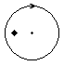

* An equilibrium point is ***asymptotically stable*** if all nearby solutions not only stay nearby, but also tend to the equilibrium point. An equilibrium point is stable if all nearby solutions.



1. If , then *f* is ***decreasing*** at and is asymptotically stable.
2. If , then *f* is ***increasing*** at and is unstable.
3. If  no conclusion can be drawn.

The family of all solution curves without the presence of the independent variable is called the ***phase portrait***.

When an independent variable ***t*** is interpreted as time and the solution curve  could be thought of as the path of a particle moving in the solution space, then the system is considered as a ***dynamical system***, where the solution curves are called *t****rajectories*** or ***orbits***.

***Example* 2**

Discover the behavior as of all solutions to the differential equation



***Solution***

The equilibrium points: 



 are equilibrium.



 ***unstable***

 is ***asymptotically stable***

 ***unstable***



These are constant functions, the position of the point the phase line modeled by them is also constant

-1 1 2

***Phase Portrait***

***Exercises Section* 1.10 - Autonomous Equations and Stability**

(**1 – 4**) The graph of the right-hand side  is shown. Identify the equilibrium points and sketch the equilibrium solutions in the *ty*-plane. Classify each equilibrium point as either unstable or asymptotically stable.

**1.**



**2.**



**3.**



**4.** Impose the equilibrium solution(s), classifying each as either unstable or asymptotically stable

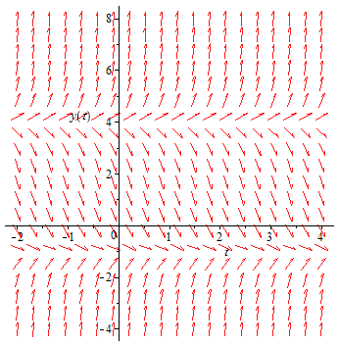

(**5 – 20**) An autonomous differential equation is given. Perform each of the following exercises

1. Sketch a graph of 
2. Use the graph of *f* to develop a phase line for the autonomous equation. Classify each equilibrium point as either unstable or asymptotically stable.
3. Sketch the equilibrium solutions in the *ty*-plane into regions. Sketch at least one solution trajectory in each of these regions.

|  |  |  |
| --- | --- | --- |
|  |  |  |

(**21 – 22**) Determine the stability of the equilibrium solutions

|  |  |
| --- | --- |
|  |  |

1. A tank contains 100 *gal* of pure water. A salt solution with concentration 3 *lb/gal* enters the tank at a rate of 2 *gal/min*. Solution drains from the tank at a rate of 2 *gal/min*. Use the qualitative analysis to find the eventual concentration of the salt in the tank.
2. A mathematical model for rate at which a drug disseminates into the bloodstream at time *t*.



Where *r* and *k* are positive constants. The function  describes the concentration of the drug in the bloodstream at time *t*.

1. Since the *DE* is autonomous, use the phase portrait concept to find the limiting value of  as 
2. Solve  subject to . Sketch the graph of  and verify your prediction in part (*a*). At what time is the concentration one-half this limiting value?
3. When forgetfulness is taken into account, the rate of memorization of a subject is given by



Where , ,  is the amount memorized in time *t*, *M* is the total amount to be memorized, and  is the amount remaining to be memorized.

1. Since the *DE* is autonomous, use the phase portrait concept to find the limiting value of  as . Interpret the result
2. Solve  subject to . Sketch the graph of  and verify your prediction in part (*a*).
3. The number  of supermarkets throughout the country that are using a computerized checkout system is described by the initial-value problem



1. Use the phase portrait concept to predict how many supermarkets are expected to adopt the new procedure over a long period of time. Sketch a solution curve of the given initial-value problem.
2. Solve the initial-value problem and then graph it to verify the solution in part (*a*)
3. How many companies are expected to adopt the new technology when ?
4. For the linear ODE 
5. Find all solution of the given *DE* equation.
6. Show that the initial value , has exactly one solution.
7. But if  there is no solution at all. Why doesn’t this contradict the Existence and Uniqueness Theorem?
8. Plot several solutions of the *ODE* over the interval 