***Lecture Four* − Series**

***Section* 4.1 – Introduction and Review of Power Series**

**4.1-1 *Definition***

A ***power series*** *about the point*  is a series of the form



The series is said to converge at  if the sequence of partial sums





Converges as . The sum of the series at the point  is defined to be the limit at the partial sums,



***Example* 1**

Show that the geometric series  converges for  and that 

Show that the series diverges for .

***Solution***

The partial sums  can be evaluates as follows.











If , then 



If , then  diverges and therefore the  *diverges*

If , then 

**4.1-2 Radius of Convergence of a Power Series**

***Corollary to Theorem***

The convergence of the series  is described by one of the following three cases:

1. There is a positive number *R* such the series diverges for *x* with  but converges absolutely for *x* with . The series may or may not converge at either of the endpoints  and .
2. The series converges absolutely for every *x* .
3. The series converges at *x* = *a* and diverges elsewhere (*R* = 0)

*R* is called the ***radius of convergence*** of the power series, and the interval of radius *R* centered at *x = a* is called the ***interval of convergence***.

**4.1-3 Interval of convergence**

***Theorem***

For any power series  there is an ***R***, either a nonnegative number or ∞, such that the series converges if  and diverges if 

**4.1-4 The ratio Test**

***Theorem***

Suppose the terms of the series  have the property that



exists. If  the series converges, while if  the series diverges

**4.1-5 *Definition***

Suppose that  exists or is ∞. Then the power series  has radius of convergence .

If *L* = 0, then *R* = ∞

If *L* = ∞, then *R* = 0

And

**4.1-6 How to Test a Power Series for Convergence**

1. Use the Ratio Test (or Root Test) to find the interval where the series converges. Ordinarily, this is an open interval



1. If the interval of absolute convergence is finite, test for convergence or divergence at each endpoint. Use the Comparison Test, the Integral Test, or the Alternating Series Test.
2. If the interval of absolute convergence is , the series diverges for  (it does not even converge conditionally) because the *n*th term does not approach zero for those values of *x*.

***Example* 2**

Find the radius of convergence for the series. 

***Solution***









By the ratio test, the series converges if , so the radius of convergence is 



***Example* 3**

Determine the centre, radius, and interval of convergence of 

***Solution***



The centre of convergence is













The series converges absolutely on ***interval***

 

It diverges on 

At 

1. 







1. 

Therefore, the series converges by Alternating Series Test.

At 









Therefore, the series converges by Integral Test.

Both series converge (absolutely).

Therefore, the interval of convergence of the given power is 

**4.1-7 Algebraic Operations on Series**

The ***sum*** and ***difference*** of two series







 

**4.1-8 *Differentiating Power Series***

***Theorem***

The function: 



Can be differentiating the series by terms









In general: 

**4.1-9 *Identity* Theorem**

Suppose that the series  has a positive radius of convergence. Then



The coefficients of a power series are determined by the values of the sum .

If  has a series representation, then the series must be



**4.1-10 Taylor and Maclaurin Series**

***Definitions***

Let  be a function with derivatives of all orders throughout some interval containing ***a*** as an interior point. Then the ***Taylor series generated by***  at  is



The ***Maclaurin series generated by***  is



The Taylor series generated by  at .

***Example* 4**

Find the Taylor series and the Taylor polynomials generated by  at 

***Solution***





The Taylor series generated by  at  is













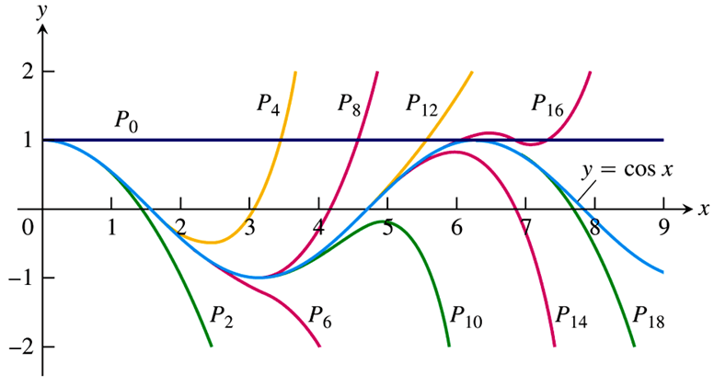

***Example* 5**

Find the Taylor series for  in powers of . Where does the series converge to ?

***Solution***

Let , then







 

 

 

 

 















Since the series for  is valid for , this series for  is valid for 



**4.1-11 Integrating Power Series**

**Theorem**

Suppose the power series  converges for 



***Exercises*** ***Section* 4.1 – Introduction and Review of Power Series**

(**1 – 6**) Determine the *centre*, *radius*, and *interval of convergence* of each of the power series

|  |  |  |
| --- | --- | --- |
|  |  |  |

(**7 – 21**) Find the Taylor polynomials of orders 0, 1, 2, and 3 generated by 

|  |  |
| --- | --- |
|  |  |

(**22 – 33**) Find the *n*th Maclaurin polynomial for the function

|  |  |
| --- | --- |
|  |  |

(**34 – 37**) Finding Taylor and Maclaurin Series generated by 

|  |  |
| --- | --- |
|  |  |

(**38 – 53**) Find the Maclaurin series for

|  |  |  |
| --- | --- | --- |
|  |  |  |

***Section* 4.2 – Series Solutions near Ordinary Points**

In this section, we consider methods of solving second order linear equations when the coefficients are function of the independent variable.

The second order linear homogeneous equation is given by:



**4.2-1 *Example of a First-Order Equation***

Find the series solution for the differential equation 

***Solution***

We look for a solution of the form: 

















 

 

 









**4.2-2 *Example* 2**

Find the general series solution to the equation



Find the particular solution with  and 

***Solution***























 

 

 

 

The general solution can be written as:



For the given initial  and , the solution is:



***Summary***

|  |  |  |  |
| --- | --- | --- | --- |
| ***Front*** |  |  |  |
|  |  |  |  |
|  |  |  |  |
|  |  |  |  |

Use the appropriate *Sigma* corresponds to *x*’s in front of  to eliminate changing the first value of *n* to combine the *Sigma*.

***Example***

For  always the product 

That implies to 

For , is the result that we need to take out of *Sigma* to combine all *Sigma* into single one with the same first value of *n*.

***Exercises*** ***Section* 4.2 – Series Solutions near Ordinary Points**

(**1 – 56**) Find the series solution.

|  |  |
| --- | --- |
|  |  |

1. 
2. 
3. 

(**57 – 80**) Find the series solution to the initial value problems

1. 
2. 
3. 
4. 
5. 
6. 
7. 
8. 
9. 
10. 
11. 
12. 
13. 
14. 
15. 
16. 
17. 
18. 
19. 
20. 
21. 
22. 
23. 
24. 

(**81 – 84**) Find the series solution near the given value

1. 
2. 
3. 
4. 
5. As a spring is heated, its spring “constant” decreases. Suppose the spring is heated so that the spring “constant” at time *t* is .



If the unforced mass-spring system has mass  and a damping constant  with initial conditions  and , then the displacement  is governed by the initial value problem



Find at least the first four nonzero terms in a power series expansion about  for the displacement.

***Section* 4.3 – Legendre’s Equation**

Solving a homogeneous linear differential equation with constant coefficients can be reduced to the algebraic problem of finding the roots of its characteristic equation.

**4.3-1 Legendre’s Equation of order *n***

The Legendre’s equation of order *n* is important in many applications. It has the form







Any solution of that equation is called a ***Legendre*** function.

Note that: and  are analytic at . *P* at .

Hence Legendre’s equation has power series solutions of the form













To obtain the same general power , then we must set 



|  |  |
| --- | --- |
|  |  |
|  |  |
|  |  |
|  |  |







This is called a ***recurrence relation*** or ***recursion formula***.

|  |  |
| --- | --- |
|  |  |

The general Legendre equation solution is: 

Where



**4.3-2 Legendre Polynomials** 

For Legendre’s equation  will happen when the parameter ***n*** is nonnegative integer. Otherwise, when *n* is even,  reduces to a polynomial of degree *n*. If *n* is odd,  reduces (the same) to a polynomial of degree *n*.



If 

From previous Proof (4.3-1):



Then, 

If 



















In general; 

The resulting solution of Legendre’s differential equation is called the Legendre polynomial of degree ***n*** and is denoted by .

















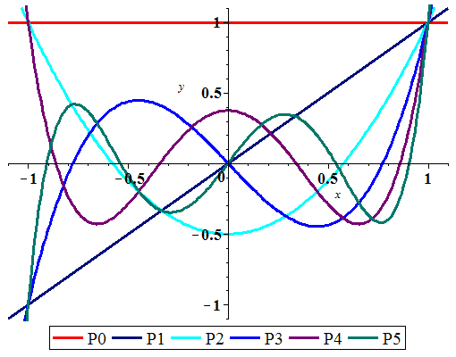

***Exercise*** ***Section* 4.3 – Legendre’s Equation**

1. Establish the recursion formula using the following two steps
2. Differentiate both sides of equation

 with respect to *t* to show that



1. Equate the coefficients of  in this equation to show that



and



1. Show that 
2. Show that 



***Hint***: Use Legendre’s equation 

1. The differential equation  is called ***Airy’s equation***, and its solutions are called ***Airy functions***. Find the series for the solutions  and  where  and , while  and . What is the radius of convergence for these two series?
2. The Hermite equation of order *α* is 
3. Find the general solution is 

Show that  is a polynomial if *α* is an even integer, whereas  is a polynomial if *α* is an odd integer.

1. When , use  to find polynomial solutions for , , and , then use  to find polynomial solutions for , , and .
2. The Hermite polynomial of degree *n* is denoted by . It is the *n*th-degree polynomial solution of Hermite’s equation, multiplied by a suitable constant so that the coefficient of  is . Use part (*b*) to show the first six Hermite polynomials are













1. A general formula for the Hermite polynomials is



Verify that this formula does in fact give an *n*th-degree polynomial.

1. Rodrigues’s Formula is given by: 

For the *n*th-degree Legendre polynomial.

1. Show that  satisfies the differential equation 

Differentiate each side of this equation to obtain



1. Differentiate each side of the last equation *n* times in succession to obtain



which satisfies Legendre’s equation of order *n*.

1. Show that the coefficient of  in *u* is  ; then state why this proves Rodrigues. Formula.

***Note***: that the coefficient of  in  is 

***Section* 4.4 – Solution about Singular Points**

**4.4-1 *Solution about Singular Points***

The Standard form 

In the neighborhood of a singular point, as the behavior of the solutions.

***Definition***

A point  is an ***ordinary point*** if both  and  are analytic at . If a point in not ordinary it is a ***singular point***.

**4.4-2 *Definition*** (*Regular and Irregular Singular Points*)

A singular point  is said to be a ***regular singular*** point of a differential equation if the functions  and  are both analytic at .

A singular point is not regular is said to be an ***irregular singular point*** of the equation.

The singular points are those points where  or  fails to be analytic, when the denominators are zero.

* If appears at most to the first power in the denominator of  and at most to the second power in the denominator of , then is a ***regular singular point***.

***Example* 1**

Determine the singular points for 

***Solution***





 

The singular points are: 

At 





Denominator: 

∴ It is *not* an analytic at , it fails because  in the denominator.





Denominator: 

∴ It is an analytic at 

At 





Denominator: 

∴ It is an analytic at 





Denominator: 

∴ It is an analytic at 

**4.4-3 Frobenius *Theorem***

If is a regular singular point of the differential equation. There exists at least one solution of the form





*r*: constant to be determined.

The series will converge at least on some interval 

**4.4-4 The model of Frobenius**

The simplest equation, of a second-order linear differential equation near the regular singular point , is the constant-coefficient ***equidimensional*** equation



If *r* is a root of the quadratic equation: 

The two possible *Frobenius* series solutions are then of the forms



***Example* 2**

Find the exponents in the possible Frobenius series solutions of the equation



***Solution***





Therefore; 

The indicial equation is:





With roots 

The two possible Frobenius series solutions are then of the forms



**4.4-5 *Theorem* − Frobenius Series Solutions**

Suppose that  is a regular point of the equation 

Let  denote the minimum of the radii of convergence of the power series



Let  and  be the (real ) roots, with , of the ***indicial equation*** . Then

* For , there exist a solution of the form

 corresponding to the larger root .



* If , a positive integer, then the equation has two solutions  and  of the form







Where 

The radii of convergence of the power series of this theorem are all at least *ρ*. The coefficients in these series (and the constant *C*) may be determined by direct substitution of the series.

***Example* 3**

Find the general solution to the equation  near the point 

***Solution***





That implies to  and , both are analytic.

Hence,  is a regular point



























 

 

 

 

 

 

 

 













***Example* 4**

Find the general solution to the equation 

***Solution***



























 

 

 

 

 

 

 

 

 

 





***OR***



 

 











**4.4-6 *Theorem*** The Extended Theorem and Procedure of ***Frobenius***

The *ODE* is given by: 

Has a regular singular point at . The extended Method of ***Frobenius*** produce *two* independent solutions of the *ODE* if the indicial roots are real.

* Find the indicial roots  and of the indicial polynomial 

Verify that they are real; index them such that 

* Construct the solution  by the method of Frobenius. The recursion formula is 
* If  
* If  is a positive integer, then a second independent solution has the form



***Exercises*** ***Section* 4.4 – Solution about Singular Points**

(**1 – 19**) Determine all the singular points of the given differential equation and classify each singular point as regular or irregular

1. 
2. 
3. 
4. 
5. 
6. 
7. 
8. 
9. 
10. 
11. 
12. 
13. 
14. 
15. 
16. 
17. 
18. 
19. 

(**20 – 21**) Determine whether  is an ordinary point, singular point, or irregular singular point of the given differential equation

1. 
2. 

(**22 – 53**) Find the Frobenius series solutions near the point 

|  |  |
| --- | --- |
|  |  |

1. Find the Frobenius series solutions:



***Section* 4.5 – Bessel’s Equation and Bessel Functions**

**4.5-1 Bessel’s Equation**

In this section we consider three special cases of ***Bessel’s equation***



Where υ is a constant, and the solutions are called ***Bessel functions***.

When solving partial differential equations involving the Laplacian in polar and cylindrical coordinates. The Bessel’s equation is a whole family of differential equations, one for each value of υ.

From the *Frobenius* model: 



The indicial equation is given by:







We will consider the three cases , , and  for the interval .























 

 



We must choose 



 











**4.5-2 Gamma Function**

Many important functions in applied sciences are defined via improper integrals. Maybe the most famous among them is the ***Gamma Function***.



The gamma function is defined by













The series solution is denoted by :



For , then



The functions  and  are called the ***Bessel function of the first kind*** of order υ and −υ.

**4.5-3 Bessel Equation of Order Zero**

In this case , that implies to Bessel’s equation: 

The roots of the indicial equation are equal: 

Hence, 



 





Where γ is ***Euler’s*** constant, defined by







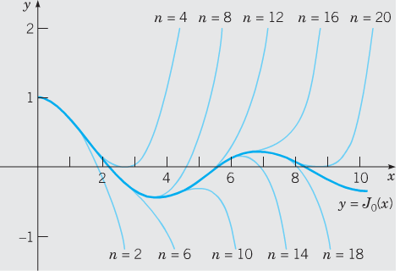 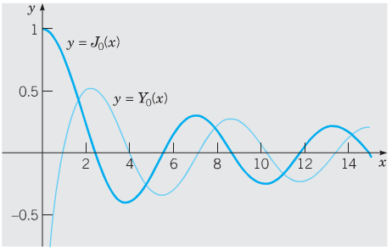

**4.5-4 Bessel Equation of Order *One-Half***

In this case , that implies to Bessel’s equation:



The roots of the indicial equation are equals: 









Taking  , we obtain







For ,









The general solution is: 

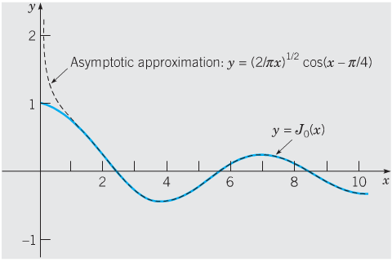

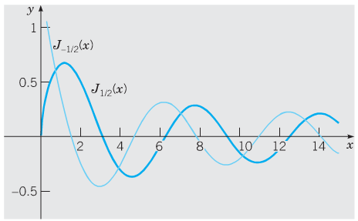

**4.5-5 Bessel Equation of Order *One***

In this case , that implies to Bessel’s equation: 

The roots of the indicial equation are equal: 





Taking  , we obtain







The general solution is:



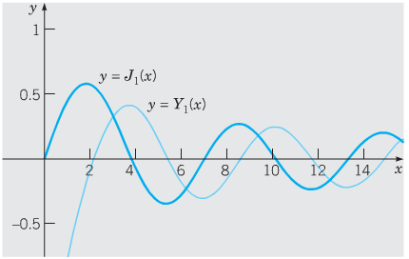

**4.5-6 Applications of *Bessel* Functions**

The importance of Bessel functions stems not only from the frequent appearance of Bessel’s equation in applications, but also from the fact that the solutions of many other second-order linear differential equations can be expressed in terms of Bessel functions.

The Bessel’s equation is given by:



Let 



































Then substitute into the Bessel’s equation:



That is equivalent to:



Where 





Which follows that the general solution is:





Where



**4.5-7 *Theorem***: Solutions in Bessel Functions

If , and , then the general solution (for )



Where *α, β, k*, and  are given. If  is an integer, then  is to be replaced by .

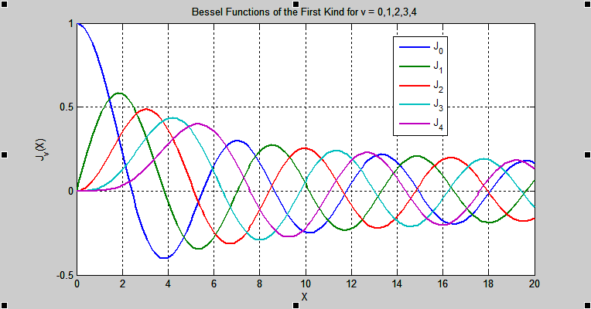

|  |  |
| --- | --- |
|  | |
|  |  |
|  |  |
|  |  |

|  |  |  |  |
| --- | --- | --- | --- |
| ***Zeros of*** | | | |
|  |  |  |  |
| 2.4048 | 0.0000 | 0.8936 | 2.1971 |
| 5.5201 | 3.8317 | 3.9577 | 5.4297 |
| 8.6537 | 7.156 | 7.0861 | 8.5960 |
| 11.7915 | 10.1735 | 10.2223 | 11.7492 |
| 14.9309 | 13.3237 | 13.3611 | 14.8974 |

|  |  |  |  |  |
| --- | --- | --- | --- | --- |
| ***Numerical Values*** | | | | |
|  |  |  |  |  |
| 0 | 1.0000 | 0.00 | − | − |
| 1 | 0.7652 | 0.4401 | 0.0883 | −0.7812 |
| 2 | 0.2239 | 0.5767 | 0.5104 | −0.1070 |
| 3 | −0.2601 | 0.3391 | 0.3769 | 0.3247 |
| 4 | −0.3971 | −0.0660 | −0.0169 | 0.3979 |
| 5 | −0.1776 | −0.3276 | −0.3085 | 0.1479 |
| 6 | 0.1506 | −0.2767 | −0.2882 | −0.1750 |
| 7 | 0.3001 | −0.0047 | −0.0259 | −0.3027 |
| 8 | 0.1717 | 0.2346 | 0.2235 | −0.1581 |
| 9 | −0.0903 | 0.2453 | 0.2499 | 0.143 |
| 10 | −0.2459 | 0.0435 | 0.0557 | 0.2490 |
| 11 | −0.1712 | −0.1768 | −0.1688 | 0.1637 |
| 12 | 0.0477 | −0.2234 | −0.2252 | −0.0571 |
| 13 | 0.2069 | −0.0703 | −0.0782 | −0.2101 |
| 14 | 0.1711 | 0.1334 | 0.1272 | −0.1666 |
| 15 | −0.0142 | 0.2051 | 0.2055 | 0.0211 |

***Exercises Section* 4.5 – Bessel’s Equation and Bessel Functions**

(**1 – 6**) Find the general solution of the given differential equation on  using Bessel equation



|  |  |
| --- | --- |
|  |  |

(**7 – 10**) Find the general solution of the given differential equation on  using Bessel equation



|  |  |
| --- | --- |
|  |  |

(**11 – 31**) Determine the general solution in terms of Bessel functions or, if possible, in terms of elementary functions.

|  |  |
| --- | --- |
|  |  |

1. Find a Frobenius solution of Bessel’s equation of order ***zero*** 
2. Derive the formula 
3. Derive the formula 
4. Derive the formula 
5. Prove that 
6. Show that  is a solution of 
7. Show that 
8. Show that  is a solution of Airy’s differential equation , , whenever *w* is a solution of Bessel’s equation of order , that is, , 

[*Hint*: After differentiating, substituting, and simplifying, then let ].

1. Use the relation and if  is nonnegative integer, then show that



1. A linearly tapered rod with circular cross section, subject to an axial force *P* of compression. Its deflection curve  satisfies the endpoint value problem



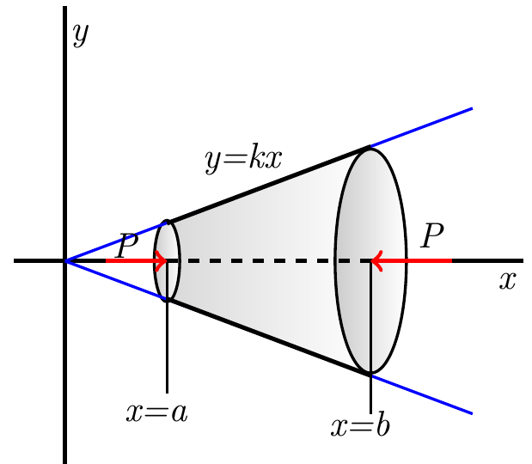

Here, however, the moment of inertia  of the cross section at *x* is given by



Where , the value of *I* at . Substitution of  in the differential equation  yields to the eigenvalue problem



Where 

1. Show that the general solution of  is 
2. Conclude that the *n*th eigenvalue is given by , where  is the length of the rod, and hence that the *n*th buckling force is



1. When a constant vertical compressive force or load *P* was applied to a thin column of uniform cross section, the deflection  was a solution of the boundary-value problem



The assumption here is that the column is hinged at both ends. The column will buckle or deflect only when the compression force is a critical load 

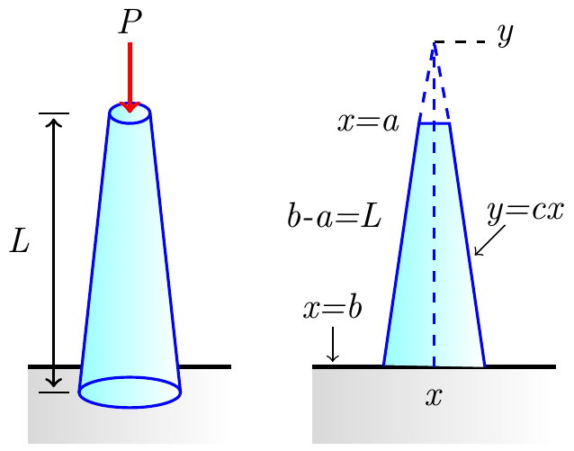

1. Let assume that the column is of length *L*, is hinged at both ends, has circular cross sections, and is tapered. If the column, a truncated cone, has a linear taper  in cross section, the moment of inertia of a cross section with respect to an axis perpendicular to the  is , where  and . Hence, we can write  , where . Substituting into the differential equation, we see that the deflection in this case is determine from the *BVP*?



Where 

Find the critical loads  for the tapered column. Use an appropriate identity to express the buckling modes  as a single function.

1. Plot the graph of the first buckling mode  corresponding to the Euler load  when  and 
2. For a practical application, we now consider the problem of determining when a uniform vertical column will buckle under its own weight (after, perhaps, being nudged laterally just a bit by a passing breeze). We take  at the free top end of the column and  at its bottom; we assume that the bottom is rigidly imbedded in the ground, perhaps in concrete.

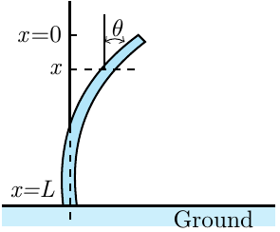

Denote the angular deflection of the column at the point *x* by . From the theory of elasticity, it follows that



Where *E* is the Young’s modulus of the material of the column,

*I* is the cross-sectional moment of inertia

 is the linear density of the column

*g* is gravitational acceleration.

For physical reasons − no bending at the free top of the column and no deflection at its imbedded bottom − the boundary conditions are 

Determine the general equation of the length *L*.