***Lecture* R − Introduction to Differential Equation**

***Section* R.1 – Derivative**

***Constant Rule***

 *c* is constant

***Example***

Find the derivative:

1.  
2. *y* = π 

***Power Rule***

 *n* is any real number

***Constant Times a Function***



***Example***

Find the derivative each function

1.  

***Solution***



*b.* 

***Solution***







***The Product Rule***

The derivative of the product of two differentiable functions is equal to the first function times the derivative of the second plus the second function times the derivative of the first,





***Example***

Find the derivative of 

***Solution*** 









***Example***

Find the derivative of 

***Solution***















***Quotient Rule***



***Example***

Find the derivative of 

***Solution***









***Example***

Find the derivative of 

***Solution***



 





***The Chain Rule***

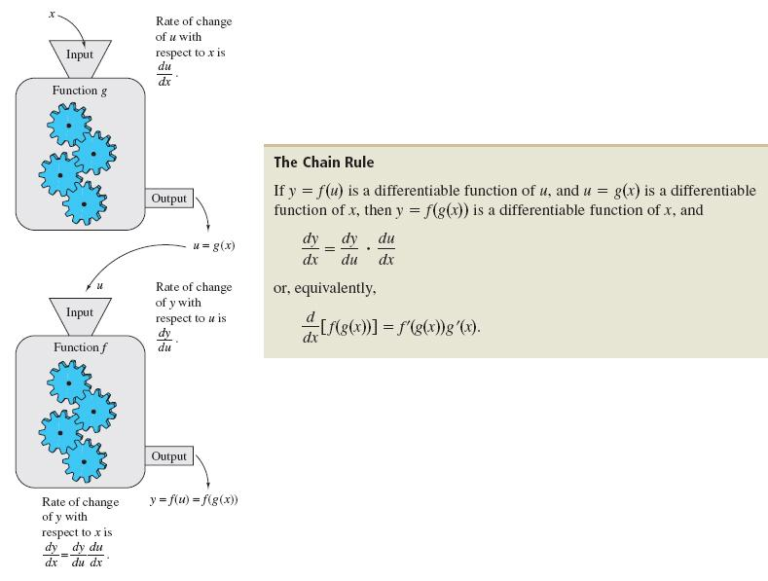

***The General Power Rule***





***Example***

Find the derivative of 

***Solution***









***Derivatives of Trigonometric Functions***

|  |  |  |
| --- | --- | --- |
|  |  |  |
|  |  |  |

***Example***

Find the derivatives

1. 







1. 





 





***Derivative of the Natural Exponential Function***





Differentiate each function.

1. 







1. 







1. 







***Derivative of ln***





***Note***: 

***Derivative* of **



***Example***

Find the Derivatives

1. 









1. 

 







1. 











***Other Bases and Differentiation***







***Formula ***

***Proof***



 





***Exercises Section* R.1 – Derivative**

*Find the derivative to the following functions*

|  |  |  |
| --- | --- | --- |
|  |  |  |

*Use the General Power Rule to find the derivative of the function*

|  |  |  |
| --- | --- | --- |
|  |  |  |

*Find the derivative of the trigonometric function*

|  |  |
| --- | --- |
|  |  |

*Differentiate each function.*

|  |  |  |  |  |
| --- | --- | --- | --- | --- |
|  |  | | |  |
|  | |  |  | |

***Section* R.2 – Integration**

***Definition of Antiderivative***

A Function *F* is an Antiderivative of a function *f* if for every *x* in the domain of *f*, it follows that 

***Notation for Antiderivatives and indefinite integrals***

The notation



where *C* is an arbitrary constant, means that *F* is an Antiderivative of *f*.

That is  for all *x* in the domain of *f*.

 Indefinite integral

Antiderivative

Integrand

Integral sign



Differential

**Basic Integration Rules**











***The General Power Rule***

The Simple Power Rule is given by:



u3



du



***General Power Rule for Integration***

If *u* is a differentiable function of *x*, then



***Example***

Find each indefinite integral.















***Using the Exponential Rule***

Let *u* be a differentiable function of *u*

 *General Exponential Rule*

***Example***

Find the indefinite integral 

***Solution***

Let *u* = 2*x* + 3 → d*u* = 2d*x*









***Using the Log Rule***

Let *u* be a differentiable function of *x*.

 *General Logarithmic Rule*

***Example***

Find the indefinite integral 

***Solution***

Let 









***Integration by Parts***

Let *u* and *v* be differentiable functions of *x*.



**Guidelines for integration by Parts**

1. Let *dv* be the most complicated portion of the integrand that fits a basic integration formula. Let *u* be the remaining factor.
2. Let *u* be the portion of the integrand whose derivative is a function simpler than *u*. Let *dv* be the remaining factor.

***Example***

Find 

***Solution***

Let:









***Example***

|  |  |  |
| --- | --- | --- |
|  | ***derivative*** |  |
|  |  |  |
|  |  |  |
|  |  |  |
|  |  |  |

Evaluate 

***Solution***





***Particular Solutions***

In many applications of integrations, we are given enough information to determine a particular solution. To do this, we need to know the value of *F(x)* for one value of *x*. This information is called an initial condition.

***Example***

Solve the differential equation:  that satisfies 

***Solution***



Integration by part: 















***Example***

Solve the differential equation:  that satisfies 

***Solution***











***Example***

Suppose a ball thrown into the air with initial velocity . Assuming the ball thrown from a height of , how long does it take for the ball to hit the ground?

***Solution***

























***Theorem* − The Fundamental Theorem of Calculus, P-2**

If *f* is continuous at every point in [*a, b*], then *F* is any antiderivative of *f* on [*a, b*], then



***Example***

1. 





1. 





1. 







***Exercises Section* R.2 − Integration**

Find each indefinite integral.

|  |  |  |
| --- | --- | --- |
|  |  |  |

Find the general solution of the differential equation

|  |  |  |
| --- | --- | --- |
|  |  |  |

Evaluate the integrals

|  |  |
| --- | --- |
|  |  |

1. Find the general solution of , and find the particular solution that satisfies the initial condition *F*(1) = 8.
2. Find the general solution of the differential equation: 
3. A ball is thrown into the air from an initial height of 6 *m* with an initial velocity of 120 *m/s*. What will be the maximum height of the ball and at what time will this event occur?
4. Derive the position function if a ball is thrown upward with initial velocity of 32 *ft* per *second* from an initial height of 48 *ft*. When does the ball hit the ground? With what velocity does the ball hit the ground?