***Lecture Two − Second & Higher Order Equations***

***Section* 2.1- Definitions of Second and Higher Order Equations**

A second-order differential equation is an equation involving the independent variable *t* and unknown function *y*.



***Linear equation***: 

The coefficient  can be arbitrary functions.

The equation is said to be ***homogeneous*** when:



***Newton's -* Hooke’s Law for Springs: *F* = *kx***

***Hooke’s Law*** says that the force required to hold a stretched or compressed spring *x* units from its natural (unstressed) length is proportional to *x*. In symbols



The constant *k*, measured in force units per unit length, is a characteristic of the spring, called ***the force constant*** (or ***spring constant***) of the spring.

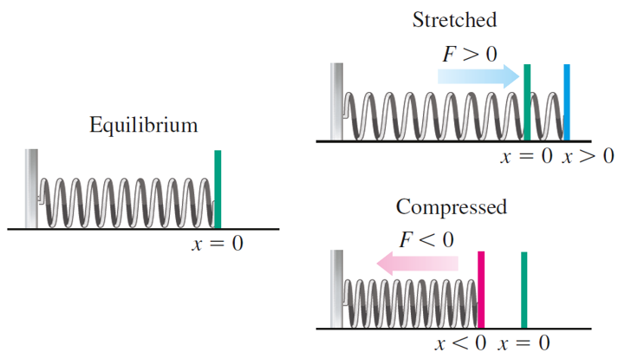 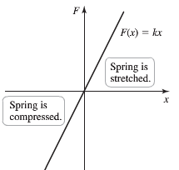

* To stretch the spring to a position , a force  (in the positive direction) is required.
* To compress the spring to a position , a force  (in the negative direction) is required.



***Example***

A 4-*kg* weight is suspended from a spring. The displacement of the spring-mass equilibrium from the spring equilibrium is measured to be 49 *cm*. What is the spring constant?

***Solution***









***Proposition***



***Solutions***: 

are any constant.

 are linearly independent solutions forming a ***fundamental set of solutions***.

***Definition***

A linear combination of the two functions  is any function of the form



***Definition***

Two functions  are said to be linearly independent on the interval , if neither is a constant multiple of the order on that interval. If one is a constant multiple of the other on , they said to be linearly dependent there.

***Wronskian***

The Wronskian is a function named after the Polish mathematician Józef Hoene-Wroński and it is used to determine whether a set of differentiable functions (solutions) is ***linearly independent*** on a given interval.





If  are linearly dependent.

If  are linearly independent.

***Theorem***

Suppose that  and  are two solutions of the homogeneous second-order linear equation



On an open interval *I* on which *p* and *q* are continuous

1. If and  are linearly dependent, then  on *I*.
2. If and  are linearly independent, then  at each point of *I*.

***Example***

Use the Wronskian to show that  are linearly independence

***Solution***

The Wronskian is



This function is not identically zero. Thus the functions are linearly independent.

**System Equations**

A Planar System of 1*st*- order equations is a set of two first-order differential equations involving two unknown



whereare functions of the independent variable *t* and the unknown *x* and *y*.

***Second-Order* Equations and Planar Systems**



Let's re-write in first-order system:











***Example***

Consider a damped unforced spring: ; which satisfies the initial conditions  and 

***Solution***







 

















The *yv-*plane is called the ***phase plane***.

 

Phase Plane Plot Displacement *y* and the velocity *v*

***Exercises Section* 2.1 − Definitions of 2nd and Higher Order Equations**

(*Exercises* 1- 4) Decide whether the equation is linear or nonlinear. For the linear equation, state whether the equation is homogenous or inhomogeneous.

|  |  |
| --- | --- |
|  |  |

Show by direct substitution that the given functions  and  are solutions of the given differential equation. Then verify by direct substitution, that any linear combination  of the 2 given solutions is also a solution.

1. 
2. 
3. Explain why  and  are linearly independent solutions. Calculate Wronskian and use it to explain the independence of the given solutions.



1. Show that  and  form a fundamental set of solutions for  then find a solution satisfying and .

Use the Wronskian to show that are linearly independence

1. 
2. 
3. 
4. 
5. 
6. 

Determine whether the functions  and  are linearly dependent on the interval 

|  |  |
| --- | --- |
|  |  |

Use the substitution  to write each second-order equation as a system of two first-order differential equation.

|  |  |
| --- | --- |
|  |  |

(*Exercises* 17-18) Given the mass, damping, and spring constants of an undriven spring-mass system



1. Provide separate plots of the position versus time (*y* vs. *t*) and the velocity versus time (*v* vs. *t*)
2. Provide a combined plot of both position and velocity versus time
3. Provide a plot of the velocity versus position (*v* vs. *y*) in the *yv* phase plane.
4. 
5. 
6. When the values of a solution to a differential equation are specified at two different points, these conditions. (In contrast, initial conditions specify the values of a function and its derivative at the same point). The purpose of this is to show that for boundary value problems there is no existence-uniqueness theorem. Given that every solution to

 is of the form 

Where  and  are arbitrary constants, show that

1. There is a unique solution to the given differential equation that satisfies the boundary conditions  and 
2. There is no solution to given equation that satisfies  and 
3. There are infinitely many solution to the given DE equation that satisfy  and 

***Section* 2.2 - Linear, Homogeneous Equations with Constant Coefficients**

The equations of the form: 

This is a class of equations that we can solve easily.

The analogous first-order, linear, homogeneous equation:



It is separable and easily solved, its general solution is



Let look for a solution of the type













 *This is called the* ***characteristic equation***

We can rewrite the differential equation and its characteristic equations





The roots are: 







***Case* 1: *Distinct Real Root***

*and*are both solutions.

***Proposition***

If the characteristic equations  has two distinct real roots and , then the ***general solution*** to  is



Where  and are arbitrary constants.

***Example***

Find the general solution to the equation 

Find the unique solution corresponding to the initial conditions  and 

***Solution***

The characteristic equation:





The solution: 

The general solution





 



 





The unique solution is: 

***Case* 2: *Complex Roots***

***Proposition***

If the characteristic equations  has two complex conjugate roots and .

1. The functions

and

So the general solution is



Where  and are arbitrary complex constants.

1. The functions

and

So the general solution is



Where  and are constants.

***Example***

Find the general solution to the equation 

Find the unique solution corresponding to the initial conditions  and 

***Solution***

The characteristic equation:





The solution: 



The general solution





















***Example***

Find the general solution to the equation 

***Solution***

The characteristic equation: 

The solutions: 



The general solution: 

***Case* 3: *Repeated Roots***

If the roots of the characteristic equations are repeated









































***Proposition***

If the characteristic equations  has one double root , then the ***general solution*** to  is





Where  and are arbitrary constants.

***Example***

Find the general solution to the equation 

Find the unique solution corresponding to the initial conditions  and 

***Solution***

The characteristic equation:



The solution: 















***Example***

Find the general solution to the equation 

***Solution***

The characteristic equation: 

The solutions are: 

The general solution: 

***Higher*-Order Equations**

In general, to solve an *n*th-order differential equation, we must solve an *n*th degree characteristic polynomial equation



If all roots are real and distinct, then the general solution is



If all roots are equal to λ, then the general solution is



***Example***

Find the general solution of 

***Solution***

|  |  |
| --- | --- |
| ***Solve for λ*** | ***Rational zero theorem***: |

***Example***

Find the general solution of 

***Solution***



The solution: 



***Summary***

The equation: 

The characteristic equations 

|  |  |  |
| --- | --- | --- |
|  |  |  |
|  |  |  |
|  |  |  |

***Exercises Section* 2.2 − Linear, Homogeneous Equations with Constant Coefficients**

Find the general solution of the second order differential equation

|  |  |  |
| --- | --- | --- |
|  |  |  |

Find the general solution of the given higher-order differential equation

|  |  |  |  |
| --- | --- | --- | --- |
|  | |  | |
|  | |  | |

Find the solution of the given initial value problem.

|  |  |  |
| --- | --- | --- |
|  |  | |
|  | |  | |

1. 
2. 
3. The roots of the characteristic equation of a certain differential equation are:

3, −5, 0, 0, 0, 0, −5,  and 

Write a general solution of this homogeneous differential equation.

1.  is the general solution of a homogeneous equation. What is the equation?
2. Show that the second differential equation 
3. Has no solution to the boundary value 
4. There are infinitely many solutions to the boundary value 
5. Show that the general solution of the equation



(where *P* and *Q* are constant) approaches 0 as  if and only if *P* and *Q* are both positive.

***Section* 2.3 − Harmonic Motion**

**Hooke’s Law**

The restoring force of a spring is proportional to the displacement



**Newton’s Second Law**

Force equals mass times acceleration



Mathematical model: 







 is called natural frequency of the system

**Damped, Free Vibrations**

A resistance force *R* (e.g. friction) proportional to the velocity  and acting in a direction opposite to the motion



Force equation: 

Mathematical model: 



The equation for the motion of a vibrating spring is given by



Where the constant coefficients are:

*m* mass

*μ* damping constant

*k* spring constant

*F*(*t*) external force

The differential equation that modeled simple *RLC* circuits is given by



Comparing the 2 systems are almost identical.

Combine the two systems:





If we let: 



Where  are constants.

This equation called ***harmonic motion***.

*c* ***damping*** constant

*f* ***forcing term***

***Example***

For a circuit without resistance  and no source voltage, then the equation simplifies to

 *Divide by L*







 

The general solution: 



**Simple Harmonic Motion**

In the special case when there is no damping  the motion is called ***simple harmonic motion***.



The characteristic equation is:



The roots are 



If we define 

Then the periodic of the trigonometry functions implies that  for all *t*.

Thus, the solution *x* is periodic with period *T*.

is called the ***natural frequency***.

**Amplitude and Phase Angle**



Consider the point , we can rewrite this in polar coordinates with a length of *A*.









Where *A* ***amplitude*** of the oscillation 

* ***Phase*** of the oscillation  

***Period***: 

***Frequency***: 

***Time lag*** of the motion is: 

***Example***

A mass of 4 *kg* is attached to a spring with a spring constant of . It is then stretched 10 *cm* from the spring mass equilibrium and set to oscillating with an initial velocity is 130 *cm/s*. Assuming it oscillates without damping, find the frequency, amplitude, and phase of the vibration.

***Solution***



 *Divide by 4*



The natural frequency: 





Stretched 10 cm 





Initial velocity is 130 cm/s 





















**Damped Harmonic Motion**

In this case, .



The characteristic equation is: 

The roots are 

There are 3 cases to consider damping and depend on the sign of the discriminant

1. . This is the ***underdamped*** case. The roots are distinct complex numbers.

The general solution is



Where 

1. . This is the ***overdamped*** case. The roots are distinct and real numbers.

The general solution is



Where 



1. . This is the ***damped*** case. The root is a double root.

The general solution is



Where 

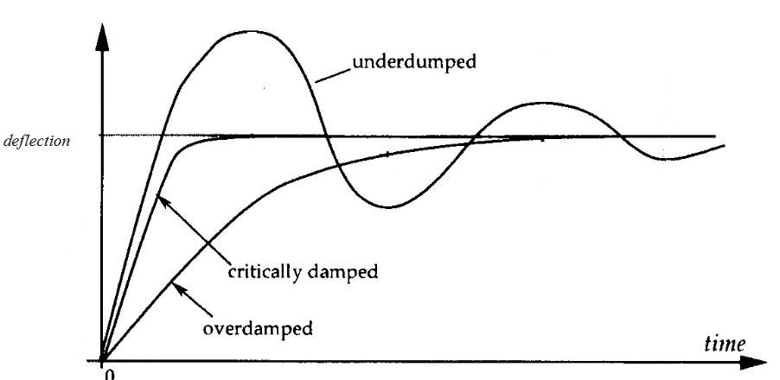

***Example***

A mass of 4 *kg* is attached to a spring with a spring constant of  and damping constant .With initial values of  and. Find the frequency, amplitude, and phase of the vibration.

***Solution***











The general solution:





















***OR***











***Example***

A mass of 4 *kg* is attached to a spring with a spring constant of  and damping constant .With initial values of and. Find the general solution.

***Solution***











The general solution:



















***Example***

A mass of 4 *kg* is attached to a spring with a spring constant of ; with initial values of  and . Find the damping constant *µ* for which there is critical damping

***Solution***

Critical damping occurs when

Since





























*Important facts that the differential equations for electrical and mechanical (Translation and Rotational) are identical in some forms.*

**TABLE *A***: Relationships between the variables of the analog system components.

|  |  |  |
| --- | --- | --- |
| ***Electrical*** | ***Mechanical Translation*** | ***Mechanical Rotational*** |
|  |  | T = J |

*Engineers sometimes utilize the similarity by determining the properties of a proposed mechanical system with a simple electrical analog.*

**TABLE *B***: Analogous between electrical and mechanical systems.

|  |  |  |
| --- | --- | --- |
| ***Electrical*** | ***Mechanical Translation*** | ***Mechanical Rotational*** |
| Current, ***i*** | Force , ***f*** N, lb | Torque, ***T*** N-m, lb-ft |
| Voltage, ***V*** | Velocity, ***v*** | Angular velocity, ***ω*** |
| Flux linkages | Displacement | Angular displacement, Nφ,*xh* or *rad* |
| Capacitance. ***C*** | Mass, **M**  kg, slug | Moment of inertia, **J** kg-m2, lb-ft/sec2**.** |
| Conductance  **G = 1/R** | Damping coefficient (of dash pot) **D** or **B N/m/sec**, lb/ft/sec | Rotational damping Coefficient friction: **D** or **B** |
| Inductance, ***L*** | Compliance  of spring | Torsional compliance  of spring |

***Summary***

|  |  |  |  |
| --- | --- | --- | --- |
|  | ***Abv.*** |  | ***Unit*** |
| Capacitor | *C* |  | Farad (**F**) |
| Current | *I* |  | Ampere (**A**) |
| Electric Charge | *q* |  | Coulomb (**C**) |
| Electromotive Force | *emf* |  | **Emf** |
| Inductor | *L* |  | Henry (**H**) |
| Resistor | *R* |  | Ohm (**Ω**) |
| Time | *t* |  | Second (**s**) |
| Voltage | *V* |  | Volt (**V**) |

***Exercises Section* 2.3 *−* Harmonic Motion**

(***Exercises***1 - 2)

1. Plot the function
2. Place the solution in the form and compare the graph with the plot in (***i***)
3. 
4. 
5. A 1-*kg* mass, when attached to a large spring, stretches the spring a distance of 4.9 *m*.
6. Calculate the spring constant.
7. The system is placed in a viscous medium that supplies a damping constant . The system is allowed to come to rest. Then the mass is displaced 1 *m* in the downward direction and given a sharp tap, imparting an instantaneous velocity of 1 *m/s* in the downward direction. Find the position of the mass as a function of time and plot the solution.
8. The undamped system



is observed to have period  and amplitude 2. Find *k* and 

1. A body with mass *m* = 0.5 *kg* is attached to the end of a spring that is stretched 2 *m* by a force of 100 *N*. It is set in motion with initial position  and initial velocity . (Note that these initial conditions indicate that he body is displaced to the right and is moving to the left at time *t* = 0.) Find the position function of the body as well as the amplitude, frequency, period of oscillation, and time lag of its motion.
2. A  mass is attached to a spring with a stiffness . The damping constant . If the mass is displaced  to the left and given an initial velocity of  to the left.



1. Find the equation of motion.
2. What is the maximum displacement that the mass will attain?
3. A  mass is attached to a spring with a stiffness . The mass is displaced  to the left of the equilibrium point and given a velocity of  to the left. Neglecting the damping,
4. Find the equation of motion of the mass along with the amplitude, period, and frequency.
5. How long after release does the mass pass through the equilibrium position?
6. A  mass is attached to a spring with a stiffness . The damping constant . If the mass is pulled  to the right of the equilibrium point and given an initial velocity of . Neglecting the damping,
7. Find the equation of motion.
8. When will it first return to its equilibrium position?
9. A  mass is attached to a spring with a stiffness . The damping constant . If the mass is displaced  to the left of equilibrium and released, what is the maximum displacement to the right that the mass will attain?
10. A  mass is attached to a spring with a stiffness . The damping constant . If the mass is pushed  to the left of equilibrium and given a leftward velocity of , when will the mass attain its maximum displacement to the left?
11. A  mass weight stretches a spring 2 *feet*. Assuming that a damping force numerically equal to 2 times the instantaneous velocity acts on the system, determine the equation if motion if the mass released from the equilibrium position with an upward velocity of 
12. A  mass weight is attached to a 5-*foot* spring. At equilibrium the spring measures 5.2 feet. If the mass is initially released from rest at a point  above the equilibrium position, find the displacements  if it is further known that the surrounding medium offers a resistance numerically equal to the instantaneous velocity.
13. A mass weighing 4-*lb* is attached to a spring whose spring constant is 16 *lb/ft*.
14. Find the equation of motion.
15. What is the period of simple harmonic motion?
16. A 20-*kg* mass is attached to a spring. If the frequency of simple harmonic motion is .
17. What is the spring constant *k*?
18. Find the equation of motion.
19. What is the frequency of simple harmonic motion if the original mass is replaced with an 80-*kg* mass.?
20. A 24-*lb* mass weight is attached to the end of a spring, stretches it 4 *inches*. Initially, the mass is released from rest from a point 3 *inches* above the equilibrium position.
21. Find the equation of the motion.
22. If the mass is initially released from the equilibrium position with a downward velocity of 

If it is underdamped, write the position function in the form .

Also find the undamped position function  that would result if the mass on the spring were set in motion with the same initial position and velocity, but with the dashpot disconnected (so ). Then, construct a figure that illustrates the effect of damping by comparing the graphs of  and 

|  |  |
| --- | --- |
|  |  |

***Section* 2.4 - Inhomogeneous Equations; the Method of Undetermined Coefficients**

The second order ***nonhomogeneous*** equation is given by: 

The corresponding ***homogeneous*** equation: 

***Theorem***

Suppose that  is a particular solution to the nonhomogeneous (or inhomogeneous) equation and that and form a fundamental set of solutions to the homogeneous equation  Then the general solution to the inhomogeneous equation is given by



are arbitrary constants.

***Theorem***

Let  be ***linearly independent***  solutions of the reduced equation (*H*) and let  be a ***particular solution*** of (*N*). Then the general solution of (*N*) consists of the general solution of the reduced equation (*H*) ***plus*** a particular solution of (*N*):



***Forcing Term***

If the forcing term *f* has a form that is replicated under differentiation, then look for a solution with the same general form as the forcing term.

***Example***

Find a particular solution to the equation 

***Solution***

The forcing term ⇒ the particular solution 















**Trigonometric Forcing Term**



The general solution: 

***Example***

Find a particular solution to the equation 

***Solution***

The particular solution: 

















***The Complex Method***

***Example***

Find a particular solution to the equation 

***Solution***





The particular solution: 







































**Polynomial Forcing Term**



***Example***

Find a particular solution to the equation 

***Solution***

The right-hand side is a polynomial of degree 1.

The particular solution: 











 



**Exceptional Cases**

***Example***

Find a particular solution to the equation 

***Solution***

The particular solution 



The particular solution  or 



 









The particular solution 

***Summary***

|  |  |
| --- | --- |
|  |  |
| *Any Constant* | *A* |
|  |  |
|  |  |
|  |  |
|  |  |
|  |  |
|  |  |
|  |  |
|  |  |
|  |  |
|  |  |

***Exercises Section* 2.4 - Inhomogeneous Equations; the Method of Undetermined Coefficients**

1. Show that the 3 solutions  of the 3rd order equation

 are linearly independent on an open interval . Then find a particular solution that satisfies the initial conditions 

Find the particular solution for the given differential equation

|  |  |
| --- | --- |
|  |  |

Use the ***complex method***to find the particular solution for

|  |  |
| --- | --- |
|  |  |

Find the general solution for the given differential equation

|  |  |
| --- | --- |
|  |  |

|  |  |
| --- | --- |
|  |  |

Find the general solution that satisfy the given initial conditions

1. 
2. 
3. 
4. 
5. 
6. 
7. 
8. 
9. 
10. 
11. 
12. 
13. 
14. 
15. 
16. 
17. 
18. 
19. 
20. 
21. 
22. 

***Section* 2.5 − Variation of Parameters**

In this section, we will introduce a technique called ***variation of parameters***.

The inhomogeneous equation is given by: 

A fundamental set of solutions and  to associated homogeneous equation 

Then the general solution to the inhomogeneous equation is given by



are arbitrary constants.

***General Case***

A differential system can be written in a form:



andfundamental set of solution to the homogenous equation, they are linearly independent Then the determinant will be recognized as the Wronskian:



Which we can obtain:

 

 



***Example***

 is a fundamental set of solutions of .

Find a particular solution of the equation?

***Solution***



 

 

The particular solution:







The general solution: 

***Example***

 is a fundamental set of solutions of .

Find a particular solution of the equation?

***Solution***



 

 

The particular solution:

 

The general solution:







***Example***

Find the particular solution for 

***Solution***

The homogeneous equation for the differential equation

Therefore; 



The system has a solution





















***Exercises Section* 2.5 − Variation of Parameters**

1.  is a fundamental set of solutions of .

Find a particular solution of the equation?

Find a particular solution to the given second-order differential equation (Use ***variation of parameters***):

|  |  |
| --- | --- |
|  |  |

1. Verify that  and are solution to the homogenous equation



Use variation of parameters to find the general solution to



Find the general solution to the given differential equation (Use ***variation of parameters***).

|  |  |
| --- | --- |
|  |  |

***Section* 2.6 − Forced Harmonic Motion**

A sinusoidal forcing is giving by the model:



**: Amplitude if the driving force (constant)

*ω*: driving frequency.

*c*: damping constant.

: natural frequency.

**Forced undamped harmonic motion**

The undamped equation has  or



The homogeneous equation is: 

With general solution: 

***Case* 1** **

The particular solution is given by the form: 













 

  







When the *motion starts at equilibrium*; this means











***Example***

Suppose  with these values of the parameters the solution becomes

***Solution***









 

***Mean frequency***:  ***Half difference***: 

***Case*****2** **

The particular solution is given by the form: 













 















***Forced Damped Harmonic Motion***

In real physical systems, there is always some damping, from frictional effects if nothing else.

Let's add damping to the system

 

The homogeneous equation (***transient solution***) is:

|  |  |
| --- | --- |
|  |  |

The particular solution is: 







 







The amplitude:









The phase shift: 



***Underdamped Case***: 



Where 

To determine the inhomogeneous equation, it is better to use complex method.



However,

The particular solution: 













 is called the ***transfer function.***

 





Polar Coordinates:  



 





We will define the ***gain*** *G* by:  

The solution: 



 ***transient*** term.

: ***time constant***.

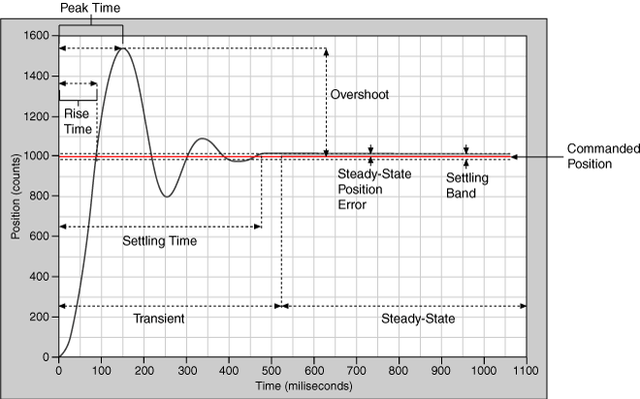

***Exercises Section* 2.6 − Forced Harmonic Motion**

1. A 1-*kg* mass is attached to a spring and the system is allowed to come to rest. The spring-mass system is attached to a machine that supplies external driving force *Newtons*. The system is started from equilibrium; the mass is having no initial displacement or velocity. Ignore any damping forces.
2. Find the position of the mass as a function of time
3. Place your answer in the form . Select an near the natural frequency of the system to demonstrate the "beating" of the system. Sketch a plot shows the "beats:" and include the envelope of the beating motion in your plot.

Find a particular solution to the differential equation using undetermined coefficients. Find and plot the solution of the initial value problem. Superimpose the plots of the transient response and the steady state solution.

1.  
2. 
3. Find a particular solution of  given the set  where *A, B, C* are to be determined
4. A forced mass−spring−dashpot system with equation . Investigate the possibility of practical resonance of this system. In particular, find the amplitude  of steady state periodic forced oscillations with frequency *ω*. Sketch the graph  of and find the practical resonance frequency *ω* (if any).

|  |  |
| --- | --- |
|  |  |

1. A mass weighing 100 *lb*. (mass *m* = 3.125 *slugs* in *fps* units) is attached to the end of a spring that is stretched 1 *in*. by a force of 100 *lb*. A force  acts on the mass. At what frequency (in hertz) will resonance oscillation occur? Neglect damping.
2. A mass *m* on the end of a pendulum (of length *L*) also attached to a horizontal spring (with constant *k*). Assume small oscillations of *m* so that the spring remains essentially horizontal and neglect damping. Find the natural circular frequency  of motion of the mass in terms of *L, k, m*, and the gravitational constant *g*.
3. A mass *m* hangs on the end of a cord around a pullet of radius *a* and moment of inertia *I*. The rim of the pulley is attached to a spring (with constant *k*). Assume small oscillations so that the spring remains essentially and neglect friction. Find the natural circular frequency in terms of *m, a, k, I*, and *g*.



1. Find the transient motion and steady periodic oscillations of a damped mass-and-spring system with , , and  under the influence of an external force  with  and . Also investigate the possibility of practical resonance for this system.
2. Consider a floating cylindrical buoy with radius *r*, height *h*, and uniform density  (recall that the density of water is ). The buoy is initially suspended at rest with its bottom at the top surface of the water and is released at time . Therafter it is acted on by two forces: a downward gravitational force equal to its weight  and (by Archmedes’ principle of buoyancy) an upward force equal to the weight  of water displaced, where  is the depth of the bottom of the buoy beneath the surface at time *t*.

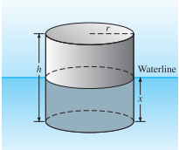

Conclude that the buoy undergoes simple harmonic motion around its equilibrium position  with period .

1. Compute *p* and the amplitude of the motion if , , and 
2. If the cylindrical buoy weighting 100 *lb* floats in water with its axis vertical. When depressed slightly and released, it oscillates up and down four times every 10 *sec*. assume that friction is negligible. Find the radius of the buoy.
3. Assume that the earth is a solid sphere of uniform density, with mass *M* and radius *R* = 3960 (*mi*). For a particle of mass *m* within the earth at distance *r* from the center of the earth, the gravitational force attracting *m* toward the center is , where  is the mass of the part of the earth within a sphere of radius *r*.



1. Show that 
2. Now suppose that a small hole is drilled straight through the center of the earth, thus connecting two antipodal points on its surface. Let a particle of mass *m* be dropped at time  into this hole with initial speed zero, and let  be its distance from the center of the earth at time *t*. conclude from Newton’s second law and part (*a*) that , where .
3. Take , and conclude from part (*b*) that the particle undergoes simple harmonic motion back and forth between the ends of the hole, with a period of about 84 *min*.
4. Look up (or derive) the period of a satellite that just skims the surface of the earth; compare with the result in part (*c*). How do you explain the coincidence? Or is it a coincidence?
5. With what speed (in miles per hours) does the particle pass through the center of the earth?
6. Look up (or derive) the orbital velocity of a satellite that just skims the surface of the earth; compare with the result in part (*e*). How do you explain the coincidence? Or is it a coincidence?

***Section* 2.7 − Euler's & Runge-Kutta Methods**

***Euler's method*** named after ***Leonhard Euler*** is an example of a ***fixed-step*** solver.

Euler's method is a first-order numerical procedure for solving ordinary differential equations (***ODE***s) with a given initial value. It is the most basic kind of explicit method for numerical integration of ordinary differential equations.

[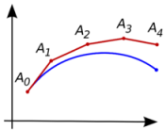](http://en.wikipedia.org/wiki/File:Euler_method.png)

 

The setting size: 

Then, 





*Last point* 

By the definition of the derivative:





The tangent line at the point  is:





This method is known as *Euler's Method* with step size *h*.

***Example***

Compute the first four step in the Euler's method approximation to the solution of  with, using the step size . Compare the result with the actual solution to the initial value problem.

***Solution***



The *first* step:









The *second* step:









The *third* step:









The *fourth* step:









The exact solution to is

|  |  |  |  |
| --- | --- | --- | --- |
|  | : Euler's | - exact | *Error* |
| 1.0 | 1.0 | 1.0 | 0 |
| 1.1 | 1.0 | 0.9948 | −0.0052 |
| 1.2 | 0.990 | 0.9786 | −0.0114 |
| 1.3 | 0.969 | 0.9501 | −0.0189 |
| 1.4 | 0.9359 | 0.9082 | −0.0277 |

**Runge-Kutta Methods**

Like Euler's method, the Runge-Kutta methods are fixed-step solvers.

**The Second-Order Runge-Kutta Method**

The Second-Order Runge-Kutta method is also known as the improved Euler's method.

Starting from the initial value point , we compute two slopes:







But an analysis using Taylor's theorem reveals that there is an improvement in the estimate for the truncation error.

For the Second-Order Runge-Kutta method, we have



The constant M depends on the function .

The Second-Order Runge-Kutta method is controlled by the cube of the step size instead of the square.

Input 

For k = 1 to N









***Example***

Compute the first four step in the Second-Order Runge-Kutta method approximation to the solution of  with, using the step size . Compare the result with the actual solution to the initial value problem.

***Solution***



The *first* step:































The *second* step:









The *third* step:









The *fourth* step:









|  |  |  |  |  |
| --- | --- | --- | --- | --- |
|  | : Runge-Kutta | - Exact | ***Runge-Kutta Error*** | ***Euler's Error*** |
| 1.0 | 1.0 | 1.0 | **0** | **0** |
| 1.1 | 0.9950000 | 0.994829081 | **−0.000170918** | **−0.0052** |
| 1.2 | 0.9789750 | 0.978597241 | **−0.000377758** | **−0.0114** |
| 1.3 | 0.9507673 | 0.950141192 | **−0.000626182** | **−0.0189** |
| 1.4 | 0.9090979 | 0.908175302 | **−0.000922647** | **−0.0277** |



***Fourth-Order*  Runge-Kutta Method**

This method is the most commonly used solution algorithm. For most equations and systems it is suitably fast and accurate.

Starting from the initial value point , we compute two slopes:











***Example***

Compute the first four step in the Second-Order Runge-Kutta method approximation to the solution of  with, using the step size . Compare the result with the actual solution to the initial value problem.

***Solution***



The *first* step:









































|  |  |  |  |
| --- | --- | --- | --- |
|  | : Runge-Kutta | - Exact | ***Runge-Kutta Error*** |
| 1.0 | 1.0 | 1.0 | **0** |
| 1.1 |  | 0.994829081 | **−0.000000086** |
| 1.2 |  | 0.978597241 | **0.000000295** |
| 1.3 |  | 0.950141192 | **−0.000000310** |
| 1.4 |  | 0.908175302 | **−0.000000457** |



***Exercises Section* 2.7 − Euler's & Runge-Kutta Methods**

Calculate the first five iterations of Euler's method with step of

1. 
2. 
3. 
4. Given: 
5. Use a computer and Euler's method to calculate three separate approximate solutions on the interval , one with step size , a second with step size , a second with step size .
6. Use the appropriate analytic to compute the exact solution
7. Plot the exact solution and approximate solutions as discrete points.
8. Given: 
9. Use a computer and Euler's method to calculate three separate approximate solutions on the interval , one with step size , a second with step size , a third with step size .
10. Use the appropriate analytic to compute the exact solution
11. Plot the exact solution and approximate solutions as discrete points.
12. Consider the initial value problem 

Use Euler's method with step size  to sketch solution on the interval 

1. You've seen that the error in Euler's method varies directly as the first power of the step size . This makes Euler's method an order to halve the error? How does this affect the number of required iterations?
2. Use Euler’s method to provide an approximate solution over the given time interval using the given steps sizes. Provide a plot of ***v*** versus ***y*** for each step size



1. Given 
2. Use a computer and Runge-Kutta method to calculate three separate approximate solutions on the interval , one with step size , a second with step size , a second with step size .
3. Use the appropriate analytic to compute the exact solution
4. Plot the exact solution and approximate solutions as discrete points.
5. Given 
6. Use a computer and Runge-Kutta method to calculate three separate approximate solutions on the interval , one with step size , a second with step size , a second with step size .
7. Use the appropriate analytic to compute the exact solution
8. Plot the exact solution and approximate solutions as discrete points.
9. Consider the initial value problem 

Use Runge-Kutta method with step size  to sketch solution on the interval 