***Lecture Four* − Series**

***Section* 4.1 – Introduction and Review of Power Series**

**Definition**

A ***power series*** *about the point*  is a series of the form



The series is said to converge at  if the sequence of partial sums





Converges as . The sum of the series at the point  is defined to be the limit at the partial sums,



***Example***

Show that the geometric series  converges for  and that



Show that the series diverges for .

***Solution***

The partial sums  can be evaluates as follows.









If , then 

If , then  diverges and therefore the  diverges

If , then 

**Interval of convergence**

***Theorem***

For any power series  there is an ***R***, either a nonnegative number or ∞, such that the series converges if  and diverges if 

**The ratio Test**

***Theorem***

Suppose the terms of the series  have the property that



exists. If  the series converges, while if  the series diverges

***Example***

Find the radius of convergence for the series. 

***Solution***











By the ratio test, the series converges if , so the radius of convergence is 



**Algebraic Operations on Series**

The ***sum*** and ***difference*** of two series

 



 

***Differentiating Power Series***

**Theorem**

The function 

Can be differentiating the series by terms









***Identity* Theorem**

Suppose that the series  has a positive radius of convergence. Then



The coefficients of a power series are determined by the values of the sum .

***Integrating Power Series***

**Theorem**

Suppose the power series  converges for 



***Section* 4.2 – Series Solutions near Ordinary Points**

***Example of a First-Order Equation***

Find the series solution for the differential equation 

***Solution***

We look for a solution of the form: 















 

 

 

 







***Example***

Find the general series solution to the equation



Find the particular solution with  and 

***Solution***



















 

 

 

 

The general solution can be written as:



For the given initial  and , the solution is:



***Exercises*** ***Section* 4.2 – Series Solutions near Ordinary Points**

Find the series solution.

|  |  |  |
| --- | --- | --- |
|  |  |  |

Find the series solution to the initial value problems

1. 
2. 
3. 
4. 
5. 
6. 
7. 
8. 

***Section* 4.3 – Legendre’s Equation**

Solving a homogeneous linear differential equation with constant coefficients can be reduced to the algebraic problem of finding the roots of its characteristic equation.

The Legendre’s equation of order *n* is important in many applications. It has the form







Any solution of that equation is called a Legendre function.

Note that: and  are analytic at . *P* are .

Hence Legendre’s equation has power series solutions of the form 











To obtain the same general power , then we must set 



|  |  |
| --- | --- |
|  |  |
|  |  |
|  |  |
|  |  |







This is called a ***recurrence relation*** or ***recursion formula***.

|  |  |
| --- | --- |
|  |  |

The general Legendre equation solution is: 

Where



**Legendre Polynomials **

For Legendre’s equation  will happen when the parameter ***n*** is nonnegative integer. Otherwise, when *n* is even,  reduces to a polynomial of degree *n*. If *n* is odd,  reduces (the same) to a polynomial of degree *n*.



If 



If 



















In general; 

The resulting solution of Legendre’s differential equation is called the Legendre polynomial of degree ***n*** and is denoted by .





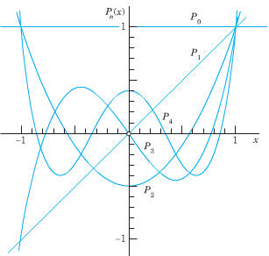













***Exercise*** ***Section* 4.3 – Legendre’s Equation**

1. Establish the recursion formula using the following two steps
2. Differentiate both sides of equation

 with respect to *t* to show that



1. Equate the coefficients of  in this equation to show that

 and



1. Show that 
2. Show that 

***Hint***: Use Legendre’s equation 

1. The differential equation  is called ***Airy’s equation***, and its solutions are called ***Airy functions***. Find the series for the solutions  and  where  and , while  and . What is the radius of convergence for these two series?

***Section* 4.4 – Solution about Singular Points**

***Solution about Singular Points***

The Standard form 

***Definition*** (*Regular and Irregular Singular Points*)

A singular point  is said to be a ***regular singular point*** of the differential equation if the functions

 

Are both analytic at .

If it isn’t regular ⇒ irregular singular point of the equation

***Example***

Determine the singular points for 

***Solution***





 

The points are: 

At



 ⇒ is not an analytic at 



 ⇒ It is an analytic at 

At



 ⇒ It is an analytic at 



 ⇒ It is an analytic at 

**Frobenius *Theorem***

If is a regular singular point of the differential equation. There exists at least one solution of the form



*r*: constant to be determined.

The series will converge at least on some interval 

**The model of Frobenius**

The simplest equation, of a second-order linear differential equation near the regular singular point , is the constant-coefficient ***equidimensional*** equation



If *r* is a root of the quadratic equation



***Example***

Find the exponents in the possible Frobenius series solutions of the equation



***Solution***





Therefore; 

The indicial equation is 

With roots 

The two possible Frobenius series solutions are then of the forms



***Theorem* − Frobenius Series Solutions**

Suppose that  is a regular point of the equation 

Let  denote the minimum of the radii of convergence of the power series



Let  and  be the (real ) roots, with , of the ***indicial equation*** . Then

* For , there exist a solution of the form

 corresponding to the larger root .



* If , a positive integer, then the equation has two solutions  and  of the form



The radii of convergence of the power series of this theorem are all at least *ρ*. The coefficients in these series (and the constant C) may be determined by direct substitution of the series.

***Example***

Find the general solution to the equation  near the point 

***Solution***





That implies to  and , both are analytic. Hence,  is a regular point

  





















 

 

 

 

 

 

 









***Example***

Find the general solution to the equation 

***Solution***

  



















 

 

 

 

 

 

 

 

 





***OR***



 

 











***Exercises*** ***Section* 4.4 – Solution about Singular Points**

1. Find the Frobenius series solutions of 
2. Find the general solution to the equation 
3. Find a Frobenius solution of Bessel’s equation of order zero 

***Section* 4.5 – Bessel’s Equation and Bessel Functions**

In this section we consider three special cases of ***Bessel’s equation***



Where υ is a constant, and the solutions are called ***Bessel functions***.

The indicial equation is





We will consider the three cases , , and  for the interval .





















 



We must choose 

 











***Gamma Function***



The gamma function is defined by 









The series solution is denoted by : 

For , then 

The functions  and  are called the ***Bessel function of the first kind*** of order υ and −υ.

**Bessel Equation of Order Zero**

In this case , that implies to Bessel’s equation: 

The roots of the indicial equation are equal: 

Hence, 



 





Where γ is ***Euler’s constant***, defined by







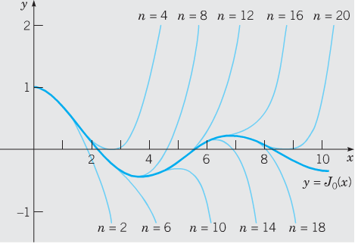 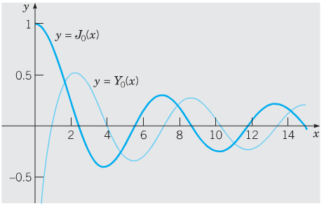

**Bessel Equation of Order One-Half**

In this case , that implies to Bessel’s equation: 

The roots of the indicial equation are equal: 





Taking  , we obtain





For , 







The general solution is:



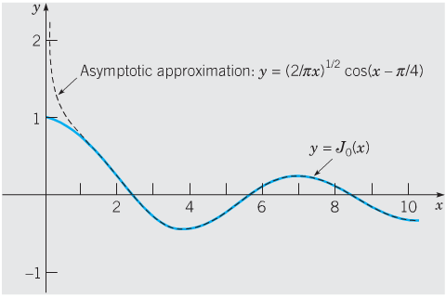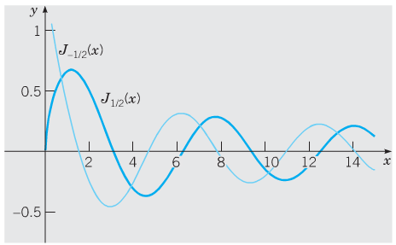

**Bessel Equation of Order One**

In this case , that implies to Bessel’s equation: 

The roots of the indicial equation are equal: 





Taking  , we obtain







The general solution is:



