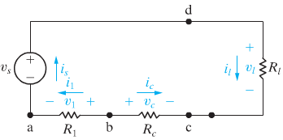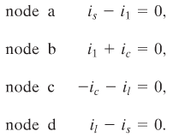

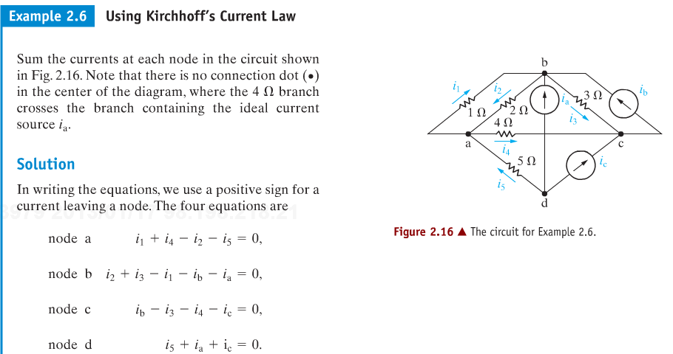

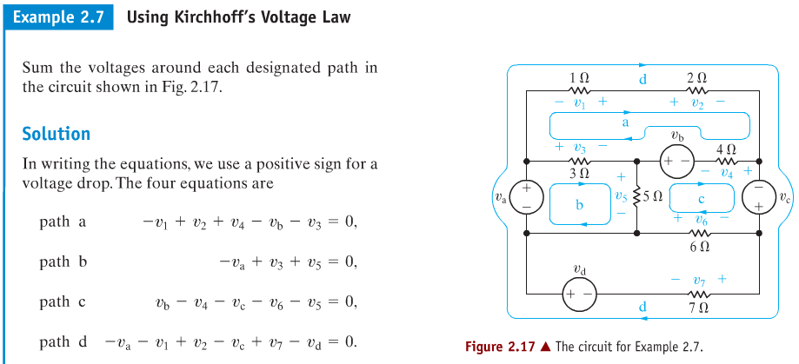



Let  and  be the amount of salt in the respective tanks at time *t*.

The volume of each tank remains constant.

The rate of increase of salt, in any given tank, is given by

*Rate of increase = rate in – rate out*

**For *Tank* 1**:

The rate of salt flowing into Tank 1 is





The rate of salt flows out of Tank 1 is





Therefore, 

**For *Tank* 2**:

The rate of salt flowing into Tank 2 is





The rate of salt flows out of Tank 2 is





Therefore, 





With initial conditions are:  and 







