***Chapter* 1- Introduction to Differential Equation**

***Section* 1.1 – Differential Equation Models**

In mathematics, the rate at which a quantity changes is the derivative of that quantity.

The 2nd way of computing the rate of change comes from the application itself and is different from on application to another.

***Mechanics***

**Law of mechanics – Newton’s 2nd Law** (1665-1671)

The force acting on a mass is equal to the rate of change of momentum with respect to time. Momentum is defined as the product of mass and velocity (*m.v*).

The force is equal to the derivative of the momentum



***Universal Law of gravitation***

Any body with mass M attacks any other body with mass *m* directly toward the mass M, with a magnitude proportional to the product of the 2 masses and inversely proportional to the square of the distance separating them.









Motion ball: 



**Population Models**

Consider a population  varying with time





*r*: reproductive rate

: initial population

**Logistic Equation** 



K: is a constant

This equation does a creditable job of predicting how single populations grow in isolated circumstances.

**Pollution**

Consider a lake that has a volume of , it is fed by an input river, and there is another river which is fed by the lake at a rate that keeps the volume of the lake constant.

The input rate: 

The maximum flow into the lake occurs when 

In addition, there is a factory on the lake that introduces a pollutant into the lake at the rate of 2 .

Let  denote the total amount of pollution in the lake at time *t*. If we make the assumption that the pollutant is rapidly mixed throughout the lake, then



***Exercises Section* 1.1 – Differential Equation Models**

***Exercise* 1.1-1**

The rate of growth of bacteria in a petri dish is proportional to the number of bacteria in the dish.

***Exercise* 1.1-2**

The rate of growth of a population of field mice is inversely proportional to the square root of the population.

***Section* 1.2 – Derivative**

***Constant Rule***

 *c* is constant

***Proof:***

Let *f*(*x*) = *c*







So, 

***Example***

Find the derivative:

1.  
2. *y* = π 
3. *g*(*w*) = 
4.  

***Power Rule***

 *n* is any real number

***Proof:***

Let 









***Constant Times a Function***



***Example***

Find the derivative each function

1. 



*Solution*





*b.* 



*Solution*







***The Product Rule***

The derivative of the product of two differentiable functions is equal to the first function times the derivative of the second plus the second function times the derivative of the first,







***Example***

Find the derivative of 

*Solution* 









***Example***

Find the derivative of 

*Solution*















***Quotient Rule***



***Example***

Find the derivative of 

*Solution*









***Example***

Find the derivative of 

*Solution*









***The Chain Rule***

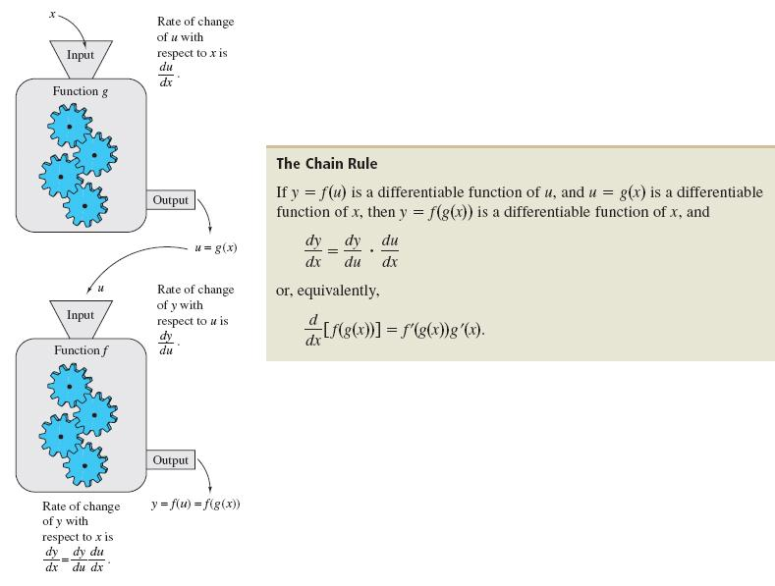

***The General Power Rule***







***Example***

Find the derivative of 

*Solution*









***Derivatives of Trigonometric Functions***

|  |  |  |
| --- | --- | --- |
|  |  |  |
|  |  |  |

***Example***

Find the derivatives

1. 







1. 





 





***Derivative of the Natural Exponential Function***





Differentiate each function.

1. 



1. 







1. 







1. 





1. 







***Derivative of ln***





***Note***: 

***Derivative* of **



***Example***

Find the Derivatives of 

*Solution*

Let u = 5x 







***Example***

Find the Derivatives

1. 

Let u = x2 – 4 







1. 

 







1. 











***Other Bases and Differentiation***







***Exercises Section* 1.2 – Derivative**

*Find the derivative to the following functions*

1. 
2. 
3. 
4. 
5. 
6. 
7. 
8. 
9. 
10. 
11. 
12. 
13. 
14. 
15. 
16. 
17. 

*Use the General Power Rule to find the derivative of the function*

1. 
2. 
3. 
4. 
5. 
6. 
7. 

*Find the derivative of the trigonometric function*

1. 
2. 
3. 
4. 
5. 
6. 

*Differentiate each function.*

1. 
2. 
3. 
4. 
5. 
6. 
7. 
8. 
9. 
10. 
11. 
12. 
13. 

***Section* 1.3 – Integration**

***Definition of Antiderivative***

A Function *F* is an Antiderivative of a function *f* if for every *x* in the domain of *f*, it follows that 

***Notation for Antiderivatives and indefinite integrals***

The notation



where *C* is an arbitrary constant, means that *F* is an Antiderivative of *f*.

That is  for all *x* in the domain of *f*.

 Indefinite integral

Antiderivative

Integrand

Integral sign



Differential

**Basic Integration Rules**











***The General Power Rule***

The Simple Power Rule is given by:



u3



du



***General Power Rule for Integration***

If *u* is a differentiable function of *x*, then



***Example***

Find each indefinite integral.















***Using the Exponential Rule***

Let *u* be a differentiable function of *x*

 *Simple Exponential Rule*

 *General Exponential Rule*

***Example***

Find the indefinite integral 

*Solution*

Let *u* = 2*x* + 3 → d*u* = 2d*x*









***Using the Log Rule***

Let *u* be a differentiable function of *x*.

 *Simple Logarithmic Rule*

 *General Logarithmic Rule*

***Example***

Find the indefinite integral 

*Solution*

Let 









***Area Under the Graph***

Area under the graph: 



***Solution by Integration***



***Example***

Solve the differential equation: 

*Solution*





***Particular Solutions***

In many applications of integrations, we are given enough information to determine a particular solution. To do this, we need to know the value of *F(x)* for one value of *x*. This information is called an initial condition.

***Example***

Solve the differential equation:  that satisfies 

*Solution*



Integration by part: 















***Example***

Solve the differential equation:  that satisfies 

*Solution*











***Example***

Suppose a ball thrown into the air with initial velocity . Assuming the ball thrown from a height of , how long does it take for the ball to hit the ground?

*Solution*

























***Exercises Section* 1.3 - Integration**

Find each indefinite integral.

1. 
2. 
3. 
4. 
5. 
6. 
7. 
8. 
9. 

Find the general solution of the differential equation

1. 
2. 
3. 
4. 
5. 
6. 
7. 
8. 
9. 
10. 
11. Find the general solution of , and find the particular solution that satisfies the initial condition *F*(1) = 8.
12. Find the general solution of the differential equation: 
13. A ball is thrown into the air from an initial height of 6 *m* with an initial velocity of 120 *m/s*. What will be the maximum height of the ball and at what time will this event occur?
14. Derive the position function if a ball is thrown upward with initial velocity of 32 ft per second from an initial height of 48 ft. When does the ball hit the ground? With what velocity does the ball hit the ground?