***Chapter* 3**

***SOLUTION Section -* 3.1- 2*nd* Order Equations**

***Exercise***

Decide whether the equation is linear or nonlinear. For the linear equation, state whether the equation is homogenous or inhomogeneous.



*Solution*





It is linear and inhomogeneous 

***Exercise***

Decide whether the equation is linear or nonlinear. For the linear equation, state whether the equation is homogenous or inhomogeneous.



*Solution*



It is linear and inhomogeneous 

***Exercise***

Decide whether the equation is linear or nonlinear. For the linear equation, state whether the equation is homogenous or inhomogeneous.



*Solution*

It is nonlinear 

***Exercise***

Show by direct substitution that the given functions  and  are solutions of the given differential equation. Then verify by direct substitution, that any linear combination  of the 2 given solutions is also a solution.

  

*Solution*









If , then







***Exercise***

Explain why  and  are linearly independent solutions. Calculate Wronskian and use it to explain the independence of the given solutions.

  

*Solution*





  
 



The solutions  are linearly independent.

***Exercise***

Show that  and  form a fundamental set of solutions for  then find a solution satisfying  and .

*Solution*

 



 

 





***Solution Section* 3.2 - Second-Order Equations and Systems**

***Exercise***

Use the substitution  to write each second-order equation as a system of two first-order differential equation.



*Solution*





***Exercise***

Use the substitution  to write each second-order equation as a system of two first-order differential equation.



*Solution*





***Exercise***

Given the mass, damping, and spring constants of an undriven spring-mass system





1. Provide separate plots of the position versus time (*y* vs. *t*) and the velocity versus time (*v* vs. *t*)
2. Provide a combined plot of both position and velocity versus time
3. Provide a plot of the velocity versus position (*v* vs. *y*) in the *yv* phase plane.

*Solution*





Let  







 





***Solution Section* 3.3 - Linear, Homogeneous Equations with Constant Coefficients**

***Exercise***

Find the general solution: 

*Solution*

The characteristic equation: 





***Exercise***

Find the general solution: 

*Solution*

The characteristic equation: 





***Exercise***

Find the general solution: 

*Solution*

The characteristic equation: 





***Exercise***

Find the general solution: 

*Solution*

The characteristic equation: 





***Exercise***

Find the general solution: 

*Solution*

The characteristic equation: 



 

 





***Exercise***

Find the general solution: 

*Solution*

The characteristic equation: 













***Exercise***

Find the general solution: 

*Solution*

The characteristic equation: 













***Exercise***

Find the general solution:  

*Solution*

The characteristic equation: 









***Solution Section* 3.4 - Harmonic Motion**

***Exercise***



*Solution*

1. Plot the function



1. Place the solution in the form  and compare the graph with the plot in (***i***)



 







***Exercise***

A 1-kg mass, when attached to a large spring, stretches the spring a distance of 4.9 *m*.

1. Calculate the spring constant.

*Solution*

By Hooke's law: 







1. The system is placed in a viscous medium that supplies a damping constant . The system is allowed to come to rest. Then the mass is displaced 1 *m* in the downward direction and given a sharp tap, imparting an instantaneous velocity of 1 *m/s* in the downward direction. Find the position of the mass as a function of time and plot the solution.

***Given:*** 



The characteristic equation is:  

The general solution: 

***Solution Section* 3.5 - Inhomogeneous Equations; the Method of Undetermined Coefficients**

***Exercise***

Find the particular solution for 

*Solution*

















The particular solution: 

***Exercise***

Find the particular solution for 

*Solution*

















The particular solution: 

***Exercise***

Use  to find the particular solution for 

*Solution*

The particular solution: 













 

The particular solution: 

***Exercise***

Use the complex method to find the particular solution for 

*Solution*

The particular solution: 















***Exercise***

Find the particular solution for 

*Solution*

The particular solution: 











 

The particular solution: 

***Exercise***

Find the particular solution for 

*Solution*

The particular solution: 









 

The particular solution: 

***Exercise***

Find the particular solution for 

*Solution*

The particular solution: 















The particular solution: 

***Exercise***

Find a solution to the homogeneous equation; then find a particular solution to form a general solution. Then find the solution satisfying the given initial conditions



*Solution*

The homogeneous eq.: 

The characteristic eq.: 

























 **(1)**







 **(2)**

 and 



***Exercise***

Find a solution to the homogeneous equation; then find a particular solution to form a general solution. Then find the solution satisfying the given initial conditions



*Solution*

The homogeneous eq.: 

The characteristic eq.: 

























The general solution: 

***Exercise***

Find the particular solution for 

*Solution*

 when *y* = 1

The particular solution: 





















The general solution: 

***Solution Section* 3.6 - Variation of Parameters**

***Exercise***

Find a particular solution to: 

*Solution*

The homogeneous equation for the differential equation 

 *Solve for λ*



Therefore; 



































***Exercise***

Find a particular solution to: 

*Solution*

 *Solve for λ*



Therefore; 























 







***Exercise***

Find a particular solution to: 

*Solution*

  




































***Exercise***

Verify that  and are solution to the homogenous equation



*Solution*



For 







 is a solution

For 







 is a solution

Wronskian: 























Thus, the general solution is: 

***Solutions Section* 3.7 - Forced Harmonic Motion**

***Exercise***

A 1-*kg* mass is attached to a spring and the system is allowed to come to rest. The spring-mass system is attached to a machine that supplies external driving force  *Newtons*. The system is started from equilibrium; the mass is having neither initial displacement nor velocity. Ignore any damping forces.

1. Find the position of the mass as a function of time
2. Place your answer in the form . Select an  near the natural frequency of the system to demonstrate the "beating" of the system. Sketch a plot shows the "beats:" and include the envelope of the beating motion in your plot.

*Solution*

*a*) 

 







*b*)  





*Mean frequency*: 



*Half difference*: 













If we choose  near to 

That implies to:  and 



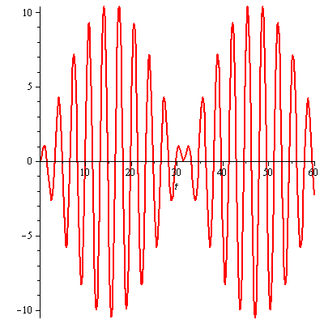

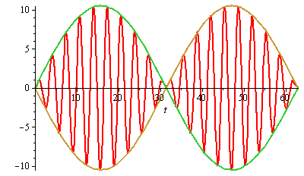

***Exercise***

Find a particular solution to the differential equation using undetermined coefficients. Find and plot the solution of the initial value problem. Superimpose the plots of the transient response and the steady state solution.

 

*Solution*

The particular solution: 















The particular solution (***steady-state*** ***solution***): 

The homogeneous eq.: 

The characteristic eq.: 



 

















***Transient response*** ***solution***: 



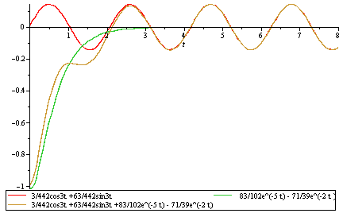

***Complex Method***



The particular solution: 

























The particular solution (***steady-state*** ***solution***): 

 

Pendulum motion with damping Undamped pendulum.

