***Chapter 6* – Systems of Linear Equations**

***Section* 6.1 –Introduction to Systems**

A system of differential equations is a set of one or more equations, involving one or more differential equations.

There are several physical problems that involve number of separate elements such as an example: electrical networks, mechanical, and more other fields.

**Example of a parallel LRC circuit**

Consider the parallel LRC circuit as shown below

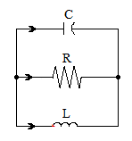

Let V be the voltage drop across the capacitor and I current through the inductor.

The current is described by the ***equation***



The voltage is described by the ***equation***



Therefore, we can rewrite the equation as ***system equations***



**Example of a Spring-Mass (*mechanical*)**

Two masses move on a frictionless surface under the influence of external forces and, and they are also constraint by the three springs whose constant are 

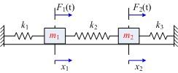

Let examine the forces acting on

The first spring exerts a force of: 

The second spring exerts a force of: 

By Newton’s second law:











**Example of Predator-Prey Systems** (***Ecology***)

The dynamical of biological growth of populations is a branch of ecology.

The growth rate of species is depending on their population. The rate is increased by birth and food supply causes the species to live, and decreased by death, overcrowded, etc….

Consider two species that exist together and interact as an example such as wolves and deer, shark and food fish, etc... Vito Volterra, an Italian mathematician, formulated a predator-prey system model.

Let the *prey* population denoted by.

Let the *predator* population denoted by.

For each and , we have a reproductive rate which denoted by  and for prey and predator respectively.

Therefore, that will imply to:



Let assume there is absence of predator, by using *Malthusian*model, the prey population will be given by



When there are predator activities, then , and the decrease in the reproductive rate would also be proportional to .



In the absence of prey, by using *Malthusian* model, the predator population will be given by



The presence of the prey would decrease in the reproductive rate would be proportional to the size of the prey population..



That will give us a system of:



This model is ***nonlinear*** because the right-side contains the product .

It is ***autonomous*** because the right-side doesn’t depend explicitly on the independent variable.

***Summary of Predator-Prey***

The Predator-Prey or***Lotka–Volterra***system is given by:



Where *x* is the predator, their prey is ‘*y*’, and the coefficient *a, b, c*, and *d* are positive real numbers and they are defined as follow:

***a***: is the natural decay.

***ax***: is a rate term, which shows that without prey to eat, the predator population diminishes.

***c***: is the natural growth coefficient.

***cy***: is a rate term, where the prey population increases.

***b****and****c***: predator efficiency in converting food into fertility and the probability that are predator-prey encounter removes of the prey.

***bxy****and****cxy***: Food promotes the predator population’s growth rate, while serving as food diminishes the prey populations’ growth rate.

The predator-prey system or model is based on the population Law of Mass Action.

The Law of Mass Action is defined as:

“*The rate of change of one population due to interaction of another is proportional to the product of the two populations*.”

***Section* 6.2 – Basic Theory of Linear Systems**

***Definition***

A linear system of differential equations is any set of differential equations having the following ***standard form***:



Where  are the unknown functions. The ***coefficients*** and  are known functions of the independent variable  is an interval in **R**.

If all of the , the system said to be ***homogeneous***. Otherwise it is ***inhomogeneous***.

The inhomogeneous part is sometimes called the ***forcing term***.

**Matrix Notation for Linear Systems**



In simple form, we can rewrite:





***Example***

Given the linear system



Write in the form 

*Solution*

  



***Example***

Consider the spring-mass system consisting of two masses that are constraint by the three springs whose constant are . Assume there is no damping and there are no external forces.

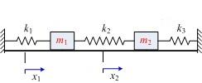

Write an equivalent linear system of the first-order differential equations.

*Solution*







To write an equivalent first-order system, let 

Where    







The initial conditions for this system involve the initial position and velocity of both masses.

   

***Example***

Find a first-order system the models the circuit below

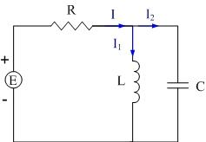

*Solution*

Using Kirchhoff’s current law:



Kirchhoff’s voltage law applied to the loop containing the source and the inductor:









Kirchhoff’s voltage law applied to the loop containing the source, resistor and the capacitor:



Differentiate the equation:

 

















**Properties of Linear Systems**

***Properties of Homogeneous Systems***

***Theorem***

Suppose  and  are solution to the homogeneous linear system



If  and  are any constants, then is also a solution

***Theorem***

Suppose  are solution to the homogeneous linear system

If  are any constants, then



is also a solution to 

**Linearly Independence and Dependence**

**Proposition**

Suppose  are solution to the *n*-dimensional system  defined on the interval .

1. If the vectors  are linearly dependent for some , then there are constants  not all zero, such that  for all . In particular,  are linearly dependent for all .
2. If for some the vectors  are linearly independent, then  are linearly independent for all .

**Definition**

A set of ***n*** solutions to the linear system  is linearly independent if it is linearly independent for any one value of *t*.

***Example***

Given  and  are solutions to the homogeneous system 

Show that all solutions to this system can be expressed as linear combination of  and 

*Solution*

















⇒ The matrix is nonsingular and , are linearly independent



***Example***

Consider the system of homogeneous equations



We can show that

 

are solutions the given system









⇒andare linearly independent

***Exercises Section* 6.2 – Basic Theory of Linear Systems**

Write the given system of equations in matrix-form then show that the given vector is a solution to the system

1. 
2. 

Verify by substitution that  and  are solutions of the given homogenous equation. Show also that the solutions  and  are linearly independent. Find the solution of the given homogeneous equation with the initial condition 

1. 
2. 
3. 
4. Consider the RLC parallel circuit below. Let V represent the voltage drop across the capacitor and I represent the current across the inductor.



Show that:



1. Consider the RLC parallel circuit below. Let V represent the voltage drop across the capacitor and I represent the current across the inductor.



Show that:



1. Two tanks are connected by two pipes. Each tank contains 500 gallons of a salt solution. Through on pipe solution is pumped from the first tank to the second at 1 *gal/min*. Through the other pipe, solution is pumped at the same rate from the second to the first tank. Show the salt content in each tank varies with time.



1. Each tank contains 100 gallons of a salt solution.Pure water flows into the upper tank at a rate of 4 *gal/min*. Salt solution drains from the upper tank into the lower tank at a rate of 4 *gal/min*. Finally, salt solution drains from the lower tank at a rate of 4 *gal/min*, effectively keeping the volume of solution in each tank at a constant 100 *gal*. If the initial salt content of the upper and lower tanks is 10 and 20 pounds, respectively. Set up an initial value problem that models the amount of salt in each tank over time (do not solve).Write the model in matrix-vector form. Is the system homogeneous or inhomogeneous?

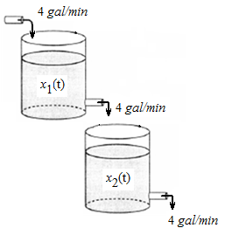

1. Two masses on a frictionless tabletop are connected with a spring having spring constant . The first mass is connected to a vertical support with a spring having spring constant . The second mass is shaken harmonically via a force equaling . Let  and  measure the displacements of the masses and ., respectively, from their equilibrium positions as a function of time. If both masses start from rest at their equilibrium positions at time .



Set up an initial value problem that models the position of the masses over time (do not solve).Write the model in matrix-vector form. Is the system homogeneous or inhomogeneous?

***Section* 6.3 – Linear Systems with Constant Coefficients**

Consider the system equation:



Where *A* is a matrix with constant entries 

The 1st-order homogeneous equation can be written as



The solution to this system is given by:



We can rewrite the solution in form of vector:



The first derivative of the solution: 







**Definition**

Suppose *A* is an *n*x*n* matrix and



The values of  are called eigenvalues of the matrix A and the nonzero vectors  are called the eigenvectors corresponding to that eigenvalue.

***Eigenvalues***

Let’s change the form of the system to a general matrix form and is defined by the form:



Where *A* is a square matrix (*nxn*)

The behavior of a system can be determined from equilibrium point(s) by finding the eigenvalues and the eigenvectors of the system.

Therefore; the equation can be rewritten into the form:



Let’s rewrite the equation .

 : are the eigenvalues and not a vector









Since is a nonzero vector that implies that the matrix  has a nontrivial null space.

This exists if and only if (*iff*):



Therefore, the eigenvalues (λ’s) are the roots which can be determined by solving the determinant:





where the eigenvalues are the solutions

***Example***

Find the eigenvalues of the matrix



*Solution*









The characteristic polynomial is: 

Thus, the eigenvalues of ***A*** are 2 and -1.

***Eigenvectors***

From the eigenvalues, the eigenvectors, in the form,of the system can be determined by letting:

 and

The general solution can be written as:



***Example***

Find the eigenvectors of the matrix



*Solution*

The eigenvalues of ***A*** are 2 and -1.

For , we have









If 



For , we have







If 







***Summary***

In general, a polynomial of degree *n* has *n* roots. Each root  is an eigenvalue, and for each we can find an eigenvector. From these, we can form the solution.

However, the numbers of the eigenvalue solutions are as follow:

1. Two Distinct real roots
2. Two complex conjugate roots
3. One real Repeated roots

***Exercises Section* 6.3 – Linear Systems with Constant Coefficients**

Find the eigenvalues and the eigenvectors for each of the matrices.

1. 
2. 
3. 
4. 
5. 
6. 

Find a fundamental set of solutions for the system  , where *A* is the given matrices.

1. 
2. 

***Section* 6.4 – Planar Systems – *Distinct, Complex, and Repeated Eigenvalues***

**Planar Systems**

2-dimension linear systems are also called planar systems, we will enable to solve the system

















**Proposition**

Suppose  and  are eigenvalues of an  matrix A. Suppose  is an eigenvector for  and  is an eigenvector for . If  then  and  are linearly independent.

**Distinct Real Eigenvalues**

If , then the solutions of the characteristic equation are:



Then , and both are real eigenvalues of A.

Let  and  be the associated eigenvectors. Then we have two exponential solutions:



The general solution is:





***Example***

Two tanks are connected by two pipes. Each tank contains 500 gallons of a salt solution. Through on pipe solution is pumped from the first tank to the second at 1 *gal/min*. Through the other pipe, solution is pumped at the same rate from the second to the first tank. Suppose that at time  there is no salt in the tank on the right and 100 *lb* in the tank on the left. Show the salt content in each tank varies with time.



*Solution*

Rate in 

Rate out 

Rate in – Rate out 







The system is: 

Where 











The eigenvalues are: 

For , we have











For , we have









The general solution:













**Complex Eigenvalues**

If , then the solutions of the characteristic equation are the complex conjugate:



***Example***

Find the eigenvalues and eigenvectors for the matrix



*Solution*











For ;















For ;





***Theorem***

Suppose that  is a  matrix with complex conjugate eigenvalues and . Suppose that *V* is an eigenvector associated with . Then the general solution to the system is



***Example***

Find the current and for the circuit below, where , , and . Assume that and .



*Solution*

Since there is no voltage:







The system can be written as:, where





 

For ;

































The general solution is:





**One Real Eigenvalue of Multiplicity 2**

If , then the solutions of the characteristic equation:





***Example***

Find all exponential solutions for

*Solution*





































***Exercises Section* 6.4– Planar Systems – *Distinct, Complex, and Repeated Eigenvalues***

Find the general solution of the system 

1. 
2. 
3. 
4. 
5. 
6. 
7. 
8. 
9. Find the real and imaginary part of 

***Section* 6.5 – Phase Plane Portraits**

***EquilibriumPoints***(*Review*)

The dynamical behavior of a linear system is easier than non-linear system. We need to determine a set of points to satisfy the autonomous system. These set of points are called ***equilibrium points***.

From these equilibrium points, we can determine the stability of the system.

* An equilibrium point is ***stable*** if all nearby solutions stay nearby.
* An equilibrium point is ***asymptotically stable*** if all nearby solutions not only stay nearby, but also tend to the equilibrium point. An equilibrium point is stable if all nearby solutions.

The equilibrium point is the intersection of the eigenvectors, and we can plot those two lines by joining these points  and  together.

The general solution for the system is given by:



The behavior of the system or the solutions is depending on the value of and, and if they are real or complex values.



Eigenvectors and plot.

The family of all solution curves without the presence of the independent variable is **called *phase portrait***.

***Stability of the equilibrium point condition***

* An equilibrium point is *stable* if all nearby solutions stay nearby
* An equilibrium point is *asymptotically stable* if all nearby solutions not only stay nearby, but also tend the equilibrium.

**Case 1**: If  and  are real values.



and*source* or *repel* (unstable at point (0, 0))

The system is unstable and the solution as the time go by, will diverge away from the equilibrium point

***Example***



*Solution*





**Case 2**: If 



*sink* or *attractor* ((0, 0) is asymptotically stable) *proper node*.

***Example***



*Solution*



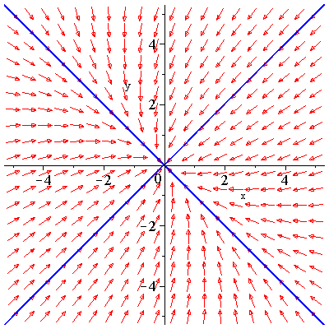

**Case 3**: If 



A *saddle point*. ((0,0) is semi-stable)

***Example***



*Solution*



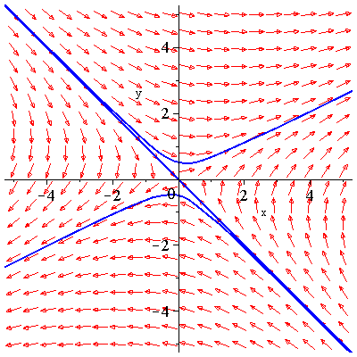

**Case 4**: If are complex values:  and 

If *b*> 0, the behavior of the system is spiral clockwise (*cw*), then otherwise is *ccw*.

 

*spiral out*. (unstable at (0,0) point)

***or***

 

*spiral in*. (asymptotically stable at (0,0) point)



‘circle’ periodic solution- (0, 0) is a *center* stable.

***Example***



*Solution*



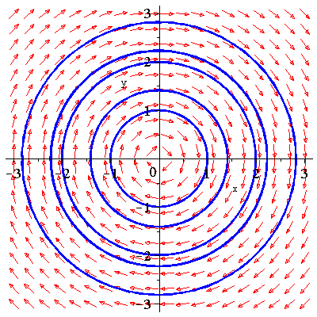

The equilibrium point is the center, but the solution curves are circles.

***Example***



*Solution*



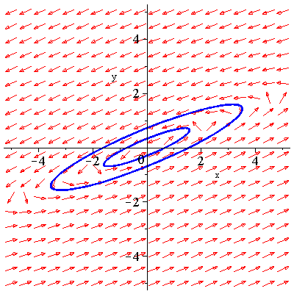

The equilibrium point is the center, but the solution curves are ellipses.

***Example***



*Solution*



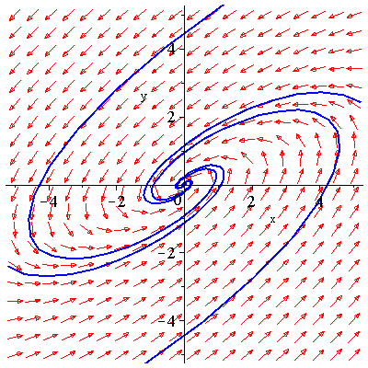

The behavior of the system at the equilibrium point center is an asymptotically stable andspiral in.

***Stability properties of linear systems*(*in 2-dimensions*)**

|  |  |  |
| --- | --- | --- |
| ***Eigenvalues*** | ***Type of critical point*** | ***Stability*** |
| *λ1>λ2> 0* | *Improper node* | *Unstable.* |
| *λ1<λ2< 0* | *Improper node* | *Asymptotically stable* |
| *λ2< 0 <λ1* | *Saddle point* | *Unstable.* |
| *λ1 = λ2> 0* | *Proper/improper node* | *Unstable* |
| *λ1 = λ2< 0* | *Proper/improper node* | *Asymptotically stable* |
| *λ1,2 = a ±ib* | *Spiral point* |  |
| *a > 0* | *spiral out* | *Unstable* |
| *a < 0* | *spiral in* | *Asymptotically stable* |
| *λ1,2 = ±ib* | *Center* | *Stable* |

***Exercises Section* 6.5–Phase Plane Portraits**

Sketch a rough approximation of a solution in each region determined by the half-line solutions. Use arrows to indicate the direction of motion on all solutions. Determine the behavior of the equilibrium point and the stability.

1. 
2. 
3. 

Sketch a rough approximation of the given system. Use arrows to indicate the direction of motion on all solutions. Determine the behavior of the equilibrium point and the stability.

1. 
2. 
3. 
4. 
5. 
6. 
7. 