***Solution Section* 1.1 – Differential Equations & Solutions**

***Exercise***

Show that  is a solution of the 1st order equation  

***Solution***











***Exercise***

Show that  is a solution of the 1st order equation 

***Solution***





 

 

 

 

 





***Exercise***

A general solution may fail to produce all solutions of a differential equation . Show that  is a solution of the differential equation, but no value of C in the given general solution will produce this solution.

***Solution***





***Exercise***

Use the given general solution to find a solution of the differential equation having the given initial condition. 

***Solution***











The interval of existence is 

***Exercise***

Show that  is a solution of the 1st order equation 

***Solution***





 ***√***

***Exercise***

Use the given general solution to find a solution of the differential equation having the given initial condition. 

***Solution***









***Exercise***

Use the given general solution to find a solution of the differential equation having the given initial condition. 

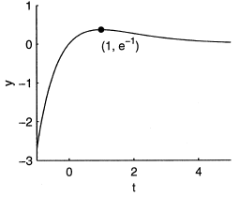***Solution***









Hence, *C* = 0

The solution is: 

This function is defined and differentiable on the whole real line. Hence, the interval of existence is the whole real line.

***Exercise***

Use the given general solution to find a solution of the differential equation having the given initial condition. 

***Solution***

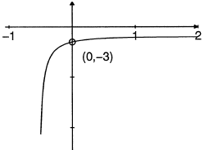









The solution is:





***Exercise***

Find the values of ***m*** so that the function  is a solution of the given differential equation

|  |  |
| --- | --- |
|  |  |

***Solution***



1. 





1. 





1. 





1. 





***Exercise***

Let  is 2-parameter family solutions of the second order differential equation of . Find a solution of the second-order consisting of this differential equation and the given initial conditions.

|  |  |
| --- | --- |
|  |  |

***Solution***



1. 



1. 



1. 





1. 





***Solution Section* 1.2 – Solutions to Separable Equations**

***Exercise***

Find the general solution of the differential equation 

***Solution***













 Where 

***Exercise***

Find the general solution of the differential equation 

***Solution***

















***Exercise***

Find the general solution of the differential equation. If possible, find an explicit solution 

***Solution***











***Exercise***

Find the general solution of the differential equation. If possible, find an explicit solution 

***Solution***









***Exercise***

Find the general solution of the differential equation. If possible, find an explicit solution 

***Solution***









***Exercise***

Find the general solution of the differential equation. If possible, find an explicit solution 

***Solution***

















***Exercise***

Find the general solution of the differential equation. If possible, find an explicit solution 

***Solution***













  





***Exercise***

Find the general solution of the differential equation. If possible, find an explicit solution 

***Solution***















***Exercise***

Find the general solution of the differential equation. If possible, find an explicit solution



***Solution***

 Let 

















***Exercise***

Find the general solution of the differential equation. If possible, find an explicit solution



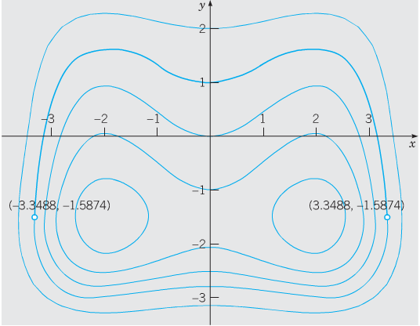***Solution***













***Exercise***

Find the general solution of the differential equation. If possible, find an explicit solution



***Solution***



 











***Exercise***

Find the general solution of the differential equation 

***Solution***





***Exercise***

Find the general solution of the differential equation 

***Solution***





***Exercise***

Find the general solution of the differential equation 

***Solution***





***Exercise***

Find the general solution of the differential equation 

***Solution***









***Exercise***

Find the general solution of the differential equation 

***Solution***









***Exercise***

Find the general solution of the differential equation 

***Solution***





***Exercise***

Find the general solution of the differential equation 

***Solution***











***Exercise***

Find the general solution of the differential equation 

***Solution***









***Exercise***

Find the general solution of the differential equation 

***Solution***













***Exercise***

Find the general solution of the differential equation 

***Solution***

|  |  |  |  |  |  |  |  |  |  |  |
| --- | --- | --- | --- | --- | --- | --- | --- | --- | --- | --- |
|  | |  |  |  | | --- | --- | --- | |  |  |  | | **+** | *y* |  | | **−** | 1 |  | |

***Exercise***

Find the general solution of the differential equation 

***Solution***











***Exercise***

Find the general solution of the differential equation 

***Solution***









***Exercise***

Find the general solution of the differential equation 

***Solution***













***Exercise***

Find the general solution of the differential equation 

***Solution***











***Exercise***

Find the general solution of the differential equation 

***Solution***









***Exercise***

Find the general solution of the differential equation 

***Solution***









***Exercise***

Find the general solution of the differential equation. 

***Solution***









***Exercise***

Find the general solution of the differential equation. 

***Solution***











***Exercise***

Find the general solution of the differential equation. 

***Solution***





***Exercise***

Find the general solution of the differential equation. 

***Solution***







***Exercise***

Find the general solution of the differential equation. 

***Solution***







***Exercise***

Find the general solution of the differential equation. 

***Solution***





***Exercise***

Find the general solution of the differential equation. 

***Solution***











***Exercise***

Find the general solution of the differential equation. 

***Solution***











 



***Exercise***

Find the general solution of the differential equation. 

***Solution***









***Exercise***

Find the general solution of the differential equation. 

***Solution***











***Exercise***

Find the general solution of the differential equation. 

***Solution***











***Exercise***

Find the general solution of the differential equation. 

***Solution***





***Exercise***

Find the general solution of the differential equation. 

***Solution***









***Exercise***

Find the general solution of the differential equation. 

***Solution***









***Exercise***

Find the general solution of the differential equation. 

***Solution***











***Exercise***

Find the general solution of the differential equation. 

***Solution***















***Exercise***

Find the general solution of the differential equation. 

***Solution***











***Exercise***

Find the general solution of the differential equation. 

***Solution***







***Exercise***

Find the general solution of the differential equation. 

***Solution***









***Exercise***

Find the general solution of the differential equation. 

***Solution***







***Exercise***

Find the general solution of the differential equation. 

***Solution***









***Exercise***

Find the general solution of the differential equation. 

***Solution***



Let 









***Exercise***

Find the general solution of the differential equation. 

***Solution***



 









***Exercise***

Find the general solution of the differential equation. 

***Solution***

|  |  |  |
| --- | --- | --- |
|  |  |  |
| **+** |  |  |
| **−** |  |  |

|  |  |  |
| --- | --- | --- |
|  |  |  |
| **+** |  |  |
| **−** |  |  |









***Exercise***

Find the general solution of the differential equation. 

***Solution***







***Exercise***

Find the general solution of the differential equation. 

***Solution***











***Exercise***

Find the general solution of the differential equation. 

***Solution***

 









***Exercise***

Find the general solution of the differential equation. 

***Solution***







***Exercise***

Find the general solution of the differential equation. 

***Solution***









***Exercise***

Find the exact solution of the initial value problem. 

***Solution***





















***Exercise***

Find the exact solution of the initial value problem. 

***Solution***

















 























The interval of existence: 

/***Exercise***

Find the exact solution of the initial value problem. Indicate the interval of existence.



***Solution***



















The interval of existence will be the interval containing  and 



***Exercise***

Find the exact solution of the initial value problem. 

***Solution***



 









***Exercise***

Find the exact solution of the initial value problem. 

***Solution***













The negative value is taken to satisfy the initial condition.

***Exercise***

Find the exact solution of the initial value problem. 

***Solution***



 































***Exercise***

Find the exact solution of the initial value problem. Indicate the interval of existence.

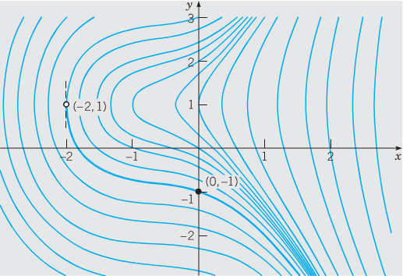

***Solution***

















***Exercise***

Find the exact solution of the initial value problem. 

***Solution***





 





***Exercise***

Find the exact solution of the initial value problem 

***Solution***



|  |  |  |  |  |  |  |  |  |  |  |
| --- | --- | --- | --- | --- | --- | --- | --- | --- | --- | --- |
|  | |  |  |  | | --- | --- | --- | |  |  |  | | + |  |  | | **−** | 1 |  | |

***Exercise***

Find the exact solution of the initial value problem 

***Solution***







***Exercise***

Find the exact solution of the initial value problem. 

***Solution***









 









***Exercise***

Find the exact solution of the initial value problem. 

***Solution***

 

 







 



***Exercise***

Find the exact solution of the initial value problem. 

***Solution***



 



  









***Exercise***

Find the exact solution of the initial value problem. 

***Solution***







 





***Exercise***

Find the exact solution of the initial value problem. 

***Solution***





  



***Exercise***

Find the exact solution of the initial value problem. 

***Solution***



 







***Exercise***

Find the exact solution of the initial value problem. 

***Solution***



  





***Exercise***

Find the exact solution of the initial value problem. 

***Solution***





 









***Exercise***

Find the exact solution of the initial value problem. 

***Solution***



  





***Exercise***

Find the exact solution of the initial value problem 

***Solution***

















***Exercise***

Find the exact solution of the initial value problem 

***Solution***









***Exercise***

Find the exact solution of the initial value problem 

***Solution***











***Exercise***

Find the exact solution of the initial value problem 

***Solution***













***Exercise***

Find the exact solution of the initial value problem 

***Solution***















***Exercise***

Find the exact solution of the initial value problem 

***Solution***











***Exercise***

Find the exact solution of the initial value problem 

***Solution***

















***Exercise***

Find the exact solution of the initial value problem 

***Solution***













***Exercise***

Find the exact solution of the initial value problem 

***Solution***











***Exercise***

Find the exact solution of the initial value problem 

***Solution***













***Exercise***

Find the exact solution of the initial value problem 

***Solution***















***Exercise***

Find the exact solution of the initial value problem 

***Solution***















***Exercise***

Find the exact solution of the initial value problem 

***Solution***















***Exercise***

Find the exact solution of the initial value problem 

***Solution***













***Exercise***

Find the exact solution of the initial value problem 

***Solution***













***Exercise***

Find the exact solution of the initial value problem 

***Solution***















***Exercise***

Find the exact solution of the initial value problem 

***Solution***

















***Exercise***

Find the exact solution of the initial value problem 

***Solution***













***Exercise***

Find the exact solution of the initial value problem 

***Solution***











***Exercise***

Find the exact solution of the initial value problem 

***Solution***































***Exercise***

Find the exact solution of the initial value problem 

***Solution***











***Exercise***

Find the exact solution of the initial value problem 

***Solution***













***Exercise***

Find the exact solution of the initial value problem 

***Solution***











***Exercise***

Find the exact solution of the initial value problem 

***Solution***











***Exercise***

Find the exact solution of the initial value problem 

***Solution***



 









***Exercise***

Find the exact solution of the initial value problem 

***Solution***















***Exercise***

Find the exact solution of the initial value problem 

***Solution***









***Exercise***

Find the exact solution of the initial value problem 

***Solution***











***Exercise***

Find the exact solution of the initial value problem 

***Solution***

















***Exercise***

Find the exact solution of the initial value problem 

***Solution***











***Exercise***

Find the exact solution of the initial value problem 

***Solution***









***Exercise***

Find the exact solution of the initial value problem 

***Solution***









***Exercise***

Find the exact solution of the initial value problem 

***Solution***













***Exercise***

Find the exact solution of the initial value problem 

***Solution***











***Exercise***

Find the exact solution of the initial value problem 

***Solution***









***Exercise***

Find the exact solution of the initial value problem 

***Solution***













***Exercise***

Find the exact solution of the initial value problem 

***Solution***

















***Exercise***

A thermometer reading 100°*F* is placed in a medium having a constant temperature of 70°*F*. After 6 *min*, the thermometer reads 80°*F*. What is the reading after 20 *min*?

***Solution***

***Given***:  













***Exercise***

Blood plasma is stored at 40°*F*. Before the plasma can be used, it must be at 90°*F*. When the plasma is placed in an oven at 120°*F*, it takes 45 *min* for the plasma to warm to 90°*F*. How long will it take for the plasma to warm to 90°*F* if the oven temperature is set at:

1. 100°*F*.
2. 140°*F*.
3. 80°*F*.

***Solution***

***Given***:  









1. 







1. 







1. 







***Exercise***

A pot of boiling water at 100°*C* is removed from a stove at time  and left to cool in the kitchen. After 5 *min*, the water temperature has decreased to 80°*C*, and another 5 *min* later it has dropped to 65°*C*. Assuming Newton’s law for cooling, determine the (constant) temperature of the kitchen.

***Solution***

***Given***: 

Let:  









 









 





***Exercise***

A murder victim is discovered at midnight and the temperature of the body is recorded at 31°*C*. One hour later, the temperature of the body is 29°*C*. Assume that the surrounding air temperature remains constant at 21°*C*. Use Newton’s law of cooling to calculate the victim’s time of death. *Note*: The normal temperature of a living human being is approximately 37°*C*

***Solution***

***Given***: The initial temperature: 

At 

The surrounding temperature: 

The temperature is given by the formula: 

























The murder occurred 2 *hours* and 6 *minutes* earlier.

***Exercise***

Suppose a cold beer at 40°*F* is placed into a warn room at 70°*F*. suppose 10 minutes later, the temperature of the beer is 48°*F*. Use Newton’s law of cooling to find the temperature 25 *minutes* after the beer was placed into the room.

***Solution***

***Given***: The initial temperature: .

At 

The surrounding temperature: 

Let be the temperature of the beer at time *t* minutes after being placed into the room.

From Newton’s law of cooling: 





 

 







From the initial condition:























***Exercise***

A thermometer is removed from a room where the temperature is  and is taken outside, where the air temperature is . After one-half minute the thermometer reads .

1. What is the reading of the thermometer at ?
2. How long will it take for the thermometer to reach ?

***Solution***



1. ***Given***: 















1. 









***Exercise***

A thermometer is taken from an inside room to the outside, where the air temperature is . After 1 *minute* the thermometer reads , and after 5 *minutes* the thermometer reads . What is the initial temperature of the inside room?

***Solution***

***Given***:  















 

***Exercise***

A small metal bar, whose initial temperature was , is dropped into a large container of boiling water.

1. How long will it take the bar to reach  if it is known that its temperature increases  in 1 *second*?
2. How long will it take the bar to reach 

***Solution***

1. ***Given***: 

 















1. 





***Exercise***

Two large containers ***A*** and ***B*** of the same size are filled with different fluids. The fluids in containers ***A*** and ***B*** are maintained at  and , respectively. A small metal bar, whose initial temperature is , is lowered into container ***A***. After 1 *minute* the temperature of the bar is . After 2 *minutes* the bar is removed and instantly transferred to the other container. After 1 *minute* in container ***B*** the temperature of the bar rises . How long, measured from the start of the entire process, will it take the bar to reach ?

***Solution***

***Given***: 



 







***Tank*** ***B***: 

 











∴ The entire process will take the bar to reach  is approximately 9.02 *minutes*.

***Exercise***

A thermometer reading  is placed in an oven preheated to a constant temperature. Through a glass window in the oven door, an observer records that the thermometer reads  after  *minute* and  after 1 *minute*. How hot is the oven?

***Solution***

***Given***: 

 













∴ The temperature in the oven is 390° *F*.

***Exercise***

At  a sealed test tube containing a chemical is immersed in a liquid bath. The initial temperature of the chemical in the test tube is 80° *F*. the liquid bath has a controlled temperature given by , , where *t* is measured in *minutes*.

1. Assume that , describe in words what you expect the temperature  of the chemical to be like in the short term. In the long term.
2. Solve the initial-value problem.
3. Graph .

***Solution***

1. ***Given***: 



The temperature decreases (or cool off), in the short time.

Over time, the temperature will increase towards 100° since  decrease from 1 to 0 as *t* approaches infinity. Thus, in the long term, the temperature of the chemical should increase or warm toward 100°.

1. 







 





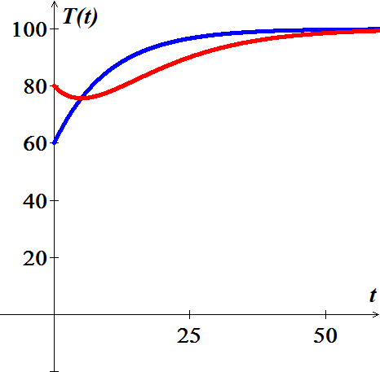

***Exercise***

The mathematical model for the shape of a flexible cable strung between two vertical supports is given by



Where *W* denotes the portion of the total vertical load between the points  and 

The model is separable under the following conditions that describe a suspension bridge.

Let assume that the *x-*axis runs along the horizontal roadbed, and the *y-*axis passes through , which is the lowest point on one cable over the span of the bridge, coinciding with the interval .

In the case of a suspension bridge, the usual assumption is that the vertical load in the given equation is only a uniform roadbed, distributed along the horizontal axis. In other words, it is assumed that the weight of all cables is negligible in comparison to the weight of the roadbed and that the weight per unit length of the roadbed  is a constant *ρ*. Use this information to set up and solve an appropriate initial-value problem from which the shape (a curve with equation ) of each of the two cables in a suspension bridge is determined. Express the solution of the IVP in terms of the sag *h* and span *L*.

***Solution***

Since the tension  (or magnitude ) acts at the lowest point of the cable, using the symmetry to solve the problem on the interval .

The assumption that the roadbed is uniform (that is, weighs a constant *ρ*  implies

, where 





 

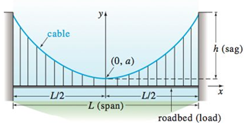









***Exercise***

The Brentano-Stevens Law in psychology models the way that a subject reacts to a stimulus. It states that if *R* represents the reaction to an amount *S* of stimulus, then the relative rates of increase are proportional:



Where *k* is a positive constant. Find *R* as a function of *S*.

***Solution***









 



***Exercise***

Barbara weighs 60 *kg* and is on a diet of 1600 *calories* per day, of which 850 are used automatically by basal metabolism. She spends about 15 *cal/kg/day* times her weight doing exercises. If 1 *kg* of fat contains 10,000 *cal*. and we assume that the storage of calories in the form of fat is 100% efficient, formulate a differential equation and solve it to find her weight as a function of time. Does her weight ultimately approach an equilibrium weight?

***Solution***

: mass at time *t*.

The net intake of calories per day at time *t* is

 





















Thus, Barbara’s mass gradually settles down to 50 *kg*.

***Exercise***

When a chicken is removed from an oven, its temperature is measured at 300° *F*. Three minutes later its temperature is 200° *F*. How long will it take for the chicken to cool off to a room temperature of 70° *F*.

***Solution***

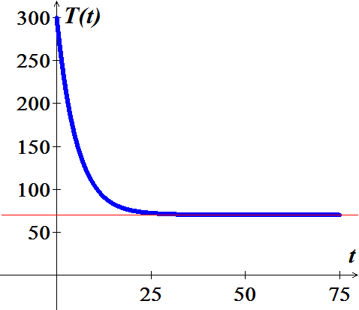***Given***: 

 













***Solution Section* 1.3– Models of Motions**

***Exercise***

A stone is released from rest and dropped into a deep well. Eight seconds later, the sound of the stone splashing into the water at the bottom of the well returns to the ear of the person who released the stone. How long does it take the stone to drop to the bottom of the well? How deep is the well? Ignore air resistance. The speed of sound is 340 *m/s*.

***Solution***





















***Exercise***

A rocket is fired vertically and ascends with constant acceleration  for 1.0 *min*. At that point, the rocket motor shuts off and the rocket continues upward under the influence of gravity. Find the maximum altitude acquired by the rocket and the total time elapsed from the take-off until the rocket returns to the earth. *Ignore air resistance*.

***Solution***



















The velocity will be reduced: 



The altitude: 





Back to the ground: 



Total time: 

***Exercise***

A ball having mass  falls from rest under the influence of gravity in a medium that provides a resistance that is proportional to its velocity. For a velocity of the force due to the resistance of the medium is −1 N. Find the terminal velocity of the ball.

1 N is the force required to accelerate a 1 kg mass at a rate of : 

***Solution***

The resistance force: 

 

The terminal velocity: 





***Exercise***

A ball is projected vertically upward with initial velocity from ground level. Ignore air resistance.

1. What is the maximum height acquired by the ball?
2. How long does it take the ball to reach its maximum height? How long does it take the ball to return to the ground? Are these times identical?
3. What is the speed of the ball when it impacts with the ground on its return?

***Solution***

The position: 

1. The maximum height when the velocity is zero





Maximum height 





1. The ball will take to reach the maximum height  and the same to return to the ground, both are equal to 
2. When the ball hits the ground the time is equal to zero.



***Exercise***

An object having mass 70 kg falls from rest under the influence of gravity. The terminal velocity of the object is . Assume that the air resistance is proportional to the velocity.

1. Find the velocity and distance traveled at the end of 2 seconds.
2. How long does it take the object to reach 80% of its terminal velocity?

***Solution***

1. The terminal velocity: 



























1. The velocity is 80% of its terminal velocity when 





***Exercise***

A lunar lander is falling freely toward the surface of the moon at a speed of 450 m/s. Its retrorockets, when fired, provide a constant deceleration of 2.5  (the gravitational acceleration produced by the moon is assumed to be included in the given acceleration). At What height above the lunar surface should the retrorockets be activated to ensure a “soft touchdown? (*v* = 0 at impact)?

***Solution***

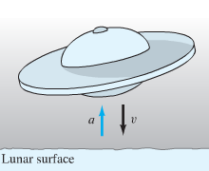***Given***:  

Because an upward thrust increases the velocity *v* (although decreases the speed ), then









 is the height of the lander above the lunar surface at the time *t* = 0 when the retrorockets should be activated.





When 





Thus the retrorockets should be activated when the lunar lander is 40.500 m (40,5 km) above the surface of the moon, and it will touch down softly on the lunar surface after 3 minutes of decelerating descent.

***Exercise***

A body falling in a relatively dense fluid, oil for example, is acted on by three forces: a resistance force *R,* a buoyant force *B,* and its weight *w* due to gravity. The buoyant force is equal to the weight of the fluid displaced by the object. For a slowly moving spherical body of radius *a*, the resistive force is given by Stokes’s law , where *v* is the velocity of the body, and *μ* is the coefficient of viscosity of the surrounding fluid?

1. Find the limiting velocity of a solid sphere of radius *a* and density *ρ* falling freely in a medium of density  and coefficient of viscosity *μ*.
2. In 1910 R. A. Millikan studied the motion of tiny droplets of oil falling in an electric field. A field of strength *E* exerts a force on a droplet with charge *e*. Assume that *E* has been adjusted so the droplet is held stationary  and that *w* and *B* are as given. Find an expression for *e*.

***Solution***

1. 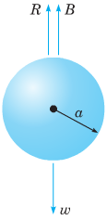The equation of motion is 



The limiting velocity occurs when 

1. Since the droplet is motionless, , we have the equation of motion



Where ρ is the density of the oil and  is the density of air.







***Exercise***

A hemispherical bowl has top radius of 4*ft*. and at time *t* = 0 is full of water. At that moment a circular hole with diameter 1 *in*. is opened in the bottom of the tank. How long will it take for all the water to drain from the tank?

***Solution***

 (***Right*** ***Triangle***)



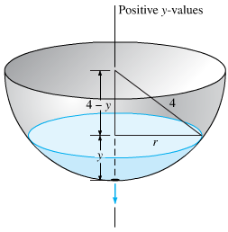























The tank is empty when y = 0, thus when







That is about 35 min. 50 s. So it takes slightly less than 36 minutes for the tank to drain.

***Exercise***

Suppose that the tank has a radius of 3 *feet*. and that its bottom hole is circular with radius 1 *in*. How long will it take the water (initially 9 *ft*. deep) to drain completely?

***Solution***

























Hence  when 

***Exercise***

At time *t* = 0 the bottom plug (at the vertex) of a full conical water tank 16 *ft*. high is removed. After 1 *hr* the water in the tank is 9 *ft*. deep. When will the tank be empty?

***Solution***

The radius of the cross-section of the cone at height *y* is proportional to *y*, so  is proportional to . Therefore,

 









With initial condition: 

 







 



Hence  when 

***Exercise***

Suppose that a cylindrical tank initially containing  gallons of water drains (through a bottom hole) in *T* *minutes*. Use Torricelli’s law to show that the volume of water in the tank after  minutes is 

***Solution***

 





With initial condition:   





 







If *r* denotes the radius of the cylinder, then







***Exercise***

The clepsydra, or water clock – A 12*-hr* water clock is to be designed with the dimensions, shaped like the surface obtained by revolving the curve  around the *y-*axis. What should be this curve, and what should be the radius of the circular bottom hole, in order that the water level will fall at the constant rate of 4 *inches* per *hour*?

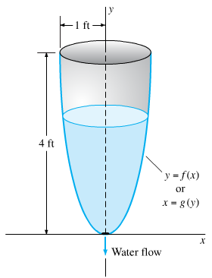***Solution***

The rate of fall of the water level is















The curve is of the form 













***Exercise***

One of the famous problems in the history of mathematics is the brachistochrone problem: to find the curve along which a particle will slide without friction in the minimum time from one given point *P* to another point *Q*, the second point being lower than the first but not directly beneath it.

This problem was posed by Johann Bernoulli in 1696 as a challenge problem to the mathematicians of his day. Correct solutions were found by Johann Bernoulli and his brother Jakob Bernoulli and by Isaac Newton, Gottfried Leibniz, and the Marquis de L’Hospital. The brachistochrone problem is important in the development of mathematics as one of the forerunners of the calculus of variations.

In solving this problem, it is convenient to take the origin as the upper point *P* and to orient the axes as shown. The lower point Q has coordinates . It is then possible to show that the curve of minimum time is given by a function  that satisfies the differential equation



Where  is a certain positive constant to be determined later

1. Solve the equation  for  . Why is it necessary to choose the positive square root?
2. Introduce the new variable t by the relation



Show that the equation found in part (a) then takes the form



1. Letting , show that the solution of  for which *x* = 0 when *y* = 0 is given by



Equations (*iv*) are parametric equations of the solution of (eq. *i*) that passes through (0, 0). The graph of Eqs. (*iv*) is called a cycloid.

1. If we make a proper choice of the constant k, then the cycloid also passes through the point  and is the solution of the brachistochrone problem. Find *k* if  and 

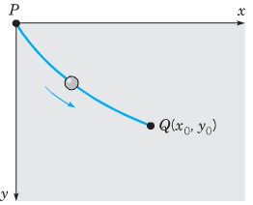***Solution***

1. 









The positive answer is chosen, since *y* is an increasing function of *x*.

1. Let 

 















1. Setting , 







  at the origin.







 

1. 



Letting  



The solution is: 









***Exercise***

Many chemical reactions are the result of the interaction of 2 molecules that undergo a change to produce a new product. The rate of the reaction typically depends on the concentrations of the two kinds of molecules. If *a* is the amount of substance *A* and *b* is the substance *B* at time *t* = 0, and if *x* is the amount of product at time *t*, then the rate of formation of *x* may be given by the differential equation



Where *k* is a constant for the reaction. Integrate both sides of this equation to obtain a relation between *x* and *t*.

1. If 
2. If 

Assume in each case that  when 

***Solution***



1. 















1. 

|  |  |
| --- | --- |
|  |  |

***Exercise***

An open cylindrical tank initially filled with water drains through a hole in the bottom of the tank according to Torricelli’s Law. If  is the depth of water in the tank for , then Torricelli’s Law implies  , where *k* is a constant that includes the acceleration due to gravity, the radius of the tank, and the radius of the drain. Assume that the initial depth of the water is .

1. Find the solution of the initial value problem.
2. Find the solution in the case that  and .
3. In general, how long does it take the tank to drain in terms of *k* and *H*?

***Solution***

1. 

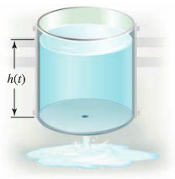









1. Given:  



1. The tank is drained when 





***Exercise***

An object in free fall may be modeled by assuming that the only forces at work are the gravitational force and resistance (friction due to the medium in which the objects falls). By Newton’s second law (mass × acceleration = the sum of the external forces), the velocity of the object satisfies the differential equation



Where  is a function that models the resistance and the positive direction is downward. One common assumption (often used for motion in air) is that , where  is a drag coefficient.

1. Show that the equation can be written in the form  where 
2. For what (positive) value of *v* is  (This equilibrium solution is called the ***terminal velocity***.)
3. Find the solution of this separable equation assuming  for 
4. Graph the solution found in part (***c***) with , and verify the terminal velocity agrees with the value found in part (***b***).

***Solution***

1. ***Given***: 







 where 

1. 

|  |  |
| --- | --- |
|  |  |







 

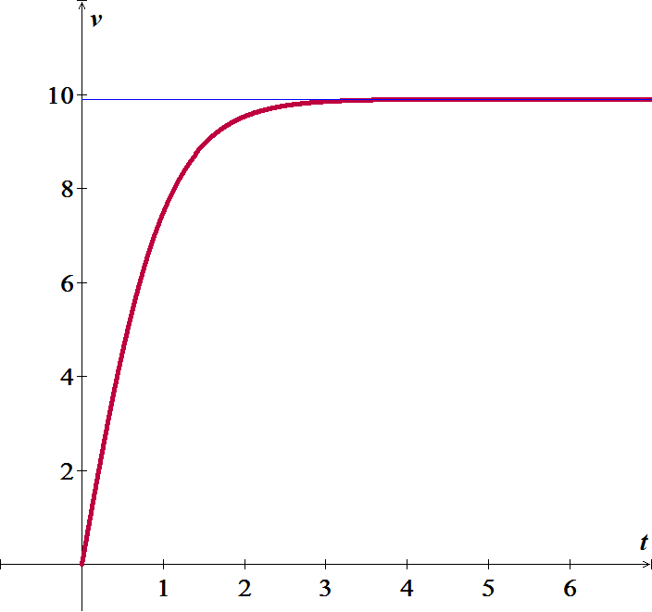



1. 





***Exercise***

Suppose a small cannonball weighing 16 *pounds* is shot vertically upward, with an initial velocity 

The answer to the question “How high does the cannonball go?” depends on whether we take air resistance into account.

1. Suppose air resistance is ignored. If the positive direction is upward, then a model for the state of the cannonball is given by . Since  the last differential equation is the same as , where we take . Find the velocity  of the cannonball at time *t*.
2. Use the result in part (*a*) to determine the height  of the cannonball measured from ground level. Find the maximum height attained by the cannonball.

***Solution***

1. 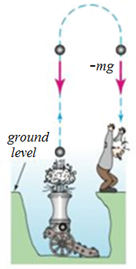







1. 









The maximum height: 

***Exercise***

Two chemicals *A* and *B* are combined to form a chemical *C*. The resulting reaction between the two chemicals is such that for each *gram* of *A*, 4 *grams* of *B* is used. It is observed that 30 grams of the compound *C* is formed in 10 *minutes*.

1. Determine the amount of *C* at time *t* if the rate of the reaction is proportional to the amounts of *A* and *B* remaining and if initially there are 50 *grams* of *A* and 32 *grams* of *B*.
2. How much of the compound *C* is present at 15 minutes.
3. Interpret the solution as 

***Solution***

1. Let assume that we used *a* *grams* of *A* and *b* *grams* of *B*.

Then there *x* *grams* of compound *C*.

 and 



The rate at which compound *C* is formed satisfies:



 







































1. 
2. 









For chemical *A*: 



For chemical *B*: 

***Exercise***

Two chemicals *A* and *B* are combined to form a chemical *C*. The rate, or velocity, of the reaction is proportional to the product of the instantaneous amounts of *A* and *B* not converted to chemical *C*. Initially, there are 40 *grams* of *A* and 50 *grams* of *B*, and each gram of *B*, 2 *grams* of *A* is used. It is observed that 10 *grams* of *C* is formed in 5 *minutes*.

1. How much is formed in 20 *minutes*?
2. What is the limiting amount of *C* after a long time?
3. How much of chemicals *A* and *B* remains after a long time?
4. If 100 *grams* of chemical *A* is present initially, at what time is chemical *C* half-formed?

***Solution***

1. Let assume that we used *a* *grams* of *A* and *b* *grams* of *B*.

Then there *x* *grams* of compound *C*.

 and 



The rate at which compound *C* is formed satisfies:



 









































1. 







1. 

For chemical *A*: 



For chemical *B*: 





 























When the chemical *C* is half-formed, that implies to 









***Exercise***

A skydiver weighs 125 *pounds*, and her parachute and equipment combined weigh another 35 *pounds*. After exiting from a plane at an altitude of 15,000 *feet*, she waits 15 *seconds* and opens her parachute. Assume that the constant of proportionality has the value  during free fall and  after the parachute is opened.

Assume that her initial velocity on leaving the plane is *zero*.

1. What is her velocity and how far has she traveled 20 *seconds* after leaving the plane?
2. How does her velocity at 20 *seconds* compare with her terminal velocity?
3. How long does it take her to reach the ground?

***Solution***

1. Assume that the air resistance is proportional to velocity and the positive direction is downward.

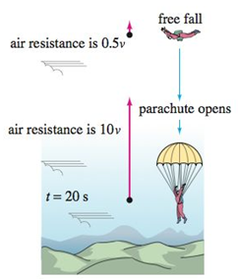 

















***Given***: , , and 













When the parachute opens at 





With the parachute opens at  then  (reset) with the given information , , and 















After the parachute opens at 





After leaving the plane, at 





1. 

She has very nearly reached her terminal velocity in 5 *seconds* after the parachute opens.

1. She exited the plane at an altitude of 15,000 *feet.*

When she open the parachute the distance to the ground is







The total time:





***Exercise***

A tank in the form of a right-circular cylinder standing on end is leaking water through a circular hole in its bottom. When friction and contraction of water at the hole are ignored, the height *h* of water in the tank is described by



Where  and  are the cross-sectional areas of the water and the hole, respectively.

1. Find  if the initial height of the water is *H*.
2. Sketch the graph  and give the interval *I* of definition in terms of the symbols , , and *H*.
3. Suppose the tank is 10 *feet* high and has radius 2 *feet* and the circular hole has radius  *inch*. If the tank is initially full, how long will it take to empty?

***Solution***

1. 









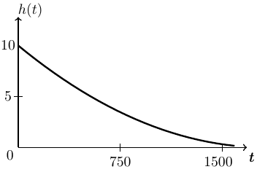

1. 





1. ***Given***: 















***Exercise***

A tank in the form of a right-circular cylinder cone standing on end, vertex down, is leaking water through a circular hole in its bottom.

1. Suppose the tank is 20 *feet* high and has radius 8 *inches*. Show that the differential equation governing the height *h* of water leaking from a tank is



In this model, friction and contraction of the water at the hole were taken into account with  and . If the tank is initially full, how long will it take the tank to empty?

1. Suppose the tank has a vertex angle of 60° and the circular hole has radius 2 *inches*. Determine the differential equation governing the height *h* of water. Use  and .
2. If the height of the water is initially 9 *feet*, how long will it take the tank to empty?

***Solution***

1. 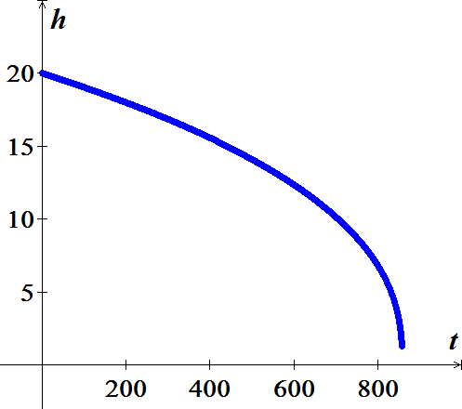















1. 























***Exercise***

Suppose that the conical tank is inverted and that water leaks out a circular hole of radius 2 *inches* in the center of its circular base. Is the time it takes to empty a full tank the same as for the tank with vertex down? Take the friction/.contraction coefficient to be  and 

***Solution***

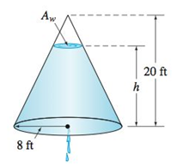





 



















The tank empties more slowly when the base of the cone is on the bottom.

***Exercise***

A differential equation for the velocity *v* of a falling mass m subjected to air resistance proportional to the square of the instantaneous velocity is



Where  is a constant of proportionality. The positive direction is downward.

1. Solve the equation subject to the initial condition .
2. Use the solution in part (*a*) to determine the limiting, or terminal, velocity of the mass.
3. If the distance *s*, measured from the point where the mass was released above the ground, is related to velocity *v* by , find an explicit expression for  if 

***Solution***

1.  











1. 





1. 





***Exercise***

An object is dropped from altitude 

1. Determine the impact velocity if the drag force is proportional to the square of velocity, with drag coefficient .
2. If the terminal velocity is known to −120 *mph* and the impact velocity was −90 *mph*, what was the initial altitude ?

***Solution***

1. 

















Since the object is falling: 









1. 



















***Exercise***

An object is dropped from altitude 

1. Assume that the drag force is proportional to the velocity, with drag coefficient . Obtain an implicit solution relating velocity and altitude.
2. If the terminal velocity is known to −120 *mph* and the impact velocity was −90 *mph*, what was the initial altitude ?

***Solution***

1. 

 



















1. 











***Exercise***

An object of mass 3 *kg* is released from rest 500 *m* above the ground and allowed to fall under the influence of gravity. Assume the gravitational force constant, with , and the force due to air resistance is proportional to the velocity of the object with proportionality constant . Determine when the object will hit the ground.

***Solution***

By Newton second law: 















***Given***: 

















 

***Exercise***

A parachutist whose mass is 75 *kg* drops from helicopter hovering 4000 *m* above the ground and falls toward the earth under the influence of gravity. Assume the gravitational force is constant. Assume also that the force due to air resistance is proportional to the velocity of the parachutist, with the proportionality constant  when the chute is closed and with constant  when the chute is open. If the chute does not open until 1 *min* after the parachutist leaves the helicopter, after how many *seconds* will he hit the ground?

***Solution***

***Given***: 

***Before*** the chute is open

By Newton second law: 



























***When*** the chute is opened, he is  above the ground.

***Given***: 

















 

***Exercise***

A parachutist whose mass is 75 *kg* drops from helicopter hovering 2000 *m* above the ground and falls toward the earth under the influence of gravity. Assume the gravitational force is constant. Assume also that the force due to air resistance is proportional to the velocity of the parachutist, with the proportionality constant  when the chute is closed and with constant  when the chute is open. If the chute does not open until the velocity of the parachutist reaches , after how many seconds will he reach the ground?

***Solution***

***Given***: 

***Before*** the chute is open

By Newton’s second law: 



























***When*** the chute is opened, he is  above the ground.

***Given***: 

















 

***Exercise***

An object of mass 5 *kg* is released from rest 1000 *m* above the ground and allowed to fall under the influence of gravity. Assume the gravitational force constant, with , and the force due to air resistance is proportional to the velocity of the object with proportionality constant . Determine when the object will hit the ground.

***Solution***

By Newton’s second law: 









***Given***: 





















***Exercise***

An object of mass 500 *kg* is released from rest 1000 *m* above the ground and allowed to fall under the influence of gravity. Assume the gravitational force constant, with , and the force due to air resistance is proportional to the velocity of the object with proportionality constant . Determine when the object will hit the ground.

***Solution***

***Given***: 

By Newton’s second law: 





























***Exercise***

A 400-*lb* object is released from rest 500 *ft* above the ground and allowed to fall under the influence of gravity. Assuming that the force in pounds due to air resistance is , where *v* is the velocity of the object in , determine the equation of motion of the object. When will the object hit the ground?

***Solution***

***Given***: 

By Newton second law: 





























***Exercise***

An object of mass 8 *kg* is given an upward initial velocity of  and then allowed to fall under the influence of gravity. Assume that the force in Newton due to air resistance is , where *v* is the velocity of the object in .

1. Determine the equation of motion of the object.
2. If the object is initially 100 m above the ground, determine when the object will hit the ground.

***Solution***

***Given***: 

1. By Newton’s second law: 























1. 



***Exercise***

An object of mass 5 *kg* is given an downward initial velocity of  and then allowed to fall under the influence of gravity. Assume that the force in Newton due to air resistance is , where *v* is the velocity of the object in .

1. Determine the equation of motion of the object.
2. If the object is initially 100 *m* above the ground, determine when the object will hit the ground.

***Solution***

***Given***: 

1. By Newton’s second law: 























1. 



***Exercise***

A shell of mass 2 *kg* is shot upward with an initial velocity of . The magnitude of the force on the shell due to air resistance is .

1. When will the shell reach its maximum height above the ground?
2. What is the maximum height?

***Solution***

***Given***: 

1. 













At maximum height, 





1. 











***Exercise***

We need to design a ballistics chamber to decelerate test projectiles fired into it. Assume the resistive force encountered by the projectile is proportional to the square of its velocity and neglect gravity.

The chamber is to be constructed so that the coefficient  associated with this resistive force is not constant but is, in fact, a linearly increasing function of distance into the chamber:

Let , where  is a constant; the resistive force then has the form .

If we use time *t* as the independent variable, Newton’s law of motion leads us to the differential equation



1. Adopt distance *x* into the chamber as the new independent variable and rewrite the given differential equation as a first order equation in terms of the new independent variable.
2. Determine the value  needed if the chamber is to reduce projectile velocity to 1% of its incoming value within *d* units of distance.

***Solution***

1. 



 when 

1. 

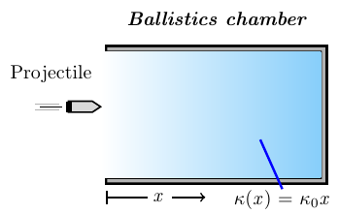









Let 









***Exercise***

When the velocity *v* of an object is very large, the magnitude of the force due to air resistance is proportional to  with the force acting in opposition to the motion of the object. A shell of mass 3 *kg* is hot upward from the ground with an initial velocity of 500 . If the magnitude of the force due to air resistance is .

1. When will the shell reach its maximum height above the ground?
2. What is the maximum height?

***Solution***

***Given***: 

1. 



















1. 









***Exercise***

A sailboat has been running (on a straight course) under a light wind at . Suddenly the wind picks up, blowing hard enough to apply a constant force of 600 *N* to the sailboat. The only other force acting on the boat is water resistance that is proportional to the velocity of the boat. If the proportionality constant for water resistance is  and the mass of the sailboat is 50 *kg*.

1. Find the equation of motion of the sailboat.
2. What is the limiting velocity of the sailboat under this wind?
3. When the velocity of the sailboat reaches , the boat begins to rise out of the water and plane. When this happens, the proportionality constant for the water resistance drop to . Find the equation of motion of the sailboat.
4. What is the limiting velocity of the sailboat under this wind as it is planning?

***Solution***

***Given***: 

1. 











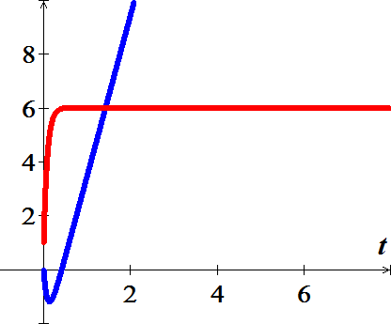 











1. 
2. 





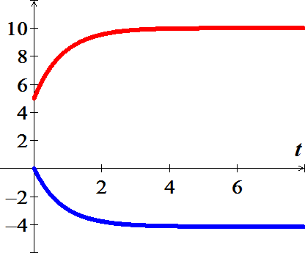

















1. 

***Exercise***

According to Newton’s law of gravitation, the attractive force between two objects varies inversely as the square of the distances between them. That is, 

Where  and  are the masses of the objects, *r* is the distance between them (center to center), is the attractive force, and *G* is the constant of proportionality.

Consider ta projectile of constant mass *m* being fired vertically from Earth.

Let *t* represent time and *v* the velocity of the projectile.

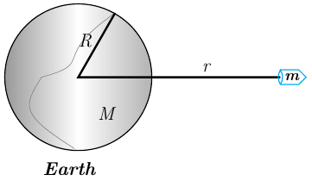

1. Show that the motion of the projectile, under Earth’s gravitational force, is governed by the equation



Where *r* is the distance between the projectile and the center of Earth, *R* is the radius of Earth, *M* is the mass of Earth, and .

1. Use the fact the  to obtain 
2. If the projectile leaves Earth’s surface with velocity , show that



1. Use the result of part (*c*) to how that the velocity of the projectile remains positive if and only if . The velocity  is called the escape velocity?
2. If  and  for Earth, what is Earth’s escape velocity?
3. If the acceleration due to gravity for the Moon is  and the radius of the Moon is , what is the escape velocity of the Moon?

***Solution***

1.  









1. ***Given***: 





1. 









1. 

Since 



1. ***Given***: 

 



1. ***Given***: 

 



***Exercise***

A 180*-lb* skydiver drops from a hot-air balloon. After 10 *sec* of free fall, a parachute is opened. The parachute immediately introduces a drag force proportional to velocity. After an additional 4 *sec*, the parachutist reaches the ground. Assume that air resistance is negligible during free fall and that the parachute is designed so that a 200-*lb* person will reach a terminal velocity of −10 *mph*.

1. What is the speed of the skydiver immediately before the parachute is opened?
2. What is the parachutist’s impact velocity?
3. At what altitude was the parachute opened?
4. What is the balloon’s altitude?

***Solution***

***Given***: 

1. 





1. 



























1. 











1. 



