***Solution Section* 1.4– Linear Equations**

***Exercise***

Find the general solution of 

***Solution***

 











***Exercise***

Find the general solution of 

***Solution***







 







***Exercise***

Find the general solution of 

***Solution***











***Exercise***

Find the general solution of 

***Solution***











***Exercise***

Find the general solution of 

***Solution***









***Exercise***

Find the general solution of 

***Solution***



 

 









***Exercise***

Find the general solution of 

***Solution***









***Exercise***

Find the general solution of 

***Solution***









***Exercise***

Find the general solution of 

***Solution***













***Exercise***

Find the general solution of 

***Solution***















***Exercise***

Find the general solution of 

***Solution***









***Exercise***

Find the general solution of 

***Solution***



|  |  |
| --- | --- |
|  |  |

***Exercise***

Find the general solution of 

***Solution***



 







***Exercise***

Find the general solution of 

***Solution***









***Exercise***

|  |  |  |
| --- | --- | --- |
|  |  |  |
| **+** | *t* |  |
| **−** | 1 |  |

Find the general solution of 

***Solution***













***Exercise***

Find the general solution of 

***Solution***











***Exercise***

Find the general solution of 

***Solution***













***Exercise***

Solve the differential equation: 

***Solution***









***Exercise***

Solve the differential equation: 

***Solution***



 









***Exercise***

Solve the differential equation: 

***Solution***











***Exercise***

Solve the differential equation: 

***Solution***











***Exercise***

Solve the differential equation: 

***Solution***











***Exercise***

Solve the differential equation: 

***Solution***





 









***Exercise***

Solve the differential equation: 

***Solution***









 









***Exercise***

Solve the differential equation: 

***Solution***









***Exercise***

Solve the differential equation: 

***Solution***









***Exercise***

Solve the differential equation: 

***Solution***









***Exercise***

Solve the differential equation: 

***Solution***



|  |  |  |
| --- | --- | --- |
|  |  |  |
| **+** |  |  |
| **−** |  |  |
| **+** | 2 |  |









***Exercise***

Solve the differential equation: 

***Solution***











***Exercise***

Solve the differential equation: 

***Solution***











***Exercise***

Solve the differential equation: 

***Solution***









***Exercise***

Solve the differential equation: 

***Solution***











***Exercise***

Solve the differential equation: 

***Solution***











***Exercise***

Solve the differential equation: 

***Solution***

 







***Exercise***

Solve the differential equation: 

***Solution***











***Exercise***

Solve the differential equation: 

***Solution***







***Exercise***

Solve the differential equation: 

***Solution***











***Exercise***

Solve the differential equation: 

***Solution***











***Exercise***

Solve the differential equation: 

***Solution***



 





***Exercise***

Solve the differential equation: 

***Solution***



|  |  |  |
| --- | --- | --- |
|  |  |  |
| **+** |  |  |
| **−** |  |  |
| **+** | 2 |  |











***Exercise***

Solve the differential equation: 

***Solution***











***Exercise***

|  |  |  |
| --- | --- | --- |
|  |  |  |
| **+** |  |  |
| **−** |  |  |
| **+** | 2 |  |

Solve the differential equation: 

***Solution***















***Exercise***

Solve the differential equation: 

***Solution***

|  |  |  |
| --- | --- | --- |
|  |  |  |
| **+** |  |  |
| **−** |  |  |











***Exercise***

Solve the differential equation: 

***Solution***













***Exercise***

Solve the differential equation: 

***Solution***

|  |  |  |
| --- | --- | --- |
|  |  |  |
| **+** |  |  |
| **−** |  |  |
| **+** | 2 |  |









***Exercise***

Solve the differential equation: 

***Solution***







***Exercise***

Solve the differential equation: 

***Solution***







***Exercise***

Solve the differential equation: 

***Solution***











***Exercise***

Solve the differential equation: 

***Solution***











***Exercise***

Solve the differential equation: 

***Solution***











***Exercise***

Solve the differential equation: 

***Solution***









***Exercise***

Solve the differential equation: 

***Solution***









***Exercise***

Solve the differential equation: 

***Solution***











***Exercise***

Solve the differential equation: 

***Solution***







***Exercise***

Solve the differential equation: 

***Solution***





***Exercise***

Solve the differential equation: 

***Solution***









***Exercise***

Solve the differential equation: 

***Solution***









***Exercise***

Solve the differential equation: 

***Solution***







***Exercise***

Solve the differential equation: 

***Solution***









***Exercise***

Solve the differential equation: 

***Solution***











***Exercise***

Solve the differential equation: 

***Solution***









***Exercise***

Find the general solution of 

***Solution***











***Exercise***

Find the general solution of 

***Solution***









***Exercise***

Find the general solution of 

***Solution***



|  |  |  |
| --- | --- | --- |
|  |  |  |
| **+** |  |  |
| **−** | 1 |  |











***Exercise***

Find the general solution of 

***Solution***









***Exercise***

Find the general solution of 

***Solution***











***Exercise***

Find the general solution of 

***Solution***











***Exercise***

Find the general solution of 

***Solution***











***Exercise***

Find the general solution of 

***Solution***

|  |  |  |
| --- | --- | --- |
|  |  |  |
| + |  |  |
| − |  |  |
| + |  |  |













***Exercise***

Find the general solution of 

***Solution***









***Exercise***

Find the general solution of 

***Solution***









***Exercise***

Find the general solution of 

***Solution***

|  |  |  |
| --- | --- | --- |
|  |  |  |
| + |  |  |
| − | 1 |  |













***Exercise***

Find the general solution of 

***Solution***









***Exercise***

Find the general solution of 

***Solution***







***Exercise***

Find the general solution of 

***Solution***









***Exercise***

Find the general solution of 

***Solution***











 



***Exercise***

Find the general solution of 

***Solution***















 



***Exercise***

Find the general solution of 

***Solution***





 





 



***Exercise***

Solve the initial value problem: 

***Solution***











 



***Exercise***

Solve the initial value problem: 

***Solution***











  



***Exercise***

Solve the initial value problem: 

***Solution***





 



 





***Exercise***

Solve the initial value problem: 

***Solution***





|  |  |
| --- | --- |
| ***1st method*** | ***2nd method*** |
|  |  |

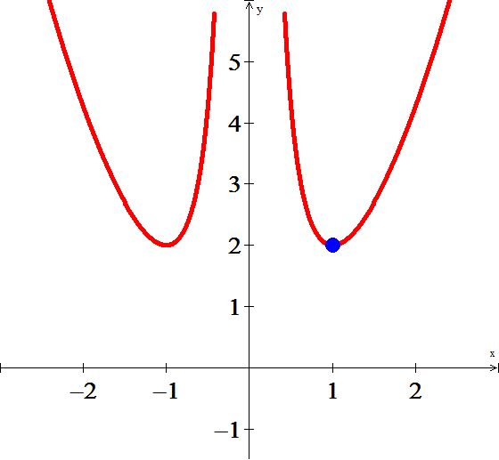









***Exercise***

Find the solution of the initial value problem 

***Solution***











Given , then 





***Exercise***

Solve the initial value problem: 

|  |  |  |
| --- | --- | --- |
|  |  |  |
| **+** |  |  |
| **−** |  |  |

***Solution***









 





***Exercise***

Solve the initial value problem: 

***Solution***





|  |  |  |
| --- | --- | --- |
|  |  |  |
| + |  |  |
| − |  |  |





 





***Exercise***

Solve the initial value problem: 

***Solution***













***Exercise***

Solve the initial value problem: 

***Solution***













***Exercise***

Solve the initial value problem: 

***Solution***







 





***Exercise***

Solve the initial value problem: 

***Solution***



|  |  |  |
| --- | --- | --- |
|  |  |  |
| **+** |  |  |
| **−** |  |  |









 



***Exercise***

Solve the initial value problem: 

***Solution***







 





***Exercise***

Solve the initial value problem: 

***Solution***





 





***Exercise***

Solve the initial value problem: 

***Solution***





 





***Exercise***

Solve the initial value problem: 

***Solution***







 





***Exercise***

Solve the initial value problem: 

***Solution***













***Exercise***

Solve the initial value problem: 

***Solution***











***Exercise***

Solve the initial value problem: 

***Solution***















***Exercise***

Solve the initial value problem: 

***Solution***















***Exercise***

Solve the initial value problem: 

***Solution***















***Exercise***

Solve the initial value problem: 

***Solution***















***Exercise***

Solve the initial value problem: 

***Solution***















***Exercise***

Solve the initial value problem: 

***Solution***













***Exercise***

Solve the initial value problem: 

***Solution***















***Exercise***

Solve the initial value problem: 

***Solution***













***Exercise***

Solve the initial value problem: 

***Solution***















***Exercise***

Solve the initial value problem: 

***Solution***













***Exercise***

Solve the initial value problem: 

***Solution***















***Exercise***

Solve the initial value problem: 

***Solution***













***Exercise***

Solve the initial value problem: 

***Solution***













***Exercise***

Solve the initial value problem: 

***Solution***















***Exercise***

Solve the initial value problem: 

***Solution***























***Exercise***

Solve the initial value problem: 

***Solution***













***Exercise***

Solve the initial value problem: 

***Solution***













***Exercise***

Solve the initial value problem: 

***Solution***















***Exercise***

Solve the initial value problem: 

***Solution***













***Exercise***

Solve the initial value problem: 

***Solution***















***Exercise***

Solve the initial value problem: 

***Solution***

|  |  |  |
| --- | --- | --- |
|  |  |  |
| **+** |  |  |
| **−** | 1 |  |















***Exercise***

Find a solution to the initial value problem that is continuous on the given interval 

  

***Solution***

For :















For :

 







***Exercise***

Solve the initial value problem: 

***Solution***



|  |  |  |
| --- | --- | --- |
|  |  |  |
| **+** |  |  |
| **−** |  |  |
| **+** |  |  |









***Exercise***

Solve the initial value problem: 

***Solution***













***Exercise***

Solve the initial value problem: 

***Solution***





 













***Exercise***

Find a solution to the initial value problem that is continuous on the given interval 

  

***Solution***

For :













 

For :

 















***Exercise***

Find a solution to the initial value problem that is continuous on the given interval 

  

***Solution***

For :









 

For :













***Exercise***

Find a solution to the initial value problem that is continuous on the given interval 

  

***Solution***

For :









 

For :







 

For :











***Exercise***

Solve  

***Solution***



 









 *Integration by part* 





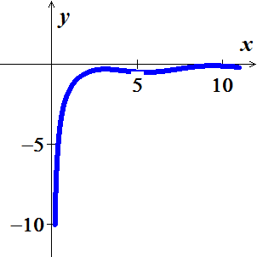 









 

***Exercise***

Find the solution of the initial value problem. Discuss the interval of existence and provide a sketch of your solution 

***Solution***









 





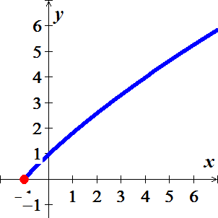 







***Exercise***

Find the general solution of the given differential equation. Then find the particular solution satisfying the given initial condition of 

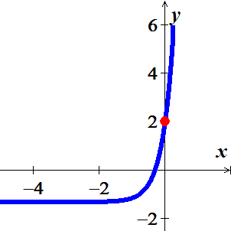***Solution***













***Exercise***

Find the general solution of the given differential equation. Then find the particular solution satisfying the given initial condition of

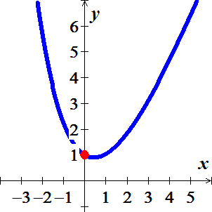

***Solution***





 













***Exercise***

Find the general solution of the given differential equation. Then find the particular solution satisfying the given initial condition of



***Solution***

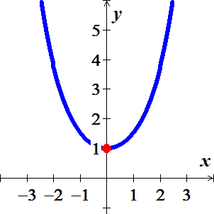











***Exercise***

The following system of differential equations is encountered in the study of the decay of a special type of radioactive series of elements





Where  are constants.

Discuss how to solve this system subject to 

***Solution***





























***Exercise***

Let  be the performance level of someone learning a skill as a function of the training time *t*. The graph of *P* is called a ***learning curve***. We proposed the differential equation



As a reasonable model for learning, where *k* is a positive constant. Solve it as a linear differential equation and use your solution to graph the learning curve.

***Solution***



 







***Exercise***

A differential equation describing the velocity *v* of a falling mass subject to air resistance proportional to the instantaneous velocity is



Where  is a constant of proportionality. The positive direction is downward.

1. Solve the equation subject to the initial condition 
2. Use the solution in part (*a*) to determine the limiting, or terminal, velocity of the mass.
3. If the distance *s*, measured from the point where the mass was released above ground, is related to velocity *v* by , find an explicit expression for  if 

***Solution***

1. 













1. 
2. 











***Exercise***

As a raindrop falls, it evaporates while retaining its spherical shape. If we make the further assumptions that the rate at which the raindrop evaporates is proportional to its surface and that air resistance is negligible, then a model for the velocity  of the raindrop is



Here  is the density of water,  is the radius of the raindrop at ,  is the constant of proportionality, and downward direction is taken to be the positive direction.

1. Solve for  if the raindrop falls from rest.
2. Show that the radius of the raindrop at time *t* is .
3. If  and  10 *seconds* after the raindrop falls from a cloud, determine the time at which the raindrop has evaporated completely.

***Solution***

1. 











1. 









1. ***Given***:  and 











***Exercise***

A model that describes the population of a fishery in which harvesting takes place at a constant rate is given by



Where *k* and *h* are positive constants.

1. Solve  given the initial value 
2. Describe the behavior of the population  for increasing time in three cases , , and 
3. Use the results from part (*b*) to determine whether the fish population will ever go extinct in finite time, that is, whether there exists a time  such that . If the population goes extinct then find *T*.

***Solution***

1. 













1. For 



 increases as time increases

For 



 remains constant as time increases

For 



 decreases as time increases.

1. 







