***Solution Section* 1.5– Mixing Problems**

***Exercise***

Consider two tanks, label tank *A* and tank *B* for reference. Tank *A* contains 100 *gal* of solution in which is dissolved 20 *lb* of salt. Tank *B* contains 200 *gal* of solution which is dissolved 40 *lb* of salt. Pure water flows into the tank *A* at rate of 5 *gal/s*. There is a drain at the bottom of tank *A*. The solution leaves tank *A* via the drain at a rate of 5 *gal/s* and flows immediately into tank *B* at the same rate. A drain at the bottom of tank *B* allows the solution to leave tank *B* at a rate of 2.5 *gal/s*. What is the salt content in tank *B* at the precise moment that tank *B* contains 250 *gal* of solution?

***Solution***

Tank ***A*** contains 100 *gal* of solution in which is dissolved 20 *lb* of salt

*Volume*: 

Concentration at time *t*: 

Rate out = Volume Rate *x* Concentration

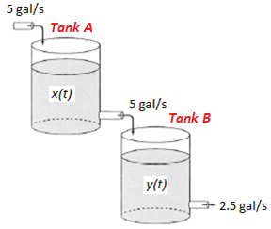 

















 



Tank ***B*** contains 200 *gal* of solution which is dissolved 40 *lb* of salt.

*Volume*: 





























 



 





















 











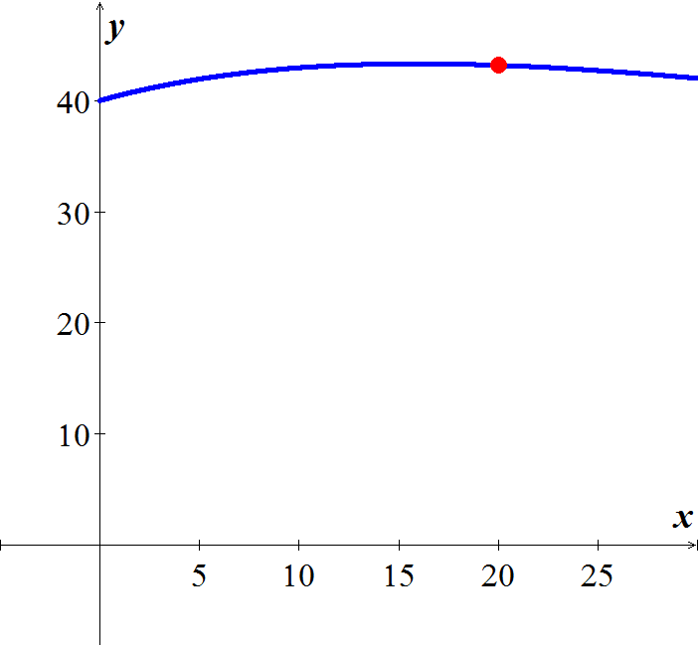

***Exercise***

A tank contains 100 *gal* of pure water. At time zero, a sugar-water solution containing 0.2 *lb* of sugar per gal enters the tank at a rate of 3 *gal/min*. Simultaneously, a drain is opened at the bottom of the tank allowing the sugar solution to leave the tank at 3 *gal/min*. Assume that the solution in the tank is kept perfectly mixed at all times.

1. What will be the sugar content in the tank after 20 *minutes*?
2. How long will it take the sugar content in the tank to reach 15 *lb*?
3. What will be the eventual sugar content in the tank?

***Solution***

1. 

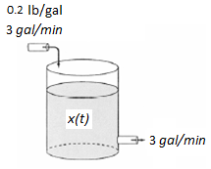 











 









1. 









1. 



***Exercise***

A tank initially contains 50 *gal* of sugar water having a concentration of 2 *lb*. of sugar for each gal of water. At time zero, pure water begins pouring into the tank at a rate of 2 *gal* per *minute*. Simultaneously, a drain is opened at the bottom of the tank so that the volume of sugar-water solution in the tank remains constant.

1. How much sugar is in the tank after 10 *minutes*?
2. How long will it take the sugar content in the tank to dip below 20 *lb*.?
3. What will be the eventual sugar content in the tank?

***Solution***

 represents the number of pounds of sugar.

1. 









The initial condition: 









1. 









1. 

***Exercise***

A 50-*gal* tank initially contains 20 *gal* of pure water. Salt-water solution containing 0.5 *lb* of salt for each gallon of water begins entering the tank at a rate of 4 *gal/min*. Simultaneously, a drain is opened at the bottom of the tank, allowing the salt-water solution to leave the tank at a rate of 2 *gal/min*. What is the salt content (*lb*) in the tank at the precise moment that the tank is full of salt-water solution?

***Solution***

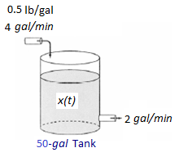











 





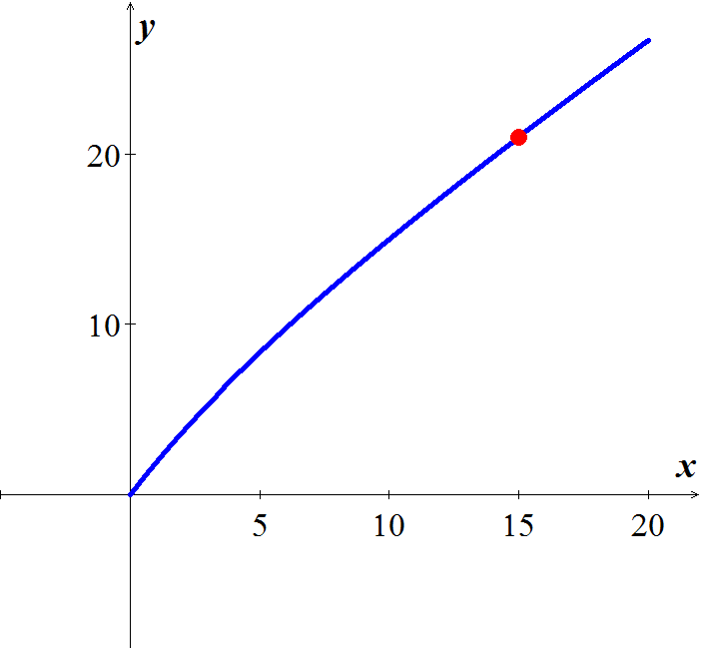















Full tank: 









***Exercise***

A tank contains 500 *gal* of a salt-water solution containing 0.05 *lb* of salt per gallon of water. Pure water is poured into the tank and a drain at the bottom of the tank is adjusted so as to keep the volume of solution in the tank constant. At what rate (*gal*/*min*) should the water be poured into the tank to lower the salt concentration to 0.01 *lb/gal* of water in less than one hour?

***Solution***



















The concentration at time *t* is given by: 

The concentration reaches 1% in one hour or 60 minutes.









***Exercise***

A tank contains 100 *gal* of fresh water. A solution containing 1 *lb./gal* of soluble lawn fertilizer runs into the tank at the rate of 1 *gal/min*, and the mixture is pumped out of the tank at a rate of 3 *gal/min*. Find the maximum amount of fertilizer in the tank and the time required to reach the maximum.

***Solution***

Volume of the tank at time *t* is:



































The maximum amount is: 



***Exercise***

A 200-*gal* tank is half full of distilled water. At time *t* = 0, a solution containing 0.5 *lb./gal* of concentrate enters the tank at the rate of 5 *gal/min*, and the well-stirred mixture is withdrawn at the rate of 3 *gal/min*.

1. At what time will the tank be full?
2. At the time the tank is full, how many pounds of concentrate will it contain?

***Solution***

1. 





1. Let *y*(*t*) be the amount of concentrate in the tank at time *t*.



















 







***Exercise***

Suppose that an Iowa class battleship has mass 51,000 *metric* *tons* (51,000,000 *kg*) and . Assume that the ship loses power when it is moving at a speed of 9 *m/sec*.

1. About how far will the ship coast before it is dead in the water?
2. About how long will it take the ship’s speed to drop to 1 *m/sec*?

***Solution***



1. 





















The ship will coast about 7780 meters or 7.78 km.

1. 







It will take about 

***Exercise***

A 66-*kg* cyclist on a 7-*kg* bicycle starts coasting on level ground at 9 *m/sec*. The 

1. About how far will the cyclist coast before reaching a complete stop?
2. How long will it take the cyclist’s speed to drop to 1 *m/sec*?

***Solution***

Mass: 



1. 























The cyclist coast about 168.5 *meters*.

1. 





It will take about 41.13 *seconds*.

***Exercise***

An Executive conference room of a corporation contains 4500  of air initially free of carbon monoxide. Starting at time *t* = 0, cigarette smoke containing 4% carbon monoxide is blown into the room at the rate of 0.3 . A ceiling fan keeps the air in the room well circulated and the air leaves the room at the same rate of 0.3 . Find the time when the concentration of carbon monoxide in the room reaches 0.01%.

***Solution***

Let  be the amount of carbon monoxide (CO) in the room at time *t*.























When the concentration of CO is 0.01% in the room, the amount of CO satisfies



When the room contains the amount 













***Exercise***

Consider the cascade of 2 tanks with  and  the volumes of brine in the 2 tanks. Each tank also initially contains 50 *lb*. of salt. The three flow rates indicated in the figure are each 5 *gal/min*, with pure water flowing into tank.

1. Find the amount  of salt in tank 1 at time *t*.
2. Suppose that  is the amount of salt in tank 2 at time *t*. Show first that



And then solve for , using the function  found in part (*a*).

1. Finally, find the maximum amount of salt ever in tank 2.

***Solution***

1. 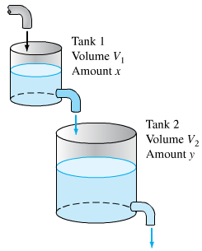****















1. 















With 









1. The maximum value of *y* occurs when













***Exercise***

Suppose that in the cascade tank 1 initially 100 *gal* of pure ethanol and tank 2 initially contains 100 *gal* of pure water. Pure water flows into tank 1 at 10 *gal/min*, and the other two flow rates are also 10 gal/min.

1. Find the amounts  and  of ethanol in the two tanks at time  .
2. Find the maximum amount of ethanol ever in tank 2.

***Solution***

1. The initial value problem 

For ***Tank*** 1:



















The initial value problem 

For ***Tank*** 2:



 





 

 





1. The maximum value of *y* occurs when







Thus when *t* = 10,







***Exercise***

A multiple cascade is shown in the figure. At time *t* = 0, tank 0 contains 1 *gal* of ethanol and 1 *gal* of water; all the remaining tanks contain 2 *gal* of pure water each. Pure water is pumped into tank 0 at 1 *gal/.min*, and the varying mixture in each tank is pumped into the one below it at the same rate. Assume, as usual, that the mixtures are kept perfectly uniform by stirring. Let  denote the amount of ethanol in tank *n* at time *t*.

1. Show that 
2. Show that the maximum value of  for *n* > 0 is 

***Solution***

1. 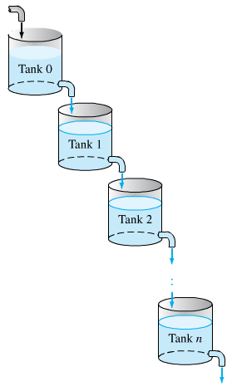For ***Tank*** **0**: 

















1. Using the induction

For ***n* = 0**, then  **√** True

Assume it is true for *n*: 

We need to prove that the equation for

 is also true.



























 **√** It is also true

1. 













***Exercise***

Assume that Lake Erie has a volume of 480  and that its rate of inflow (from Lake Huron) and outflow (to Lake Ontario) are both 350  per year. Suppose that at the time *t* = 0 (years), the pollutant concentration of Lake Erie – caused by past industrial pollution that has now been ordered to cease – is 5 times that of Lake Huron. If the outflow henceforth is perfectly mixed lake water, how long will it take to reduce the pollution concentration in Lake Erie to twice that of Lake Huron?

***Solution***

***Given***: *V* = 480 



 (The pollutant concentration of Lake Huron)























When is 













***Exercise***

A 120 *gal* tank initially contains 90 *lb*. of salt dissolved in 90 *gal* of water. Brine containing 2 *lb./gal* of salt flows into the tank at rate of 4 *gal/min*, and the well-stirred mixture flows out the tank at the rate of 3 *gal/min*. How much salt does the tank contain when it is full?

***Solution***

The volume of brine in the tank increase steadily with: 

The change  in the amount *x* of salt in the tank from time *t* to time  is given by:







 





















The tank is full after 30 min, Therefore when *t* = 30,





The tank contains 202 *lb*. of salt.

***Exercise***

A tank contains 50 *gallons* of a solution composed of 90% water and 10% alcohol. A second solution containing 50% water and 50% alcohol is added to the tank at the rate of . As the second solution is being added, the tank is being drained at a rate of . The solution in the tank is stirred constantly. How much alcohol is in the tank after 10 *minutes*?

***Solution***

Let *y* be the amount (in *lb*.) of additive in the tank at time *t* and 































***Exercise***

A 200-*gallon* tank is half full of distilled water. At time , a concentrate solution containing  enters the tank at the rate of , and well-stirred mixture is withdrawn at the rate of .

1. At what time will the tank be full?
2. At the time the tank is full, how many pounds of concentrate will it contain?

***Solution***

1. 



1. 





















***Exercise***

A 200-*gallon* tank is half full of distilled water. At time , a concentrate solution containing  enters the tank at the rate of , and well-stirred mixture is withdrawn at the rate of .

1. At what time will the tank be full?
2. At the time the tank is full, how many pounds of concentrate will it contain?

***Solution***

1. 



1. 

























***Exercise***

A 200-*gallon* tank is full of a concentrate solution containing . Starting at time , distilled water is admitted to the tank at the rate of , and well-stirred mixture is withdrawn at the same rate.

1. Find the amount of concentrate in the solution as a function of *t*.
2. Find the time at which the amount of concentrate in the tank reaches 15 *pounds*.
3. Find the quantity of the concentrate in the solution as .

***Solution***

1. 















1. 







1. 

***Exercise***

A tank contains 200 *liters* of fluid in which 30 *grams* of salt is dissolved. Brine containing 1 *gram* of salt per liter is then pumped into the tank at a rate of 4 *L/min*; the well-mixed solution is pumped out at the same rate.

1. Find the number  of grams of salt in the tank at time *t*.
2. Solve by assuming that pure water is pumped into the tank.

***Solution***

1. 



















***Given***: 



1. 









***Given***: 



***Exercise***

A large tank is filled to capacity with 500 *gallons* of pure water. Brine containing 2 *pounds* of salt per gallon is pumped into the tank at a rate of 5 *gal/min*. The well-mixed solution is pumped out at the same rate.

1. Find the number  of grams of salt in the tank at time *t*.
2. What is the concentration  of the salt in the tank at time *t*? At time ?
3. What is the concentration of the salt in the tank after a long time, that is, as ?
4. What is the concentration of the salt in the tank equal to one-half this limiting value?
5. Solve under assumption that the solution is pumped out at a faster rate of 10 *gal/min*. when tis the tank empty?

***Solution***

1. 



















***Given***: 



1. 





1. 
2. 







1. 



















***Given***: 









The tank is empty in 

***Exercise***

A large tank is filled to capacity with 100 *gallons* of fluid in which 10 *pounds* of salt is dissolved. Brine containing  *pound* of salt per gallon is pumped into the tank at a rate of 6 *gal/min*. The well-mixed solution is pumped out at the slower rate of 4 *gal/min*. Find the number of pounds of salt in the tank after 30 *minutes*.

***Solution***





















***Given***: 





***Exercise***

A 5000-*gal* tank is maintained with a pumping system that passes 100 *gal* of water per minute through the tank. To treat a certain fish malady, a soluble antibiotic is introduced into the inflow system. Assume that the inflow concentration of medicine is  *mg/gal*, where *t* is measured in *minutes*. The well-stirred mixture flows out of the tank at the same rate.

1. Solve for the amount of medicine in the tank as function of time.
2. What is the maximum concentration of medicine achieved by this dosing and when does it occur?
3. For the antibiotic to be effective, its concentration must exceed 100 *mg/gal* for a minimum of 60 *min*. was the dosing effective?

***Solution***

1. 





















1. 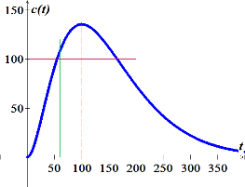





The maximum concentration





1. From the graph, the dosing was effective.





***Exercise***

A tank initially contains 400 *gal* of fresh water. At time , a brine solution with a concentration of 0.1 *lb*. of salt per gallon enters the tank at a rate of 1 *gal/min* and the well-stirred mixture flows out at a rate of 2 *gal/min*.

1. How long does it take for the tank to become empty?
2. How much salt is present when the tank contains 100 *gal* of brine?
3. What is the maximum amount of salt present in the tank during the time interval found in part (*a*)?
4. When is the maximum achieved?

***Solution***

1. 





1. 





























1. 











***Exercise***

A tank, having a capacity of 700 *gal*, initially contains 10 *lb*. of salt dissolved in 100 *gal* of water. At time , a solution containing 0.5 *lb*. of salt per gallon flows into the tank at a rate of 3 *gal/min* and the well-stirred mixture flows out of the tank at a rate of 2 *gal/min*.

1. How much time will elapse before the tank is filled to capacity?
2. What is the salt concentration in the tank when it contains 400 *gal* of solution?
3. What is the salt concentration at the instant the tank is filled to capacity?

***Solution***

1. 



1. 































 

1. 

 

***Exercise***

A 500-*gal* aquarium is cleansed by the recirculating filter system schematically shown in the figure.

Water containing impurities is pumped out at a rate of 15 *gal/min*, filtered, and returned to the aquarium at the same rate. Assume that passing through the filter reduces the concentration of impurities by a fractional amount *α*. In the other words, if the impurity concentration upon entering the filter is , the exit concentration is , where .

1. Apply the basic conservation principle  to obtain a differential equation for the amount of impurities present in the aquarium at time *t*. Assume that filtering occurs instantaneously. If the outflow concentration at any time is , assume that the inflow concentration at that same instant is .
2. What value of filtering constant *α*. will reduce impurity levels to 1% of their original values in a period of 3 *hr.*?

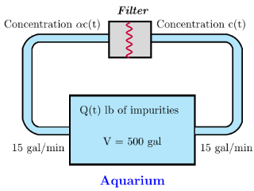***Solution***

1. 







1. 















***Exercise***

A mixing chamber initially contains 2 *gal* of a clear fluid. Clear fluid flows into the chamber at a rate of 10 *gal/min*. A dye solution having a concentration of 4  is injected into the mixing chamber at a rate of *r* *gal/min*. When the mixing process is started, the well-mixed mixture is pumped from the chamber at a rate .

1. Develop a mathematical model for the mixing process.
2. The objective is to obtain a dye concentration in the outflow mixture of 1 . What injection rate *r* is required to achieve this equilibrium solution? Would this equilibrium value of *r* be different if the fluid in the chamber at time  contained some dye?
3. Assume the mixing chamber contains 2 *gal* of clear fluid at time . How long will it take for the outflow concentration to rise to within 1% of the desired concentration?

***Solution***

1. 

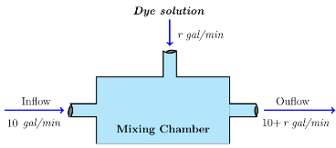









1. 







1. 













 

















***Exercise***

Suppose a brine containing 0.2 *kg* of salt per liter runs into a tank initially filled with 500 *L* of water containing 5 *kg* of salt The brine enter the tank at a rate of . The mixture, kept uniform by stirring, is flowing out at the rate at the same rate.

1. Find the concentration, in , of salt in the tank after 10 *min*.
2. After 10 *min*, a leak develops in the tank and an additional liter per minute of mixture flows out of the tank. What will be the concentration, in , of salt in the tank 20 *min* after the leak develops?

***Solution***

1. 





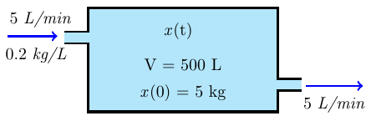

















Concentration of salt in the tank after 10 *min*:



1. 



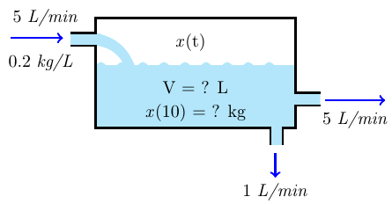



















Concentration of salt in the tank after 20 *min*:



***Solution Section* 1.6 – Exact Differential Equations**

***Exercise***

Solve the differential equation 

***Solution***















***Exercise***

Solve the differential equation 

***Solution***















***Exercise***

Solve the differential equation 

***Solution***















***Exercise***

Solve the differential equation 

***Solution***





















***Exercise***

Solve the differential equation 

***Solution***













***Exercise***

Solve the differential equation 

***Solution***



 









***Exercise***

Find the general solution 

***Solution***

Let 























***Exercise***

Find the general solution 

***Solution***

Let 

 ***Divide both side by*** 













***Exercise***

Find the general solution 

***Solution***

Let 



 ***Divide both side by*** 















***Exercise***

Find the general solution 

***Solution***

Let 

 ***Divide both side by*** 















***Exercise***

Find the general solution 

***Solution***

Let 

 ***Divide both side by*** 















***Exercise***

Find the general solution 

***Solution***

Let 

 ***Divide both side by*** 















***Exercise***

Find the general solution 

***Solution***

Let 

 ***Divide both side by*** 



















***Exercise***

Find the general solution 

***Solution***

Let 

 ***Divide both side by*** 





























***Exercise***

Find the general solution 

***Solution***

Let 



 ***Divide both side by*** 

















***Exercise***

Find the general solution 

***Solution***

Let 



 ***Divide both side by*** 















***Exercise***

Find the general solution 

***Solution***



Let 



 ***Multiply both sides by*** 











***Exercise***

Find the general solution 

***Solution***

 ***Divide by*** 

Let 



 ***Multiply both sides by*** 











***Exercise***

Find the general solution 

***Solution***



 ***Divide by*** 

Let 



 ***Multiply both sides by*** 













***Exercise***

Find the general solution 

***Solution***



 ***Divide both sides by ***

Let 



 ***Multiply both sides by*** 











***Exercise***

Find the general solution 

***Solution***

 ***Divide both sides by ***

Let 



 ***Multiply both sides by*** 











***Exercise***

Find the general solution 

***Solution***

 ***Divide both sides by ***



Let 

 ***Multiply both sides by*** 













***Exercise***

Find the general solution 

***Solution***

Let 















***Exercise***

Find the general solution 

***Solution***

Let 







Let 



 ***Multiply both sides by*** 













***Exercise***

Find the general solution 

***Solution***

Let 





Let 















 







***Exercise***

Find the general solution 

***Solution***



 



Let 



























***Exercise***

Find the general solution 

***Solution***



Let 





 









***Exercise***

Solve the differential equation 

***Solution***















***Exercise***

Solve the differential equation 

***Solution***









 



***Exercise***

Solve the differential equation 

***Solution***

  









***Exercise***

Solve the differential equation 

***Solution***

Multiply both side by  since  

  









***Exercise***

Solve the differential equation 

***Solution***



 









***Exercise***

Solve the differential equation 

***Solution***















***Exercise***

Solve the differential equation 

***Solution***









 



***Exercise***

Solve the differential equation 

***Solution***

  









***Exercise***

Solve the differential equation 

***Solution***

Multiply both side by  since  

  









***Exercise***

Find the general solution 

***Solution***













***Exercise***

Find the general solution 

***Solution***







 



***Exercise***

Find the general solution 

***Solution***











***Exercise***

Find the general solution 

***Solution***













***Exercise***

Find the general solution 

***Solution***







 



***Exercise***

Find the general solution 

***Solution***









 



***Exercise***

Find the general solution 

***Solution***













***Exercise***

Find the general solution 

***Solution***







 



***Exercise***

Find the general solution 

***Solution***







 



***Exercise***

Find the general solution 

***Solution***







 



***Exercise***

Find the general solution 

***Solution***







 





***Exercise***

Find the general solution 

***Solution***









 





***Exercise***

Find the general solution 

***Solution***







 



***Exercise***

Find the general solution 

***Solution***







 



***Exercise***

Find the general solution 

***Solution***







 



***Exercise***

Find the general solution 

***Solution***











 



***Exercise***

Find the general solution 

***Solution***

















***Exercise***

Find the general solution 

***Solution***











***Exercise***

Find the general solution 

***Solution***











***Exercise***

Find the general solution 

***Solution***









 

***Exercise***

Find the general solution 

***Solution***











***Exercise***

Find the general solution 

***Solution***







 



***Exercise***

Find the general solution 

***Solution***











***Exercise***

Find the general solution 

***Solution***











***Exercise***

Find the general solution 

***Solution***











***Exercise***

Find the general solution 

***Solution***











***Exercise***

Find the general solution 

***Solution***



















***Exercise***

The given equation is not exact. However, if you multiply by the given integrating factor, then it becomes exact. Then solve the equation



***Solution***













***Exercise***

The given equation is not exact. However, if you multiply by the given integrating factor, then it becomes exact. Then solve the equation



***Solution***

 













***Exercise***

The given equation is not exact. However, if you multiply by the given integrating factor, then it becomes exact. Then solve the equation



***Solution***

 













***Exercise***

The given equation is not exact. However, if you multiply by the given integrating factor, then it becomes exact. Then solve the equation



***Solution***

 

















***Exercise***

The given equation is not exact. However, if you multiply by the given integrating factor, then it becomes exact. Then solve the equation



***Solution***

















***Exercise***

The given equation is not exact. However, if you multiply by the given integrating factor, then it becomes exact. Then solve the equation



***Solution***



















***Exercise***

The given equation is not exact. However, if you multiply by the given integrating factor, then it becomes exact. Then solve the equation 

***Solution***











 



***Exercise***

Find the general solution of the homogenous equation 

***Solution***

















 

 



***Exercise***

Find the general solution of the homogenous equation 

***Solution***















 









***Exercise***

Find the general solution of the homogenous equation 

***Solution***























***Exercise***

Find an integrating factor and solve the given equation 

***Solution***



















|  |  |
| --- | --- |
|  |  |
|  |  |
|  |  |
|  |  |







 



***Exercise***

Find an integrating factor and solve the given equation 

***Solution***

 *Multiply by* ***y*** *both sides*

|  |  |
| --- | --- |
|  |  |
|  |  |
|  |  |











***Exercise***

Find an integrating factor and solve the given equation 

***Solution***



 *Multiply by* ***siny*** *both sides*









 





***Exercise***

Find an integrating factor and solve the given equation 

***Solution***









 



***Exercise***

Find an integrating factor and solve the given equation 

***Solution***





 









 



***Exercise***

Find an integrating factor and solve the given equation 

***Solution***





 









 



***Exercise***

Find an integrating factor and solve the given equation 

***Solution***





 









 



***Exercise***

Find an integrating factor and solve the given equation 

***Solution***





 









 



***Exercise***

Find an integrating factor and solve the given equation 

***Solution***





 









 



***Exercise***

Find an integrating factor and solve the given equation 

***Solution***





 















***Exercise***

Solve the given initial-value problem 

***Solution***



 



 







 



***Exercise***

Solve the given initial-value problem 

***Solution***

 



 







***Exercise***

Solve the given initial-value problem 

***Solution***













***Exercise***

Solve the given initial-value problem 

***Solution***













***Exercise***

Solve the given initial-value problem 

***Solution***



















***Exercise***

Solve the given initial-value problem 

***Solution***



















***Exercise***

Solve 

***Solution***







 











  



***Exercise***

Solve the given initial-value problem 

***Solution***

Let 





 

 













 





***Exercise***

Solve the given initial-value problem 

***Solution***

















Since 

***Exercise***

Solve the given initial-value problem 

***Solution***













***Exercise***

Solve the given initial-value problem 

***Solution***



















***Exercise***

Solve the given initial-value problem 

***Solution***















***Exercise***

Solve the given initial-value problem 

***Solution***













***Exercise***

Solve the given initial-value problem 

***Solution***















***Exercise***

Solve the given initial-value problem 

***Solution***













***Exercise***

Solve the given initial-value problem 

***Solution***















***Exercise***

Solve the given initial-value problem 

***Solution***















***Exercise***

Solve the given initial-value problem 

***Solution***







 







***Exercise***

Solve the given initial-value problem 

***Solution***





 







***Exercise***

Solve the given initial-value problem 

***Solution***





 







***Exercise***

Solve the given initial-value problem 

***Solution***





 







***Exercise***

Find an integrating factor of the form  and solve the equation



***Solution***







For the equation to be exact, then





















***Exercise***

Find an integrating factor of the form  and solve the equation



***Solution***







For the equation to be exact, then





















***Exercise***

Find the general solution by using either Bernoulli 

***Solution***



Let 





 





|  |  |  |
| --- | --- | --- |
|  |  |  |
| **+** |  |  |
| **−** |  |  |







***Exercise***

Find the general solution by using either Bernoulli 

***Solution***



Let 





 













***Exercise***

Find the general solution by using either Bernoulli 

***Solution***



Let 





 









 

***Exercise***

Find the general solution by using either Bernoulli 

***Solution***



Let  



 













***Exercise***

Find the general solution by using either Bernoulli 

***Solution***



Let 





 











***Exercise***

Find the general solution by using either Bernoulli 

***Solution***





Let 



|  |  |  |
| --- | --- | --- |
|  |  |  |
| **+** |  |  |
| **−** |  |  |

 









 

***Exercise***

Find the general solution by using homogeneous equations. 

***Solution***

 

Let 













***Exercise***

Find the general solution by using homogeneous equations. 

***Solution***





Let 





















***Exercise***

Find the general solution by using homogeneous equations. 

***Solution***





Let 













***Exercise***

Find the general solution by using homogeneous equations. 

***Solution***



Let 











***Exercise***

Find the general solution by using homogeneous equations. 

***Solution***



Let 



















***Exercise***

Find the general solution by using Equation with Linear Coefficients



***Solution***













Let 





















 



***Exercise***

Find the general solution by using Equation with Linear Coefficients



***Solution***













Let 

















 



***Exercise***

Find the general solution by using Equation with Linear Coefficients



***Solution***













Let 

















 

 

***Exercise***

Find the general solution by using Equation with Linear Coefficients



***Solution***













Let 







 

 









 







 



***Exercise***

Prove that  has an integrating factor that depends only on the sum  if and only if the expression

 depends only on 

Use the prove to solve the equation 

***Solution***

An equation  has an integrating factor  iff 

For the equation to be exact, then











































***Exercise***

A portion of a uniform chain of length 8 *feet* is loosely coiled around a peg at the edge of a high horizontal platform, and the remaining portion of the chain hangs at rest over the edge of the platform.

Suppose the length of the overhanging chain is 3 *feet*, that the chain weighs 2 , and that the positive direction is downward. Starting at  seconds, the weight of the overhanging portion causes the chain on the table to uncoil smoothly and to fall to the floor. If  denotes the length of the chain overhanging the table at time , then  is its velocity. When all resistive forces are ignored, it can be shown that a mathematical model relating *v* to *x* is given by



1. Rewrite this model in differential form and solve the *DE* for *v* in terms of *x* by finding am appropriate integrating factor. Find an explicit solution .
2. Determine the velocity with which the chain leaves the platform.

***Solution***

1. 

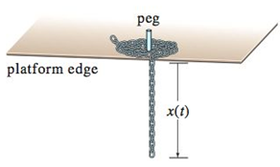

 









 



 



***Given***:  











1. The chain leaves the platform when 

