***SOLUTION Section* 2.1 − Definitions of 2nd and Higher Order Equations**

***Exercise***

Decide whether the equation is linear or nonlinear. For the linear equation, state whether the equation is homogenous or inhomogeneous. 

***Solution***



 It is linear and inhomogeneous

***Exercise***

Decide whether the equation is linear or nonlinear. For the linear equation, state whether the equation is homogenous or inhomogeneous. 

***Solution***



 It is linear and inhomogeneous 

***Exercise***

Decide whether the equation is linear or nonlinear. For the linear equation, state whether the equation is homogenous or inhomogeneous. 

***Solution***

It is nonlinear 

***Exercise***

Decide whether the equation is linear or nonlinear. For the linear equation, state whether the equation is homogenous or inhomogeneous. 

***Solution***

Compare to 

 

Hence, the equation is linear and inhomogeneous.

***Exercise***

Show by direct substitution that the given functions  and  are solutions of the given differential equation. Then verify by direct substitution, that any linear combination  of the 2 given solutions is also a solution.

  

***Solution***









If , then







***Exercise***

Show by direct substitution that the given functions  and  are solutions of the given differential equation. Then verify by direct substitution, that any linear combination  of the 2 given solutions is also a solution.



***Solution***



























If 

















***Exercise***

Explain why  and  are linearly independent solutions. Calculate Wronskian and use it to explain the independence of the given solutions.

  

***Solution***





  
 



The solutions  are linearly independent.

***Exercise***

Show that  and  form a fundamental set of solutions for  then find a solution satisfying  and .

***Solution***

 



 

  



***Exercise***

Use the Wronskian to show that  are linearly independence

***Solution***

The Wronskian is



Thus the functions are linearly independent.

***Exercise***

Determine whether  is a set of linearly independent.

***Solution***









Thus the set  is linearly dependent.

***Exercise***

Show that the functions  are linearly independent.

***Solution***







 are linearly independent.

***Exercise***

Use the substitution  to write each second-order equation as a system of two first-order differential equation.



***Solution***

Let 





The following system of the first-order equations: 

***Exercise***

Use the substitution  to write each second-order equation as a system of two first-order differential equation.



***Solution***

Let 





The following system of the first-order equations: 

***Exercise***

Use the substitution  to write each second-order equation as a system of two first-order differential equation. 

***Solution***

Let 





The following system of the first-order equations: 

***Exercise***

Use the substitution  to write each second-order equation as a system of two first-order differential equation. 

***Solution***

Let 





The following system of the first-order equations:



***Exercise***

Use the substitution  to write each second-order equation as a system of two first-order differential equation. 

***Solution***

Let 







The following system of the first-order equations: 

***Exercise***

Given the mass, damping, and spring constants of an undriven spring-mass system 



1. Provide separate plots of the position versus time (*y* vs. *t*) and the velocity versus time (*v* vs. *t*)
2. Provide a combined plot of both position and velocity versus time
3. Provide a plot of the velocity versus position (*v* vs. *y*) in the *yv* phase plane.

***Solution***





Let  







 

 

***Exercise***

Given the mass, damping, and spring constants of an undriven spring-mass system 



1. Provide separate plots of the position versus time (*y* vs. *t*) and the velocity versus time (*v* vs. *t*)
2. Provide a combined plot of both position and velocity versus time
3. Provide a plot of the velocity versus position (*v* vs. *y*) in the *yv* phase plane.

***Solution***



Let  





The following system of the first-order equations: 

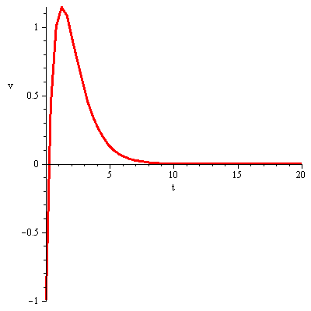 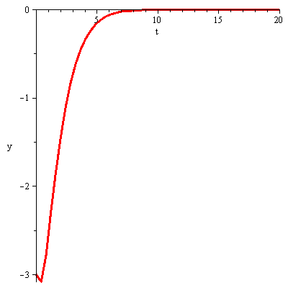

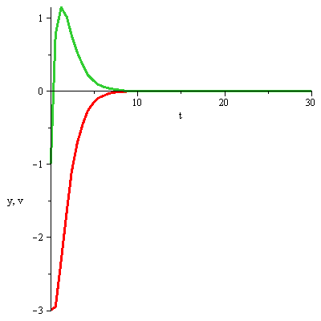 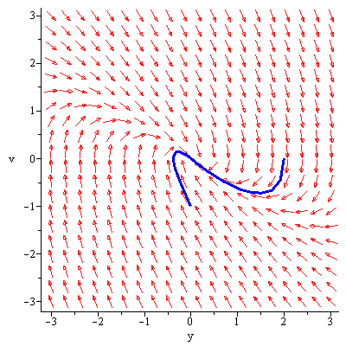

***Solution Section* 2.2 − Linear, Homogeneous Equations with Constant Coefficients**

***Exercise***

Find the general solution: 

***Solution***

The characteristic equation: 





***Exercise***

Find the general solution: 

***Solution***

The characteristic equation: 





***Exercise***

Find the general solution: 

***Solution***

The characteristic equation: 





***Exercise***

Find the general solution: 

***Solution***

The characteristic equation:  



***Exercise***

Find the general solution: 

***Solution***

The characteristic equation:  



***Exercise***

Find the general solution: 

***Solution***

The characteristic equation:  



***Exercise***

Find the general solution: 

***Solution***

The characteristic equation: 



***Exercise***

Find the general solution: 

***Solution***

The characteristic equation: 



***Exercise***

Find the general solution: 

***Solution***

The characteristic equation: 



***Exercise***

Find the general solution: 

***Solution***

The characteristic equation: 



***Exercise***

Find the general solution: 

***Solution***

The characteristic equation: 



***Exercise***

Find the general solution: 

***Solution***

The characteristic equation: 



***Exercise***

Find the general solution: 

***Solution***

The characteristic equation: 



***Exercise***

Find the general solution: 

***Solution***

The characteristic equation: 



***Exercise***

Find the general solution: 

***Solution***

The characteristic equation: 



***Exercise***

Find the general solution: 

***Solution***

The characteristic equation: 



***Exercise***

Find the general solution: 

***Solution***

The characteristic equation: 



***Exercise***

Find the general solution of the given higher-order differential equation: 

***Solution***





***Exercise***

Find the general solution of the given higher-order differential equation: 

***Solution***

|  |  |
| --- | --- |
| ***Solve for λ*** | ***Rational Zero Theorem***: |

***Exercise***

Find the general solution of the given higher-order differential equation: 

***Solution***





***Exercise***

Find the general solution of the given higher−ODE: 

***Solution***

The characteristic equation:



 

The general solution is: 

***Exercise***

Find the general solution of the given higher−ODE: 

***Solution***

The characteristic equation:



 

The general solution is: 

***Exercise***

Find the general solution of the given higher-order differential equation: 

***Solution***







***OR***  

***Exercise***

Find the general solution of the given higher-order differential equation: 

***Solution***







***Exercise***

Find the general solution of the given higher−ODE: 

***Solution***

The characteristic equation: 

Since 







The general solution is: 

***Exercise***

Find the general solution of the given higher−ODE: 

***Solution***

The characteristic equation:



 

 

The general solution is: 

***Exercise***

Find the general solution of the given higher-order differential equation: 

***Solution***







***Exercise***

Find the general solution of the given higher-order differential equation: 

***Solution***

The characteristic equation:



The general solution is: 

***Exercise***

Find the general solution of the given higher-order differential equation 

***Solution***



The solution: 



***Exercise***

Find the general solution: 

***Solution***

The characteristic equation:  

 

 





***Exercise***

Find the general solution: 

***Solution***

The characteristic equation: 















***Exercise***

Find the general solution: 

***Solution***

The characteristic equation: 















***Exercise***

Find the general solution:  

***Solution***

The characteristic equation: 









***Exercise***

Find the solution of the given initial value problem. 

***Solution***

The characteristic equation: 















***Exercise***

Find the solution of the given initial value problem. 

***Solution***

The characteristic equation: 















***Exercise***

Find the solution of the given initial value problem. 

***Solution***

The characteristic equation: 















***Exercise***

Find the solution of the given initial value problem: 

***Solution***

The characteristic equation: 







 



***Exercise***

The roots of the characteristic equation of a certain differential equation are:

3, −5, 0, 0, 0, 0, −5,  and 

Write a general solution of this homogeneous differential equation.

***Solution***

For 

For 

For 

For 



***Exercise***

 is the general solution of a homogeneous equation. What is the equation?

***Solution***









***Solution Section* 2.3 − Harmonic Motion**

***Exercise***



1. Plot the function
2. Place the solution in the form  and compare the graph with the plot in (***i***)

***Solution***

1. Plot the function

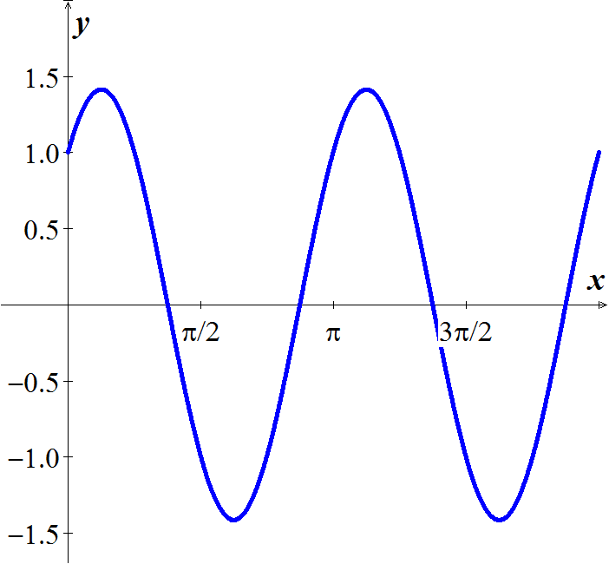

1. Place the solution in the form  and compare the graph with the plot in (***i***)



 

 





***Exercise***



1. Plot the function
2. Place the solution in the form  and compare the graph with the plot in (***i***)

***Solution***

1. Plot the function

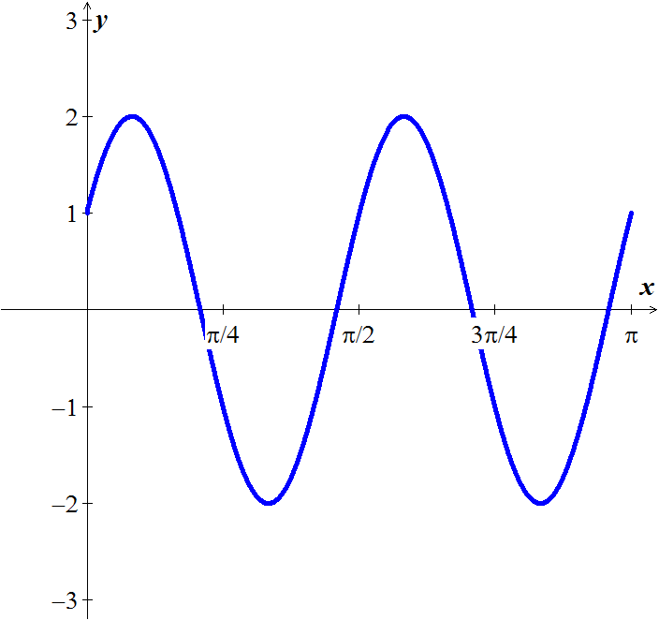 

1. Place the solution in the form  and compare the graph with the plot in (***i***)



 

 







***Exercise***

A 1-kg mass, when attached to a large spring, stretches the spring a distance of 4.9 *m*.

1. Calculate the spring constant.
2. The system is placed in a viscous medium that supplies a damping constant . The system is allowed to come to rest. Then the mass is displaced 1 *m* in the downward direction and given a sharp tap, imparting an instantaneous velocity of 1 *m/s* in the downward direction. Find the position of the mass as a function of time and plot the solution.

***Solution***

1. By Hooke's law: 







1. ***Given: ***



The characteristic equation is:  

The general solution: 

***Exercise***

The undamped system  is observed to have period  and amplitude 2. Find *k* and 

***Solution***



The characteristic equation is:  

It is a complex root, thus we have a complex solution:



The general solution: 

This solution is periodic with period  (since the period is  given)















The amplitude is 2, therefore:









***Exercise***

A body with mass *m* = 0.5 *kg* is attached to the end of a spring that is stretched 2 *m* by a force of 100 *N*. It is set in motion with initial position  and initial velocity . (Note that these initial conditions indicate that he body is displaced to the right and is moving to the left at time *t* = 0.) Find the position function of the body as well as the amplitude, frequency, period of oscillation, and time lag of its motion.

***Solution***

Spring constant: 



The differential equation can be written as:





Period: 

Frequency: 

***Given***: 







Amplitude of motion is: 

Time lag?





Phase angle φ: 

Since  

Time lag of the motion is: 



If it is underdamped, write the position function in the form .

Also find the undamped position function  that would result if the mass on the spring were set in motion with the same initial position and velocity, but with the dashpot disconnected (so ).

Finally, construct a figure that illustrates the effect of damping by comparing the graphs of  and 



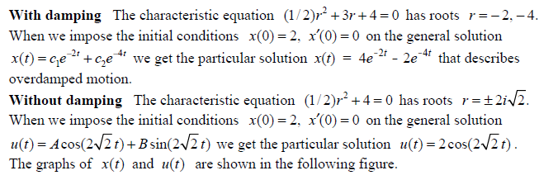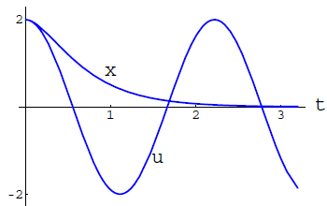



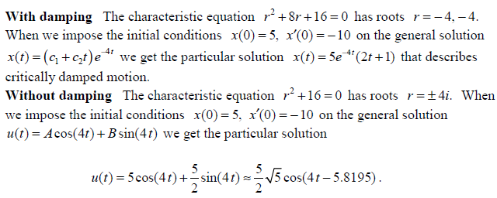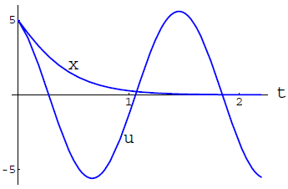



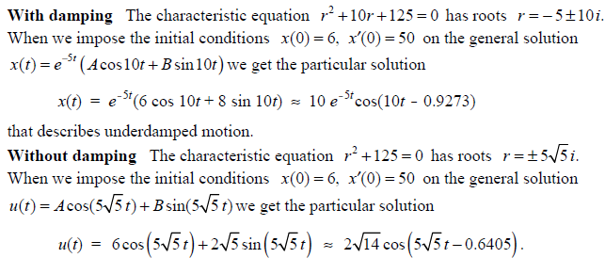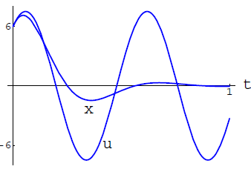



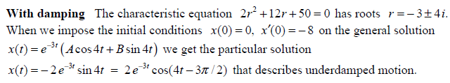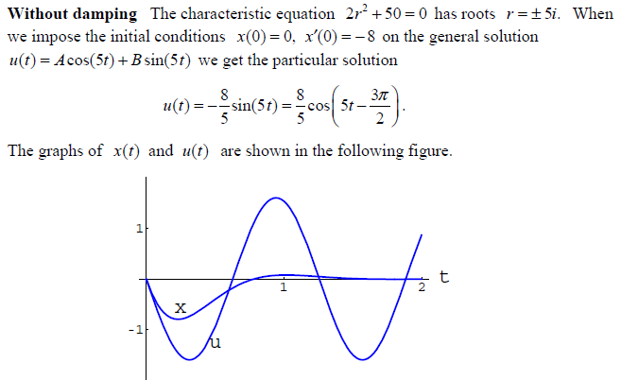



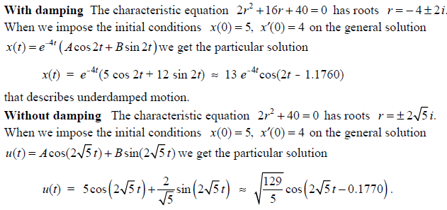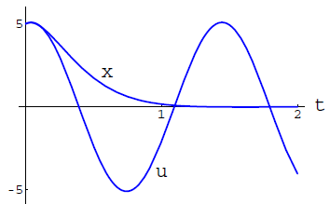



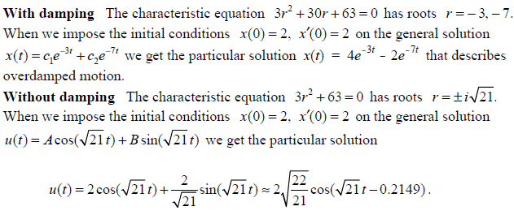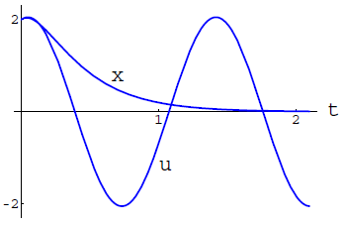

***Solution Section* 2.4 − Inhomogeneous Equations; the Method of Undetermined Coefficients**

***Exercise***

Show that the 3 solutions  of the 3rd order equation

 are linearly independent on an open interval . Then find a particular solution that satisfies the initial conditions 

***Solution***







 are linearly independent.







***Exercise***

Find the particular solution for 

***Solution***

 













The particular solution: 

***Exercise***

Find the particular solution for 

***Solution***















Therefore, the particular solution is: 

***Exercise***

Find the particular solution for 

***Solution***

















The particular solution: 

***Exercise***

Find the particular solution for the given differential equation 

***Solution***



















The particular solution: 

***Exercise***

Use  to find the particular solution for 

***Solution***

The particular solution: 













 

The particular solution: 

***Exercise***

Use  to find the particular solution for 

***Solution***

The particular solution: 















The particular solution: 

***Exercise***

Find the particular solution for 

***Solution***

The particular solution: 















The particular solution: 

***Exercise***

Find the particular solution for 

***Solution***

The particular solution: 













The particular solution: 

***Exercise***

Find the particular solution for 

***Solution***

The particular solution: 













 

The particular solution: 

***Exercise***

Find the particular solution for 

***Solution***

 when *y* = 1

The particular solution: 

























The general solution: 

***Exercise***

Find the particular solution for 

***Solution***

The characteristic eq.: 

The particular solution: 











The homogenous solution: 

Because the inhomogeneous part of  is also the solution.

Therefore: 















Therefore,





***Exercise***

Find the particular solution for 

***Solution***

The particular solution: 



















***Exercise***

Find the particular solution for 

***Solution***

*Characteristic equation*: 

*Homogeneous equation*: 

The particular solution: 



















  



***Exercise***

Use the complex method to find the particular solution for 

***Solution***

The characteristic eq.: 

The homogenous solution: 

The particular solution: 



















This gives the particular solution:







 is a solution of 

 is a solution of 

Therefore;









***Exercise***

Use the complex method to find the particular solution for 

***Solution***

The particular solution: 













***Exercise***

Find the general solution for the given differential equation 

***Solution***

The characteristic equation: 



The particular equation: 













***Exercise***

Find the general solution for the given differential equation 

***Solution***

The characteristic equation: 



The particular equation: 









The particular equation: 













***Exercise***

Find the general solution for the given differential equation 

***Solution***

The characteristic equation: 



The particular equation: 













***Exercise***

Find the general solution for the given differential equation 

***Solution***

The characteristic equation: 



The particular equation: 











The particular equation: 

















***Exercise***

Find the general solution for the given differential equation 

***Solution***

The characteristic equation: 



The particular equation: 









The particular equation: 















***Exercise***

Find the general solution for the given differential equation 

***Solution***

The characteristic equation: 



The particular equation: 















***Exercise***

Find the general solution for the given differential equation 

***Solution***

The characteristic equation: 



The particular equation: 



















***Exercise***

Find a solution to the homogeneous equation; then find a particular solution to form a general solution. Then find the solution satisfying the given initial conditions



***Solution***

The *homogeneous* eq.: 

The *characteristic* eq.: 

























 **(1)**







 **(2)**

 and 



***Exercise***

Find a solution to the homogeneous equation; then find a particular solution to form a general solution. Then find the solution satisfying the given initial conditions



***Solution***

The characteristic eq.: 

The homogenous solution: 

The particular solution: 





















This gives the particular solution:







The real part of this solution  is the particular solution of the system.

Thus, the general solution is:



The initial condition: 











The initial condition: 







The general solution: 

***Exercise***

Find a solution to the homogeneous equation; then find a particular solution to form a general solution. Then find the solution satisfying the given initial conditions



***Solution***

The homogeneous eq.: 

The characteristic eq.: 















The particular solution is: 

The general solution: 













The general solution: 

***Exercise***

Find a solution to the homogeneous equation; then find a particular solution to form a general solution. Then find the solution satisfying the given initial conditions



***Solution***

The homogeneous *eqn*. : 

The characteristic *eqn*. :  











The particular solution is: 

The general solution is: 











The general solution is: 

***Exercise***

Find a solution to the homogeneous equation; then find a particular solution to form a general solution. Then find the solution satisfying the given initial conditions



***Solution***

The characteristic equation: 



The particular equation: 















***Exercise***

Find a solution to the homogeneous equation; then find a particular solution to form a general solution. Then find the solution satisfying the given initial conditions



***Solution***

The characteristic equation: 



The particular equation: 





















***Exercise***

Find a solution to the homogeneous equation; then find a particular solution to form a general solution. Then find the solution satisfying the given initial conditions



***Solution***

The characteristic equation: 



The particular equation: 























***Solution Section* 2.5 − Variation of Parameters**

***Exercise***

 is a fundamental set of solutions of .

Find a particular solution of the equation?

***Solution***



 

 

The particular solution:







The general solution:







***Exercise***

Find a particular solution to: 

***Solution***

The homogeneous equation for the differential equation 

 ***Solve for λ***



Therefore; 



|  |  |
| --- | --- |
|  |  |









***Exercise***

Find a particular solution to: 

***Solution***

The homogeneous equation for the differential equation 

 ***Solve for λ***



Therefore; 



































***Exercise***

Find a particular solution to: 

***Solution***

The homogeneous equation for the differential equation: 

 ***Solve for λ***



Therefore; 







|  |  |
| --- | --- |
|  |  |







***Exercise***

Find a particular solution to: 

***Solution***

The homogeneous equation for the differential equation:   




































***Exercise***

Find a particular solution to the given second-order differential equation 

***Solution***







 











 

The particular solution:







***Exercise***

Find a particular solution to the given second-order differential equation 

***Solution***







 

 

The particular solution:







***Exercise***

Find a particular solution to the given second-order differential equation 

***Solution***







 

 







The particular solution:





***Exercise***

Find a particular solution to the given second-order differential equation 

***Solution***







 

 

The particular solution:









***Exercise***

Verify that  and are solution to the homogenous equation



***Solution***

The homogeneous equation for the differential equation: 

For 







 is a solution

For 







 is a solution

*Wronskian*: 













Thus, the general solution is: 

***Exercise***

Find the general solution to the given differential equation. 

***Solution***

*Characteristic Eqn*.: 

*The homogeneous Eqn*.: 



 

 









***Exercise***

Find the general solution to the given differential equation. 

***Solution***

*Characteristic Eqn*.: 

*The homogeneous Eqn*.: 



 

 



 



***Exercise***

Find the general solution to the given differential equation. 

***Solution***

*Characteristic Eqn*.: 

*The homogeneous Eqn*.: 



 

 

 

The ***general*** solution: 

***Exercise***

Find the general solution to the given differential equation. 

***Solution***

*Characteristic Eqn*.: 

*The homogeneous Eqn*.: 



 

 

 









The ***general*** solution: 

***Exercise***

Find the general solution to the given differential equation. 

***Solution***

*Characteristic Eqn*.: 

*The homogeneous Eqn*.: 



 

 







 







The ***general*** solution: 

***Exercise***

Find the general solution to the given differential equation. 

***Solution***

*Characteristic Eqn*.: 

*The homogeneous Eqn*.: 



 







 





 











The ***general*** solution: 



***Exercise***

Find the general solution to the given differential equation. 

***Solution***

*Characteristic Eqn*.: 

*The homogeneous Eqn*.: 



 

 

 

The ***general*** solution: 

***Exercise***

Find the general solution to the given differential equation. 

***Solution***

*Characteristic Eqn*.: 

*The homogeneous Eqn*.: 



 









 

 





The ***general*** solution: 

***Exercise***

Find the general solution to the given differential equation. 

***Solution***

*Characteristic Eqn*.: 

*The homogeneous Eqn*.: 



 





 

 

The ***general*** solution: 

***Exercise***

Find the general solution to the given differential equation. 

***Solution***

*Characteristic Eqn*.: 

*The homogeneous Eqn*.: 



 





 





 





The ***general*** solution: 

***Exercise***

Find the general solution to the given differential equation. 

***Solution***

*Characteristic Eqn*.: 

The *homogeneous Eqn*.: 



 

 

The *particular* solution:  

The ***general*** solution: 

***Exercise***

Find the general solution to the given differential equation. 

***Solution***

*Characteristic Eqn*.: 

The *homogeneous Eqn*.: 



 

 

The *particular* solution:  



The ***general*** solution: 





***Exercise***

Find the general solution to the given differential equation. 

***Solution***

*Characteristic Eqn*.: 

The *homogeneous Eqn*.: 



 

 

The *particular* solution:  

The ***general*** solution: 

***Exercise***

Find the general solution to the given differential equation. 

***Solution***

*Characteristic Eqn*.: 

The *homogeneous Eqn*.: 



 







 





 





The ***general*** solution: 

***Exercise***

Find the general solution to the given differential equation. 

***Solution***

*Characteristic Eqn*.: 

The *homogeneous Eqn*.: 



 

 



 

 

 







The ***general*** solution: 



***Exercise***

Find the general solution to the given differential equation. 

***Solution***

*Characteristic Eqn*.: 

The *homogeneous Eqn*.: 



 

 

 

The ***general*** solution: 

***Exercise***

Find the general solution to the given differential equation. 

***Solution***

*Characteristic Eqn*.: 

The *homogeneous Eqn*.: 



 

 

 

The ***general*** solution: 

***Exercise***

Find the general solution to the given differential equation. 

***Solution***

*Characteristic Eqn*.: 

The *homogeneous Eqn*.: 



 

 

 

The ***general*** solution: 

***Exercise***

Find the general solution to the given differential equation. 

***Solution***

*Characteristic Eqn*.: 

The *homogeneous Eqn*.: 



 







 













 

The ***general*** solution: 

***Exercise***

Find the general solution to the given differential equation. 

***Solution***

*Characteristic Eqn*.: 

The *homogeneous Eqn*.: 



 

 

The *particular* solution:  

The ***general*** solution: 

***Solution Section* 2.6 − Forced Harmonic Motion**

***Exercise***

A 1-*kg* mass is attached to a spring and the system is allowed to come to rest. The spring-mass system is attached to a machine that supplies external driving force  *Newtons*. The system is started from equilibrium; the mass is having neither initial displacement nor velocity. Ignore any damping forces.

1. Find the position of the mass as a function of time
2. Place your answer in the form . Select an  near the natural frequency of the system to demonstrate the "beating" of the system. Sketch a plot shows the "beats:" and include the envelope of the beating motion in your plot.

***Solution***

***a*)** 

 







***b*)**  





*Mean frequency*: 



*Half difference*: 













If we choose  near to 

That implies to:  and 



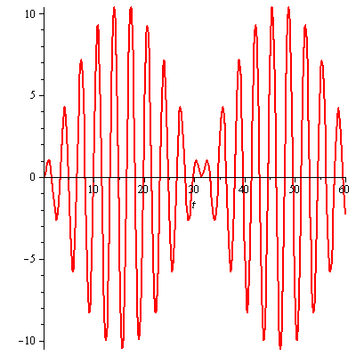

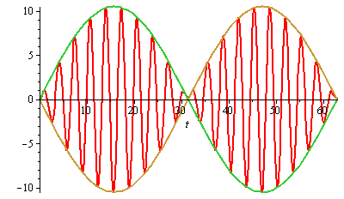

***Exercise***

Find a particular solution to the differential equation using undetermined coefficients. Find and plot the solution of the initial value problem. Superimpose the plots of the transient response and the steady state solution.

 

***Solution***

The particular solution: 















The particular solution (***steady-state*** ***solution***):



The homogeneous eq.: 

The characteristic eq.: 



 

















***Transient response*** ***solution***:



The general solution:



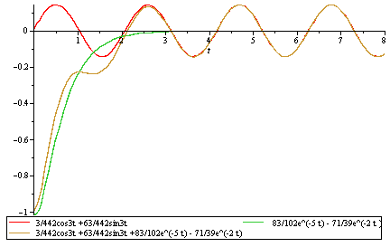

***Complex Method***



The particular solution: 

























The particular solution (***steady-state*** ***solution***):



***Exercise***

Find a particular solution to the differential equation using undetermined coefficients. Find and plot the solution of the initial value problem. Superimpose the plots of the transient response and the steady state solution.



***Solution***



The particular solution: 



























The homogeneous eq.: 

The characteristic eq.: 



 



















The steady-state solution is the particular solution:



The transient response is:





***Exercise***

Find a particular solution of  given the set  where *A, B, C* are to be determined

***Solution***













The particular solution: 

***Solution******Section* 2.7 − Euler's & Runge-Kutta Methods**

***Exercise***

Calculate the first five iterations of Euler's method with step  of



***Solution***

|  |  |
| --- | --- |
| *t* | *y* |
| 0.1 | 1.00000000 |
| 0.2 | 1.01000000 |
| 0.3 | 1.03020000 |
| 0.4 | 1.06110600 |
| 0.5 | 1.10355024 |













***Exercise***

Calculate the first five iterations of Euler's method with step  of



***Solution***

|  |  |
| --- | --- |
| *x* | *z* |
| 0.0 | 1.00000000 |
| 0.1 | 0.80000000 |
| 0.2 | 0. 65000000 |
| 0.3 | 0.54000000 |
| 0.4 | 0.46200000 |
| 0.5 | 0.40960000 |

***Exercise***

Calculate the first five iterations of Euler's method with step  of: 

***Solution***



The *first* step:





The *second* step:





***Euler Method***

***t Approx. Exact Difference***

----------------------------------------------------------------

0.00 | 0.00000000 | 0.00000000 | 0.00000000

0.10 | 0.50000000 | 0.47581291 | -0.02418709

0.20 | 0.95000000 | 0.90634623 | -0.04365377

0.30 | 1.35500000 | 1.29590890 | -0.05909110

0.40 | 1.71950000 | 1.64839977 | -0.07110023

0.50 | 2.04755000 | 1.96734670 | -0.08020330



***Exercise***

Given: 

1. Use a computer and Euler's method to calculate three separate approximate solutions on the interval , one with step size , a second with step size , a second with step size .
2. Use the appropriate analytic to compute the exact solution
3. Plot the exact solution and approximate solutions as discrete points.

***Solution***

|  |  |
| --- | --- |
| *x* | *y* |
| 0.0 | 8.00000000 |
| 0.2 | 8.00000000 |
| 0.4 | 7.40000000 |
| 0.6 | 6.29600000 |
| 0.8 | 4.90496000 |
| 1.0 | 3.49537280 |
| *x* | *y* |
| 0.0 | 8.00000000 |
| 0.1 | 8.00000000 |
| 0.2 | 7.85000000 |
| 0.3 | 7.55600000 |
| 0.4 | 7.13264000 |
| 0.5 | 6.60202880 |
| 0.6 | 5.99182592 |
| 0.7 | 5.33280681 |
| 0.8 | 4.65621386 |
| 0.9 | 3.99121964 |
| 1.0 | 3.36280010 |

|  |  |  |  |
| --- | --- | --- | --- |
| *x* | *y* | *x* | *y* |
| 0.0 | 8.00000000 |  |  |
| 0.05 | 8.00000000 | 0.55 | 6.16870319 |
| 0.10 | 7.96250000 | 0.60 | 5.85692451 |
| 0.15 | 7.88787500 | 0.65 | 5.53550904 |
| 0.20 | 7.77705688 | 0.70 | 5.20820096 |
| 0.25 | 7.63151574 | 0.75 | 4.87862689 |
| 0.30 | 7.45322784 | 0.80 | 4.55022987 |
| 0.35 | 7.24463101 | 0.85 | 4.22621148 |
| 0.40 | 7.00856892 | 0.90 | 3.90948351 |
| 0.45 | 6.74822617 | 0.95 | 3.60262999 |
| 0.50 | 6.46705599 | 1.00 | 3.30788014 |



***t Approx. Exact Difference***

--------------------------------------------------------

0.00 | 8.00000000 | 8.00000000 | 0.00000000

0.20 | 8.00000000 | 7.70592079 | -0.29407921

0.40 | 7.40000000 | 6.89107842 | -0.50892158

0.60 | 6.29600000 | 5.73257245 | -0.56342755

0.80 | 4.90496000 | 4.45469318 | -0.45026682

1.00 | 3.49537280 | 3.25909581 | -0.23627699

***t Approx. Exact Difference***

--------------------------------------------------------

0.00 | 8.00000000 | 8.00000000 | 0.00000000

0.10 | 8.00000000 | 7.92537375 | -0.07462625

0.20 | 7.85000000 | 7.70592079 | -0.14407921

0.30 | 7.55600000 | 7.35448389 | -0.20151611

0.40 | 7.13264000 | 6.89107842 | -0.24156158

0.50 | 6.60202880 | 6.34100587 | -0.26102293

0.60 | 5.99182592 | 5.73257245 | -0.25925347

0.70 | 5.33280681 | 5.09469796 | -0.23810885

0.80 | 4.65621386 | 4.45469318 | -0.20152068

0.90 | 3.99121964 | 3.83643550 | -0.15478414

1.00 | 3.36280010 | 3.25909581 | -0.10370430

***t Approx. Exact Difference***

--------------------------------------------------------

0.00 | 8.00000000 | 8.00000000 | 0.00000000

0.05 | 8.00000000 | 7.98127342 | -0.01872658

0.10 | 7.96250000 | 7.92537375 | -0.03712625

0.15 | 7.88787500 | 7.83313428 | -0.05474072

0.20 | 7.77705688 | 7.70592079 | -0.07113608

0.25 | 7.63151574 | 7.54559797 | -0.08591777

0.30 | 7.45322784 | 7.35448389 | -0.09874395

0.35 | 7.24463101 | 7.13529429 | -0.10933672

0.40 | 7.00856892 | 6.89107842 | -0.11749051

0.45 | 6.74822617 | 6.62514862 | -0.12307755

0.50 | 6.46705599 | 6.34100587 | -0.12605012

0.55 | 6.16870319 | 6.04226366 | -0.12643953

0.60 | 5.85692451 | 5.73257245 | -0.12435207

0.65 | 5.53550904 | 5.41554691 | -0.11996214

0.70 | 5.20820096 | 5.09469796 | -0.11350300

0.75 | 4.87862689 | 4.77337119 | -0.10525570

0.80 | 4.55022987 | 4.45469318 | -0.09553669

0.85 | 4.22621148 | 4.14152671 | -0.08468477

0.90 | 3.90948351 | 3.83643550 | -0.07304801

0.95 | 3.60262999 | 3.54165879 | -0.06097120

1.00 | 3.30788014 | 3.25909581 | -0.04878433

***Exercise***

Given: 

1. Use a computer and Euler's method to calculate three separate approximate solutions on the interval , one with step size , a second with step size , a third with step size .
2. Use the appropriate analytic to compute the exact solution
3. Plot the exact solution and approximate solutions as discrete points.

***Solution***

***a***)

***Euler Method***

***t Approx. Exact Difference***

--------------------------------------------------------

0.00 | 1.00000000 | 1.00000000 | 0.00000000

0.20 | 1.40000000 | 1.52166119 | 0.12166119

0.40 | 2.01967299 | 2.40358420 | 0.38391121

0.60 | 3.00558546 | 3.91773797 | 0.91215251

0.80 | 4.60623367 | 6.53800280 | 1.93176913

1.00 | 7.24121233 | 11.08358415 | 3.84237182

***Euler Method***

***t Approx. Exact Difference***

--------------------------------------------------------

0.00 | 1.00000000 | 1.00000000 | 0.00000000

0.10 | 1.20000000 | 1.22750977 | 0.02750977

0.20 | 1.45221403 | 1.52166119 | 0.06944716

0.30 | 1.77249333 | 1.90411415 | 0.13162082

0.40 | 2.18165556 | 2.40358420 | 0.22192865

0.50 | 2.70700830 | 3.05806706 | 0.35105875

0.60 | 3.38432406 | 3.91773797 | 0.53341391

0.70 | 4.26039588 | 5.04872396 | 0.78832807

0.80 | 5.39633906 | 6.53800280 | 1.14166374

0.90 | 6.87184946 | 8.49975469 | 1.62790522

1.00 | 8.79068763 | 11.08358415 | 2.29289652

***Euler Method***

***t Approx. Exact Difference***

--------------------------------------------------------

0.00 | 1.00000000 | 1.00000000 | 0.00000000

0.05 | 1.10000000 | 1.10655238 | 0.00655238

0.10 | 1.21276293 | 1.22750977 | 0.01474684

0.15 | 1.34014623 | 1.36504472 | 0.02489849

0.20 | 1.48428480 | 1.52166119 | 0.03737639

0.25 | 1.64763153 | 1.70024381 | 0.05261229

0.30 | 1.83300369 | 1.90411415 | 0.07111045

0.35 | 2.04363584 | 2.13709506 | 0.09345922

0.40 | 2.28324010 | 2.40358420 | 0.12034410

0.45 | 2.55607493 | 2.70863793 | 0.15256300

0.50 | 2.86702349 | 3.05806706 | 0.19104356

0.55 | 3.22168289 | 3.45854614 | 0.23686325

0.60 | 3.62646574 | 3.91773797 | 0.29127223

0.65 | 4.08871582 | 4.44443559 | 0.35571976

0.70 | 4.61683955 | 5.04872396 | 0.43188441

0.75 | 5.22045550 | 5.74216412 | 0.52170862

0.80 | 5.91056439 | 6.53800280 | 0.62743841

0.85 | 6.69974213 | 7.45141089 | 0.75166876

0.90 | 7.60235911 | 8.49975469 | 0.89739558

0.95 | 8.63482915 | 9.70290431 | 1.06807516

1.00 | 9.81589205 | 11.08358415 | 1.26769209

***b***) 















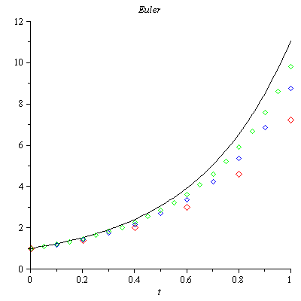

***Exercise***

Consider the initial value problem 

Use Euler's method with step size  to sketch solution on the interval 

***Solution***



***t Approx. Exact Difference***

--------------------------------------------------------

0.00 | 1.00000000 | 1.00000000 | 0.00000000

0.04 | 2.44000000 | 2.77812333 | 0.33812333

0.08 | 4.26707200 | 3.75770045 | -0.50937155

0.12 | 3.72005658 | 3.96254078 | 0.24248419

0.16 | 4.21993115 | 3.99446397 | -0.22546718

0.20 | 3.77444588 | 3.99918742 | 0.22474154

0.24 | 4.18308995 | 3.99988085 | -0.18320910

0.28 | 3.81546672 | 3.99998253 | 0.18451582

0.32 | 4.15342541 | 3.99999744 | -0.15342797

0.36 | 3.84754974 | 3.99999962 | 0.15244989

0.40 | 4.12909852 | 3.99999994 | -0.12909858

0.44 | 3.87322947 | 3.99999999 | 0.12677052

0.48 | 4.10891492 | 4.00000000 | -0.10891492

0.52 | 3.89410430 | 4.00000000 | 0.10589570

0.56 | 4.09204138 | 4.00000000 | -0.09204138

0.60 | 3.91125556 | 4.00000000 | 0.08874444

0.64 | 4.07786461 | 4.00000000 | -0.07786461

0.68 | 3.92545437 | 4.00000000 | 0.07454563

0.72 | 4.06591460 | 4.00000000 | -0.06591460

0.76 | 3.93727310 | 4.00000000 | 0.06272690

0.80 | 4.05582011 | 4.00000000 | -0.05582011

0.84 | 3.94714987 | 4.00000000 | 0.05285013

0.88 | 4.04728141 | 4.00000000 | -0.04728141

0.92 | 3.95542805 | 4.00000000 | 0.04457195

0.96 | 4.04005260 | 4.00000000 | -0.04005260

1.00 | 3.96238159 | 4.00000000 | 0.03761841

1.04 | 4.03392967 | 4.00000000 | -0.03392967

1.08 | 3.96823212 | 4.00000000 | 0.03176788

1.12 | 4.02874204 | 4.00000000 | -0.02874204

1.16 | 3.97316079 | 4.00000000 | 0.02683921

1.20 | 4.02434630 | 4.00000000 | -0.02434630

1.24 | 3.97731688 | 4.00000000 | 0.02268312

1.28 | 4.02062150 | 4.00000000 | -0.02062150

1.32 | 3.98082411 | 4.00000000 | 0.01917589

1.36 | 4.01746532 | 4.00000000 | -0.01746532

1.40 | 3.98378549 | 4.00000000 | 0.01621451

1.44 | 4.01479115 | 4.00000000 | -0.01479115

1.48 | 3.98628712 | 4.00000000 | 0.01371288

1.52 | 4.01252558 | 4.00000000 | -0.01252558

1.56 | 3.98840115 | 4.00000000 | 0.01159885

1.60 | 4.01060636 | 4.00000000 | -0.01060636

1.64 | 3.99018815 | 4.00000000 | 0.00981185

1.68 | 4.00898069 | 4.00000000 | -0.00898069

1.72 | 3.99169905 | 4.00000000 | 0.00830095

1.76 | 4.00760380 | 4.00000000 | -0.00760380

1.80 | 3.99297675 | 4.00000000 | 0.00702325

1.84 | 4.00643771 | 4.00000000 | -0.00643771

1.88 | 3.99405741 | 4.00000000 | 0.00594259

1.92 | 4.00545023 | 4.00000000 | -0.00545023

1.96 | 3.99497153 | 4.00000000 | 0.00502847

2.00 | 4.00461405 | 4.00000000 | -0.00461405

***Exercise***

You've seen that the error in Euler's method varies directly as the first power of the step size . This makes Euler's method an order to halve the error? How does this affect the number of required iterations?

***Solution***

Because  halving the step size should halve the error.



The number of iterations is given by: , therefore halving the step size should double the number of iterations.



***Exercise***

Use Euler’s method to provide an approximate solution over the given time interval using the given steps sizes. Provide a plot of ***v*** versus ***y*** for each step size



***Solution***

|  |  |
| --- | --- |
| ***h* = 0.1** | ***h* = 0.01** |

|  |  |
| --- | --- |
| ***h* = 0.001** |  |

***Exercise***



1. Use a computer and Runge-Kutta method to calculate three separate approximate solutions on the interval , one with step size , a second with step size , a second with step size .
2. Use the appropriate analytic to compute the exact solution
3. Plot the exact solution and approximate solutions as discrete points.

***Solution***



***Runge-Kutta* 2*nd Order***

t Approx. Exact Difference

--------------------------------------------------------

0.00 | 1.00000000 | 1.00000000 | 0.00000000

0.20 | 0.99800666 | 0.99873333 | 0.00072667

0.40 | 0.98887689 | 0.99039969 | 0.00152281

0.60 | 0.96709749 | 0.96939486 | 0.00229738

0.80 | 0.92871746 | 0.93169588 | 0.00297842

1.00 | 0.87131508 | 0.87482637 | 0.00351128

***Runge-Kutta* 4*th Order***

t Approx. Exact Difference

--------------------------------------------------------

0.00 | 1.00000000 | 1.00000000 | 0.00000000

0.20 | 0.99873272 | 0.99873333 | 0.00000061

0.40 | 0.99039822 | 0.99039969 | 0.00000147

0.60 | 0.96939245 | 0.96939486 | 0.00000241

0.80 | 0.93169258 | 0.93169588 | 0.00000330

1.00 | 0.87482232 | 0.87482637 | 0.00000405

***Runge-Kutta* 2*nd Order***

t Approx. Exact Difference

--------------------------------------------------------

0.00 | 1.00000000 | 1.00000000 | 0.00000000

0.10 | 0.99975021 | 0.99983750 | 0.00008729

0.20 | 0.99855245 | 0.99873333 | 0.00018088

0.30 | 0.99555979 | 0.99583746 | 0.00027767

0.40 | 0.99002480 | 0.99039969 | 0.00037489

0.50 | 0.98129932 | 0.98176938 | 0.00047006

0.60 | 0.96883388 | 0.96939486 | 0.00056098

0.70 | 0.95217687 | 0.95282259 | 0.00064572

0.80 | 0.93097330 | 0.93169588 | 0.00072258

0.90 | 0.90496314 | 0.90575327 | 0.00079013

1.00 | 0.87397921 | 0.87482637 | 0.00084716

***Runge-Kutta* 4*th Order***

t Approx. Exact Difference

--------------------------------------------------------

0.00 | 1.00000000 | 1.00000000 | 0.00000000

0.10 | 0.99983748 | 0.99983750 | 0.00000002

0.20 | 0.99873329 | 0.99873333 | 0.00000004

0.30 | 0.99583739 | 0.99583746 | 0.00000007

0.40 | 0.99039960 | 0.99039969 | 0.00000009

0.50 | 0.98176926 | 0.98176938 | 0.00000012

0.60 | 0.96939471 | 0.96939486 | 0.00000015

0.70 | 0.95282241 | 0.95282259 | 0.00000018

0.80 | 0.93169568 | 0.93169588 | 0.00000020

0.90 | 0.90575304 | 0.90575327 | 0.00000023

1.00 | 0.87482612 | 0.87482637 | 0.00000025

***Runge-Kutta* 2*nd Order***

t Approx. Exact Difference

--------------------------------------------------------

0.00 | 1.00000000 | 1.00000000 | 0.00000000

0.05 | 0.99996876 | 0.99997943 | 0.00001067

0.10 | 0.99981570 | 0.99983750 | 0.00002180

0.15 | 0.99942531 | 0.99945859 | 0.00003328

0.20 | 0.99868831 | 0.99873333 | 0.00004502

0.25 | 0.99750164 | 0.99755858 | 0.00005694

0.30 | 0.99576852 | 0.99583746 | 0.00006894

0.35 | 0.99339836 | 0.99347931 | 0.00008094

0.40 | 0.99030682 | 0.99039969 | 0.00009287

0.45 | 0.98641574 | 0.98652039 | 0.00010465

0.50 | 0.98165315 | 0.98176938 | 0.00011623

0.55 | 0.97595326 | 0.97608078 | 0.00012752

0.60 | 0.96925639 | 0.96939486 | 0.00013847

0.65 | 0.96150896 | 0.96165799 | 0.00014903

0.70 | 0.95266344 | 0.95282259 | 0.00015915

0.75 | 0.94267832 | 0.94284709 | 0.00016877

0.80 | 0.93151803 | 0.93169588 | 0.00017785

0.85 | 0.91915289 | 0.91933924 | 0.00018635

0.90 | 0.90555903 | 0.90575327 | 0.00019423

0.95 | 0.89071835 | 0.89091981 | 0.00020146

1.00 | 0.87461836 | 0.87482637 | 0.00020801

***Runge-Kutta* 4*th Order***

t y y(t) Difference

--------------------------------------------------------

0.00 | 1.00000000 | 1.00000000 | 0.00000000

0.05 | 0.99997943 | 0.99997943 | 0.00000000

0.10 | 0.99983750 | 0.99983750 | 0.00000000

0.15 | 0.99945859 | 0.99945859 | 0.00000000

0.20 | 0.99873333 | 0.99873333 | 0.00000000

0.25 | 0.99755858 | 0.99755858 | 0.00000000

0.30 | 0.99583745 | 0.99583746 | 0.00000000

0.35 | 0.99347930 | 0.99347931 | 0.00000001

0.40 | 0.99039969 | 0.99039969 | 0.00000001

0.45 | 0.98652039 | 0.98652039 | 0.00000001

0.50 | 0.98176937 | 0.98176938 | 0.00000001

0.55 | 0.97608077 | 0.97608078 | 0.00000001

0.60 | 0.96939485 | 0.96939486 | 0.00000001

0.65 | 0.96165798 | 0.96165799 | 0.00000001

0.70 | 0.95282258 | 0.95282259 | 0.00000001

0.75 | 0.94284708 | 0.94284709 | 0.00000001

0.80 | 0.93169587 | 0.93169588 | 0.00000001

0.85 | 0.91933923 | 0.91933924 | 0.00000001

0.90 | 0.90575325 | 0.90575327 | 0.00000001

0.95 | 0.89091979 | 0.89091981 | 0.00000001

1.00 | 0.87482635 | 0.87482637 | 0.00000002

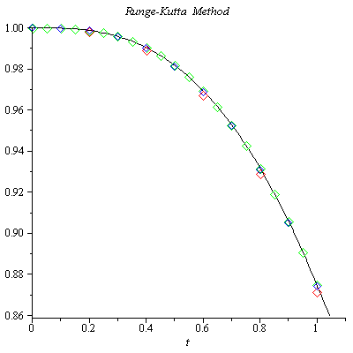

***Exercise***

Given 

1. Use a computer and Runge-Kutta method to calculate three separate approximate solutions on the interval , one with step size , a second with step size , a second with step size .
2. Use the appropriate analytic to compute the exact solution
3. Plot the exact solution and approximate solutions as discrete points.

***Solution***

***Runge-Kutta* 2*th Order***

***t Approx. Exact Difference***

--------------------------------------------------------

0.00 | 1.00000000 | 1.00000000 | 0.00000000

0.20 | 1.01961161 | 1.01980390 | 0.00019229

0.40 | 1.07636229 | 1.07703296 | 0.00067067

0.60 | 1.16495094 | 1.16619038 | 0.00123944

0.80 | 1.27887002 | 1.28062485 | 0.00175483

1.00 | 1.41205020 | 1.41421356 | 0.00216336

***Runge-Kutta* 4*th Order***

***t Approx. Exact Difference***

--------------------------------------------------------

0.00 | 1.00000000 | 1.00000000 | 0.00000000

0.20 | 1.01980437 | 1.01980390 | -0.00000046

0.40 | 1.07703431 | 1.07703296 | -0.00000135

0.60 | 1.16619234 | 1.16619038 | -0.00000196

0.80 | 1.28062701 | 1.28062485 | -0.00000216

1.00 | 1.41421570 | 1.41421356 | -0.00000214

***Runge-Kutta* 2*th Order***

***t Approx. Exact Difference***

--------------------------------------------------------

0.00 | 1.00000000 | 1.00000000 | 0.00000000

0.10 | 1.00497519 | 1.00498756 | 0.00001238

0.20 | 1.01975618 | 1.01980390 | 0.00004772

0.30 | 1.04392938 | 1.04403065 | 0.00010127

0.40 | 1.07686631 | 1.07703296 | 0.00016665

0.50 | 1.11779652 | 1.11803399 | 0.00023747

0.60 | 1.16588199 | 1.16619038 | 0.00030839

0.70 | 1.22027989 | 1.22065556 | 0.00037567

0.80 | 1.28018776 | 1.28062485 | 0.00043708

0.90 | 1.34487075 | 1.34536240 | 0.00049165

1.00 | 1.41367433 | 1.41421356 | 0.00053923

***Runge-Kutta* 4*th Order***

***t Approx. Exact Difference***

--------------------------------------------------------

0.00 | 1.00000000 | 1.00000000 | 0.00000000

0.10 | 1.00498757 | 1.00498756 | -0.00000001

0.20 | 1.01980393 | 1.01980390 | -0.00000003

0.30 | 1.04403071 | 1.04403065 | -0.00000006

0.40 | 1.07703304 | 1.07703296 | -0.00000008

0.50 | 1.11803409 | 1.11803399 | -0.00000010

0.60 | 1.16619050 | 1.16619038 | -0.00000012

0.70 | 1.22065569 | 1.22065556 | -0.00000013

0.80 | 1.28062498 | 1.28062485 | -0.00000013

0.90 | 1.34536254 | 1.34536240 | -0.00000013

1.00 | 1.41421369 | 1.41421356 | -0.00000013

***Runge-Kutta* 2*th Order***

***t Approx. Exact Difference***

--------------------------------------------------------

0.00 | 1.00000000 | 1.00000000 | 0.00000000

0.05 | 1.00124844 | 1.00124922 | 0.00000078

0.10 | 1.00498447 | 1.00498756 | 0.00000309

0.15 | 1.01118058 | 1.01118742 | 0.00000684

0.20 | 1.01979199 | 1.01980390 | 0.00001191

0.25 | 1.03075829 | 1.03077641 | 0.00001812

0.30 | 1.04400537 | 1.04403065 | 0.00002528

0.35 | 1.05944783 | 1.05948101 | 0.00003317

0.40 | 1.07699136 | 1.07703296 | 0.00004160

0.45 | 1.09653524 | 1.09658561 | 0.00005037

0.50 | 1.11797470 | 1.11803399 | 0.00005929

0.55 | 1.14120301 | 1.14127122 | 0.00006821

0.60 | 1.16611337 | 1.16619038 | 0.00007701

0.65 | 1.19260047 | 1.19268604 | 0.00008557

0.70 | 1.22056174 | 1.22065556 | 0.00009382

0.75 | 1.24989830 | 1.25000000 | 0.00010170

0.80 | 1.28051568 | 1.28062485 | 0.00010917

0.85 | 1.31232426 | 1.31244047 | 0.00011621

0.90 | 1.34523959 | 1.34536240 | 0.00012281

0.95 | 1.37918245 | 1.37931142 | 0.00012898

1.00 | 1.41407885 | 1.41421356 | 0.00013471

***Runge-Kutta* 4*th Order***

***t Approx. Exact Difference***

--------------------------------------------------------

0.00 | 1.00000000 | 1.00000000 | 0.00000000

0.05 | 1.00124922 | 1.00124922 | -0.00000000

0.10 | 1.00498756 | 1.00498756 | -0.00000000

0.15 | 1.01118742 | 1.01118742 | -0.00000000

0.20 | 1.01980390 | 1.01980390 | -0.00000000

0.25 | 1.03077641 | 1.03077641 | -0.00000000

0.30 | 1.04403065 | 1.04403065 | -0.00000000

0.35 | 1.05948101 | 1.05948101 | -0.00000000

0.40 | 1.07703297 | 1.07703296 | -0.00000001

0.45 | 1.09658562 | 1.09658561 | -0.00000001

0.50 | 1.11803400 | 1.11803399 | -0.00000001

0.55 | 1.14127123 | 1.14127122 | -0.00000001

0.60 | 1.16619039 | 1.16619038 | -0.00000001

0.65 | 1.19268605 | 1.19268604 | -0.00000001

0.70 | 1.22065557 | 1.22065556 | -0.00000001

0.75 | 1.25000001 | 1.25000000 | -0.00000001

0.80 | 1.28062486 | 1.28062485 | -0.00000001

0.85 | 1.31244048 | 1.31244047 | -0.00000001

0.90 | 1.34536241 | 1.34536240 | -0.00000001

0.95 | 1.37931143 | 1.37931142 | -0.00000001

1.00 | 1.41421357 | 1.41421356 | -0.00000001

1. The equation is separable:





















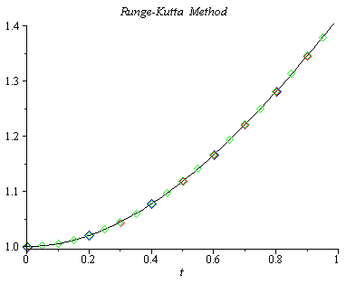

***Exercise***

Consider the initial value problem 

Use Runge-Kutta method with step size  to sketch solution on the interval 

***Solution***



***Runge-Kutta* 4*th Order***

t Approx. Exact Difference

--------------------------------------------------------

0.00 | 1.00000000 | 1.00000000 | 0.00000000

0.04 | 1.00079936 | 1.00079936 | -0.00000000

0.08 | 1.00318981 | 1.00318981 | -0.00000000

0.12 | 1.00714877 | 1.00714877 | -0.00000000

0.16 | 1.01263957 | 1.01263957 | -0.00000000

0.20 | 1.01961283 | 1.01961282 | -0.00000000

0.24 | 1.02800822 | 1.02800822 | -0.00000000

0.28 | 1.03775651 | 1.03775651 | -0.00000000

0.32 | 1.04878166 | 1.04878166 | -0.00000001

0.36 | 1.06100297 | 1.06100297 | -0.00000001

0.40 | 1.07433708 | 1.07433707 | -0.00000001

0.44 | 1.08869975 | 1.08869974 | -0.00000001

0.48 | 1.10400743 | 1.10400742 | -0.00000001

0.52 | 1.12017855 | 1.12017854 | -0.00000001

0.56 | 1.13713450 | 1.13713449 | -0.00000001

0.60 | 1.15480036 | 1.15480035 | -0.00000001

0.64 | 1.17310545 | 1.17310544 | -0.00000001

0.68 | 1.19198361 | 1.19198360 | -0.00000001

0.72 | 1.21137336 | 1.21137335 | -0.00000001

0.76 | 1.23121787 | 1.23121787 | -0.00000001

0.80 | 1.25146496 | 1.25146495 | -0.00000001

0.84 | 1.27206683 | 1.27206682 | -0.00000001

0.88 | 1.29297992 | 1.29297991 | -0.00000001

0.92 | 1.31416464 | 1.31416463 | -0.00000001

0.96 | 1.33558509 | 1.33558508 | -0.00000001

1.00 | 1.35720882 | 1.35720881 | -0.00000001

1.04 | 1.37900650 | 1.37900650 | -0.00000001

1.08 | 1.40095174 | 1.40095173 | -0.00000001

1.12 | 1.42302075 | 1.42302075 | -0.00000001

1.16 | 1.44519217 | 1.44519216 | -0.00000001

1.20 | 1.46744679 | 1.46744678 | -0.00000001

1.24 | 1.48976740 | 1.48976739 | -0.00000001

1.28 | 1.51213855 | 1.51213854 | -0.00000001

1.32 | 1.53454641 | 1.53454640 | -0.00000001

1.36 | 1.55697860 | 1.55697859 | -0.00000001

1.40 | 1.57942403 | 1.57942403 | -0.00000001

1.44 | 1.60187281 | 1.60187281 | -0.00000001

1.48 | 1.62431609 | 1.62431608 | -0.00000001

1.52 | 1.64674596 | 1.64674596 | -0.00000001

1.56 | 1.66915540 | 1.66915539 | -0.00000001

1.60 | 1.69153812 | 1.69153811 | -0.00000001

1.64 | 1.71388854 | 1.71388853 | -0.00000001

1.68 | 1.73620170 | 1.73620169 | -0.00000001

1.72 | 1.75847320 | 1.75847319 | -0.00000001

1.76 | 1.78069914 | 1.78069913 | -0.00000001

1.80 | 1.80287607 | 1.80287606 | -0.00000000

1.84 | 1.82500094 | 1.82500094 | -0.00000000

1.88 | 1.84707109 | 1.84707109 | -0.00000000

1.92 | 1.86908417 | 1.86908417 | -0.00000000

1.96 | 1.89103813 | 1.89103813 | -0.00000000

2.00 | 1.91293119 | 1.91293118 | -0.00000000