***SOLUTION Section* 2.1 − Definitions of 2*nd* and Higher Order Equations**

***Exercise***

Decide whether the equation is linear or nonlinear. For the linear equation, state whether the equation is homogenous or inhomogeneous. 

***Solution***



 It is linear and inhomogeneous

***Exercise***

Decide whether the equation is linear or nonlinear. For the linear equation, state whether the equation is homogenous or inhomogeneous. 

***Solution***



 It is linear and inhomogeneous 

***Exercise***

Decide whether the equation is linear or nonlinear. For the linear equation, state whether the equation is homogenous or inhomogeneous. 

***Solution***

It is nonlinear  

***Exercise***

Decide whether the equation is linear or nonlinear. For the linear equation, state whether the equation is homogenous or inhomogeneous. 

***Solution***

Compare to 

 

Hence, the equation is linear and inhomogeneous.

***Exercise***

Show by direct substitution that the given functions  and  are solutions of the given differential equation. Then verify by direct substitution, that any linear combination  of the 2 given solutions is also a solution.

  

***Solution***









If , then







***Exercise***

Show by direct substitution that the given functions  and  are solutions of the given differential equation. Then verify by direct substitution, that any linear combination  of the 2 given solutions is also a solution.



***Solution***



























If 

















***Exercise***

Explain why  and  are linearly independent solutions. Calculate Wronskian and use it to explain the independence of the given solutions.

  

***Solution***





  
 



The solutions  are linearly independent.

***Exercise***

Show that  and  form a fundamental set of solutions for  then find a solution satisfying  and .

***Solution***

 



 

  



***Exercise***

Use the Wronskian to show that are linearly independence 

***Solution***







Thus the functions are linearly independent.

***Exercise***

Use the Wronskian to show that are linearly independence 

***Solution***

The Wronskian is



Thus the functions are linearly independent.

***Exercise***

Use the Wronskian to show that are linearly independence 

***Solution***









Thus the set  is linearly dependent.

***Exercise***

Use the Wronskian to show that are linearly independence



***Solution***







 are linearly independent.

***Exercise***

Use the Wronskian to show that are linearly independence 

***Solution***







 are linearly independent.

***Exercise***

Use the Wronskian to show that are linearly independence



***Solution***

Since  & 



Let: 



The set of functions are linearly dependent.

***Exercise***

Determine whether the functions  and  are linearly dependent on the interval 



***Solution***





The given functions are linearly dependent.

***Exercise***

Determine whether the functions  and  are linearly dependent on the interval 



***Solution***





Since an exponential function is strictly monotone, this is a contradiction.

Hence, given functions are linearly independent on 

***Exercise***

Determine whether the functions  and  are linearly dependent on the interval 



***Solution***





Hence, given functions are linearly independent on 

***Exercise***

Determine whether the functions  and  are linearly dependent on the interval 



***Solution***





Hence, given functions are linearly independent on 

***Exercise***

Determine whether the functions  and  are linearly dependent on the interval 



***Solution***





The given functions are linearly dependent.

***Exercise***

Determine whether the functions  and  are linearly dependent on the interval 



***Solution***





The given functions are linearly dependent.

***Exercise***

Use the substitution  to write each second-order equation as a system of two first-order differential equation.



***Solution***

Let 





The following system of the first-order equations: 

***Exercise***

Use the substitution  to write each second-order equation as a system of two first-order differential equation.



***Solution***

Let 





The following system of the first-order equations: 

***Exercise***

Use the substitution  to write each second-order equation as a system of two first-order differential equation. 

***Solution***

Let 





The following system of the first-order equations: 

***Exercise***

Use the substitution  to write each second-order equation as a system of two first-order differential equation. 

***Solution***

Let 





The following system of the first-order equations:



***Exercise***

Use the substitution  to write each second-order equation as a system of two first-order differential equation. 

***Solution***

Let 







The following system of the first-order equations: 

***Exercise***

Given the mass, damping, and spring constants of an undriven spring-mass system 



1. Provide separate plots of the position versus time (*y* vs. *t*) and the velocity versus time (*v* vs. *t*)
2. Provide a combined plot of both position and velocity versus time
3. Provide a plot of the velocity versus position (*v* vs. *y*) in the *yv* phase plane.

***Solution***





Let  







 

 

***Exercise***

Given the mass, damping, and spring constants of an undriven spring-mass system 



1. Provide separate plots of the position versus time (*y* vs. *t*) and the velocity versus time (*v* vs. *t*)
2. Provide a combined plot of both position and velocity versus time
3. Provide a plot of the velocity versus position (*v* vs. *y*) in the *yv* phase plane.

***Solution***



Let  





The following system of the first-order equations: 

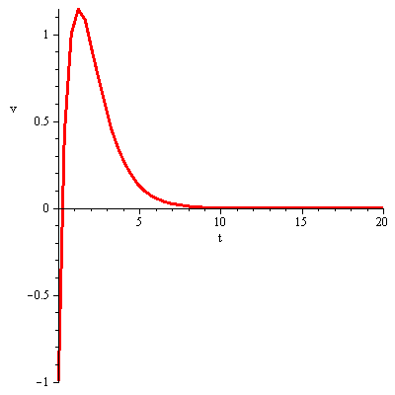 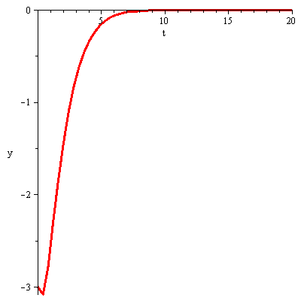

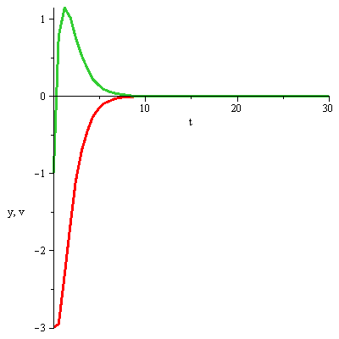 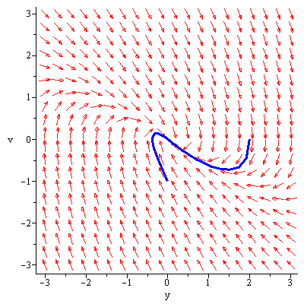

***Exercise***

When the values of a solution to a differential equation are specified at two different points, these conditions. (In contrast, initial conditions specify the values of a function and its derivative at the same point). The purpose of this is to show that for boundary value problems there is no existence-uniqueness theorem. Given that every solution to

 is of the form 

Where  and  are arbitrary constants, show that

1. There is a unique solution to the given differential equation that satisfies the boundary conditions  and 
2. There is no solution to given equation that satisfies  and 
3. There are infinitely many solution to the given DE equation that satisfy  and 

***Solution***

1. 









1. 



This system is inconsistent, so there is no solution satisfying the given boundary.

1. 





Which has infinitely many solutions given  is an arbitrary constant.

***Solution Section* 2.2 − Linear, Homogeneous Equations with Constant Coefficients**

***Exercise***

Find the general solution: 

***Solution***

The characteristic equation: 



***Exercise***

Find the general solution: 

***Solution***

The characteristic equation: 



***Exercise***

Find the general solution: 

***Solution***

The characteristic equation: 



***Exercise***

Find the general solution: 

***Solution***

The characteristic equation: 



***Exercise***

Find the general solution: 

***Solution***

The characteristic equation: 



***Exercise***

Find the general solution: 

***Solution***

The characteristic equation: 



***Exercise***

Find the general solution: 

***Solution***

The characteristic equation: 



***Exercise***

Find the general solution: 

***Solution***

The characteristic equation: 



***Exercise***

Find the general solution: 

***Solution***

The characteristic equation: 



***Exercise***

Find the general solution: 

***Solution***

The characteristic equation: 



***Exercise***

Find the general solution: 

***Solution***

The characteristic equation: 



***Exercise***

Find the general solution: 

***Solution***

The characteristic equation: 



***Exercise***

Find the general solution: 

***Solution***

The characteristic equation: 



***Exercise***

Find the general solution: 

***Solution***

The characteristic equation: 



***Exercise***

Find the general solution: 

***Solution***

The characteristic equation:  



***Exercise***

Find the general solution: 

***Solution***

The characteristic equation:  



***Exercise***

Find the general solution: 

***Solution***

The characteristic equation:  



***Exercise***

Find the general solution: 

***Solution***

The characteristic equation:  



***Exercise***

Find the general solution: 

***Solution***

The characteristic equation:  



***Exercise***

Find the general solution: 

***Solution***

The characteristic equation:  



***Exercise***

Find the general solution: 

***Solution***

The characteristic equation:  



***Exercise***

Find the general solution: 

***Solution***

The characteristic equation:  



***Exercise***

Find the general solution: 

***Solution***

The characteristic equation:  



***Exercise***

Find the general solution: 

***Solution***

The characteristic equation: 



***Exercise***

Find the general solution: 

***Solution***

The characteristic equation: 



***Exercise***

Find the general solution: 

***Solution***

The characteristic equation: 



***Exercise***

Find the general solution: 

***Solution***

The characteristic equation:  



***Exercise***

Find the general solution: 

***Solution***

The characteristic equation:  



***Exercise***

Find the general solution: 

***Solution***

The characteristic equation: 



***Exercise***

Find the general solution: 

***Solution***

The characteristic equation: 



***Exercise***

Find the general solution: 

***Solution***

The characteristic equation: 



***Exercise***

Find the general solution: 

***Solution***

The characteristic equation: 



***Exercise***

Find the general solution: 

***Solution***

The characteristic equation: 



***Exercise***

Find the general solution: 

***Solution***

The characteristic equation: 



***Exercise***

Find the general solution: 

***Solution***

The characteristic equation: 



***Exercise***

Find the general solution: 

***Solution***

The characteristic equation:  



***Exercise***

Find the general solution: 

***Solution***

The characteristic equation:  



***Exercise***

Find the general solution: 

***Solution***

The characteristic equation: 



***Exercise***

Find the general solution: 

***Solution***

The characteristic equation: 



***Exercise***

Find the general solution: 

***Solution***

The characteristic equation: 



***Exercise***

Find the general solution: 

***Solution***

The characteristic equation: 



***Exercise***

Find the general solution: 

***Solution***

The characteristic equation: 



***Exercise***

Find the general solution: 

***Solution***

The characteristic equation: 



***Exercise***

Find the general solution: 

***Solution***

The characteristic equation: 



***Exercise***

Find the general solution: 

***Solution***

The characteristic equation: 



***Exercise***

Find the general solution: 

***Solution***

The characteristic equation: 



***Exercise***

Find the general solution: 

***Solution***

The characteristic equation: 



***Exercise***

Find the general solution: 

***Solution***

The characteristic equation: 



***Exercise***

Find the general solution: 

***Solution***

The characteristic equation: 



***Exercise***

Find the general solution: 

***Solution***

The characteristic equation: 



***Exercise***

Find the general solution: 

***Solution***

The characteristic equation: 



***Exercise***

Find the general solution: 

***Solution***

The characteristic equation: 



***Exercise***

Find the general solution: 

***Solution***

The characteristic equation: 



***Exercise***

Find the general solution: 

***Solution***

The characteristic equation: 



***Exercise***

Find the general solution: 

***Solution***

The characteristic equation: 



***Exercise***

Find the general solution: 

***Solution***

The characteristic equation: 



***Exercise***

Find the general solution: 

***Solution***

The characteristic equation: 



***Exercise***

Find the general solution: 

***Solution***

The characteristic equation: 



***Exercise***

Find the general solution: 

***Solution***

The characteristic equation: 



***Exercise***

Find the general solution: 

***Solution***

The characteristic equation: 



***Exercise***

Find the general solution: 

***Solution***

The characteristic equation: 



***Exercise***

Find the general solution: 

***Solution***

The characteristic equation: 



***Exercise***

Find the general solution: 

***Solution***

The characteristic equation: 



***Exercise***

Find the general solution: 

***Solution***

The characteristic equation: 



***Exercise***

Find the general solution: 

***Solution***

The characteristic equation: 



***Exercise***

Find the general solution: 

***Solution***

The characteristic equation: 



***Exercise***

Find the general solution: 

***Solution***

The characteristic equation: 



***Exercise***

Find the general solution: 

***Solution***

The characteristic equation: 



***Exercise***

Find the general solution: 

***Solution***

The characteristic equation: 



***Exercise***

Find the general solution: 

***Solution***

The characteristic equation: 



***Exercise***

Find the general solution: 

***Solution***

The characteristic equation: 



***Exercise***

Find the general solution: 

***Solution***

The characteristic equation: 



***Exercise***

Find the general solution: 

***Solution***

The characteristic equation: 



***Exercise***

Find the general solution: 

***Solution***

The characteristic equation: 



***Exercise***

Find the general solution: 

***Solution***

The characteristic equation: 



***Exercise***

Find the general solution: 

***Solution***

The characteristic equation: 



***Exercise***

Find the general solution: 

***Solution***

The characteristic equation: 



***Exercise***

Find the general solution: 

***Solution***

The characteristic equation: 



***Exercise***

Find the general solution: 

***Solution***

The characteristic equation: 



***Exercise***

Find the general solution: 

***Solution***

The characteristic equation: 



***Exercise***

Find the general solution: 

***Solution***

The characteristic equation: 



***Exercise***

Find the general solution: 

***Solution***

The characteristic equation: 



***Exercise***

Find the general solution of the given higher-order differential equation: 

***Solution***





***Exercise***

Find the general solution of the given higher-order differential equation: 

***Solution***

 



***Exercise***

Find the general solution of the given higher-order differential equation: 

***Solution***

The characteristic equation: 



***Exercise***

Find the general solution of the given higher−ODE: 

***Solution***

The characteristic equation: 

 

The general solution is: 

***Exercise***

Find the general solution of the given higher−ODE: 

***Solution***

The characteristic equation:



 

The general solution is: 

***Exercise***

Find the general solution of the given higher ODE: 

***Solution***

The characteristic equation: 

 





***Exercise***

Find the general solution of the given higher ODE: 

***Solution***

The characteristic equation: 

 





***Exercise***

Find the general solution of the given higher ODE: 

***Solution***

The characteristic equation: 

 





***Exercise***

Find the general solution of the given higher ODE: 

***Solution***

The characteristic equation: 

 





***Exercise***

Find the general solution of the given higher ODE: 

***Solution***

The characteristic equation: 







***Exercise***

Find the general solution of the given higher ODE: 

***Solution***

The characteristic equation: 





***Exercise***

Find the general solution of the given higher ODE: 

***Solution***

The characteristic equation: 





***Exercise***

Find the general solution of the given higher ODE: 

***Solution***

The characteristic equation: 

 





***Exercise***

Find the general solution of the given higher ODE: 

***Solution***

The characteristic equation: 







***Exercise***

Find the general solution of the given higher ODE: 

***Solution***

The characteristic equation: 

  



***Exercise***

Find the general solution of the given higher ODE: 

***Solution***

The characteristic equation: 

  



***Exercise***

Find the general solution of the given higher ODE: 

***Solution***

The characteristic equation: 

  



***Exercise***

Find the general solution of the given higher ODE: 

***Solution***

The characteristic equation: 

  



***Exercise***

Find the general solution of the given higher ODE: 

***Solution***

The characteristic equation: 

 



***Exercise***

Find the general solution of the given higher ODE: 

***Solution***

The characteristic equation: 

 



***Exercise***

Find the general solution of the given higher ODE: 

***Solution***

The characteristic equation: 

 



***Exercise***

Find the general solution of the given higher ODE: 

***Solution***

The characteristic equation: 

 



***Exercise***

Find the general solution of the given higher-order differential equation: 

***Solution***







***OR***  

***Exercise***

Find the general solution of the given higher-order differential equation: 

***Solution***







***Exercise***

Find the general solution of the given higher−ODE: 

***Solution***

The characteristic equation: 

Since 







The general solution is: 

***Exercise***

Find the general solution of the given higher−ODE: 

***Solution***

The characteristic equation:



 

 

The general solution is: 

***Exercise***

Find the general solution of the given higher ODE: 

***Solution***

The characteristic equation: 



 

 

 





***Exercise***

Find the general solution of the given higher ODE: 

***Solution***

The characteristic equation: 



 





***Exercise***

Find the general solution of the given higher-order differential equation: 

***Solution***







***Exercise***

Find the general solution of the given higher-order differential equation: 

***Solution***

The characteristic equation: 





***Exercise***

Find the general solution of the given higher-order differential equation 

***Solution***



The solution: 



***Exercise***

Find the solution of the given initial value problem 

***Solution***

The characteristic equation: 













***Exercise***

Find the solution of the given initial value problem 

***Solution***

The characteristic equation: 











***Exercise***

Find the solution of the given initial value problem 

***Solution***

The characteristic equation: 













***Exercise***

Find the general solution: 

***Solution***

The characteristic equation:  

 

  



***Exercise***

Find the solution of the given initial value problem 

***Solution***

The characteristic equation: 











***Exercise***

Find the solution of the given initial value problem 

***Solution***

The characteristic equation: 











***Exercise***

Find the solution of the given initial value problem 

***Solution***

The characteristic equation: 











***Exercise***

Find the solution of the given initial value problem 

***Solution***

The characteristic equation: 













***Exercise***

Find the solution of the given initial value problem 

***Solution***

The characteristic equation: 









There is No solution the *ODE* under the given conditions.

***Exercise***

Find the solution of the given initial value problem. 

***Solution***

The characteristic equation:  













***Exercise***

Find the solution of the given initial value problem 

***Solution***

The characteristic equation: 













***Exercise***

Find the general solution: 

***Solution***

The characteristic equation: 















***Exercise***

Find the solution of the given initial value problem 

***Solution***

The characteristic equation: 









***Exercise***

Find the solution of the given initial value problem 

***Solution***

The characteristic equation: 











 



***Exercise***

Find the solution of the given initial value problem 

***Solution***

The characteristic equation: 













***Exercise***

Find the solution of the given initial value problem 

***Solution***

The characteristic equation: 

















***Exercise***

Find the solution of the given initial value problem: 

***Solution***

The characteristic equation: 







 



***Exercise***

Find the solution of the given initial value problem 

***Solution***

The characteristic equation: 











***Exercise***

Find the solution of the given initial value problem 

***Solution***

The characteristic equation: 















***Exercise***

Find the solution of the given initial value problem 

***Solution***

The characteristic equation: 















***Exercise***

Find the solution of the given initial value problem. 

***Solution***

The characteristic equation: 





 







***Exercise***

Find the solution of the given initial value problem 

***Solution***

The characteristic equation: 













***Exercise***

Find the solution of the given initial value problem 

***Solution***

The characteristic equation: 















***Exercise***

Find the solution of the given initial value problem 

***Solution***

The characteristic equation: 













***Exercise***

Find the solution of the given initial value problem 

***Solution***

The characteristic equation: 











***Exercise***

Find the solution of the given initial value problem 

***Solution***

The characteristic equation: 











***Exercise***

Find the solution of the given initial value problem 

***Solution***

The characteristic equation: 













***Exercise***

Find the solution of the given initial value problem. 

***Solution***

The characteristic equation: 





 







***Exercise***

Find the solution of the given initial value problem 

***Solution***

The characteristic equation: 











***Exercise***

Find the general solution:  

***Solution***

The characteristic equation: 









***Exercise***

Find the solution of the given initial value problem 

***Solution***

The characteristic equation: 











***Exercise***

Find the solution of the given initial value problem 

***Solution***

The characteristic equation: 











***Exercise***

Find the solution of the given initial value problem 

***Solution***

The characteristic equation: 











***Exercise***

Find the general solution: 

***Solution***

The characteristic equation: 















***Exercise***

Find the solution of the given initial value problem 

***Solution***

The characteristic equation: 













***Exercise***

Find the solution of the given initial value problem 

***Solution***

The characteristic equation: 











***Exercise***

Find the solution of the given initial value problem 

***Solution***

The characteristic equation: 













***Exercise***

Find the solution of the given initial value problem 

***Solution***

The characteristic equation: 













***Exercise***

Find the solution of the given initial value problem 

***Solution***

The characteristic equation: 











***Exercise***

Find the solution of the given initial value problem 

***Solution***

The characteristic equation: 











***Exercise***

Find the solution of the given initial value problem 

***Solution***

The characteristic equation: 











***Exercise***

Find the solution of the given initial value problem 

***Solution***

The characteristic equation: 













***Exercise***

Find the solution of the given initial value problem



***Solution***

The characteristic equation: 

 



















***Exercise***

The roots of the characteristic equation of a certain differential equation are:

3, −5, 0, 0, 0, 0, −5,  and 

Write a general solution of this homogeneous differential equation.

***Solution***

For 

For 

For 

For 



***Exercise***

 is the general solution of a homogeneous equation. What is the equation?

***Solution***









***Exercise***

Show that the second differential equation 

1. Has no solution to the boundary value 
2. There are infinitely many solutions to the boundary value 

***Solution***

The characteristic equation: 



1. 



Therefore, there is no solution since 

1. 





∴ There are infinite many solutions.

***Exercise***

Show that the general solution of the equation



(where *P* and *Q* are constant) approaches 0 as  if and only if *P* and *Q* are both positive.

***Solution***



The solutions: 

If  (*P* & *Q* are positives)







 

If 





If 









