***Solution Section* 2.5 − Variation of Parameters**

***Exercise***

 is a fundamental set of solutions of .

Find a particular solution of the equation?

***Solution***



 

 

The particular solution:







The general solution:







***Exercise***

Find a particular solution to: 

***Solution***

The homogeneous equation for the differential equation 

 ***Solve for λ***



Therefore; 



|  |  |
| --- | --- |
|  |  |









***Exercise***

Find a particular solution to: 

***Solution***

The homogeneous equation for the differential equation 

 ***Solve for λ***



Therefore; 



































***Exercise***

Find a particular solution to: 

***Solution***

The homogeneous equation for the differential equation: 

 ***Solve for λ***



Therefore; 







|  |  |
| --- | --- |
|  |  |







***Exercise***

Find a particular solution to: 

***Solution***

The homogeneous equation for the differential equation:   




































***Exercise***

Find a particular solution to the given second-order differential equation 

***Solution***







 











 

The particular solution:







***Exercise***

Find a particular solution to the given second-order differential equation 

***Solution***







 

 

The particular solution:







***Exercise***

Find a particular solution to the given second-order differential equation 

***Solution***







 

 







The particular solution:





***Exercise***

Find a particular solution to the given second-order differential equation 

***Solution***







 

 

The particular solution:









***Exercise***

Verify that  and are solution to the homogenous equation



***Solution***

The homogeneous equation for the differential equation: 

For 







 is a solution

For 







 is a solution

*Wronskian*: 













Thus, the general solution is: 

***Exercise***

Find the general solution to the given differential equation. 

***Solution***

*Characteristic Eqn*.: 

*The homogeneous Eqn*.: 



 

 









***Exercise***

Find the general solution to the given differential equation. 

***Solution***

*Characteristic Eqn*.: 

*The homogeneous Eqn*.: 



 

 



 



***Exercise***

Find the general solution to the given differential equation. 

***Solution***

*Characteristic Eqn*.: 

*The homogeneous Eqn*.: 



 

 

 

The ***general*** solution: 

***Exercise***

Find the general solution to the given differential equation. 

***Solution***

*Characteristic Eqn*.: 

*The homogeneous Eqn*.: 



 

 

 









The ***general*** solution: 

***Exercise***

Find the general solution to the given differential equation. 

***Solution***

*Characteristic Eqn*.: 

*The homogeneous Eqn*.: 



 

 







 







The ***general*** solution: 

***Exercise***

Find the general solution to the given differential equation. 

***Solution***

*Characteristic Eqn*.: 

*The homogeneous Eqn*.: 



 







 





 











The ***general*** solution: 



***Exercise***

Find the general solution to the given differential equation. 

***Solution***

*Characteristic Eqn*.: 

*The homogeneous Eqn*.: 



 

 

 

The ***general*** solution: 

***Exercise***

Find the general solution to the given differential equation. 

***Solution***

*Characteristic Eqn*.: 

*The homogeneous Eqn*.: 



 









 

 





The ***general*** solution: 

***Exercise***

Find the general solution to the given differential equation. 

***Solution***

*Characteristic Eqn*.: 

*The homogeneous Eqn*.: 



 





 

 

The ***general*** solution: 

***Exercise***

Find the general solution to the given differential equation. 

***Solution***

*Characteristic Eqn*.: 

*The homogeneous Eqn*.: 



 





 





 





The ***general*** solution: 

***Exercise***

Find the general solution to the given differential equation. 

***Solution***

*Characteristic Eqn*.: 

The *homogeneous Eqn*.: 



 

 

The *particular* solution:  

The ***general*** solution: 

***Exercise***

Find the general solution to the given differential equation. 

***Solution***

*Characteristic Eqn*.: 

The *homogeneous Eqn*.: 



 

 

The *particular* solution:  



The ***general*** solution: 





***Exercise***

Find the general solution to the given differential equation. 

***Solution***

*Characteristic Eqn*.: 

The *homogeneous Eqn*.: 



 

 

The *particular* solution:  

The ***general*** solution: 

***Exercise***

Find the general solution to the given differential equation. 

***Solution***

*Characteristic Eqn*.: 

The *homogeneous Eqn*.: 



 







 





 





The ***general*** solution: 

***Exercise***

Find the general solution to the given differential equation. 

***Solution***

*Characteristic Eqn*.: 

The *homogeneous Eqn*.: 



 

 



 

 

 







The ***general*** solution: 



***Exercise***

Find the general solution to the given differential equation. 

***Solution***

*Characteristic Eqn*.: 

The *homogeneous Eqn*.: 



 

 

 

The ***general*** solution: 

***Exercise***

Find the general solution to the given differential equation. 

***Solution***

*Characteristic Eqn*.: 

The *homogeneous Eqn*.: 



 

 

 

The ***general*** solution: 

***Exercise***

Find the general solution to the given differential equation. 

***Solution***

*Characteristic Eqn*.: 

The *homogeneous Eqn*.: 



 

 

 

The ***general*** solution: 

***Exercise***

Find the general solution to the given differential equation. 

***Solution***

*Characteristic Eqn*.: 

The *homogeneous Eqn*.: 



 







 













 

The ***general*** solution: 

***Exercise***

Find the general solution to the given differential equation. 

***Solution***

*Characteristic Eqn*.: 

The *homogeneous Eqn*.: 



 

 

The *particular* solution:  

The ***general*** solution: 

***Solution Section* 2.6 − Forced Harmonic Motion**

***Exercise***

A 1-*kg* mass is attached to a spring and the system is allowed to come to rest. The spring-mass system is attached to a machine that supplies external driving force  *Newtons*. The system is started from equilibrium; the mass is having neither initial displacement nor velocity. Ignore any damping forces.

1. Find the position of the mass as a function of time
2. Place your answer in the form . Select an  near the natural frequency of the system to demonstrate the "beating" of the system. Sketch a plot shows the "beats:" and include the envelope of the beating motion in your plot.

***Solution***

***a*)** 

 







***b*)**  





*Mean frequency*: 



*Half difference*: 













If we choose  near to 

That implies to:  and 



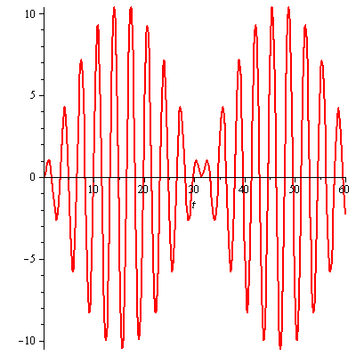

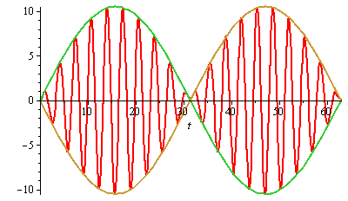

***Exercise***

Find a particular solution to the differential equation using undetermined coefficients. Find and plot the solution of the initial value problem. Superimpose the plots of the transient response and the steady state solution.

 

***Solution***

The particular solution: 















The particular solution (***steady-state*** ***solution***):



The homogeneous eq.: 

The characteristic eq.: 



 

















***Transient response*** ***solution***:



The general solution:



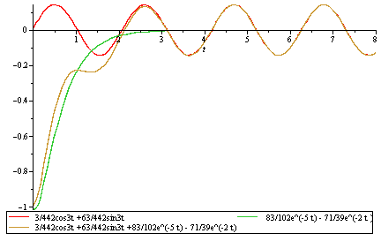

***Complex Method***



The particular solution: 

























The particular solution (***steady-state*** ***solution***):



***Exercise***

Find a particular solution to the differential equation using undetermined coefficients. Find and plot the solution of the initial value problem. Superimpose the plots of the transient response and the steady state solution.



***Solution***



The particular solution: 



























The homogeneous eq.: 

The characteristic eq.: 



 



















The steady-state solution is the particular solution:



The transient response is:





***Exercise***

Find a particular solution of  given the set  where *A, B, C* are to be determined

***Solution***













The particular solution: 

***Exercise***

A forced mass−spring−dashpot system with equation . Investigate the possibility of practical resonance of this system. In particular, find the amplitude  of steady state periodic forced oscillations with frequency *ω*. Sketch the graph  of and find the practical resonance frequency *ω* (if any).



***Solution***

 

 





















 

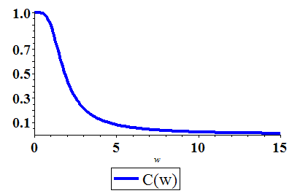

 starts with  and steadily decreases as *ω* increases.

Hence there is no practical resonance frequency.

***Exercise***

A forced mass−spring−dashpot system with equation . Investigate the possibility of practical resonance of this system. In particular, find the amplitude  of steady state periodic forced oscillations with frequency *ω*. Sketch the graph  of and find the practical resonance frequency *ω* (if any).



***Solution***

 

 

 

 

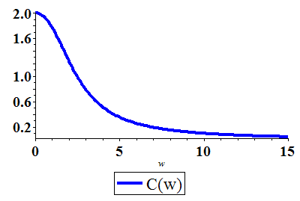

 starts with  and steadily decreases as *ω* increases.

Hence there is no practical resonance frequency.

***Exercise***

A forced mass−spring−dashpot system with equation . Investigate the possibility of practical resonance of this system. In particular, find the amplitude  of steady state periodic forced oscillations with frequency *ω*. Sketch the graph  of and find the practical resonance frequency *ω* (if any).



***Solution***

 

 

 

 

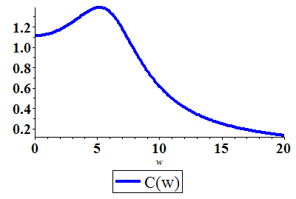



 (*C.N*)

 starts with , hence the practical resonance frequency is .

***Exercise***

A forced mass−spring−dashpot system with equation . Investigate the possibility of practical resonance of this system. In particular, find the amplitude  of steady state periodic forced oscillations with frequency *ω*. Sketch the graph  of and find the practical resonance frequency *ω* (if any).



***Solution***

 

 

 

 

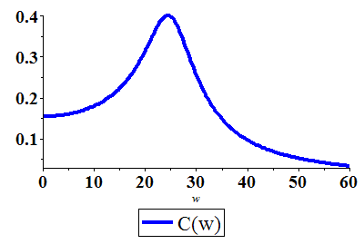



 (*C.N*)

 starts with , hence the practical resonance frequency is .

***Exercise***

A mass weighing 100 *lb*. (mass *m* = 3.125 *slugs* in *fps* units) is attached to the end of a spring that is stretched 1 *in*. by a force of 100 *lb*. A force  acts on the mass. At what frequency (in hertz) will resonance oscillation occur? Neglect damping.

***Solution***

***Given***: *m* = 3.125 *slug*











***Exercise***

A mass *m* on the end of a pendulum (of length *L*) also attached to a horizontal spring (with constant *k*). Assume small oscillations of *m* so that the spring remains essentially horizontal and neglect damping. Find the natural circular frequency  of motion of the mass in terms of *L, k, m*, and the gravitational constant *g*.

***Solution***

Let *θ* is the angular displacement.

The displacement of the mass is: 

Its total energy  is

















***Exercise***

A mass *m* hangs on the end of a cord around a pullet of radius *a* and moment of inertia *I*. The rim of the pulley is attached to a spring (with constant *k*). Assume small oscillations so that the spring remains essentially and neglect friction. Find the natural circular frequency in terms of *m, a, k, I*, and *g*.

***Solution***

Let *x* be the displacement of the mass from its equilibrium position.

 be the velocity.

 the angular velocity of the pulley.

 Conservation of energy











***Exercise***

Find the transient motion and steady periodic oscillations of a damped mass-and-spring system with , , and  under the influence of an external force  with  and . Also investigate the possibility of practical resonance for this system.

***Solution***

***Given***: , , , and  ; 

 

 















 



 













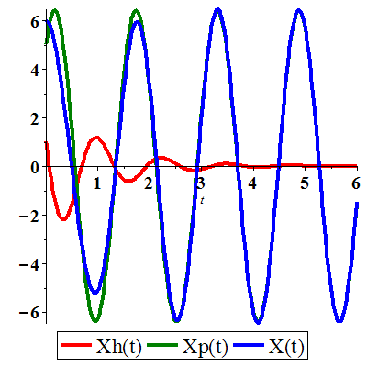

The forced amplitude at frequency *ω* is:







The mass-and-spring’s undamped critical frequency of 

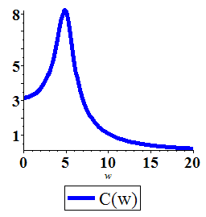

***Exercise***

Consider a floating cylindrical buoy with radius *r*, height *h*, and uniform density  (recall that the density of water is ). The buoy is initially suspended at rest with its bottom at the top surface of the water and is released at time . Therafter it is acted on by two forces: a downward gravitational force equal to its weight  and (by Archmedes’ principle of buoyancy) an upward force equal to the wieght  of water displaced, where  is the depth of the bottom of the buoy beneath the surface at time *t*.

Conclude that the buoy undergoes simple harmonic motion around its equilibrium position  with period .

1. Compute *p* and the amplitude of the motion if , , and 
2. If the cylindrical buoy weighting 100 *lb* floats in water with its axis vertical. When depressed slightly and released, it oscillates up and down four times every 10 *sec*. assume that friction is negligible. Find the radius of the buoy.

***Solution***

1. 

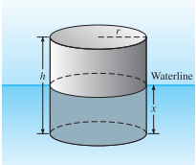











 











Amplitude: 

Period: 

1. ***Given***: 

The weight of water: 

 







***Exercise***

Assume that the earth is a solid sphere of uniform density, with mass *M* and radius *R* = 3960 (*mi*). For a particle of mass *m* within the earth at distance *r* from the center of the earth, the gravitational force attracting *m* toward the center is , where  is the mass of the part of the earth within a sphere of radius *r*.

1. Show that 
2. Now suppose that a small hole is drilled straight through the center of the earth, thus connecting two antipodal points on its surface. Let a particle of mass *m* be dropped at time  into this hole with initial speed zero, and let  be its distance from the center of the earth at time *t*. conclude from Newton’s second law and part (*a*) that , where .
3. Take , and conclude from part (*b*) that the particle undergoes simple harmonic motion back and forth between the ends of the hole, with a period of about 84 *min*.
4. Look up (or derive) the period of a satellite that just skims the surface of the earth; compare with the result in part (*c*). How do you explain the coincidence? Or is it a coincidence?
5. With what speed (in miles per hours) does the particle pass through the center of the earth?
6. Look up (or derive) the orbital velocity of a satellite that just skims the surface of the earth; compare with the result in part (*e*). How do you explain the coincidence? Or is it a coincidence?

***Solution***

1. 





 

1. Since 







1. 



 







***Given***: 

The period of the particle’s simple harmonic motion is:



1. The orbital velocity *v* of such a satellite must be such that the centrifugal force  on the satellite just offsets the weight *mg* of the satellite at the surface of the earth. Thus







Because the circumference of the earth is , the period of the satellite’s orbit is



Let assume that at time , the satellite is directly over the hole in the earth at the top, and its orbit proceeds in a clockwise direction.

The distance *r* of the particle, from part (*c*), from the center of the earth is



The key observation is that  is the angle drawn clockwise from the vertical to the radius vector of the satellite at time *t*; thus, the distance  is simply the vertical component of the satellite’s position. It follows that  completes one cycle through the earth (and back) in the same length of time required for the satellite to complete one orbit around the earth.

1. The particle passes through the center of the earth when , that is when .

At this time the speed of the particle is











1. The orbital velocity is .

The vertical component of the satellite’s velocity vector  at any given time *t* is equal to the speed  of the particle at that time.

At the moment when the particle passes through the center of earth, the satellite is travelling straight downward, and hence  is vertical.

Therefore, the orbital velocity *v* of the satellite, which is the magnitude of , is equal to the speed of the particle at this moment.

***Solution******Section* 2.7 − Euler's & Runge-Kutta Methods**

***Exercise***

Calculate the first five iterations of Euler's method with step  of



***Solution***

|  |  |
| --- | --- |
| *t* | *y* |
| 0.1 | 1.00000000 |
| 0.2 | 1.01000000 |
| 0.3 | 1.03020000 |
| 0.4 | 1.06110600 |
| 0.5 | 1.10355024 |













***Exercise***

Calculate the first five iterations of Euler's method with step  of



***Solution***

|  |  |
| --- | --- |
| *x* | *z* |
| 0.0 | 1.00000000 |
| 0.1 | 0.80000000 |
| 0.2 | 0. 65000000 |
| 0.3 | 0.54000000 |
| 0.4 | 0.46200000 |
| 0.5 | 0.40960000 |

***Exercise***

Calculate the first five iterations of Euler's method with step  of: 

***Solution***



The *first* step:





The *second* step:





***Euler Method***

***t Approx. Exact Difference***

----------------------------------------------------------------

0.00 | 0.00000000 | 0.00000000 | 0.00000000

0.10 | 0.50000000 | 0.47581291 | -0.02418709

0.20 | 0.95000000 | 0.90634623 | -0.04365377

0.30 | 1.35500000 | 1.29590890 | -0.05909110

0.40 | 1.71950000 | 1.64839977 | -0.07110023

0.50 | 2.04755000 | 1.96734670 | -0.08020330



***Exercise***

Given: 

1. Use a computer and Euler's method to calculate three separate approximate solutions on the interval , one with step size , a second with step size , a second with step size .
2. Use the appropriate analytic to compute the exact solution
3. Plot the exact solution and approximate solutions as discrete points.

***Solution***

|  |  |
| --- | --- |
| *x* | *y* |
| 0.0 | 8.00000000 |
| 0.2 | 8.00000000 |
| 0.4 | 7.40000000 |
| 0.6 | 6.29600000 |
| 0.8 | 4.90496000 |
| 1.0 | 3.49537280 |
| *x* | *y* |
| 0.0 | 8.00000000 |
| 0.1 | 8.00000000 |
| 0.2 | 7.85000000 |
| 0.3 | 7.55600000 |
| 0.4 | 7.13264000 |
| 0.5 | 6.60202880 |
| 0.6 | 5.99182592 |
| 0.7 | 5.33280681 |
| 0.8 | 4.65621386 |
| 0.9 | 3.99121964 |
| 1.0 | 3.36280010 |

|  |  |  |  |
| --- | --- | --- | --- |
| *x* | *y* | *x* | *y* |
| 0.0 | 8.00000000 |  |  |
| 0.05 | 8.00000000 | 0.55 | 6.16870319 |
| 0.10 | 7.96250000 | 0.60 | 5.85692451 |
| 0.15 | 7.88787500 | 0.65 | 5.53550904 |
| 0.20 | 7.77705688 | 0.70 | 5.20820096 |
| 0.25 | 7.63151574 | 0.75 | 4.87862689 |
| 0.30 | 7.45322784 | 0.80 | 4.55022987 |
| 0.35 | 7.24463101 | 0.85 | 4.22621148 |
| 0.40 | 7.00856892 | 0.90 | 3.90948351 |
| 0.45 | 6.74822617 | 0.95 | 3.60262999 |
| 0.50 | 6.46705599 | 1.00 | 3.30788014 |



***t Approx. Exact Difference***

--------------------------------------------------------

0.00 | 8.00000000 | 8.00000000 | 0.00000000

0.20 | 8.00000000 | 7.70592079 | -0.29407921

0.40 | 7.40000000 | 6.89107842 | -0.50892158

0.60 | 6.29600000 | 5.73257245 | -0.56342755

0.80 | 4.90496000 | 4.45469318 | -0.45026682

1.00 | 3.49537280 | 3.25909581 | -0.23627699

***t Approx. Exact Difference***

--------------------------------------------------------

0.00 | 8.00000000 | 8.00000000 | 0.00000000

0.10 | 8.00000000 | 7.92537375 | -0.07462625

0.20 | 7.85000000 | 7.70592079 | -0.14407921

0.30 | 7.55600000 | 7.35448389 | -0.20151611

0.40 | 7.13264000 | 6.89107842 | -0.24156158

0.50 | 6.60202880 | 6.34100587 | -0.26102293

0.60 | 5.99182592 | 5.73257245 | -0.25925347

0.70 | 5.33280681 | 5.09469796 | -0.23810885

0.80 | 4.65621386 | 4.45469318 | -0.20152068

0.90 | 3.99121964 | 3.83643550 | -0.15478414

1.00 | 3.36280010 | 3.25909581 | -0.10370430

***t Approx. Exact Difference***

--------------------------------------------------------

0.00 | 8.00000000 | 8.00000000 | 0.00000000

0.05 | 8.00000000 | 7.98127342 | -0.01872658

0.10 | 7.96250000 | 7.92537375 | -0.03712625

0.15 | 7.88787500 | 7.83313428 | -0.05474072

0.20 | 7.77705688 | 7.70592079 | -0.07113608

0.25 | 7.63151574 | 7.54559797 | -0.08591777

0.30 | 7.45322784 | 7.35448389 | -0.09874395

0.35 | 7.24463101 | 7.13529429 | -0.10933672

0.40 | 7.00856892 | 6.89107842 | -0.11749051

0.45 | 6.74822617 | 6.62514862 | -0.12307755

0.50 | 6.46705599 | 6.34100587 | -0.12605012

0.55 | 6.16870319 | 6.04226366 | -0.12643953

0.60 | 5.85692451 | 5.73257245 | -0.12435207

0.65 | 5.53550904 | 5.41554691 | -0.11996214

0.70 | 5.20820096 | 5.09469796 | -0.11350300

0.75 | 4.87862689 | 4.77337119 | -0.10525570

0.80 | 4.55022987 | 4.45469318 | -0.09553669

0.85 | 4.22621148 | 4.14152671 | -0.08468477

0.90 | 3.90948351 | 3.83643550 | -0.07304801

0.95 | 3.60262999 | 3.54165879 | -0.06097120

1.00 | 3.30788014 | 3.25909581 | -0.04878433

***Exercise***

Given: 

1. Use a computer and Euler's method to calculate three separate approximate solutions on the interval , one with step size , a second with step size , a third with step size .
2. Use the appropriate analytic to compute the exact solution
3. Plot the exact solution and approximate solutions as discrete points.

***Solution***

***a***)

***Euler Method***

***t Approx. Exact Difference***

--------------------------------------------------------

0.00 | 1.00000000 | 1.00000000 | 0.00000000

0.20 | 1.40000000 | 1.52166119 | 0.12166119

0.40 | 2.01967299 | 2.40358420 | 0.38391121

0.60 | 3.00558546 | 3.91773797 | 0.91215251

0.80 | 4.60623367 | 6.53800280 | 1.93176913

1.00 | 7.24121233 | 11.08358415 | 3.84237182

***Euler Method***

***t Approx. Exact Difference***

--------------------------------------------------------

0.00 | 1.00000000 | 1.00000000 | 0.00000000

0.10 | 1.20000000 | 1.22750977 | 0.02750977

0.20 | 1.45221403 | 1.52166119 | 0.06944716

0.30 | 1.77249333 | 1.90411415 | 0.13162082

0.40 | 2.18165556 | 2.40358420 | 0.22192865

0.50 | 2.70700830 | 3.05806706 | 0.35105875

0.60 | 3.38432406 | 3.91773797 | 0.53341391

0.70 | 4.26039588 | 5.04872396 | 0.78832807

0.80 | 5.39633906 | 6.53800280 | 1.14166374

0.90 | 6.87184946 | 8.49975469 | 1.62790522

1.00 | 8.79068763 | 11.08358415 | 2.29289652

***Euler Method***

***t Approx. Exact Difference***

--------------------------------------------------------

0.00 | 1.00000000 | 1.00000000 | 0.00000000

0.05 | 1.10000000 | 1.10655238 | 0.00655238

0.10 | 1.21276293 | 1.22750977 | 0.01474684

0.15 | 1.34014623 | 1.36504472 | 0.02489849

0.20 | 1.48428480 | 1.52166119 | 0.03737639

0.25 | 1.64763153 | 1.70024381 | 0.05261229

0.30 | 1.83300369 | 1.90411415 | 0.07111045

0.35 | 2.04363584 | 2.13709506 | 0.09345922

0.40 | 2.28324010 | 2.40358420 | 0.12034410

0.45 | 2.55607493 | 2.70863793 | 0.15256300

0.50 | 2.86702349 | 3.05806706 | 0.19104356

0.55 | 3.22168289 | 3.45854614 | 0.23686325

0.60 | 3.62646574 | 3.91773797 | 0.29127223

0.65 | 4.08871582 | 4.44443559 | 0.35571976

0.70 | 4.61683955 | 5.04872396 | 0.43188441

0.75 | 5.22045550 | 5.74216412 | 0.52170862

0.80 | 5.91056439 | 6.53800280 | 0.62743841

0.85 | 6.69974213 | 7.45141089 | 0.75166876

0.90 | 7.60235911 | 8.49975469 | 0.89739558

0.95 | 8.63482915 | 9.70290431 | 1.06807516

1.00 | 9.81589205 | 11.08358415 | 1.26769209

***b***) 















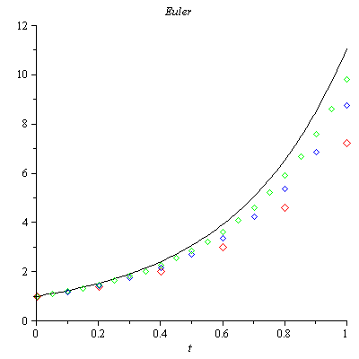

***Exercise***

Consider the initial value problem 

Use Euler's method with step size  to sketch solution on the interval 

***Solution***



***t Approx. Exact Difference***

--------------------------------------------------------

0.00 | 1.00000000 | 1.00000000 | 0.00000000

0.04 | 2.44000000 | 2.77812333 | 0.33812333

0.08 | 4.26707200 | 3.75770045 | -0.50937155

0.12 | 3.72005658 | 3.96254078 | 0.24248419

0.16 | 4.21993115 | 3.99446397 | -0.22546718

0.20 | 3.77444588 | 3.99918742 | 0.22474154

0.24 | 4.18308995 | 3.99988085 | -0.18320910

0.28 | 3.81546672 | 3.99998253 | 0.18451582

0.32 | 4.15342541 | 3.99999744 | -0.15342797

0.36 | 3.84754974 | 3.99999962 | 0.15244989

0.40 | 4.12909852 | 3.99999994 | -0.12909858

0.44 | 3.87322947 | 3.99999999 | 0.12677052

0.48 | 4.10891492 | 4.00000000 | -0.10891492

0.52 | 3.89410430 | 4.00000000 | 0.10589570

0.56 | 4.09204138 | 4.00000000 | -0.09204138

0.60 | 3.91125556 | 4.00000000 | 0.08874444

0.64 | 4.07786461 | 4.00000000 | -0.07786461

0.68 | 3.92545437 | 4.00000000 | 0.07454563

0.72 | 4.06591460 | 4.00000000 | -0.06591460

0.76 | 3.93727310 | 4.00000000 | 0.06272690

0.80 | 4.05582011 | 4.00000000 | -0.05582011

0.84 | 3.94714987 | 4.00000000 | 0.05285013

0.88 | 4.04728141 | 4.00000000 | -0.04728141

0.92 | 3.95542805 | 4.00000000 | 0.04457195

0.96 | 4.04005260 | 4.00000000 | -0.04005260

1.00 | 3.96238159 | 4.00000000 | 0.03761841

1.04 | 4.03392967 | 4.00000000 | -0.03392967

1.08 | 3.96823212 | 4.00000000 | 0.03176788

1.12 | 4.02874204 | 4.00000000 | -0.02874204

1.16 | 3.97316079 | 4.00000000 | 0.02683921

1.20 | 4.02434630 | 4.00000000 | -0.02434630

1.24 | 3.97731688 | 4.00000000 | 0.02268312

1.28 | 4.02062150 | 4.00000000 | -0.02062150

1.32 | 3.98082411 | 4.00000000 | 0.01917589

1.36 | 4.01746532 | 4.00000000 | -0.01746532

1.40 | 3.98378549 | 4.00000000 | 0.01621451

1.44 | 4.01479115 | 4.00000000 | -0.01479115

1.48 | 3.98628712 | 4.00000000 | 0.01371288

1.52 | 4.01252558 | 4.00000000 | -0.01252558

1.56 | 3.98840115 | 4.00000000 | 0.01159885

1.60 | 4.01060636 | 4.00000000 | -0.01060636

1.64 | 3.99018815 | 4.00000000 | 0.00981185

1.68 | 4.00898069 | 4.00000000 | -0.00898069

1.72 | 3.99169905 | 4.00000000 | 0.00830095

1.76 | 4.00760380 | 4.00000000 | -0.00760380

1.80 | 3.99297675 | 4.00000000 | 0.00702325

1.84 | 4.00643771 | 4.00000000 | -0.00643771

1.88 | 3.99405741 | 4.00000000 | 0.00594259

1.92 | 4.00545023 | 4.00000000 | -0.00545023

1.96 | 3.99497153 | 4.00000000 | 0.00502847

2.00 | 4.00461405 | 4.00000000 | -0.00461405

***Exercise***

You've seen that the error in Euler's method varies directly as the first power of the step size . This makes Euler's method an order to halve the error? How does this affect the number of required iterations?

***Solution***

Because  halving the step size should halve the error.



The number of iterations is given by: , therefore halving the step size should double the number of iterations.



***Exercise***

Use Euler’s method to provide an approximate solution over the given time interval using the given steps sizes. Provide a plot of ***v*** versus ***y*** for each step size



***Solution***

|  |  |
| --- | --- |
| ***h* = 0.1** | ***h* = 0.01** |

|  |  |
| --- | --- |
| ***h* = 0.001** |  |

***Exercise***



1. Use a computer and Runge-Kutta method to calculate three separate approximate solutions on the interval , one with step size , a second with step size , a second with step size .
2. Use the appropriate analytic to compute the exact solution
3. Plot the exact solution and approximate solutions as discrete points.

***Solution***



***Runge-Kutta* 2*nd Order***

t Approx. Exact Difference

--------------------------------------------------------

0.00 | 1.00000000 | 1.00000000 | 0.00000000

0.20 | 0.99800666 | 0.99873333 | 0.00072667

0.40 | 0.98887689 | 0.99039969 | 0.00152281

0.60 | 0.96709749 | 0.96939486 | 0.00229738

0.80 | 0.92871746 | 0.93169588 | 0.00297842

1.00 | 0.87131508 | 0.87482637 | 0.00351128

***Runge-Kutta* 4*th Order***

t Approx. Exact Difference

--------------------------------------------------------

0.00 | 1.00000000 | 1.00000000 | 0.00000000

0.20 | 0.99873272 | 0.99873333 | 0.00000061

0.40 | 0.99039822 | 0.99039969 | 0.00000147

0.60 | 0.96939245 | 0.96939486 | 0.00000241

0.80 | 0.93169258 | 0.93169588 | 0.00000330

1.00 | 0.87482232 | 0.87482637 | 0.00000405

***Runge-Kutta* 2*nd Order***

t Approx. Exact Difference

--------------------------------------------------------

0.00 | 1.00000000 | 1.00000000 | 0.00000000

0.10 | 0.99975021 | 0.99983750 | 0.00008729

0.20 | 0.99855245 | 0.99873333 | 0.00018088

0.30 | 0.99555979 | 0.99583746 | 0.00027767

0.40 | 0.99002480 | 0.99039969 | 0.00037489

0.50 | 0.98129932 | 0.98176938 | 0.00047006

0.60 | 0.96883388 | 0.96939486 | 0.00056098

0.70 | 0.95217687 | 0.95282259 | 0.00064572

0.80 | 0.93097330 | 0.93169588 | 0.00072258

0.90 | 0.90496314 | 0.90575327 | 0.00079013

1.00 | 0.87397921 | 0.87482637 | 0.00084716

***Runge-Kutta* 4*th Order***

t Approx. Exact Difference

--------------------------------------------------------

0.00 | 1.00000000 | 1.00000000 | 0.00000000

0.10 | 0.99983748 | 0.99983750 | 0.00000002

0.20 | 0.99873329 | 0.99873333 | 0.00000004

0.30 | 0.99583739 | 0.99583746 | 0.00000007

0.40 | 0.99039960 | 0.99039969 | 0.00000009

0.50 | 0.98176926 | 0.98176938 | 0.00000012

0.60 | 0.96939471 | 0.96939486 | 0.00000015

0.70 | 0.95282241 | 0.95282259 | 0.00000018

0.80 | 0.93169568 | 0.93169588 | 0.00000020

0.90 | 0.90575304 | 0.90575327 | 0.00000023

1.00 | 0.87482612 | 0.87482637 | 0.00000025

***Runge-Kutta* 2*nd Order***

t Approx. Exact Difference

--------------------------------------------------------

0.00 | 1.00000000 | 1.00000000 | 0.00000000

0.05 | 0.99996876 | 0.99997943 | 0.00001067

0.10 | 0.99981570 | 0.99983750 | 0.00002180

0.15 | 0.99942531 | 0.99945859 | 0.00003328

0.20 | 0.99868831 | 0.99873333 | 0.00004502

0.25 | 0.99750164 | 0.99755858 | 0.00005694

0.30 | 0.99576852 | 0.99583746 | 0.00006894

0.35 | 0.99339836 | 0.99347931 | 0.00008094

0.40 | 0.99030682 | 0.99039969 | 0.00009287

0.45 | 0.98641574 | 0.98652039 | 0.00010465

0.50 | 0.98165315 | 0.98176938 | 0.00011623

0.55 | 0.97595326 | 0.97608078 | 0.00012752

0.60 | 0.96925639 | 0.96939486 | 0.00013847

0.65 | 0.96150896 | 0.96165799 | 0.00014903

0.70 | 0.95266344 | 0.95282259 | 0.00015915

0.75 | 0.94267832 | 0.94284709 | 0.00016877

0.80 | 0.93151803 | 0.93169588 | 0.00017785

0.85 | 0.91915289 | 0.91933924 | 0.00018635

0.90 | 0.90555903 | 0.90575327 | 0.00019423

0.95 | 0.89071835 | 0.89091981 | 0.00020146

1.00 | 0.87461836 | 0.87482637 | 0.00020801

***Runge-Kutta* 4*th Order***

t y y(t) Difference

--------------------------------------------------------

0.00 | 1.00000000 | 1.00000000 | 0.00000000

0.05 | 0.99997943 | 0.99997943 | 0.00000000

0.10 | 0.99983750 | 0.99983750 | 0.00000000

0.15 | 0.99945859 | 0.99945859 | 0.00000000

0.20 | 0.99873333 | 0.99873333 | 0.00000000

0.25 | 0.99755858 | 0.99755858 | 0.00000000

0.30 | 0.99583745 | 0.99583746 | 0.00000000

0.35 | 0.99347930 | 0.99347931 | 0.00000001

0.40 | 0.99039969 | 0.99039969 | 0.00000001

0.45 | 0.98652039 | 0.98652039 | 0.00000001

0.50 | 0.98176937 | 0.98176938 | 0.00000001

0.55 | 0.97608077 | 0.97608078 | 0.00000001

0.60 | 0.96939485 | 0.96939486 | 0.00000001

0.65 | 0.96165798 | 0.96165799 | 0.00000001

0.70 | 0.95282258 | 0.95282259 | 0.00000001

0.75 | 0.94284708 | 0.94284709 | 0.00000001

0.80 | 0.93169587 | 0.93169588 | 0.00000001

0.85 | 0.91933923 | 0.91933924 | 0.00000001

0.90 | 0.90575325 | 0.90575327 | 0.00000001

0.95 | 0.89091979 | 0.89091981 | 0.00000001

1.00 | 0.87482635 | 0.87482637 | 0.00000002

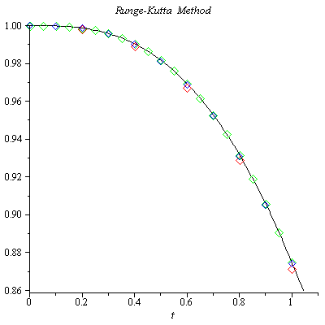

***Exercise***

Given 

1. Use a computer and Runge-Kutta method to calculate three separate approximate solutions on the interval , one with step size , a second with step size , a second with step size .
2. Use the appropriate analytic to compute the exact solution
3. Plot the exact solution and approximate solutions as discrete points.

***Solution***

***Runge-Kutta* 2*th Order***

***t Approx. Exact Difference***

--------------------------------------------------------

0.00 | 1.00000000 | 1.00000000 | 0.00000000

0.20 | 1.01961161 | 1.01980390 | 0.00019229

0.40 | 1.07636229 | 1.07703296 | 0.00067067

0.60 | 1.16495094 | 1.16619038 | 0.00123944

0.80 | 1.27887002 | 1.28062485 | 0.00175483

1.00 | 1.41205020 | 1.41421356 | 0.00216336

***Runge-Kutta* 4*th Order***

***t Approx. Exact Difference***

--------------------------------------------------------

0.00 | 1.00000000 | 1.00000000 | 0.00000000

0.20 | 1.01980437 | 1.01980390 | -0.00000046

0.40 | 1.07703431 | 1.07703296 | -0.00000135

0.60 | 1.16619234 | 1.16619038 | -0.00000196

0.80 | 1.28062701 | 1.28062485 | -0.00000216

1.00 | 1.41421570 | 1.41421356 | -0.00000214

***Runge-Kutta* 2*th Order***

***t Approx. Exact Difference***

--------------------------------------------------------

0.00 | 1.00000000 | 1.00000000 | 0.00000000

0.10 | 1.00497519 | 1.00498756 | 0.00001238

0.20 | 1.01975618 | 1.01980390 | 0.00004772

0.30 | 1.04392938 | 1.04403065 | 0.00010127

0.40 | 1.07686631 | 1.07703296 | 0.00016665

0.50 | 1.11779652 | 1.11803399 | 0.00023747

0.60 | 1.16588199 | 1.16619038 | 0.00030839

0.70 | 1.22027989 | 1.22065556 | 0.00037567

0.80 | 1.28018776 | 1.28062485 | 0.00043708

0.90 | 1.34487075 | 1.34536240 | 0.00049165

1.00 | 1.41367433 | 1.41421356 | 0.00053923

***Runge-Kutta* 4*th Order***

***t Approx. Exact Difference***

--------------------------------------------------------

0.00 | 1.00000000 | 1.00000000 | 0.00000000

0.10 | 1.00498757 | 1.00498756 | -0.00000001

0.20 | 1.01980393 | 1.01980390 | -0.00000003

0.30 | 1.04403071 | 1.04403065 | -0.00000006

0.40 | 1.07703304 | 1.07703296 | -0.00000008

0.50 | 1.11803409 | 1.11803399 | -0.00000010

0.60 | 1.16619050 | 1.16619038 | -0.00000012

0.70 | 1.22065569 | 1.22065556 | -0.00000013

0.80 | 1.28062498 | 1.28062485 | -0.00000013

0.90 | 1.34536254 | 1.34536240 | -0.00000013

1.00 | 1.41421369 | 1.41421356 | -0.00000013

***Runge-Kutta* 2*th Order***

***t Approx. Exact Difference***

--------------------------------------------------------

0.00 | 1.00000000 | 1.00000000 | 0.00000000

0.05 | 1.00124844 | 1.00124922 | 0.00000078

0.10 | 1.00498447 | 1.00498756 | 0.00000309

0.15 | 1.01118058 | 1.01118742 | 0.00000684

0.20 | 1.01979199 | 1.01980390 | 0.00001191

0.25 | 1.03075829 | 1.03077641 | 0.00001812

0.30 | 1.04400537 | 1.04403065 | 0.00002528

0.35 | 1.05944783 | 1.05948101 | 0.00003317

0.40 | 1.07699136 | 1.07703296 | 0.00004160

0.45 | 1.09653524 | 1.09658561 | 0.00005037

0.50 | 1.11797470 | 1.11803399 | 0.00005929

0.55 | 1.14120301 | 1.14127122 | 0.00006821

0.60 | 1.16611337 | 1.16619038 | 0.00007701

0.65 | 1.19260047 | 1.19268604 | 0.00008557

0.70 | 1.22056174 | 1.22065556 | 0.00009382

0.75 | 1.24989830 | 1.25000000 | 0.00010170

0.80 | 1.28051568 | 1.28062485 | 0.00010917

0.85 | 1.31232426 | 1.31244047 | 0.00011621

0.90 | 1.34523959 | 1.34536240 | 0.00012281

0.95 | 1.37918245 | 1.37931142 | 0.00012898

1.00 | 1.41407885 | 1.41421356 | 0.00013471

***Runge-Kutta* 4*th Order***

***t Approx. Exact Difference***

--------------------------------------------------------

0.00 | 1.00000000 | 1.00000000 | 0.00000000

0.05 | 1.00124922 | 1.00124922 | -0.00000000

0.10 | 1.00498756 | 1.00498756 | -0.00000000

0.15 | 1.01118742 | 1.01118742 | -0.00000000

0.20 | 1.01980390 | 1.01980390 | -0.00000000

0.25 | 1.03077641 | 1.03077641 | -0.00000000

0.30 | 1.04403065 | 1.04403065 | -0.00000000

0.35 | 1.05948101 | 1.05948101 | -0.00000000

0.40 | 1.07703297 | 1.07703296 | -0.00000001

0.45 | 1.09658562 | 1.09658561 | -0.00000001

0.50 | 1.11803400 | 1.11803399 | -0.00000001

0.55 | 1.14127123 | 1.14127122 | -0.00000001

0.60 | 1.16619039 | 1.16619038 | -0.00000001

0.65 | 1.19268605 | 1.19268604 | -0.00000001

0.70 | 1.22065557 | 1.22065556 | -0.00000001

0.75 | 1.25000001 | 1.25000000 | -0.00000001

0.80 | 1.28062486 | 1.28062485 | -0.00000001

0.85 | 1.31244048 | 1.31244047 | -0.00000001

0.90 | 1.34536241 | 1.34536240 | -0.00000001

0.95 | 1.37931143 | 1.37931142 | -0.00000001

1.00 | 1.41421357 | 1.41421356 | -0.00000001

1. The equation is separable:





















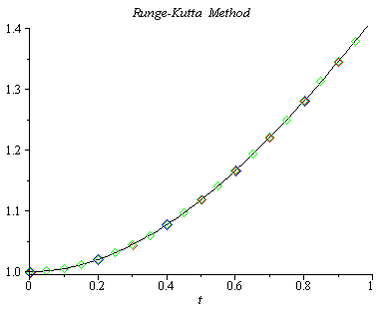

***Exercise***

Consider the initial value problem 

Use Runge-Kutta method with step size  to sketch solution on the interval 

***Solution***



***Runge-Kutta* 4*th Order***

t Approx. Exact Difference

--------------------------------------------------------

0.00 | 1.00000000 | 1.00000000 | 0.00000000

0.04 | 1.00079936 | 1.00079936 | -0.00000000

0.08 | 1.00318981 | 1.00318981 | -0.00000000

0.12 | 1.00714877 | 1.00714877 | -0.00000000

0.16 | 1.01263957 | 1.01263957 | -0.00000000

0.20 | 1.01961283 | 1.01961282 | -0.00000000

0.24 | 1.02800822 | 1.02800822 | -0.00000000

0.28 | 1.03775651 | 1.03775651 | -0.00000000

0.32 | 1.04878166 | 1.04878166 | -0.00000001

0.36 | 1.06100297 | 1.06100297 | -0.00000001

0.40 | 1.07433708 | 1.07433707 | -0.00000001

0.44 | 1.08869975 | 1.08869974 | -0.00000001

0.48 | 1.10400743 | 1.10400742 | -0.00000001

0.52 | 1.12017855 | 1.12017854 | -0.00000001

0.56 | 1.13713450 | 1.13713449 | -0.00000001

0.60 | 1.15480036 | 1.15480035 | -0.00000001

0.64 | 1.17310545 | 1.17310544 | -0.00000001

0.68 | 1.19198361 | 1.19198360 | -0.00000001

0.72 | 1.21137336 | 1.21137335 | -0.00000001

0.76 | 1.23121787 | 1.23121787 | -0.00000001

0.80 | 1.25146496 | 1.25146495 | -0.00000001

0.84 | 1.27206683 | 1.27206682 | -0.00000001

0.88 | 1.29297992 | 1.29297991 | -0.00000001

0.92 | 1.31416464 | 1.31416463 | -0.00000001

0.96 | 1.33558509 | 1.33558508 | -0.00000001

1.00 | 1.35720882 | 1.35720881 | -0.00000001

1.04 | 1.37900650 | 1.37900650 | -0.00000001

1.08 | 1.40095174 | 1.40095173 | -0.00000001

1.12 | 1.42302075 | 1.42302075 | -0.00000001

1.16 | 1.44519217 | 1.44519216 | -0.00000001

1.20 | 1.46744679 | 1.46744678 | -0.00000001

1.24 | 1.48976740 | 1.48976739 | -0.00000001

1.28 | 1.51213855 | 1.51213854 | -0.00000001

1.32 | 1.53454641 | 1.53454640 | -0.00000001

1.36 | 1.55697860 | 1.55697859 | -0.00000001

1.40 | 1.57942403 | 1.57942403 | -0.00000001

1.44 | 1.60187281 | 1.60187281 | -0.00000001

1.48 | 1.62431609 | 1.62431608 | -0.00000001

1.52 | 1.64674596 | 1.64674596 | -0.00000001

1.56 | 1.66915540 | 1.66915539 | -0.00000001

1.60 | 1.69153812 | 1.69153811 | -0.00000001

1.64 | 1.71388854 | 1.71388853 | -0.00000001

1.68 | 1.73620170 | 1.73620169 | -0.00000001

1.72 | 1.75847320 | 1.75847319 | -0.00000001

1.76 | 1.78069914 | 1.78069913 | -0.00000001

1.80 | 1.80287607 | 1.80287606 | -0.00000000

1.84 | 1.82500094 | 1.82500094 | -0.00000000

1.88 | 1.84707109 | 1.84707109 | -0.00000000

1.92 | 1.86908417 | 1.86908417 | -0.00000000

1.96 | 1.89103813 | 1.89103813 | -0.00000000

2.00 | 1.91293119 | 1.91293118 | -0.00000000