***Lecture Three***

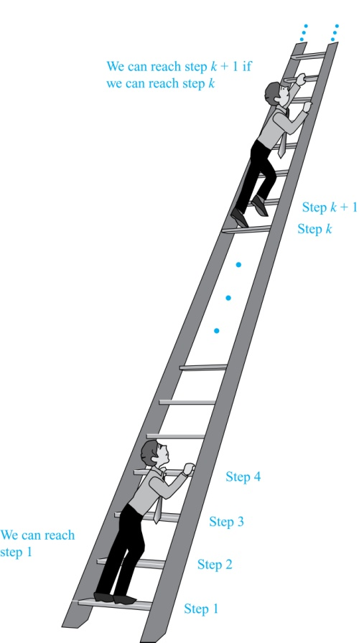***Section* 3.1 − Mathematical Induction**

**Introduction**

Suppose we have an infinite ladder:

1. We can reach the first rung of the ladder.
2. If we can reach a particular rung of the ladder, then we can reach the next rung.

From (1), we can reach the first rung. Then by applying (2), we can reach the second rung. Applying (2) again, the third rung. And so on. We can apply (2) any number of times to reach any particular rung, no matter how high up.

This example motivates proof by mathematical induction.

**Mathematical Induction**

***Principle of Mathematical Induction***

To prove that *P*(*n*) is true for all positive integers *n*, we complete these steps:

* + ***Basis Step***: Show that *P*(1) is true.
  + ***Inductive Step***: Show that *P*(*k*) *→ P*(*k +* 1) is true for all positive integers *k*.

To complete the inductive step, assuming the *inductive hypothesis* that *P*(*k*)holds for an arbitrary integer *k*, show that must *P*(*k +* 1) be true.

**Climbing an Infinite Ladder Example**:

BASIS STEP: By (1), we can reach rung 1.

INDUCTIVE STEP: Assume the inductive hypothesis that we can reach rung *k*. Then by (2), we can reach rung *k* + 1.

Hence, *P*(*k*) *→ P*(*k +* 1) is true for all positive integers *k.* We can reach every rung on the ladder.

**Examples of Proofs by Mathematical induction**

Mathematical induction can be expressed as the rule of inference



where the domain is the set of positive integers.

In a proof by mathematical induction, we don’t assume that *P*(*k*) is true for all positive integers! We show that if we assume that *P*(*k*) is true, then *P*(*k +* 1) must also be true.

Proofs by mathematical induction do not always start at the integer 1. In such a case, the basis step begins at a starting point *b* where *b* is an integer.

**Validity of Mathematical Induction**

Mathematical induction is valid because of the well ordering property, which states that every nonempty subset of the set of positive integers has a least element. Here is the proof:

* + Suppose that *P*(1) holds and *P*(*k*)→ *P*(*k +* 1) is true for all positive integers *k*.
  + Assume there is at least one positive integer *n* for which P(*n*) is false. Then the set *S* of positive integers for which P(*n*) is false is nonempty.
  + By the well-ordering property, *S* has a least element, say *m*.
  + We know that *m* cannot be 1 since *P*(1) holds.
  + Since *m* is positive and greater than 1, *m* − 1 must be a positive integer. Since *m* − 1 < *m*, it is not in S, so *P*(*m* − 1) must be true.
  + But then, since the conditional *P*(*k*)→ *P*(*k +* 1) for every positive integer *k* holds, *P*(*m*) must also be true. This contradicts *P*(*m*) being false.
  + Hence, *P*(*n*) must be true for every positive integer *n*

***Example***

Show that if *n* is a positive integer, then 

***Solution***

***Basis Step***: *P*(1) is true since .

***Inductive Step***: Assume true for *P*(*k*). The inductive hypothesis is 

Under this assumption, 





 ***√***

The last equation shows that  is true under the assumption that  is true. This completes the inductive step.

***Example***

Conjecture and prove correct a formula for the sum of the first *n* positive odd integers. Then prove your conjecture.

***Solution***

The sums of the first n positive odd integers for *n* = 1, 2, 3, 4, 5 are

1 = 1, 1 + 3 = 4, 1 + 3 + 5 = 9, 1 + 3 + 5 + 7 = 16, 1 + 3 + 5 + 7 + 9 = 25.

***Basis Step***: *P*(1) is true since 12 = 1.

***Inductive Step***: *P(k) → P*(*k +* 1) for every positive integer *k*.

Assume the inductive hypothesis holds and then show that *P*(*k*) holds has well.

*Inductive Hypothesis*: 

So, assuming *P*(*k*), it follows that:





 ***√***

Hence, we have shown that *P*(*k +* 1) follows from *P*(*k*). Therefore the sum of the first *n* positive odd integers is *n*2.

***Example***

Use mathematical induction to show that  for all nonnegative integers *n*.

***Solution***

***Basis Step***: For ***n* = 0** ⇒ ; hence  is true.

***Inductive Step***:  is true for every positive integer *k*.







 ***√***

Hence  is true.

By mathematical induction, the statement  is true

***Example***

Use mathematical induction to prove this formula for the sum of a finite number of terms of a geometric progression with initial term *a* and common ratio *r*:



for all nonnegative integers *n*.

***Solution***

***Basis Step***: For ***n* = 0** ⇒ ; hence  is true.

***Inductive Step***:  is true for every positive integer *k*.











 ***√***

Hence  is true.

By mathematical induction, the statement  is true

**Proving Inequalities**

***Example***

Prove that the statement is true for every positive integer *n*. 

***Solution***

***Basis Step***: For ***n* = 1** ⇒  ***√*** ⇒  is true.

***Inductive Step***. Assume that  is true 

We need to prove that  is true, that is 





 ***√***

Thus,  is true.

By mathematical induction, the statement  is true.

***Example***

Prove that the statement is true for every positive integer *n*.  for every integer *n* with 

***Solution***

***Basis Step***: For ***n* = 4** ⇒  ***√*** ⇒  is true.

***Inductive Step***. Assume that  is true 

We need to prove that  is true, that is 





 

 ***√***

Thus,  is true.

By mathematical induction, the statement  is true.

***Harmonic* Numbers**

***Example***

The harmonic numbers  are defined by



Use the mathematical method to show that  for all nonnegative integers *n*.

***Solution***

***Basis Step***: For ***n* = 0** ⇒  ***√*** ⇒  is true.

***Inductive Step***. Assume that  is true 

We need to prove that  is true, that is 







 



 ***√***

Thus,  is true.

By mathematical induction, the statement  is true.

***Example***

Use mathematical induction to prove that is divisible by 3*,* for every positive integer *n*.

***Solution***

Let *P*(*n*) be the proposition that is divisible by 3*.*

***Basis Step***: For ***n* = 1** ⇒  which is divisible by 3⇒  is true.

***Inductive Step***. Assume that  holds is divisible by 3

We need to prove that  is true, that is is divisible by 3







 is divisible by 3, by the inductive hypothesis,

 is divisible by 3, since it is an integer multiplied by 3.

Thus,  is true.

By mathematical induction, the statement is divisible by 3 is true, for every positive integer *n*.

***Example***

Use mathematical induction to prove that is divisible by 57*,* for every nonnegative integer *n*.

***Solution***

***Basis Step***: For ***n* = 0** ⇒  which is divisible by 57⇒  is true.

***Inductive Step***: Assume that  holds is divisible by 57

We need to prove that  is true, that is is also divisible by 57









 is divisible by 57, by the inductive hypothesis,

 is divisible by 57, since it is an integer multiplied by 57.

Thus,  is true.

By mathematical induction, the statement is divisible by 57 is true, for every positive integer *n*.

**Number of Subsets of a Finite Set**

***Inductive Hypothesis***

For an arbitrary nonnegative integer *k*, every set with *k* elements has  subsets.

Let *T* be a set with *k* + 1 elements. Then , where *a* ∈ *T* and *S* = *T −* {*a*}. Hence |*T*| = *k*.

For each subset *X* of *S*, there are exactly two subsets of *T*, i.e., *X* and .

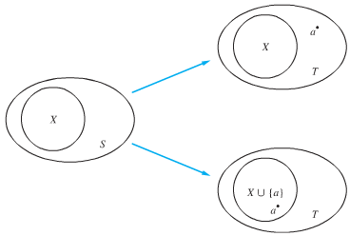

By the inductive hypothesis *S*  has subsets. Since there are two subsets of *T* for each subset of *S*, the number of subsets of *T* is 

***Example***

Show that every  checkerboard with one square removed can be tiled using right triominoes.

A right triomino is an L-shaped tile which covers three squares at a time.

 

***Solution***

Let *P*(*n*) be the proposition that every  checkerboard with one square removed can be tiled using right triominoes. Use mathematical induction to prove that *P*(*n*) is true for all positive integers *n*.

***Basis Step***: *P*(1) is true, because each of the four 2 ×2 checkerboards with one square removed can be tiled using one right triomino.



***Inductive Step***: Assume that *P*(*k*) is true for every checkerboard, for some positive integer *k*. with one square removed can be tiled using right triominoes.

Consider a 2*k+*1 ×2*k+*1 checkerboard with one square removed. Split this checkerboard into four checkerboards of size 2*k* ×2*k*,by dividing it in half in both directions.

 

Remove a square from one of the four checkerboards. By the inductive hypothesis, this board can be tiled. Also by the inductive hypothesis, the other three boards can be tiled with the square from the corner of the center of the original board removed. We can then cover the three adjacent squares with a triominoe.

Hence, the entire  checkerboard with one square removed can be tiled using right triominoes.

***Guidelines*: Mathematical Induction Proofs**

*Template for Proofs by Mathematical Induction*

1. Express the statement that is to be proved in the form “for all ” for a fixed integer *b*.
2. Write out the words “Basis Step” or “step 1”. Then show that  is true, taking care that the correct value of *b* is used. This completes the first part of the proof.
3. Write out the words “Inductive Step.”
4. State and clearly identify, the inductive hypothesis, in the form “assume that  is true for an arbitrary fixed integer .”
5. State what needs to be proved under the assumption that the inductive hypothesis is true. That is, write out what  says.
6. Prove the statement  making use the assumption . Be sure that your proof is valid for all integers *k* with , taking care that the proof works for small values of *k*, including 
7. Clearly identify the conclusion of the inductive step, such as by saying “this completes the inductive step.”
8. After completing the basis step and the inductive step. State the conclusion, namely that by mathematical induction,  is true for all integers *n* with .

***Exercises Section* 3.1 − Mathematical Induction**

1. Prove that  whenever *n* is a nonnegative integer.
2. Prove that  whenever *n* is a positive integer.
3. Prove that  whenever *n* is a nonnegative integer.
4. Prove that  whenever *n* is a nonnegative integer.
5. Find a formula for the sum of the first *n* even positive integers. Prove the formula.
6. *a*) Find a formula for  by examining the values of this expression for values of this expression for small values of *n*.

*b*) Prove the formula.

1. Prove that  whenever *n* is a positive integer.
2. Prove that for very positive integer *n,*  .
3. Prove that for very positive integer *n,* .
4. Prove that for very positive integer *n,*
5. Let  be the statement that  where *n* is an integer greater than 1.
6. Show is the statement ?
7. Show that  is true, completing the basis step of the proof.
8. What is the inductive hypothesis?
9. What do you need to prove in the inductive step?
10. Complete the inductive step.
11. Explain why these steps show that this inequality is true whenever *n* is an integer greater than 1.
12. Prove that  if *n* is an integer greater than 6.
13. Prove that  if *n* is an integer greater than 4.
14. Prove that for every positive integer *n*, .
15. Use mathematical induction to prove that 2 divides whenever *n* is a positive integer.
16. Use mathematical induction to prove that 3 divides whenever *n* is a positive integer.
17. Use mathematical induction to prove that 5 divides whenever *n* is a positive integer.
18. Use mathematical induction to prove that is divisible by 8 whenever *n* is an odd positive integer.
19. Use mathematical induction to prove that 21 divides whenever *n* is a positive integer.
20. Prove that the statement is true: 
21. Prove that the statement is true: 
22. Prove that the statement is true: 
23. Prove that the statement is true: 
24. Prove that the statement is true: 
25. Prove that the statement is true: 
26. Prove that the statement is true: 
27. Prove that the statement is true: 
28. Prove that the statement is true: 
29. Prove that the statement is true: 
30. Prove that the statement is true: 
31. Prove that the statement is true: 
32. Prove that the statement is true: 
33. Prove that the statement is true: 
34. Prove that the statement is true: 
35. Prove that the statement is true for every positive integer *n*. 
36. Prove that the statement is true for every positive integer *n*. 3 is a factor of 
37. Prove that the statement is true for every positive integer *n*. 4 is a factor of 
38. Prove that the statement by mathematical induction:  (*a* and *m* are constant)
39. Prove that the statement by mathematical induction: 
40. Prove that the statement by mathematical induction: If , then 
41. Prove that the statement by mathematical induction: If , then 
42. Prove that the statement by mathematical induction: 
43. Prove that the statement by mathematical induction: 
44. Prove that the statement by mathematical induction: 
45. A pile of *n* rings, each smaller than the one below it, is on a peg on board. Two other pegs are attached to the board. In the game called the Tower of Hanoi puzzle, all the rings must be moved, one at a time, to a different peg with no ring ever placed on top of a smaller ring. Find the least number of moves that would be required. Prove your result by mathematical induction.

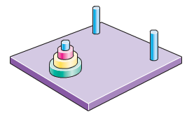

***Section* 3.2 − Recursive Definitions and Structural Induction**

**Recursive Algorithms**

***Definition***

A ***recursive*** or ***inductive*** *definition* of a function consists of two steps.

1. ***BASIS STEP***: Specify the value of the function at zero.
2. ***RECURSIVE STEP***: Give a rule for finding its value at an integer from its values at smaller integers.

***Example***

Suppose *f* is defined by:



Find *f*(1), *f*(2), *f*(3), *f*(4)

***Solution***

*f*(1) = 2*f*(0) *+* 3 = 2∙3 + 3 = 9

*f*(2) = 2*f*(1)*+* 3 = 2∙9 + 3 = 21

*f*(3) = 2*f*(2) *+* 3 = 2∙21 + 3 = 45

*f*(4) = 2*f*(3) *+* 3 = 2∙45 + 3 = 93

***Example***

Give a recursive definition of the factorial function *n*!

***Solution***

*f*(0) *=* 1

*f*(*n +* 1) *=* (*n +* 1)∙ *f*(*n*)

These 2 equations define *n*!

***Example***

Give a recursive definition of , where *a* is a nonzero real number and *n* is a nonnegative integer.

***Solution***



 for *n* = 0, 1, 2, 3, ….

These 2 equations define  for all nonnegative integers *n*.

***Example***

Give a recursive definition of: 

***Solution***

The first part of the definition is 

The second part is 

***Fibonacci Numbers***

***Example***

The Fibonacci numbers are defined as follows:



Find 

***Solution***









***Example***

Show that whenever , where 

***Solution***

***Basis Step***: *n* = 3, 

*n* = 4, 

***Inductive Step***: Assume that  holds 

We need to prove that  is true, that is is also true.

 





By the inductive hypothesis, we have 

Therefore. 

Hence,  is true. This completes the proof.

***Lamé’s* *Theorem***

Let *a* and *b* be positive integers with *a* ≥ *b*. Then the number of divisions used by the Euclidian algorithm to find  is less than or equal to five times the number of decimal digits in *b*.

***Proof***

When we use the Euclidian algorithm to find  with *a* ≥ *b,*

*n* divisions are used to obtain :











Since each quotient is at least 1 and :













It follows that if *n* divisions are used by the Euclidian algorithm to find  with *a* ≥ *b,* then . , for *n* > 2, where . Therefore, .

Because . Hence, 

Suppose that *b* has *k* decimal digits. Then *b* < 10*k* and . It follows that *n* − 1 < 5*k* and since *k* is an integer, *n* ≤ 5*k*.

As a consequence of Lamé’s Theorem, *O*(log *b*) divisions are used by the Euclidian algorithm to find whenever *a* > *b*.

**Recursively Defined Sets and Structures**

***Recursive definitions***of sets have two parts:

* + The ***basis step***specifies an initial collection of elements.
  + The ***recursive step***gives the rules for forming new elements in the set from those already known to be in the set.

Sometimes the recursive definition has an *exclusion rule*, which specifies that the set contains nothing other than those elements specified in the basis step and generated by applications of the rules in the recursive step.

We will always assume that the exclusion rule holds, even if it is not explicitly mentioned.

We will later develop a form of induction, called *structural induction*, to prove results about recursively defined sets.

***Example***

Consider the subset *S* of the set of integers recursively defined by

***Basis step***: 3 ∊S.

***Recursive step***: If *x* ∊ *S* and *y* ∊ *S*, then *x + y* is in *S.*

Initially 3 is in *S*, then 3 + 3 = 6, then 3 + 6 = 9, etc.

***Example***

Consider the subset **N**of the set of natural numbers recursively defined by

***Basis step***: 0 ∊ **N.**

***Recursive step***: If *n* is in **N**, then *n +* 1is in **N**.

Initially 0 is in *S*, then 0 + 1 = 1, then 1 + 1 = 2, etc.

**Strings**

***Definition***

The set of *strings* over the alphabet Σ:

***Basis step***: λ ∊ (λ is the empty string)

***Recursive step***: If *w* ∊ and *x* ∊ Σ*,* then *wx* ∈ *.*

***Example***

If Σ *=* {0,1}, the strings in in are the set of all bit strings, λ,0,1, 00,01,10, 11, etc.

***Example***

If Σ *=* {*a*,*b*}, show that *aab* is in .

Since λ ∊ and *a* ∊ Σ, *a* ∊ .

Since *a* ∊ and *a* ∊ Σ, *aa* ∊ .

Since *aa* ∊ and *b* ∊ Σ, *aab* ∊ .

**String Concatenation**

***Definition***

Two strings can be combined via the operation of *concatenation*. Let Σ be a set of symbols and  be the set of strings formed from the symbols in Σ. We can define the concatenation of two strings, denoted by ∙, recursively as follows.

***Basis step***: If *w* ∈ *,* then *w* ∙ λ= *w***.**

***Recursive step***: If  andand *x* ∈ Σ*,* then **.

* Often ** is written as **.
* If ** and **, the concatenation **.

**Length of a String**

***Example***

Give a recursive definition of *l*(*w*), the length of the string *w*.

***Solution***

The length of a string can be recursively defined by:

*l*(*w*) = 0;

*l*(*wx*) = *l*(*w*) + 1 if  and *x* ∊ Σ*.*

**Well-Formed Formulae in Propositional Logic**

***Definition***

The set of *well-formed formulae* in propositional logic involving **T**, **F**, propositional variables, and operators from the set {¬, ∧, ∨, →, ↔}.

***Basis step***: **T**, **F**, and *s*, where *s* is a propositional variable, are well-formed formulae.

***Recursive step***: If *E* and *F* are well formed formulae, then (¬ *E*)*,* (*E* ∧ *F*),(*E* ∨ *F*), (*E* → *F*), (*E* ↔ *F*), are well-formed formulae.

***Examples***

((*p* ∨*q*) → (*q* ∧ **F**)) is a well-formed formula.

*pq* ∧ is not a well formed formula.

**Rooted Trees**

***Definition***

The set of *rooted trees,* where a rooted tree consists of a set of vertices containing a distinguished vertex called the *root*, and edges connecting these vertices, can be defined recursively by these steps:

***Basis step***: A single vertex *r* is a rooted tree.

***Recursive step***: Suppose that  are disjoint rooted trees with roots , respectively. Then the graph formed by starting with a root *r*, which is not in any of the rooted trees, and adding an edge from *r* to each of the vertices , is also a rooted tree.

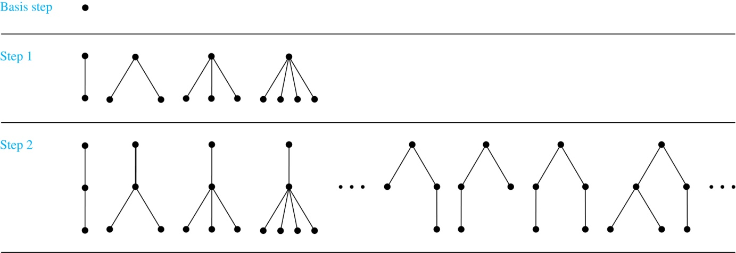

***Definition***

The set of ***extended binary trees*** can be defined recursively by these steps:

***Basis step***: The empty set is an extended binary tree.

***Recursive step***: If  and  are disjoint extended binary trees, there is an extended binary tree, denoted by , consisting of a root *r* together with edges connecting the root to each of the roots of the left subtree  and the right subtree  when these trees are nonempty.

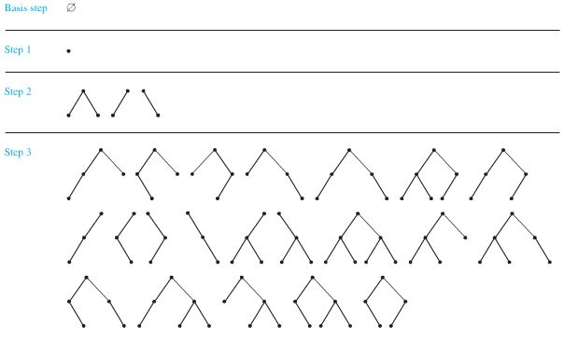

***Extended Binary Trees***

***Definition***

The set of ***full binary trees*** can be defined recursively by these steps:

***Basis step***: There is a full binary tree consisting only of a single vertex *r*.

***Recursive step***: If  and  are disjoint full binary trees, there is a full binary tree, denoted by , consisting of a root *r* together with edges connecting the root to each of the roots of the left subtree  and the right subtree .

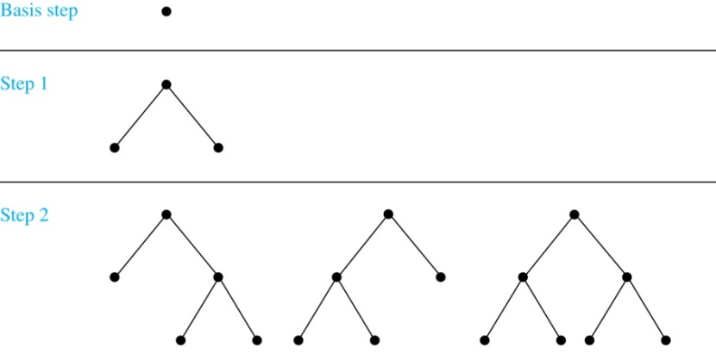

***Full Binary Trees***

**Structural Induction**

***Example***

Show that the set *S* defined by specifying that 3 ∊ *S* and that if *x* ∊ *S* and *y* ∊ *S*, then *x + y* is in *S,* isthe set of all positive integers that are multiples of 3.

***Solution***

Let *A* be the set of all positive integers divisible by 3.

To prove that *A* = *S*, show that *A* is a subset of *S* and *S* is a subset of *A*.

A⊂ S: Let P(*n*) be the statement that 3*n* belongs to *S*.

***Basis step***: 3∙1 = 3 ∊S, by the first part of recursive definition.

***Inductive step***: Assume *P*(*k*) is true. By the second part of the recursive definition, if 3*k* ∊S, then since 3 ∊S, 3*k +* 3 *=* 3(*k* + 1) ∊S. Hence, *P*(*k* + 1) is true.

S ⊂ A:

***Basis step***: 3 ∊S by the first part of recursive definition, and 3 = 3∙1.

***Inductive step***: The second part of the recursive definition adds *x* + *y* to *S*, if both *x* and *y* are in *S*. If *x* and *y* are both in *A*, then both *x* and *y* are divisible by 3. It follows that  is divisible by 3.

**Full Binary Trees**

***Definition***

The *height* of a full binary tree *T* is defined recursively as follows:

***Basis step***: The height of a full binary tree *T* consisting of only a root *r* is .

***Recursive step***: If  and  are full binary trees, then the full binary tree  has height *.*

The number of vertices *n*(*T*) of a full binary tree *T* satisfies the following recursive formula:

***Basis step***: The number of vertices of a full binary tree *T* consisting of only a root *r* is *n*(*T*) *=* 1.

***Recursive step***: If  and  are full binary trees, then the full binary tree  has the number of vertices .

***Theorem***

If *T* is a full binary tree, then 

***Proof***

Use structural induction.

***Basis step***: The result holds for a full binary tree consisting only of a root, *n*(*T*) = 1 and *h*(*T*) = 0.

Hence, *n*(*T*) = 1 ≤ 20+1 – 1 = 1.

***Recursive step***: Assume  and also whenever  and  are full binary trees.

 **(*by recursive formula of n(T)*)**

 **(*by inductive hypothesis*)**



 

 **(*by recursive definition of h(T)*)**



***Exercises Section* 3.2 − Recursive Definitions and Structural Induction**

1. Find ,,, and  if  is defined recursively by  and for 

|  |  |
| --- | --- |
|  |  |
|  |  |

1. Find ,,,  and  if  is defined recursively by  and for 

|  |  |
| --- | --- |
|  |  |
|  |  |

1. Find ,,  and  if  is defined recursively by  and for 

|  |  |
| --- | --- |
|  |  |
|  |  |

1. Determine whether each of these proposed definitions is a valid recursive definition of a function *f* from the set of nonnegative integers to the set of integers. If *f* is well defined, fund a formula for  when n is nonnegative integer and prove that your formula is valid.
2. 
3. 
4. 
5. 
6. 
7. 
8. 
9. 
10.  if *n* is odd and  and  if *n* is even and 
11.  if *n* is odd and  and  if *n* is even and 
12. Give a recursive definition of the sequence  if

|  |  |  |  |
| --- | --- | --- | --- |
|  |  |  |  |
|  |  |  |  |

1. Prove that  when *n* is a positive integer and  is the *n*th Fibonacci number.
2. Prove that  when *n* is a positive integer and  is the *n*th Fibonacci number.
3. Give a recursive definition of
4. The set of odd positive integers
5. The set of positive integers powers of 3
6. The set of polynomial with integer coefficients
7. The set of even integers
8. The set of positive integers congruent to 2 modulo 3.
9. The set of positive integers not divisible by 5
10. Let *S* be the subset of the set of ordered pairs of integers defined recursively by

*Basis step*: (0, 0) ∊ *S*.

*Recursive step*: If (*a, b*) ∊ *S*, then  *and* 

1. List the elements of *S* produced by the first five applications of the recursive definition.
2. Use strong induction on the number of applications of the recursive step of the definition to show that  when (*a, b*) ∊ *S*.
3. Use structural induction to show that  when (*a, b*) ∊ *S*.
4. Let *S* be the subset of the set of ordered pairs of integers defined recursively by

*Basis step*: (0, 0) ∊ *S*.

*Recursive step*: If (*a, b*) ∊ *S*, then ,  *and* 

1. List the elements of *S* produced by the first five applications of the recursive definition.
2. Use strong induction on the number of applications of the recursive step of the definition to show that  whenever (*a, b*) ∊ *S*.
3. Use structural induction to show that  whenever (*a, b*) ∊ *S*.

***Section* 3.3 − The Basics of Counting**

**Basic Counting Principle**

***The Product Rule***

A procedure can be broken down into a sequence of two tasks. There are  ways to do the first task and  ways to do the second task. Then there are ways to do the procedure

***Example***

How many bit strings of length seven are there?

***Solution***

Since each of the seven bits is either a 0 or a 1, the answer is 27 = 128.

***Example***

A new company with just two employees rents a floor of a building with 12 offices. How many ways are there to assign different offices to these two employees?

***Solution***

The procedure of assigning offices to these 2 employees consists of assigning an office to one employee, which can be done in 12 ways, then assigning an office to the second different from the office assigned to the first, which can be done in 11 ways.

By the product rule, there are  to assign offices to these 2 employees.

***Example***

There are 32 microcomputers in a computer center. Each microcomputer has 24 ports. How many different ports to a computer in the center are there?

***Solution***



***Example***

How many different license plates can be made if each plate contains a sequence of three uppercase English letters followed by three digits?

***Solution***

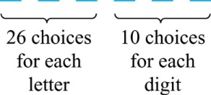By the product rule, there are 26 ∙ 26 ∙ 26 ∙ 10 ∙ 10 ∙ 10 = 17,576,000 different possible license plates.

**Counting Functions**

***Example***

How many functions are there from a set with *m* elements to a set with *n* elements?

*Solution*

Since a function represents a choice of one of the *n* elements of the codomain for each of the *m* elements in the domain, the product rule tells us that there are  such functions.

***Counting One-to-One Functions***

***Example***

How many one-to-one functions are there from a set with *m* elements to one with *n* elements?

***Solution***

Suppose the elements in the domain are . There are *n* ways to choose the value of  and *n* − 1 ways to choose , etc. The product rule tells us that there are  such functions.

***Counting Subsets of a Finite Set***

***Example***

Use the product rule to show that the number of different subsets of a finite set *S* is .

***Solution***

When the elements of S are listed in an arbitrary order, there is a one-to-one correspondence between subsets of *S* and bit strings of length |*S*|. When the *i*th element is in the subset, the bit string has a 1 in the *i*th position and a 0 otherwise. By the product rule, there are  such bit strings, and therefore  subsets.

**Product Rule in Terms of Sets**

* If  are finite sets, then the number of elements in the Cartesian product of these sets is the product of the number of elements of each set.
* The task of choosing an element in the Cartesian product is done by choosing an element in , an element inand an element in .
* By the product rule, it follows that: 

**Basic Counting Principles**

***Definition***: ***The Sum Rule***

If a task can be done either in one of  ways or in one of ways to do the second task, where none of the set of ways is the same as any of the ways, then there are ways to do the task.

***Example***

The mathematics department must choose either a student or a faculty member as a representative for a university committee. How many choices are there for this representative if there are 37 members of the mathematics faculty and 83 mathematics majors and no one is both a faculty member and a student.

***Solution***

By the sum rule it follows that there are 37 + 83 = **120** possible ways to pick a representative.

***Example***

A student can choose a computer project from one of three lists. The three lists contain 23, 15, and 19 possible projects, respectively. No project is on more than one list. How many possible projects are there to choose from?

***Solution***

Since no project is on more than one list, by the sum rule there are 23 + 15 + 19 = **57** ways to choose a project.

**The Sum Rule in terms of sets**

The sum rule can be phrased in terms of sets.

|*A* ∪ *B*|= |*A*| + |*B*| as long as *A* and *B* are disjoint sets.

Or more generally, when for all *i*, *j*.

***Example***

Suppose statement labels in a programming language can be either a single letter or a letter followed by a digit. Find the number of possible labels.

***Solution***

Use the product rule. 26 + 26 ∙ 10 **= 286**

***Subtraction Rule***

***Definition***

If a task can be done either in one of ways or in one of  ways, then the total number of ways to do the task is minus the number of ways to do the task that are common to the two different ways. Also known as, the *principle of inclusion-exclusion*: 

***Example***

How many bit strings of length eight either start with a 1 bit or end with the two bits 00?

**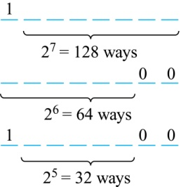*Solution***

Use the subtraction rule.

* + Number of bit strings of length eight that start with a 1 bit: 
  + Number of bit strings of length eight that start with bits 00: 
  + Number of bit strings of length eight that start with a 1 bit and end with bits 00 : 

Hence, the number is 128 + 64 − 32 = 160.

***Example***

A computer company receives 350 applications from computer graduates for a job planning a line of new Web servers. Suppose that 220 of these applicants majored in computer science, 147 majored in business, and 51 majored both in computer science and in business. How many of these applicants majored neither in computer science nor in business?

***Solution***

Let *A*: majored in computer science

*B*: majored in business









We conclude that 34 of the applicants majored neither in computer science nor in business

***Division Rule***

***Definition***

There are *n*/*d* ways to do a task if it can be done using a procedure that can be carried out in *n* ways, and for every way *w*, exactly *d* of the *n* ways correspond to way *w*.

* Restated in terms of sets: If the finite set *A* is the union of *n* pairwise disjoint subsets each with *d* elements, then *n* = |*A*|/*d*.
* In terms of functions: If *f* is a function from *A* to B, where both are finite sets, and for every value *y* ∈ *B* there are exactly *d* values *x* ∈ *A* such that *f*(*x*) = *y*, then |*B*| = |*A*|/*d.*

***Example***

How many ways are there to seat four people around a circular table, where two seatings are considered the same when each person has the same left and right neighbor?

***Solution***

Number the seats around the table from 1 to 4 proceeding clockwise.

There are four ways to select the person for seat 1, 3 for seat 2, 2, for seat 3, and one way for seat 4.

Thus there are 4! = 24 ways to order the four people.

But since two seatings are the same when each person has the same left and right neighbor, for every choice for seat 1, we get the same seating.

Therefore, by the division rule, there are 24/4 = 6 different seating arrangements.

***Tree Diagrams***

***Definition***

We can solve many counting problems through the use of *tree diagrams*, where a branch represents a possible choice and the leaves represent possible outcomes.

***Example***

How many bit strings of length four do not have two consecutive 1s?

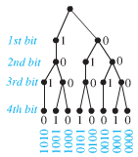

***Solution***

There are eight bits strings of length ***four*** without two consecutive 1s

***Example***

Suppose that “I Love Discrete Math” T-shirts come in five different sizes: S,M,L,XL, and XXL. Each size comes in four colors (white, red, green, and black), except XL, which comes only in red, green, and black, and XXL, which comes only in green and black. What is the minimum number of stores that the campus book store needs to stock to have one of each size and color available?

***Solution***

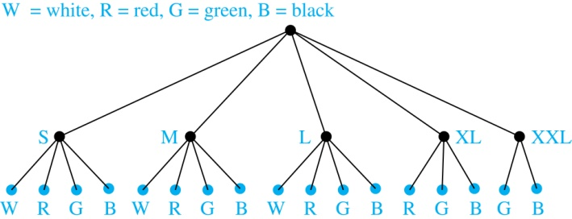

The store must stock **17** T-shirts.

***Exercises Section* 3.3 − The Basics of Counting**

1. There are 18 mathematics majors and 325 computer science majors at a college
2. In how many ways can two representatives be picked so that one is a mathematics major and the other is a computer science major?
3. In how many ways can one representative be picked who either a mathematics major or a computer science major?
4. An office building contains 27 floors and has 37 offices on each floor. How many offices are in the building?
5. A multiple-choice test contains 10 questions. There are four possible answers for each question
6. In how many ways can a student answer the questions on the test if the student answers every question?
7. In how many ways can a student answer the questions on the test if the student can leave answers blank?
8. A particular brand of shirt comes in 12 colors, has a male version and a female version, and comes in three sizes for each sex. How many different types of the shirts are made?
9. How many different three-letter initials can people have?
10. How many different three-letter initials with none of the letters repeated can people have?
11. How many different three-letter initials are there, that begin with an A?
12. How many bit strings are there of length eight?
13. How many bit strings of length ten both begin and end with a 1?
14. How many bit strings of length *n*, where *n* is a positive integer, start and end with 1s?
15. How many strings are there of lowercase letters of length four or less, not counting the empty string?
16. How many strings are there of four lowercase letters that have the letter *x* in them?
17. How many positive integers between 50 and 100
18. Are divisible by 7? Which integers are these
19. Are divisible by 11? Which integers are these
20. Are divisible by 7 and 11? Which integers are these
21. How many positive integers less than 100
22. Are divisible by 7?
23. Are divisible by 7 but not by 11?
24. Are divisible by both 7 and 11?
25. Are divisible by either 7 or 11?
26. Are divisible by exactly one of 7 and 11?
27. Are divisible by neither 7 nor 11?
28. How many positive integers less than 1000
29. Are divisible by 7?
30. Are divisible by 7 but not by 11?
31. Are divisible by both 7 and 11?
32. Are divisible by either 7 or 11?
33. Are divisible by exactly one of 7 and 11?
34. Are divisible by neither 7 nor 11?
35. have distinct digits?
36. have distinct digits and are even?
37. A committee is formed consisting of one representative from each of the 50 states in the United States, where the representative from a state is either the governor or one of the two senators from that state. How many ways are there to form this committee?
38. How many license plates can be made using either three digits followed by three uppercase English letters or three uppercase English letters followed by three digits?
39. How many license plates can be made using either two uppercase English letters followed by four digits or two digits followed by four uppercase English letters?
40. How many license plates can be made using either three uppercase English letters followed by three digits or four uppercase English letters followed by two digits?
41. How many strings of eight English letter are there
42. that contain no vowels, if letters can be repeated?
43. that contain no vowels, if letters cannot be repeated?
44. that start with a vowel, if letters can be repeated?
45. that start with a vowel, if letters cannot be repeated?
46. That contain at least one vowel, if letters can be repeated?
47. That contain at least one vowel, if letters cannot be repeated?
48. How many ways are there to seat four of a group of ten people around a circular table where two seatings are considered the same when everyone has the same immediate left and immediate right neighbor?
49. In how many ways can a photographer at a wedding arrange 6 people in a row from a group of 10 people, where the bride and the groom are among these 10 people, if
50. The bride must be in the picture?
51. Both the bride and groom must be in the picture?
52. Exactly one of the bride and the groom is in the picture?

1. How many different types of homes are available if a builder offers a choice of 6 basic plans, 3 roof styles, and 2 exterior finishes?
2. A menu offers a choice of 3 salads, 8 main dishes, and 7 desserts. How many different meals consisting of one salad, one main dish, and one dessert are possible?
3. A couple has narrowed down the choice of a name for their new baby to 4 first names and 5 middle names. How many different first- and middle-name arrangements are possible?
4. An automobile manufacturer produces 8 models, each available in 7 different exterior colors, with 4 different upholstery fabrics and 5 interior colors. How many varieties of automobile are available?
5. A biologist is attempting to classify 52,000 species of insects by assigning 3 initials to each species. Is it possible to classify all the species in this way? If not, how many initials should be used?
6. How many 4-letter code words are possible using the first 10 letters of the alphabet under:
7. No letter can be repeated
8. Letters can be repeated
9. Adjacent can’t be alike
10. How many 3 letters license plate without repeats
11. How many ways can 2 coins turn up heads, H, or tails, T – if the combined outcome (H, T) is to be distinguished from the outcome (T, H)?
12. How many 2-letter code words can be formed from the first 3 letters of the alphabet if no letter can be used more than once?
13. A coin is tossed with possible outcomes heads, H, or tails, T. Then a single die is tossed with possible outcomes 1, 2, 3, 4, 5, or 6. How many combined outcomes are there?
14. In how many ways can 3 coins turn up heads, H, or tails, T – if combined outcomes such as (H,T,H), (H, H, T), and (T, H, H) are to be considered different?
15. An entertainment guide recommends 6 restaurants and 3 plays that appeal to a couple.
16. If the couple goes to dinner or to a play, how many selections are possible?
17. If the couple goes to dinner and then to a play, how many combined selections are possible?

***Section* 3.4 − Permutations and Combinations**

***Permutation***

A permutation of a set of distinct objects is an arrangement of the objects is a ***specific Order* *Without*** repetition. An ordered arrangement of *r* elements of a set is called an ***r -permutation***.

***Theorem***

If *n* is a positive integer and *r* is an integer with , then there are



*r –*permutation of a set with *n* distinct elements.

***Proof***

Use the product rule. The first element can be chosen in *n* ways. The second in *n* − 1 ways, and so on until there are (*n* − ( *r* − 1)) ways to choose the last element.

***Corollary***

If *n* and *r* are integers with *,* then



***Example***

In mid 2007, eight candidates sought the Democratic nomination for president. In how many ways could voters rank their first, second, and third choices?

***Solution***

 

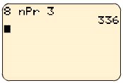

***Example***

How many ways are there to select a first-prize winner, a second prize winner, and a third-prize winner from 100 different people who have entered a contest?

***Solution***



***Example***

Suppose that there are eight runners in a race. The winner receives a gold medal, the second-place finisher receives a silver medal, and the third-place finisher receives a bronze medal. How many different ways are there to award these medals, if all possible outcomes of the race can occur and there are no ties?

***Solution***

There are: 

***Example***

Suppose that a saleswoman has to visit eight different cities. She must begin her trip in a specified city, but she can visit the other seven cities in any order she wishes. How many possible orders can the saleswoman use when visiting these cities?

***Solution***

The first city is chosen, and the rest are ordered arbitrarily. Hence the orders are:



If she wants to find the tour with the shortest path that visits all the cities, she must consider 5040 paths!

***Example***

How many permutations of the letters *ABCDEFGH* contain the string *ABC* ?

***Solution***

We solve this problem by counting the permutations of six objects, *ABC*, *D*, *E*, *F*, *G*, and *H*.



***Combination***

***Definition***

An *r-combination* of elements of a set is an unordered selection of *r* elements from the set. Thus, an *r*-combination is simply a subset of the set with *r* elements

Combination of a set of *n* distinct objects taken *r* @ a time ***without*** repetition is an *r* element subset of the set of *n* objects.

The arrangement of the elements *doesn’t matter*.



*n*Math → Prob → 3(*nCr*) *r*

***Example***

Let *S* be the set {*a*, *b*, *c*, *d*}. Then {*a*, *c*, *d*} is a 3-combination from *S*. It is the same as {*d*, *c*, *a*} since the order listed does not matter.

***Solution***

*C*(4,2) = 6 because the 2-combinations of {*a*, *b*, *c*, *d*} are the six subsets

{*a*, *b*}, {*a*, *c*}, {*a*, *d*}, {*b*, *c*}, {*b*, *d*}, and {*c*, *d*}.

***Theorem***

The number of *r*-combinations of a set with *n* elements, where *n* ≥ *r* ≥ 0, equals



***Proof***

By the product rule *P*(*n*, *r*) = *C*(*n*, *r*) ∙ *P*(*r*, *r*). Therefore,



***Example***

How many poker hands of five cards can be dealt from a standard deck of 52 cards? Also, how many ways are there to select 47 cards from a deck of 52 cards?

***Solution***

Since the order in which the cards are dealt does not matter, the number of five card hands is:



***Corollary***

Let *n* and *r* be nonnegative integers with *r* ≤ *n*. Then *C*(*n*, *r*) = *C*(*n*, *n* − *r*).

***Proof***

From Theorem 2, it follows that 

and 

Hence, *C*(*n*, *r*) = *C*(*n*, *n* − *r*).

***Definition***

A *combinatorial proof* of an identity is a proof that uses one of the following methods.

* A *double counting proof* uses counting arguments to prove that both sides of an identity count the same objects, but in different ways.
* A *bijective proof* shows that there is a bijection between the sets of objects counted by the two sides of the identity.

***Example***

How many ways are there to select five players from a 10-member tennis team to make a trip to a match at another school?

***Solution***

The number of combinations is 

***Example***

A group of 30 people have been trained as astronauts to go on the first mission to Mars. How many ways are there to select a crew of six people to go on this mission?

***Solution***

The number of possible crews is 

***Example***

How many bits strings of length *n* contain exactly *r* 1s?

***Solution***

The positions of *r* 1s in a bit string of length *n* form an *r*-combination of the set . There are .

***Example***

Suppose that there are 9 faculty members in the mathematics department and 11 in the computer science department. How many ways are there to select a committee to develop a discrete mathematics course at a school if the committee is to consist of three faculty member from the mathematics department and four from the computer science department?

***Solution***





***Exercises Section* 3.4 − Permutations and Combinations**

1. Decide whether the situation involves ***permutations*** or ***combinations***
2. A batting order for 9 players for a baseball game
3. An arrangement of 8 people for a picture
4. A committee of 7 delegates chosen from a class of 30 students to bring a petition to the administration
5. A selection of a chairman and a secretary from a committee of 14 people
6. A sample of 5 items taken from 71 items on an assembly line
7. A blend of 3 spices taken from 7 spices on a spice rack
8. From the 7 male and 10 female sales representatives for an insurance company, team of 8 will be selected to attend a national conference on insurance fraud.
9. Marbles are being drawn without replacement from a bag containing 15 marbles.
10. The new university president named 3 new officers a vice-president of finance, a vice-president of academic affairs, and a vice-president of student affairs.
11. A student checked out 4 novels from the library to read over the holiday.
12. A father ordered an ice cream cone (chocolate, vanilla, or strawberry) for each of his 4 children.
13. How many different permutations are the of the set ?
14. How many permutations of end with *a*?
15. Find the number of 5-permutations of a set with nine elements
16. In how many different orders can five runners finish a race if no ties are allowed?
17. A coin flipped eight times where each flip comes up either heads or tails. How many possible outcomes
18. Are there in total?
19. Contain exactly three heads?
20. Contain at least three heads?
21. Contain the same number of heads and tails?
22. A coin flipped 10 times where each flip comes up either heads or tails. How many possible outcomes
23. Are there in total?
24. Contain exactly two heads?
25. Contain at least three heads?
26. Contain the same number of heads and tails?
27. How many bit strings of length 12 contain
28. Exactly three 1s?
29. At most three 1s?
30. At least three 1s?
31. An equal number of 0s and 1s?
32. A group contains *n* men and *n* women. How many ways are there to arrange these people in a row if the men and women alternate?
33. In how many ways can a set of two positive integers less than 100 be chosen?
34. In how many ways can a set of five letters be selected from the English alphabet?
35. How many subsets with an odd number of elements does a set with 10 elements have?
36. How many subsets with more than two elements does a set with 100 elements have?
37. How many ways are there for eight men and five women to stand in a line so that no two women stand next to each other?
38. How many ways are there for six men and 10 women to stand in a line so that no two men stand next to each other?
39. A professor writes 40 discrete mathematics true/false questions. Of the statements in these questions. 17 are true. If the questions can be positioned in any order, how many different answer keys are possible?
40. Thirteen people on a softball team show up for a game.
41. How many ways are there to choose 10 players to take the field?
42. How many ways are there to assign the 10 positions by selecting players from the 13 people who show up?
43. Of the 13 people who show up, there are three women. How many ways are there to choose 10 players to take the field if at least one of these players must be a woman?
44. A club has 25 members
45. How many ways are there to choose four members of the club to serve on an executive committee?
46. How many ways are there to choose a president, vice president, secretary, and treasurer of the club, where no person can hold more than one office?
47. How many 4-permutations of the positive integers not exceeding 100 contain three consecutive integers, *k*, *k* + 1, *k* + 2, in the order
48. Where these consecutive integers can perhaps be separated by other integers in the permutation?
49. Where they are in consecutive positions in the permutation?
50. The English alphabet contains 21 constants and five vowels. How many strings of six lowercase letters of the English alphabet contain
51. Exactly one vowel?
52. Exactly two vowels?
53. At least one vowel?
54. At least two vowels?
55. Suppose that a department contains 10 men and 15 women. How many ways are there to form a committee with six members if it must have
56. The same number of men and women?
57. More women than men?
58. How many bit strings contain exactly eight 0s and 10 1s if every 0 must be immediately followed by a 1?
59. How many bit strings contain exactly five 0s and 14 1s if every 0 must be immediately followed by two 1s?
60. A concert to raise money for an economics prize is to consist of 5 works; 2 overtures, 2 sonatas, and a piano concerto.
61. In how many ways can the program be arranged?
62. In how many ways can the program be arranged if an overture must come first?
63. A zydeco band from Louisiana will play 5 traditional and 3 original Cajun compositions at a concert. In how many ways can they arrange the program if
64. The begin with a traditional piece?
65. An original piece will be played last?
66. In an election with 3 candidates for one office and 6 candidates for another office, how many different ballots may be printed?
67. A business school gives courses in typing, shorthand, transcription, business English, technical writing, and accounting. In how many ways can a student arrange a schedule if 3 courses are taken? assume that the order in which courses are schedules matters.
68. If your college offers 400 courses, 25 of which are in mathematics, and your counselor arranges your schedule of 4 courses by random selection, how many schedules are possible that do not include a math course? Assume that the order in which courses are scheduled matters.
69. A baseball team has 19 players. How many 9-player batting orders are possible?
70. A chapter of union Local 715 has 35 members. In how many different ways can the chapter select a president, a vice-president, a treasurer, and a secretary?
71. An economics club has 31 members.
72. If a committee of 4 is to be selected, in how many ways can the selection be made?
73. In how many ways can a committee of at least 1 and at most 3 be selected?
74. In a club with 9 male and 11 female members, how many 5-member committees can be chosen that have
75. All men?
76. All women?
77. 3 men and 2 women?
78. In a club with 9 male and 11 female members, how many 5-member committees can be selected that have
79. At least 4 women?
80. No more than 2 men?
81. In a game of musical chairs, 12 children will sit in 11 chairs arranged in a row (one will be left out). In how many ways can this happen, if we count rearrangements of the children in the chairs as different outcomes?
82. A group of 3 students is to be selected from a group of 14 students to take part in a class in cell biology.
83. In how many ways can this be done?
84. In how many ways can the group who will not take part be chosen?
85. Marbles are being drawn without replacement from a bag containing 16 marbles.
86. How many samples of 2 marbles can be drawn?
87. How many samples of 2 marbles can be drawn?
88. If the bag contains 3 yellow, 4 white, and 9 blue marbles, how many samples of 2 marbles can be drawn in which both marbles are blue?
89. A bag contains 5 black, 1 red, and 3 yellow jelly beans; you take 3 at random. How many samples are possible in which the jelly beans are
90. All black?
91. All red?
92. All yellow?
93. 2 black and 1 red?
94. 2 black and 1 yellow?
95. 2 yellow and 1 black?
96. 2 red and 1 yellow?

***Section* 3.5 − Applications of Recurrence Relations**

**Modeling with Recurrence Relations**

***Definition***

A *recurrence relation* for the sequence {*an*}is an equation that expresses *an* in terms of one or more of the previous terms of the sequence, namely, , for all integers *n* with , where  is a nonnegative integer

***Example***

A young pair of rabbits (one of each gender) is placed on an island. A pair of rabbits does not breed until they are 2 months old. After they are 2 months old, each pair of rabbits produces another pair each month. Find a recurrence relation for the number of pairs of rabbits on the island after *n* months, assuming that rabbits never die.

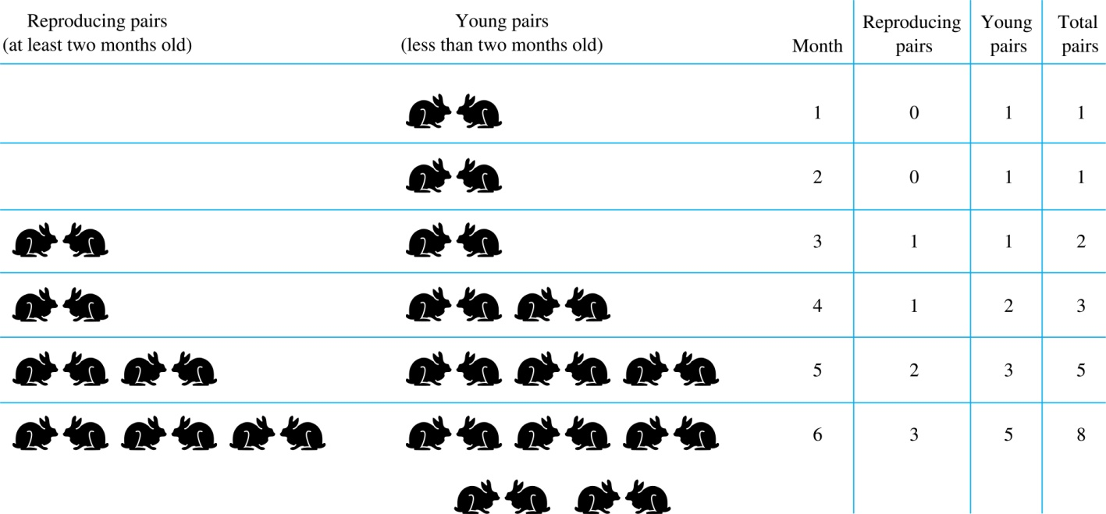

***Modeling the Population Growth of Rabbits on an Island***

***Solution***

Let  be the number of pairs of rabbits after *n* months.

* + - There are is  pairs of rabbits on the island at the end of the first month.
    - We also have  because the pair does not breed during the first month*.*
    - To find the number of pairs on the island after *n* months, add the number on the island after the previous month, , and the number of newborn pairs, which equals , because each newborn pair comes from a pair at least two months old.

Consequently the sequence satisfies the recurrence relation  for *n* ≥ 3 with the initial conditions  and .

The number of pairs of rabbits on the island after *n* months is given by the *n*th Fibonacci number.

**The Tower of Hanoi**

In the late nineteenth century, the French mathematician Édouard Lucas invented a puzzle, called the Tower of Hanoi, consisting of three pegs on a board with disks of different sizes. Initially all of the disks are on the first peg in order of size, with the largest on the bottom

***Rules*:** You are allowed to move the disks one at a time from one peg to another as long as a larger disk is never placed on a smaller.

***Goal*:** Using allowable moves, end up with all the disks on the second peg in order of size with largest on the bottom.

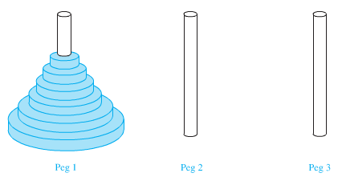

***Solution***

Let denote the number of moves needed to solve the Tower of Hanoi Puzzle with *n* disks. Set up a recurrence relation for the sequence . Begin with *n* disks on peg 1. We can transfer the top *n* −1 disks, following the rules of the puzzle, to peg 3 using moves.

First, we use 1 move to transfer the largest disk to the second peg. Then we transfer the *n* −1 disks from peg 3 to peg 2 using additional moves. This cannot be done in fewer steps. Hence,



The initial condition is  since a single disk can be transferred from peg 1 to peg 2 in one move.

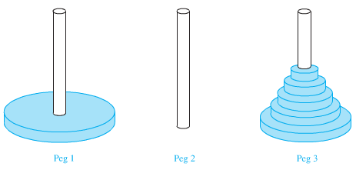

We can use an iterative approach to solve this recurrence relation by repeatedly expressing *Hn* in terms of the previous terms of the sequence.













 



***Using the formula for the sum of the terms of geometric series***



There was a myth created with the puzzle. Monks in a tower in Hanoi are transferring 64 gold disks from one peg to another following the rules of the puzzle. They move one disk each day. When the puzzle is finished, the world will end.

Using this formula for the 64 gold disks of the myth,

264 − 1 = 18,446, 744,073, 709,551,615 days are needed to solve the puzzle, which is more than 500 billion years.

Reve’s puzzle (proposed in 1907 by Henry Dudeney) is similar but has 4 pegs. There is a well-known unsettled conjecture for the minimum number of moves needed to solve this puzzle.

***Example***

Find a recurrence relation and give initial conditions for the number of bit strings of length *n* without two consecutive 0s. How many such bit strings are there of length five?

***Solution***

Let *an*  denote the number of bit strings of length *n* without two consecutive 0s. To obtain a recurrence relation for  note that the number of bit strings of length *n* that do not have two consecutive 0s is the number of bit strings ending with a 0 plus the number of such bit strings ending with a 1.

Now assume that *n* ≥ 3.

The bit strings of length *n* ending with 1 without two consecutive 0s are the bit strings of length *n* −1 with no two consecutive 0s with a 1 at the end. Hence, there are  such bit strings.

The bit strings of length *n* ending with 0 without two consecutive 0s are the bit strings of length *n* −2 with no two consecutive 0s with 10 at the end. Hence, there are  such bit strings.

We conclude that  for *n* ≥ 3.

The initial conditions are:

, since both the bit strings 0 and 1 do not have consecutive 0s.

, since the bit strings 01, 10, and 11 do not have consecutive 0s, while 00 does.

To obtain , we use the recurrence relation three times to find that:







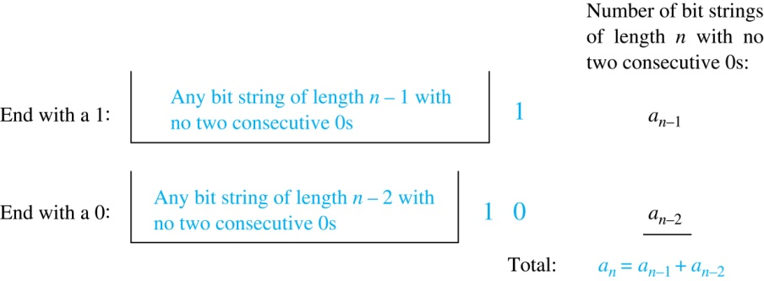

***Example***

A computer system considers a string of decimal digits a valid codeword if it contains an even number of 0 digits. For instance, 1230407869 is valid, whereas 1230407869 is not valid. Let  be the number of valid *n*-digit codewords. Find a recurrence relation for .

***Solution***

Note that  because there are 10 one-digit strings, and only one, namely the string 0, is not valid. A recurrence relation can be derived for this sequence by considering how a valid *n*-digit string can be obtained from strings of *n* – 1 digits. There are two ways to form a valid string with *n* digits from a string with one fewer digit.

1. A valid string with *n* digits can be obtained by appending a valid string of *n* – 1 digits with a digit other than 0. This appending can be done in 9 ways. Hence, a valid string with n digits can be formed in this manner in  ways.
2. A valid string with *n* digits can be obtained by appending a 0 to a string of length *n* – 1 that is not valid. The number of ways that this can be done equals the number of invalid (*n* – 1)-digit strings. Because there are  strings of length *n* – 1, and  are valid, there are  valid *n* –digit strings obtained by appending an invalid string of length *n* – 1 with a 0.

Because all valid strings of length *n* are produced in one of these two ways, it follows that there are





Valid strings of length *n*.

***Example***

Find a recurrence relation for , the number of ways to parenthesize the product of *n* + 1 numbers, , to specify the order of multiplication. For example,, since all the possible ways to parenthesize 4 numbers are

  

 

***Solution***

Note that however parentheses are inserted in , one “∙” operator remains outside all parentheses. This final operator appears between two of the *n* + 1 numbers, say  and . Since there are  ways to insert parentheses in the productand ways to insert parentheses in the product , we have





The initial conditions are .

***Exercises Section* 3.5 − Applications of Recurrence Relations**

1. *a*) Find a recurrence relation for the number of permutation of a set with *n* elements

*b*) Use the recurrence relation to find the number of permutations of a set with *n* elements using iteration.

1. A vending machine dispensing books of stamps accepts only one-dollar coins, $1 bills, and $5 bills.
2. Find a recurrence relation for the number of ways to deposit n dollars in the vending machine, where the order in which the coins and bills are deposited matter.
3. What are the initial conditions?
4. How many ways are there to deposit $10 for a book of stamps?
5. *a*) Find a recurrence relation for the number of bit strings of length *n* that contain three consecutive 0s.

*b*) What are the initial conditions?

*c*) How many bit strings of length seven contain three consecutive 0s?

1. *a*) Find a recurrence relation for the number of bit strings of length *n* that do not contain three consecutive 0s.

*b*) What are the initial conditions?

*c*) How many bit strings of length seven do not contain three consecutive 0s?

1. *a*) Find a recurrence relation for the number of ways to climb *n* stairs if the person climbing the stairs can take one stair or two stairs at a time.

*b*) What are the initial conditions?

*c*) In how many can this person climb a flight of eight stairs

***Section* 3.6 − Solving Linear Recurrence Relations**

***Definition***

A *linear homogeneous recurrence relation of degree k with constant coefficients* is a recurrence relation of the form



Where  are real numbers, and 

* It is *linear* because the right-hand side is a sum of the previous terms of the sequence each multiplied by a function of *n*.
* It is *homogeneous* because no terms occur that are not multiples of the . Each coefficient is a constant.
* The *degree* is *k* because is expressed in terms of the previous *k* terms of the sequence.

**Solving Linear Homogeneous Recurrence Relations**

The basic approach is to look for solutions of the form , where *r* is a constant.

Note that  is a solution to the recurrence relation  if and only if .

Algebraic manipulation yields the *characteristic equation*:



The sequence {*an*} with  is a solution if and only if *r* is a solution to the characteristic equation. The solutions to the characteristic equation are called the *characteristic roots* of the recurrence relation. The roots are used to give an explicit formula for all the solutions of the recurrence relation.

***Theorem***

Let  and be real numbers. Suppose that  has two distinct roots  and . Then the sequence {*an*} is a solution to the recurrence relation if and only if for *n* = 0, 1, 2, … , where  and  are constants.



This shows that the sequence  with  is a solution of the recurrence relation.

***Example***

What is the solution to the recurrence relation  with  and ?

***Solution***

The characteristic equation is .

Its roots are *r =* 2 and *r = −*1*.* Therefore, {*an*}is a solution to the recurrence relation if and

only if , for some constants  and .

To find the constants  and , note that



.

Solving these equations, we find that  and .

Hence, the solution is the sequence {*an*}with 

**An Explicit Formula for the Fibonacci Numbers**

***Example***

We can use Theorem to find an explicit formula for the Fibonacci numbers. The sequence of Fibonacci numbers satisfies the recurrence relation  with the initial conditions:  and .

***Solution***

The roots of the characteristic equation  are 

Therefore, from the theorem it follows that the Fibonacci numbers are given by



Using the initial conditions  and  , we have





The solution to these simultaneous equations for  and is  and 

Consequently, the Fibonacci numbers are given by



***Theorem***

Let  and be real numbers with . Suppose that has one repeated root . Then the sequence {*an*} is a solution to the recurrence relation   *iff*  for *n =* 0,1,2*,…* , where  and  are constants.

***Example***

What is the solution to the recurrence relation  with  and ?

***Solution***

The characteristic equation is *.*

The only root is *r =* 3*.* Therefore, {*an*}is a solution to the recurrence relation if and only if  where  and are constants.



Hence, .

***Theorem***

Let  be real numbers. Suppose that the characteristic equation



has *k* distinct roots . Then a sequence {*an*} is a solution of the recurrence relation



*iff* 

for *n* = 0, 1, 2, …, where are constants.

***Example***

Find the solution to the recurrence relation  with ,  and ?

***Solution***

The characteristic equation is *.*

The characteristic roots are .

The solutions to the recurrence relation are of the form  where , and are constants.





***Theorem***

Let be real numbers. Suppose that the characteristic equation



has *t* distinct roots  with multiplicities  respectively so that  for *i* = 0, 1, 2, …, *t*  and Then a sequence {*an*} is a solution of the recurrence relation



*iff* 





for *n* = 0, 1, 2, …, where  are constants for 1≤ *i* ≤ *t* and 0 ≤ *j* ≤ *mi−*1.

***Example***

Suppose that the roots of the characteristic equation of a linear homogeneous recurrence relation are 2, 2, 2, 5, 5, and 9 (that is, there are three roots, the root 2 with multiplicity three, the root 5 with multiplicity two, and the root 9 with multiplicity one). What is the form of the general solution?

***Solution***

The general form of the solution is:



***Example***

Find the solution to the recurrence relation 

with ,  and ?

***Solution***

The characteristic equation is *.*

The characteristic root is a single root  of multiplicity three.

The solutions to the recurrence relation are of the form

 where , and are constants.





**Linear Nonhomogeneous Recurrence Relations with Constant Coefficients**

***Definition***

A *linear nonhomogeneous recurrence relation with constant coefficients* is a recurrence relation of the form:



where  are real numbers, and *F*(*n*) is a function not identically zero depending only on *n*. The recurrence relation



is called the ***associated homogeneous recurrence relation***.

* The following are linear nonhomogeneous recurrence relations with constant coefficients:

**



**



where the following are the associated linear homogeneous recurrence relations, respectively:

**



**



***Theorem***

If  is a particular solution of the nonhomogeneous linear recurrence relation with constant coefficients



then every solution is of the form , where  is a solution of the associated homogeneous recurrence relation



***Example***

Find all solutions of the recurrence relation *.* What is the solution with *?*

***Solution***

The associated linear homogeneous equation is *.*

Its solutions are *,* where α is a constant.

Because *F*(*n*)= 2*n* is a polynomial in *n* of degree one.

Let the linear function  be such a solution

Then  becomes *cn* + *d =* 3(*c*(*n−* 1) + *d*)*+* 2*n.*

⇒ (2 + 2*c*)*n +* (2*d −* 3*c*) = 0.

It follows that *cn* + *d* is a solution if and only if 2 + 2*c*  = 0 and 2*d −* 3*c* = 0.

Therefore, *cn* + *d* is a solution if and only if c = *−* 1 and d = *−* 3/2.

Consequently,  is a particular solution.

By Theorem, all solutions are of the form*,* where α is a constant.

, let *n* = 1. Then .

Hence, the solution is *.*

***Example***

Find all solutions of the recurrence relation *.*

***Solution***

The linear nonhomogeneous equation is *.*

Its solutions are *,* where  and are constants

The trial solution is 













Hence, 

Hence, the solution is *.*

*Exercises* ***Section* 3.6 − Solving Linear Recurrence Relations**

1. Determine which of these are linear homogeneous recurrence relations with constant coefficients. Also find the degree of those that are
2. 
3. 
4. 
5. 
6. 
7. 
8. 
9. 
10. 
11. 
12. 
13. 
14. Solve these recurrence relations together with the initial conditions given
15. 
16. 
17. 
18. 
19. 
20. 
21. 
22. 
23. 
24. How many different messages can be transmitted in *n* microseconds using three different signals if one signal requires 1 microsecond for transmittal, the other two signals require 2 microseconds each for transmittal, and a signal in a message is followed immediately by the next signal?
25. In how many ways can a  rectangular checkerboard be tiled using  and  pieces?
26. Find the solution to 
27. Find the solution to 
28. Find the solution to 
29. Find the recurrence relation 
30. Find the recurrence relation 
31. Find the general form of the solutions of the recurrence relation 
32. What is the general form of the solutions of a linear homogeneous recurrence relation if its characteristic equation has roots 1, 1, 1, 1, −2, −2, −2, 3, 3, −4?
33. What is the general form of the solutions of a linear homogeneous recurrence relation if its characteristic equation has roots −1, −1, −1, 2, 2, 5, 5, 7?