***Lecture Four***

***Section* 4.1 – Relations and Their Properties**

***Definition***

Let *A* and *B* be sets. A binary relation from *A* to *B* is a subset of 

A binary relation from *A* to *B* is a set *R* of ordered pairs where the first element of each ordered pair comes from *A* and the second element comes from *B*. We use the notation  to denote that  and  to denote that . Moreover, when  belongs to *R*, *a* is said to be related to *b* by *R*.

***Example***

Let  and . Then  is a relation from *A* to *B*.

This means, for instance, that  but the .

Relations can be represented graphically, as shown below, using arrows to represent ordered pairs.



Another way to represent this relation is to use a table.

|  |  |  |
| --- | --- | --- |
| ***R*** | ***a*** | ***b*** |
| **0** | x | x |
| **1** | x |  |
| **2** |  | x |

**Relations on a Set**

***Definition***

A ***relation*** on a set *A* is a relation from *A* to *A*. and it’s a subset of 

***Example***

Let *A* = {1, 2, 3, 4} which ordered pairs are the relation ?

***Solution***

*R* = {(1, 1), (1, 2), (1, 3), (1, 4), (2, 2), (2, 4), (3, 3), (4, 4)}

***Example***

Consider these relations on the set of integers:













Which of these relations contain each of the pairs (1, 1), (1, 2), (2, 1), (1, −1), and (2, 2)?

***Solution***

**(1, 1) **

**(1, 2) **

**(2, 1) **

**(1, −1) **

**(2, 2) **

***Example***

How many relations are there on a set with *n* elements?

***Solution***

A relation on a set *A* is a subset of . Because  has  elements when *A* has *n* elements, and a set with *m* elements has subsets, there are  subset of .

Thus there are relations on a set with *n* elements.

**Properties of Relations**

***Reflexive***

***Definition***

A relation *R* on a set *A* is called ***reflexive*** if  for every element 

***Example***

Consider the following relations on {1,2 ,3 ,4}:













Which of these relations are ***reflexive***?

***Solution***

The relations and  are reflexive because they contain all pairs of the form (*a, a*), namely, (1, 1), (2, 2), (3, 3), and (4, 4).

 are not reflexive because (3, 3) is not in any of these relations.

***Example***

Is the “divides” relation on the set of positive integers reflexive?

***Solution***

Because  whenever *a* is a positive integer, the “divides” relation is reflexive.

(0 is doesn’t divide 0)

***Symmetric***

***Definition***

A relation *R* on a set *A* is called ***symmetric*** if  whenever , for all .



A relation *R* on a set *A* such that for all , if  and , then  is called ***antisymmetric***.



***Example***

Is the “divides” relation on the set of positive integers symmetric? Is it antisymmetric?

***Solution***

It is antisymmetric because  bur 

***Example***

Consider the following relations on {1,2 ,3 ,4}:













Which of these relations are symmetric and which are antisymmetric?

***Solution***

The relations and  are symmetric because in each case (*b, a*) belongs to the relation whenever (*a, b*) does.  in  in .

The relations , , and  are antisymmetric because for each relations there is no pair of elements *a* and *b* with  such that both (*a, b*) and (*b, a*) belong to the relation.

***Transitive***

***Definition***

A relation ***R*** on a set ***A*** is called ***transitive*** if whenever  and  then , for all 



***Example***

Consider the following relations on {1,2 ,3 ,4}:













Which of these relations are transitive?

***Solution***

The relations  and  are transitive because in each of these relations case that is  and belong to this relation then also does.

|  |  |  |
| --- | --- | --- |
| For | For |  |

The relation  is not transitive because  belong to  but not 

The relation  is not transitive because  belong to  but not 

The relation  is not transitive because  belong to  but not 

***Example***

Consider these relations on the set of integers:

 

 

 

Which of these relations contain each of the pairs (1, 1), (1, 2), (2, 1), (1, −1), and (2, 2)?

***Solution***

The relations , , and are transitive.

 is transitive because  and  imply that 

 is transitive because  and  imply that 

 is transitive because  and  imply that 

 is transitive because  and  imply that 

The relations  and are not transitive.

 is not transitive because  and  imply that 

 is not transitive because  and  imply that 

***Example***

Is the “divides” relation on the set of positive integers transitive?

***Solution***

Suppose *a* divides *b* and *b* divides *c*. Then there are positive integers *m* and *n* such that  and  . Hence , so *a* divides *c*.

Therefore this relation is transitive.

**Combining Relations**

Let *A* = {1, 2, 3} and *B* = {1, 2, 3, 4}.

The relations  and 









***Example***

Let  be the “less than” relation on the set of real numbers and let be the “greater than” relation on the set of real numbers, that is  and .

What are , , , , and ?

***Solution***

 if and only if . That implies  *iff* *x < y* or *x > y*. Since *x < y* or *x > y* means that, that follows that .

, since it is impossible for a pair  to belong to both and  because *x < y* and *x > y*.

, since 

, since 



***Definition***

Let *R* be a relation from a set *A* to a set *B* and *S* a relation from *B* to a set *C*. The composite of *R* and *A* is the relation consisting of ordered pairs (*a, c*), where , and for which there exists an element  such that  and . We denote the composite of *R* and *S* by .

***Example***

What is the composite of the relation *R* and *S*, where

*R* is the relation from {1, 2, 3} to {1, 2, 3, 4} with *R* = {(1, 1), (1, 4), (2, 3), (3, 1), (3, 4)}.

*S* is the relation from {1, 2, 3, 4} to {0, 1, 2} with *S* = {(1, 0), (2, 0), (3, 1), (3, 2), (4, 1)}.

***Solution***















***Definition***

Let *R* be a relation on the set *A*. Then powers  are defined recursively by



***Example***

Let *R* = {(1, 1), (2, 1), (3, 2), (4, 3)}. Find the powers 

***Solution***







From that , it follows that  for *n* = 5, 6, 7, ….

***Theorem***

The relation on a set *A* is transitive ***iff***  for *n* = 1, 2, 3, ….

***Proof***

Suppose that  for *n* = 1, 2, 3, …. In particular, . If  and , then by definition of composite, . Because , this means that . Hence, *R* is transitive.

Using mathematical induction to prove the only if part of the theorem

Assume that  where *n* is a positive integer. This is the inductive hypothesis.

To complete the inductive step we must show that this implies that  is also a subset of *R*.

Assume that , then because , there is an element *x* with  such that  and . The inductive hypothesis, namely, that , implies that 

Furthermore, because R is transitive, and  and , it follows that .

This shows that .

***Exercises Section* 4.1 – Relations and Their Properties**

1. List the ordered pairs in the relation *R* from *A* = {0, 1, 2, 3, 4} to *B* = {0, 1, 2, 3} where  if and only if

|  |  |  |
| --- | --- | --- |
|  |  |  |
|  |  |  |

1.  List all the ordered pairs in the relation  on the set {1, 2, 3, 4, 5, 6}

 Display this relation graphically.

 Display this relation in tabular form.

1. For each of these relations on the set {1, 2, 3, 4}, decide whether it is reflexive, symmetric, antisymmetric and transitive
2. {(2, 2), (2, 3), (2, 4), (3, 2), (3, 3), (3, 4)}
3. {(1, 1), (1, 2), (2, 1), (2, 2), (3, 3), (4, 4)}
4. {(2, 4), (4, 2)}
5. {(1, 2), (2, 3), (3, 4)}
6. {(1, 1), (2, 2), (3, 3), (4, 4)}
7. {(1, 3), (1, 4), (2, 3), (2, 4), (3, 1), (3, 4)}
8. Determine whether the relation *R* on the set of all people is reflexive, symmetric, antisymmetric, and/or transitive, where  if and only if
9. *a* is taller than *b*.
10. *a* and *b* were born on the same day
11. *a* has the same first name as *b*.
12. *a* and *b* have a common grandparent.
13. Determine whether the relation ***R*** on the set of all ***real numbers*** is reflexive, symmetric, antisymmetric, and/or transitive, where  if and only if

|  |  |  |  |
| --- | --- | --- | --- |
|  |  |  |  |
|  |  |  |  |

1. Determine whether the relation *R* on the set of all ***integers*** ***numbers*** is reflexive, symmetric, antisymmetric, and/or transitive, where  if and only if

|  |  |  |  |  |
| --- | --- | --- | --- | --- |
|  |  |  |  | |
|  |  |  | |  | |

1. Show that the relation  on nonempty set *S* is symmetric and transitive, but not reflexive.
2. Show that the relation  on nonempty set  is reflexive, symmetric and transitive.
3. Give an example of a relation on a set that is
4. both symmetric and antisymmetric
5. neither symmetric nor antisymmetric
6. A relation *R* is called ***asymmetric*** if implies that . Explore the notion of an asymmetric relation to the following
7. {(2, 2), (2, 3), (2, 4), (3, 2), (3, 3), (3, 4)}
8. {(1, 1), (1, 2), (2, 1), (2, 2), (3, 3), (4, 4)}
9. {(2, 4), (4, 2)}
10. {(1, 2), (2, 3), (3, 4)}
11. {(1, 1), (2, 2), (3, 3), (4, 4)}
12. {(1, 3), (1, 4), (2, 3), (2, 4), (3, 1), (3, 4)}
13. *a* is taller than *b*.
14. *a* and *b* were born on the same day
15. *a* has the same first name as *b*.
16. *a* and *b* have a common grandparent.
17. Let *R* be the relation  on the set of integers. Find

***a****)*  ***b)*** 

1. Let *R* be the relation  on the set of positive integers. Find

***a****)*  ***b)*** 

1. Let *R* be the relation on the set of all states in the U.S. consisting of pairs (*a, b*) where state *a* borders state *b*. Find

***a****)*  ***b)*** 

1. Let  and  be relation from

{1, 2, 3} to {1, 2, 3, 4}. Find

|  |  |  |  |
| --- | --- | --- | --- |
|  |  |  |  |

1. Let the relation R = {(1, 2), (1, 3), (2, 3), (2, 4), (3, 1)} and the relation S = {(2, 1), (3, 1), (3, 2), (4, 2)}. Find 
2.   

  

Find the following:

    

    

    

1. Let  be the “*divides*” and “*is a multiple of*” relations on the set of all positive integers, respectively. That is  and 

Find the following:

    

***Section* 4.2 – Representing Relations**

**Representing Relations Using Matrices**

A relation between finite sets can be represented using a zero-one matrix. Suppose that *R* is a relation from  to . The relation *R* can be represented by the matrix  where



***Example***

Suppose that *A* = {1, 2, 3} and *B* = {1, 2}. Let *R* the relation from *A* to *B* containing (*a, b*) if , and *a > b*. What is the matrix representing *R* is and ?

***Solution***

*R* = {(2, 1), (3, 1), (3, 2)} 

***Example***

Let and . Which ordered pairs are in the relation *R* represented by the matrix

 ?

***Solution***



A relation *R* on *A* is ***reflexive*** if  whenever 



A relation *R* on *A* is ***symmetric***



A relation *R* on *A* is ***antisymmetric*** iff  and 



***Example***

Suppose that the relation *R* on the set is represented by the matrix



Is *R* reflexive, symmetric, and/or antisymmetric?

***Solution***

Because the diagonal elements are equal to 1, *R* is reflexive.

is symmetric and it is not antisymmetric.

**Relations Using Diagraphs**

***Definition***

A directed ***graph***, or ***diagraph***, consists of a set *V* of ***vertices*** (or *nodes*) together with a set *E* ordered pairs of elements of *V* called ***edges*** (or *arcs*). The vertex *a* is called the ***initial*** vertex of the edge (*a, b*), and the vertex b is called the ***terminal*** vertex of this edge.

***Example***

Draw the directed graph with vertices *a, b, c*, and *d*, and edges (*a, b*), (*a, d*), (*b, b*), (*b, d*), (*c, a*), (*c, b*), and (*d, b*)

***Solution***

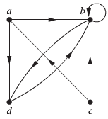

***Example***

Draw the directed graph of the relation *R* = {(1, 1), (1, 3), (2, 1), (2, 3), (2, 4), (3, 1), (3, 2), (4, 1)} on the set {1, 2, 3, 4}

***Solution***

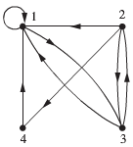

***Example***

What are the ordered pairs in the relation *R* represented by the directed graph shown below

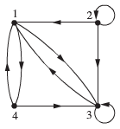

***Solution***

*R* = {(1, 3), (1, 4), (2, 1), (2, 2), (2, 3), (3, 1), (3, 3), (4, 1), (4, 3)}

***Exercises Section* 4.2 – Representing Relations**

1. Represent each of these relations on {1, 2, 3} with a matrix (with the elements of this set listed in increasing order). Then draw the directed graphs representing each relation
2. {(1, 1), (1, 2), (1, 3)}
3. {(1, 2), (2, 1), (2, 2), (3, 3)}
4. {(1, 1), (1, 2), (1, 3), (2, 2), (2, 3), (3, 3)}
5. {(1, 3), (3, 1)}
6. Represent each of these relations on {1, 2, 3, 4} with a matrix (with the elements of this set listed in increasing order). Then draw the directed graphs representing each relation
7. {(1, 2), (1, 3), (1, 4), (2, 3), (2, 4), (3, 4)}
8. {(1, 1), (1, 4), (2, 2), (3, 3), (4, 1)}
9. { (1, 2), (1, 3), (1, 4), (2, 1), (2, 3), (2, 4), (3, 1), (3, 2), (3, 4), (4, 1), (4, 2), (4, 3)}
10. {(2, 4), (3, 1), (3, 2), (3, 4)}
11. List the ordered pairs in the relations on {1, 2, 3} corresponding to these matrices (where the rows and columns correspond to the integers listed in increasing order). Then draw the directed graphs representing each relation

  

1. List the ordered pairs in the relations on {1, 2, 3, 4} corresponding to these matrices (where the rows and columns correspond to the integers listed in increasing order). Then draw the directed graphs representing each relation

  

1. Let *R* be the relation represented by the matrix



Find: *a*)  *b*)  *c*) 

1. Draw the directed graph that represents the relation {(*a, a*), (*a, b*), (*b, c*), (*c, b*), (*c, d*), (*d, a*), (*d, b*)}
2. Determine whether the relations represented by the directed graphs are reflexive, irreflexive, symmetric, antisymmetric, and/or transitive

|  |  |  |
| --- | --- | --- |
| ***a)*** | ***b)*** | ***c)*** |
| ***d)*** | ***e)*** | ***f)*** |

***Section* 4.3 – Closures of Relations**

**Closures**

The ***reflexive closure*** of *R* can be formed by adding to *R* all pairs of the form (*a, a*) with , not already in *R*.

The reflexive closure of *R* equals  where

 is the ***diagonal relation*** on *A*.

***Example***

What is the reflexive closure of the relation  on the set of integers?

***Solution***

The reflexive closure of *R* is the relation





***Example***

What is the symmetric closure of the relation  on the set of positive integers?

***Solution***

The symmetric closure of *R* is the relation





**Path in Directed Graphs**

***Definition***

A path from *a* to *b* in the directed graph *G* is a sequence of edges  in *G*, where *n* is nonnegative integer, and  and , that is, a sequence of edges where the terminal vertex of an edge is the same as the initial vertex in the next edge in the path. The path is denoted by  and has length *n*. We view the empty set of edges as a path of length zero from *a* to *a*. A path of length  that begins and ends at the same vertex is called a ***circuit*** or ***cycle***.

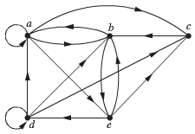***Example***

Which of the following are paths in the directed graph: *a, b, e, d; a, e, c, d, b; b ,a, c, b, a, a, b; d, c; c, b, a; e, b, a, b, a, b, e*?

What are the lengths of those that are paths?

Which of the paths in this list are circuits?

***Solution***

Each of (*a, b*), (*b, e*), and (*e, d*) is an edge *a, b, e, d* is a path of length 3

(*c, d*) is not an edge, therefore *a, e, c, d, b* is not a path

*b ,a, c, b, a, a, b* is a path of length 6

*d, c* is a path of length 1

*c, b, a* is a path of length 2

*e, b, a, b, a, b, e* is a path of length 6

The 2 paths *b, a, c, b, a, a, b* and *e, b, a, b, a, b, e* are circuits because they begin and end the same vertex.

The paths *a, b, e, d; c, b, a;* and *d, c* are not circuits

***Theorem***

Let *R* be a relation on a set *A*. There is a path of length *n*, where *n* is a positive integer, from *a* to *b* if and only if 

***Proof***

Using mathematical induction

There is a path from *a* to *b* of length one if and only if , which is true when *n* = 1.

Assume that the theorem is true for a positive integer *n*.

We need to prove that there is a path of length *n* + 1 from *a* to *b* if and only if  such there is a path of length 1 from *a* to *c*, so , and path of length *n* from *c* to *b* .

Consequently, by the inductive hypothesis, there is a path of length *n* + 1 from *a* to *b* if and only if there is an element *c* with  and . But there is such an element iff .

Therefore, there is a path of length *n* + 1 from *a* to *b* iff . This completes the proof.

**Transitive Closures**

***Definition***

Let *R* be a relation on a set *A*. The ***connectivity relation***  consists of the pairs (*a, b*) such that there is a path of length at least one from *a* to *b* in *R*.

***Example***

Let *R* be the relation on the set of all people in the world that contains (*a, b*) if *a* has met *b*. What is, where *n* is a positive integer greater than one? What is?

***Solution***

The relation  contain (*a, b*) if there is a person *c* such that  and , that is, if there is a person *c* such that *a* has met *c* and *c* has met *b*.

Similarly,  consists of those pairs (*a, b*) such that there are people  such that *a* has met .  has met  has met *b*.

The relation  contains (*a, b*) if there is a sequence of people, starting with *a* and ending with *b*, such that each person in the sequence has met next person in the sequence.

***Example***

Let *R* be the relation on the set of all states in U.S. that contains (*a, b*) if state *a* and state *b* have a common border. What is, where *n* is a positive integer? What is?

***Solution***

The relation  contain (*a, b*), where it is possible to go from state *a* to state *b* by crossing exactly *n* state borders. The relation consists of the ordered pairs (*a, b*), where it is possible to go from state *a* to state *b* crossing as many borders as necessary.

The only ordered pairs not in  are those containing sates that are not connected to the continental U.S.

***Theorem***

The transitive closure of a relation *R* equals the connectivity relation .

***Lemma***

Let *A* be a set with n elements, and let *R* be the relation on *A*. If there is a path of length at least one in *R* from *a* to *b*, then there is such a path with length not exceeding n. Moreover, when , if there is a path of length at least one in *R* from *a* to *b*, then there is such a path with length not exceeding *n* – 1.

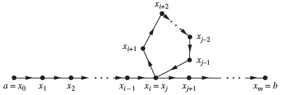

***Proof***

Suppose there is a path from *a* to *b* in *R*. Let *m* be the length of the shortest such path.

Suppose that , where  and , is such a path.

Suppose that *a = b* and that *m* > *n*, so that .

By the pigeonhole principle, because there are *n* vertices in *A*, among *m* vertices , at least two are equal.

Suppose that  with . Then the path contains a circuit from  to itself. This circuit can be deleted from the path from *a* to *b*, leaving a path, namely, , from *a* to *b* of shorter length. Hence, the path of shortest length must have less than or equal to *n*.

***Exercises Section* 4.3 – Closures of Relations**

1. Let *R* be the relation on the set {0, 1, 2, 3} containing the ordered pairs (0, 1), (1, 1), (1, 2), (2, 0),

(2, 2), and (3, 0). Find the

1. Reflexive closure of R.
2. Symmetric closure of R.
3. Let *R* be the relation  on the set of integers. What is the reflexive closure of *R*?
4. Let *R* be the relation  on the set of integers. What is the symmetric closure of *R*?
5. How can the directed graph representing the reflexive closure of a relation on a finite set be constructed from the directed graph of the relation?
6. Draw the directed graph of the *reflexive*, *symmetric*, and *both reflexive and symmetric* closure of the relations with the directed graph shown

|  |  |  |
| --- | --- | --- |
| ***a)*** | ***b)*** | ***c)*** |

1. 1. Determine whether these sequences of vertices are paths in this directed graph

|  |  |
| --- | --- |
| 1. *a, b, c, e* 2. *b, e, c, b, e* 3. *a, a, b, e, d, e* 4. *b, c, e, d, a, a, b* 5. *b, c, c, b, e, d, e, d* 6. *a, a, b, b, c, ,c, b, e, d* |  |

2. Find all circuits of length three in the directed graph

1. Let *R* be the relation on the set {1, 2, 3, 4, 5} containing the ordered pairs (1, 3), (2, 4), (3, 1), (3, 5), (4, 3), (5, 1), and (5, 2). Find

|  |  |  |  |  |  |
| --- | --- | --- | --- | --- | --- |
|  |  |  |  |  |  |

1. Let *R* be the relation on the pair (*a, b*) if a and b are cities such that there is a direct non-stop airline flight from *a* to *b*. When is (*a, b*) in

|  |  |  |  |
| --- | --- | --- | --- |
|  |  |  |  |

1. Let *R* be the relation on the set of all students containing the ordered pair (*a, b*) if *a* and *b* are in at least one common class and *a* ≠ *b*. When is (*a, b*) in

|  |  |  |
| --- | --- | --- |
|  |  |  |

1. Suppose that the relation *R* is reflexive. Show that  is reflexive.
2. Suppose that the relation *R* is symmetric. Show that  is symmetric.
3. Suppose that the relation *R* is irreflexive. Is the relation  necessarily irreflexive.

***Section* 4.4 – Equivalence Relations**

***Definition***

A relation on a set *A* is called an ***equivalence relation*** if it is reflexive, symmetric, and transitive.

***Definition***

Two elements *a* and *b* that related by an equivalence relation are called ***equivalent***. The notation  is often used to denotes that *a* and *b* are equivalent elements with respect to a particular equivalence relation.

***Example***

Let *R* be the relation on the set of integers such that *aRb* if and only if *a* = *b* or *a* = −*b*. It follows that *R* is an equivalence relation.

***Example***

Let *R* be the relation on the set of real numbers such that *aRb* if and only if *a* −*b* is an integer . Is *R* an equivalence relation?

***Solution***

Because *a – a* = 0 is an integer for all real numbers *a*, *aRa* for all real numbers *a*. Hence, *R* is reflexive

Suppose that *aRb*, then *a – b* is an integer, so *b – a* and *b – c* are integers.

Therefore, *a – c* = (*a – b*) + (*b – c*) is also an integer. Hence, *aRc*.

Thus, *R* is transitive. Consequently, *R* is an equivalence relation.

***Example***

Let *m* be an integer with *m* > 1. Show that the relation  is an equivalence relation on the set of integers.

***Solution***

 *iff* *m* divides *a – b*.

Since  then *a – a* = 0 is divisible by *m*. Hence, , so congruence modulo *m* is reflexive.

Suppose that , then *a – b* is divisible by *m*, so *a – b* = *km*, where *k* is an integer. It follows that *b – a* = (−*k*)*m*, so . Hence, congruence modulo *m* is symmetric.

Suppose that  and , then m divides both *a – b* and *b – c*. so  and , where *k* and *l* are integers. It follows that , so . Hence, congruence modulo *m* is transitive.

The congruence modulo *m* is an equivalence relation.

***Example***

Let *n* be a positive integer and *S* a set of strings. Suppose that  is the relation on S such that  if and only if *s = t*, or both *s* and *t* have at least *n* characters and the first *n* characters of *s* and *t* are the same. That is, a string of fewer than *n* characters is related only to itself; a string *s* with at least *n* characters is related to a string *t* if and only if *t* has at least *n* characters and *t* begins with the *n* characters at the start of *s*. For example, let *n* = 3 and let *S* be the set of all bit strings. Then  either when *s = t* or both *s* and *t* are bit strings of length 3 or more that begin with the same three bits. For instant,  and  but  and 

Show that every set *S* of strings and every positive integer *n*,  is an equivalence relation on *S*.

***Solution***

The relation  is reflexive because *s* = *s*, so that  whenever *s* is a string in *S*.

If , then either *s* = *t* or *s* and *t* are both at least *n* characters long that begin with same *n* characters. This means that . Therefore, is symmetric.

Suppose that  and . Then either *s* = *t* or *s* and *t* are both at least *n* characters long *s* and *t* begin with same *n* characters, and either *t* = *u* or *t* and *u* are both at least *n* characters long *t* and *u* begin with same *n* characters. From this, we can deduce that either *s* = *u* or *s* and *u* are both at least *n* characters long *s* and *u* begin with same *n* characters.

Because *s,* *t* and *u* are all at least *n* characters long *s* and *u* begin with same *n* characters as *t* does.

Therefore, is transitive.

It follows that  is an equivalence relation.

***Example***

Let *R* be the relation on the set of real numbers such that  if and only if *x* and *y* are real numbers that differ by less than 1, that is . Show that R is not an equivalence relation.

***Solution***

Let , , and , so that

 and 

But . That is , , but 

**Equivalence Classes**

***Definition***

Let *R* be an equivalent relation on a set *A*. The set of all elements that are related to an element *a* of *A* is called the ***equivalence class*** of *a*. The equivalence class of a with respect to *R* is denoted by . When only one relation is under consideration, we can delete the subscript *R* and write [*a*] for this equivalence class.



, then *b* called a ***representative*** of this equivalence class.

***Example***

Let *R* be the relation on the set of integers such that *aRb* if and only if *a* = *b* or *a* = −*b*. What is the equivalence class for this relation?

***Solution***

Because an integer is equivalent to itself and its negative in this equivalence relation, it follows that . This set contains two distinct integers unless .

For instance, , , and 

***Example***

What is the equivalence class of 0 and 1 for congruence modulo 4?

***Solution***

The equivalence class of 0 contains all integers *a* such that . The integers in this class are those divisible by 4, Hence, the equivalence class of 0 for this relation is

[0] = {…, −8, −4, 0, 4, 8, …}

The equivalence class of 1 contains all integers *a* such that . The integers in this class are those that have a remainder of 1when divided by 4, Hence, the equivalence class of 1 for this relation is

[1] = {…, −7, −3, 1, 5, 9, …}

***Example***

What is the equivalence class of the string 0111 with respect to the equivalence relation  on the set of all bit strings?

Recall that  if and only if *s* and *t* are bit strings with *s = t* or *s* and *t* are strings of at least three bits that start with the same three bits.

***Solution***

The bit strings equivalent to 0111 are the bit strings with at least three bits that begin with 011. These are the bit strings 011, 0110, 0111, 01100, 01101, 01110, 01111, and so on …



**Equivalence Classes and Partitions**

***Theorem***

Let *R* be an equivalence relation on a set *A*. These statements for elements *a* and *b* of *A* are equivalent:



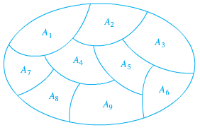



***Example***

Suppose that *S* = {1, 2, 3, 4, 5, 6}.

The collection of sets , , and  forms a partition of *S*.

Because these sets are disjoint and their union is *S*.

***Theorem***

Let *R* be an equivalent relation on a set *S*. Then the equivalence classes of *R* form a partition of *S*, Conversely, given a partition  of the set *S*, there is an equivalence relation *R* that has the sets , as its equivalence classes.

***Example***

List the ordered pairs in the equivalence relation *R* produced by the partition , , and  of *S* = {1, 2, 3, 4, 5, 6}.

***Solution***

The subsets in the partition are the equivalence classes of *R*. The pair  if and only if *a* and *b* are in the same subset of the partition.

The pairs (1, 1), (1, 2), (1, 3), (2, 1), (2, 2), (2, 3), (3, 1), (3, 2), and (3, 3) belong to *R* because  is an equivalence class.

The pairs (4, 4), (4, 5), (5, 4), and (5, 5) belong to *R* because  is an equivalence class.

The pair (6, 6) belong to *R* because  is an equivalence class

***Example***

What are the sets in the partition of the integers arising from congruence modulo 4?

***Solution***









***Exercises Section* 4.4 – Equivalence Relations**

1. Which of these relations on {0, 1, 2, 3} are equivalence relations?

Determine the properties of an equivalence relation that the others lack.

What are the equivalence classes of the equivalence relations?

1. {(0, 0), (1, 1), (2, 2), (3, 3)}
2. {(0, 0), (0, 2), (2, 0), (2, 2), (2, 3), (3, 2), (3, 3)}
3. {(0, 0), (1, 1), (1, 2), (2, 1), (3, 2), (3, 3)}
4. {(0, 0), (1, 1), (1, 3), (2, 2), (2, 3), (3, 1), (3, 2), (3, 3)}
5. {(0, 0), (0, 1), (0, 2), (1, 0), (1, 1), (1, 2), (2, 0), (2, 2), (3, 3)}
6. Which of these relations on the set of all people are equivalence relations?

Determine the properties of an equivalence relation that the others lack.

What are the equivalence classes of the equivalence relations?

1. 
2. 
3. 
4. 
5. 
6. Which of these relations on the set of all functions from Z to Z are equivalence relations?

Determine the properties of an equivalence relation that the others lack.

What are the equivalence classes of the equivalence relations?

1. 
2. 
3. 
4. 
5. 
6. Define three equivalence relations on the set of students in your discrete mathematics class different from the relations discussed in the text. Determine the equivalence classes for each of these equivalence relations.
7. Define three equivalence relations on the set of buildings on a college campus. Determine the equivalence classes for each of these equivalence relations.
8. Let *R* be the relation on the set of all sets of real numbers such that *S R T* if and only if *S* and *T* have the same cardinality. Show that *R* is an equivalence relation. What are the equivalence classes of the sets {0, 1, 2} and ?
9. Suppose that *A* is a nonempty set, and *f* is a function that has *A* as its domain. Let *R* be the relation on A consisting of all ordered pairs (*x, y*) such that 
10. Show that *R* is an equivalence relation on *A*.
11. What are the equivalence classes of *R*?
12. Suppose that *A* is a nonempty set, and *R* is an equivalence relation on *A*. Show that there is a function *f* with *A* as its domain such that  if and only if 
13. Determine whether the relation with the directed graph shown is an equivalence relation

|  |  |  |
| --- | --- | --- |
|  |  |  |

1. Which of these collections of subsets are partitions of {1, 2, 3, 4, 5, 6}
2. {1, 2}, {2, 3, 4}, {4, 5, 6}
3. {1}, {2, 3, 6}, { 4}, {5}
4. {2, 4, 6}, {1, 3, 5}
5. {1, 4, 5}, {2, 6}
6. Which of these collections of subsets are partitions of {−3, −2, −1, 0, 1, 2, 3}
7. {−3, −1, 1, 3}, {−2, 0, 2}
8. {−3, −2, −1, 0}, {0, 1, 2, 3}
9. {−3, 3}, {−2, 2}, {−1, 1}, {0}
10. {−3, −2, 2, 3}, {−1, 1}

***Section* 4.5 − Partial Orderings**

***Definition***

A relation *R* on set *S* is called a partial ordering or partial order if it is reflexive, antisymmetric, and transitive. A set *S* together with a partial ordering *R* is called a partially ordered set, or poset, and is denoted by (*S, R*). Members of *S* are called elements of the poset.

***Example***

Show that the “greater than or equal” relation  is a partial ordering on the set of integers

***Solution***

Because  for every integer *a*, ≥ is reflexive.

If  and , then . Hence, ≥ is symmetric.

If  and  imply that . Hence, ≥ is transitive.

It follows that  is a partial ordering on the set of integers and  is a poset.

***Example***

Show that the inclusion relation  is a partial ordering on the power set of a set *S*.

***Solution***

Because  whenever is a subset of *S*.  is reflexive.

It is antisymmetric because  and  imply that

 and  imply that, Hence  is transitive.

Hence,  is a partial ordering on  and  is a poset.

***Example***

Let *R* be the relation on the set of people such that  if *x* and *y* are people and *x* is older than *y*. Show that is not a partial ordering,

***Solution***

*R* is not reflexive, because no person is older than herself or himself 

*R* is antisymmetric because if a person *x* is older than *y*, then *y* is not older than *x*. That is, then .

The relation is transitive because a person *x* is older than *y*, then *y* is older than *z*, then *x* is older than *z*.

*R* is not a partial ordering.

***Definition***

The elements *a* and *b* of poset  are called comparable if either  or . When *a* and *b* are elements of *S* such that neither  nor , *a* and *b* are called incomparable.

***Example***

In the poset  are the integers 3 and 9 comparable? Are 5 and 7 comparable?

***Solution***

The integers 3 and 9 are comparable, because 3 | 9.

The integers 5 and 7 are ***incomparable***, because  and 

***Definition***

If  is a poset and every two elements of *S* are comparable, *S* is called a ***totally ordered*** or ***linearly ordered*** set, and is called a ***total order*** or a ***linear order***. A totally ordered set is also called a ***chain***.

***Example***

The poset  is totally ordered, because  or  whenever *a* and *b* are integers.

***Example***

The poset  is not totally ordered, because it contains elements that are incomparable, such as 5 and 7.

***Definition***

If  is well-ordered set if it is a poset such that is a total ordering and every nonempty subset of *S* has a least element.

***Example***

The set of ordered pairs of positive integers, , with  if , or if and (Lexicographic ordering), is a well-ordered set.

The set ***Z***, with the usual ≤ ordering, is not well-ordered because the set of negative integers, which is a subset of ***Z***, has no least element.

***Theorem* – The Principle of Well-Ordered Induction**

Suppose that *S* is a well-ordered set. Then  is true for all , if

Inductive Step: For every , if  is true for all  with , then  is true.

***Proof***

Suppose it is not the case that  is true for all . Then there is an element  such that,  is false.

Consequently, the set  is nonempty. Because *S* is well ordered, *A* has a least element *a*. By the choice of *a* as a least element of *A*, we know that  is true for all with . This implies by the inductive step  is true. This contradiction shows that  must be true for all .

***Example***

Determine whether , whether , and whether  in the poset , where  is the lexicographic ordering constructed from the usual ≤ relation on .

***Solution***

Because 3 < 4, it follows that  and that . We have , because the first entries of  and  are the same but 9 < 11.

**Maximal and Minimal Elements**

An element of a poset is called maximal if it is not less than any element of the poset. That is, *a* is ***maximal*** in the poset  if there is no element  such that .

Similarly, an element of a poset is called minimal if it is not greater than any element of the poset. That is, *a* is ***minimal*** in the poset  if there is no element  such that .

Maximal and minimal elements are easy to spot using a ***Hasse*** diagram. They are the “top” and “bottom” elements in the diagram.

Sometimes there is an element in a poset that is greater than every other element. Such that an element is called the greatest element. That is, a s the ***greatest element*** of the poset 

***Example***

Which elements of the poset ({2, 4, 5, 10, 12, 20, 25},, |) are maximal, and which are minimal?

***Solution***

From the Hasse diagram, the poset shows that the maximal elements are 12, 20, and 25

The minimal elements are 2 and 5.

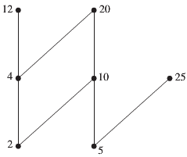

***Hasse Diagram***

***Example***

Determine whether the posets represented by each of the Hasse diagrams in figure below have greatest element and a least element.

|  |  |  |  |
| --- | --- | --- | --- |
|  |  |  |  |
| (*a*) | (*b*) | (*c*) | (*d*) |

***Solution***

The least element of the poset with Hasse diagram (*a*) is *a*. This poset has no greatest element.

The poset with Hasse diagram (*b*) has neither a least nor a greatest element.

The poset with Hasse diagram (*c*) has no least element. Its greatest element is *d*.

The poset with Hasse diagram (*d*) has least element *a* and greatest element *d*.

***Example***

Let *S* be a set. Determine whether there is a greatest element and a least element in the poset 

***Solution***

The least element is the empty set, because  for any subset *T* of *S*.

The greatest element in this poset, because  whenever T is a subset of *S*.

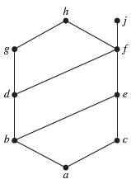***Example***

Find the lower and upper bounds of the subsets {*a, b, c*}, {*j, h*}, and

{*a, c, d, f*} in the poset with the Hasse diagram shown in the figure.

***Solution***

The upper bounds of {*a, b, c*} are *e, f, j* and *h* and its only lower bound is *a*.

There is no upper bounds of {*j, h*}, and its lower bounds are *a, b, c, d, e*, and *f*.

The upper bounds of {*a, c, d, f*} are *f, h*, and *j*, and its lower bound is *a*.

***Lattices***

A partially ordered set in which every pair of elements has both a least upper bound and a greatest lower bound is called a ***lattice***. Lattices have many special properties.

***Example***

Determine whether the posets represented by each of the Hasse diagrams are lattices

|  |  |  |
| --- | --- | --- |
|  |  |  |
| (*a*) | (*b*) | (*c*) |

***Solution***

The posets represented by the Hasse diagrams in (***a***) and (***c***) are both lattices because in each poset every pair of elements has both a least upper bound and a greatest lower bound.

On the other hand, the poset with the Hasse diagram shown in (***b***) is not a lattice, because the elements *b* and *c* have no least upper bound. Each of the elements *d, e*, and *f* is an upper bound, but none of these 3 elements precedes the other two with respect to the ordering of this poset.

***Example***

Is the poset  a lattice?

***Solution***

Let *a* and *b* be two positive integers, The least upper bound and greatest lower bound of these 2 integers are the least common multiple and the greatest common divisor of these integers, respectively, as the reader should verify. It follows that this is a lattice.

***Example***

Determine whether the posets  and  are lattices

***Solution***

Because 2 and 3 have no upper bound in , they are certainly do not have a least upper bound. Hence, the first poset is not a lattice.

Every elements of the second poset have both a least upper bound and a greatest lower bound. The least upper bound of 2 elements in this poset is the larger of the elements and the greatest lower bound of 2 elements is the smaller of the elements. Hence, the second poset is a lattice.

***Example***

Determine whether  is a lattice where *S* is a set.

***Solution***

Let *A* and *B* be 2 subsets of *S*. The least upper bound and the greatest lower bound of *A* and *B* are  and , respectively.

Hence,  is a lattice.

***Exercises Section* 4.5 − Partial Orderings**

1. Which of these relations on {0, 1, 2, 3} are partial orderings? Determine the properties of a partial ordering that the others lack.
2. {(0, 0), (1, 1), (2, 2), (3, 3)}
3. {(0, 0), (1, 1), (2, 0), (2, 2), (2, 3), (3, 2), (3, 3)}
4. {(0, 0), (1, 1), (1, 2), (2, 2), (3, 3)}
5. {(0, 0), (1, 1), (1, 2), (1, 3), (2, 2), (2, 3), (3, 3)}
6. {(0, 0), (0, 1), (0, 2), (1, 0), (1, 1), (1, 2), (2, 0), (2, 2), (3, 3)}
7. {(0, 0), (2, 2), (3, 3)}
8. {(0, 0), (1, 1), (2, 0), (2, 2), (2, 3), (3, 3)}
9. {(0, 0), (1, 1), (1, 2), (2, 2), (3, 1), (3, 3)}
10. {(0, 0), (1, 1), (1, 2), (1, 3), (2, 0), (2, 2), (2, 3), (3, 0), (3, 3)}
11. {(0, 0), (0, 1), (0, 2), (0, 3), (1, 0), (1, 1), (1, 2), (1, 3), (2, 0), (2, 2), (3, 3)}
12. Is (*S, R*) a poset If *S* is the set of all people in the world and , where *a* and *b* are people, if
13. *a* is a taller than *b*?
14. *a* is not taller than *b*?
15. *a* = *b* or *a* is an ancestor of *b*?
16. *a* and *b* have a common friend?
17. *a* is a shorter than *b*?
18. *a* weighs more than *b*?
19. *a* = *b* or *a* is a descendant of *b*?
20. *a* and *b* do not have a common friend?
21. Which of these are posets?

|  |  |  |  |
| --- | --- | --- | --- |
| 1. (Z, =) |  |  |  |
|  |  |  |  |

1. Determine whether the relations represented by these zero-one matrices are partial orders

|  |  |  |  |
| --- | --- | --- | --- |
|  |  |  |  |
|  |  |  |  |

1. Determine whether the relation with the directed graph shown is a partial order.

|  |  |
| --- | --- |
|  |  |
|  |  |

1. Let  be a poset. Show that  is also a poset, where  is the inverse of *R*. The poset  is called the dual of .
2. Draw the Hasse diagram for the “greater than or equal to” relation on {0, 1, 2, 3, 4, 5}

***Section* 4.6 − Graphs: Definitions and Basic Properties**

***Definition***

A graph  consists of *V*, a nonempty set of vertices (or nodes) and *E*, a set of edges. Each edge has either one or two ***vertices*** (plural of ***vertex***) associated with it, called its ***endpoints***. An edge is said to connect its endpoints.

Visualize the graphs by using points to represent vertices and line segments, possibly curved, to represent edges, where the endpoints of a line segment representing an edge are the points representing the ***edge-endpoints***.

 

To model a computer network, we need graphs that have more than one edge connecting the same pair of vertices. Graphs that may have ***multiple edges*** connecting the same vertices are called ***multigraphs***. Sometimes a communications link connects a data center with itself, a feedback loop for diagnostic purposes. Such edges are called ***loops***.

Graphs that may include loops, and possibly multiple edges connecting the same pair of vertices or a vertex to itself, are sometimes called ***pseudographs***.

Sometimes we have a ***one-way*** communication link like

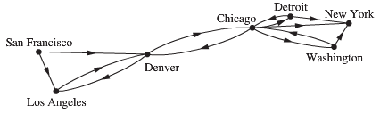

**Basic Terminology**

***Definition***

Two vertices *u* and *v* in an undirected graph *G* are called adjacent (or neighbors) in *G* if *u* and *v* are endpoints of an edge *e* of *G*. Such an edge *e* is called incident with the vertices *u* and *v* and *e* is said to connect *u* and *v*.

|  |  |  |  |
| --- | --- | --- | --- |
| ***Graph Terminology*** | | | |
| ***Type*** | ***Edges*** | ***Multiple Edges Allowed?*** | ***Loops Allowed?*** |
| Simple graph | Undirected | No | No |
| Multigraph | Undirected | Yes | No |
| Pseudograph | Undirected | Yes | Yes |
| Simple directed graph | Directed | No | No |
| Directed multigraph | Directed | Yes | Yes |
| Mixed graph | Directed and undirected | Yes | Yes |

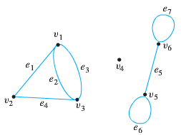***Example***

Consider the following graph:

1. Write the vertex set and the edge set, and give a table showing the edge-point function.
2. Find all edges that are incident on , all vertices that are adjacent to , all edges that are adjacent to , all loops, all parallel edges, all vertices that are adjacent to themselves, and all isolated vertices.

***Solution***

1. Vertex set = 

Edge set = 

Edge-point function:

|  |  |
| --- | --- |
| ***Edge*** | ***Endpoints*** |
|  |  |
|  |  |
|  |  |
|  |  |
|  |  |
|  |  |
|  |  |

1.  are incident on 

 are adjacent to 

 are adjacent to 

 are loops.

 are parallel.

 are adjacent to themselves.

 is an isolated vertex.

***Example***

Consider the two drawing shown below.

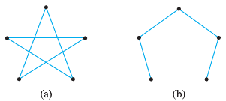

Label vertices and edges in such a way that both drawings represent the same graph

***Solution***

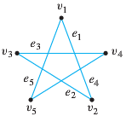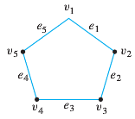

|  |  |
| --- | --- |
| ***Edge*** | ***Endpoints*** |
|  |  |
|  |  |
|  |  |
|  |  |
|  |  |

***Definition***

A ***directed graph*** (or ***digraph***) (*V, E*) consists of a nonempty set of vertices *V* and a set of ***directed edges*** (or ***arcs***) *E*. Each directed edge is associated with an ordered pair of vertices. The directed edge associated with the ordered pair (*u, v*) is said to *start* at *u* and *end* at *v*.

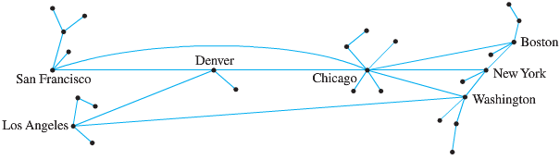

**Special Graphs**

***Definition***

A ***simple graph*** is a graph that does not have any loops or parallel edges. In a simple graph, an edge with endpoints *v* and *w* is denoted 

***Example***

Draw all simple graphs with the four vertices {*u, v, w, x*} and two edges, one of which is {*u, v*}

***Solution***

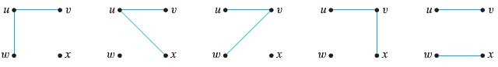

***Definition***

Let *n* be a positive integer. A ***complete graph*** on ***n vertices***, denoted  is a simple graph with *n* vertices and exactly one edge connecting each pair of distinct vertices.

The complete graphs  can be drawn as follows

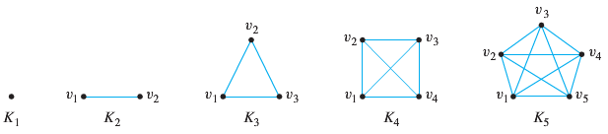

***Definition***

Let *m* and *n* be a positive integers. A ***complete bipartite graph*** on**(*m, n*) *vertices***, denoted  is a simple graph with distinct vertices that satisfies the following properties:

For all *i, k* = 1, 2, …, *m* and for all *j, l* = 1, 2, …, *n,*

1. There is an edge from each vertex  to each vertex 
2. There is no edge from each vertex  to any other vertex 
3. There is no edge from each vertex  to any other vertex 

***Example***

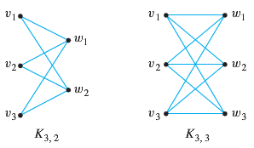

***Definition***

A graph *H* is said to be a subgraph of a graph if, and only if, every vertex in *H* is also a vertex in *G*, every edge in *H* is also an edge in *G*, and every edge in *H* has the same endpoints as it has in *G*.

***Example***

List all subgraphs of the graph *G* with vertex set  and edge set  where the endpoints of  are and , the endpoints of  are and  and  is a loop at.

***Solution***

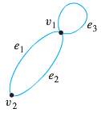

There are 11 subgraphs of G, which can be grouped according to those that do not have any edges, those that have one edge, those that have 2 edges, and those that have 3 edges.

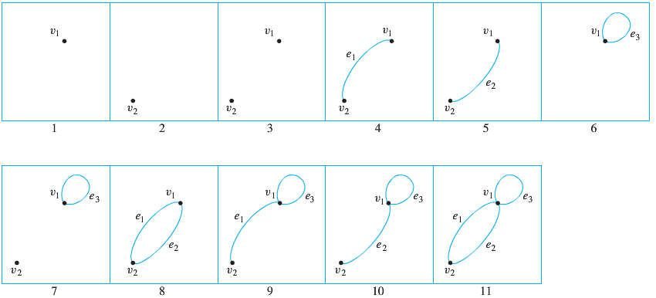

**The concept of Degree**

***Definition***

Let *G* be a graph and *v* a vertex of *G*. The ***degree of v***, denoted , equals the number of edges that are incident on *v*, with an edge that is a loop counted twice. The *total degree* of *G* is the sum of the degrees of all vertices of *G*.

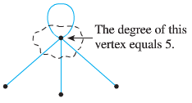

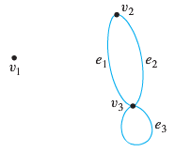***Example***

Find the degree of each vertex of the graph *G* shown below. Then find the total degree of G.

***Solution***

 since no edge is incident on  

 since both and  are incident on 

 since both and  are incident on  and the loop  is also incident on 

(contributes 2 to the degree of )

Total degree of *G* = 

**The Handshake *Theorem***

If *G* is any graph, then the sum of the degrees of all the vertices of *G* equals twice the number of edges of *G*. Specially, if the vertices of *G* are , where *n* is a nonegative integer, then

The total degree of G 



***Corollary***

The total degree of a graph is even.

***Example***

Draw a graph with the specified properties or show that no such graph exists.

1. A graph with four vertices of degrees 1, 1, 2, and 3
2. A graph with four vertices of degrees 1, 1, 3, and 3
3. A simple graph with four vertices of degrees 1, 1, 2, and 3

***Solution***

1. No such graph is possible. By Corollary, the total degree of a graph is even.

But a graph with four vertices of degrees 1, 1, 2, and 3 would have a total degree of  which is odd.

1. Let G be any of the graphs shown below

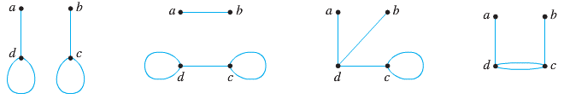

In each case, no matter how the edges are labeled,  and 

1. There is no simple graph with four vertices of degrees 1, 1, 3, and 3.

***Example***

Is it possible in a group of 9 people for each to be friends with exactly five others?

***Solution***

Imagine constructing an “acquaintance graph” in which each of the nine people represented by a vertex and 2 vertices are joined by an edge if, and only if, the people they represent are friends.

Suppose each of the people were friends with exactly five others. Then the degree of each of the 9 vertices of the graph would be 5, and so the total degree of the graph would be **45** (*odd*). Contradicts Corollary, which says that the total degree of a graph is even.

Therefore, the answer is no.

***Example***

A tournament where each team plays every other team exactly once and no ties are allowed is called a round-robin tournament. Such tournaments can be modeled using directed graphs where each team is represented by a vertex, Note that (*a, b*) is an edge if team *a* beats team *b*. This graph is a simple directed graph, containing no loops or multiple directed edges (because no 2 teams play each other more than once. Such a directed graph model is presented

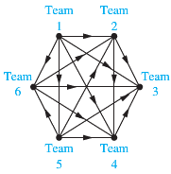

We see that team 1 is undefeated in this tournament, and Team 3 is winless.

***Exercises Section* 4.6 − Graphs: Definitions and Basic Properties**

1. Determine whether the graph shown has directed or undirected edges, whether it has multiple edges, and whether it has one or more loops.

|  |  |  |
| --- | --- | --- |
| *a)* | *b)* | *c)* |
| *d)* | *e)* | *f)* |
| *g)* |  |  |

1. Define each graph formally by specifying its vertex set, its edge set, and a table giving the edge-endpoint function

|  |  |
| --- | --- |
| *a)* | *b)* |

1. Graph *G* has vertex set  and edge set , with edge-endpoint function as follow

|  |  |
| --- | --- |
| ***Edge*** | ***Endpoints*** |
|  |  |
|  |  |
|  |  |
|  |  |

1. Graph *H* has vertex set  and edge set , with edge-endpoint function as follow

|  |  |
| --- | --- |
| ***Edge*** | ***Endpoints*** |
|  |  |
|  |  |
|  |  |
|  |  |

1. Show that the 2 drawings represent the same graph by labeling the vertices and edges of the right-hand drawing to correspond to those of the left-hand drawing.

|  |
| --- |
| *a)* |
| *b)* |
| *c)* |

1. For each of the graphs
2. Find all edges that are incident on 
3. Find all vertices that are adjacent to 
4. Find all edges that are adjacent to 
5. Find all loops
6. Find all parallel edges
7. Find all isolated vertices
8. Find the degree of 
9. Find the total degree of the graph

|  |  |
| --- | --- |
|  |  |

1. Let *G* be a simple graph. Show that the relation *R* on the set of vertices of *G* such that  if and only if there is an edge associated to  is a symmetric, irreflexive relation on *G*.
2. Let *G* be an undirected graph with a loop at every vertex. Show that the relation *R* on the set of vertices of *G* such that  if and only if there is an edge associated to  is a symmetric, reflexive relation on *G*.
3. Explain how graphs can be used to model electronic mail messages in a network. Should the edges be directed or undirected? Should multiple edges be allowed? Should loops be allowed? Describe a graph that models the electronic mail sent in a network in a particular week.
4. A bipartite graph *G* is a simple graph whose vertex set can be portioned into two disjoint nonempty subsets  and  such that vertices in  may be connected to vertices in , but no vertices in  are connected to other vertices in  and no vertices in  are connected to other vertices in . For example, the graph *G* illustrated in (*i*) can be redrawn as shown in (*ii*). From the drawing in (*ii*), you can see that *G* is bipartite with mutually disjoint vertex set  and 

|  |  |  |  |
| --- | --- | --- | --- |
| (*i*) | | (*ii*) | |
|  | |  | |  | |
|  | |  | |  | |

***Section* 4.7 − Representing Graphs and Graph Isomorphism**

Sometimes, two graphs have exactly the same form, in the sense that there is a one-to-one correspondence between their vertex sets that preserves edges. In such case, we say that the two graphs are isomorphic.

**Adjacency**

Use the adjacency lists to describe the given graph

|  |  |  |  |  |  |  |  |  |  |  |  |  |  |  |  |
| --- | --- | --- | --- | --- | --- | --- | --- | --- | --- | --- | --- | --- | --- | --- | --- |
|  | |  |  | | --- | --- | | **Adjacency List for a Simple Graph** | | | ***Vertex*** | ***Adjacent Vertices*** | | *a* | *b, c , e* | | *b* | *a* | | *c* | *a, d, e* | | *d* | *c, e* | | *e* | *a, c , d* | |

|  |  |  |  |  |  |  |  |  |  |  |  |  |  |  |  |
| --- | --- | --- | --- | --- | --- | --- | --- | --- | --- | --- | --- | --- | --- | --- | --- |
|  | |  |  | | --- | --- | | **Adjacency List for a Directed Graph** | | | ***Initial Vertex*** | ***Terminal Vertices*** | | *a* | *b, c, d, e* | | *b* | *b, d* | | *c* | *a, c, e* | | *d* |  | | *e* | *b, c , d* | |

**Adjacency Matrices**

Suppose that  is a simple graph where . Suppose that the vertices of *G* are listed arbitrary as . The adjacency matrix ***A***  of *G*, with respect to this listing of the vertices, is the  zero-one matrix with 1 as its (*i, j*)*th* entry when  and are adjacent, and 0 as its (*i, j*)*th* entry when they are not adjacent.



***Example***

Draw a graph with the adjacency matrix

 with respect to the ordering of vertices *a, b, c, d*.

***Solution***

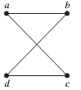

***Example***

Use an adjacency matrix to represent the pseudograph shown below.

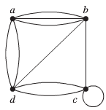

***Solution***



**Incidence Matrices**

Let  be undirected graph. Suppose that  are the vertices and  are the edges of *G*. Then the incident matrix with respect to this ordering of *V* and *E* is the  matrix , where



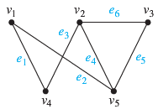***Example***

Represent the graph shown with an incidence matrix.

***Solution***

The incidence matrix is



***Example***

Represent the graph shown below with an incidence matrix.

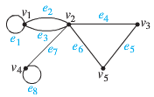

***Solution***

The incidence matrix is



**Isomorphism of Graphs**

***Definition***

The simple graphs  and  are isomorphic if there exists a one-to-one and onto function  from  to  with the property that *a* and *b* are adjacent in if and only if

 and  are adjacent in , for all *a* and *b* in . Such a function  is called an ***isomorphism***.

Two simple graphs that are not isomorphic are called ***nonisomorphic***.

***Example***

Show that the graphs  and , displayed below are isomorphic

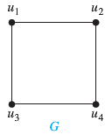 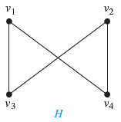

***Solution***

The function  with   and  is a one-to-one correspondence between *V* and *W*. To see that this correspondence preserves adjacency, note that adjacent vertices in *G* are  and , and each of the pairs  and ,  and ,  and ,  and  consists of two adjacent vertices in *H*.

∴ If we flip , we end up the same graph.

**Determining whether Two Simple Graphs are Isomorphic**

Sometimes it is not hard to show that two graphs are not isomorphic. In Particular, we can show that two graphs are not isomorphic if we can find a property only one of the two graphs has, but that is preserved by isomorphism. A property preserved by isomorphism of graphs is called a ***graph invariant***.

***Example***

Show that the graphs shown below are not isomorphic

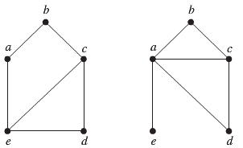

***G H***

***Solution***

Both graphs *G* & *H* have 5 vertices and 6 edges.

H has a vertex of degree one, @ *e*, whereas *G* has no vertices of degree one.

It follows that *G* & *H* are not isomorphic.

***Example***

Determine whether the graphs shown below are isomorphic

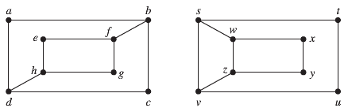

***G H***

***Solution***

Both graphs *G* & *H* have 8 vertices and 10 edges.

Also both have 4 vertices of degree 2 and 4 vertices of degree 3.

 in *G*, *a* must correspond to either *t, u ,x*, or *y* in *H*, because these are the vertices of degree 2 in *H*. However, each of these four vertices in *H* is adjacent to another vertex of degree 2 in *H*, which is not true for *a* in *G*. Therefore, *G* & *H* are not isomorphic.

Another way to see that *G* & *H* are not isomorphic is by checking the subgraphs of *G* & *H* shown below, they have a different shape.

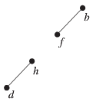 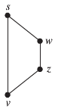

***Example***

Determine whether the graphs shown below are isomorphic

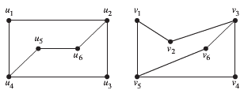

***G H***

***Solution***

Both graphs *G* & *H* have 6 vertices and 7 edges.

Also both have 4 vertices of degree 2 and 2 vertices of degree 3.

From the subgraphs of *G* & *H*, all vertices of degree 2 and the edges connecting them are isomorphic.



***Exercises Section* 4.7 − Representing Graphs and Graph Isomorphism**

Use the adjacency list to represent the given graph, then represent with an adjacency matrix

|  |  |
| --- | --- |
|  |  |
|  |  |

1. Draw a graph with the given adjacency

  

1. Represent the given graph using adjacency matrix

|  |  |  |
| --- | --- | --- |
|  |  |  |

1. Draw an undirected graph represented by the given adjacency

  

1. Find the adjacency matrix of the given directed multigraph with respect to the vertices listed in alphabetic order.

|  |  |  |
| --- | --- | --- |
|  |  |  |

Determine whether the given pair of graphs is isomorphic. Exhibit an isomorphism or provide a rigorous argument that none exists.

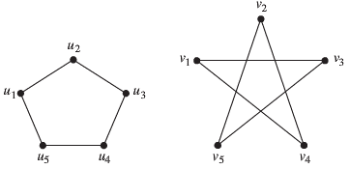

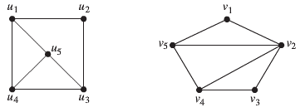

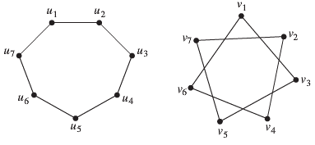

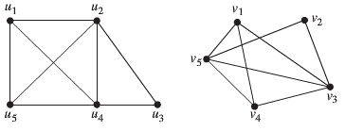

***Section* 4.8 − Connectivity**

***Paths***

A path is a sequence of edges that begins at a vertex of a graph and travels from vertex to vertex along edges of the graph.

***Definitions***

Let *G* be a graph, and let *v* and *w* be vertices in *G*.

A ***walk*** from *v* to *w* is a finite alternating sequence of adjacent vertices and edges of *G*. Thus a walk has the form



Where the v’s represent vertices, the e’s represents edges,  and for all *i* = 1, 2, …, *n*,  are the endpoints of . The trivial walk from *v* to *v* consists of the single vertex *v*.

A ***trail*** from *v* to *w* is a walk from *v* to *w* that does not contain a repeated edge.

A ***closed walk*** is a walk that starts and ends at the same vertex.

A ***circuit*** is a closed walk that contains at least one edge and does not contain a repeated edge.

A ***simple*** ***circuit*** is a circuit that does not any other repeated vertex except first and last.

|  |  |  |  |  |
| --- | --- | --- | --- | --- |
|  | **Repeated Edge?** | **Repeated Vertex** | **Starts & Ends at Same Point?** | **Must Contain at Least One Edge?** |
| ***Walk*** | Allowed | Allowed | Allowed | No |
| ***Trail*** | No | Allowed | Allowed | No |
| ***Path*** | No | No | No | No |
| ***Closed Walk*** | Allowed | Allowed | Yes | Yes |
| ***Circuit*** | No | Allowed | Yes | Yes |
| ***Simple Circuit*** | No | First & last only | Yes | Yes |

**Notation for Walks**

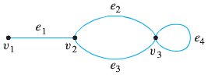

The notation  refers unambiguous to the following walk: . On the other hand, the notation is ambiguous if used to refer to a walk. It could mean either  or .

The notation  is ambiguous if used to refer to a walk. It could mean  or . On the other hand,

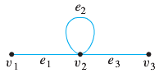

The notation  refers unambiguously to the walk 

***Example***

Determine which of the following walks are trails, paths, circuits, or simple circuits to the graph below.

*a)*  *b)*  *c)* 

*d)*  *e)*  *f)* 

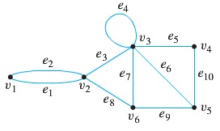

***Solution***

1. This walk has a repeated vertex but does not have a repeated edge, so it is a trail from  but not a path.
2. This is just a walk from . It is not a trail because it has a repeated edge.
3. This walk starts and ends at , contains at least one edge, and does not have a repeated edge, so it is a circuit. Since the vertex  is repeated in the middle, it is not a simple circuit.
4. This walk starts and ends at , contains at least one edge, and does not have a repeated edge, and does not have a repeated vertex. Thus it is a simple circuit.
5. This is just a closed walk starting and ending at . It is not a circuit because edge  is repeated.
6. The first vertex of this walk is the same as its last vertex, but it does not contain an edge, and so it is not a circuit, It is a closed walk from . (It is also a trail from )

***Example***

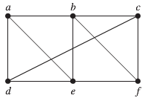

The given graph, *a, d, c, f, e* is a simple path of length 4, because {*a, d*}, {*d, c*}, {*c, f*}, and {*f, e*} are all edges. However, *d, e, c, a* is not a path, because {*e, c*} is not an edge.

Note that *b, c, f, e, b* is a circuit of length 4 because {*b, c*}, {*c, f*}, {*f, e*}, and {*e, b*} are edges, and this path begins and ends at *b*. The path *a, b, e, d, a, b*, which is of length 5, is not simple because it contains the edge {*a, b*} twice.

**Connectedness**

***Definition***

Let *G* be a graph. Two vertices *v* and *w* of *G* are ***connected*** if, and only if, there is a walk from *v* to *w*. The graph *G* is connected if, and only if, given any two vertices *v* and *w* in *G*, there is a walk from *v* to *w*. Symbolically,



***Definition***

An undirected graph is called ***connected*** if there is a path between every pair of distinct vertices of the graph. An undirected graph that is not *connected* is called ***disconnected***. We say that we *disconnect* a graph when we remove vertices or edges, or both, to produce a disconnected subgraph.

***Example***

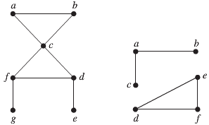

 

The graph  is connected, because for every pair of distinct vertices there is a path between them. However, the graph is not connected. For instance, there is no path in between vertices *a* and *b*.

**Connected and Disconnected Graphs**

***Example***

Which of the following graphs are connected?

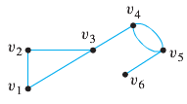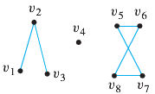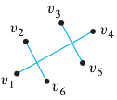

**(*a*) (*b*) (*c*)**

***Solution***

The graph represented in (*a*) is connected, whereas those of (*b*) and (*c*) are not.

To understand why (*c*) is not connected, two edges may cross at a point that is not a vertex.

Thus the graph in (*c*) can be drawn as follows:

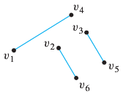

***Theorem***

There is a simple path between every pair distinct vertices of a connected undirected graph.

***Proof***

Let *u* and *v* be two distinct vertices of the connected undirected graph . Because *G* is connected, there is at least one path between *u* and *v*. Let  where  and , be the vertex sequence of a path of least length. This path of least length is simple. To see this, suppose it is not simple. Then  for some *i* and *j* with . This means that there is a path from *u* to *v* of shorter length with vertex sequence  obtained by deleting the edges corresponding to the vertex sequence 

***Definition***

A graph *H* is a connected component of a graph *G* if, and only if,

* *H* is subgraph of *G*;
* *H* is connected; and
* No connected subgraph of *G* has *H* as a subgraph and contains vertices or edges that are not in *H*.

***Example***

What are the connected components of the graph H shown below?

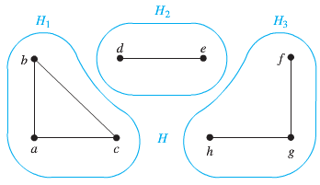

***Solution***

The graph *H* is the union of the three disjoint connected subgraphs . These three subgraphs are the connected components of *H*.

***Example***

Find all connected components of the following graph *G*.

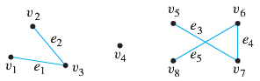

***Solution***

*G* has three connected components:  with vertex sets  and edges , where

 

 

 

***Example***

Find the cut vertices and cut edges in the graph .

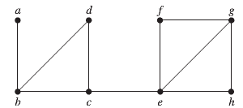



***Solution***

The cut vertices of *G* are *b, c*, and *e*. The removal of one of these vertices (and its adjacent edges) disconnects the graph. The cut edges are {*a, b*} and {*c, e*}. Removing either one of these edges disconnects *G*.

***Definition***

A directed graph is weakly connected of there is a path between every two vertices in the underlying undirected graph.

***Example***

Are the directed graphs *G* and *H* shown below strongly connected? Are they weakly connected?

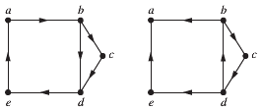

*G H*

***Solution***

*G* is strongly connected because there is a path between any two vertices in this directed graph. Hence, *G* is also weakly connected.

The graph *H* is not strongly connected. There is no directed path from *a* to *b* in this graph. However, *H* is weakly connected, because there is a path between any 2 vertices in the underlying undirected graph of *H*.

***Exercises Section* 4.8 − Connectivity**

1. Does each of these lists of vertices form a path in the following graph? Which paths are simple? Which are circuits? Which are the lengths of those that are paths?



***a)*** *a, e, b, c, b* ***b)*** *a, e, a, d, b, c, a* ***c)*** *e, b, a, d, b, e* ***d)*** *c, b , d, a, e, c*

1. Does each of these lists of vertices form a path in the following graph? Which paths are simple? Which are circuits? Which are the lengths of those that are paths?



***a)*** *a, b, e, c, b* ***b)*** *a, d, a, d, a* ***c)*** *a, d, b, e, a* ***d)*** *a, b , e, c, b, d, a*

1. Determine whether of the following walks are trails, paths, circuits, or simple circuits or just walk to the graph below.

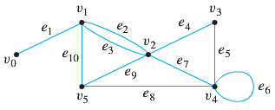

*a)*  *b)*  *c)* 

*d)*  *e)*  *f)* 

1. Determine whether of the following walks are trails, paths, circuits, or simple circuits or just walk to the graph below.

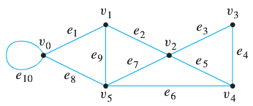

*a)*  *b)*  *c)* 

*d)*  *e)*  *f)* 

***Section* 4.9 − Euler and Hamilton Paths**

The town of  was divided into 4 sections by the branches of the Pregel River. The town people took long walks through town. They wondered whether it was possible to start at some location in the town, travel across all the bridges once without crossing and bridge twice, and return to the starting point.

 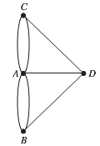

 Town *Multigraph*

The Swiss mathematician Leonhard Euler solved this problem. His solution, published in 1736, may be the first use of graph theory. Euler studied this problem using the multigraph obtained when the four regions are represented by vertices and the bridges by edges.

***Definition***

Let *G* be a graph. An Euler Circuit for *G* is a circuit that contains every vertex and every edge of *G*. That is, an Euler circuit for *G* is a sequence of adjacent vertices and edges in *G* that has at least one edge, starts and ends at the same vertex, uses every vertex of *G* at least once, and uses every edge of *G* exactly once.

***Theorem***

A connected multigraph with at least two vertices has an Euler circuit if and only if each of its vertices has even degree.

***Theorem***

A connected multigraph has Euler path but not an Euler circuit if and only if it has exactly 2 vertices of odd degree.

***Example***

Which of the undirected graph have Euler circuit? Of those that do not, which have an Euler path?

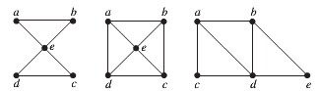

  

***Solution***

The graph has Euler circuit, for example, *a, e, c, d, e, b, a*.

&  do not have Euler circuit. Because vertices *a, b, c, d* of  & *a, b* of have degree 3

 has an Euler path, *a, c, d, e, b, d, a, b*.  does not have Euler path.

***Example***

Which of the undirected graph have Euler circuit? Of those that do not, which have an Euler path?

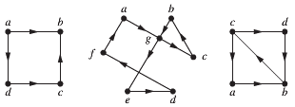

  

***Solution***

The graph  has Euler circuit, for example, *a, g, c, b, g, e, d, f, a*.

&  do not have Euler circuit. Because vertices *a, b, c, d* of  have degree 1 (*odd*) & *c, b* of have degree 3

 has an Euler path, *c, a, b, c, d, b*. but  does not have Euler path.

***Example***

Show that the graph below does not have an Euler circuit

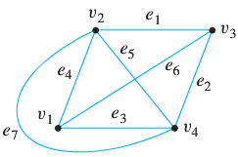

***Solution***

Vertices  both have degree 3, which is odd. Hence by the contrapositive form, this graph does not have an Euler circuit.

***Definition***

Let *G* be a graph, and let *v* and *w* be two distinct vertices of *G*. An Euler trail from *v* to *w* is a sequence of adjacent edges and vertices that starts at *v*, ends at *w*, passes through every vertex of *G* at least once, and traverses every edge of *G* exactly once.

***Example***

Many puzzles ask you to draw a picture in a continuous motion without lifting a pencil so that no part of the picture is retraced. We can solve such puzzles using Euler circuits and paths. For example, can Mohammed’s scimitars, shown in Figure below, be drawn in this way, where the drawing begins and ends at the same point?

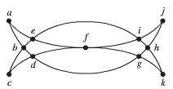

***Solution***

Let denote G for the graph. G has an Euler circuit, because all its vertices have even degree.

1. Form the circuit: *a, b, d, c, b, e, i, f, e, a*. We obtain the subgraph *H* by deleting the edges in this circuit and all vertices that become isolated when these edges are removed.
2. Form: *d, g, h, j, i, h, k, g, f, d* in H. After forming this circuit we have used all edges in G. Splicing this new circuit into the first circuit at the appropriate place produces the Euler circuit *a, b, d, g, h, j, i, h, k, g, f, d, c, b, e, i, f, e, a*. This circuit gives a way to draw the scimitars without lifting the pencil or retracting part of the picture.

**Hamilton Path and Circuits**

A simple path in a graph *G* that passes through every vertex exactly once is called a ***Hamilton path***, and a simple circuit *G* in a graph *G* that passes through every vertex exactly once is called a *Hamilton circuit*.

That is, the simple path  in the graph  is a Hamilton path if  and  for , and the simple circuit  (with *n* > 0) is a Hamilton circuit if  is a Hamilton path.

|  |  |
| --- | --- |
|  |  |
| ***Hamilton’s “A Voyage Round the World” Puzzle*** | ***Solution to the “A Voyage Round the World” Puzzle*** |

***Example***

Which of the simple given graphs have a Hamilton circuit or, if not, a Hamilton path?

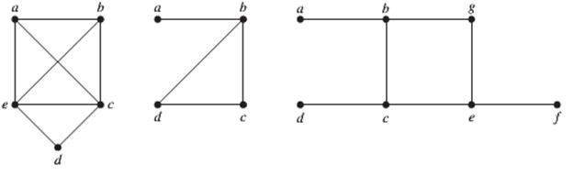

  

***Solution***

 has a Hamilton circuit: *a, b, c, d, e, a*.

There is no Hamilton circuit in , every vertex contain the edge {*a, b*} twice, but does have a Hamilton path, namely *a, b, c, d*.

 has neither a Hamilton circuit nor a Hamilton path, because any path containing all vertices must contain one of the edges {*a, b*}, {*e, f*}, and {*c, d*} more than once.

***Example***

Show that  has a Hamilton circuit whenever 

***Solution***

We can form a Hamilton circuit in  beginning at any vertex. Such a circuit can be built by visiting vertices in any order we choose, as long as the path begins and ends at the same vertex and visits each other vertex exactly once. This is possible because there are edges in  between any two vertices.

***Exercises Section* 4.9 − Euler and Hamilton Paths**

Determine whether the given graph has an Euler circuit. Construct such a circuit when one exists. If no Euler circuit exists, determine whether the graph has an Euler path and construct such a path if one exists.

|  |  |  |
| --- | --- | --- |
| **1**. | **2**. | **3**. |
| **4**. | **5.** |  |

**6.**

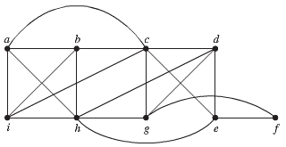

**7.**

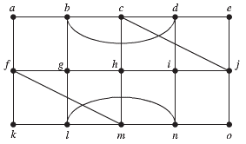

1. Can someone cross all the bridges shown in this map exactly once and return to the starting point?



Determine whether the picture shown can be drawn with a pencil in a continuous motion without lifting the pencil or retracing part of the picture

|  |  |  |
| --- | --- | --- |
| **9.** | **10.** | **11.** |

Determine whether the given graph has a Hamilton circuit. If it does, find such a circuit. If it does not, give an argument to show why no such circuit exists.

|  |  |
| --- | --- |
| **12.** | **13.** |
| **14.** | **15.** |
| **16.** | **17.** |
|  |  |

**18.** Imagine that the drawing below is a map showing 4 cities and the distances in kilometers between them. Suppose that a salesman must travel to each city exactly once, starting and ending in city *A*. Which route from city to city will minimize the total distance that must be traveled?

