***Lecture Three***

***Section* 3.1 – Introduction to Linear Systems**

***Definition***

A ***linear*** (algebraic) ***equation*** in *n* unknowns,  , is an equation of the form



Where  and *b* are real numbers.

***Matrices***



This is called Matrix (*Matrices*)

Each number in the array is an ***element*** or ***entry***

The matrix is said to be of order *m x n*

*m*: numbers of rows,

*n*: number of columns

When *m = n*, then matrix is said to be ***square***.

*Given the system equations*



Write into an ***augmented matrix*** form



***Example***

Given the linear equations



The solution to this system is , which means that 2 lines meeting at a single point.

We can rewrite the system equation as linear combination:









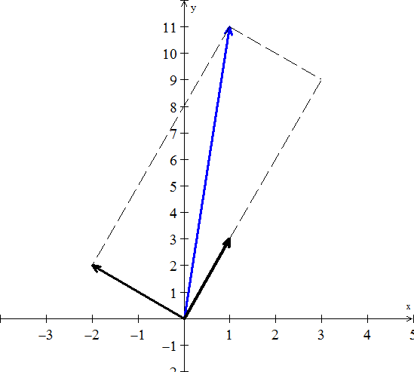 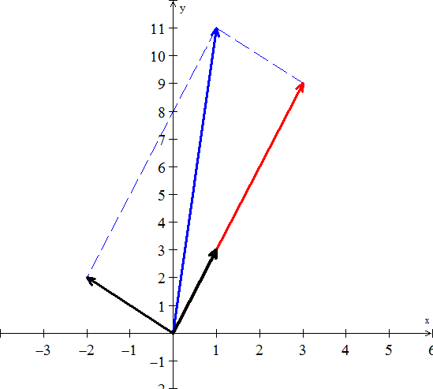

Therefore, the side vectors are

The diagonal sum is 

The linear combination is given by: 

Thus, the solution is 

***Note***

is called the coefficient matrix

The matrix form of the system is written as 



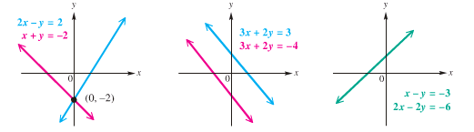

***One solution (lines intersect) No Solution (lines // ) Infinite solution***

***Consistent Inconsistent Consistent***

***Independent Independent Dependent***

***Three* Equations in 3 Unknowns**

A linear equation in three unknowns *x, y, z*:



A solution of the equation is an ordered triple of numbers 

If , all ordered triples satisfy the equation  (***infinitely many***)

If , no ordered triples satisfies the equation  (***no solution***)

If *a, b, c*, not all 0, then the set of all ordered triples that satisfy the equation is a plane (in 3-space)

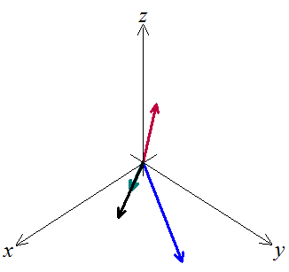***Example***

|  |  |
| --- | --- |
| Given the system equations |  |

This system can be written as linear combination:

 Let 

We want to multiply the three column vectors by  to produce ***b***.

The combination of the three vectors that produces

vector *b* is 2 times the third vector. 

Therefore the coefficients that we need are .



**Homogeneous Systems**

The system of linear equations



Is ***homogeneous*** if  otherwise, the system is ***nonhomogeous***.

A ***homogeneous*** system



***Always*** has at least one solution namely  called the ***trivial solution***

That is, homogeneous systems are always ***consistent***

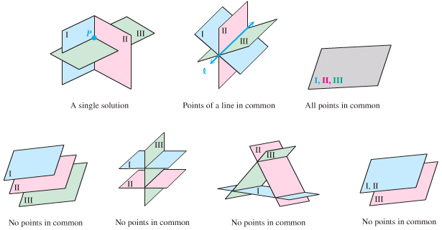

***Exercises Section* 3.1 – Introduction to Linear Systems**

1. Find a solution for *x, y, z* to the system of equations



1. Draw the two pictures in two planes for the equations: 
2. Normally 4 planes in 4-dimensional space meet at a ________. Normally 4 column vectors in 4-deimensional space can combine to produce *b*. what combinations of  produces ?

What 4 equations for  are you solving?

1. What 2 by 2 matrix *A* rotates every vector through 45° ?

The vector (1, 0) goes to . The vector (0, 1) goes to .

Those determine the matrix. Draw these particular vectors is the *xy*-plane and find *A*.

1. What two vectors are obtained by rotating the plane vectors  and  by 30° (*cw*) ?

Write a matrix *A* such that for every vector *v* in the plane, *Av* is the vector obtained by rotating *v* clockwise by 30°.

Find a matrix *B* such that for every 3-dimensional vector *v*, the vector *Bv* is the reflection of *v* through the plane . 

1. In each part, find a system of linear equation corresponding to the given augmented matrix
2.  *b)* 
3. Find the augmented matrix for the given system of linear equations.

|  |  |  |
| --- | --- | --- |
|  |  |  |

***Section* 3.2 – Gaussian Elimination**

Elimination produces an ***upper triangular system***.



The equation 

This process is called ***back substitution***.

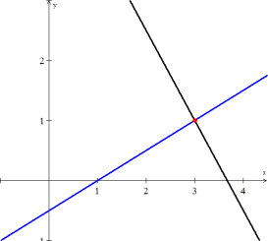 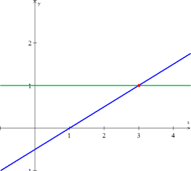

***Before elimination After elimination***

***Definitions***

***Pivot***: first nonzero in the row that does the elimination

***Multiplier***: (entry to eliminate) divide by pivot



The first pivot is 4 (the coefficient of *x*) and the multiplier is 

The pivots are on the diagonal of the triangle after elimination.

***Reduced Row Echelon Form***

  

***Example***

Use the Gaussian elimination method to solve the system



***Solution***

 

 0 1 2 13

 

 0 0 1 5

 ⇒ 

(2) ⇒ *y* = 13 − 2*z* = 13 − 2(5) = 3

(3) ⇒ *x* = 19 − *y* − 2*z* = 19 − 3 − 10 = 6

**⇒ (6, 3, 5)**

***Example***

Use Gauss-Jordan elimination to solve the linear system



***Solution***











 

The general solution of the system: 

***Example***

Use Gauss-Jordan elimination to solve the homogeneous linear system



***Solution***





 *Interchange* 





Solution: 

***Exercises Section* 3.2 – Gaussian Elimination**

1. When elimination is applied to the matrix 
2. What are the first and second pivots?
3. What is the multiplier in the first step ( times row 1 is subtracted from row 2)?
4. What entry in the 2, 2 position (instead of 9) would force an exchange of rows 2 and 3?
5. What is the multiplier , subtracting 0 times row 1 from row 3?
6. Use elimination to reach upper triangular matrices U. Solve by back substitution or explain why this impossible. What are the pivots (never zero)? Exchange equations when necessary. The only difference is the  in equation (3).

 

1. For which numbers *a* does the elimination break down (1) permanently (2) temporarily



Solve for *x* and *y* after fixing the second breakdown by a row change.

1. Find the pivots and the solution for these four equations:



1. Look for a matrix that has row sums 4 and 8, and column sums 2 and *s*.



The four equations are solvable only if *s* = ____. Then find two different matrices that have the correct row and column sums.

1. Three planes can fail to have an intersection point, even if no planes are parallel. The system is singular if row 3 of *A* is a _______ of the first two rows. Find a third equation that can’t be solved together with  and 
2. Solve the linear system by Gauss-Jordan elimination.

 

 

1. Solve the given linear system by any method

 

1. Add 3 times the second row to the first of



1. Solve the system using Gaussian elimination 
2. For what value(s) of *k*, if any, does the system  have
3. A unique solution?
4. Infinitely many solutions?
5. No solution?

***Section* 3.3 – Algebra of Matrices**



***Equality of Matrices***

**Definition of Equality of Matrices**

Two matrices ***A*** and ***B*** are equal if and only if they have the same order (size) *m* *x* *n* and if each pair corresponding elements is equal

 for *i* = 1, 2, …, *m* ***and*** *j* = 1, 2, …, *n*

***Example***

Find the values of the variables for which each statement is true, if possible.

1. 



1. 

*can’t be true*

1. 



***Addition* and *Subtraction* of Matrices**

***Definition***

If  and  are  matrices, their sum, is the  matrix obtained by adding the corresponding entries; that is



Matrices can be added if their shapes are the same, meaning have the same ***order***.





***Scalar* Multiplication Matrices**

***Definition***

If *k* is a scalar and  is an  matrices, then scalar product ***kA*** is the  matrix obtained by multiplying each entry of *A* by *k*; that is







***Example***





***Definition***

If  are matrices of the same size, and if  are scalars, then expression of the form



Is called a ***linear combination*** of  with *coefficients* .

***Matrix Multiplication***

**Product of Two Matrices**

Let ***A*** be an *m x n* matrix and let ***B*** be an *n x k* matrix. To find the element in the *ith* row and *jth* column of the product matrix ***AB***, multiply each element in the *ith* row of ***A*** by the corresponding element in the *jth* column of ***B***, and then add these products. The product matrix ***AB*** is an *m x k* matrix.

*Matrix* ***A*** *Matrix B*

*m x n n x k*

***Outer***: Order of *AB* is *m x k*

***Inner*** *must be equal*

* To multiply ***AB*** or dot product, if ***A*** has ***n*** columns, ***B*** must have ***n*** rows.
* Squares matrices can be multiplied if and only if (***iff***) they have the same size.
* The entry in row *i* and column *j* of AB is 

The result: 







 

 

 

 



***Example***

Find: 

***Solution***





***Special Case***

When *A* is a square matrix, then









***Block Multiplication***

If the cuts between columns of ***A***match the cuts between rows of ***B***, then the block multiplication of ***AB*** allowed.



***Important special case***





**Matrix Form of the Equations**

The coefficient matrix is 

The equivalent matrix equation is in the form :



Multiplication by ***rows*** 

Multiplication by ***columns*** 



***Identity Matrix***

The identity matrix is given by the form:  

***Properties of Matrix***

**Addition and Scalar Multiplication**

 *Commutative Property of Addition*

 *Associative Property of Addition*

 *Associative Property of Scalar Multiplication*

 *Distributive Property*

 *Distributive Property*

 *Distributive Property*

 *Distributive Property*

 *Additive Identity Property*

 *Additive Inverse Property*



***Multiplication***

 *Commutative “****law****” is usually broken*

 *Associative Property of Multiplication* (***Parentheses not needed***)

 *Distributive Property*

 *Distributive Property*

 *Distributive Property*

 *Distributive Property*

***Exercises Section* 3.3 – Algebra of Matrices**

1. For the matrices:  and , when does 
2. *A* is 3 by 5, *B* is 5 by 3, *C* is 5 by 1, and *D* is 3 by 1. All entries are 1. Which of these matrix operations are allowed, and what are the results?

*a*) *AB* *b*) *BA* *c*) *ABD* *d*) *DBA*

*e*) *ABC* *f*) *ABCD* *g*) *A*(*B* + *C*)

1. What rows or columns or matrices do you multiply to find.
2. The third column of *AB*?
3. The second column of *AB*?
4. The first row of *AB*?
5. The second row of *AB*?
6. The entry in row 3, column 4 of *AB*?
7. The entry in row 2, column 3 of *AB*?
8. Add *AB* to *AC* and compare with :



1. True or False
2. If  is defined then A is necessarily square.
3. If  and  are defined then A and B are square.
4. If  and  are defined then and  are square.
5. If , then 
6. *a*) Find a nonzero matrix *A* such that 

*b*) Find a matrix that has  but 

1. Suppose you solve  for three special right sides *b*:



If the three solutions  are the columns of a matrix *X*, what is *A* times *X*?

1. Show that  is different from , when



Write down the correct rule for 

1. Find the product of the 2 matrices by rows or by columns:

|  |  |
| --- | --- |
|  |  |
|  |  |

1. Given   Find 
2. Given   Find 
3. Given   Find 
4. Given   Find 
5. Consider the matrices

    

Compute the following (where possible):

***a***)  ***b***)  ***c***)  ***d***)  ***e***)  ***g***) 

***Section* 3.4 – Inverse Matrices**

***Definition***

The matrix *A* is invertible if there exists a matrix  such that:



 and *A* has to be a ***square matrix***.

***Not all matrices have inverses***.

1. The inverse exists *iff* elimination produces *n* pivots (row exchanges allow).
2. The matrix *A* cannot have two different inverses.
3. If *A* is invertible, the one and only one solution to  is 



 ***Multiply both side by A-1***

 ***Associate property***

 ***Multiplicative inverse property***

 ***Identity property***

1. Suppose there is a ***nonzero*** vector *x* such that . Then *A* cannot have an inverse
2. A 2 by 2 matrix is invertible iff  is not zero.

 ⇒  ***Only for 2 by 2 matrices***

If is the determinant, then doesn’t exist

**The Inverse of a Product **

***Theorem***

If an  matrix has an inverse, that inverse is unique.

***Proof***

Suppose that *A* has an inverse  and *B* is a matrix such that 



***Theorem***

If *A* and *B* are invertible then so is  Theinverse of a product is 

***Proof***









***Reverse Order***



***Theorem***

If *A* is invertible and *n* is a nonnegative integer, then:

1.  is *invertible* and 
2.  is *invertible* and 
3.  is *invertible* for any nonzero scalar *k*, and 

***Proof***





**Finding  using Gauss-Jordan Elimination**



Find 

  





  

 

* Matrix ***A*** is ***symmetric*** across its main diagonal. So is 
* Matrix ***A*** is ***tridiagonal*** (only three nonzero diagonals). But  is a full matrix with no zeros. (another reason we don’t compute )

**Singular *versus* Invertible**

 exists when *A* has a full set of *n* pivots. (Row exchanges allowed)

* With *n* pivots, elimination solves all the equations . The columns  go into . Then  is at least a ***right-inverse***.
* Elimination is really a sequence of multiplications.

***Conclusion***

* If *A* doesn’t have *n* pivots, elimination will lead to a ***zero row***.
* Elimination steps are taken by an invertible *M*. So a row of *MA* is zero.
* If  then . The zero row of *MA*, times *B*, gives a zero row of *M*.
* The invertible matrix *M* can’t have a zero row! A must have *n* pivots if .

***Elementary Matrices***

***Definition***

Let ***e*** be an elementary row operation. Then the  ***elementary matrix*** *E* associated with ***e*** is the matrix obtained by applying ***e*** to the identity matrix. Thus



***Example***

1. 
2. 
3. 
4. 

***Theorem***

Let *e* be an elementary operation and let *E* be the corresponding elementary matrix . Then for every  matrix *A*



That is, an elementary row operation can be performed on *A* by multiplying *A* on the left by the corresponding elementary matrix.

***Example***

Let    



This result can be obtained from *A* by multiplying the first row by 2.



This result can be obtained from *A* by interchanging rows 2 and 3.



This result can be obtained from *A* by adding 3 times row 1 to row 3.

**Uniqueness of Echelon Form**

Two matrices *A* and *B* are row-equivalent if and only if they have the same reduced echelon form.

***Proof***

If *A* and *B* have the same reduced echelon form *E*, then *A* is row-equivalent to *E* and *E* is row-equivalent to *B*. It follows that *A* is row-equivalent to *B*.

Now Suppose *A* and *B* are row-equivalent. Let  be a reduced echelon form of *A* and  be a reduced echelon form of *B*. Then  and  are row equivalent.

Suppose . Since  and  are row equivalent, for some matrix C. This means  and . But then .

***Example***

Show that the two matrices are row equivalent



***Solution***







***Definition***

A relationship ~ (equivalent) between elements of a set is called an equivalence relation if

* A ~ A is always true,
* A ~ B always implies B ~ A,
* A ~ B and B ~ C always implies A ~ C.

***Exercises Section* 3.4 – Inverse Matrices**

1. Apply Gauss-Jordan method to find the inverse of this triangular “Pascal matrix”

***Triangular Pascal matrix*** 

1. If *A* is invertible and , prove that 
2. If , find two matrices  such that 
3. If *A* has ***row*** 1 + ***row*** 2 = ***row*** 3, show that *A* is not invertible
4. Explain why  can’t have a solution.
5. Which right sides  might allow a solution to
6. What happens to ***row*** 3 in elimination?
7. True or false (with a counterexample if false and a reason if true):
8. A 4 by 4 matrix with a row of zeros is not invertible.
9. A matrix with 1’s down the main diagonal is invertible.
10. If *A* is invertible then  is invertible.
11. If *A* is invertible then  is invertible.
12. Do there exist 2 by 2 matrices *A* and *B* with real entries such that , where *I* is the identity matrix?
13. If *B* is the inverse of , show that  is the inverse of *A*.
14. Find and check the inverses (assuming they exist) of these block matrices.



1. For which three numbers *c* is this matrix not invertible, and why not? 
2. Find  and  (if they exist) by elimination. 

1. Find  using the Gauss-Jordan method, which has a remarkable inverse.



1. Find the inverse.

|  |  |  |
| --- | --- | --- |
|  |  |  |

1. Show that *A* is not invertible for any values of the entries



1. Prove that if *A* is an invertible matrix and *B* is row equivalent to *A*, then *B* is also invertible.
2. Determine if the given matrix has an inverse, and find the inverse if it exists. Check your answer by multiplying 

|  |  |
| --- | --- |
|  |  |

1. Show that the inverse of  is 

***Section* 3.5 – Determinants and Cramer’s Rule**

The determinant is a number that contains information about matrix. It is used to find formulas for inverse matrices, pivots, and solutions.

 has inverse 

Determinant of the matrix  is written  and is define as



The determinant is zero when the matrix has no inverse.

**Properties of the Determinants**

There are 3 basic properties (rules 1, 2, 3), by using those rules we can compute the determinant of any square matrix.

1. ***Determinant of the n by n identity matrix is* 1.**



1. ***Determinant changes sign when 2 rows are exchanged.***



1. ***Determinant is a linear function of each row separately***.

Multiply row 1 by any number *t*: 

Add row 1 of A to row 1 of A ′: 

* ***For 2 by 2 determinants, if you expand to a rectangle, the determinants equal areas.***
* ***For n-dimensional, the determinants equal volumes.***

1. ***If 2 rows of A are equal, then***.



1. ***Subtracting a multiple of one row from another row leaves *** ***unchanged.***



1. ***A matrix with a row of zeros has ***.



1. ***If A is triangular then  = product of diagonal entries.***



1. ***If A is singular then *. *If A is invertible then*.**
2. ***The determinant of AB *** ***is times : ***
3. ***The transpose has the same determinant as A:***  

* 

***Big Formula* for Determinants (Diagonal)**

***Determinant Using Diagonal Method***



 

 

*Determinant***: *D* = (1) + (2)**



***Example***

Evaluate: 

***Solution***







**Determinant by *Cofactors***



***Minor***

For a square matrix **, the minor . Of an element  is the ***determinant*** of the matrix formed by deleting the *ith* row and the *j*th column of *A*.

***Example***

Let  Find 

***Solution***







***Theorem***

The determinant is the dot product of any row ***i*** of ***A*** with its cofactors:

Cofactor Formula: 





***Example***

Find the determinant of the matrix:



***Solution***





= −8(−30 – (−21)) – 0 + 6(−12 − 6)

= −8(−9) + 6(−18)

= −36

* By the property of determinants, If ***A*** is triangular then  = product of diagonal entries.

***Example***



***Theorem***

Let ***A*** be any *n* by *n* matrix.

1. If ***A*′** is the matrix that results when a single row of ***A*** is multiplied by a constant ***k***, then .
2. If ***A*′** is the matrix that results when two rows of ***A*** are interchanged, then 
3. If ***A*′** is the matrix that results when a multiple of one row of ***A*** is added to another row then 

***Cramer*’s Rule**

***Theorem***

If  is a system of a linear equations in n unknowns such that , then the system has a unique solution. This solution is



Where 



***Example***

Use Cramer’s rule to solve



***Solution***



  

   ***Solution***: 

***Example***

Use Cramer’s Rule to solve.



***Solution***











**A Formula for** 

***Theorem***: ***Inverse of a matrix using its Adjoint***

The  entry of  is the cofactor  divided by det(***A***):

***Formula for ***: 



***Example***

Find the inverse matrix of using its adjoint.

***Solution***







 and  

***Theorem***

If *A* is an  matrix, then the following statements are equivalent

1. *A* is invertible
2. *A****x*** = 0 has only the trivial solution
3. The reduced row echelon form of *A* is 
4. *A* can be expressed as a product of elementary matrices
5. *A****x*** = ***b*** is consistent for every  matrix ***b***
6. 

***Exercises Section* 3.5 – Determinants and Cramer’s Rule**

1. Verify that  when: 
2. For which value(s) of ***k*** does *A* fail to be invertible? 
3. Without directly evaluating, show that 
4. If the entries in every row of *A* add to zero, solve ***Ax*** = 0 to prove det *A* = 0. If those entries add to one, show that det (*A – I*) = 0. Does this mean det *A = I*?
5. Does  in general?
6. True or false if ***A*** and ***B*** are square *n* x *n* matrices?
7. True or false if ***A*** is *m* x *n* and B is *n* x *m* with ?
8. True or false, with a reason if true or a counterexample if false:
9. The determinant of  is 1 + det ***A***.
10. The determinant of ABC is .
11. The determinant of 4*A* is 
12. The determinant of *AB – BA* is zero. (try an example)
13. If *A* is not invertible then *AB* is not invertible.
14. The determinant of *A – B* equals to det *A* – det *B*.
15. Use row operations to show the 3 by 3 “Vandermonde determinant” is



1. The inverse of a 2 by 2 matrix seems to have determinant = 1:



What is wrong with this calculation? What is the correct 

1. A *Hessenberg* matrix is a triangular matrix with one extra diagonal. Use cofactors of row 1 to show that the 4 by 4 determinant satisfies Fibonacci’s rule . The same rule will continue for all sizes . Which Fibonacci number is ?



1. Evaluate the determinant:

|  |  |  |
| --- | --- | --- |
|  |  |  |

1. Find all the values of λ for which det(***A***) = 0



1. Prove that if a square matrix ***A*** has a column of zeros, then det(***A***) = 0
2. With 2 by 2 blocks in 4 by 4 matrices, you cannot always use block determinants:



1. Why is the first statement true? Somehow *B* doesn’t enter.
2. Show by example that equality fails (as shown) when *C* enters.
3. Show by example that the answer  is also wrong.
4. Show that the value of the following determinant is independent of *θ*.



1. Show that the matrices  commute if and only if 
2. Show that  for every  matrix A.
3. What is the maximum number of zeros that a  matrix can have without a zero determinant? Explain your reasoning.
4. Evaluate *det* ***A***, *det* ***E***, and *det* (***AE***). Then verify that (*det* ***A***)( *det* ***E***) = *det*(***AE***)



1. Show that  is not invertible for any values of *α, β, γ*
2. Use Cramer’s Rule with ratios  to solve *A****x*** *= b*. Also find the inverse matrix . Why is the solution ***x*** is the first part the same as column 3 of ? Which cofactors are involved in computing that column ***x***?



1. Verify that  and determine whether the equality  holds



1. Verify that 

|  |  |
| --- | --- |
|  |  |

1. Solve by using Cramer’s rule

|  |  |
| --- | --- |
|  |  |

1. Show that the matrix *A* is invertible for all values of *θ*, then find  using 



***Section* 3.6 – Vectors in 2-Space, 3-Space, and *n*-Space**

Vectors in two dimensions are also called **2**−***space***

Vectors in three dimensions are also called **3**−***space*** by arrow

The direction of the arrowhead specifies the ***direction*** of the vector and the ***length*** of the arrow specifies the *magnitude*.

The tail of the arrow is called the ***initial point*** of the vector and the tip the ***terminal point***.

**Parallelogram Rule for Vector Addition**

|  |  |
| --- | --- |
| If ***v*** and ***w*** are vectors in 2-space or 3-space that are positioned so their initial points coincides, then the vectors form adjacent sides of a parallelogram, and then the sum ***v*** + ***w*** is the vector represented by the arrow from the common initial point of ***v*** and ***w*** to the opposite vertex of the parallelogram. |  |

**Triangle Rule for Vector Addition**

If ***v*** and ***w*** are vectors in 2-space or 3-space that are positioned so the initial point of *w* is at the terminal point of ***v***, then the sum ***v*** + ***w*** is represented by the arrow from the initial point of ***v*** to the terminal point of ***w***.

|  |  |  |
| --- | --- | --- |
|  |  |  |

***Special Cases*:**

* A  matrix  also written as  is called a ***row vector***.
* A  matrix  is called a ***column vector***.

The entries of a row or column vector are called the ***components*** of the vector.

***Example of Sum and Difference of vectors***

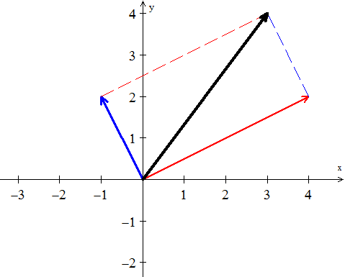Consider the vector  is given by the component  and represented by an arrow. The arrow goes from 4 units to the right and 2 units up.

Consider anther vector 

***v + w***

Vector addition (head to tail) at the end of , place the start of .

***w***

***v***

The vector addition and  produces the diagonal of a parallelogram.



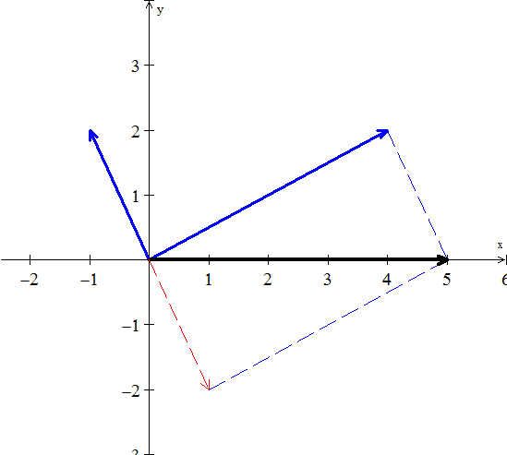

***w***

***v***

***v -w***



In 3-dimensional space, the arrow starts at the origin , where the *xyz* axis meet.

is also written as 

***Notes***:

1. The picture of the combinations  fills a line
2. The picture of the combinations  fills a plane
3. The picture of the combinations  fills a 3-dimensional space.

**Linear Combination**

***Definition***

The sum of  and  is a linear combination of vectors and; *c*, *d* are constants.

4-Special linear Combinations:









***Vectors in Coordinate Systems***

It is sometimes necessary to consider vectors whose initial are not at the origin. If  denotes the vector with initial point  and terminal point , then the components of this vector are given by the formula



If 



***Example***

The components of the vector  with initial point  and terminal point, find ***v***?

***Solution***



***n− Space***

The vector spaces are denoted by . Each space  consists of a whole collection of vectors.

***Definition***

The space  consists of all column vectors *v* with *n* components.

***Example***



The one-dimensional space  is a line (like the *x*-axis)

The two essential vector operations go on inside the vector space that we can add any vectors in , and we can multiply any vector by any scalar. The ***result*** stays in the space.

A real vector space is a set of “***vectors***” together with rules for vector addition and for multiplication by real numbers. The addition and the multiplication must produce vectors that are in the space.

Here are three other spaces other than :

**M** The vector space of ***all real 2 by 2 matrices***.

**F** The vector space of ***all real functions*** .

**Z** The vector space that consists only of a ***zero vector***.

The zero vector in  is the vector (0, 0, 0).

**Operation on Vectors in** 

***Definition***

If *n* is a positive integer, then an ordered ***n*-*tuple*** is a sequence of real numbers . The set of all ordered *n*-tuples is called ***n*-*space*** and is denoted by 

***Definition***

Vectors  and  in  are said to be ***equivalent*** (also called ***equal***) if



We indicate this by 

***Example***



***Solution***

*Iff* 

**Vector Space of Infinite Sequences of Real Numbers**

If  and  are vectors in , and if ***k*** is any scalar, then we defined











**The *Zero* Vector Space**

Let V consist of a single object, which we denote by 0, and define



***Theorem***

If ***u***, ***v***, and ***w*** are vectors in , and if ***k*** and ***m*** are scalars, then

1. 
2. 
3. 
4. 
5. 
6. 
7. 
8. 
9. 
10. 
11. 

***Proof***: 













***Exercises Section* 3.6 – Vectors in 2-Space, 3-Space, and *n*-Space**

1. Sketch the following vectors with initial points located at the origin

|  |  |  |
| --- | --- | --- |
|  |  |  |

1. Find the components of the vector 

|  |  |  |
| --- | --- | --- |
|  |  |  |

1. Find the terminal point of the vector that is equivalent to ***u*** = (1, 2) and whose initial point is 
2. Find the initial point of the vector that is equivalent to ***u*** = (1, 1, 3) and whose terminal point is 
3. Find a nonzero vector ***u*** with initial point *P*(−1, 3 , −5) such that
4. ***u*** has the same direction as ***v*** = (6, 7, −3)
5. ***u*** is oppositely directed as ***v*** = (6, 7, −3)
6. Let ***u*** = (−3, 1, 2), ***v*** = (4, 0, −8), and ***w*** = (6, −1, −4). Find the components

|  |  |  |
| --- | --- | --- |
|  |  |  |

1. Let ***u*** = (2, 1, 0, 1, −1) and ***v*** = (−2, 3, 1, 0, 2). Find scalars *a* and *b* so that 

1. Find all scalars  such that 
2. Find the distance between the given points 
3. Let *V* be the set of all ordered pairs of real numbers, and consider the following addition and scalar multiplication operation on 

 

1. Compute  and  for ***u*** = (0, 4), ***v*** = (1, −3), and *k* = 2.
2. Show that (0, 0) **≠ 0**.
3. Show that (−1, −1) = 0.
4. Show that  for 
5. Find two vector space axioms that fail to hold.

***Section* 3.7 – Linear Dependence and Independence**

There are *n* columns in an *m* by *n* matrix, and each column has *m* components. But the true ***dimension*** of the column space is not necessarily *m* or *n*. The dimension is measured by counting ***independent columns***.

* **Independent vectors** (*not too many*)
* **Spanning a space** (*not too few*)

**Linear Independence** (**LI**)

The column of A are ***linearly independent*** when the only solution to  is . ***No other combination  of the columns gives the zero vector***.

***Definitions***

* A set of two or more vectors is ***linearly dependent*** if one vector in the set is a linear combination of the others. A set of one vector is ***linearly dependent*** if that one vector is the zero vector.



* The sequence of vectors  is ***linearly independent*** if the only combination that gives the zero vector is . Thus linear independence means that:

 only happens when all *x*’s are zero.

* A (nonempty) set of vectors is ***linearly independent*** if it is not linearly dependent.
* If three vectors  are in the same plane, they are dependent.

***Theorem***

A set S with two or more vectors  is

1. Linearly dependent *iff* at least one of the vectors in *S* is expressible as a linear combination of the other vectors in *S*. There are numbers  at least one of which is nonzero, such that 
2. Linearly independent *iff* no vector in *S* is expressible as a linear combination of the other vectors in *S*.

|  |  |  |
| --- | --- | --- |
|  |  |  |
| Independent vectors |  | Dependent vectors  The combination  is (0, 0, 0) |

***Example***

1. The vectors (1, 0) and (0, 1) are ***independent***.
2. The vectors (1, 1) and (1, 0.0001) are ***independent***.
3. The vectors (1, 1) and (2, 2) are ***dependent***.
4. The vectors (1, 1) and (0, 0) are ***dependent***.

***Theorem***

1. A finite set that contains **0** is linearly dependent.
2. A set with exactly one vector is linearly independent if and only if that vector is not **0**.
3. A set with exactly two vectors is linearly independent *iff* neither vector is a scalar multiple of the other.

***Theorem***

Let *S* be a set ***k*** vectors in , then if *k* > *n*, *S* is ***linearly dependent***.

***Example***

 are 3 vectors in  ⇒ Linearly dependent.

***Example***

Determine whether the vectors  are linearly dependent or linearly independent in 

***Solution***









Solve the system equations: 

This shows that the system has nontrivial solutions and hence that the vectors are linearly dependent.

***2nd method*** to determine the linearly is to compute the determinant of the coefficient matrix



 Which has nontrivial solutions and the vectors are linearly dependent.

***Example***

Determine whether the vectors are linearly dependent or linearly independent in 



***Solution***





Which yields the homogeneous linear system



Solve the system equations:  has a trivial solution.

The vectors  are linearly independent.

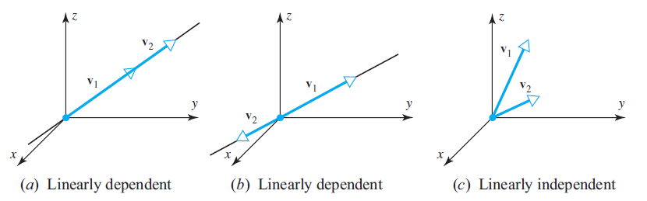

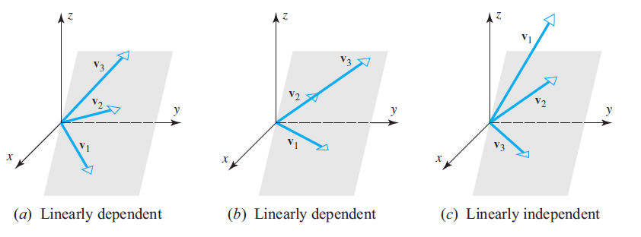

**Linear independence of Functions**

***Definition***

If  are functions that are *n* - 1 times differentiable on the interval (−∞, ∞), the determinant



is called the ***Wronskian*** of 

***Example***

Use the Wronskian to show that  are linearly independence

***Solution***

The Wronskian is



This function is not identically zero. Thus the functions are linearly independent.

***Example***

Use the Wronskian to show that  are linearly independence

***Solution***

The Wronskian is



Thus the functions are linearly independent.

***Exercises Section* 3.7 – Linear Dependence and Independence**

1. Given three independent vectors . Take combinations of those vectors to produce . Write the combinations in a matrix form as 

 which is 

What is the test on a matrix **V** to see if its columns are linearly independent?

If  show that  are linearly independent.

If  show that  are linearly *dependent*.

1. Find the largest possible number of independent vectors among



1. Show that are independent but  are dependent:



Solve either . The *v*’s go in the columns of ***A***.

1. Decide the dependence or independence of
2. The vectors (1, 3, 2) and (2, 1, 3) and (3, 2, 1).
3. The vectors  and  and .
4. Find two independent vectors on the plane  in . Then find three independent vectors. Why not four? This plane is the nullspace of what matrix?
5. Determine whether the vectors are linearly dependent or linearly independent in 

|  |  |
| --- | --- |
| 1. (4, −1, 2), (−4, 10, 2) 2. (8, −1, 3), (4, 0, 1) | 1. (−3, 0, 4), (5, −1, 2), (1, 1, 3) 2. (−2, 0, 1), (3, 2, 5), (6, −1, 1), (7, 0, −2) |

1. Determine whether the vectors are linearly dependent or linearly independent in 
2. (3, 8, 7, −3), (1, 5, 3, −1), (2, −1, 2, 6), (1, 4, 0, 3)
3. (0, 0, 2, 2), (3, 3, 0, 0), (1, 1, 0, −1)
4. (0, 3, −3, −6), (−2, 0, 0, −6), (0, −4, −2, −2), (0, −8, 4, −4)
5. (3, 0, −3, 6), (0, 2, 3, 1), (0, −2, −2, 0), (−2, 1, 2, 1)
6. *a* ) Show that the three vectors  form a linearly dependent set in .

*b*) Express each vector in part (*a*) as a linear combination of the other two.

1. For which real values of λ do the following vectors form a linearly dependent set in 



1. Show that if  is a linearly independent set of vectors, then so is every nonempty subset of S.
2. Show that if  is a linearly dependent set of vectors in a vector space *V*, and if  are vectors in *V* that are not in *S*, then  is also linearly dependent.
3. Show that  is linearly independent and  does not lie in span , then  is a linearly independent.
4. By using the appropriate identities, where required, determine  are linearly dependent.

|  |  |  |
| --- | --- | --- |
|  |  |  |

1.  are linearly independent in  because neither function is a scalar multiple of the other. Confirm the linear independence using Wroński’s test.
2. Use the Wronskian to show that  span a three-dimensional subspace of 
3. Show by inspection that the vectors are linearly dependent.



1. Determine if the given vectors are linearly dependent or independent, (any method)
2. .
3. .
4. 
5. Suppose that the vectors  are linearly dependent. Are the vectors , , and  also linearly dependent?

(***Hint***: Assume that , and see what the  can be.)

***Section* 3.8 – Dot Product and Orthogonality**

***Norm* of a Vector**

The ***length*** (or ***norm***) of a vector  is the square root of 



 **2-*dimension***

 **3-*dimension***

***Definition***

If  is a vector in , then the norm of ***v*** (also called the length of ***v*** or the magnitude of ***v***) is denoted by , and is defined by the formula



***Example***

Find the length of the vector 

***Solution***





***Theorem***

If ***v*** is a vector in , and if ***k*** is any scalar, then:

1. 
2. 
3. 

***Unit Vectors***

***Definition***

A ***unit vector*** is a vector whose length equals to one. Then 

Divide any nonzero vector  by its length. Then  is a unit vector in the same direction as .

***Example***

Find the unit vector ***u*** that has the same direction as ***v*** = (2, 2, −1)

***Solution***















 **√**

***Example of unit vectors***



In  

In general, these formulas can be defined as ***standard unit vector*** in 





***Example ***

***Distance*** **in** 

***Definition***

If  and  are points in , then we denote the distance between u and v by  and define it to be



In  

In  

***Dot Product***

If ***u*** and ***v*** are nonzero vectors in  or , and if *θ* is he angle between ***u*** and ***v***, then the ***dot product*** (also called the ***Euclidean inner product***) of ***u*** and ***v*** is denoted by  and is defined as



***Cosine Formula***

If  and  are nonzero vectors that implies 

***Example***

Find the dot product of the vectors ***u*** = (0, 0, 1) and ***v*** = (0, 2, 2) and have an angle of 45°.

***Solution***











***Component Form of the Dot Product***

The ***dot product*** or ***inner product*** of  and  is the number



***Example***

Find the dot product of  and 

***Solution***



* ***For dot products, zero means that the 2 vectors are perpendicular*** (= 90°).

***Example***

Put a weight of 4 at the point  and weight of 2 at the point . The *x*-axis will balance on the center point .

***Solution***

The weight balance is  (*dot product*).

In 3-dimensionals the dot product:



***Theorem***

1. 
2. 
3. 
4. 
5. 
6. 
7. 
8. 
9. 

**Right Angles**

The dot product is  when  is ***perpendicular*** to 

***Proof***

Perpendicular vectors: 





 



If *u* and *U* are unit vectors, then 

Certainly,







***Schwarz Inequality***

If  and  are any vectors 

***Proof***

The dot product of  and  is  and both lengths are .

Then, the Schwarz inequality says that: 







This proves the Schwarz inequality:  

**Orthogonality**

***Definition***

Two nonzero vectors ***u*** and ***v*** in  are said to be ***orthogonal*** (or ***perpendicular***) if their dot product is zero ***u.v*** = 0.

We will also agree that he zero vector in  is orthogonal to every vector in . A nonempty set of vectors  is called an ***orthogonal set*** if all pairs of distinct vectors in the set are orthogonal. An orthogonal set of unit vectors is called an ***orthonormal set***.

***Example***

The floor of your room (extended to infinity) is a subspace ***V***. The line where two walls meet is a subspace ***W*** (one-dimensional). Those subspaces are orthogonal. Every vector up the meeting line is perpendicular to every vector on the floor. The origin (0, 0, 0) is in the corner.

***Example***

Show that ***u*** = (−2, 3, 1, 4) and ***v*** = (1, 2, 0, −1) are orthogonal in 

***Solution***

***u.v*** = (−2)(1) + (3)(2) + (1)(0) +(4)( −1)

= −2 + 6 + 0 −4



These vectors are orthogonal in 

***Standard Unit Vectors***



***Proof***



***Normal***

To specify slope and inclination is to use a nonzero vector ***n***, called a ***normal***, which is orthogonal to the line or plane.

The line passes through a point  that has a normal ***n*** = (*a, b*) and the plane through  that has a normal ***n*** = (*a, b, c*). Both the line and the plane are represented by the vector equation



The line equation: 



The plane equation: 



***Exercises Section* 3.8 – Dot Product and Orthogonality**

1. If  and , what are the smallest and largest possible values of  and ?
2. If  and , what are the smallest and largest possible values of  and ?
3. Given that  and . Similarly, and . The angle  is . Substitute into the trigonometry formula  for  to find 
4. Can three vectors in the *xy* plane have ,  and ?
5. Find the norm of *v*, a unit vector that has the same direction as *v*, and a unit vector that is oppositely directed.
6. *v* = (4, −3)
7. *v* = (1, −1, 2)
8. *v* = (−2, 3, 3, −1)
9. Evaluate the given expression with ***u*** = (2, −2, 3), ***v*** = (1, −3, 4), and ***w*** = (3, 6, −4)

|  |  |  |
| --- | --- | --- |
|  |  |  |

1. Let ***v*** = (1, 1, 2, −3, 1). Find all scalars *k* such that 
2. Find 
3. *u* = (3, 1, 4), *v* = (2, 2, −4)
4. *u* = (1, 1, 4, 6), *v* = (2, −2, 3, −2)
5. *u* = (2, −1, 1, 0, −2), *v* = (1, 2, 2, 2, 1)
6. Find the Euclidean distance between ***u*** and ***v***, then find the angle between them
7. *u* = (3, 3, 3), *v* = (1, 0, 4)
8. *u* = (1, 2, −3, 0), *v* = (5, 1, 2, −2)
9. *u* = (0, 1, 1, 1, 2), *v* = (2, 1, 0, −1, 3)
10. Find a unit vector that has the same direction as the given vector

|  |  |  |
| --- | --- | --- |
| 1. (−4, −3) |  | 1. (1, 2, 3, 4, 5) |

1. Find a unit vector that is oppositely to the given vector

|  |  |  |
| --- | --- | --- |
| 1. (−12, −5) | 1. (3, −3, 3) |  |

1. Verify that the Cauchy-Schwarz inequality holds
2. *u* = (−3, 1, 0), *v* = (2, −1, 3)
3. *u* = (0, 2, 2, 1), *v* = (1, 1, 1, 1)
4. *u* = (1, 3, 5, 2, 0, 1), *v* = (0, 2, 4, 1, 3, 5)
5. Find  and then the angle  *θ* between ***u*** and ***v*** 
6. Find the norm: ,  for 
7. Find all numbers *r* such that: 
8. Find the distance between and 
9. Given ***u*** = (1, −5, 4), ***v*** = (3, 3, 3)
10. Find 
11. Find the cosine of the angle *θ* between ***u*** and ***v***.
12. Determine whether ***u*** and ***v*** are orthogonal

|  |  |
| --- | --- |
|  |  |

1. Determine whether the vectors form an orthogonal set
2. 
3. 
4. 
5. 
6. 
7. 
8. 
9. Find a unit vector that is orthogonal to both ***u*** = (1, 0, 1) and ***v*** = (0, 1, 1)
10. *a*) Show that ***v*** = (*a, b*) and ***w*** = (−*b, a*) are orthogonal vectors.

*b*) Use the result to find two vectors that are orthogonal to ***v*** = (2, −3).

*c*) Find two unit vectors that are orthogonal to (−3, 4)

1. Show that if ***v*** is orthogonal to both  and , then ***v*** is orthogonal to for all scalars and .
2. Show that  is orthogonal to  if and only if 
3. Given 
4. Find 
5. Find  and then the angle *θ* between ***u*** and ***v***.
6. *a*) Show that ***v*** = (*a, b*) and ***w*** = (*−b, a*) are orthogonal vectors

*b*) Use the result in part (*a*) to find two vectors that are orthogonal to ***v*** = (2, −3)

*c*) Find two unit vectors that are orthogonal to (−3, 4)

1. Show that *A* (3, 0, 2), .*B* (4, 3, 0), and *C* (8, 1, −1) are vertices of a right triangle. At which vertex is the right angle?
2. Establish the identity: 

***Section* 3.9 – Eigenvalues and Eigenvectors**

In many problems in science and mathematics, linear equations ***Ax*** = ***b*** come from steady state problems. Eigenvalues have their greatest importance in dynamic problems. The solution of  (is changing with time) has nonzero solutions. (***All matrices are square***)

***Definition***

Suppose *A* is an *n* x *n* matrix and



The values of  are called eigenvalues of the matrix ***A*** and the nonzero vectors ***x*** in  are called the eigenvectors corresponding to that eigenvalue .

* One of the meanings of the word “***eigen***” in German is “***proper***”; eigenvalues are also called ***proper values, characteristic values,*** or ***latent roots***.

***Example***

The vector  is an eigenvector of  corresponding to the eigenvalue λ = 3 since



Eigenvalues and eigenvectors have a useful geometric interpretation in  and .

**The equation for the *eigenvalues***

Let’s rewrite the equation .

 : are the eigenvalues and not a vector





The matrix  times the eigenvectors ***x*** is the zero vector. The eigenvectors makes up the nullspace of .

***Definition***

The number λ is an eigenvalue of ***A*** if and only if  is singular:



This is called ***characteristic equation*** of ***A***; the scalars satisfying this equation are the eigenvalues of ***A***. when expanding the determinant  is a polynomial in *λ* called the ***characteristic polynomial*** of ***A***.

***Example***

Find the eigenvalues of the matrix 

***Solution***









The characteristic equation of ***A*** is:

; these are the eigenvalues of ***A***.

***Theorem***

If ***A*** is an *n* x *n* triangular matrix (upper triangular, lower triangular, or diagonal), then the eigenvalues of ***A*** are the entries on the main diagonal of ***A***.

***Example***

Find the eigenvalues of the lower triangular matrix



***Solution***

The eigenvalues are: 

***Theorem***

If ***A*** is an *n* x *n* matrix, the following are equivalent.

1. λ is an eigenvalue of ***A***.
2. The system of equations  has nontrivial solutions.
3. There is a nonzero vector ***x*** in  such that .
4. λ is a real solution of the characteristic equation 

***Eigenvectors***

To find the eigenvector ***x***, for each eigenvalue λ solve 

From the eigenvalues, the eigenvectors, in the form , of the system can be determined by letting:

 and

***Example***

Find the eigenvalues and the eigenvectors of the matrix 

***Solution***











The eigenvalues of ***A*** are: 

For , we have:







If *y* = −1 ⇒ *x* = 2, therefore the eigenvector 

Or 

For , we have:







If *x* = 1 ⇒  *y* = 2, therefore the eigenvector 

**Power of a Matrix**

***Theorem***

If *k* is a positive integer, λ is an eigenvalue of a matrix *A*, and ***x*** is a corresponding eigenvector, then  is an eigenvalue of  and ***x*** is a corresponding eigenvector.

***Example***

Find the eigenvalues of  for 

***Solution***



The eigenvalues of *A*: 

The eigenvalues of  are: 

***Theorem***

A square matrix *A* is invertible *iff*  is not an eigenvalue of *A*.

***Summary***

To solve the eigenvalue problem for an *n* by *n* matrix:

1. Compute the determinant of . With λ subtracted along the diagonal, this determinant starts with  or . It is a polynomial in λ of degree *n*.
2. Find the roots of this polynomial, by solving . The *n* roots are the *n* eigenvalues of A. They make  singular.
3. For each eigenvalue λ, solve  ***to find an eigenvector*** ***x***.

**Imaginary Eigenvalues**

***Example***

Find the eigenvalues and the eigenvectors of the matrix 

***Solution***











The solutions are: .

:



Therefore the eigenvector 

:



Therefore the eigenvector 

***Example***

Find the eigenvalues and the eigenvectors of the matrix 

***Solution***





The matrix ***A*** is a 90° rotation which has no real eigenvalues or eigenvectors.

No vector ***Ax*** stays in the same direction as ***x*** (except the zero vector which is useless).

If we add the eigenvalues together the result is zero which is the trace of ***A***.

:



Therefore the eigenvector 

:



Therefore the eigenvector 

***Exercises*** ***Section* 3.9 – Eigenvalues and Eigenvectors**

1. Find the eigenvalues and eigenvectors of :



Check the trace  and the determinant  for *A* and also .

1. Show directly that the given vectors are eigenvectors of the given matrix. What are the corresponding eigenvalues



1. For which real numbers c does this matrix A have



1. Two real eigenvalues and eigenvectors.
2. A repeated eigenvalue with only one eigenvector
3. Two complex eigenvalues and eigenvectors.
4. Find the eigenvalues of ***A***, ***B***, ***AB***, and ***BA***:



1. The eigenvalues of ***AB*** (are equal to) (are not equal to) eigenvalues of ***A*** times eigenvalues of ***B***.
2. The eigenvalues of ***AB*** (are equal to) (are not equal to) eigenvalues of ***BA***.
3. When  show that (1, 1) is an eigenvector and find both eigenvalues of



1. The eigenvalues of *A* equal to the eigenvalues of . This is because  equals . That is true because _____. Show by an example that the eigenvectors of *A* and  are not the same.
2. Let . Compute the eigenvalues and eigenvectors of *A*.
3. Let 
4. What is the characteristic polynomial for *A* (i.e. compute ?
5. Verify that 1 is an eigenvalue of *A*. What is a corresponding eigenvector?
6. What are the other eigenvalues of *A*?
7. For the following matrices:

|  |  |  |
| --- | --- | --- |
|  |  |  |
|  |  |  |
|  |  |  |
|  |  |  |

1. Find the characteristic equation
2. Find the eigenvalues
3. Find the eigenvectors
4. Find the eigenvalues of  for 
5. Find the eigenvalues of the matrices



1. Given the matrix 
2. Find the characteristic polynomial.
3. Find the eigenvalues
4. Find the bases for its eigenspaces
5. Graph the eigenspaces
6. Verify directly that , for all associated eigenvectors and eigenvalues.
7. Given the matrix 
8. Find the characteristic polynomial.
9. Find the eigenvalues
10. Find the bases for its eigenspaces
11. Graph the eigenspaces
12. Verify directly that , for all associated eigenvectors and eigenvalues.
13. Given: . Compute 