***Lecture Four***

***Section* 4.1 – First-Order Systems**

Consider a system of differential equations that can be solved for the highest-order derivatives of the dependent variables.

For instance, in the case of a system of two 2nd-order equations can be written in the form



Any higher-order system can be transformed into an equivalent system of 1st-order equations.

Consider a system consisting of the single nth-order equation.



We introduce the dependent variables  defined as follows:



Note that 





***Example***

The 3rd-order equation  can be written in the form



Let 

Yield the system



***Example***

Transform this system into an equivalent 1st-order system



***Solution***

Let 

⇒  

Of 4 1st-order equations in the dependent variables 

**Simple 2−Dimensional Systems**

The linear 2nd-order differential equation 

Let 



***Example***

Solve the 2-dimensional system



Then solve using the initial values 

***Solution***





∴ Have a general solution: 





Let 



















***Example***

Find the general solution of the system

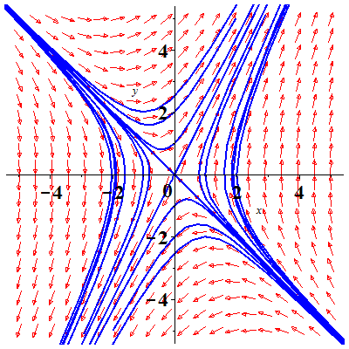

***Solution***







The eigenvalues are: 

∴ General solution: 

***Example***

Solve the initial value problem



***Solution***

















∴ General solution: 

***Exercises Section* 4.1 – First-Order Systems**

Transform the given differential equation or system into an equivalent system of 1st-order differential equation

1. 
2. 
3. 
4. 
5. 
6. 
7. 
8. 

Find the general solution

1. 
2. 
3. 
4. 
5. 
6. 

Derive the equations 

For the displacements (from equilibrium) of the 2 masses.

1. 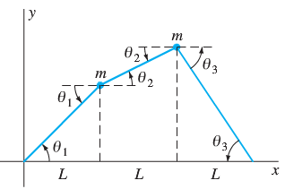Two particles each of mass *m* are attached to a string under (constant) tension *T*. Assume that the particles oscillate vertically (that is, parallel to the *y-*axis) with amplitudes so small that the sines of the angles shown are accurately approximated by their tangents. Show that the displacement  and  satisfy the equations



1. 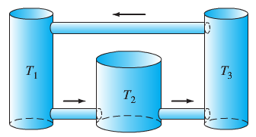There 100-gal fermentation vats are connected, and the mixtures in each tank are kept uniform by stirring. Denote by  the amount (in pounds) of alcohol in tank  at time *t* (*i* = 1, 2, 3). Suppose that the mixture circulates between the tanks at the rate of 10 gal/min. Derive the equations



1. Suppose that a particle with mass *m* and electrical charge *q* moves in the *xy*-plane under the influence of the magnetic field  (thus a uniform field parallel to the *z*-axis), so the force on the particle is  if its velocity is . Show that the equations of motion of the particle are



***Section* 4.2 – Matrices and Linear Systems**

Let  and  be continuous functions on the interval *I*. The system of *n* 1st-order differential equations:



Is called a 1st-order linear differential system.

The system is ***homogeneous*** if  on *I*, otherwise, the system is ***nonhomogeous*** if the functions  are not all identically zero on *I*.

  

The system can be written in the vector-matrix form 

: Coefficient matrix

: Constant matrix

A solution of the linear differential system  is a differentiable vector function

 Satisfies  on the interval *I*.

The derivative of *A*: 

***Example***

Find the derivative if 

***Solution***



***Example***

The 1st-order system 









To verify that the vector functions:



Are both solutions of the matrix differential equations with coefficient matrix *P*.





When  is a homogeneous equation

A ***homogeneous*** system



***Always*** has at least one solution namely  called the ***trivial solution***

That is, homogeneous systems are always ***consistent***

***Theorem***

If  is a solution of (*H*) and *α* is any, then is also a solution of (*H*); any constant multiple of a solution of (*H*) is a solution of (*H*).

***Theorem***

If  and  are solutions of (*H*), then  is also a solution of (*H*); the sum of any 2 solutions of (*H*) is a solution of (*H*).



 Since 

In general,

***Theorem***

If  are solutions of (*H*), and is  are  then



Is a solution of (*H*); any linear combination of solutions of (*H*) is also a solution of (*H*).









**Linear Dependent and Independent**

Let



Be vector functions defined on some interval *I*.

The vectors are linearly dependent on *I* if exist *n* real numbers  not all zero such that



Otherwise the vectors are linearly independent on I.

**Wronskian of solutions**

***Theorem***

Let  are *n* solutions of the homogeneous linear equation  on an interval *I*.

Let 



Called the Wronskian of the vector functions 

***Special Case*** *n* solutions of (*H*)

***Theorem***

Let  be solution of (*H*). Exactly one of the following holds.

1.  on *I* and the solutions are Linearly Dependent.
2.  for all  and the solutions are Linearly Independent.

***Theorem***

Let  be *n* L.I solutions of (*H*) 

Let  be any solution of (*H*). Then there exists a unique set of constants  such that



That is, every solution of (*H*) can be written as a unique linear combination of 

A set of *n* L.I solutions  of (*H*) is called a ***fundamental set of solutions***.

A fundamental set is also called a ***solution basis*** for (*H*).

***Example***

Determine if the solutions are linearly dependent or independent using Wronskian.



***Solution***





The solutions  are linearly independent.

***Example***

Find the general solution of: 

***Solution***





 

The Fundamental set: 



Particular solution: 









General solution: 





 

 is a solution of the equation

***Proof***: 





 ***√***

Therefore; 

For  

For  

For  





***Exercises Section* 4.2 – Matrices and Linear Systems**

Write the given system in the form 

1. 
2. 
3. 
4. 
5. 
6. 
7. 
8. 

For the systems below:

1. Verify that the given vectors are solutions of the given system.
2. Use the Wronskian to show that they are linearly independent.
3. Write the general solution of the system.
4. Find the particular solution that satisfies the given initial conditions
5. 
6. 
7. 
8. 
9. 
10. 
11. 

***Section* 4.3 – Eigenvalue Method for Linear System**

A homogeneous first-order system with constant coefficients is given by



We can find *n* linear independent solution vectors  and the linear combination



We apply the characteristics root method for solving a single homogeneous equation with constant coefficients.



***Theorem***

Let λ be an eigenvalue of the constant coefficient matrix *A* of the first-order linear system



If  is an eigenvector associated with λ, then



is a nontrivial solution of the system

If  are distinct eigenvalues of *A* with corresponding , then



form a fundamental set of solutions of 

And  is the general solution.

***Note***

* Recall that an eigenvalue λ of the matrix *A* is a solution of the characteristic equation 
* An eigenvector  associated with λ is then a solution of the eigenvector equation 

**Distinct Real *Eigenvalues***

***Examples***

Find a general solution of the system



***Solution***



The characteristic equation:





The distinct real eigenvalues: 

For 





For 



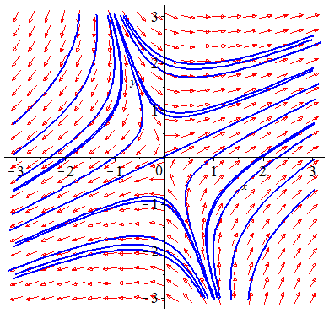 



Using Wronskian: 

The general solution: 

***OR*** 

***Examples***

If  and the initial amounts of salt in 3 brine tanks, in lbs, are . Find the amount of salt in each tank at time .

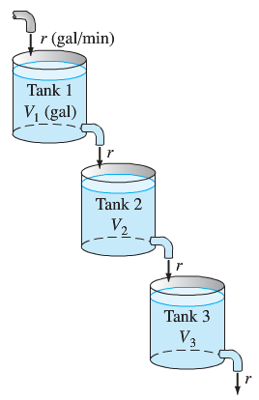***Solution***

 where 





 *with* 





The eigenvalues are: 

For 





For 





For 









With *initial* values



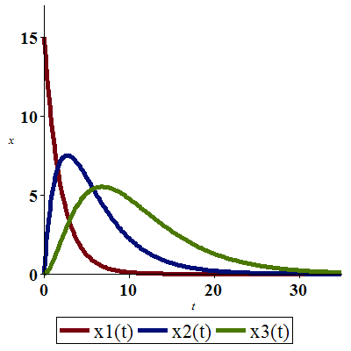

**Complex *Eigenvalues***

***Examples***

Find a general solution of the system



***Solution***



The characteristic equation:





The distinct real eigenvalues: 

For 

 

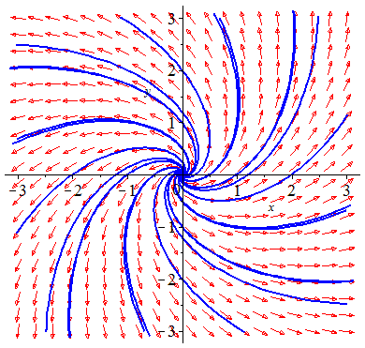

 











***Examples***

If , find the amount  of salt in each tank at time 

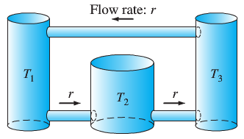***Solution***

 where 













 

The eigenvalues are: 

For 





For 



Let 







 



***Exercises Section* 4.3 – Eigenvalue Method for Linear System**

Find the general solution of the given system. Graph and construct a direction field and typical solution curves for the given system.

1. 
2. 
3. 
4. 
5. 
6. 
7. 
8. 
9. 
10. 
11. 
12. 

Find the general solution of the given system.

1. 
2. 
3. 
4. 
5. 
6. 

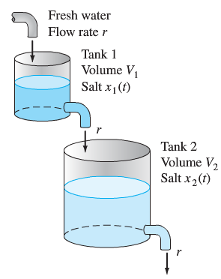

Find the amount  of salt in each tank at time , with . If

1. 
2. 

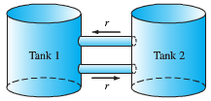Find the amount  of salt in each tank at time , with . If

1. 
2. 



Find the amount  of salt in each tank at time , if

1. 



1. 



1. 



***Section* 4.4 – Second-Order System & Mechanical Applications**

**Second-Order Homogeneous Linear systems**

***Theorem***

Let matrix *A* , If *A* has distinct negative eigenvalues  with associated real eigenvalues , then a general solution of



Is given by 

With  and  arbitrary constants.

In the special case of a nonrepeated zero eigenvalue  with associated eigenvector 



***Example***



Consider the mass-and–spring systems, as shown above. Three masses connected to each other and to two walls by 4 indicated springs. Assume the masses slide without friction and each spring obeys Hooke’s law .

By applying Newton’s law  to the 3-masses:







The displacement vector: 

The mass matrix 

The stiffness matrix 

***Example***

Consider the mass-and-spring system.



Where  and 

***Solution***

 

 

 

 









The eigenvalues are: 

By the theorem, the natural frequencies: 

For 

 

For 

 

The free oscillation of the mass-and-spring system, follows by:



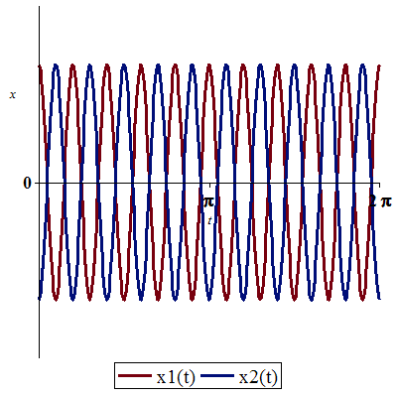The natural mode:





Where ; 

Which has the scalar equations:



The second part:

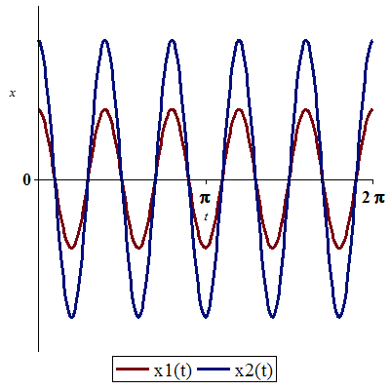



Where ; 

Which has the scalar equations:



***Example***

Three railway cars are connected by buffer springs that react when compressed, but disengage instead of stretching.



Given that  and 

Suppose that the leftmost car is moving to the right with velocity  and at time  strikes the other 2 cars. The corresponding initial conditions are:





***Solution***









 



 









The eigenvalues are: 

For 

 

For 

 

For 

 





Applying the initial values







  

 

For these equations to hold, only when the 2 buffer springs remain compressed; that is, while both



























 until 





We conclude that the 3 railway cars remain engaged and moving to the right until disengagement occurs at time .

At 











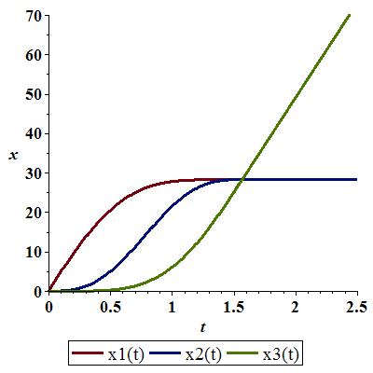

***Exercises Section* 4.4 – Second-Order System & Mechanical Applications**

Consider the mass-and-spring system shown below and with the given masses and spring constants values.



Find the 2 natural frequencies of the system and describe its natural modes of oscillation.

1. 
2. 
3. 
4. 

Consider the mass-and-spring system shown below and with the given masses and spring constants values.



The mass-and-spring system is set in motion from rest  in its equilibrium position .

Find the 2 natural frequencies of the system and describe its natural modes of oscillation.

For the given external forces  and  acting on the masses  and , respectively.

Find the resulting motion of the system and describe it as a superposition of oscillations at three different frequencies.

1. 
2. 
3. 
4. Consider a mass-and-spring system containing two masses  whose displacement functions  and  satisfy the differential equations



1. Describe the two fundamental modes of free oscillation of the system.
2. Assume that the two masses start in motion with the initial conditions



And are acted on by the same force, . Describe the resulting motion as a superposition of oscillations at three different frequencies.

1. Consider a mass-and-spring system shown below. Assume that  in mks units, and that . Then find  so that in the resulting steady periodic oscillations, the mass will remain at rest (!).



Thus the effect of the second mass-and-spring pair will be to neutralize the effect of the force on the first mass. This is an example of a dynamic damper. It has an electrical analogy that some cable companies use to prevent your reception of certain cable channels.

1. Consider a mass-and-spring system shown below. Assume that

 (in mks units).



Find the solution of the system  that satisfies the initial conditions 

1. A car with two axles and with separate front and rear suspension systems.

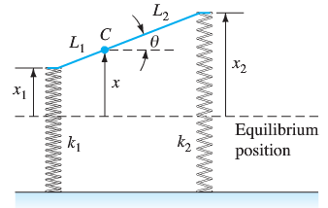

We assume that the car body acts as would a solid bar of mass *m* and length . It has moment of inertia I about its center of mass *C*, which is at distance  from the front of the car. The car has front and back suspension springs with Hooke’s constants  and , respectively. When the car is in motion, let  denote the vertical displacement of the center of mass of the car from equilibrium; let  denote its angular displacement (in radians) from the horizontal. Then Newton’s laws of motion for linear and angular acceleration can be used to derive the equations.



Suppose that  (the car weighs 2400 *lb*),  (it’s a rear engine car), , and .

1. Find the two natural frequencies  and of the car.
2. Now suppose that the car is driven at a speed of  along a washboard surface shaped like a sine curve with a wavelength of 40 *ft*. The result is a periodic force on the car with frequency . Resonance occurs when . Find the corresponding two critical speeds of the car (in *ft/sec*)

The system is taken as a model for an undamped car with the given parameters in *fps* units.

1. Find the two natural frequencies  and of the car (in hertz).
2. Assume that his car is driven along a sinusoidal washboard surface with a wavelength of 40 *ft*. The result is a periodic force on the car with frequency . Resonance occurs when . Find the corresponding two critical speeds of the car (in *ft/sec*)
3. 
4. 
5. 

***Section* 4.5 – Multiple Eigenvalues Solutions**

Matrix *A*  has *n* distinct (real or complex) eigenvalues  with respective eigenvectors, then a general solution of the system is given by



When the characteristic equation  doesn’t have *n* distinct roots, and thus has at least one repeated root.

An eigenvalue is of multiplicity *k* > 1 if it is a *k*-fold root. For each eigenvalue *λ*, the eigenvector equation



has at least one nonzero solution *V*, so there is at least one eigenvector with *λ*.

***Example***

Find a general solution of the system



***Solution***

The characteristic equation:











The distinct eigenvalues are:  of multiplicity *k* = 2.

For 

 

For 

 

If  

 and are linearly independent eigenvectors.







***Defective Eigenvalues***

***Example***

Find a general solution of the system 

***Solution***

The characteristic equation:







The eigenvalues are: 

For 

 

Since the eigenvalue  has only one independent eigenvector, and hence is incomplete.

An eigenvalue λ of multiplicity  is called ***defective*** if it is not complete.

If λ has only  linearly independent eigenvectors, then the number



of ***missing*** eigenvectors is called the defect of the defective eigenvalue λ.

**Defective Multiplicity 2 Eigenvalues**

1. First find a nonzero solution  of the equation



is nonzero, and therefore is an eigenvectors associated with λ.

1. Then from the two independent solutions



***Example***

Find a general solution of the system 

***Solution***

 

 The eigenvalues are: 



Since  and is a nonzero vector, we can let 

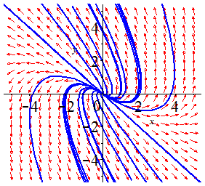



The general solution: 



**Generalized Eigenvectors**

If λ is an eigenvalue of the matrix ***A***, then a rank *r* generalized eigenvector  such that





***Example***

Find three linearly independent solutions of the system 

***Solution***









The eigenvalues are 

For 

 

The defect of  is 2.

To apply the method for triple eigenvalues, then





Since , therefore any nonzero vector  will be a solution.







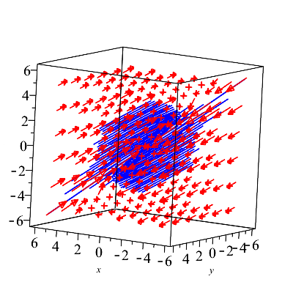

The general solution:





***Example***

Suppose that the matrix ***A***  has two multiplicity 3 eigenvalues  with defects 1 and 2, respectively.

Then  must have an eigenvector  and a length 2 chain  of generalized eigenvectors. 

And  must have a length 3 chain  of generalized eigenvectors.

The six eigenvectors  are then L.I and yield the following 6 independent solutions.



***Example***

Two railway cars that are connected with a spring (permanently attached to both cars) and with a damper that exerts opposite forces on the two cars, of magnitude  proportional to their relative velocity. The two cars are also subject to frictional resistance forces  and  proportional to their respective velocities.



Let 

***Solution***

The equations of motion:



The equations can be written in the form: 

where  is the ***resistance*** matrix.

To use the equations as a 1st-order system, let assume 

 















The eigenvalues are:  and  (***triple***)

For 

 

For 



Let  

Let  









 

The general solution: 



Recall that  and since the position of the 2 cars in initial positon at rest, so  with initial velocity of 

 



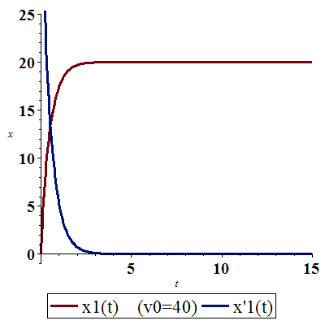

**Diagonalization**

Suppose the *n* by *n* matrix ***A*** has *n* linearly independent eigenvectors . Put them into the column of an ***eigenvector*** ***matrix*** ***P***. Then  is the eigenvalue matrix ***A***:



***Definition***

A square matrix *A* is called ***diagonalizable*** if there is an invertible matrix *P* such that  is diagonal; the matrix *P* is said to ***diagonalize*** *A*.

***Theorem***

***Independent x from different λ*** - Eigenvectors  that correspond to distinct (all different) eigenvalues are linearly independent. An *n* by *n* matrix that has *n* different eigenvalues (no repeated λ’s) must be diagonalizable.

**The *Jordan* Form**

For every *A*, we want to choose *M* so that  is as nearly diagonal as possible. When *A* has a full set of *n* eigenvectors, they go into the columns of *M*. Then *M* = *P*. The matrix is diagonal.

If *A* has ***s*** independent eigenvectors, it is similar to a matrix *J* that has ***s*** Jordan blocks on its diagonal. There is a matrix *M* such that



Each block in *J* has one eigenvalue , one eigenvector, and 1’s above the diagonal:



***A is similar to B if they share the same Jordan form J – not otherwise.***

***Similar Matrices***

***Definition***

If *A* and *B* are square matrices, then we say that ***B is similar to A*** if there exists an invertible matrix *P* such that 

***Example***

Jordan matrix *J* has triple eigenvalues 5, 5, 5. Its only eigenvectors are multiples of (1, 0, 0). Algebraic multiplicity 3, geometric multiplicity 1:

If  has rank 2.

Every similar matrix  has the same triple eigenvalues 5, 5, 5. Also *B* – 5*I* must have the same rank 2. Its nullspace has dimension 3 − 2 = 1. So each similar matrix B also has only one independent eigenvector.

The transpose matrix  has the same eigenvalues 5, 5, 5, and  has the same rank 2. ***Jordan’s theory says that  is similar to J***. The matrix that produces the similarity happens to be the reserve identity *M*:



There is one line of eigenvectors  for *J* and another line  for .

***Example***

Find Jordan form of the matrix 

***Solution***

 

 The eigenvalues are: 



Since  and is a nonzero vector, we can let 











 is a single  Jordan block corresponding to the single eigenvalue  of *A*.

**The General Cayley-Hamilton Theorem**

Every diagonalizable matrix A satisfies its characteristic equation . Using Jordan normal form to show that this is true whether or not *A* is diagonalizable.

If 

If the Jordan blocks  have sizes  that is  matrix and the corresponding eigenvalues  *respectively*, then



→ 

 has the same block-diagonal structure as  itself



***Exercises Section* 4.5 – Multiple Eigenvalues Solutions**

Find the general solutions

|  |  |
| --- | --- |
|  |  |

1. The characteristic equation of the coefficient matrix ***A*** of the system

 is 

Therefore, ***A*** has the repeated complex pair  of eigenvalues. First show that the complex vectors  form a length 2 chain  associated with the eigenvalue . Then calculate the real and imaginary parts of the complex-valued solutions



To find four independent real-valued solutions of 