***Solution Section* 1.4 – Exact Differential Equations**

***Exercise***

Solve the differential equation 

***Solution***















***Exercise***

Solve the differential equation 

***Solution***















***Exercise***

Solve the differential equation 

***Solution***















***Exercise***

Solve the differential equation 

***Solution***





















***Exercise***

Solve the differential equation 

***Solution***













***Exercise***

Solve the differential equation 

***Solution***



 









***Exercise***

Find the general solution 

***Solution***

Let 























***Exercise***

Find the general solution 

***Solution***

Let 

 ***Divide both side by*** 













***Exercise***

Find the general solution 

***Solution***

Let 



 ***Divide both side by*** 















***Exercise***

Find the general solution 

***Solution***

Let 

 ***Divide both side by*** 















***Exercise***

Find the general solution 

***Solution***

Let 

 ***Divide both side by*** 















***Exercise***

Find the general solution 

***Solution***

Let 

 ***Divide both side by*** 















***Exercise***

Find the general solution 

***Solution***

Let 

 ***Divide both side by*** 



















***Exercise***

Find the general solution 

***Solution***

Let 

 ***Divide both side by*** 





























***Exercise***

Find the general solution 

***Solution***

Let 



 ***Divide both side by*** 

















***Exercise***

Find the general solution 

***Solution***

Let 



 ***Divide both side by*** 















***Exercise***

Find the general solution 

***Solution***



Let 



 ***Multiply both sides by*** 











***Exercise***

Find the general solution 

***Solution***

 ***Divide by*** 

Let 



 ***Multiply both sides by*** 











***Exercise***

Find the general solution 

***Solution***



 ***Divide by*** 

Let 



 ***Multiply both sides by*** 













***Exercise***

Find the general solution 

***Solution***



 ***Divide both sides by*** 

Let 



 ***Multiply both sides by*** 











***Exercise***

Find the general solution 

***Solution***

 ***Divide both sides by*** 

Let 



 ***Multiply both sides by*** 











***Exercise***

Find the general solution 

***Solution***

 ***Divide both sides by*** 



Let 

 ***Multiply both sides by*** 













***Exercise***

Find the general solution 

***Solution***

Let 















***Exercise***

Find the general solution 

***Solution***

Let 







Let 



 ***Multiply both sides by*** 













***Exercise***

Find the general solution 

***Solution***

Let 





Let 















 







***Exercise***

Find the general solution 

***Solution***



 



Let 



























***Exercise***

Find the general solution 

***Solution***



Let 





 











***Exercise***

Solve the differential equation 

***Solution***

















***Exercise***

Solve the differential equation 

***Solution***









 



***Exercise***

Solve the differential equation 

***Solution***



 









***Exercise***

Solve the differential equation 

***Solution***

Multiply both side by  since  

  









***Exercise***

Solve the differential equation 

***Solution***



 









***Exercise***

Solve the differential equation 

***Solution***















***Exercise***

Solve the differential equation 

***Solution***



















***Exercise***

Solve the differential equation 

***Solution***

  









***Exercise***

Solve the differential equation 

***Solution***

Multiply both side by  since  



 









***Exercise***

Find the general solution 

***Solution***













***Exercise***

Find the general solution 

***Solution***







 



***Exercise***

Find the general solution 

***Solution***











***Exercise***

Find the general solution 

***Solution***













***Exercise***

Find the general solution 

***Solution***













***Exercise***

Find the general solution 

***Solution***

















***Exercise***

Find the general solution 

***Solution***













***Exercise***

Find the general solution 

***Solution***













***Exercise***

Find the general solution 

***Solution***













***Exercise***

Find the general solution 

***Solution***















***Exercise***

Find the general solution 

***Solution***















***Exercise***

Find the general solution 

***Solution***



















***Exercise***

Find the general solution 

***Solution***













***Exercise***

Find the general solution 

***Solution***















***Exercise***

Find the general solution 

***Solution***















***Exercise***

Find the general solution 

***Solution***



















***Exercise***

Find the general solution 

***Solution***

















***Exercise***

Find the general solution 

***Solution***















***Exercise***

Find the general solution 

***Solution***













***Exercise***

Find the general solution 

***Solution***















***Exercise***

Find the general solution 

***Solution***











***Exercise***

Find the general solution 

***Solution***













***Exercise***

Find the general solution 

***Solution***













***Exercise***

Find the general solution 

***Solution***













***Exercise***

Find the general solution 

***Solution***





 

 





***Exercise***

Find the general solution 

***Solution***











***Exercise***

Find the general solution 

***Solution***











***Exercise***

Find the general solution 

***Solution***











***Exercise***

Find the general solution 

***Solution***











***Exercise***

Find the general solution 

***Solution***



















***Exercise***

The given equation is not exact. However, if you multiply by the given integrating factor, then it becomes exact. Then solve the equation



***Solution***













***Exercise***

The given equation is not exact. However, if you multiply by the given integrating factor, then it becomes exact. Then solve the equation



***Solution***

 















***Exercise***

The given equation is not exact. However, if you multiply by the given integrating factor, then it becomes exact. Then solve the equation



***Solution***

 















***Exercise***

The given equation is not exact. However, if you multiply by the given integrating factor, then it becomes exact. Then solve the equation



***Solution***

 





















***Exercise***

The given equation is not exact. However, if you multiply by the given integrating factor, then it becomes exact. Then solve the equation



***Solution***

















***Exercise***

The given equation is not exact. However, if you multiply by the given integrating factor, then it becomes exact. Then solve the equation



***Solution***

























***Exercise***

The given equation is not exact. However, if you multiply by the given integrating factor, then it becomes exact. Then solve the equation 

***Solution***





















***Exercise***

Find the general solution of the homogenous equation 

***Solution***























 



***Exercise***

Find the general solution of the homogenous equation 

***Solution***















 









***Exercise***

Find the general solution of the homogenous equation 

***Solution***























***Exercise***

Find an integrating factor and solve the given equation 

***Solution***

















|  |  |
| --- | --- |
|  |  |
|  |  |
|  |  |
|  |  |









 



***Exercise***

Find an integrating factor and solve the given equation 

***Solution***

 *Multiply by* ***y*** *both sides*

|  |  |
| --- | --- |
|  |  |
|  |  |
|  |  |











***Exercise***

Find an integrating factor and solve the given equation 

***Solution***



 *Multiply by* ***siny*** *both sides*

















***Exercise***

Find an integrating factor and solve the given equation 

***Solution***















***Exercise***

Find an integrating factor and solve the given equation 

***Solution***





 















***Exercise***

Find an integrating factor and solve the given equation 

***Solution***





 

















***Exercise***

Find an integrating factor and solve the given equation 

***Solution***





























***Exercise***

Find an integrating factor and solve the given equation 

***Solution***





 

















***Exercise***

Find an integrating factor and solve the given equation 

***Solution***





 



















***Exercise***

Find an integrating factor and solve the given equation 

***Solution***





 















***Exercise***

Solve the given initial-value problem 

***Solution***



 

















 



***Exercise***

Solve the given initial-value problem 

***Solution***



















***Exercise***

Solve the given initial-value problem 

***Solution***





















***Exercise***

Solve the given initial-value problem 

***Solution***























***Exercise***

Solve the given initial-value problem 

***Solution***























***Exercise***

Solve 

***Solution***







 













 



***Exercise***

Solve the given initial-value problem 

***Solution***

Let 





 

 













 





***Exercise***

Solve the given initial-value problem 

***Solution***

















Since 

***Exercise***

Solve the given initial-value problem 

***Solution***















***Exercise***

Solve the given initial-value problem 

***Solution***



















***Exercise***

Solve the given initial-value problem 

***Solution***



















***Exercise***

Solve the given initial-value problem 

***Solution***





















***Exercise***

Solve the given initial-value problem 

***Solution***



















***Exercise***

Solve the given initial-value problem 

***Solution***





















***Exercise***

Solve the given initial-value problem 

***Solution***























***Exercise***

Solve the given initial-value problem 

***Solution***

















***Exercise***

Solve the given initial-value problem 

***Solution***





 















***Exercise***

Solve the given initial-value problem 

***Solution***

Let 

















 





***Exercise***

Solve the given initial-value problem 

***Solution***



Let 











 







***Exercise***

Solve the given initial-value problem 

***Solution***



Let 













 











***Exercise***

Solve the given initial-value problem 

***Solution***





Let 





















***Exercise***

Solve the given initial-value problem 

***Solution***





Let 





























Since the given initial 



***Exercise***

Solve the given initial-value problem 

***Solution***



Let 





















***Exercise***

Solve the given initial-value problem 

***Solution***

Let 









|  |  |
| --- | --- |
|  |  |



















***Exercise***

Solve the given initial-value problem 

***Solution***

















***Exercise***

Solve the given initial-value problem 

***Solution***



















***Exercise***

Solve the given initial-value problem 

***Solution***















***Exercise***

Solve the given initial-value problem 

***Solution***









 







***Exercise***

Solve the given initial-value problem 

***Solution***



















***Exercise***

Solve the given initial-value problem 

***Solution***



 















***Exercise***

Solve the given initial-value problem 

***Solution***



 



















***Exercise***

Solve the given initial-value problem 

***Solution***





 















***Exercise***

Solve the given initial-value problem 

***Solution***

 















***Exercise***

Solve the given initial-value problem 

***Solution***





 













***Exercise***

Find an integrating factor of the form  and solve the equation



***Solution***







For the equation to be exact, then

























***Exercise***

Find an integrating factor of the form  and solve the equation



***Solution***







For the equation to be exact, then

























***Exercise***

Find an integrating factor of the form  and solve the equation



***Solution***









For the equation to be exact, then

























***Exercise***

Find the general solution by using either Bernoulli 

***Solution***



Let 





 

|  |  |  |
| --- | --- | --- |
|  |  |  |
| **+** |  |  |
| **−** |  |  |











***Exercise***

Find the general solution by using either Bernoulli 

***Solution***



Let 





 













***Exercise***

Find the general solution by using either Bernoulli 

***Solution***



Let 





 









 

***Exercise***

Find the general solution by using either Bernoulli 

***Solution***



Let  



 













***Exercise***

Find the general solution by using either Bernoulli 

***Solution***



Let 





 











***Exercise***

Find the general solution by using either Bernoulli 

***Solution***





Let 



|  |  |  |
| --- | --- | --- |
|  |  |  |
| **+** |  |  |
| **−** |  |  |

 









 

***Exercise***

Find the general solution by using homogeneous equations. 

***Solution***

 

Let 













***Exercise***

Find the general solution by using homogeneous equations. 

***Solution***





Let 





















***Exercise***

Find the general solution by using homogeneous equations. 

***Solution***





Let 













***Exercise***

Find the general solution by using homogeneous equations. 

***Solution***



Let 











***Exercise***

Find the general solution by using homogeneous equations. 

***Solution***



Let 



















***Solution Section* 1.5– Population: Exponential Growth/Decay**

***Exercise***

The rate of growth of bacteria in a petri dish is proportional to the number of bacteria in the dish.

***Solution***



***Exercise***

The rate of growth of a population of field mice is inversely proportional to the square root of the population.

***Solution***



***Exercise***

A biologist starts with 100 *cells* in a culture. After 24 *hrs,* he counts 300. Assuming a Malthusian model, what the reproductive rate? What will be the number of cells of the end of 5 *days*?

***Solution***



 **24 *hrs =* 1 *day P =* 300**













***Exercise***

A biologist prepares a culture. After 1 *day* of growth, the biologist counts 1000 *cells*. After 2*days,* he counts 3000. Assuming a Malthusian model, what the reproductive rate and how many cells were present initially?

***Solution***

***Given***: 

The equation of the Malthusian model is 

































***Exercise***

A population of bacteria is growing according to the Malthusian model. If the population is triples in 10 *hrs*, what is the reproduction rate? How often does the population double itself?

***Solution***









 



***Exercise***

Consider a lake that is stocked with walleye pike and that the population of pike is governed by the logistic equation



where time is measured in days and *P* in thousands of fish. Suppose that fishing is started in this lake and that 100 fish are removed each day.

***Solution***

1. Modify the logistic model to account for the fishing.

The modified logistic model





1. Find and classify the equilibrium points for your model.

 *Multiply 100 each term*



 *Solve for P*



 Asymptotically stable

 Unstable

1. Use qualitative analysis to completely discuss the fate of the fish population with this model. In particular, if the initial fish population is 1000, what happens to the fish as time passes? what will happen to an initial population having 2000 fish?

 

For the 1000 (= 1) population, the population decreases until it dies out (doomed);

For the 2000 (= 2) population, the population tend towards the equilibrium 





***Exercise***

Suppose that in 1885 the population of a certain country was 50 *million* and was growing at the rate of 750,000 people per year at that time. Suppose also that in 1940 its population was 100 *million* and was then growing at the rate of 1 *million* per year. Assume that this population satisfies the logistic equation. Determine both the limiting population *M* and the predicted population for the year 2000.

***Solution***





















 



***Exercise***

The time rate of change of a rabbit population *P* is proportional to the square root of *P*. At time  (months) the population numbers 100 rabbits and is increasing at the rate of 20 rabbits per month. How many rabbits will there be one year later?

***Solution***

***Given***: 

















***Exercise***

Suppose that the fish population  in a lake is attacked by a disease at time , with the result that the fish cease to reproduce (so that the birth rate is ) and the death rate *δ* (deaths per week per fish) is thereafter proportional to . If there were initially 900 fish in the lake and 441 were left after 6 weeks, how long did it take all the fish in the lake to die?

***Solution***

***Given***: 

















It will take 20 weeks for the fish to die in the lake.

***Exercise***

Suppose that when a certain lake is stocked with fish, the birth and death rates *β* and *δ* are both inversely proportional to 

1. Show that , where *k* is a constant.
2. If  and after 6 months there are 169 fish in the lake, how many will there be after 1 year?

***Solution***

1. 













1. ***Given***: 









There are 256 fish after 1 year.

***Exercise***

The time rate of change of an alligator population *P* in a swamp is proportional to the square of *P*. The swamp contained a dozen alligators in 1988, two dozen in 1998.

1. When will there be four dozen alligators in the swamp?
2. What happens thereafter?

***Solution***

***Given***: 

1. 













 









, that is, in the year 2003

1. 

The population approaches infinity as *t* approaches 20 years.

***Exercise***

Consider a prolific breed of rabbits whose birth and death rates, *β* and *δ*, are each proportional to the rabbit population , with 

1. Show that 

Note that . This is doomsday

1. Suppose that  and that there are nine rabbits after ten months. When does doomsday occur?
2. With , repeat part (*a*)
3. What now happens to the rabbit population in the long run?

***Solution***

1. If the birth & death both are proportional to  with 











 

1. 

***Given***: 









 (doomsday)

1. If the birth & death both are proportional to  with 













1. 

Therefore , so the population die out in the long run.

***Exercise***

Consider a population  satisfying the logistic equation , where  is the time rate at which births occur and  is the rate at which deaths occur.

1. If the initial population is , and  births per month and  deaths per month are occurring at time , show that the limiting population is .
2. If the initial population is 120 rabbits and there are 8 births per month and 6 deaths per month occurring at time , how many months does it take for  to reach 95% of the limiting population *M*?
3. If the initial population is 240 rabbits and there are 9 births per month and 12 deaths per month occurring at time , how many months does it take for  to reach 105% of the limiting population *M*?

***Solution***

1.  



 ***√***

1. ***Given***: 





 





For 











1. ***Given***: 



 





For 











***Exercise***

The amount of drug in the blood of a patient (in *mg*) due to an intravenous line is governed by the initial value problem



Where *t* is measured in hours

1. Find and graph the solution of the initial value problem.
2. What is the steady-state level of the drug?
3. When does the drug level reach 90% of the steady-state value?

***Solution***

|  |  |
| --- | --- |
|  |  |

1. The steady-state level is 
2. 









***Exercise***

A fish hatchery has 500 *fish* at time , when harvesting begins at a rate of *b* *fish/yr*. where . The fish population is modeled by the initial value problem.



Where *t* is measured in years.

1. Find the fish population for  in terms of the harvesting rate *b*.
2. Graph the solution in the case that . Describe the solution.
3. Graph the solution in the case that . Describe the solution.

***Solution***

1. 











|  |  |  |
| --- | --- | --- |
| 1. For | |  |
| 1. For |  | |

***Exercise***

A community of hares on an island has a population of 50 when observations begin at . The population for  is modeled by the initial value problem.



1. Find the solution of the initial value problem.
2. What is the steady-state population?

***Solution***

1. 























1. 

***Exercise***

When an infected person is introduced into a closed and otherwise healthy community, the number of people who become infected with the disease (in the absence of any intervention) may be modeled by the logistic equation



Where *k* is a positive infection rate, *A* is the number of people in the community, and  is the number of infected people at . The model assumes no recovery or intervention.

1. Find the solution of the initial value problem in terms of *k*, *A*, and .
2. Graph the solution in the case that  .
3. For fixed values of *k* and *A*, describe the long-term behavior of the solutions for any  with 

***Solution***

1. 





















|  |  |
| --- | --- |
|  |  |

1. 



 Which is the ***steady-state*** solution

***Exercise***

The reaction of chemical compounds can often be modeled by differential equations. Let  be the concentration of a substance in reaction for  (typical units of *y* are *moles/L*). The change in the concentration of a substance, under appropriate conditions, is , where  is a rate constant and the positive integer *n* is the order of the reaction.

1. Show that for a first-order reaction , the concentration obeys an exponential decay law.
2. Solve the initial value problem for a second-order reaction  assuming 
3. Graph and compare the concentration for a first-order and second-order reaction with  and 

***Solution***

1. 





1. 

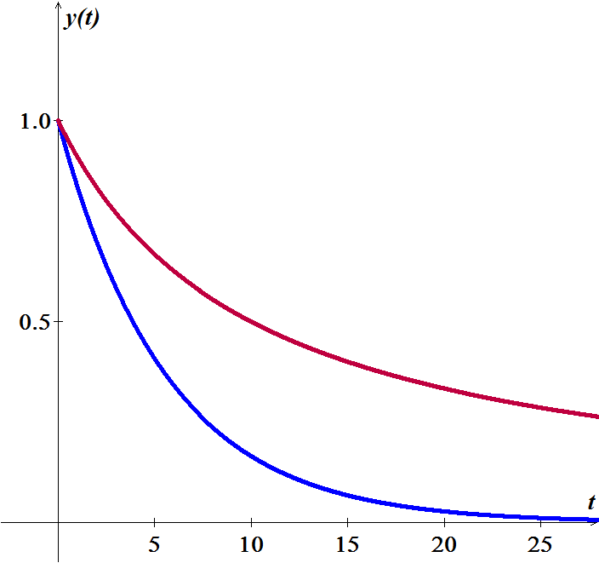









1. 



***Exercise***

The growth of cancer turmors may be modeled by the Gomperts growth equation. Let  be the mass of the tumor for . The relevant intial value problem is



Where *a* and *K* are positive constants and 

1. Graph the growth rate function  assuming  and . For what values of *M* is the growth rate positive? For what values of *M* is maximum?
2. Solve the initial cvalue problem and graph the solution for , , and . Describe the groath pattern of the tumor. Is the growth unbounded? If not, what is the limiting size of the tumor?
3. In the general equation, what is the meaning of *K*?

***Solution***

1. 



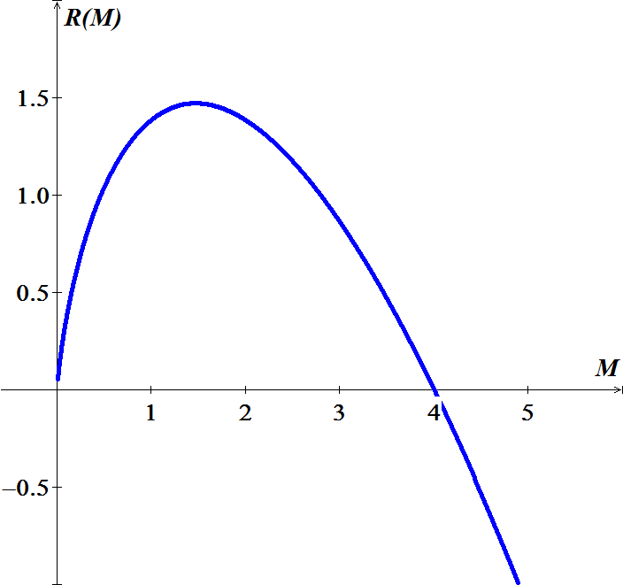

For  and 



1. 











For , , and 







So the limiting size of the tumor is 4.

1.  since 

***Exercise***

The halibut fishery has been modeled by the differential equation



Where  is the biomass (the total mass of the members of the population) in kilograms at time *t* (measured in years), the carrying capacity is estimated to be  and .

1. If , find the biomass a year later.
2. How long will it take for the biomass to reach .

***Solution***

1. 

 









 















1. 











***Exercise***

Suppose a population  satisfies  where *t* is measured in years.

1. What is the carrying capacity?
2. What is ?
3. When will the population reach 50% of the carrying capacity?

***Solution***

1. 



 

























The carrying capacity is 400.

1. 
2. 









***Exercise***

The board of directors of a corporation is calculating the price to pay for a business that is forecast to yield a continuous flow of profit of $500,000 per year. The money will earn a nominal rate of 5% per year compounded continuously. What is the present value of the business?

1. For 20 years?
2. Forever (in perpetuity)?

***Solution***







1. 
2. 

***Exercise***

The population of a community is known to increase at a rate proportional to the number of people present at a time *t*. If the population has doubled in 6 *years*, how long it will take to triple?

***Solution***









***Exercise***

Let population of country be decreasing at the rate proportional to its population. If the population has decreased to 25% in 10 *years*, how long will it take to be half?

***Solution***









***Exercise***

Suppose that we have an artifact, say a piece of fossilized wood, and measurements show that the ratio of *C*−14 to carbon in the sample is 37% of the current ratio. Let us assume that the wood died at time 0, then compute the time *T* it would take for one gram of the radioactive carbon to decay this amount.

***Solution***

The half-life of carbon C-14 is about 5550.





***Exercise***

A certain radioactive material is known to decay at a rate proportional to the amount present. If initially there is  of the material present and after 2 *hours* it is observed that the material has lost 10% of its original mass, find

1. An expression for the mass of the material remaining at any time *t*.
2. The mass of the material after 4 *hours*
3. The time at which the material has decayed to one half of its initial mass.

***Solution***

1. 























1. 
2. 

***Exercise***

The rate at which radioactive nuclei decay is proportional to the number of such nuclei that are present in given sample. Half of the original number of radioactive nuclei have undergone disintegration in a period of 1,500 *years*.

1. What percentage of the original radioactive nuclei will remain after 4,500 *years*?
2. In how many years will only one-tenth of the original number remain?

***Solution***

1. 









 





The percentage of the original radioactive nuclei will remain after 4,500 *years*: 

1. 

 