***Solution Section* 1.1 – Introduction to Differential Equations**

***Exercise***

Show that  is a solution of the 1st order equation  

***Solution***









***Exercise***

Show that  is a solution of the 1st order equation 

***Solution***





 

 

 

 

 





***Exercise***

A general solution may fail to produce all solutions of a differential equation . Show that  is a solution of the differential equation, but no value of C in the given general solution will produce this solution.

***Solution***



 ***√***

***Exercise***

Use the given general solution to find a solution of the differential equation having the given initial condition. 

***Solution***













The interval of existence is 

***Exercise***

Show that  is a solution of the 1st order equation 

***Solution***





 ***√***

***Exercise***

Use the given general solution to find a solution of the differential equation having the given initial condition. 

***Solution***









***Exercise***

Use the given general solution to find a solution of the differential equation having the given initial condition. 

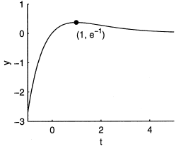***Solution***









Hence, *C* = 0

The solution is: 

This function is defined and differentiable on the whole real line. Hence, the interval of existence is the whole real line.

***Exercise***

Use the given general solution to find a solution of the differential equation having the given initial condition. 

***Solution***

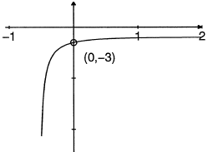









The solution is:





***Exercise***

Find the values of ***m*** so that the function  is a solution of the given differential equation

|  |  |
| --- | --- |
|  |  |

***Solution***



1. 





1. 





1. 





1. 





***Exercise***

Let  is 2-parameter family solutions of the second order differential equation of . Find a solution of the second-order consisting of this differential equation and the given initial conditions.

|  |  |
| --- | --- |
|  |  |

***Solution***



1. 



1. 



1. 





1. 





***Exercise***

Find values of *r* such that  is a solution of 

***Solution***













***Exercise***

Solve the differential equation 

***Solution***



***Exercise***

Solve the differential equation 

***Solution***









***Exercise***

Given the differential equation, is the given equation a solution to?

***Solution***

1. 









 *√*

 is a solution.

1. 











 is ***not*** a solution.

***Solution Section* 1.2 – Separable Equations**

***Exercise***

Find the general solution of the differential equation 

***Solution***















Where 

***Exercise***

Find the general solution of the differential equation 

***Solution***

















***Exercise***

Find the general solution of the differential equation. If possible, find an explicit solution 

***Solution***











***Exercise***

Find the general solution of the differential equation. If possible, find an explicit solution 

***Solution***











***Exercise***

Find the general solution of the differential equation. If possible, find an explicit solution 

***Solution***











***Exercise***

Find the general solution of the differential equation. If possible, find an explicit solution 

***Solution***

















***Exercise***

Find the general solution of the differential equation. If possible, find an explicit solution 

***Solution***

















 





***Exercise***

Find the general solution of the differential equation. If possible, find an explicit solution 

***Solution***















***Exercise***

Find the general solution of the differential equation. If possible, find an explicit solution



***Solution***



Let 



















***Exercise***

Find the general solution of the differential equation. If possible, find an explicit solution



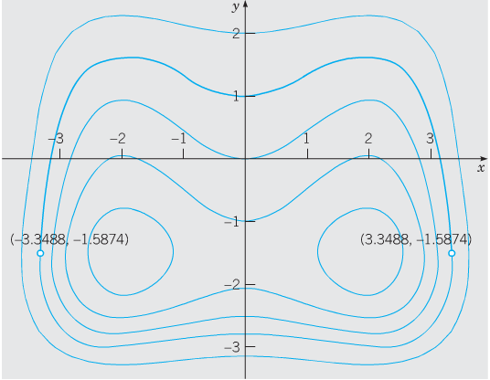***Solution***













***Exercise***

Find the general solution of the differential equation. If possible, find an explicit solution



***Solution***



 











***Exercise***

Find the exact solution of the initial value problem. Indicate the interval of existence.



***Solution***





















***Exercise***

Find the exact solution of the initial value problem. Indicate the interval of existence.



***Solution***













































The interval of existence: 

***Exercise***

Find the exact solution of the initial value problem. Indicate the interval of existence.



***Solution***



















The interval of existence will be the interval containing  and 



***Exercise***

Find the exact solution of the initial value problem. Indicate the interval of existence.



***Solution***





 









***Exercise***

Find the exact solution of the initial value problem. Indicate the interval of existence.



***Solution***













The negative value is taken to satisfy the initial condition.

***Exercise***

Find the exact solution of the initial value problem. Indicate the interval of existence.



***Solution***



 































***Exercise***

Find the exact solution of the initial value problem. Indicate the interval of existence.

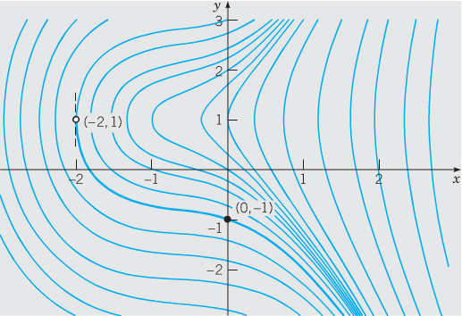

***Solution***

















***Exercise***

Find the exact solution of the initial value problem. Indicate the interval of existence.



***Solution***







 





***Exercise***

A murder victim is discovered at midnight and the temperature of the body is recorded at 31°C. One hour later, the temperature of the body is 29°C. Assume that the surrounding air temperature remains constant at 21°C. Use Newton’s law of cooling to calculate the victim’s time of death. *Note*: The normal temperature of a living human being is approximately 37°C

***Solution***

***Given***:

The initial temperature: .

At 

The surrounding temperature: 

The temperature is given by the formula: 

























The murder occurred 2 *hours* and 6 *minutes* earlier.

***Exercise***

Suppose a cold beer at 40°F is placed into a warn room at 70°F. suppose 10 minutes later, the temperature of the beer is 48°F. Use Newton’s law of cooling to find the temperature 25 minutes after the beer was placed into the room.

***Solution***

***Given***:

The initial temperature: .

At 

The surrounding temperature: 

Let be the temperature of the beer at time *t* minutes after being placed into the room.

From Newton’s law of cooling,







 

 







From the initial condition:























***Solution Section* 1.3– Linear Differential Equations**

***Exercise***

Find the general solution of 

***Solution***















***Exercise***

Find the general solution of 

***Solution***









 







***Exercise***

Find the general solution of 

***Solution***















***Exercise***

Find the general solution of 

***Solution***

 











***Exercise***

Find the general solution of 

***Solution***











***Exercise***

Find the general solution of 

***Solution***





 

 









***Exercise***

Find the general solution of 

***Solution***













***Exercise***

Find the general solution of 

***Solution***













***Exercise***

Find the general solution of 

***Solution***

 













***Exercise***

Find the general solution of 

***Solution***















***Exercise***

Find the general solution of 

***Solution***







 



***Exercise***

Find the general solution of 

***Solution***



|  |  |
| --- | --- |
|  |  |

***Exercise***

Find the general solution of 

***Solution***





 







***Exercise***

Find the general solution of 

***Solution***







 



***Exercise***

Find the general solution of 

***Solution***



|  |  |  |
| --- | --- | --- |
|  |  |  |
| **+** | *t* |  |
| **−** | 1 |  |









 



***Exercise***

Find the general solution of 

***Solution***









 



***Exercise***

Find the general solution of 

***Solution***













***Exercise***

Solve the differential equation: 

***Solution***











***Exercise***

Solve the differential equation: 

***Solution***



 











***Exercise***

Solve the differential equation: 

***Solution***













***Exercise***

Solve the differential equation: 

***Solution***













***Exercise***

Solve the differential equation: 

***Solution***











***Exercise***

Solve the differential equation: 

***Solution***





 









***Exercise***

Solve the differential equation: 

***Solution***









 









***Exercise***

Find the general solution of 

***Solution***























***Exercise***

Find the general solution of 

***Solution***

 





















***Exercise***

Find the general solution of 

***Solution***

















 















***Exercise***

Solve the initial value problem: 

***Solution***

















***Exercise***

Solve the initial value problem: 

***Solution***



















***Exercise***

Solve the initial value problem: 

***Solution***





 















***Exercise***

Solve the initial value problem: 

***Solution***

 



|  |  |
| --- | --- |
| ***1st method*** | ***2nd method*** |
|  |  |

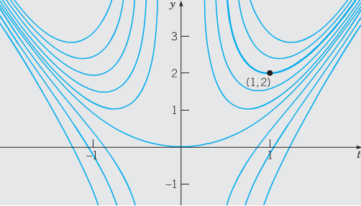











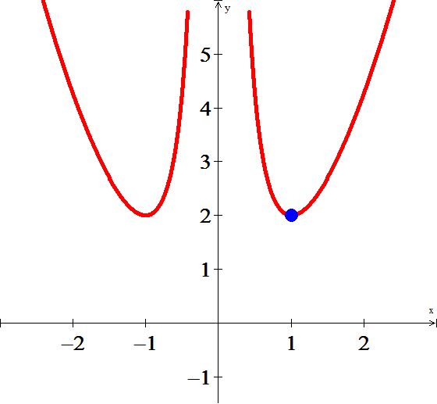

***Exercise***

Find the solution of the initial value problem 

***Solution***



 





 

Given , then







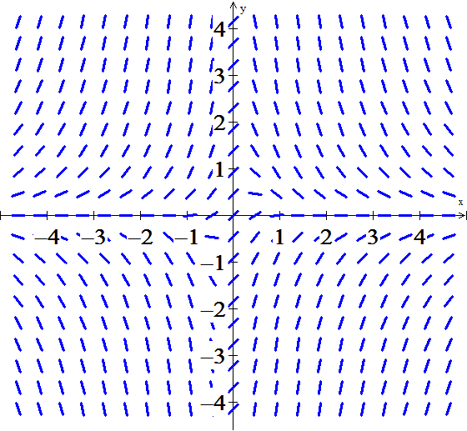 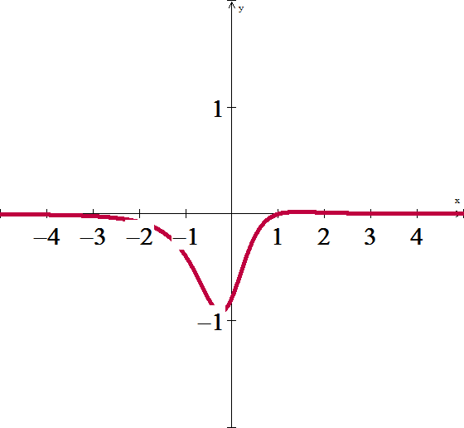

***Exercise***

Solve  

***Solution***



 











*Integration by part*



















 

***Exercise***

Find the solution of the initial value problem. Discuss the interval of existence and provide a sketch of your solution 

***Solution***



 





 











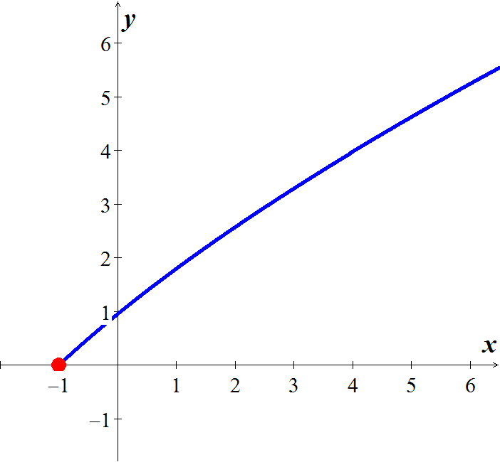





***Exercise***

Find the general solution of the given differential equation. Then find the particular solution satisfying the given initial condition of 

***Solution***

















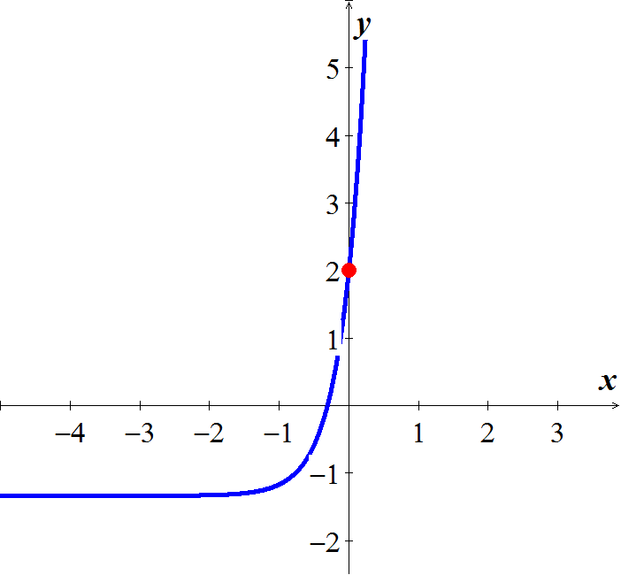

***Exercise***

Find the general solution of the given differential equation. Then find the particular solution satisfying the given initial condition of



***Solution***







 

















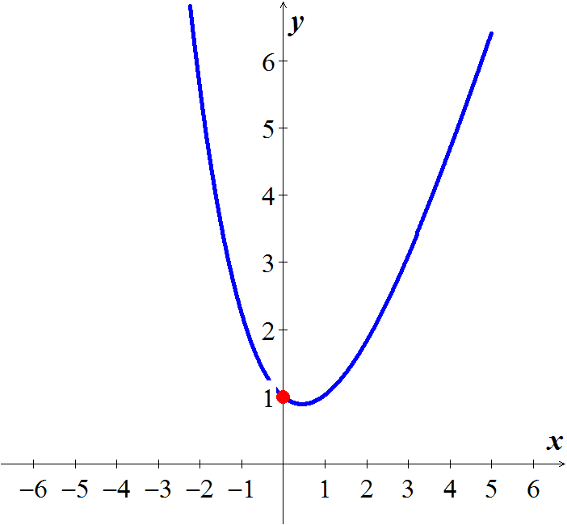

***Exercise***

Find the general solution of the given differential equation. Then find the particular solution satisfying the given initial condition of



***Solution***



















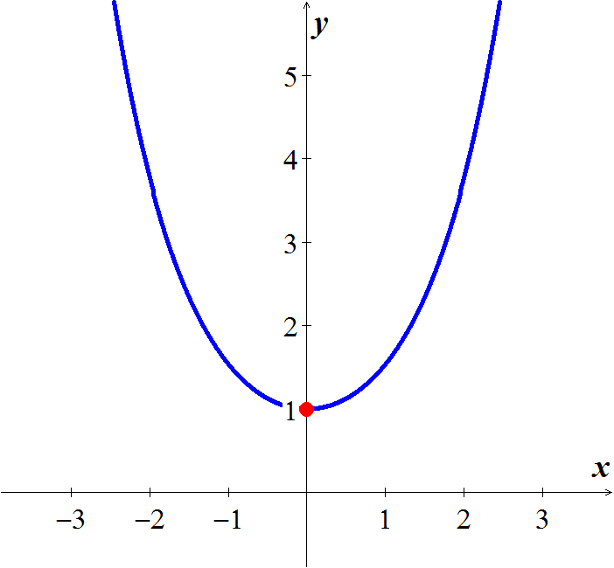

***Solution Section* 1.4 – Exact Differential Equations**

***Exercise***

Solve the differential equation 

***Solution***















***Exercise***

Solve the differential equation 

***Solution***















***Exercise***

Solve the differential equation 

***Solution***















***Exercise***

Solve the differential equation 

***Solution***





















***Exercise***

Solve the differential equation 

***Solution***

















***Exercise***

Solve the differential equation 

***Solution***















***Exercise***

Solve the differential equation 

***Solution***















***Exercise***

Solve the differential equation 

***Solution***















***Exercise***

Solve the differential equation 

***Solution***

Multiply both side by  since 



  









***Exercise***

The given equation is not exact. However, if you multiply by the given integrating factor, then it becomes exact. Then solve the equation



***Solution***

 











***Exercise***

The given equation is not exact. However, if you multiply by the given integrating factor, then it becomes exact. Then solve the equation



***Solution***

 





 







***Exercise***

The given equation is not exact. However, if you multiply by the given integrating factor, then it becomes exact. Then solve the equation



***Solution***

 





 







***Exercise***

The given equation is not exact. However, if you multiply by the given integrating factor, then it becomes exact. Then solve the equation



***Solution***









 









***Exercise***

The given equation is not exact. However, if you multiply by the given integrating factor, then it becomes exact. Then solve the equation



***Solution***

  





 









***Exercise***

The given equation is not exact. However, if you multiply by the given integrating factor, then it becomes exact. Then solve the equation



***Solution***

  

















***Exercise***

Find the general solution of the homogenous equation 

***Solution***

 











 



 

 



***Exercise***

Find the general solution of the homogenous equation 

***Solution***















 









***Exercise***

Find the general solution of the homogenous equation 

***Solution***























***Exercise***

Find an integrating factor and solve the given equation 

***Solution***

















|  |  |
| --- | --- |
|  |  |
|  |  |
|  |  |
|  |  |













***Exercise***

Find an integrating factor and solve the given equation 

***Solution***

 *Multiply by* ***y*** *both sides*

|  |  |
| --- | --- |
|  |  |
|  |  |
|  |  |











***Exercise***

Find an integrating factor and solve the given equation 

***Solution***

 

 *Multiply by* ***siny*** *both sides*





 











***Exercise***

Find an integrating factor and solve the given equation 

***Solution***









 





***Exercise***

Solve the given initial-value problem 

***Solution***



 



 







 



***Exercise***

Solve the given initial-value problem 

***Solution***

 



 







***Exercise***

Solve the given initial-value problem 

***Solution***













***Exercise***

Solve the given initial-value problem 

***Solution***













***Exercise***

Solve the given initial-value problem 

***Solution***



















***Exercise***

Solve the given initial-value problem 

***Solution***



















***Exercise***

Find the general solution 

***Solution***

Let 























***Exercise***

Find the general solution 

***Solution***

Let 

 ***Divide both side by*** 













***Exercise***

Find the general solution 

***Solution***

Let 



 ***Divide both side by*** 















***Exercise***

Find the general solution 

***Solution***

Let 

 ***Divide both side by*** 















***Exercise***

Find the general solution 

***Solution***

Let 

 ***Divide both side by*** 















***Exercise***

Find the general solution 

***Solution***

Let 

 ***Divide both side by*** 















***Exercise***

Find the general solution 

***Solution***

Let 

 ***Divide both side by*** 



















***Exercise***

Find the general solution 

***Solution***

Let 

 ***Divide both side by*** 





























***Exercise***

Find the general solution 

***Solution***

Let 



 ***Divide both side by*** 

















***Exercise***

Find the general solution 

***Solution***

Let 



 ***Divide both side by*** 















***Exercise***

Find the general solution 

***Solution***



Let 



 ***Multiply both sides by*** 











***Exercise***

Find the general solution 

***Solution***

 ***Divide by*** 

Let 



 ***Multiply both sides by*** 











***Exercise***

Find the general solution 

***Solution***



 ***Divide by*** 

Let 



 ***Multiply both sides by*** 













***Exercise***

Find the general solution 

***Solution***



 ***Divide both sides by ***

Let 



 ***Multiply both sides by*** 











***Exercise***

Find the general solution 

***Solution***

 ***Divide both sides by ***

Let 



 ***Multiply both sides by*** 











***Exercise***

Find the general solution 

***Solution***

 ***Divide both sides by ***



Let 

 ***Multiply both sides by*** 













***Exercise***

Find the general solution 

***Solution***

Let 















***Exercise***

Find the general solution 

***Solution***

Let 







Let 



 ***Multiply both sides by*** 













***Exercise***

Find the general solution 

***Solution***

Let 





Let 















 







***Solution Section* 1.5– Population: Exponential Growth/Decay**

***Exercise***

A biologist starts with 100 cells in a culture. After 24 *hrs,* he counts 300. Assuming a Malthusian model, what the reproductive rate? What will be the number of cells of the end of 5 days?

***Solution***



 **24 *hrs =* 1 *day P =* 300**













***Exercise***

A biologist prepares a culture. After 1 *day* of growth, the biologist counts 1000 cells. After 2*days,* he counts 3000. Assuming a Malthusian model, what the reproductive rate and how many cells were present initially?

***Solution***

***Given***: 

The equation of the Malthusian model is 

































***Exercise***

A population of bacteria is growing according to the Malthusian model. If the population is triples in 10 *hrs*, what is the reproduction rate? How often does the population double itself?

***Solution***















***Exercise***

Consider a lake that is stocked with walleye pike and that the population of pike is governed by the logistic equation



where time is measured in days and *P* in thousands of fish. Suppose that fishing is started in this lake and that 100 fish are removed each day.

1. Modify the logistic model to account for the fishing.
2. Find and classify the equilibrium points for your model.
3. Use qualitative analysis to completely discuss the fate of the fish population with this model. In particular, if the initial fish population is 1000, what happens to the fish as time passes? What will happen to an initial population having 2000 fish?

***Solution***

1. The modified logistic model



 

1.  *Multiply 100 each term*



 *Solve for P*



 Asymptotically stable

 Unstable

1. 

For the 1000 (= 1) population, the population decreases until it dies out (doomed);

For the 2000 (= 2) population, the population tend towards the equilibrium 





***Exercise***

Suppose that in 1885 the population of a certain country was 50 million and was growing at the rate of 750,000 people per year at that time. Suppose also that in 1940 its population was 100 million and was then growing at the rate of 1 million per year. Assume that this population satisfies the logistic equation. Determine both the limiting population *M* and the predicted population for the year 2000.

***Solution***





















 



***Exercise***

The time rate of change of a rabbit population *P* is proportional to the square root of *P*. At time  (months) the population numbers 100 rabbits and is increasing at the rate of 20 rabbits per month. How many rabbits will there be one year later?

***Solution***

***Given***: 

















***Exercise***

Suppose that the fish population  in a lake is attacked by a disease at time , with the result that the fish cease to reproduce (so that the birth rate is ) and the death rate *δ* (deaths per week per fish) is thereafter proportional to . If there were initially 900 fish in the lake and 441 were left after 6 weeks, how long did it take all the fish in the lake to die?

***Solution***

***Given***: 

















It will take 20 weeks for the fish to die in the lake.

***Exercise***

Suppose that when a certain lake is stocked with fish, the birth and death rates *β* and *δ* are both inversely proportional to 

1. Show that , where *k* is a constant.
2. If  and after 6 months there are 169 fish in the lake, how many will there be after 1 year?

***Solution***

1. 













1. ***Given***: 









There are 256 fish after 1 year.

***Exercise***

The time rate of change of an alligator population *P* in a swamp is proportional to the square of *P*. The swamp contained a dozen alligators in 1988, two dozen in 1998.

1. When will there be four dozen alligators in the swamp?
2. What happens thereafter?

***Solution***

***Given***: 

1. 

























, that is, in the year 2003

1. 

The population approaches infinity as *t* approaches 20 years.

***Exercise***

Consider a prolific breed of rabbits whose birth and death rates, *β* and *δ*, are each proportional to the rabbit population , with 

1. Show that 

Note that . This is doomsday

1. Suppose that  and that there are nine rabbits after ten months. When does doomsday occur?
2. With , repeat part (*a*)
3. What now happens to the rabbit population in the long run?

***Solution***

1. If the birth & death both are proportional to  with 











 

1. 

***Given***: 









 (doomsday)

1. If the birth & death both are proportional to  with 













1. 

Therefore , so the population die out in the long run.

***Exercise***

Consider a population  satisfying the logistic equation , where  is the time rate at which births occur and  is the rate at which deaths occur.

1. If the initial population is , and  births per month and  deaths per month are occurring at time , show that the limiting population is .
2. If the initial population is 120 rabbits and there are 8 births per month and 6 deaths per month occurring at time , how many months does it take for  to reach 95% of the limiting population *M*?
3. If the initial population is 240 rabbits and there are 9 births per month and 12 deaths per month occurring at time , how many months does it take for  to reach 105% of the limiting population *M*?

***Solution***

1.  



 ***√***

1. ***Given***: 





 





For 











1. ***Given***: 



 





For 











***Solution Section* 1.6– More Applications**

***Exercise***

A murder victim is discovered at midnight and the temperature of the body is recorded at 31°C. One hour later, the temperature of the body is 29°C. Assume that the surrounding air temperature remains constant at 21°C. Use Newton’s law of cooling to calculate the victim’s time of death. *Note*: The normal temperature of a living human being is approximately 37°C

***Solution***

***Given***:

The initial temperature: .

At 

The surrounding temperature: 

The temperature is given by the formula: 

























The murder occurred 2 *hours* and 6 *minutes* earlier.

***Exercise***

Suppose that a corpse was discovered in a motel room at midnight and its temperature was  . The temperature of the room is kept constant at . Two hours later the temperature of the corpse dropped to . Find the time of death.

***Solution***

First we use the observed temperatures of the corpse to find the constant *k*. We have



In order to find the time of death we need to remember that the temperature of a corpse at time of death is  (assuming the dead person was not sick!). Then we have











Which means that the death happened around 7:26 P.M.

***Exercise***

Suppose that a corpse was discovered at 10 PM and its temperature was  . Two hours later, its temperature is . If the ambient temperature is . Estimate the time of death.

***Solution***

***Given***: 



 









The death happened around 8:52 P.M

***Exercise***

Suppose a cold beer at 40°F is placed into a warn room at 70°F. suppose 10 minutes later, the temperature of the beer is 48°F. Use Newton’s law of cooling to find the temperature 25 minutes after the beer was placed into the room.

***Solution***

***Given***:

The initial temperature: .

At 

The surrounding temperature: 

Let be the temperature of the beer at time *t* minutes after being placed into the room.

From Newton’s law of cooling,







 

 







From the initial condition:























***Exercise***

Suppose that an Iowa class battleship has mass 51,000 metric tons (51,000,000 kg) and . Assume that the ship loses power when it is moving at a speed of 9 m/sec.

1. About how far will the ship coast before it is dead in the water?
2. About how long will it take the ship’s speed to drop to 1 m/sec?

***Solution***



1. 





















The ship will coast about 7780 meters or 7.78 km.

1. 







It will take about 

***Exercise***

A 66-kg cyclist on a 7-kg bicycle starts coasting on level ground at 9 m/sec. The 

1. About how far will the cyclist coast before reaching a complete stop?
2. How long will it take the cyclist’s speed to drop to 1 m/sec?

***Solution***

Mass: 



1. 





















The cyclist coast about 168.5 meters.

1. 





It will take about 41.13 seconds.

***Exercise***

An Executive conference room of a corporation contains 4500  of air initially free of carbon monoxide. Starting at time *t* = 0, cigarette smoke containing 4% carbon monoxide is blown into the room at the rate of 0.3 . A ceiling fan keeps the air in the room well circulated and the air leaves the room at the same rate of 0.3 . Find the time when the concentration of carbon monoxide in the room reaches 0.01%.

***Solution***

Let  be the amount of carbon monoxide (CO) in the room at time *t*.























When the concentration of CO is 0.01% in the room, the amount of CO satisfies



When the room contains the amount 













***Exercise***

A stone is released from rest and dropped into a deep well. Eight seconds later, the sound of the stone splashing into the water at the bottom of the well returns to the ear of the person who released the stone. How long does it take the stone to drop to the bottom of the well? How deep is the well? Ignore air resistance. The speed of sound is 340 *m/s*.

***Solution***





















***Exercise***

A rocket is fired vertically and ascends with constant acceleration  for 1.0 *min*. At that point, the rocket motor shuts off and the rocket continues upward under the influence of gravity. Find the maximum altitude acquired by the rocket and the total time elapsed from the take-off until the rocket returns to the earth. *Ignore air resistance*.

***Solution***



















The velocity will be reduced: 



The altitude: 





Back to the ground: 



Total time: 

***Exercise***

A ball having mass  falls from rest under the influence of gravity in a medium that provides a resistance that is proportional to its velocity. For a velocity of the force due to the resistance of the medium is −1 N. Find the terminal velocity of the ball.

1 N is the force required to accelerate a 1 kg mass at a rate of : 

***Solution***

The resistance force: 





The terminal velocity: 





***Exercise***

A ball is projected vertically upward with initial velocity from ground level. Ignore air resistance.

1. What is the maximum height acquired by the ball?
2. How long does it take the ball to reach its maximum height? How long does it take the ball to return to the ground? Are these times identical?
3. What is the speed of the ball when it impacts with the ground on its return?

***Solution***

The position: 

1. The maximum height when the velocity is zero





Maximum height 





1. The ball will take to reach the maximum height  and the same to return to the ground, both are equal to 
2. When the ball hits the ground the time is equal to zero.



***Exercise***

An object having mass 70 kg falls from rest under the influence of gravity. The terminal velocity of the object is . Assume that the air resistance is proportional to the velocity.

1. Find the velocity and distance traveled at the end of 2 seconds.
2. How long does it take the object to reach 80% of its terminal velocity?

***Solution***

1. The terminal velocity: 



























1. The velocity is 80% of its terminal velocity when 





***Exercise***

A lunar lander is falling freely toward the surface of the moon at a speed of 450 m/s. Its retrorockets, when fired, provide a constant deceleration of 2.5  (the gravitational acceleration produced by the moon is assumed to be included in the given acceleration). At What height above the lunar surface should the retrorockets be activated to ensure a “soft touchdown? (*v* = 0 at impact)?

***Solution***

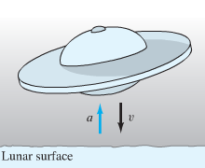***Given***:  

Because an upward thrust increases the velocity *v* (although decreases the speed ), then









 is the height of the lander above the lunar surface at the time *t* = 0 when the retrorockets should be activated.





When 





Thus the retrorockets should be activated when the lunar lander is 40.500 m (40,5 km) above the surface of the moon, and it will touch down softly on the lunar surface after 3 minutes of decelerating descent.

***Exercise***

A hemispherical bowl has top radius of 4ft. and at time *t* = 0 is full of water. At that moment a circular hole with diameter 1 in. is opened in the bottom of the tank. How long will it take for all the water to drain from the tank?

***Solution***

 (***Right*** ***Triangle***)



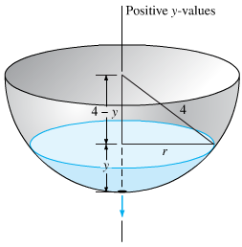























The tank is empty when y = 0, thus when







That is about 35 min. 50 s. So it takes slightly less than 36 minutes for the tank to drain.

***Exercise***

Suppose that the tank has a radius of 3 ft. and that its bottom hole is circular with radius 1 in. How long will it take the water (initially 9 ft. deep) to drain completely?

***Solution***



























Hence  when 

***Exercise***

At time *t* = 0 the bottom plug (at the vertex) of a full conical water tank 16 ft. high is removed. After 1 hr the water in the tank is 9 ft. deep. When will the tank be empty?

***Solution***

The radius of the cross-section of the cone at height *y* is proportional to *y*, so  is proportional to . Therefore,

 









With initial condition: 

















Hence  when 

***Exercise***

Suppose that a cylindrical tank initially containing  gallons of water drains (through a bottom hole) in *T* minutes. Use Torricelli’s law to show that the volume of water in the tank after  minutes is 

***Solution***

 





With initial condition: 



















If *r* denotes the radius of the cylinder, then







***Exercise***

A body falling in a relatively dense fluid, oil for example, is acted on by three forces: a resistance force *R,* a buoyant force *B,* and its weight *w* due to gravity. The buoyant force is equal to the weight of the fluid displaced by the object. For a slowly moving spherical body of radius *a*, the resistive force is given by Stokes’s law , where *v* is the velocity of the body, and *μ* is the coefficient of viscosity of the surrounding fluid?

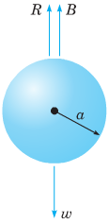

1. Find the limiting velocity of a solid sphere of radius *a* and density *ρ* falling freely in a medium of density  and coefficient of viscosity μ.
2. In 1910 R. A. Millikan studied the motion of tiny droplets of oil falling in an electric field. A field of strength *E* exerts a force on a droplet with charge *e*. Assume that *E* has been adjusted so the droplet is held stationary  and that *w* and *B* are as given. Find an expression for *e*.

***Solution***

1. The equation of motion is 



The limiting velocity occurs when 

1. Since the droplet is motionless, , we have the equation of motion



Where ρ is the density of the oil and  is the density of air.







***Exercise***

A 1,000-gallon conical tank, initially full of water, develops a leak at the bottom. Suppose that the eater drains off a rate proportional to the product of the time elapsed and the square root of the amount water present. Let  be the amount of water in the tank at time *t*.

1. Give the mathematical model (initial-value problem) which describes the process.
2. Find the solution

***Solution***

1. 







1. 





***Exercise***

The clepsydra, or water clock – A 12*-hr* water clock is to be designed with the dimensions, shaped like the surface obtained by revolving the curve  around the *y-*axis. What should be this curve, and what should be the radius of the circular bottom hole, in order that the water level will fall at the constant rate of 4 inches per hour?

***Solution***

The rate of fall of the water level is



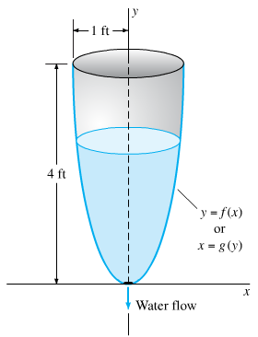 











The curve is of the form 













***Solution Section* 1.7 - Direction Fields; Existence and Uniqueness of Solutions**

***Exercise***

Which of the initial value problems are guaranteed a unique solution. 

***Solution***

→ *f* is continuous

 is also continuous on the whole plane.

Hence the hypotheses are satisfied and guarantee a unique solution.

***Exercise***

Which of the initial value problems are guaranteed a unique solution? 

***Solution***





Initial condition: 

Both  are not continuous in the rectangle containing 

Hence the hypotheses are not satisfied.

***Exercise***

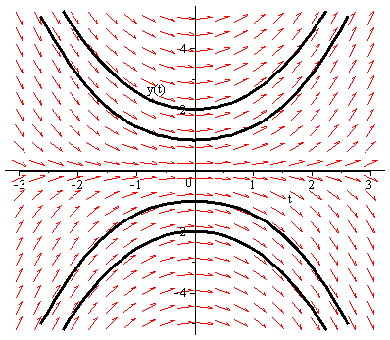Which of the initial value problems are guaranteed a unique solution? 

***Solution***

The right hand side of the equation is , which is continuous in the whole plane.  is also continuous in the whole plane.

Hence the hypotheses are satisfied and the theorem guarantees a unique solution.

***Exercise***

Which of the initial value problems are guaranteed a unique solution? 

***Solution***

The right hand side of the equation is , which is continuous in the whole plane.

 is also continuous in the whole plane.

Hence the hypotheses are satisfied and the theorem guarantees a unique solution.

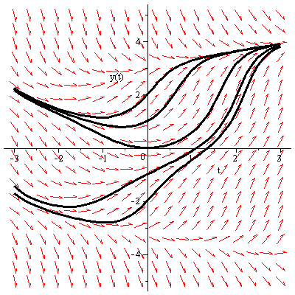

***Exercise***

Which of the initial value problems are guaranteed a unique solution? 

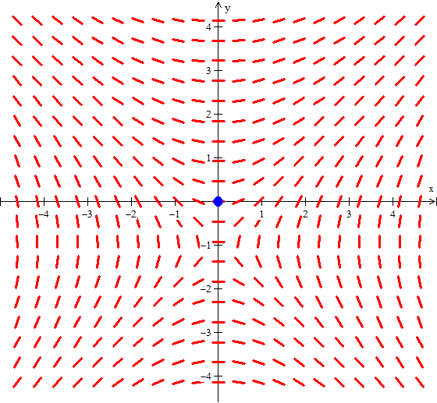***Solution***

The right hand side of the equation is , which is continuous in the whole plane, except where .

 is also continuous in the whole plane, except where .

Hence the hypotheses are satisfied in a rectangle containing the initial point (0, 0), so the theorem guarantees a unique solution.

***Exercise***

Which of the initial value problems are guaranteed a unique solution? 

***Solution***

The right hand side of the equation is , which is continuous in the whole plane, except where .

Since the initial point is (0, 1), *f* is discontinuous there,

Consequently there is no rectangle containing this point in which *f* is continuous.

The hypotheses are not satisfied, so the theorem doesn’t guarantee a unique solution.

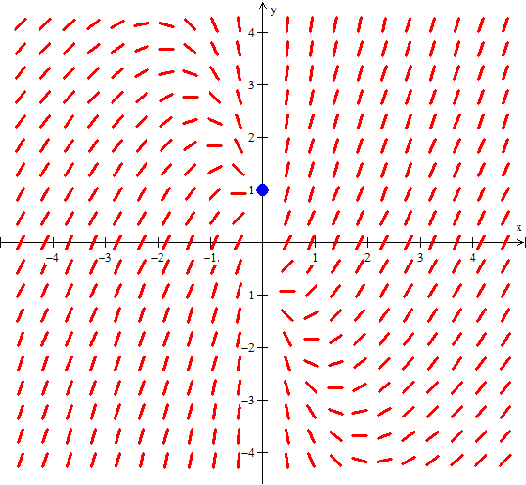

***Exercise***

Show that and  are both solutions of the initial value problem , where . Explain why this fact doesn't contradict Theorem

***Solution***



whichis not continuous at 

***Exercise***

Use a numerical solver to sketch the solution of the given initial value problem



1. Where does your solver experience difficulty? why? Use the image of your solution to estimate the interval of existence.
2. Find an explicit solution; then use your formula to determine the interval of existence. How does it compare with the approximation found in part (*a*).

***Solution***

1. 

















Solve for *y*:









***b)*** The only solution is:  and 

The interval of the solution 

***Solution Section* 1.8 - Numerical Methods**

***Exercise***

Calculate the first five iterations of Euler's method with step  of



***Solution***

|  |  |
| --- | --- |
| *t* | *y* |
| 0.1 | 1.00000000 |
| 0.2 | 1.01000000 |
| 0.3 | 1.03020000 |
| 0.4 | 1.06110600 |
| 0.5 | 1.10355024 |













***Exercise***

Calculate the first five iterations of Euler's method with step  of



***Solution***

|  |  |
| --- | --- |
| *x* | *z* |
| 0.0 | 1.00000000 |
| 0.1 | 0.80000000 |
| 0.2 | 0. 65000000 |
| 0.3 | 0.54000000 |
| 0.4 | 0.46200000 |
| 0.5 | 0.40960000 |

***Exercise***

Calculate the first five iterations of Euler's method with step  of: 

***Solution***



The *first* step:





The *second* step:





***Euler Method***

***t Approx. Exact Difference***

----------------------------------------------------------------

0.00 | 0.00000000 | 0.00000000 | 0.00000000

0.10 | 0.50000000 | 0.47581291 | -0.02418709

0.20 | 0.95000000 | 0.90634623 | -0.04365377

0.30 | 1.35500000 | 1.29590890 | -0.05909110

0.40 | 1.71950000 | 1.64839977 | -0.07110023

0.50 | 2.04755000 | 1.96734670 | -0.08020330



***Exercise***

Given: 

1. Use a computer and Euler's method to calculate three separate approximate solutions on the interval , one with step size , a second with step size , a second with step size .
2. Use the appropriate analytic to compute the exact solution
3. Plot the exact solution and approximate solutions as discrete points.

***Solution***

|  |  |
| --- | --- |
| *x* | *y* |
| 0.0 | 8.00000000 |
| 0.2 | 8.00000000 |
| 0.4 | 7.40000000 |
| 0.6 | 6.29600000 |
| 0.8 | 4.90496000 |
| 1.0 | 3.49537280 |
| *x* | *y* |
| 0.0 | 8.00000000 |
| 0.1 | 8.00000000 |
| 0.2 | 7.85000000 |
| 0.3 | 7.55600000 |
| 0.4 | 7.13264000 |
| 0.5 | 6.60202880 |
| 0.6 | 5.99182592 |
| 0.7 | 5.33280681 |
| 0.8 | 4.65621386 |
| 0.9 | 3.99121964 |
| 1.0 | 3.36280010 |

|  |  |  |  |
| --- | --- | --- | --- |
| *x* | *y* | *x* | *y* |
| 0.0 | 8.00000000 |  |  |
| 0.05 | 8.00000000 | 0.55 | 6.16870319 |
| 0.10 | 7.96250000 | 0.60 | 5.85692451 |
| 0.15 | 7.88787500 | 0.65 | 5.53550904 |
| 0.20 | 7.77705688 | 0.70 | 5.20820096 |
| 0.25 | 7.63151574 | 0.75 | 4.87862689 |
| 0.30 | 7.45322784 | 0.80 | 4.55022987 |
| 0.35 | 7.24463101 | 0.85 | 4.22621148 |
| 0.40 | 7.00856892 | 0.90 | 3.90948351 |
| 0.45 | 6.74822617 | 0.95 | 3.60262999 |
| 0.50 | 6.46705599 | 1.00 | 3.30788014 |



***t Approx. Exact Difference***

--------------------------------------------------------

0.00 | 8.00000000 | 8.00000000 | 0.00000000

0.20 | 8.00000000 | 7.70592079 | -0.29407921

0.40 | 7.40000000 | 6.89107842 | -0.50892158

0.60 | 6.29600000 | 5.73257245 | -0.56342755

0.80 | 4.90496000 | 4.45469318 | -0.45026682

1.00 | 3.49537280 | 3.25909581 | -0.23627699

***t Approx. Exact Difference***

--------------------------------------------------------

0.00 | 8.00000000 | 8.00000000 | 0.00000000

0.10 | 8.00000000 | 7.92537375 | -0.07462625

0.20 | 7.85000000 | 7.70592079 | -0.14407921

0.30 | 7.55600000 | 7.35448389 | -0.20151611

0.40 | 7.13264000 | 6.89107842 | -0.24156158

0.50 | 6.60202880 | 6.34100587 | -0.26102293

0.60 | 5.99182592 | 5.73257245 | -0.25925347

0.70 | 5.33280681 | 5.09469796 | -0.23810885

0.80 | 4.65621386 | 4.45469318 | -0.20152068

0.90 | 3.99121964 | 3.83643550 | -0.15478414

1.00 | 3.36280010 | 3.25909581 | -0.10370430

***t Approx. Exact Difference***

--------------------------------------------------------

0.00 | 8.00000000 | 8.00000000 | 0.00000000

0.05 | 8.00000000 | 7.98127342 | -0.01872658

0.10 | 7.96250000 | 7.92537375 | -0.03712625

0.15 | 7.88787500 | 7.83313428 | -0.05474072

0.20 | 7.77705688 | 7.70592079 | -0.07113608

0.25 | 7.63151574 | 7.54559797 | -0.08591777

0.30 | 7.45322784 | 7.35448389 | -0.09874395

0.35 | 7.24463101 | 7.13529429 | -0.10933672

0.40 | 7.00856892 | 6.89107842 | -0.11749051

0.45 | 6.74822617 | 6.62514862 | -0.12307755

0.50 | 6.46705599 | 6.34100587 | -0.12605012

0.55 | 6.16870319 | 6.04226366 | -0.12643953

0.60 | 5.85692451 | 5.73257245 | -0.12435207

0.65 | 5.53550904 | 5.41554691 | -0.11996214

0.70 | 5.20820096 | 5.09469796 | -0.11350300

0.75 | 4.87862689 | 4.77337119 | -0.10525570

0.80 | 4.55022987 | 4.45469318 | -0.09553669

0.85 | 4.22621148 | 4.14152671 | -0.08468477

0.90 | 3.90948351 | 3.83643550 | -0.07304801

0.95 | 3.60262999 | 3.54165879 | -0.06097120

1.00 | 3.30788014 | 3.25909581 | -0.04878433

***Exercise***

Given: 

1. Use a computer and Euler's method to calculate three separate approximate solutions on the interval , one with step size , a second with step size , a third with step size .
2. Use the appropriate analytic to compute the exact solution
3. Plot the exact solution and approximate solutions as discrete points.

***Solution***

***a***)

***Euler Method***

***t Approx. Exact Difference***

--------------------------------------------------------

0.00 | 1.00000000 | 1.00000000 | 0.00000000

0.20 | 1.40000000 | 1.52166119 | 0.12166119

0.40 | 2.01967299 | 2.40358420 | 0.38391121

0.60 | 3.00558546 | 3.91773797 | 0.91215251

0.80 | 4.60623367 | 6.53800280 | 1.93176913

1.00 | 7.24121233 | 11.08358415 | 3.84237182

***Euler Method***

***t Approx. Exact Difference***

--------------------------------------------------------

0.00 | 1.00000000 | 1.00000000 | 0.00000000

0.10 | 1.20000000 | 1.22750977 | 0.02750977

0.20 | 1.45221403 | 1.52166119 | 0.06944716

0.30 | 1.77249333 | 1.90411415 | 0.13162082

0.40 | 2.18165556 | 2.40358420 | 0.22192865

0.50 | 2.70700830 | 3.05806706 | 0.35105875

0.60 | 3.38432406 | 3.91773797 | 0.53341391

0.70 | 4.26039588 | 5.04872396 | 0.78832807

0.80 | 5.39633906 | 6.53800280 | 1.14166374

0.90 | 6.87184946 | 8.49975469 | 1.62790522

1.00 | 8.79068763 | 11.08358415 | 2.29289652

***Euler Method***

***t Approx. Exact Difference***

--------------------------------------------------------

0.00 | 1.00000000 | 1.00000000 | 0.00000000

0.05 | 1.10000000 | 1.10655238 | 0.00655238

0.10 | 1.21276293 | 1.22750977 | 0.01474684

0.15 | 1.34014623 | 1.36504472 | 0.02489849

0.20 | 1.48428480 | 1.52166119 | 0.03737639

0.25 | 1.64763153 | 1.70024381 | 0.05261229

0.30 | 1.83300369 | 1.90411415 | 0.07111045

0.35 | 2.04363584 | 2.13709506 | 0.09345922

0.40 | 2.28324010 | 2.40358420 | 0.12034410

0.45 | 2.55607493 | 2.70863793 | 0.15256300

0.50 | 2.86702349 | 3.05806706 | 0.19104356

0.55 | 3.22168289 | 3.45854614 | 0.23686325

0.60 | 3.62646574 | 3.91773797 | 0.29127223

0.65 | 4.08871582 | 4.44443559 | 0.35571976

0.70 | 4.61683955 | 5.04872396 | 0.43188441

0.75 | 5.22045550 | 5.74216412 | 0.52170862

0.80 | 5.91056439 | 6.53800280 | 0.62743841

0.85 | 6.69974213 | 7.45141089 | 0.75166876

0.90 | 7.60235911 | 8.49975469 | 0.89739558

0.95 | 8.63482915 | 9.70290431 | 1.06807516

1.00 | 9.81589205 | 11.08358415 | 1.26769209

***b***) 















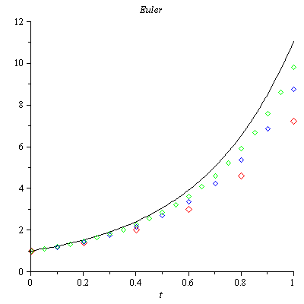

***Exercise***

Consider the initial value problem 

Use Euler's method with step size  to sketch solution on the interval 

***Solution***



***t Approx. Exact Difference***

--------------------------------------------------------

0.00 | 1.00000000 | 1.00000000 | 0.00000000

0.04 | 2.44000000 | 2.77812333 | 0.33812333

0.08 | 4.26707200 | 3.75770045 | -0.50937155

0.12 | 3.72005658 | 3.96254078 | 0.24248419

0.16 | 4.21993115 | 3.99446397 | -0.22546718

0.20 | 3.77444588 | 3.99918742 | 0.22474154

0.24 | 4.18308995 | 3.99988085 | -0.18320910

0.28 | 3.81546672 | 3.99998253 | 0.18451582

0.32 | 4.15342541 | 3.99999744 | -0.15342797

0.36 | 3.84754974 | 3.99999962 | 0.15244989

0.40 | 4.12909852 | 3.99999994 | -0.12909858

0.44 | 3.87322947 | 3.99999999 | 0.12677052

0.48 | 4.10891492 | 4.00000000 | -0.10891492

0.52 | 3.89410430 | 4.00000000 | 0.10589570

0.56 | 4.09204138 | 4.00000000 | -0.09204138

0.60 | 3.91125556 | 4.00000000 | 0.08874444

0.64 | 4.07786461 | 4.00000000 | -0.07786461

0.68 | 3.92545437 | 4.00000000 | 0.07454563

0.72 | 4.06591460 | 4.00000000 | -0.06591460

0.76 | 3.93727310 | 4.00000000 | 0.06272690

0.80 | 4.05582011 | 4.00000000 | -0.05582011

0.84 | 3.94714987 | 4.00000000 | 0.05285013

0.88 | 4.04728141 | 4.00000000 | -0.04728141

0.92 | 3.95542805 | 4.00000000 | 0.04457195

0.96 | 4.04005260 | 4.00000000 | -0.04005260

1.00 | 3.96238159 | 4.00000000 | 0.03761841

1.04 | 4.03392967 | 4.00000000 | -0.03392967

1.08 | 3.96823212 | 4.00000000 | 0.03176788

1.12 | 4.02874204 | 4.00000000 | -0.02874204

1.16 | 3.97316079 | 4.00000000 | 0.02683921

1.20 | 4.02434630 | 4.00000000 | -0.02434630

1.24 | 3.97731688 | 4.00000000 | 0.02268312

1.28 | 4.02062150 | 4.00000000 | -0.02062150

1.32 | 3.98082411 | 4.00000000 | 0.01917589

1.36 | 4.01746532 | 4.00000000 | -0.01746532

1.40 | 3.98378549 | 4.00000000 | 0.01621451

1.44 | 4.01479115 | 4.00000000 | -0.01479115

1.48 | 3.98628712 | 4.00000000 | 0.01371288

1.52 | 4.01252558 | 4.00000000 | -0.01252558

1.56 | 3.98840115 | 4.00000000 | 0.01159885

1.60 | 4.01060636 | 4.00000000 | -0.01060636

1.64 | 3.99018815 | 4.00000000 | 0.00981185

1.68 | 4.00898069 | 4.00000000 | -0.00898069

1.72 | 3.99169905 | 4.00000000 | 0.00830095

1.76 | 4.00760380 | 4.00000000 | -0.00760380

1.80 | 3.99297675 | 4.00000000 | 0.00702325

1.84 | 4.00643771 | 4.00000000 | -0.00643771

1.88 | 3.99405741 | 4.00000000 | 0.00594259

1.92 | 4.00545023 | 4.00000000 | -0.00545023

1.96 | 3.99497153 | 4.00000000 | 0.00502847

2.00 | 4.00461405 | 4.00000000 | -0.00461405

***Exercise***

You've seen that the error in Euler's method varies directly as the first power of the step size . This makes Euler's method an order to halve the error? How does this affect the number of required iterations?

***Solution***

Because  halving the step size should halve the error.



The number of iterations is given by: , therefore halving the step size should double the number of iterations.



***Exercise***

Use Euler’s method to provide an approximate solution over the given time interval using the given steps sizes. Provide a plot of ***v*** versus ***y*** for each step size



***Solution***

|  |  |
| --- | --- |
| ***h* = 0.1** | ***h* = 0.01** |

|  |  |
| --- | --- |
| ***h* = 0.001** |  |

***Exercise***



1. Use a computer and Runge-Kutta method to calculate three separate approximate solutions on the interval , one with step size , a second with step size , a second with step size .
2. Use the appropriate analytic to compute the exact solution
3. Plot the exact solution and approximate solutions as discrete points.

***Solution***



***Runge-Kutta* 2*nd Order***

t Approx. Exact Difference

--------------------------------------------------------

0.00 | 1.00000000 | 1.00000000 | 0.00000000

0.20 | 0.99800666 | 0.99873333 | 0.00072667

0.40 | 0.98887689 | 0.99039969 | 0.00152281

0.60 | 0.96709749 | 0.96939486 | 0.00229738

0.80 | 0.92871746 | 0.93169588 | 0.00297842

1.00 | 0.87131508 | 0.87482637 | 0.00351128

***Runge-Kutta* 4*th Order***

t Approx. Exact Difference

--------------------------------------------------------

0.00 | 1.00000000 | 1.00000000 | 0.00000000

0.20 | 0.99873272 | 0.99873333 | 0.00000061

0.40 | 0.99039822 | 0.99039969 | 0.00000147

0.60 | 0.96939245 | 0.96939486 | 0.00000241

0.80 | 0.93169258 | 0.93169588 | 0.00000330

1.00 | 0.87482232 | 0.87482637 | 0.00000405

***Runge-Kutta* 2*nd Order***

t Approx. Exact Difference

--------------------------------------------------------

0.00 | 1.00000000 | 1.00000000 | 0.00000000

0.10 | 0.99975021 | 0.99983750 | 0.00008729

0.20 | 0.99855245 | 0.99873333 | 0.00018088

0.30 | 0.99555979 | 0.99583746 | 0.00027767

0.40 | 0.99002480 | 0.99039969 | 0.00037489

0.50 | 0.98129932 | 0.98176938 | 0.00047006

0.60 | 0.96883388 | 0.96939486 | 0.00056098

0.70 | 0.95217687 | 0.95282259 | 0.00064572

0.80 | 0.93097330 | 0.93169588 | 0.00072258

0.90 | 0.90496314 | 0.90575327 | 0.00079013

1.00 | 0.87397921 | 0.87482637 | 0.00084716

***Runge-Kutta* 4*th Order***

t Approx. Exact Difference

--------------------------------------------------------

0.00 | 1.00000000 | 1.00000000 | 0.00000000

0.10 | 0.99983748 | 0.99983750 | 0.00000002

0.20 | 0.99873329 | 0.99873333 | 0.00000004

0.30 | 0.99583739 | 0.99583746 | 0.00000007

0.40 | 0.99039960 | 0.99039969 | 0.00000009

0.50 | 0.98176926 | 0.98176938 | 0.00000012

0.60 | 0.96939471 | 0.96939486 | 0.00000015

0.70 | 0.95282241 | 0.95282259 | 0.00000018

0.80 | 0.93169568 | 0.93169588 | 0.00000020

0.90 | 0.90575304 | 0.90575327 | 0.00000023

1.00 | 0.87482612 | 0.87482637 | 0.00000025

***Runge-Kutta* 2*nd Order***

t Approx. Exact Difference

--------------------------------------------------------

0.00 | 1.00000000 | 1.00000000 | 0.00000000

0.05 | 0.99996876 | 0.99997943 | 0.00001067

0.10 | 0.99981570 | 0.99983750 | 0.00002180

0.15 | 0.99942531 | 0.99945859 | 0.00003328

0.20 | 0.99868831 | 0.99873333 | 0.00004502

0.25 | 0.99750164 | 0.99755858 | 0.00005694

0.30 | 0.99576852 | 0.99583746 | 0.00006894

0.35 | 0.99339836 | 0.99347931 | 0.00008094

0.40 | 0.99030682 | 0.99039969 | 0.00009287

0.45 | 0.98641574 | 0.98652039 | 0.00010465

0.50 | 0.98165315 | 0.98176938 | 0.00011623

0.55 | 0.97595326 | 0.97608078 | 0.00012752

0.60 | 0.96925639 | 0.96939486 | 0.00013847

0.65 | 0.96150896 | 0.96165799 | 0.00014903

0.70 | 0.95266344 | 0.95282259 | 0.00015915

0.75 | 0.94267832 | 0.94284709 | 0.00016877

0.80 | 0.93151803 | 0.93169588 | 0.00017785

0.85 | 0.91915289 | 0.91933924 | 0.00018635

0.90 | 0.90555903 | 0.90575327 | 0.00019423

0.95 | 0.89071835 | 0.89091981 | 0.00020146

1.00 | 0.87461836 | 0.87482637 | 0.00020801

***Runge-Kutta* 4*th Order***

t y y(t) Difference

--------------------------------------------------------

0.00 | 1.00000000 | 1.00000000 | 0.00000000

0.05 | 0.99997943 | 0.99997943 | 0.00000000

0.10 | 0.99983750 | 0.99983750 | 0.00000000

0.15 | 0.99945859 | 0.99945859 | 0.00000000

0.20 | 0.99873333 | 0.99873333 | 0.00000000

0.25 | 0.99755858 | 0.99755858 | 0.00000000

0.30 | 0.99583745 | 0.99583746 | 0.00000000

0.35 | 0.99347930 | 0.99347931 | 0.00000001

0.40 | 0.99039969 | 0.99039969 | 0.00000001

0.45 | 0.98652039 | 0.98652039 | 0.00000001

0.50 | 0.98176937 | 0.98176938 | 0.00000001

0.55 | 0.97608077 | 0.97608078 | 0.00000001

0.60 | 0.96939485 | 0.96939486 | 0.00000001

0.65 | 0.96165798 | 0.96165799 | 0.00000001

0.70 | 0.95282258 | 0.95282259 | 0.00000001

0.75 | 0.94284708 | 0.94284709 | 0.00000001

0.80 | 0.93169587 | 0.93169588 | 0.00000001

0.85 | 0.91933923 | 0.91933924 | 0.00000001

0.90 | 0.90575325 | 0.90575327 | 0.00000001

0.95 | 0.89091979 | 0.89091981 | 0.00000001

1.00 | 0.87482635 | 0.87482637 | 0.00000002

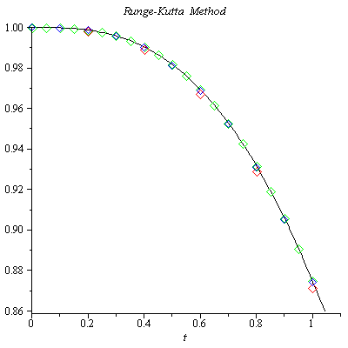

***Exercise***

Given 

1. Use a computer and Runge-Kutta method to calculate three separate approximate solutions on the interval , one with step size , a second with step size , a second with step size .
2. Use the appropriate analytic to compute the exact solution
3. Plot the exact solution and approximate solutions as discrete points.

***Solution***

***Runge-Kutta* 2*th Order***

***t Approx. Exact Difference***

--------------------------------------------------------

0.00 | 1.00000000 | 1.00000000 | 0.00000000

0.20 | 1.01961161 | 1.01980390 | 0.00019229

0.40 | 1.07636229 | 1.07703296 | 0.00067067

0.60 | 1.16495094 | 1.16619038 | 0.00123944

0.80 | 1.27887002 | 1.28062485 | 0.00175483

1.00 | 1.41205020 | 1.41421356 | 0.00216336

***Runge-Kutta* 4*th Order***

***t Approx. Exact Difference***

--------------------------------------------------------

0.00 | 1.00000000 | 1.00000000 | 0.00000000

0.20 | 1.01980437 | 1.01980390 | -0.00000046

0.40 | 1.07703431 | 1.07703296 | -0.00000135

0.60 | 1.16619234 | 1.16619038 | -0.00000196

0.80 | 1.28062701 | 1.28062485 | -0.00000216

1.00 | 1.41421570 | 1.41421356 | -0.00000214

***Runge-Kutta* 2*th Order***

***t Approx. Exact Difference***

--------------------------------------------------------

0.00 | 1.00000000 | 1.00000000 | 0.00000000

0.10 | 1.00497519 | 1.00498756 | 0.00001238

0.20 | 1.01975618 | 1.01980390 | 0.00004772

0.30 | 1.04392938 | 1.04403065 | 0.00010127

0.40 | 1.07686631 | 1.07703296 | 0.00016665

0.50 | 1.11779652 | 1.11803399 | 0.00023747

0.60 | 1.16588199 | 1.16619038 | 0.00030839

0.70 | 1.22027989 | 1.22065556 | 0.00037567

0.80 | 1.28018776 | 1.28062485 | 0.00043708

0.90 | 1.34487075 | 1.34536240 | 0.00049165

1.00 | 1.41367433 | 1.41421356 | 0.00053923

***Runge-Kutta* 4*th Order***

***t Approx. Exact Difference***

--------------------------------------------------------

0.00 | 1.00000000 | 1.00000000 | 0.00000000

0.10 | 1.00498757 | 1.00498756 | -0.00000001

0.20 | 1.01980393 | 1.01980390 | -0.00000003

0.30 | 1.04403071 | 1.04403065 | -0.00000006

0.40 | 1.07703304 | 1.07703296 | -0.00000008

0.50 | 1.11803409 | 1.11803399 | -0.00000010

0.60 | 1.16619050 | 1.16619038 | -0.00000012

0.70 | 1.22065569 | 1.22065556 | -0.00000013

0.80 | 1.28062498 | 1.28062485 | -0.00000013

0.90 | 1.34536254 | 1.34536240 | -0.00000013

1.00 | 1.41421369 | 1.41421356 | -0.00000013

***Runge-Kutta* 2*th Order***

***t Approx. Exact Difference***

--------------------------------------------------------

0.00 | 1.00000000 | 1.00000000 | 0.00000000

0.05 | 1.00124844 | 1.00124922 | 0.00000078

0.10 | 1.00498447 | 1.00498756 | 0.00000309

0.15 | 1.01118058 | 1.01118742 | 0.00000684

0.20 | 1.01979199 | 1.01980390 | 0.00001191

0.25 | 1.03075829 | 1.03077641 | 0.00001812

0.30 | 1.04400537 | 1.04403065 | 0.00002528

0.35 | 1.05944783 | 1.05948101 | 0.00003317

0.40 | 1.07699136 | 1.07703296 | 0.00004160

0.45 | 1.09653524 | 1.09658561 | 0.00005037

0.50 | 1.11797470 | 1.11803399 | 0.00005929

0.55 | 1.14120301 | 1.14127122 | 0.00006821

0.60 | 1.16611337 | 1.16619038 | 0.00007701

0.65 | 1.19260047 | 1.19268604 | 0.00008557

0.70 | 1.22056174 | 1.22065556 | 0.00009382

0.75 | 1.24989830 | 1.25000000 | 0.00010170

0.80 | 1.28051568 | 1.28062485 | 0.00010917

0.85 | 1.31232426 | 1.31244047 | 0.00011621

0.90 | 1.34523959 | 1.34536240 | 0.00012281

0.95 | 1.37918245 | 1.37931142 | 0.00012898

1.00 | 1.41407885 | 1.41421356 | 0.00013471

***Runge-Kutta* 4*th Order***

***t Approx. Exact Difference***

--------------------------------------------------------

0.00 | 1.00000000 | 1.00000000 | 0.00000000

0.05 | 1.00124922 | 1.00124922 | -0.00000000

0.10 | 1.00498756 | 1.00498756 | -0.00000000

0.15 | 1.01118742 | 1.01118742 | -0.00000000

0.20 | 1.01980390 | 1.01980390 | -0.00000000

0.25 | 1.03077641 | 1.03077641 | -0.00000000

0.30 | 1.04403065 | 1.04403065 | -0.00000000

0.35 | 1.05948101 | 1.05948101 | -0.00000000

0.40 | 1.07703297 | 1.07703296 | -0.00000001

0.45 | 1.09658562 | 1.09658561 | -0.00000001

0.50 | 1.11803400 | 1.11803399 | -0.00000001

0.55 | 1.14127123 | 1.14127122 | -0.00000001

0.60 | 1.16619039 | 1.16619038 | -0.00000001

0.65 | 1.19268605 | 1.19268604 | -0.00000001

0.70 | 1.22065557 | 1.22065556 | -0.00000001

0.75 | 1.25000001 | 1.25000000 | -0.00000001

0.80 | 1.28062486 | 1.28062485 | -0.00000001

0.85 | 1.31244048 | 1.31244047 | -0.00000001

0.90 | 1.34536241 | 1.34536240 | -0.00000001

0.95 | 1.37931143 | 1.37931142 | -0.00000001

1.00 | 1.41421357 | 1.41421356 | -0.00000001

1. The equation is separable:





















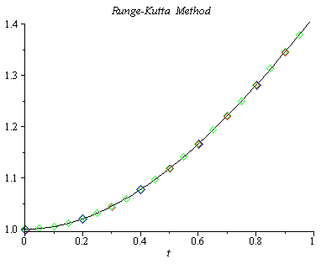

***Exercise***

Consider the initial value problem 

Use Runge-Kutta method with step size  to sketch solution on the interval 

***Solution***



***Runge-Kutta* 4*th Order***

t Approx. Exact Difference

--------------------------------------------------------

0.00 | 1.00000000 | 1.00000000 | 0.00000000

0.04 | 1.00079936 | 1.00079936 | -0.00000000

0.08 | 1.00318981 | 1.00318981 | -0.00000000

0.12 | 1.00714877 | 1.00714877 | -0.00000000

0.16 | 1.01263957 | 1.01263957 | -0.00000000

0.20 | 1.01961283 | 1.01961282 | -0.00000000

0.24 | 1.02800822 | 1.02800822 | -0.00000000

0.28 | 1.03775651 | 1.03775651 | -0.00000000

0.32 | 1.04878166 | 1.04878166 | -0.00000001

0.36 | 1.06100297 | 1.06100297 | -0.00000001

0.40 | 1.07433708 | 1.07433707 | -0.00000001

0.44 | 1.08869975 | 1.08869974 | -0.00000001

0.48 | 1.10400743 | 1.10400742 | -0.00000001

0.52 | 1.12017855 | 1.12017854 | -0.00000001

0.56 | 1.13713450 | 1.13713449 | -0.00000001

0.60 | 1.15480036 | 1.15480035 | -0.00000001

0.64 | 1.17310545 | 1.17310544 | -0.00000001

0.68 | 1.19198361 | 1.19198360 | -0.00000001

0.72 | 1.21137336 | 1.21137335 | -0.00000001

0.76 | 1.23121787 | 1.23121787 | -0.00000001

0.80 | 1.25146496 | 1.25146495 | -0.00000001

0.84 | 1.27206683 | 1.27206682 | -0.00000001

0.88 | 1.29297992 | 1.29297991 | -0.00000001

0.92 | 1.31416464 | 1.31416463 | -0.00000001

0.96 | 1.33558509 | 1.33558508 | -0.00000001

1.00 | 1.35720882 | 1.35720881 | -0.00000001

1.04 | 1.37900650 | 1.37900650 | -0.00000001

1.08 | 1.40095174 | 1.40095173 | -0.00000001

1.12 | 1.42302075 | 1.42302075 | -0.00000001

1.16 | 1.44519217 | 1.44519216 | -0.00000001

1.20 | 1.46744679 | 1.46744678 | -0.00000001

1.24 | 1.48976740 | 1.48976739 | -0.00000001

1.28 | 1.51213855 | 1.51213854 | -0.00000001

1.32 | 1.53454641 | 1.53454640 | -0.00000001

1.36 | 1.55697860 | 1.55697859 | -0.00000001

1.40 | 1.57942403 | 1.57942403 | -0.00000001

1.44 | 1.60187281 | 1.60187281 | -0.00000001

1.48 | 1.62431609 | 1.62431608 | -0.00000001

1.52 | 1.64674596 | 1.64674596 | -0.00000001

1.56 | 1.66915540 | 1.66915539 | -0.00000001

1.60 | 1.69153812 | 1.69153811 | -0.00000001

1.64 | 1.71388854 | 1.71388853 | -0.00000001

1.68 | 1.73620170 | 1.73620169 | -0.00000001

1.72 | 1.75847320 | 1.75847319 | -0.00000001

1.76 | 1.78069914 | 1.78069913 | -0.00000001

1.80 | 1.80287607 | 1.80287606 | -0.00000000

1.84 | 1.82500094 | 1.82500094 | -0.00000000

1.88 | 1.84707109 | 1.84707109 | -0.00000000

1.92 | 1.86908417 | 1.86908417 | -0.00000000

1.96 | 1.89103813 | 1.89103813 | -0.00000000

2.00 | 1.91293119 | 1.91293118 | -0.00000000