***Solution Section* 2.3 - Harmonic Motion**

***Exercise***



1. Plot the function
2. Place the solution in the form  and compare the graph with the plot in (***i***)

***Solution***

1. Plot the function

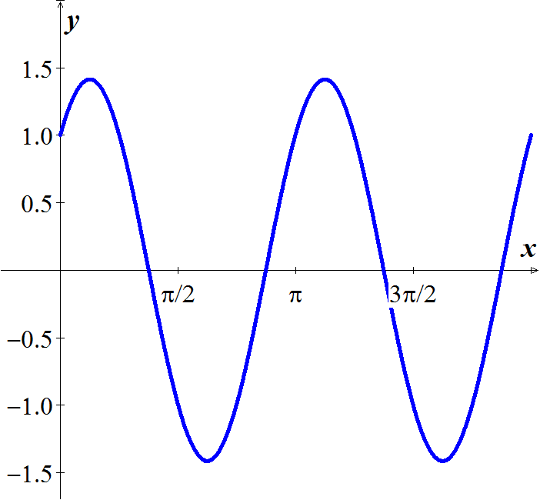

1. Place the solution in the form  and compare the graph with the plot in (***i***)



 

 





***Exercise***



1. Plot the function
2. Place the solution in the form  and compare the graph with the plot in (***i***)

***Solution***

1. Plot the function

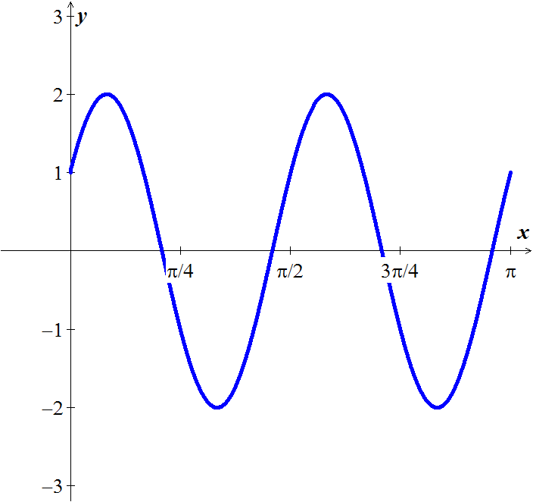 

1. Place the solution in the form  and compare the graph with the plot in (***i***)



 

 







***Exercise***

A 1-*kg* mass, when attached to a large spring, stretches the spring a distance of 4.9 *m*.

1. Calculate the spring constant.
2. The system is placed in a viscous medium that supplies a damping constant . The system is allowed to come to rest. Then the mass is displaced 1 *m* in the downward direction and given a sharp tap, imparting an instantaneous velocity of 1 *m/s* in the downward direction. Find the position of the mass as a function of time and plot the solution.

***Solution***

1. By Hooke's law: 







1. ***Given:*** 



The characteristic equation is:  

The general solution: 

***Exercise***

The undamped system  is observed to have period  and amplitude 2. Find *k* and 

***Solution***



The characteristic equation is:  

It is a complex root, thus we have a complex solution:



The general solution: 

This solution is periodic with period  (since the period is  given)













The amplitude is 2, therefore:









***Exercise***

A body with mass *m* = 0.5 *kg* is attached to the end of a spring that is stretched 2 *m* by a force of 100 *N*. It is set in motion with initial position  and initial velocity . (Note that these initial conditions indicate that he body is displaced to the right and is moving to the left at time *t* = 0.) Find the position function of the body as well as the amplitude, frequency, period of oscillation, and time lag of its motion.

***Solution***

Spring constant: 



The differential equation can be written as:





Period: 

Frequency: 

***Given***: 







Amplitude of motion is: 

Time lag?





Phase angle φ: 

Since 



Time lag of the motion is:





***Exercise***

Given the mass, damping, and spring constants of an undriven spring-mass system 



1. Provide separate plots of the position versus time (*y* vs. *t*) and the velocity versus time (*v* vs. *t*)
2. Provide a combined plot of both position and velocity versus time
3. Provide a plot of the velocity versus position (*v* vs. *y*) in the *yv* phase plane.

***Solution***





Let  







 

 

***Exercise***

Given the mass, damping, and spring constants of an undriven spring-mass system 



1. Provide separate plots of the position versus time (*y* vs. *t*) and the velocity versus time (*v* vs. *t*)
2. Provide a combined plot of both position and velocity versus time
3. Provide a plot of the velocity versus position (*v* vs. *y*) in the *yv* phase plane.

***Solution***



Let  





The following system of the first-order equations: 

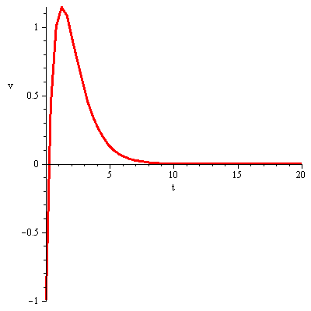 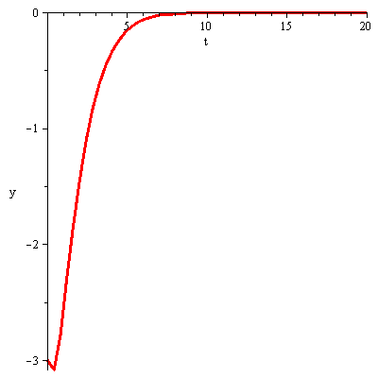

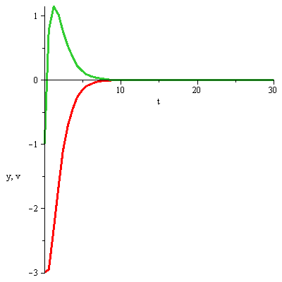 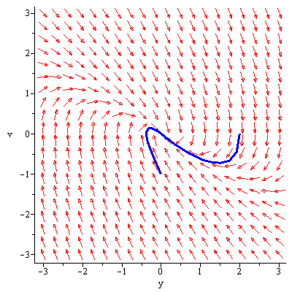

***Exercise***

A  mass is attached to a spring with a stiffness . The damping constant . If the mass is displaced  to the left and given an initial velocity of  to the left.

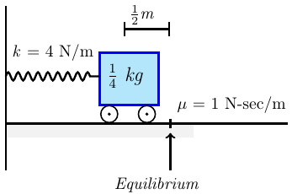

1. Find the equation of motion.
2. What is the maximum displacement that the mass will attain?

***Solution***

1.  
2. 

























***Exercise***

A  mass is attached to a spring with a stiffness . The mass is displaced  to the left of the equilibrium point and given a velocity of  to the left. Neglecting the damping,

1. Find the equation of motion of the mass along with the amplitude, period, and frequency.
2. How long after release does the mass pass through the equilibrium position?

***Solution***

1. ***Given***: 

 











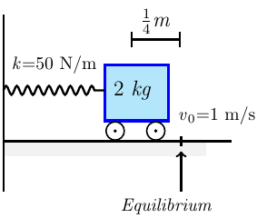

Amplitude: 

The angular velocity: 

*Period*: 

Natural *frequency* = 

1. 







***Exercise***

A  mass is attached to a spring with a stiffness . The mass is displaced  to the left of the equilibrium point and given a velocity of  to the left. Neglecting the damping,

1. Find the equation of motion of the mass
2. Find the amplitude, period, and frequency.
3. How long after release does the mass pass through the equilibrium position?

***Solution***

1. ***Given***: 

 

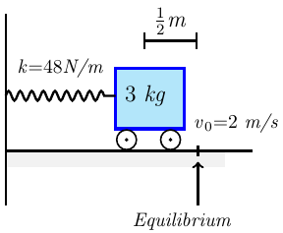











1. Amplitude: 

The angular velocity: 

*Period*: 

Natural *frequency* = 

1. 







***Exercise***

A  mass is attached to a spring with a stiffness . The damping constant . If the mass is pulled  to the right of the equilibrium point and given an initial velocity of . Neglecting the damping,

1. Find the equation of motion.
2. When will it first return to its equilibrium position?

***Solution***

1.  

















1. 

The mass will not return to the equilibrium position.

***Exercise***

A  mass is attached to a spring with a stiffness . The damping constant . If the mass is displaced  to the left of equilibrium and released, what is the maximum displacement to the right that the mass will attain?

***Solution***

 



























***Exercise***

A  mass is attached to a spring with a stiffness . The damping constant . If the mass is pushed  to the left of equilibrium and given a leftward velocity of , when will the mass attain its maximum displacement to the left?

***Solution***

 























***Exercise***

A  mass weight stretches a spring 2 *feet*. Assuming that a damping force numerically equal to 2 times the instantaneous velocity acts on the system, determine the equation if motion if the mass released from the equilibrium position with an upward velocity of 

***Solution***

 

 

 

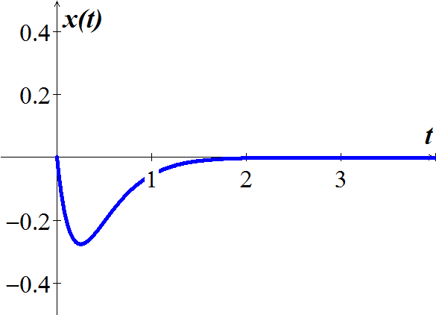













***Exercise***

A  mass weight is attached to the end of a spring, causing the spring to stretch a spring 6 *in*. beyond its natural length. The block is then pulled down 3 *in*. and released. Determine the motion of the block, assuming there are no damping or external applied force.

***Solution***

 

 

 

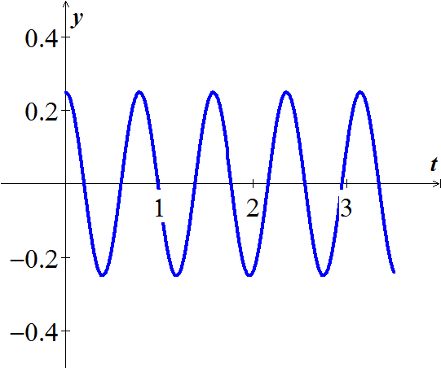 











***Exercise***

A  mass weight is attached to the end of a spring, causing the spring to stretch a spring 6 *in*. beyond its natural length. The block is then pulled down 3 *in*. and released. Determine the motion of the block, assuming there damping is present and that the damping coefficient is  and external applied force.

***Solution***

 

 

 















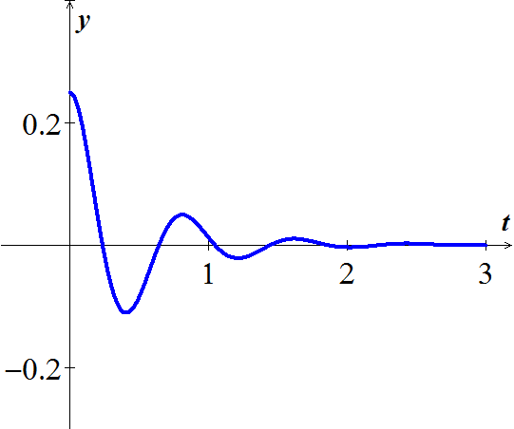

***Exercise***

A  mass weight is attached to a 5-*foot* spring. At equilibrium the spring measures 8.2 feet. If the mass is initially released from rest at a point  above the equilibrium position, find the displacements  if it is further known that the surrounding medium offers a resistance numerically equal to the instantaneous velocity.

***Solution***

 

 

 

















***Exercise***

A  mass weight is attached to a spring, stretches  by itself. There is no damping and no external forces acting on the system. The spring is initially displaced 6 *inches* upwards from its equilibrium position and given an initial velocity of downward. Find the displacement  at any time *t*.

***Solution***

 

 

 





















***Exercise***

A  mass weight is attached to a spring, stretches  by itself. A damper to the mass that will exert of 12 *lbs*. when the velocity is  . The spring is initially displaced 6 *inches* upwards from its equilibrium position and given an initial velocity of downward. Find the displacement  at any time *t*.

***Solution***

 

 

 

 



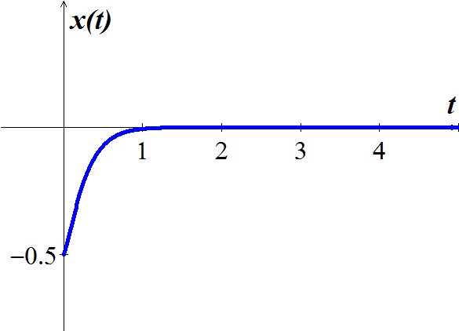 











***Exercise***

A  mass weight is attached to a spring, stretches  by itself. A damper to the mass that will exert of 5 *lbs*. when the velocity is  . The spring is initially displaced 6 *inches* upwards from its equilibrium position and given an initial velocity of downward. Find the displacement  at any time *t*.

***Solution***

 

 

 

 





















***Exercise***

A mass weighing 4-*lb* is attached to a spring whose spring constant is 16 *lb/ft*.

1. Find the equation of motion.
2. What is the period of simple harmonic motion?

***Solution***

 

1.  





1. The angular velocity: 

*Period*: 

***Exercise***

A 20-*kg* mass is attached to a spring. If the frequency of simple harmonic motion is .

1. What is the spring constant *k*?
2. Find the equation of motion.
3. What is the frequency of simple harmonic motion if the original mass is replaced with an 80-*kg* mass.?

***Solution***

1.  











1. 
2. 



Natural *frequency* = 





***Exercise***

A 24-*lb* mass weight is attached to the end of a spring, stretches it 4 *inches*. Initially, the mass is released from rest from a point 3 *inches* above the equilibrium position.

1. Find the equation of the motion.
2. If the mass is initially released from the equilibrium position with a downward velocity of 

***Solution***

 

 



1.  













1. 









***Exercise***

The motion of a mass-spring system with damping is given by:



Find the equation of motion and sketch its graph for .

***Solution***



For 





















For 













 

For 



















For 

















 

***Exercise***

A 10-*lb* mass weight is attached to the end of a spring, stretches it 3 *inches*. This mass is removed and replaced with a mass of 1.6 *slugs*, which initially released from a point 4 inches above the equilibrium position with a downward velocity of.

1. Find the equation of the motion.
2. Find the amplitude, phase angle, period and the frequency.
3. Express the motion equation in amplitude and phase angle form.
4. Determine the times the mass attains a displacement below the equilibrium position numerically equal to  the amplitude of motion.

***Solution***

1. 













1. Amplitude: 

***Phase angle:*** 

***Period***:  

***Frequency***:  

1. 
2. 







***Exercise***

A 64-*lb* mass weight is attached to the end of a spring, stretches it 0.32 *foot*. This mass is initially released from a point 8 *inches* above the equilibrium position with a downward velocity of .

1. Find the equation of the motion.
2. Find the amplitude, phase angle, period and the frequency.
3. Write the motion equation with phase angle form.
4. How many complete cycles will the mass have completed at the end of .
5. At what time does the mass pass through the equilibrium position heading downward for the second time?
6. At what times does the mass attain its extreme displacements on either side of the equilibrium position?
7. What is the position of the mass at ?
8. What is the instantaneous velocity at ?
9. What is the acceleration at ?
10. What is the instantaneous velocity at the times when the mass passes through the equilibrium position?
11. At what times is the mass 5 *inches* below the equilibrium position?
12. At what times is the mass 5 *inches* below the equilibrium position heading in the upward direction?

***Solution***

 

 

1.  













1. ***Amplitude***: 

***Phase angle:*** 

***Period***:  

***Frequency***:  

1. 
2. 
3. Mass passes through the equilibrium position: 







1. 





1. 
2. 
3. 



1. 



 



1. 









1.  & 



***Exercise***

If it is underdamped, write the position function in the form .

Also, find the undamped position function  that would result if the mass on the spring were set in motion with the same initial position and velocity, but with the dashpot disconnected (so ). Then, construct a figure that illustrates the effect of damping by comparing the graphs of  and  

***Solution***

***With damping motion***

 











 (*Overdamped motion*)

***Without damping*** 

 













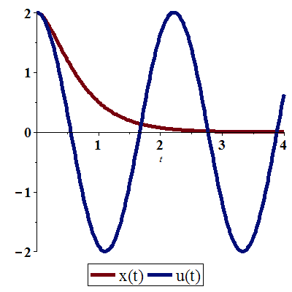

***Exercise***

If it is underdamped, write the position function in the form .

Also find the undamped position function  that would result if the mass on the spring were set in motion with the same initial position and velocity, but with the dashpot disconnected (so ). Then, construct a figure that illustrates the effect of damping by comparing the graphs of  and 



***Solution***

***With damping motion***

 











 (*Overdamped motion*)

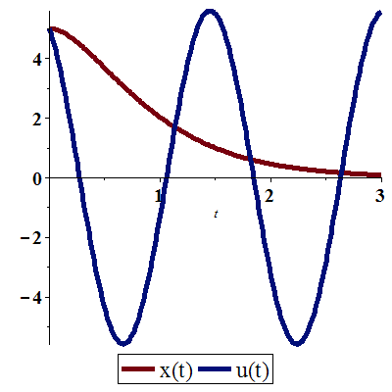***Without damping*** 

 

















***Exercise***

If it is underdamped, write the position function in the form .

Also find the undamped position function  that would result if the mass on the spring were set in motion with the same initial position and velocity, but with the dashpot disconnected (so ). Then, construct a figure that illustrates the effect of damping by comparing the graphs of  and 



***Solution***

***With damping motion***

 



 









 (*Overdamped motion*)

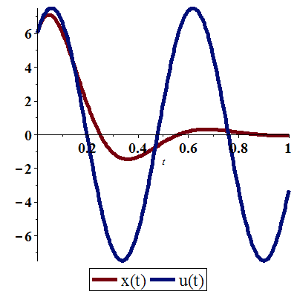***Without damping*** 

 

















***Exercise***

If it is underdamped, write the position function in the form .

Also find the undamped position function  that would result if the mass on the spring were set in motion with the same initial position and velocity, but with the dashpot disconnected (so ). Then, construct a figure that illustrates the effect of damping by comparing the graphs of  and  

***Solution***

***With damping motion***

 













 (*Overdamped motion*)

***Without damping*** 

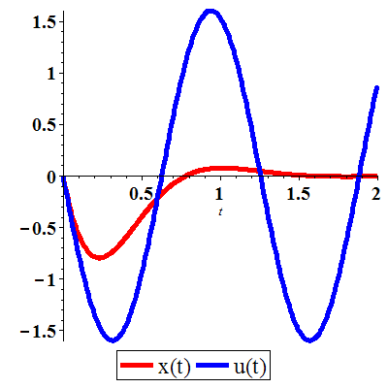 















***Exercise***

If it is underdamped, write the position function in the form .

Also find the undamped position function  that would result if the mass on the spring were set in motion with the same initial position and velocity, but with the dashpot disconnected (so ). Then, construct a figure that illustrates the effect of damping by comparing the graphs of  and  

***Solution***

***With damping motion***

 















 (*Overdamped motion*)

***Without damping*** 

 

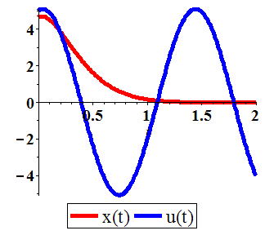 















***Exercise***

If it is underdamped, write the position function in the form .

Also find the undamped position function  that would result if the mass on the spring were set in motion with the same initial position and velocity, but with the dashpot disconnected (so ). Then, construct a figure that illustrates the effect of damping by comparing the graphs of  and  

***Solution***

***With damping motion***

 













 (*Overdamped motion*)

***Without damping*** 

 

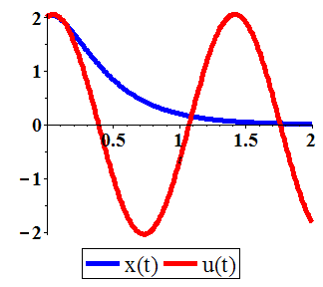 















***Exercise***

If it is underdamped, write the position function in the form .

Also find the undamped position function  that would result if the mass on the spring were set in motion with the same initial position and velocity, but with the dashpot disconnected (so ). Finally, construct a figure that illustrates the effect of damping by comparing the graphs of  and  

***Solution***

***With damping motion***

 















 (*Overdamped motion*)

***Without damping*** 

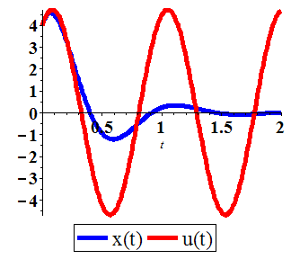 

















***Exercise***

Suppose that the mass in a mass−spring−dashpot system with is set in motion with  and 

1. Find the position function  and graph the function
2. Find how far the mass moves to the right before starting back toward the origin.

***Solution***

1.  

The *characteristic equation*: 













1. 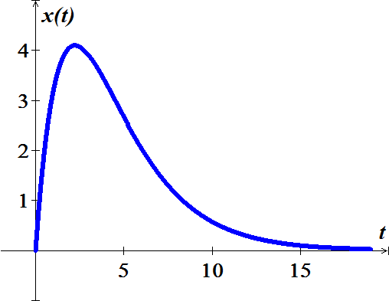







The farthest distance to the right of the mass is:









***Exercise***

Suppose that the mass in a mass−spring−dashpot system with is set in motion with  and 

1. Find the position function  and graph the function
2. Find the pseudoperiod of the oscillations and the equations of the “envelope curves” that are dashed.

***Solution***

1.  

The *characteristic equation*: 

















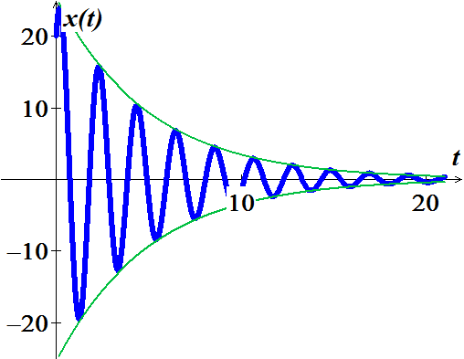

1. Since , then the oscillation are bounded by the curves  and pseudoperiod: 

***Exercise***

A mass of 1 *slug* is suspended from a spring, the spring constant is . The mass is initially released from a point 1 *foot* above the equilibrium position with an upward velocity of . Find the times at which the mass is heading downward at a velocity of 

***Solution***

 























 

 

***Exercise***

Two parallel springs, with constants  and , support a single mass, the effective spring constant of the system is given by .

A mass weight 20 *pounds* stretches one spring 6 *inches* and another spring 2 *inches*. The springs are attached to a common rigid support and then to a metal plate. The mass is attached to the center of the plate in the double-spring constant arrangement.

1. Determine the effective spring constant of this system.
2. Find the equation of motion if the mass is initially released from the equilibrium position with a downward velocity of .

***Solution***

 

1.  



 



1. 















***Exercise***

A 12−*lb* weight is attached both to a vertically suspended spring that it stretches 6 *in*. and to a dashpot that provides 3 *lb*. of resistance for every foot per second of velocity.

1. If the weight is pulled down 1 *foot*. below its static equilibrium position and then released from rest at time , find its position function .
2. Find the frequency, time-varying amplitude, and phase angle of the motion.

***Solution***

***Given***: 

 

 

1. 















1. *Frequency*: 

*Time-varying amplitude* 

*Phase angle* 



***Exercise***

A  mass is attached to a spring with a spring constant . The mass is displaced  to the right of the equilibrium point and given an outward velocity (to the right) of . Neglecting any damping or external forces that may be present,

1. Determine the equation of motion of the mass
2. Determine the equation of motion amplitude, period, and natural frequency.
3. How long after release does the mass pass through the equilibrium position?

***Solution***

1.  















1. *Amplitude*: 

*Phase angle*:  



*Period*: 

*Natural Frequency*: 

1. 







***Exercise***

A  mass is attached to a spring with a spring constant . The mass is displaced  to the left and given a velocity of  to the right. The damping force is negligible.

1. Determine the equation of motion of the mass
2. Determine the equation of motion amplitude, period, and natural frequency.
3. How long after release does the mass pass through the equilibrium position?

***Solution***

***Given***: 

1.  













1. *Amplitude*: 

*Phase angle*:  



*Period*: 

*Natural Frequency*: 

1. 







***Exercise***

A  mass is attached to a spring with a spring constant . The mass is is pulled down  and released with downward velocity of . The damping force is negligible.

1. Determine the equation of motion of the mass
2. Solve the equation to find the time when the maximum downward displacement of the mass from its equilibrium position is first achieved.
3. What is the maximum downward displacement?

***Solution***

***Given***: 

1.  



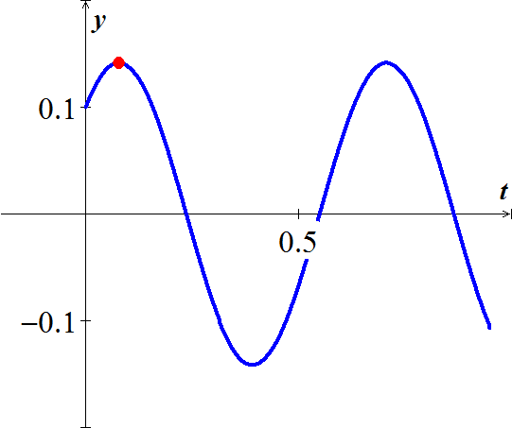









1. 



The time when the maximum downward displacement of the mass from its equilibrium position is first achieved 

1. 





***Exercise***

A  mass is attached to the end of a spring hanging vertically, stretches the spring 0.03 *m*. The mass is pulled down another 7 *cm* and released (with no initial velocity).

1. Determine the spring constant *k*.
2. Determine the equation of motion of the mass

***Solution***

1.  
2.  













***Exercise***

A  mass is attached to a spring with spring constant . At time , the mass is pulled down another 10 *cm* and released with a downward velocity of .

1. Determine the equation of motion.
2. What is the maximum downward displacement?

***Solution***

1. 













1. 











***Exercise***

A  mass is attached to the end of a spring hanging vertically at rest. The mass is pulled down another 7 *cm* and released (with no initial velocity).

1. Determine the spring constant *k*.
2. Determine the equation of motion of the mass

***Solution***

1.  
2.  













***Exercise***

A  mass is attached to the end of a spring hanging vertically, stretches the spring 0.7 *m*. The mass is started in motion from the equilibrium position with an initial velocity  in the upward direction. If the force due to air resistance is 

1. Determine the spring constant *k*.
2. Determine the equation of motion of the mass

***Solution***

1.  
2.  

















***Exercise***

A  mass is attached to the end of a spring hanging vertically, stretches the spring . The mass is started in motion from the equilibrium position with an initial velocity  in the downward direction. If the force due to air resistance is 

1. Determine the spring constant *k*.
2. Determine the equation of motion of the mass

***Solution***

1.  
2.  















***Exercise***

A  mass is attached to the end of a spring hanging vertically at rest. When given an initial downward velocity of  from its equilibrium position the mass was observed to attain a maximum displacement of 0.2 *m* from its equilibrium position.

1. Determine the spring constant *k*.
2. Determine the equation of motion of the mass

***Solution***

1.  























1. 

***Exercise***

A steel ball weighing 128-*lb* is attached to the end of a spring, stretches  from its natural length. The ball is started in motion with no initial velocity by displacing it  above the equilibrium position. Assuming no air resistance.

1. Determine the spring constant *k*.
2. Find the equation of the ball position at time *t*.
3. Find the position of the ball at 

***Solution***

1.  

 

1.  













1. 





***Exercise***

A  mass is attached to the end of a spring hanging vertically with spring constant , is perturbed from its equilibrium position with a certain upward initial velocity. The amplitude of the resulting vibrations is observed to be .

1. Determine the equation of motion.
2. What is the initial velocity?
3. Determine the period and frequency of the vibrations?

***Solution***

1.  









*Amplitude*: 



1. 



1. *Period*: 

*Frequency*: 

***Exercise***

A  mass is suspended from a spring with a spring constant of . The mass is started in motion from the equilibrium position with an initial velocity . Assuming no air resistance

1. Determine the equation of motion of the mass.
2. Determine the circular frequency, natural frequency, and period.

***Solution***

1. 















1. *Circular frequency*: 

*Natural frequency*: 

*Period:* 

***Exercise***

A  mass is attached to a spring having a spring constant of . The mass is started in motion initially displacing it  in the downward direction with an initial velocity  in the upward direction. If the force due to air resistance is . Find the subsequent motion of the mass

***Solution***















***Exercise***

A spring with a mass of has natural length . A force of  is required to maintain it stretched to a length of . If the spring is stretched to a length of  and then released with initial velocity zero. Find the position of the mass at any time *t*.

***Solution***

 















***Exercise***

A spring with a mass of has natural length . A force of  is required to maintain it stretched to a length of . The spring is immersed in a fluid with damping constant . If the spring is started from the equilibrium position and is given a push to start it with initial velocity . Find the position of the mass at any time *t*.

***Solution***

 

















***Exercise***

A spring with a mass of is held stretched  beyond its natural length by a force of . If the spring begins at its equilibrium and with initial velocity . Find the position of the mass.

***Solution***

 

 













***Exercise***

A spring with a mass of  is held stretched , has damping constant 14, and a force of . If the spring is stretched 1 *m* beyond at its equilibrium and with no initial velocity.

1. Find the position of the mass at any time *t*.
2. Find the mass that would produce critical damping.

***Solution***

1.  

 

















1. 

For critical damping: 



***Exercise***

A spring has a mass of  and its spring constant . The spring is released at a point  above its equilibrium position. Graph the position function for the following values of damping constant *c*: 10, 15, 20, 25, 30. What type of damping occurs each case?

***Solution***

***Given***: 

 

For 



∴ The motion is ***underdamped***











For 



∴ The motion is ***underdamped***











For 



∴ The motion is ***critically damped***











For 



∴ The motion is ***overdamped***







 





For 



∴ The motion is ***overdamped***







  

 





***Exercise***

A  mass is attached to a spring and set in motion. A record of the displacements was made and found to be described by , with displacement measured in centimeters and time in seconds.

1. Determine the displacement .
2. Determine the initial velocity ?
3. Determine the spring constant *k*.
4. Determine the period and frequency of the vibrations?

***Solution***

1.  

***Given***: 







1. 



1. 
2. 



***Exercise***

A  mass is attached to a spring with a spring constant ; the dashpot has damping constant . At time , the system is set into motion by pulling the mass down 0.5 *m* from its equilibrium rest position while simultaneously giving it an initial downward velocity of 

1. Solve the equation of motion.
2. What is the 
3. Plot the solution.
4. How long it takes for the magnitude of the vibrations to be reduced to 0.1 *m*.

(Estimate the smallest time, *τ*, for which )

***Solution***

1.  















1. 

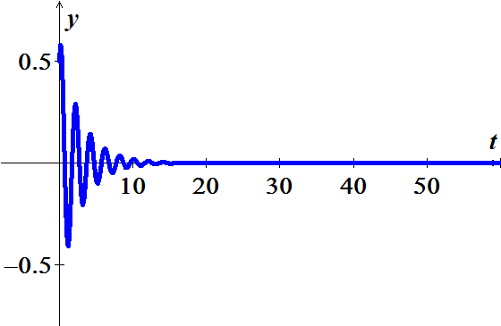 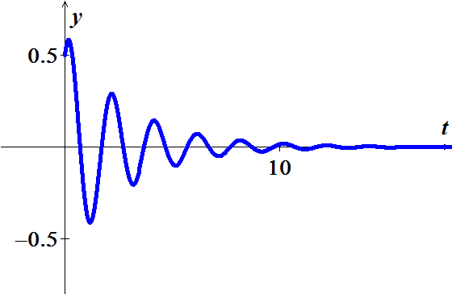

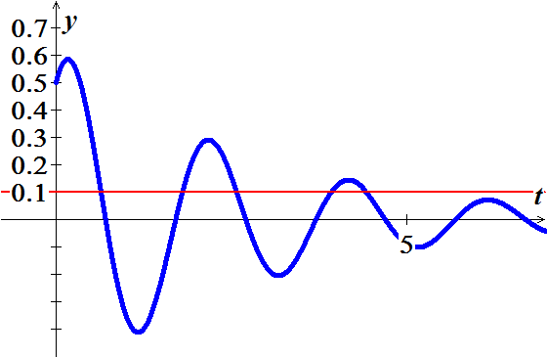

From the graph:

|  |  |
| --- | --- |
| ***τ*** | ***y*** |
| 0.63960 | 0.10046 |
| 0.64000 | 0.09983 |

***Exercise***

A spring and dashpot system is to be designed for a  weight so that the overall system is critically damped

1. How must the damping constant *c* and the spring constant *k* be related?
2. Assume the system is to be designed so that the mass, when given initial velocity of  from its rest position, will have a maximum displacement of . What values of damping constant *c* and spring constant *k* are required?
3. It is observed that the time interval between successive zero crossing is 20% larger for the damped vibration displacement than for the undamped vibration displacement. What is the damping constant *c*? (Spring constant *k* remains same from part (*b*)).

***Solution***

1.  





Since the system is critically damped, then:



1. 





















1. Since, the time interval  between successive zero crossing is 20% larger of undamped .

















***Exercise***

Find the charge  on the capacitor in an *LRC*−series circuit when , , , , , and .

***Solution***

 





















***Exercise***

Find the charge  on the capacitor in an *LRC*−series circuit at  when , , , , , and . Determine the first time at which the charge on the capacitor is equal to zero.

***Solution***

 

















 











***Exercise***

Find the charge  on the capacitor in an *LRC*−series circuit when , , , , , and . Is the charge on the capacitor ever equal to zero.

***Solution***

 

























Therefore; the charge will never equal to zero.

***Exercise***

Find the charge  on the capacitor in an *LRC*−series circuit when , , , , , and .

***Solution***

 













