***Solution Section* 2.10 – Applications**

***Exercise***

Solve using the Laplace transform: 

***Solution***





 



















***Exercise***

Solve using the Laplace transform: 

***Solution***



 













***Exercise***

Solve using the Laplace transform: 

***Solution***



 













***Exercise***

Solve using the Laplace transform: 

***Solution***

























***Exercise***

Solve using the Laplace transform: 

***Solution***



 



















***Exercise***

Solve using the Laplace transform: 

***Solution***



 













***Exercise***

Solve using the Laplace transform: 

***Solution***



 























***Exercise***

Solve using the Laplace transform: 

***Solution***

 





















***Exercise***

Solve using the Laplace transform: 

***Solution***



 



















***Exercise***

Solve using the Laplace transform: 

***Solution***



 









 





***Exercise***

Solve using the Laplace transform: 

***Solution***



 

























***Exercise***

Solve using the Laplace transform: 

***Solution***

Let: 





 

















***Exercise***

Solve using the Laplace transform: 

***Solution***

Let: 





 



















***Exercise***

Solve using the Laplace transform: 

***Solution***

Let: 





 























***Exercise***

Solve using the Laplace transform: 

***Solution***



 















***Exercise***

Solve using the Laplace transform: 

***Solution***



 

















***Exercise***

Solve using the Laplace transform: 

***Solution***



 

























***Exercise***

Solve using the Laplace transform: 

***Solution***



 







  









***Exercise***

Solve using the Laplace transform: 

***Solution***



 















***Exercise***

Solve using the Laplace transform: 

***Solution***

 

 











 





***Exercise***

Solve using the Laplace transform: 

***Solution***



 

























***Exercise***

Solve using the Laplace transform: 

***Solution***



 











***Exercise***

Solve using the Laplace transform: 

***Solution***

Let: 







 







 











***Exercise***

Solve using the Laplace transform: 

***Solution***



 









 





***Exercise***

Solve using the Laplace transform: 

***Solution***



 













***Exercise***

Solve using the Laplace transform: 

***Solution***



 





 Let 









 









***Exercise***

Solve using the Laplace transform: 

***Solution***



 















***Exercise***

Solve using the Laplace transform: 

***Solution***

Let: 





 

















***Exercise***

Solve using the Laplace transform: 

***Solution***



 







 





***Exercise***

Solve using the Laplace transform: 

***Solution***



 











***Exercise***

Solve using the Laplace transform: 

***Solution***



 













***Exercise***

Solve using the Laplace transform: 

***Solution***



 





























***Exercise***

Solve using the Laplace transform: 

***Solution***



 















***Exercise***

Solve using the Laplace transform: 

***Solution***

Let 

 

































***Exercise***

Solve using the Laplace transform: 

***Solution***



 











***Exercise***

Solve using the Laplace transform: 

***Solution***



 

























***Exercise***

Solve using the Laplace transform: 

***Solution***



 













***Exercise***

Solve using the Laplace transform: 

***Solution***



 







***Exercise***

Solve using the Laplace transform: 

***Solution***



 











***Exercise***

Solve using the Laplace transform: 

***Solution***



 













***Exercise***

Solve using the Laplace transform: 

***Solution***



 











***Exercise***

Solve using the Laplace transform: 

***Solution***



 















***Exercise***

Solve using the Laplace transform: 

***Solution***



Let 

 



































 







***Exercise***

Solve using the Laplace transform: 

***Solution***



 









 









***Exercise***

Solve using the Laplace transform: 

***Solution***



 













***Exercise***

Solve using the Laplace transform: 

***Solution***

Let: 



 

















***Exercise***

Solve using the Laplace transform: 

***Solution***



 













***Exercise***

Solve using the Laplace transform: 

***Solution***



 











***Exercise***

Solve using the Laplace transform: 

***Solution***



 











***Exercise***

Solve using the Laplace transform: 

***Solution***



 









 









***Exercise***

Solve using the Laplace transform: 

***Solution***



 







***Exercise***

Solve using the Laplace transform: 

***Solution***



 











***Exercise***

Solve using the Laplace transform: 

***Solution***



 















***Exercise***

Solve using the Laplace transform: 

***Solution***



 











***Exercise***

Solve using the Laplace transform: 

***Solution***

Let: 





 







 

 



***Exercise***

Solve using the Laplace transform: 

***Solution***



 





















***Exercise***

Solve using the Laplace transform: 

***Solution***



 

















***Exercise***

Solve using the Laplace transform: 

***Solution***









 





***Exercise***

Solve using the Laplace transform: 

***Solution***



















***Exercise***

Solve using the Laplace transform: 

***Solution***





















***Exercise***

Solve using the Laplace transform: 

***Solution***



 













***Exercise***

Solve using the Laplace transform: 

***Solution***











 





***Exercise***

Solve using the Laplace transform: 

***Solution***





 







 







***Exercise***

Solve using the Laplace transform: 

***Solution***





 







 





***Exercise***

Solve using the Laplace transform: 

***Solution***



 











***Exercise***

Solve using the Laplace transform: 

***Solution***





|  |  |
| --- | --- |
|  |  |



 





***Exercise***

Solve using the Laplace transform: 

***Solution***















***Exercise***

Solve using the Laplace transform: 

***Solution***

 













 



 

 

***Exercise***

Solve using the Laplace transform: 

***Solution***







|  |  |
| --- | --- |
|  |  |



 





***Exercise***

Solve using the Laplace transform: 

***Solution***







 









 





***Exercise***

Solve using the Laplace transform: 

***Solution***





 







 







***Exercise***

Solve using the Laplace transform: 

***Solution***











 





***Exercise***

Solve using the Laplace transform: 

***Solution***



 











***Exercise***

Solve using the Laplace transform:



***Solution***













 







***Exercise***

Given: 

1. Show that the general solution is:  and find 
2. Use Laplace transform to solve the system

***Solution***

1. 

That implies to the general solution: 













Therefore; the general solution is: 

1. 













 



That implies: 

***Exercise***

Solve the initial value problem 

Such problem arises in the motion of a mass-and-spring system with external force as shown below.

***Solution***



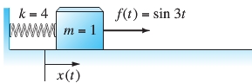















***Exercise***

Solve the system 

Subject to the initial conditions 

Thus the force  is applied to the second mass as shown below, beginning at time  when the system is at rest in its equilibrium position.

***Solution***





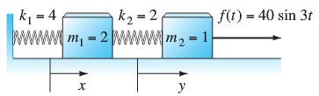***Given***: 

















 





 

|  |  |
| --- | --- |
|  |  |

***Exercise***

Consider a mass-spring system with .

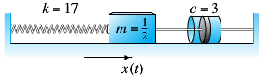

Let  be the displacement of the mass *m* from its equilibrium position. If the mass is set in motion with , find  for the resulting damped free oscillations.

***Solution***

 

 





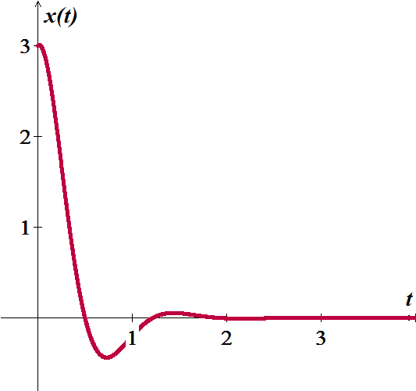















***Exercise***

A  weight stretches a spring 2 *feet*. The weight is released from rest 18 *inches* above the equilibrium position, and the resulting motion takes place in a medium offering a damping force numerically equal to  times the instantaneous velocity. Use the Laplace transform to find the equation of motion .

***Solution***







 



















***Exercise***

Consider a mass-spring-dashpot system with  with initial conditions . Let  be the displacement of the mass *m* from its equilibrium position. Find the resulting transient motion and steady periodic motion of the mass..

***Solution***

 

 



























***Exercise***

A  mass is attached to a spring hanging vertically and come to rest at equilibrium. The damping constant is given by  and the spring constant is . If the mass is driven by an external force equal to . Find the solution.

***Solution***

***Given***: 

 















 







***Exercise***

A  mass is attached to a spring hanging vertically and come to rest at equilibrium. The damping constant is given by  and the spring constant is . At time , the resulting spring-mass system is disturbed from its rest state by the force . (*t* in *seconds*). Find the equation of motion.

***Solution***

 



















***Exercise***

A  mass is attached to a spring having a spring constant of . The mass is started in motion initially from the equilibrium position with an initial velocity  in the upward direction and with an applied external force . If the force due to air resistance is . Find the equation motion of the mass.

***Solution***











 







***Exercise***

A  weight is attached to a spring having a spring constant of . The weight is started in motion initially by displacing it  above the equilibrium position with no initial velocity and with an applied external force . Assume no air resistance. Find the equation motion of the mass.

***Solution***















 





***Exercise***

Find the motion of a damped mass-and-spring system with , , and  under the influence of an external force  with  and .

***Solution***

***Given***: , , , and  ; 

 

















***Exercise***

A spring with a mass of has natural length . A force of  is required to maintain it stretched to a length of . The spring is immersed in a fluid with damping constant . If the spring is started from the equilibrium position and is given a push to start it with initial velocity . Find the position of the mass at any time *t*.

***Solution***

 



















***Exercise***

A spring with a mass of is held stretched  beyond its natural length by a force of . If the spring begins at its equilibrium and with initial velocity . Find the position of the mass.

***Solution***

 

 













***Exercise***

A spring with a mass of  is held stretched , has damping constant 14, and a force of . If the spring is stretched 1 *m* beyond at its equilibrium and with no initial velocity. Find the position of the mass at any time *t*.

***Solution***

 

 

















***Exercise***

When a uniform beam is supported by an elastic foundation, the differential equation for its deflection  is



Where *k* is the modulus of the foundation and  is the restoring force of the foundation that acts in the direction opposite to that of the load . For algebraic convenience, suppose that the differential equation is written as



Where . Assume  and . Find the deflection  of a beam that is supported on an elastic foundation when

1. The beam is simply supported at both ends and a constant load  is uniformly distributed along its length,
2. The bean is embedded at both ends and  is concentrated load applied at 

***Solution***

1. 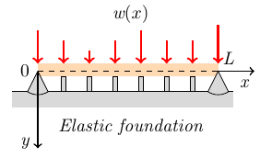

Let: 











 

























1. 













***Exercise***

Suppose two identical pendulums are coupled by means of a spring with constant *k*. when the displacement angles  and  are small, the system of linear differential equations describing the motion is

|  |  |
| --- | --- |
|  |  |

1. Use Laplace transform to solve the system when



Where  and  constants. Let 

1. Use the solution in part (*a*) to discuss the motion of the coupled pendulums in the special case when the initial conditions are 
2. Use the solution in part (*a*) to discuss the motion of the coupled pendulums in the special case when the initial conditions are 

***Solution***

1. 









































1. 



 & 

∴ This means that both pendulums swing in the same direction (free) and the spring exerts no influemce on the motion.

1. 



 & 

∴ This means that both pendulums swing in the opposite directions, stretching and compressing the spring. The amplitude of both displacements is . Which the psring is stretched to its maximum.

***Exercise***

A projectile, such as the canon ball, has weight  and initial velocity  that is tangent to its path of motion.

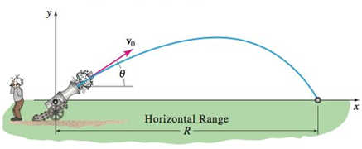

If air resistance and all other forces except its weight are ignored, that motion of the projectile is describe by the system of linear differential equations:



1. Use Laplace transform to solve the system when



Where  is constant and *θ* is the constant angle of elevation.

The solutions  and  are parametric equations of the trajectory of the projectile.

1. Use  in part (*a*) to eliminate the parameter *t* in . Use the resulting equation for *y* to show that the horizontal range *R* of the projectile is given by



1. From the formula in part (*b*), we see that *R* is a maximum when  or when . Show that the same range − less than the maximum− can be obtained by firing the gun at either of two complementary angles *θ* and . The only difference is that the smaller angle results in a low trajectory whereas the larger angle fives a high trajectory.
2. Suppose , , and . Use part (*b*) to find the horizontal range of the projectile.
3. Find the time when the projectile hits the ground.
4. Use the parametric equations  and in part (*a*) along with the numerical data in part (*d*) to plot the ballistic curve of the projectile.
5. Repeat with  and .
6. Superimpose both curves part (*f*) & (*g*) on the same coordinate system.

***Solution***

1. 



|  |  |
| --- | --- |
|  |  |

1. 









At , the projectile hits the ground.





1.  





1. ***Given***: , , and 



1. 



1. 



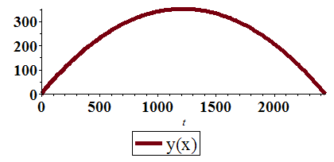

1. ***Given***: , , and 



1. 



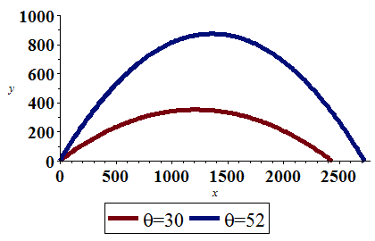

***Exercise***

Derive the system of differential equations describing the straight-line vertical motion of the coupled springs. Use the Laplace transform to solve the system when

 and 

***Solution***

 

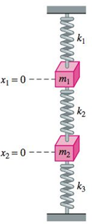





















***Solution Section* 2.11 – Piecewise Continuous with Nonhomogeneous Terms**

***Exercise***

Find the inverse Laplace transform  of each function given 

***Solution***



 





***Exercise***

Find the inverse Laplace transform  of each function given 

***Solution***



 





***Exercise***

Find the inverse Laplace transform  of each function given 

***Solution***



 







***Exercise***

Find the inverse Laplace transform  of each function given 

***Solution***



 





 

***Exercise***

Find the inverse Laplace transform  of each function given 

***Solution***



 









***Exercise***

Find the inverse Laplace transform  of each function given 

***Solution***



 







***Exercise***

Find the inverse Laplace transform  of each function given 

***Solution***



 











***Exercise***

Find the Laplace transforms of the given functions 

***Solution***

For 

For , 

 



***Exercise***

Find the Laplace transforms of the given functions 

***Solution***

For 

For 

For , 

 



***Exercise***

Find the Laplace transforms of the given functions 

***Solution***

For 

For 







***Exercise***

Find the Laplace transforms of the given functions 

***Solution***

For 

For 







***Exercise***

Find the Laplace transforms of the given functions 

***Solution***

For 





***Exercise***

Use the Laplace transform method to solve the initial-value problem



***Solution***

























For 







***Exercise***

Use the Laplace transform method to solve the initial-value problem



***Solution***

















 







For 







***Exercise***

The values of mass *m*, spring constant *k*, dashpot resistance *c*, and force  are given for a mass-spring-dashpot system with external forcing function. Solve the initial value problem, and construct the graph position  



***Solution***



The initial value problem is: 









 







***Exercise***

The values of mass *m*, spring constant *k*, dashpot resistance *c*, and force  are given for a mass-spring-dashpot system with external forcing function. Solve the initial value problem, and construct the graph position  



***Solution***



The initial value problem is: 







 











***Exercise***

The values of mass *m*, spring constant *k*, dashpot resistance *c*, and force  are given for a mass-spring-dashpot system with external forcing function. Solve the initial value problem, and construct the graph position  



***Solution***



The initial value problem is: 

















***Exercise***

The values of mass *m*, spring constant *k*, dashpot resistance *c*, and force  are given for a mass-spring-dashpot system with external forcing function. Solve the initial value problem, and construct the graph position  



***Solution***



The initial value problem is: 



















 









