***SOLUTION Section* 4.1 – First-Order Systems**

***Exercise***

Transform the given differential equation or system into an equivalent system of 1st-order differential equation 

***Solution***

Let 

Yield the system 

***Exercise***

Transform the given differential equation or system into an equivalent system of 1st-order differential equation 

***Solution***

Let 

Yield the system 

***Exercise***

Transform the given differential equation or system into an equivalent system of 1st-order differential equation 

***Solution***

Let 

Yield the system 

***Exercise***

Transform the given differential equation or system into an equivalent system of 1st-order differential equation 

***Solution***

Let 

Yield the system 

***Exercise***

Transform the given differential equation or system into an equivalent system of 1st-order differential equation 

***Solution***

Let 

⇒  

***Exercise***

Transform the given differential equation or system into an equivalent system of 1st-order differential equation 

***Solution***

Let 

⇒  

***Exercise***

Transform the given differential equation or system into an equivalent system of 1st-order differential equation 

***Solution***

Let  ⇒ 

***Exercise***

Transform the given differential equation or system into an equivalent system of 1st-order differential equation 

***Solution***

Let  ⇒ 

***Exercise***

Find the general solution 

***Solution***





The eigenvalues are: 

. Given 

∴ General solution: 

***Exercise***

Find the general solution 

***Solution***

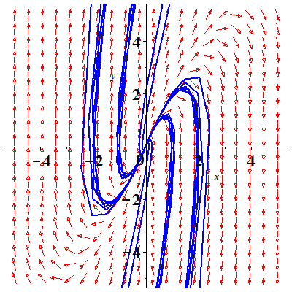





The eigenvalues are: 



Given 

∴ General solution: 

***Exercise***

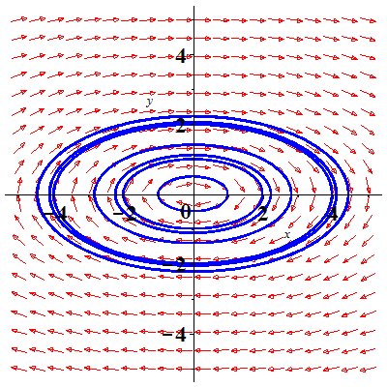Find the general solution 

***Solution***





The eigenvalues are: 

. Given 

∴ General solution: 

***Exercise***

Find the general solution 

***Solution***





The eigenvalues are: 

.

Given  



∴ General solution: 

***Exercise***

Find the general solution 

***Solution***







The eigenvalues are: 



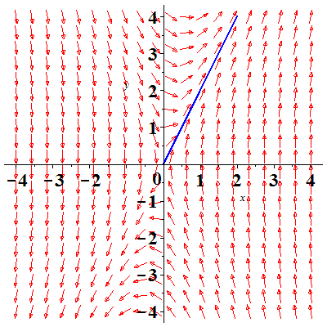



∴ General solution: 

***Exercise***

Find the general solution 

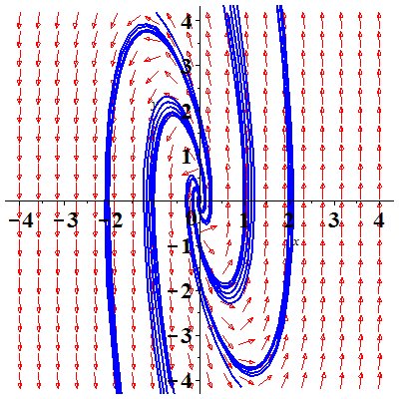***Solution***





The eigenvalues are: 



***Given*** 



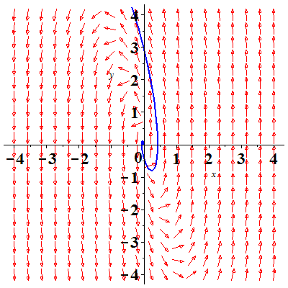



∴ General solution: 

***Exercise***

Derive the equations 

For the displacements (from equilibrium) of the 2 masses.

***Solution***

First spring is stretched by 

Second spring is stretched by 

Third spring is stretched by 

Newton’s second law gives:

For 

For 

That implies to: 

***Exercise***

Two particles each of mass *m* are attached to a string under (constant) tension *T*. Assume that the particles oscillate vertically (that is, parallel to the *y*-axis) with amplitudes so small that the sines of the angles shown are accurately approximated by their tangents. Show that the displacement  and  satisfy the equations



***Solution***

For the first mass:







 



For the second mass:







 





***Exercise***

There 100-gal fermentation vats are connected, and the mixtures in each tank are kept uniform by stirring. Denote by  the amount (in pounds) of alcohol in tank  at time *t* (*i* = 1, 2, 3). Suppose that the mixture circulates between the tanks at the rate of 10 *gal/min*. Derive the equations

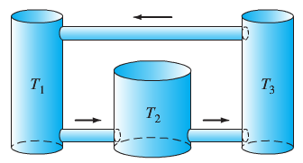

***Solution***

Concentration of salt in each tank is: 

Rate in/out = Volume Rate x Concentration

***Rate of change*** = ***Rate in – rate out***

For : 

For : 

For : 

That implies:



***Exercise***

Suppose that a particle with mass *m* and electrical charge *q* moves in the *xy*-plane under the influence of the magnetic field  (thus a uniform field parallel to the *z*-axis), so the force on the particle is  if its velocity is . Show that the equations of motion of the particle are



***Solution***

Let  be the position vector, then Newton’s law









⇒ 

***SOLUTION Section* 4.2 – Matrices and Linear Systems**

***Exercise***

Write the given system in the form  

***Solution***



***Exercise***

Write the given system in the form  

***Solution***



***Exercise***

Write the given system in the form  

***Solution***



***Exercise***

Write the given system in the form  

***Solution***



***Exercise***

Write the given system in the form  

***Solution***



***Exercise***

Write the given system in the form 



***Solution***



***Exercise***

Write the given system in the form  

***Solution***



***Exercise***

Write the given system in the form 



***Solution***



***Exercise***



1. Verify that the given vectors are solutions of the given system.
2. Use the Wronskian to show that they are linearly independent.
3. Write the general solution of the system.

***Solution***

1.   ***√***

  ***√***

1. 

The solutions  are linearly independent.

1.  

***Exercise***



1. Verify that the given vectors are solutions of the given system.
2. Use the Wronskian to show that they are linearly independent.
3. Write the general solution of the system.
4. Find the particular solution that satisfies the given initial conditions

***Solution***

1.   ***√***

  ***√***

1. 

The solutions  are linearly independent.

1.  
2. 







***Exercise***



1. Verify that the given vectors are solutions of the given system.
2. Use the Wronskian to show that they are linearly independent.
3. Write the general solution of the system.
4. Find the particular solution that satisfies the given initial conditions

***Solution***

1.   ***√***

  ***√***

1. 

The solutions  are linearly independent.

1.  
2. 







***Exercise***



1. Verify that the given vectors are solutions of the given system.
2. Use the Wronskian to show that they are linearly independent.
3. Write the general solution of the system.
4. Find the particular solution that satisfies the given initial conditions

***Solution***

1.   ***√***

  ***√***

1. 

The solutions  are linearly independent.

1. 
2. 

 



***Exercise***



1. Verify that the given vectors are solutions of the given system.
2. Use the Wronskian to show that they are linearly independent.
3. Write the general solution of the system.
4. Find the particular solution that satisfies the given initial conditions

***Solution***

1.   ***√***

  ***√***

  ***√***

1. 

The solutions  are linearly independent.

1. 



1. 

 



***Exercise***



1. Verify that the given vectors are solutions of the given system.
2. Use the Wronskian to show that they are linearly independent.
3. Write the general solution of the system.
4. Find the particular solution that satisfies the given initial conditions

***Solution***

1.   ***√***

  ***√***

  ***√***

1.  The solutions  are linearly independent.
2.  
3. 

 



***Exercise***



1. Verify that the given vectors are solutions of the given system.
2. Use the Wronskian to show that they are linearly independent.
3. Write the general solution of the system.
4. Find the particular solution that satisfies the given initial conditions

***Solution***

1.   ***√***

  ***√***

  ***√***

  ***√***

1. 

The solutions  are linearly independent.

1. 



1. 

 



***SOLUTION Section* 4.3 – Eigenvalue Method for Linear System**

***Exercise***

Find the general solution of the given system. Graph and construct a direction field and typical solution curves for the given system. 

***Solution***



The characteristic equation:





The distinct real eigenvalues: 

For 



 

For 







Using Wronskian: 

The general solution:  ***OR*** 

***Exercise***

Find the general solution of the given system. Graph and construct a direction field and typical solution curves for the given system. 

***Solution***



The characteristic equation:





The distinct real eigenvalues: 

For 





For 

 





The general solution: 

***OR*** 

***Exercise***

Find the general solution of the given system. Graph and construct a direction field and typical solution curves for the given system. 

***Solution***



The characteristic equation:



The distinct real eigenvalues: 

For 

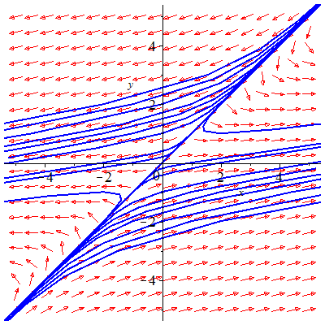 



For 





The general solution: 

***OR*** 

***Exercise***

Find the general solution of the given system. Graph and construct a direction field and typical solution curves for the given system. 

***Solution***



The characteristic equation:



The distinct real eigenvalues: 

For 





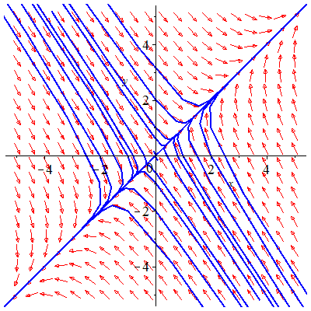For 





The general solution: 



***Exercise***

Find the general solution of the given system. Graph and construct a direction field and typical solution curves for the given system. 

***Solution***



The characteristic equation:



The distinct real eigenvalues: 

For 





 

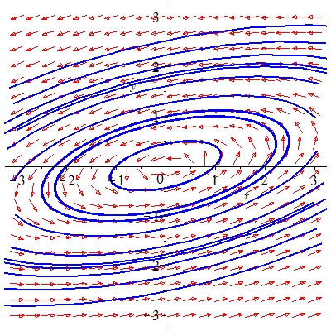 





***Exercise***

Find the general solution of the given system. Graph and construct a direction field and typical solution curves for the given system. 

***Solution***



The characteristic equation:



The distinct real eigenvalues: 

For 





 

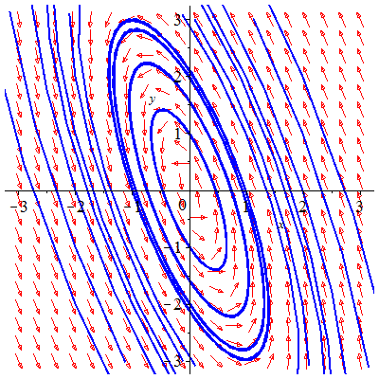 





***Exercise***

Find the general solution of the given system. Graph and construct a direction field and typical solution curves for the given system. 

***Solution***



The characteristic equation:



The distinct real eigenvalues: 

For 

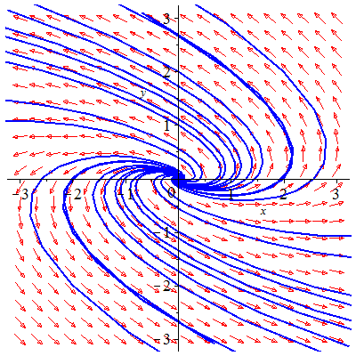 













***Exercise***

Find the general solution of the given system. Graph and construct a direction field and typical solution curves for the given system. 

***Solution***



The characteristic equation:



The distinct real eigenvalues: 

For 

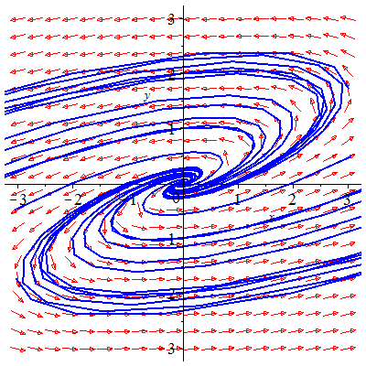 













***Exercise***

Find the general solution of the given system. Graph and construct a direction field and typical solution curves for the given system. 

***Solution***



The characteristic equation:

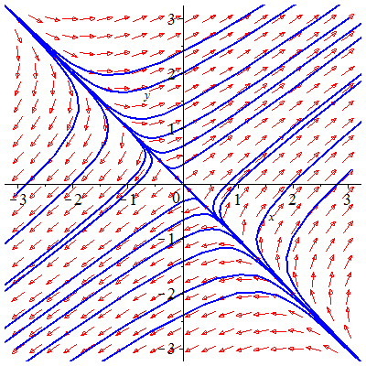 

The distinct real eigenvalues: 

For 





For 





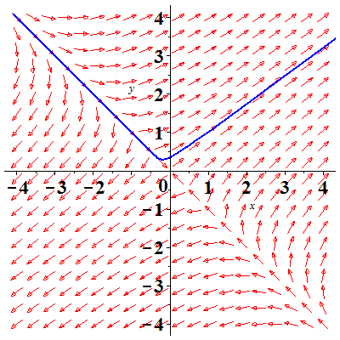The general solution: 



***Given***: 





***Exercise***

Find the general solution of the given system. Graph and construct a direction field and typical solution curves for the given system. 

***Solution***

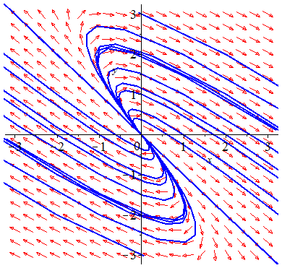

The characteristic equation:



The distinct real eigenvalues: 

For 





For 





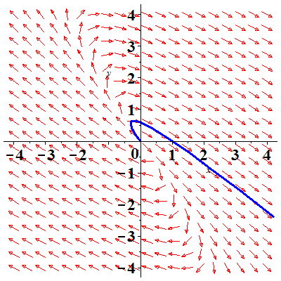The general solution: 



***Given***: 





***Exercise***

Find the general solution of the given system. Graph and construct a direction field and typical solution curves for the given system. 

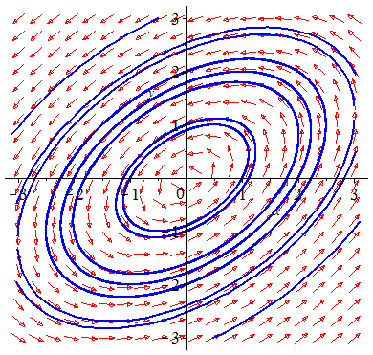***Solution***



The characteristic equation:



The distinct real eigenvalues: 

For 





 



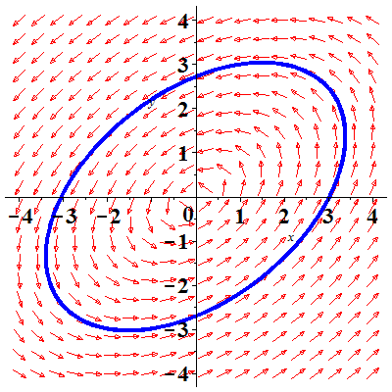 



***Given***: 







***Exercise***

Find the general solution of the given system. Graph and construct a direction field and typical solution curves for the given system. 

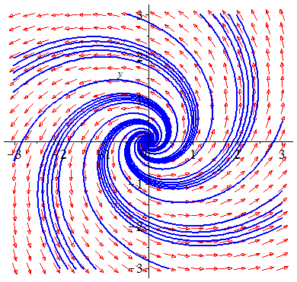***Solution***



The characteristic equation:



The distinct real eigenvalues: 

For 





 



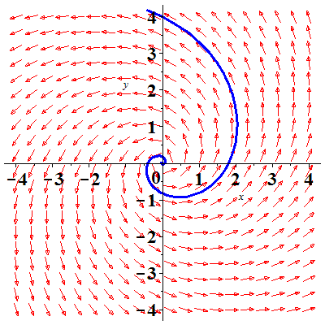 



***Given***: 





***Exercise***

Find the general solution of the given system.



***Solution***



The characteristic equation:







The distinct real eigenvalues: 

For 



Let  

For 

 

For 

 





***Exercise***

Find the general solution of the given system. 

***Solution***



The characteristic equation:







The distinct real eigenvalues: 

For 

 

For 

 

For 

 





***Exercise***

Find the general solution of the given system.



***Solution***



The characteristic equation:







The distinct real eigenvalues: 

For 

  

For 

 





***Exercise***

Find the general solution of the given system.



***Solution***



The characteristic equation:







The distinct real eigenvalues: 

For 

 

For 

 

For 

 





***Exercise***

Find the general solution of the given system.



***Solution***



The characteristic equation:







The distinct real eigenvalues: 

For 

 

For 

 

For 

 





***Exercise***

Find the general solution of the given system.



***Solution***



The characteristic equation:







The distinct real eigenvalues: 

For 

 

For 

 

For 

 





***Exercise***

Find the amount  of salt in each tank at time , with . If

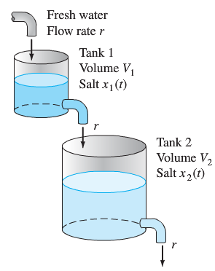

***Solution***

 where 

 





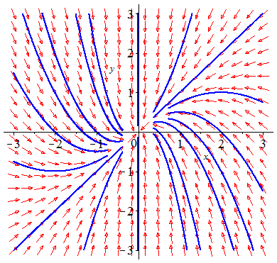The eigenvalues are: 

For 



For 





The general solution:





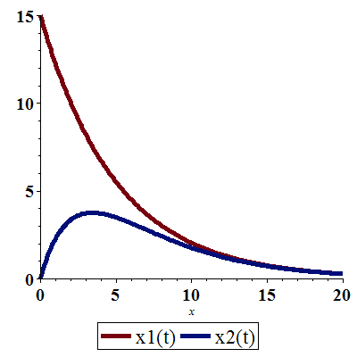

***Tank*** **2**: 









The maximum values of salt in tank 2 is:





There is no maximum values of salt in tank 1.



***Exercise***

Find the amount  of salt in each tank at time , with . If



***Solution***

 where 

 





The eigenvalues are: 

For 

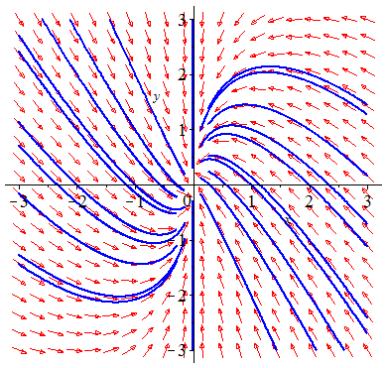

For 





The general solution:







There is no maximum values of salt in tank 1.



***Tank*** **2**: 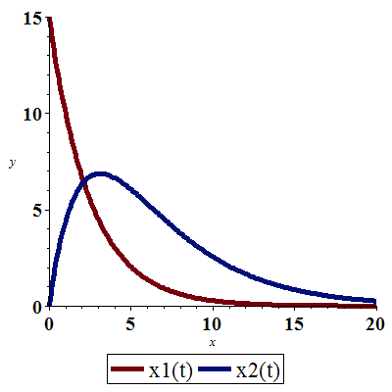











The maximum values of salt in tank 2 is:





***Exercise***

Find the amount  of salt in each tank at time , with . If



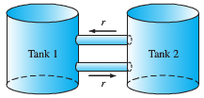***Solution***

 where 

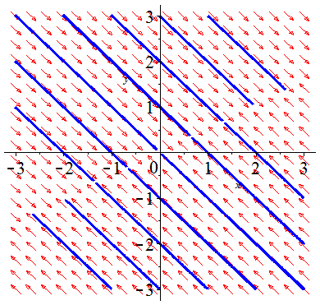 









The eigenvalues are: 

For 



For 





The general solution:







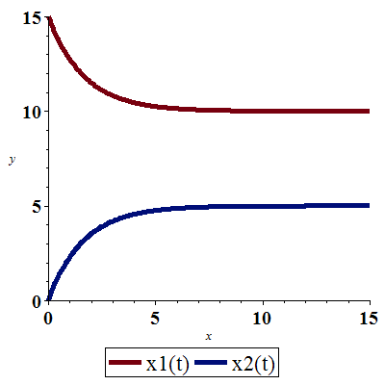

***Exercise***

Find the amount  of salt in each tank at time , with . If



***Solution***

 where 

 









The eigenvalues are: 

For 



For 



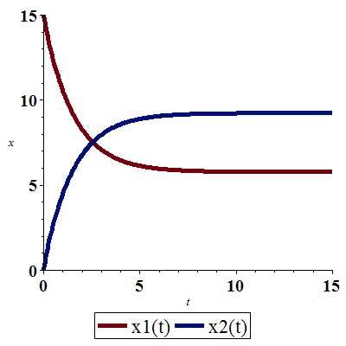

The general solution: 





***Exercise***

Find the amount  of salt in each tank at time , if

 

***Solution***

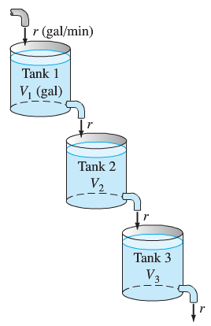 where 







 

The eigenvalues are: 

For 

 

For 

 

For 

 





With *initial* values



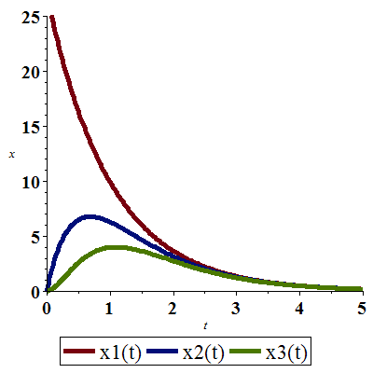

***Tank*** **2**: 





The maximum values of salt in tank 2 is:





***Tank*** **3**: 





The maximum values of salt in tank 3 is:





***Exercise***

Find the amount  of salt in each tank at time , if

 

***Solution***

 where 







 

The eigenvalues are: 

For 

 

For 

 

For 

 





With *initial* values



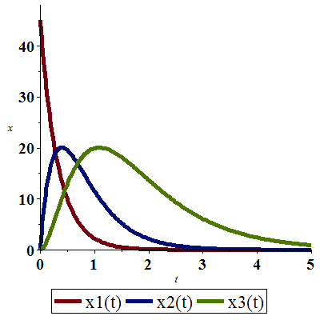

***Tank*** **2**: 





The maximum values of salt in tank 2 is:





***Tank*** **3**: 





The maximum values of salt in tank 3 is:





***Exercise***

Find the amount  of salt in each tank at time , if

 

***Solution***

 where 







 

The eigenvalues are: 

For 

 

For 

 

For 

 





With *initial* values



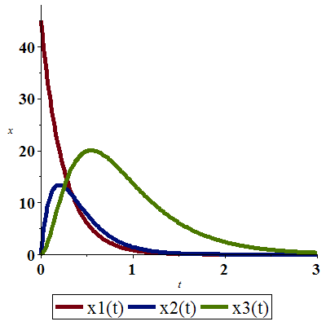

***Tank*** **2**: 





The maximum values of salt in tank 2 is:





***Tank*** **3**: 





The maximum values of salt in tank 3 is:





***SOLUTION Section* 4.4 – Second-Order System & Mechanical Applications**

***Exercise***

Consider the mass-and-spring system shown below and with the given masses and spring constants values.



Find the 2 natural frequencies of the system and describe its natural modes of oscillation.



***Solution***











The eigenvalues are: 

The natural frequencies: 

For 

 

For 

 



In the degenerate natural mode with frequency  the 2 masses move by translation without oscillating. At frequency  they oscillate in opposite directions with equal amplitudes.

***Exercise***

Consider the mass-and-spring system shown below and with the given masses and spring constants values.



Find the 2 natural frequencies of the system and describe its natural modes of oscillation.



***Solution***











The eigenvalues are: 

The natural frequencies: 

For 

 

For 

 



In the degenerate natural mode with frequency  the 2 masses move in the same direction with equal amplitudes of oscillation. At frequency  they oscillate in opposite directions with equal amplitudes.

***Exercise***

Consider the mass-and-spring system shown below and with the given masses and spring constants values.



Find the 2 natural frequencies of the system and describe its natural modes of oscillation.



***Solution***











The eigenvalues are: 

The natural frequencies: 

For 

 

For 

 



In the degenerate natural mode with frequency  the 2 masses move in the same direction with equal amplitudes of oscillation. At frequency  they oscillate in opposite directions with equal amplitudes.

***Exercise***

Consider the mass-and-spring system shown below and with the given masses and spring constants values.



Find the 2 natural frequencies of the system and describe its natural modes of oscillation.



***Solution***











The eigenvalues are: 

The natural frequencies: 

For 

 

For 

 



In the degenerate natural mode with frequency  the 2 masses move in the same direction with equal amplitudes of oscillation. At frequency  they oscillate in opposite directions with amplitude of oscillation of  twice that of .

***Exercise***

Consider the mass-and-spring system shown below and with the given masses and spring constants values.



The mass-and-spring system is set in motion from rest  in its equilibrium position .

Find the 2 natural frequencies of the system and describe its natural modes of oscillation.

For the given external forces  and  acting on the masses  and , respectively.

Find the resulting motion of the system and describe it as a superposition of oscillations at three different frequencies.



***Solution***











The eigenvalues are: 

The natural frequencies: 

For 

 

For 

 

















 





***Given*** initial values:  and .

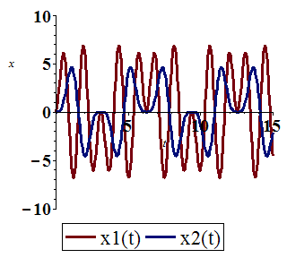





At frequency  the 2 masses move in the same direction with equal amplitudes of oscillation.

At frequency  the 2 masses move in the opposite direction with equal amplitudes of oscillation.

At frequency  they oscillate in opposite directions with amplitude of oscillation of **5** times that of .

***Exercise***

Consider the mass-and-spring system shown below and with the given masses and spring constants values.



The mass-and-spring system is set in motion from rest  in its equilibrium position .

Find the 2 natural frequencies of the system and describe its natural modes of oscillation.

For the given external forces  and  acting on the masses  and , respectively.

Find the resulting motion of the system and describe it as a superposition of oscillations at three different frequencies.



***Solution***



 







The eigenvalues are: 

The natural frequencies: 

For 

 

For 

 

















***Given*** initial values:  and .

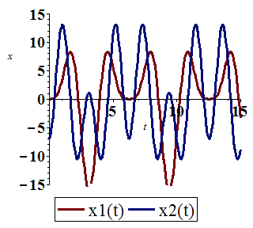





At frequency  the 2 masses oscillate in the same direction with equal amplitudes.

At frequency  the 2 masses oscillate in opposite directions with equal amplitudes of ***twice*** that of .

At frequency  they oscillate in opposite directions with amplitude of oscillation of **3** times that of .

***Exercise***

Consider the mass-and-spring system shown below and with the given masses and spring constants values.



The mass-and-spring system is set in motion from rest  in its equilibrium position .

Find the 2 natural frequencies of the system and describe its natural modes of oscillation.

For the given external forces  and  acting on the masses  and , respectively.

Find the resulting motion of the system and describe it as a superposition of oscillations at three different frequencies.



***Solution***











The eigenvalues are: 

The natural frequencies: 

For 

 

For 





















***Given*** initial values:  and .

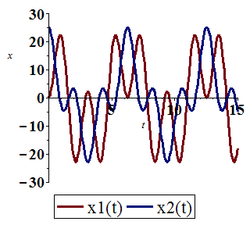





At frequency  the 2 masses oscillate in the same direction of ***twice*** that of .

At frequency  the 2 masses oscillate in opposite directions with equal amplitudes of **3** *times* that of .

At frequency  they oscillate in the same direction with equal amplitudes of oscillation.

***Exercise***

Consider a mass-and-spring system containing two masses  whose displacement functions  and  satisfy the differential equations



1. Describe the two fundamental modes of free oscillation of the system.
2. Assume that the two masses start in motion with the initial conditions



And are acted on by the same force, . Describe the resulting motion as a superposition of oscillations at three different frequencies.

***Solution***

1. 







The eigenvalues are: 

The natural frequencies: 

For 

 

For 

 



In mode 1: At frequency  the 2 masses oscillate in the same direction of ***twice*** of .

In mode 2: At frequency  the 2 masses oscillate in opposite directions of oscillation of **3 *times*** that of .

1. ***Given***  and 



















 

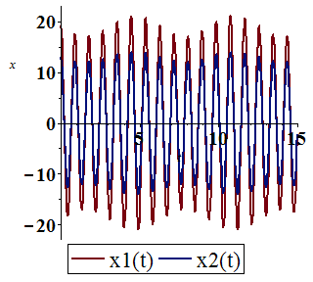

 



At frequency  the 2 masses oscillate in the same direction with amplitude of motion of ***twice*** that of .

At frequency  the 2 masses oscillate in the same direction with amplitude of motion of being  *times* that of .

At frequency the expected oscillation is missing.

***Exercise***

Consider a mass-and-spring system shown below. Assume that  in mks units, and that . Then find  so that in the resulting steady periodic oscillations, the mass will remain at rest (!).



Thus the effect of the second mass-and-spring pair will be to neutralize the effect of the force on the first mass. This is an example of a dynamic damper. It has an electrical analogy that some cable companies use to prevent your reception of certain cable channels.

***Solution***















 









 

Since , so the mass  remains at rest.

***Exercise***

Consider a mass-and-spring system shown below. Assume that

 (in mks units).



Find the solution of the system  that satisfies the initial conditions 

***Solution***



 







The eigenvalues are: 

The natural frequencies: 

For 

 

For 

 

























At frequency  the 2 masses oscillate in the same direction with amplitude of motion of  ***half***  that of .

At frequency  the 2 masses oscillate in opposite directions with amplitude of motion of being ***half***  that of .

At frequency  the 2 masses oscillate in opposite directions with equal amplitudes.

***Exercise***

A car with two axles and with separate front and rear suspension systems.

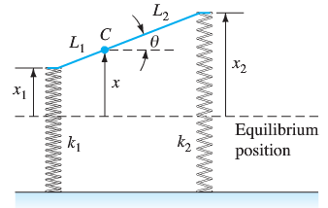

We assume that the car body acts as would a solid bar of mass *m* and length . It has moment of inertia I about its center of mass *C*, which is at distance  from the front of the car. The car has front and back suspension springs with Hooke’s constants  and , respectively. When the car is in motion, let  denote the vertical displacement of the center of mass of the car from equilibrium; let  denote its angular displacement (in radians) from the horizontal. Then Newton’s laws of motion for linear and angular acceleration can be used to derive the equations.



Suppose that  (the car weighs 2400 *lb*),  (it’s a rear engine car), , and .

1. Find the two natural frequencies  and of the car.
2. Now suppose that the car is driven at a speed of  along a washboard surface shaped like a sine curve with a wavelength of 40 *ft*. The result is a periodic force on the car with frequency . Resonance occurs when . Find the corresponding two critical speeds of the car (in *ft/sec*)

***Solution***

1. 

 







The eigenvalues are: 

The natural frequencies: 



1. 

 

 

***Exercise***

The system is taken as a model for an undamped car with the given parameters in *fps* units.



1. Find the two natural frequencies  and of the car (in hertz).
2. Assume that his car is driven along a sinusoidal washboard surface with a wavelength of 40 *ft*. The result is a periodic force on the car with frequency . Resonance occurs when . Find the corresponding two critical speeds of the car (in *ft/sec*)

***Solution***

1.  

 

 

The eigenvalues are: 

The natural frequencies: 



1.  

 

***Exercise***

The system is taken as a model for an undamped car with the given parameters in *fps* units.



1. Find the two natural frequencies  and of the car (in hertz).
2. Assume that his car is driven along a sinusoidal washboard surface with a wavelength of 40 *ft*. The result is a periodic force on the car with frequency . Resonance occurs when . Find the corresponding two critical speeds of the car (in *ft/sec*)

***Solution***

1.  

 





 

The eigenvalues are: 

The natural frequencies: 



1. 



***Exercise***

The system is taken as a model for an undamped car with the given parameters in *fps* units.



1. Find the two natural frequencies  and of the car (in hertz).
2. Assume that his car is driven along a sinusoidal washboard surface with a wavelength of 40 *ft*. The result is a periodic force on the car with frequency . Resonance occurs when . Find the corresponding two critical speeds of the car (in *ft/sec*)

***Solution***

1.  

 





 

The eigenvalues are: 

The natural frequencies: 



1. 



***SOLUTION Section* 4.5 – Multiple Eigenvalues Solutions**

***Exercise***

Find the general solution 

***Solution***

 The eigenvalues are: 



 and is a nonzero vector, we can let 

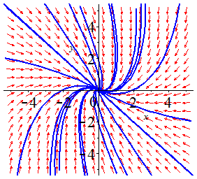





The general solution: 



***Exercise***

Find the general solution 

***Solution***

 The eigenvalues are: 



 and is a nonzero vector, we can let 

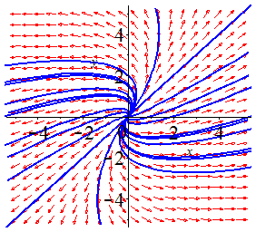





The general solution: 



***Exercise***

Find the general solution 

***Solution***

 The eigenvalues are: 



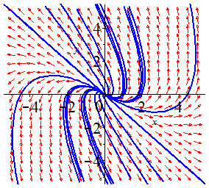 and is a nonzero vector, we can let 







The general solution: 



***Exercise***

Find the general solution 

***Solution***

 The eigenvalues are: 



 and is a nonzero vector, we can let 

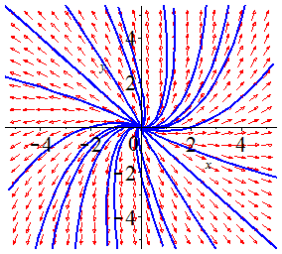





The general solution: 



***Exercise***

Find the general solution 

***Solution***



The eigenvalues are: 

For 

 

For 



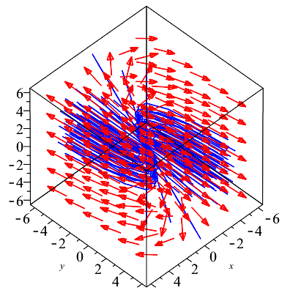Let  

Let  

The general solution: 



***Exercise***

Find the general solution 

***Solution***









The eigenvalues are: 

For 

 



For 



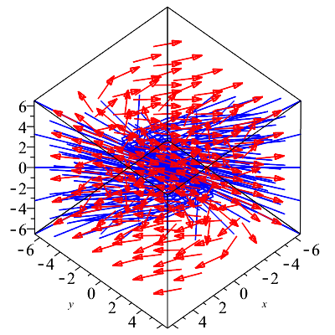Let  

Let  

The general solution: 



***Exercise***

Find the general solution 

***Solution***







The eigenvalues are: 

For 

 

The defect of  is 2.



, therefore any nonzero vector  will be a solution







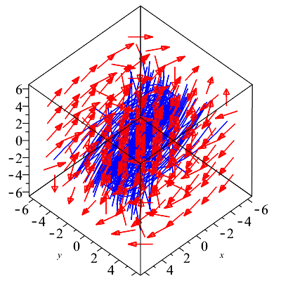The general solution:





***Exercise***

Find the general solution 

***Solution***







The eigenvalues are: . The defect of  is 2.



 

 Contradict the rule . Then, let assume 

 

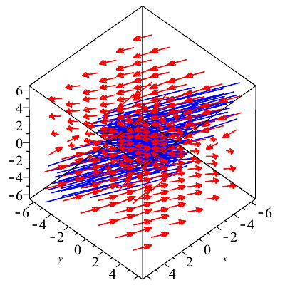

The general solution:  

***Exercise***

Find the general solution 

***Solution***



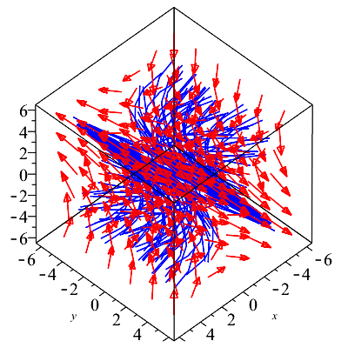 





The eigenvalues are: 

The defect of  is 2.



 

 



The general solution:

 

***Exercise***

Find the general solution 

***Solution***



The eigenvalues are: 

For 

  

For 

 

Let  

Let  

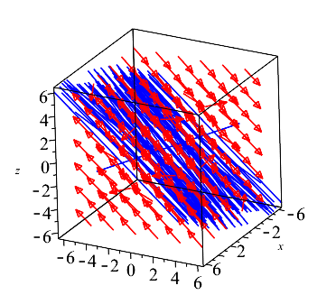The general solution: 



***Exercise***

Find the general solution 

***Solution***



The eigenvalues are:  and defect 3.





 







The general solution:







***Exercise***

Find the general solution 

***Solution***



The eigenvalues are:  and defect 2.



 



 

The general solution:







***Exercise***

The characteristic equation of the coefficient matrix ***A*** of the system

 is 

Therefore, ***A*** has the repeated complex pair  of eigenvalues. First show that the complex vectors  form a length 2 chain  associated with the eigenvalue . Then calculate the real and imaginary parts of the complex-valued solutions



To find four independent real-valued solutions of 

***Solution***

For 









⇒ 

 





The general solution:



