Math 1324 - Finite ***Exam* 1 *Review***

*Instructor*: Fred Khoury

1. Consider the following linear programming problem.
2. Find the feasible region by graphing and determine if it is bounded or not
3. Find all intersection points of lines in the graph, whether the points are in the feasible region or not
4. Determine the corner points
5. Find the maximum value of P
6. 



1. 



1. *Maximize:* P = 2x + 5y



1. *Maximize:* 



1. **



1. Consider the following tableau:

  

* 1. Which row is the pivot row?
  2. Which column is the pivot column?
  3. Take the tableau through one full pivot.

1. A contractor is planning to build a new housing development consisting of colonial, split-level, and ranch-style houses. A colonial home requires 0.5 acre of land, $60,000 capital, and 4000 labor hours to construct, and returns an estimated profit of $20,000. A split-level home requires 0.5 acre of land, $60,000 capital, and 3000 labor hours to construct, and returns an estimated profit of $18,000. A ranch-style home requires 1acre of land, $80,000 capital, and 4000 labor hours to construct, and returns an estimated profit of $24,000. There are only 30 acres of land, $3,200,000 in capital, and 180,000 labor hours available. How many homes of each type should be built to maximize profit? What is the maximum profit?
2. Farmer Phil has 640 acres to plant in corn and soybeans. Each acre of corn requires 45 labor-hours and each acre costs $100 in seed and fertilizer. Each acre of soybeans requires 60 labor hours and each acre costs $80 in seed and fertilizer. Phil estimates that he has 36,000 hours of labor and $60,000 capital to spend. Farmer Phil estimates that each acre planted in corn will yield a profit of $120 and each acre planted in soybeans will yield a profit of $100. Under these conditions, how many acres of corn and how many acres of soybeans should Farmer Phil plant to maximize his profit?
3. A dietician needs to plan a diet for a patient using two different food combinations to meet the patient’s needs. Each container of Food A contains 1 unit of Additive #1 and 1 unit of Additive #2. Each container of Food B contains 1 unit of Additive #1 and 2 units of Additive #2. The patient needs **at most** 5 units of Additive #1 and **at most** 6 units of Additive #2. If each container of Food A has 6 units of calcium and Food B has 4 units of calcium, how many containers of each food should be used to maximize the amount of calcium?
4. A political scientist has received a grant to find a research project involving voting trends. The budget of the grant includes $3,200 for conducting door-to-door interviews the day before an election. Undergraduate students, graduate students, and faculty members will be hired to conduct the interviews. Each undergraduate student will conduct 18 interviews and be paid $100. Each graduate student will conduct 25 interviews and be paid $150. Each faculty members will conduct 30 interviews and be paid $200. Due to limited transportation facilities, no more than 20 interviews can be hired. How many undergraduate students, graduate students, and faculty members should be hired in order to maximize the number of interviews that will be conducted? What is the maximum number of interviews?
5. An ad agency is developing an ad campaign for a client using radio and TV advertising. Each minute of TV ads reaches 100,000 people and each minute of radio ads reaches 45,000 people. The client must reach at least 1,500,000 people and the contract calls for a total of at least 30 minutes of ads. If each minute of TV ads cost $500 and each minute of radio ads costs $60, find the number of minutes of each kind of advertising should be purchased to minimize costs.
6. Set up the original problem.
7. Find the dual problem.
8. What is the minimum cost?
9. A company hires a lazy, but effective, salesperson on the understanding the he will contact at least 100 potential customers a week, by means of personal visits, telephone calls, or personalized letters; that at least ten of the contacts will be by personal visit, and that at least 30 customers will be spoken to each week, either in person or over the telephone. The salesperson decides that he will have to make at least fifteen sales a week in order to support himself from commissions. His experience ids that, in general, he can make one sale from two personal visits, from ten telephone calls,, or from twenty letters. He estimates that it takes him 1 hour to make a personal visit, 15 minutes for a telephone call, and 6 minutes to dictate a letter.

*a*) Set up the original problem.

*b*) Find the dual problem.

*c*) Setup the initial tableau

1. Suppose a horse feed to be mixed from soybean meal and oats must contain at least 200 lb of protein and 40 lb of fat. Each sack of soybean meal costs $20 and contains 60 lb of protein and 10 lb of fat. Each sack of oats costs $10 and contains 20 lb of protein and 5 lb of fat.

*a*) Set up the original problem.

*b*) Find the dual problem.

*c*) What is the minimum cost?

1. A dietician in a hospital is to arrange a special diet using three foods, L, M, N. Each ounce of food L contains 20 units of calcium, 10 units of iron, 10 units of vitamin A, and 20 units of cholesterol. Each ounce of food M contains 10 units of calcium, 10 units of iron, 15 units of vitamin A, and 24 units of cholesterol. Each ounce of food N contains 10 units of calcium, 10 units of iron, 10 units of vitamin A, and 18 units of cholesterol. If the minimum daily requirements are 300 units of calcium, 200 units of iron, 240 units of vitamin A.
2. Set up the original problem.
3. Find the dual problem.
4. What is the minimum cost?
5. A farmer can buy three types of plant food, mix A, mix B, and mix C. Each cubic yard of mix A contains 20 pounds of phosphoric acid, 10 pounds of nitrogen, and 10 pound of potash. Each cubic yard of mix B contains 10 pounds of phosphoric acid, 10 pounds of nitrogen, and 15 pound of potash. . Each cubic yard of mix C contains 20 pounds of phosphoric acid, 20 pounds of nitrogen, and 5 pound of potash. The minimum monthly requirements are 480 pounds of phosphoric acid, 320 pounds of nitrogen, and 225 pound of potash. If mix A costs $30 per cubic yard, nix B costs $36 per cubic yard, and mix C $39 per cubic yard.
6. Set up the original problem.
7. Find the dual problem.
8. Setup the initial tableau
9. Acme Micros markets computers with single-sided and double-sided drives. The disk driers are supplied by two other companies. Associated Electronics and Digital Drives Associated Electronics charges 250 for a single-sided disk drive and $350 for a double-sided disk drive. Digital Drives charges 290 for a single-sided disk drive and $320 for a double-sided disk drive. Associated Electronics can supply at most 1,000 disk drives in any combination of single-sided and double-sided drives. The combined monthly total supplied by Digital Drives cannot exceed 2,000 disk drives. Acme Micros needs at least 1,200 single-sided drives and at least 1,600 double-sided drives each month.
   1. Set up the original problem.
   2. Find the dual problem.
   3. Setup the initial tableau
10. An investor is considering three types of investments: a high-risk venture into oil leases with a potential return of 15%, a medium-risk investment in stocks with a 9% return, and a relatively safe bond investment with 5% return. He has $50,000 to invest. Because of the risk, he will limit his investment in oil leases and stocks to 30% and his investment in oil leases and bonds to 50%. Set up the original problem.
11. The Aged Wood Winery makes two white wines, Fruity and Crystal, from two kinds of grapes and sugar. One gallon of Fruity wines requires 3 bushels of Grape A, 2 bushels of Grape B, 2 lb. of sugar, and produces a profit of $12. One gallon of Crystal wines requires 1 bushel of Grape A, 3 bushels of Grape B, 1 lb. of sugar, and produces a profit of $15. The winery has available 110 bushels of grape A, 125 bushels of grape B, and 90 lb of sugar. Set up the original problem to maximize profit?
12. A company produces canned whole tomatoes and tomato sauce. This season, the company has available 3,000,000 kg of tomatoes for these two products. To meet the demands of regular customers, it must produce at least 80,000 kg of sauce and 800,000 kg of whole tomatoes. The cost per kilogram is $4 to produce canned whole tomatoes and $3.25 to produce tomato sauce. Labor agreements require that at least 110,000 person-hours be used. Each Kilogram can of sauce requires 3 minutes for one worker, and each kilogram can of whole tomatoes requires 6 minutes for one worker. How many kilograms of tomato should use for each product to minimize cost?
13. Your exercise regimen includes doing tai chi, riding a unicycle, and fencing. She has at most 10 hours per week to devote to these activities, Your fencing partner can work with you at most only 2 hours per week, You want the total time you do tai chi to be at least twice as long as you unicycle. According to a website a 130-pound person like you will burn an average of 236 calories per hour doing tai chi, 295 calories per hour riding a unicycle, and 354 calories per hour fencing. How many hours per week should you spend on each activity to maximize the number of calories you burn? What is the maximum number of calories you will burn?
14. For the next following problems:

*a)* Form the matrix A, using the coefficients and constants in the problem constraints and objective function.

*b)*  Find AT.

*c)* State the dual problem.

*d)* Use the simplex method to solve the dual problem.

*e)* Read the solution of the minimization problem from the bottom row of the final simplex tableau.

1. 



1. 



III. 



VI. 



***Solution***

1. 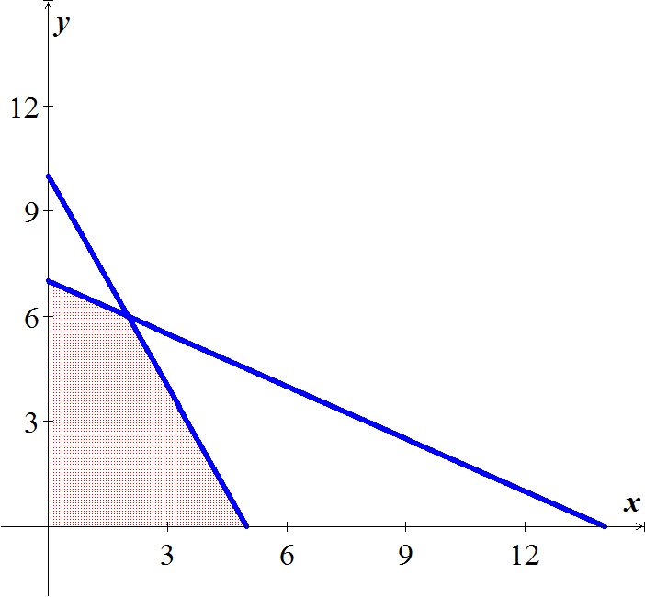Consider the following linear programming problem
2. ***a***) Bounded

***b***) (0, 0), (5, 0), (14, 0), (0, 7), (0, 10), (2, 6)

***c***) Corner points: (0, 0), (5, 0), (0, 7), (2, 6)

***d***) 

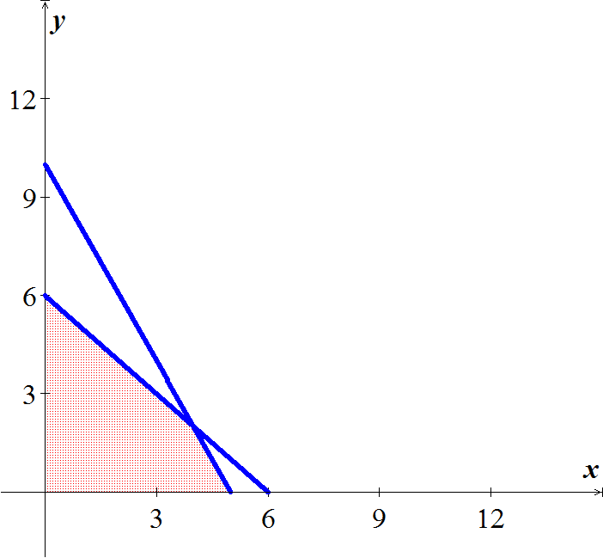

1. Bounded
2. (0, 0), (3, 0), (6, 0), (0, 6), (0, 9) & (1.5, 4.5)
3. Corner points: (0, 0), (3, 0), (0, 6), & (1.5, 4.5)
4. 
5. 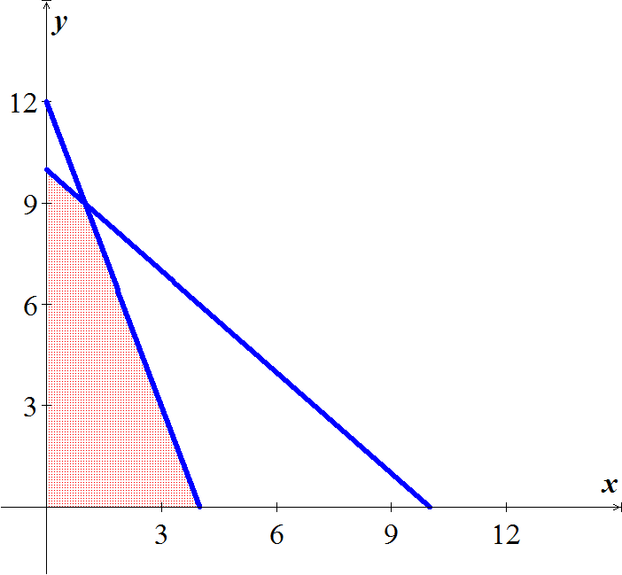
6. Bounded
7. (0, 0), (0, 10), (0, 12), (20, 0), (8, 0), (2, 9), (6, 7), and (6, 3)
8. Corner points (2, 9), (6, 7), and (6, 3)
9. Maximum = 49 @ (2, 9)
10. 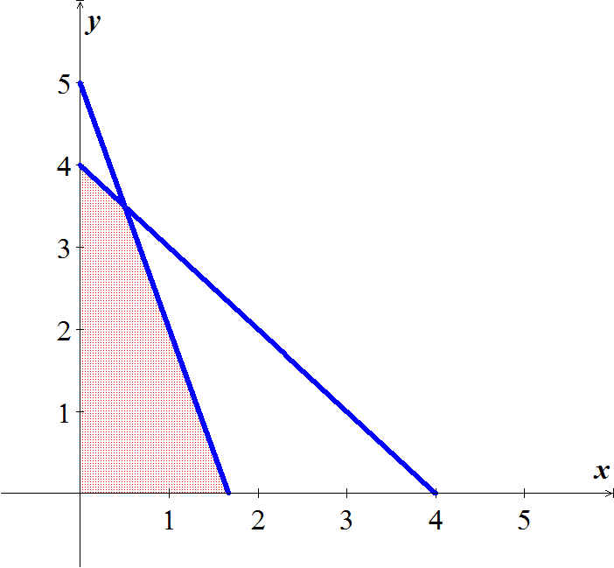
11. Bounded
12. (0, 0), (0, 5), (0, 4), (3, 0), (4, 0), & (1.5, 2.5)
13. Corner points: (0, 0), (3, 0), (0, 4), & (1.5, 2.5)
14. *P* has a maximum value of 430 at 
15. 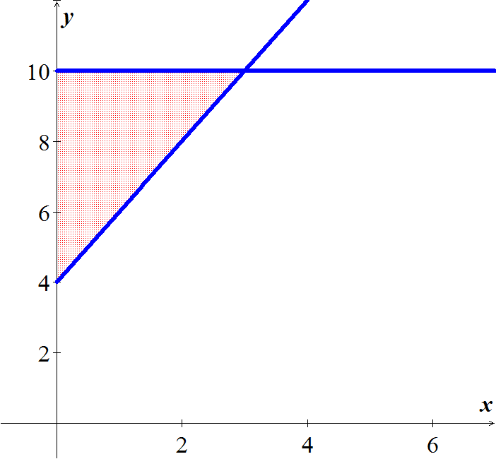
16. Unbounded
17. (0, 0), (3, 10), (0, 4)
18. Corner points: (3, 10), (0, 4)
19. no Solution
20. *i*) ***a***) Row 1 ***b***) Column 1

c) 

*ii*) ***a***) Row 1 ***b***) Column 2

 

*iii*) ***a***) Row 1 ***b***) Column 1



1. 



Initial Tableau



Use the simplex method to solve: 

1. To maximize his profit at $72,800, Farmer Phil should plant 440 acres in corn and 200 acres in soybeans.
2. To maximize the amount of calcium at 30 units, the dietician should use 5 containers of Food A and 0 container of Food B.
3. 

 

*⇒ The maximum number of interviews is* 520 *when x*1 = 0 *undergraduates, x*2 = 16 *graduates, and x*3 = 4 *faculty members are hired.*

1. *a*) 



*b*)  



⇒ Minimum Cost 

1. 





Salesperson should make: 

For a minimal investment of 

1. *a)*



b)  

c) 



 



1. 



*b*)  

*c*) 



 

The minimal cholesterol is 428 units:



1. : the number of cubic yards of mix A

: the number of cubic yards of mix B

: the number of cubic yards of mix C

1. 



1.  





1. 

 Blend A: 16 yd3; B = 2 yd3; and C = 7 yd3 with min C = $825

1. 

 





1. Let : Amount invested in oil leases

: Amount invested in bonds

: Amount invested in stock



1. Let : Number of gallons of fruity wine

: Number of gallons of crystal wine



1. Let : Number of kg of canned whole tomatoes

: Number of kg of tomato sauce produced



1. Let : Number of hours doing tai chi

: Number of hours riding a unicycle

: Number of hours fencing



The initial simplex tableau is as follows:

 

You will burn a maximum of  calories if you do  hours of tai chi,  hours riding a unicycle, and 2 hours fencing.

1. *a)* 

*b)* 

*c)* 



*d*)  

e) *C* has a minimum value of 140 @ (7, 0)

1. *a*) 

*b*) 

*c*) 



*d*)  

 

*e*) *C* has a minimum value of 900 @ (6, 1)

1. *a*) 

*b*) 

*c*) 



*d*) 

*e*) *C* has a minimum value of 628.6 @ (2.9, 14.3)

1. *a*) 

*b*) 

*c*) 



*d*) 

*e*) The problem hasno solution (unbounded)