***Solution*** ***Section* 1.1 – System of Equations**

***Exercise***

Solve the system



***Solution***

 

 



 



Solution (2, −1, 1)

***Exercise***

Solve the system: 

***Solution***

  

 

  



  

 ***Solution***: (1, −1, 0)

***Exercise***

Solve the system: 

***Solution***

  



  



  

 ***Solution***: (2, 0, −1)

***Exercise***

Katherine invests $10,000 received from her grandmother in three ways. With one part, she buys U.S saving bonds at an interest rate of 2.5% per year. She uses the second part, which amounts to twice the first, to buy mutual funds that offer a return of 6% per year. She puts the rest of the money into a money market account paying 4.5% annual interest. The first year her investments bring a return of $470. How much did she invest in each way?

***Solution***

*x* = amount invested in savings bonds (2.5 %)

*y* = amount invested in mutual bonds (6 %)

*z* = amount invested in money market (4.5%)

She invested $10,000



She invested twice as much in mutual as in savings



Total return $470.





Solution: 

$2,000 invested in savings bonds

$4,000 invested in mutual bonds

$4,000 invested in money market

***Exercise***

A Company that rents small moving trucks wants to purchase 25 trucks with a combined capacity of 28,000 cubic ft. Three different types of trucks are available: a 10-foot truck with a capacity of 350 cubic feet, a 14-foot truck with a capacity of 700 cubic feet, and a 24-foot truck with a capacity of 1,400 cubic feet. How many truck of each type of truck should the company purchase?

***Solution***

  

















***All possibilities***:

|  |  |  |
| --- | --- | --- |
| **: *24 ft*** | **: *10 ft*** | **: *14 ft*** |
| 15 | 0 | 10 |
| 16 | 2 | 7 |
| 17 | 4 | 4 |
| 18 | 6 | 1 |

***Exercise***

A flight leaves New York at 8 PM and arrives in Paris at 9 AM (Paris time). This 13-hour difference includes the flight time plus the change in time zones. The return leaves Paris at 1 PM and arrives in New York at 3 PM (NY time). This 2-hour difference includes the flight time minus time zones, plus an extra hour due to the fact that flying westward is against the wind. Find the actual flight time eastward and the difference in time zones.

***Solution***

Let: *x*: flight time

*y*: difference in time zones

13*-hour includes the flight time plus the change in time zones*



2-*hour difference includes the flight time minus time zones, plus an extra hour*





 

The flight eastward is 7 hours.

The difference in time zones is 6 hours.

***Exercise***



***Solution***



***Exercise***



***Solution***





***Exercise***



***Solution***



***Exercise***

Evaluate 

***Solution***

 =  = 

***Exercise***

Evaluate 

***Solution***

 =  = 

***Exercise***

Evaluate 

***Solution***





***Exercise***

Evaluate 

***Solution***



***Exercise***

Evaluate 

***Solution***





***Exercise***

Find: 

***Solution***

***Not Defined***

***Exercise***

Find: 

***Solution***



***Exercise***

 

***Solution***



 



***Exercise***

 

Find: A – B *and* 3A+2B

***Solution***











***Exercise***



***Solution***





***Exercise***



***Solution***





***Exercise***

Sal's Shoes and Fred's Footwear both have outlets in California and Arizona. Sal's sells shoes for $80, sandals for $40, and boots for $120. Fred's prices are $60, $30, and $150 for shoes, sandals and boots, respectively. Half of all sales in California stores are shoes, 1/4 are sandals, and 1/4 are boots. In Arizona the fractions are 1/5 shoes, 1/5 are sandals, and 3/5 are boots.

1. Write a 2 *x* 3 matrix called P representing prices for the two stores and three types of footwear.
2. Write a 2 *x* 3 matrix called F representing fraction of each type of footwear sold in each state.
3. Only one of the two products PF and FP is meaningful. Determine which one it is, calculate the product, and describe what the entries represent.

***Solution***

1. 
2. 
3. 





***Exercise***

Use the inverse of the coefficient matrix to solve the linear system 

***Solution***

 

The solution of the system is 

***Exercise***



***Solution***

  

 

 

 

  



⇒ 

***Exercise***

Find the inverse of: 

***Solution***

  



 

 

  





***Exercise***

Find the inverse of: 

***Solution***



  



  



  

 

***Exercise***

Use the inverse of the coefficient matrix to solve the linear system: 

***Solution***

 



***Solution***: (−2, −5,4)

***Exercise***

An investment advisor currently has two types of investment available for clients: a conservative investment A that pays 8% per year and an investment B paying 24% per year. Clients may divide their investments between the two to achieve any total return desired between 8% and 24%. However, the higher the desired return, the higher the risk. How should each client listed in the table invest to achieve the indicated return?

***Solution***

|  |  |  |  |  |
| --- | --- | --- | --- | --- |
|  | ***Client*** | | |  |
|  | **1** | **2** | **3** | **k** |
| Total investment | $20,000 | $50,000 | $10,000 | k1 |
| Annual return desired | $2,400 | $7,500 | $1,300 | k2 |
|  | 12% | 15% | 13% |  |

Total Investment: 

Total annual return desired: 







*Client # 1*



*Client # 2*



*Client # 3*



***Solution*** ***Section* 1.2 – Graphing Linear Inequalities**

***Exercise***

Graph the feasible region for the system



***Solution***



***Exercise***

Graph the feasible region for the system 

***Solution***

Graph: 



***Exercise***

Graph the feasible region for the system 

***Solution***





|  |  |  |  |  |
| --- | --- | --- | --- | --- |
| x | (1) |  | x | (2) |
| 0 | 21 |  | 0 | 0 |
| 7 | 0 |  | 2 | 1 |

Corner Point (6, 3)

***Exercise***

Graph the feasible region for the system 

***Solution***



***Exercise***

A manufacturing plant makes two types of inflatable boats, a two-person boat and a four-person boat. Each two-person boat requires 0.9 labor-hour in the cutting department and 0.8 labor-hour in the assembly department. Each four-person boat requires 1.8 labor-hours in the cutting department and 1.2 labor-hours in the assembly department. The maximum labor-hours available each month in the cutting and assembly departments are 864 and 672, respectively.

1. Summarize the information in a table
2. If *x* two-person boat and *y* four-person boats are manufactured each month, write a system of linear inequalities that reflect the conditions indicated. Find the set of feasible solutions graphically

***Solution***

|  |  |  |  |  |
| --- | --- | --- | --- | --- |
|  | two-person | four-person |  | **Max** |
| Cutting | .9 | 1.8 | ≤ | 864 |
| Assembly | .8 | 1.2 | ≤ | 672 |

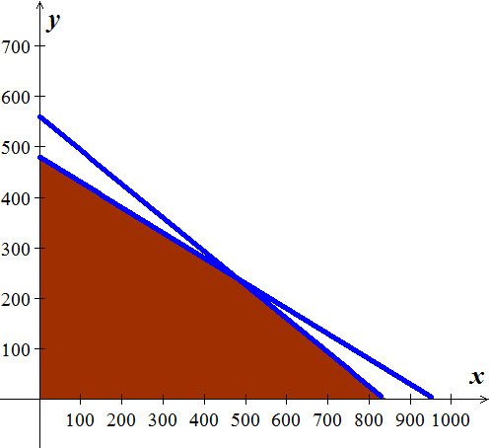

|  |  |  |  |  |
| --- | --- | --- | --- | --- |
| ***x*** | (1) |  | ***x*** | (2) |
| 0 | 480 |  | 0 | 560 |
| 960 | 0 |  | 840 | 0 |

***Solution*** ***Section* 1.3 – Solving Linear Programming and Applications**

***Exercise***

A manufacturing plant makes two types of inflatable boats, a two-person boat and a four-person boat. Each two-person boat requires 0.9 labor-hour in the cutting department and 0.8 labor-hour in the assembly department. Each four-person boat requires 1.8 labor-hours in the cutting department and 1.2 labor-hours in the assembly department. The maximum labor-hours available each month in the cutting and assembly departments are 864 and 672, respectively. The company makes a profit of $25 on each two-person boat and $40 on each four-person boat

1. Identify the decision variables
2. Summarize the relevant material in a table
3. Write the objective function P.
4. Write the problem constraints and the nonnegative constraints
5. Determine how many boats should be manufactured each month to maximize the profit. What is the maximum profit?

***Solution***

1. *x* = number of two- person boats produced each month

*y* = number of four- person boats produced each month

|  |  |  |  |  |
| --- | --- | --- | --- | --- |
|  | two-person | four-person |  | **Max** |
| Cutting | .9 | 1.8 | ≤ | 864 |
| Assembly | .8 | 1.2 | ≤ | 672 |
| Profit | 25 | 40 |  |  |

1. 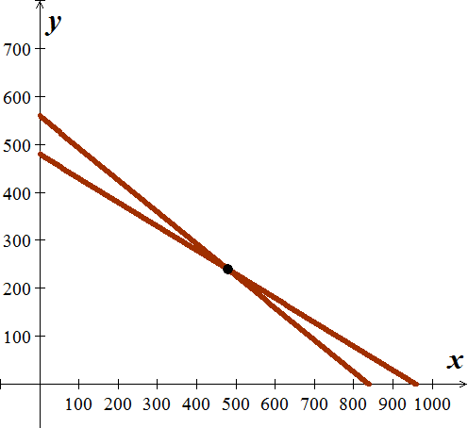
2. 
3. 480 two- person boats

240 four- person boats





***Exercise***

Maximize and minimize  subject to the constraints

|  |  |  |  |  |  |  |  |  |  |  |  |  |  |  |  |  |  |  |  |
| --- | --- | --- | --- | --- | --- | --- | --- | --- | --- | --- | --- | --- | --- | --- | --- | --- | --- | --- | --- |
|  |  |  |  |  |  |  |  |  |  |  |  |  |  |  |  |  |  |  |  |
|  | **A** |  |  |  |  |  |  |  |  |  |  |  |  |  |  |  |  |  |  |
|  |  |  |  |  |  |  |  |  |  |  |  |  |  |  |  |  |  |  |  |
|  |  |  |  |  |  |  |  |  |  |  |  |  |  |  |  |  |  |  |  |
|  |  |  |  |  |  |  |  |  |  |  |  |  |  |  |  |  |  |  |  |
|  |  |  |  |  |  |  |  |  |  |  |  |  |  |  |  |  |  |  |  |
|  |  |  |  |  |  |  |  |  |  |  |  |  |  |  |  |  |  |  |  |
|  |  |  |  |  |  |  |  |  |  |  |  |  |  |  |  |  |  |  |  |
|  |  |  |  |  |  |  |  |  |  |  |  |  |  |  |  |  |  |  |  |
|  |  |  |  |  |  |  |  |  |  |  |  |  |  |  |  |  |  |  |  |
|  |  |  |  |  |  |  |  |  |  |  |  |  |  |  |  |  |  |  |  |
|  |  |  |  |  |  |  |  |  |  |  |  |  |  |  |  |  |  |  |  |
|  |  |  |  |  |  |  |  |  |  |  |  |  |  |  |  |  |  |  |  |
|  |  |  |  |  |  |  |  |  |  |  |  |  |  |  |  |  |  |  |  |
|  |  |  |  |  |  |  |  |  |  |  |  |  |  |  |  |  |  |  |  |
|  | **C** |  |  |  |  |  |  |  |  |  |  |  |  |  |  |  |  |  |  |
|  |  |  |  |  |  |  |  |  |  |  |  |  |  |  |  |  |  |  |  |
|  |  |  |  |  |  |  |  |  | **B** |  |  |  |  |  |  |  |  |  |  |
|  |  |  |  |  |  |  |  |  |  |  |  |  |  |  |  |  |  |  |  |
|  |  |  |  |  |  |  |  |  |  |  |  |  |  |  |  |  |  |  |  |



***Solution***

A ⇒ *x* = 2 and *y* = 16

***z*** = 4(2) + 2(16) = 40

B ⇒ *x* = 8 and *y* = 4

***z*** = 4(8) + 2(4) = 40

C ⇒ *x* = 3 and *y* = 6

***z*** = 4(3) + 2(6) = 24

Minimize: **z** = 24 @ (3, 6)

Maximize: **z** = 40 @ (2, 16) & (8, 4)

***Exercise***

A chicken farmer can buy a special food mix *A* at 20¢ per pound and a special food mix *B* at 40¢ per pound. Each pound of mix *A* contains 3,000 units of nutrient N1 and 1,000 units of nutrient N2, and Each pound of mix *B* contains 4,000 units of nutrient N1 and 4,000 units of nutrient N2. If the minimum daily requirements for the chickens collectively are 36,000 units of nutrient N1 and 20,000 units of nutrient N2, how many pounds of each food mix should be used each day to minimize daily food costs while meeting (or exceeding) the minimum daily nutrient requirements? What is the minimum daily cost? Construct a mathematical model and solve using the geometric method.

***Solution***

Min 

Subject: 



8 lb of mix A, 3 lb of mix B; min  per day

***Exercise***

A company produces small engines for several manufacturers. The company receives orders from two assembly plants for their Top-flight engine. Plant I needs at least 45 engines, and plant II needs at least 32 engines. The company can send at most 90 engines to these two assembly plants. It costs $30 per engine to ship to plant I and $40 per engine to ship to plant II. Plant I gives the company $20 in rebates toward its products for each engine they buy, while plant II gives similar $15 rebates. The company estimates that they need at least $1200 in rebates to cover products they plan to buy from the two plants. How many engines should be shipped to each plant to minimize shipping costs? What is the minimum cost?

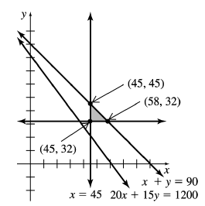***Solution***



The minimum value is $2,630, 45 engines to plan I,

and 32 engines to plant II.

***Exercise***

The Muro Manufacturing Company makes two kinds of plasma screen TV sets. It produces the Flexscan set that sells for $350 profit and the Panoramic I that sells for $500 profit. On the assembly line, the Flexscan requires 5 hours, and the Panoramic I takes 7 hours. The cabinet shop spends 1 hour on the cabinet for the Flexscan and 2 hours on the cabinet for the Panoramic I. Both sets require 4 hours for testing and packing. On a particular production run, the Muro Company has available 3600 work-hours on the assembly line, 900 work-hours in the cabinet shop, and 2600 work-hours in the testing and packing department. How many sets of each type should it produce to make a maximum profit? What is the maximum profit?

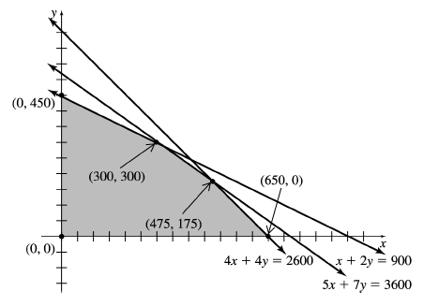***Solution***



The maximum profit is $255,000 when 300 Flexscan sets and 300 Panoramic/

***Exercise***

The manufacturing process requires that oil refineries must manufacture at least 2 gal of gasoline for every gallon of fuel oil. To meet the winter demand for fuel oil, at least 3 million gal a day must be produced. The demand for gasoline is no more than 6.4 million gal per day. It takes 0.25 hour to ship each million gal of gasoline and 1 hour to ship each million gal of fuel oil out of the warehouse. No more than 4.65 hours are available for shipping. If the refinery sells gasoline for $2.50 per gal and fuel oil for $2 per gal, how many of each should be produced to maximize revenue? Find the maximum revenue.

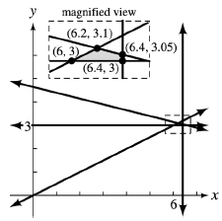***Solution***



Produce 6.4 million gal

and 3.05 gal of fuel oil

for a maximum revenue of $11.5 million.

***Exercise***

A small country can grow only two crops for export, coffee and cocoa. The country has 500,000 hectares of land available for the crops. Long-term contracts require that at least 100,000 hectares be devoted to coffee and at least 200,000 hectares to cocoa. Cocoa must be processed locally, and production bottlenecks limit cocoa to 270,000 hectares. Coffee requires two workers per hectare, with cocoa requiring five. No more than 1,750,000 people are available for working with these corps. Coffee produces a profit of $220 per hectares and cocoa a profit of 4550 per hectare. How many hectares should the country devote to each crop in order to maximize profit? Find the maximum profit.

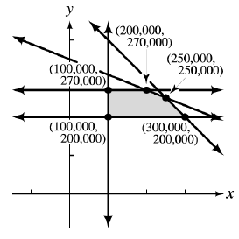***Solution***



A maximum profit of $192,500,000 is obtained

by growing 250,000 hectares of crop,

200,000 hectares of coffee, and

270,000 hectares of coffee.

***Exercise***

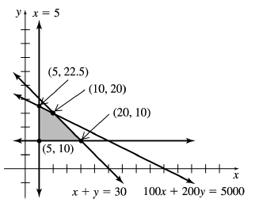A pension fund manager decides to invest a total of at most $39 million in U.S. treasury bonds paying 4% annual interest and in mutual funds paying 8% annual interest. He plans to invest at least $5 million in bonds and at least $10 million in mutual funds. Bonds have an initial fee of $100 per million dollars, while the fee for mutual funds is $200 per million. The fund manager is allowed to spend no more than $5000 on fees. How much should be invested in each to maximize annual interest? What is the maximum annual interest?

***Solution***





The Max. $2 million can be achieved by investing $5 million in Treasury bonds and 22.5 million in mutual funds.

Or $10 million in Treasury bonds and 20 million in mutual funds.

***Exercise***

A certain predator requires at least 10 units of protein and 8 units of fat per day. One prey of species I provides 5 units of protein and 2 units of fat; one prey of species II provides 3 units of protein and 4 units of fat. Capturing and digesting each species-II prey requires 3 units of energy, and capturing and digesting each species-I prey requires 2 units of energy. How many of each prey would meet the predator's daily food requirements with the least expenditure of energy?

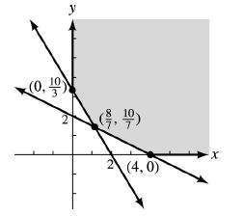***Solution***





Species I:  units.

Species II:  units.

***Exercise***

A dietician is planning a snack package of fruit and nuts. Each ounce of fruit will supply zero units of protein, 2 units of carbohydrates, and 1 unit of fat, and will contain 20 calories. Each ounce of nuts will supply 3 units of protein, 1 unit of carbohydrates, and 2 units of fat, and will contain 30 calories. Every package must provide at least 6 units of protein, at least 10 units of carbohydrates, and no more than 9 units of fat. Find the number of ounces of fruit and number of ounces of nuts that will meet the requirement with the least number of calories. What is the least number of calories?

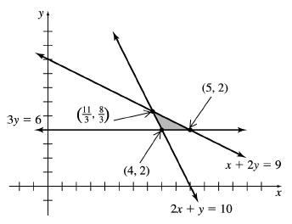***Solution***





The dietician should use 4 oz. of fruit and 2 oz. of nuts for a minimum of  calories.

***Exercise***

An anthropology article presents a hypothetical situation that could be described by a linear programming model. Suppose a population gathers plants and animals for survival. They need at least 360 units of energy, 300 units of protein, and 8 hides during some time period. One unit of plants provides 30 units of energy, 10 units of protein, and no hides. One animal provides 20 units of energy, 25 units of protein, and 1 hide.

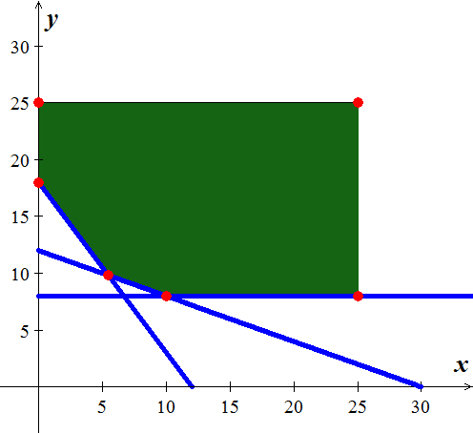***Solution***



|  |  |
| --- | --- |
| ***Corner point*** | ***Value*** |
|  | **270 (Min)** |
|  | 375 |
|  | 1125 |
|  | 870 |
|  | 310.91 |
|  | 420 |



The minimum is 

***Exercise***

In a small town in South Carolina, zoning rules require that the window space (in square feet) in a house be at least one-sixth of the space used up by solid walls. The cost to build windows is $10 per , while the cost to build solid walls is $20 per. The total amount available for building walls and windows is no more than $12,000. The estimated monthly cost to heat the house is $0,32 for each square foot of windows and $0.20 for each square foot of solid walls. Find the maximum total area (windows plus walls) if no more than $160 per month is available to pay for heat.

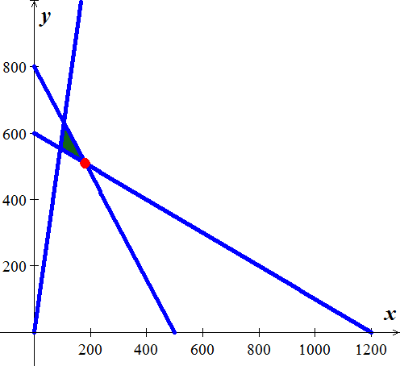***Solution***





The maximum total area is 

***Exercise***

A manufacturing company makes two types of water skis, a trick ski and a slalom ski. The trick ski requires 9 labor-hours for fabricating and 1 labor-hour for finishing. The slalom ski requires 5 labor-hours for fabricating and 1 labor-hour for finishing. The maximum labor-hours available per day for fabricating and finishing are 135 and 20 respectively. If *x* is the number of trick skis and *y* is the number of slalom skis produced per day, write a system of linear inequalities that indicates appropriate restraints on *x* and *y*. Find the set of feasible solutions graphically for the number of each type of ski that can be produced.

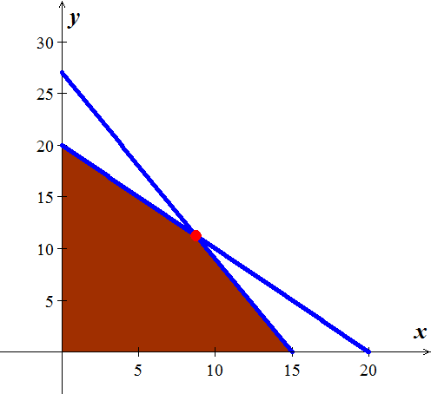***Solution***





The number of trick skis 8.75, and slalom is 11.25

***Solution Section* 1.4 – Slack Variables and the Pivot**

***Exercise***

Write the initial simplex tableau for each linear programing problem

|  |  |  |  |
| --- | --- | --- | --- |
| *a*) |  | *b*) |  |
| *c*) |  | *d*) |  |

***Solution***

1. 
2. 
3. 
4. 

***Exercise***

Pivot once as indicated in each simplex tableau. Read the solution from the result

|  |  |  |  |
| --- | --- | --- | --- |
| *a*) |  | *b*) |  |
| *c*) |  | *d*) |  |

***Solution***

1. 







1. 



 

1. 





1. 







***Exercise***

The authors of a best-selling textbook in finite mathematics are told that, for the next edition of their book, each simple figure would cost the project $20, each figure with additions would cost $35, and each computer-drawn sketch would cost $60. They are limited to 400 figures, for which they are allowed to spend up to $2200. The number of computer-drawn sketches must be no more than the number of the other two types combined, and there must be at least twice as many simple figures as there are figures with additions. If each simple figure increases the royalties by $95, each figure with additions increases royalties by $200, and each computer-drawn figure increases royalties by $325, how many of each type of figure should be included to maximize royalties, assuming that all art costs are borne by the publisher?

***Solution***







|  |  |  |  |  |
| --- | --- | --- | --- | --- |
|  |  |  |  |  |
| ***Cost*** | 20 | 35 | 60 | 2200 |
| ***Royalties*** | 95 | 200 | 325 |  |









*Maximized*: 

*Subject to:* 





To maximize royalties of $12,157.89, 23 of additional figure and 23 computer

***Exercise***

A manufacturer of bicycles builds racing, touring, and mountain models. The bicycles are made of both aluminum and steel. The company has available 91,800 units of steel and 42,000 units of aluminum. The racing, touring, and mountain models need 17, 27, and 34 units steel, and 12, 21, and 15 units of aluminum respectively. How many of each type of bicycle should be made in order to maximize profit if the company makes $8 per racing bike, $12 per touring bike, and $22 per mountain bike? What is the maximum possible profit?

***Solution***

|  |  |  |  |  |
| --- | --- | --- | --- | --- |
|  | ***Racing*** | ***Touring*** | ***Mountain*** |  |
| Steel | 17 | 27 | 34 | 91,800 |
| Aluminum | 12 | 21 | 15 | 42,000 |
| Profit | $8 | $12 | $22 |  |

*Maximized*: 

*Subject to:* 





To maximize the profit of $59,400. The should make 2,700 mountain bike only.

***Solution Section* 1.5 – Maximization Problems *with constraints of the form*** ≤

***Exercise***

Solve the simplex method:

Maximize: 

Subject to 

***Solution***

The Initial Simplex Tableau



***So the basic feasible solution at this point is:* **

(**–**80) to identify column 2 as the pivot column.



**  **

**  **





***Exercise***

Solve the simplex method:

Maximize: 

Subject to: 

***Solution***





***No Optimal*** ***solution***

***Exercise***

Solve the simplex method:

Maximize: 

Subject to: 

***Solution***

*Second Method*

** **

** **

** **

** **

** **

***Exercise***

The initial tableau of a linear programing is given. Use the simplex method to solve it



***Solution***









***Exercise***

Carrie is working to raise money for the homeless by sending information letters and making follow-up calls to local labor organizations and church groups. She discovers that each church group requires 2 hours of letter writing and 1 hour of follow-up, while for each labor union she needs 2 hours of letter writing and 3 hours of follow-up. Carrie can raise $100 from each church group and $200 from each union local, and she has a maximum of 16 hours of letter-writing time and a maximum of 12 hours of follow-up time available per month. Determine the most profitable mixture of groups she should contact and the most money she can raise in a month.

***Solution***

|  |  |  |  |
| --- | --- | --- | --- |
|  | ***Church Group*** | ***Labor Union*** | ***Max. Time*** |
| Letter Writing | 2 | 2 | 16 |
| Follow-up | 1 | 3 | 12 |
| $$$ raised | $100 | $200 |  |







The maximum amount of money raised is $1,000/moth when and 

***Exercise***

The Texas Poker Company assembles three different poker sets. Each Royal Flush poker set contains 1000 poker chips, 4 decks of cards, 10 dice, and 2 dealer buttons. Each Deluxe Diamond poker set contains 600 poker chips, 2 decks of cards, 5 dice, and one dealer button. The full House poker set contains 300 poker chips, 2 decks of cards, 5 dice, and one dealer button. The Texas Poker Company has 2,800,000 poker chips, 10,000 decks of cards, 25,000 dice, and 6000 dealer buttons in stock. They earn a profit of $38 for each Royal Flush poker set, $22 for each Deluxe Diamond poker set, and $12 for each Full House poker set.

1. How many of each type of poker set should they assemble to maximize profit? What is the maximum profit?
2. Find the values of any nonzero slack variables and describe what they tell you about any unused components.

***Solution***







The maximum profit is $104,000 and it is obtained when 1000 Royal Flush poker sets, 3000 Deluxe Diamond poker sets, and no Full House poker are assembled.

***Exercise***

The Muro Manufacturing Company makes two kinds of plasma screen TV sets. It produces the Flexscan set that sells for $350 profit and the Panoramic I that sells for $500 profit. On the assembly line, the Flexscan requires 5 hours, and the Panoramic I takes 7 hours. The cabinet shop spends 1 hour on the cabinet for the Flexscan and 2 hours on the cabinet for the Panoramic I. Both sets require 4 hours for testing and packing. On a particular production run, the Muro Company has available 3600 work-hours on the assembly line, 900 work-hours in the cabinet shop, and 2600 work-hours in the testing and packing department.

1. How many sets of each type should it produce to make a maximum profit? What is the maximum profit?
2. Find the values of any nonzero slack variables and describe what they tell you about unused time.

***Solution***

1. Let  number of Flexscan

 number of Panoramic



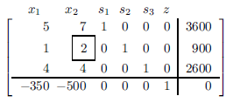

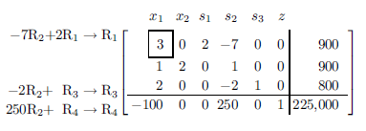

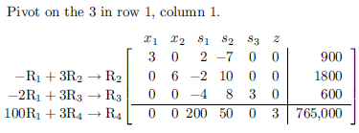

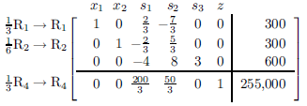

The optimal solution is $255,000 when 300 Flexscan and 300 Panoramic I sets are produced.

1.  leftover hours in the testing and packing department.

***Exercise***

A baker has 150 units of flour, 90 of sugar, and 150 of raisins. A loaf of raisin bread requires 1 unit of flour, 1 of sugar, and 2 of raisins, while a raisin cake needs 5, 2, and 1 units, respectively.

1. If raisin bread sells for $1.75 a loaf and raisin cake for $4.00 each, how many of each should baked so that gross income is maximized?
2. What is the maximum gross income?
3. Does it require all of the available units of flour, sugar, and raisins to produce the number the maximum profit? If not, how much of each ingredient is left over? Compare any leftover to the value of the relevant slack variable.

***Solution***

1. : Number of loaves of raisin bread

: Number of loaves of raisin cake







The optimal solution occurs when .

That is, when 50 loaves of raisin bread and 20 raisin cakes are baked.

1. The maximum gross income is $167.50
2. When 

The total amount for each ingredient:

Flour: 

Sugar: 

Raisins: 

***Exercise***

A farmer owns a 100 acre farm and plans to plant at most three crops. The seed for crops A, B, and C costs $24, $40, and $30 per acre, respectively. A maximum of $3,600 can be spent on seed. Crops A, B, and C require 1, 2, and 2 workdays per acre, respectively, and three are a maximum of 160 workdays available. If the farmer can make a profit of $140 per acre on crop A, $200 per acre on crop B, and $160 per acre on crop C, how many acres of each crop that should be planted to maximize the profit?

***Solution***

Maximize 

Subject to 



** **

** **

** **







∴ 40 acres of crop ***A***, 60 acres of crop ***B***, *no* crop ***C***





= $17,600

***Exercise***

A candy company makes three types of candy, solid, fruit, and cream filled, and packages these candies in three different assortments. A box of assortment I contains 4 solid, 4 fruit, and 12 cream and sells for $9.40. A box of assortment II contains 12 solid, 4 fruit, and 4 cream and sells for $7.60. A box of assortment III contains 8 solid, 8 fruit, and 8 cream and sells for $11.00. The manufacturing costs per piece of candy are $0.20 for solid, $0.25 for fruit, and $0.30 for cream. The company can manufacture up to 4800 solid, 4000 fruit, and 5600 cream candies weekly. How many boxes of each type should the company produce in order to maximize profit? What is their maximum profit?

***Solution***

This one is a bit more complicated simply because the profit per box is not given directly. To determine the profit per box, you must use the equation, Profit= Revenue – Cost.

|  |  |  |  |
| --- | --- | --- | --- |
|  | Assortment I {x1} | Assortment II {x2} | Assortment III {x3} |
| # Solid Candies @ cost | 4 @ 0.20=0.80 | 12 @ 0.20=2.40 | 8 @ 0.20=1.60 |
| # Fruit Candies @cost | 4 @ 0.25=1.00 | 4 @ 0.25=1.00 | 8 @ 0.25=2.00 |
| # Cream Candies @cost | 12 @ 0.30=3.60 | 4 @ 0.30=1.20 | 8 @ 0.30=2.40 |
| Total Cost Per Box | $5.40 | $4.60 | $6.00 |
| Total Revenue Per Box | $9.40 | $7.60 | $11.00 |
| Total Profit Per Box {R-C} | 9.40-5.40=$4.00 | 7.60-4.60=$3.00 | 11.00-6.00=$5.00 |



***Initial Tableau:***



Use the simplex method to solve:



***Exercise***

A small company manufactures three different electronic components for computers. Component A requires 2 hours of fabrication and 1 hour of assembly; component B requires 3 hours of fabrication and 1 hour of assembly; and component C requires 2 hours of fabrication and 2 hours of assembly. The company has up to 1,000 labor-hours of fabrication time and 800 labor-hours of assembly time available per week. The profit on each component, A, B, and C is $7, $8, and $10, respectively. How many components of each week in order to maximize its profit (assuming that all components that it manufactures can be sold)? What is the maximum profit?

***Solution***

Let : number of A components

: number of B components

: number of C components









The optimal solution: The maximum profit is $4400 when 200 ***A*** components and 0 ***B*** components and 300 ***C*** components are manufactured.

***Exercise***

An investor has at most $100,000 to invest in government bonds, mutual funds, and money market funds. The average yields for government bonds, mutual funds, and money market funds are 8%, 13%,, and 15%, respectively. The investor’s policy requires that the total amount invested in mutual and money market funds not exceed the amount invested in government bonds. How much should be invested in each type of investment in order to maximize the return? What is the maximum return?

***Solution***

Let : government bonds

: mutual funds

: money market funds









The optimal solution: The maximum return is $11,500 when  is invested in government bonds,  is invested in mutual bonds,  is invested in money market funds.

***Exercise***

A department store chain up to $20,000 to spend on television advertising for a sale. All ads will be placed with one television station, where 30-second as costs $1,000 on daytime TV and is viewed by 14,000 potential customers, $2000 on prime-time TV and is viewed by 24,000 potential customer, and $1,500 on late-night TV and is viewed by 18,000 potential customers. The television station will not accept a total of more than 15 ads in all three time periods. How many ads should be placed in each time period in order to maximize the number of potential customers who will see the ads? How many potential customers will see the ads?

***Solution***

Let : daytime ads

: prime-time ads

: late-night ads









Optimal Solution: maximum number of potential customers is 260,000 when  daytime ads,  prime-time ads, and  late-night ads are placed.

***Exercise***

A political scientist has received a grant to find a research project involving voting trends. The budget of the grant includes $3,200 for conducting door-to-door interviews the day before an election. Undergraduate students, graduate students, and faculty members will be hired to conduct the interviews. Each undergraduate student will conduct 18 interviews and be paid $100. Each graduate student will conduct 25 interviews and be paid $150. Each faculty members will conduct 30 interviews and be paid $200. Due to limited transportation facilities, no more than 20 interviews can be hired. How many undergraduate students, graduate students, and faculty members should be hired in order to maximize the number of interviews that will be conducted? What is the maximum number of interviews?

***Solution***

Let : government bonds

: mutual funds

: money market funds









Optimal Solution: maximum number of interviews is 520 when  undergraduates,  graduate students, and  faculty members.

***Solution*** ***Section* 1.6 – Minimization Problems** ≥ **(*Duality*)**

***Exercise***

Find the transpose of the matrix

 

***Solution***





***Exercise***

Solve the following minimization problem by maximizing the dual:



***Solution***

Solving the dual problem is a standard maximization problem, we can solve it using the simplex method.



***Initial System***



***Initial Tableau***

 



Final Tableau



*Optimal Solution (for the original minimization problem):*

Minimum: 

***Exercise***

Solve the following minimization problem by maximizing the dual:



***Solution***

***The Coefficient Matrix The Transpose***

 

***The Dual***: 

*Initial System* 







*Optimal Solution (for the original minimization problem):*

Minimum: 

***Exercise***

Customers buy 14 units of regular beer and 20 units of light beer monthly. The brewery decides to produce extra beer, beyond that needed to satisfy the customers. The cost per unit of regular beer is $33,000 and the cost per unit of light beer is $44,000. Every unit of regular beer brings in $200,000 in revenue, while every unit of light beer brings in $400,000 in revenue. The brewery wants at least $16,000,000 in revenue. At least 18 additional units of beer can be sold. How much of each beer type should be made so as to minimize total production costs? What is the minimum cost?

***Solution***

***Exercise***

Acme Micros markets computers with single-sided and double-sided drives. The disk driers are supplied by two other companies, Associated Electronics and Digital Drives. Associated Electronics charges $250 for a single-sided disk drive and $350 for a double-sided disk drive. Digital Drives charges $290 for a single-sided disk drive and $320 for a double-sided disk drive. Associated Electronics can supply at most 1,000 disk drives in any combination of single-sided and double-sided drives. The combined monthly total supplied by Digital Drives cannot exceed 2,000 disk drives. Acme Micros needs at least 1,200 single-sided drives and at least 1,600 double-sided drives each month. How many disk drives of each type should Acme Micros order from each supplier in order to meet its monthly demand and minimize the purchase cost? What is the minimum purchase cost?

***Solution***

Let : Number of single-sided - Associated Electronics

: Number of double-sided - Associated Electronics

: Number of single-sided - Digital Drives

: Number of double-sided - Digital Drives





***The Coefficient Matrix The Transpose***

 

***The Dual***: 





The minimal purchase cost is $820,000 for 1000 single-sided and 0 double-sided - Associated Electronics, 200 single-sided and 1600 double-sided - Digital Drives

***Exercise***

A farmer can buy three types of plant food, mix A, mix B, and mix C. Each cubic yard of mix A contains 20 pounds of phosphoric acid, 10 pounds of nitrogen, and 10 pound of potash. Each cubic yard of mix B contains 10 pounds of phosphoric acid, 10 pounds of nitrogen, and 15 pound of potash. . Each cubic yard of mix C contains 20 pounds of phosphoric acid, 20 pounds of nitrogen, and 5 pound of potash. The minimum monthly requirements are 480 pounds of phosphoric acid, 320 pounds of nitrogen, and 225 pound of potash. If mix A costs $30 per cubic yard, nix B costs $36 per cubic yard, and mix C $39 per cubic yard, how many cubic yards of each mix should the farmer blend to meet the minimum monthly requirements at a minimal cost? What is the minimum cost?

***Solution***

Let : Number of cubic yards of mix *A*.

: Number of cubic yards of mix *B*.

: Number of cubic yards of mix *C*.



*The Coefficient Matrix The Transpose*

 

***The Dual***: 





For the farmer, to meet the minimum monthly requirements at a minimal cost, should blend  of *A*,  of *B*, and  of *C*; and the minimum cost is $825.00**.**

***Exercise***

Mark, who is ill, takes vitamin pills. Each day he must have at least 16 units of vitamin A, 5 units of vitamin B, and 20 units of vitamin C. he can choose between pill #1, which contains 8 units of A, 1 of B, and 2 of C; and pill #2, which contains 2 units of A, 1 of B, and 7 of C. Pill 1 costs 15¢, and pill 2 costs 30¢.

1. How many of each pill should be buy in order to minimize his cost?
2. What is the minimum cost?
3. For the solution in part a, Mark is receiving more than he needs of at least one vitamin. Identify that vitamin, and tell how much surplus he is receiving. Is there any ways he can avoid receiving that surplus while still meeting the other constraints and minimizing the cost?

***Solution***

Let : Number of #1 pills

: Number of #2 pills

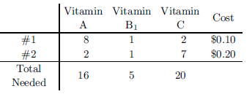

The ***dual***: 





The minimum value is 0.7 when .

Mark should buy 3 of pills #1 for a minimum cost of 60 cents, and 2 of pills #2 for a minimum cost of 70 cents.

***Exercise***

One gram of soybean meal provides at least 2.5 units of vitamins and 5 calories. One gram of meat byproducts provides at least 4.5 units of vitamins and 3 calories. One gram of grain provides at least 5 units of vitamins and 10 calories. If a gram of soybean meal costs 6 cents, a gram of meat byproducts 8 cents, and a gram of grain 9 cents, what mixture of these three ingredients will provide at least 54 units of vitamins and 60 calories per serving at minimum cost? What will be the minimum cost?

***Solution***:



 







 



***Exercise***

A metropolitan school district has two high-schools that are overcrowded and two that are underenrolled. In order to balance the enrollment, the school board has decided to bus students from the crowded schools to the underenrolled schools. North Division High School has 300 more students than it should have, and South Division High School has 500 more students than it should have. Central High School can accommodate 400 additional students and Washington High School can accommodate 500 additional students. The weekly cost of busing a student from North Division to Central is $5, from North Division to Washington is $2, from South Division to Central is $3, and from South Division to Washington is $4. Determine the number of students that should be bused from each of the overcrowded schools to each of the underenrolled schools in order to balance the enrollment and minimize the cost of busing the students. What is the minimum cost?

***Solution***

Let : Number of students from N.Div. to Central

: Number of students from N.D. to Washington

: Number of students from S.D. to Central

: Number of students from S.D. to Washington

** **

***The Coefficient Matrix The Transpose***

 





The minimal cost is $2,200 when 300 students are bused from North Division to Washington, 400 students are bused from South Division to Central, and 100 students are bused from South Division to Washington. No students bused from North Division to Central.