***Exercise* 1**

*Ox* and *Oy* are bisector to 2 adjacent acute angles,  and  where the difference is  and . *Oz* is the bisector of the angle . Determine the angle 

***Solution***

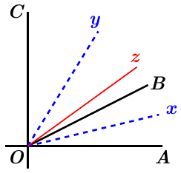

























***Exercise* 2**

*Ox* and *Oy* are bisector to 2 adjacent acute angles,  and  where the difference is . *Oz* is the bisector of the angle . Determine the angle 

***Solution***

*Ox* is the bisector  

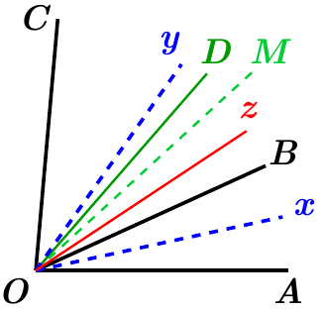*OB* is the bisector  

*OM* is the bisector  

*Oz* is the bisector  

*Oy* is the bisector  







































***Exercise* 3**

Four consecutive half-lines (segments): *OA*, *OB*, *OC*, and *OD* formed angles such as

 and 

Calculate the angles to demonstrate that the bisectors of  and  are in a straight line.

***Solution***





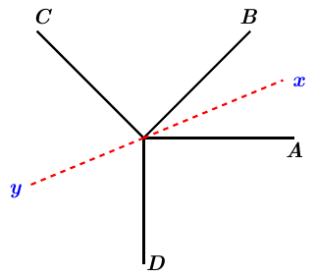







Let:

*Ox* is the bisector 

*Oy* is the bisector 









Therefore; the bisectors of  and  are in a straight line

***Exercise* 4**

The segments *OA* and *OB* formed with *OX* the angles *𝛼* and *𝛽*.

1. Demonstrate that the bisector *OC* of the angle  made with *OX* an angle .
2. Examine the cases where
   1. 
   2. 

***Solution***

***Given***:







1. 



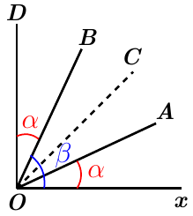 

1. ***i.*** If , then



Let:  that implies *OC* is the bisector of 

Since *OC* is the bisector of , then

 





***ii.*** If , then

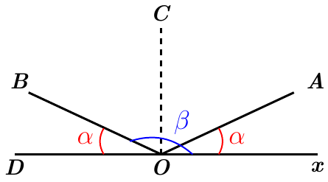

Let:  that implies *OC* is the bisector of 

Since *OC* is the bisector of , then

 





***Exercise* 5**

A point *O* takes on an infinite right  be conducted the same side half-lines *OA* and *OB*, as well as the bisectors of angles , , and .

Calculate the angles of the figure such that the bisector of the angle  is perpendicular to  and the bisectors of the extreme angles formed an angle of .

***Solution***

***Given***: 

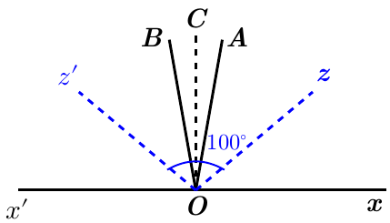

*OC* is the bisector 



*Oz* is the bisector 



 is the bisector 















***Exercise* 6**

Four consecutive half-lines *OA*, *OB*, *OC*, and *OD* formed four adjacent consecutive angles which are between them like 1, 2, 3, 4.

Calculate the angles and the adjacent consecutive angles formed by their bisectors.

***Solution***





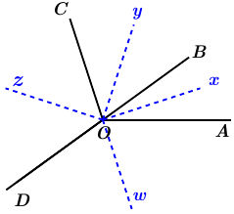









































***Exercise* 7**

A point *P* is on the base *BC* of an isosceles triangle *ABC*. The two points *M* and *N* are the middle points of the segments *PB* and *PC*, respectively, which lead the perpendicular to the base *BC*; these perpendiculars meet *AB* in *E*, *AC* in *F*.

Demonstrate that the angle *EPF* is equal to *A*.

***Solution***

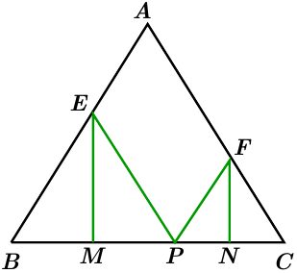

*M* is the middle of the segment *BP* and *EM*  to *BP*, therefore



*N* is the middle of the segment *CP* and *FN*  to *CP*, therefore









 *√*

***Exercise* 8**

Given the triangle *ABC* and the bisectors *BO* and *CO* of the angles of the base, where the point *O* is the intersection of the 2 bisectors. A line *DOE* passes through the point *O* parallel to base *BC*.

Prove that 

***Solution***

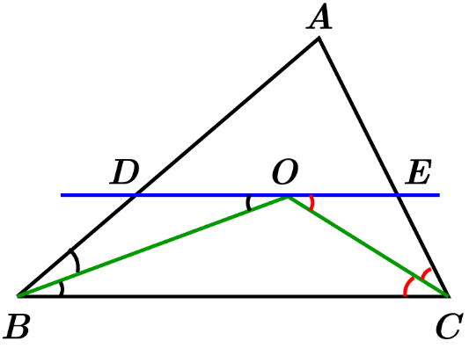*CO* is the bisector of  





Similar; *BO* is the bisector of  









***Exercise* 9**

A right triangle *ABC* at *A* with a height *AH*. We drop perpendiculars *HE* and *HD* from *H* to sides *AB* and *AC* respectively.

1. Prove that 
2. Prove that *AM* is perpendicular to *DE*, where *M* is the middle point of *BC*.
3. Prove that *MN* (*N* is the middle point of *AB*) and the segment *Bx* (parallel to *DE*) are intersect on *AH*.
4. Prove that *AM* and *HD* are intersect on *Bx*.

***Solution***

1. The triangles *AEH* and *ADH* are right triangles and angle *A* is right angle.

Then *AEHD* is a rectangle.

Therefore, 

1. A middle point of a hypotenuse of a right triangle is the center of the circle of that triangle.

Therefore, 

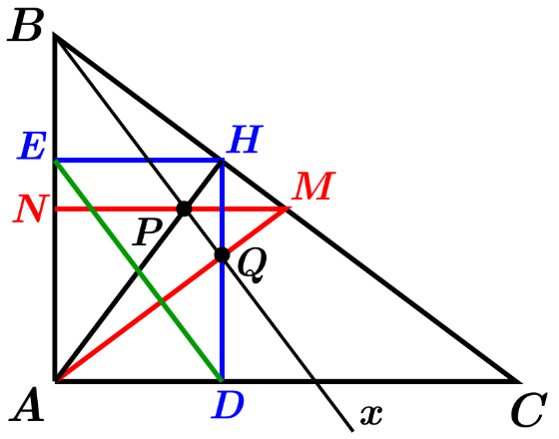That implies to: 

From the rectangle *ADHE*: 















Therefore, *AM* is perpendicular to *DE*.

1. *N* is the middle point of *AB* 

*Bx* parallel to *DE* 

Let point *P* the intersection of B*x* and *AH*. Since, then the triangle *BPA* is isosceles. *PN* is the perpendicular to *AB* as well *MN*. Which gives us that points *M*, *P*, *N* are on the same line.

Therefore, segment *MN* and *AH* intersect at point *P*.

1. Let Point *Q* be the intersection of *AM* and *Bx*.



Then, the triangles *BHA* and *BQA* are equivalent, therefore with hypotenuse *AB*.

, line *HQ* has to be perpendicular to *AC*.

*AM* and *HD* are intersecting on *Bx* at *Q*.

***Exercise* 10**

Given an isosceles triangle *ABC* with a peak at *A*. Extend base *BC* the length , then extend *AB* of a length , at the end draw a line *EHF*, *H* is the middle point of *BC* and *F* is located on *AD*.

1. Prove that 
2. Prove that 
3. Prove that 
4. Calculate the value of the angles  and  where .

***Solution***

1. 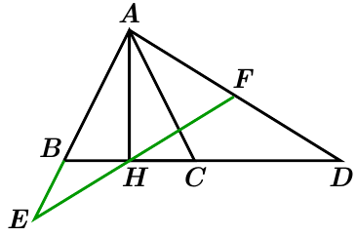Triangle *ABC* is isosceles, then 

Since , then 











1.  *H* the middle point of *BC*







 ***√***

1. 











 







 ***√***

1. 











Triangle *AFH* is isosceles then,











***Exercise* 11**

Demonstrate that the heights of a triangle share the angles of triangle that equal to each other.

***Solution***

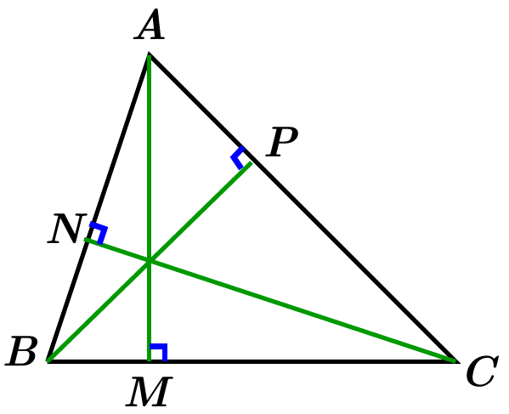

Consider the 2 right triangles *APB* and *ANC*, which they have the same angle *A*.

Therefore, .

Similar, consider the 2 right triangles *BPC* and *AMC*, which they have the same angle *C*.

Therefore, .

Similar, consider the 2 right triangles *BNC* and *AMB*, which they have the same angle *B*.

Therefore, .

***Exercise* 12**

A right triangle *ABC* at *A* where , drop a perpendicular *AH* from *A* to the hypotenuse *BC* where . From *C* drops a perpendicular *CM* at *AN*. Demonstrate that *BC* is the bisector of the angle.

***Solution***

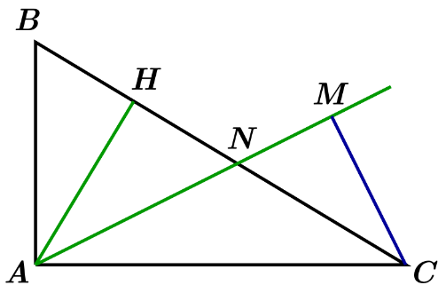

Consider the 2 right triangles *ABC* and *ABH* with a common angle *B*, then



*Given*: , then 





Consider the 2 right triangles *AHN* and *CMC*, where 

Therefore, 

Since 

Then 

Therefore, *BC* is the bisector of the angle 

***Exercise* 13**

On the sides of an angle that it takes the length *OA* and *OB*, so that  (is given) and construct a parallelogram *OABC*. What is the place of the summit *C* of parallelogram?

***Solution***

Let segment *OE* extension of segment *OA* such that 

Let segment *OF* extension of segment *OB* such that 

Then, the triangle *OEF* is isosceles.

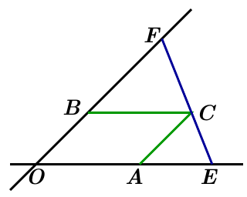









Therefore, the point *C*, *E*, and *F* are aligned.

***Exercise* 14**

Demonstrate that the sum of distances from a point *M* on the base *BC* of an isosceles triangle *ABC* to the sides equal a constant.

***Solution***

The shortest distance from a point to a line is the perpendicular from that point to the line.

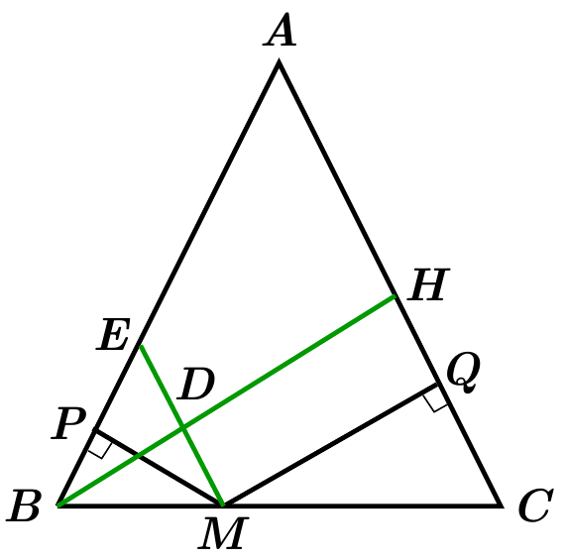Therefore, let:





Let  (Shortest distance from *B* to side *AC*.)

Let *D* be the point of intersection *ME* and *BH*.

Let 

Where the point *E* is the intersection of the lines *MD* and *AB*.

Since then 

Since triangle *ABC* is an isosceles triangle.



The right triangles *BPM* and *BDM* at *P* & *D* andhave the same hypotenuse, then



 and 







= ***constant***

Therefore, the sum of distances from a point *M* on the base *BC* of an isosceles triangle *ABC* to the sides equal a constant.

***Exercise* 15**

Demonstrate that the difference of distances from a point *M* taken on the extension of the base *BC* of an isosceles triangle *ABC* to the sides equal a constant.

***Solution***

The shortest distance from a point to a line is the perpendicular from that point to the line.

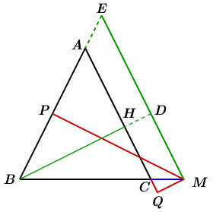Therefore, let:





Let  (Shortest distance from *B* to side *AC*.)

Let *D* be the point of intersection *ME* and *BH*.

Let 

Where the point *E* is the intersection of the extensions of the lines *MD* and *AB*.

Since then 

Since triangle *ABC* is an isosceles triangle.



The right triangles *BPM* and *BDM* at *P* & *D* andhave the same hypotenuse, then



 and 







= ***constant***

Therefore, the difference of distances from a point *M* taken on the extension of the base *BC* of an isosceles triangle *ABC* to the sides equal a constant.

***Exercise* 16**

Consider a parallelogram *ABCD* in which . In the joint *A* and *B* the middle *M* of *BC*.

Prove that the angle  is a right angle.

***Solution***

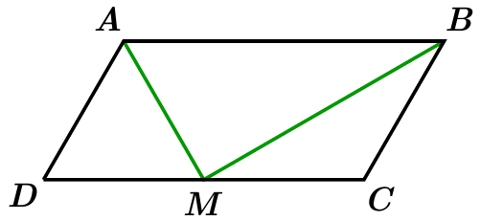

Since the point *M* is the middle of side *BC*, then





Therefore, the triangles *ADM* and *BCM* are isosceles at *D* and *C* respectively.

Which implies that 

Let *O* be the middle point of the side *AB*, and 

*O* and *M* are middle of the parallelogram *ABCD*, that implies





The triangle *MAB* inscribed in a circle with center at *O* and diameter *AB*, that will imply that is a right triangle at the point *M*.

***Or***



















***Exercise* 17**

From the sides *AB* and *AC* of a right triangle *ABC* at *A*, draw two squares *ABDE* and *ACFG*. Then lead *DN* and *FM* perpendicular to the line *BC*.

1. Prove that 
2. Prove that the points *D, A, F* on a straight line.
3. Prove that the lines *DE* and *FG* contribute on the extension of the height *AH*.

***Solution***

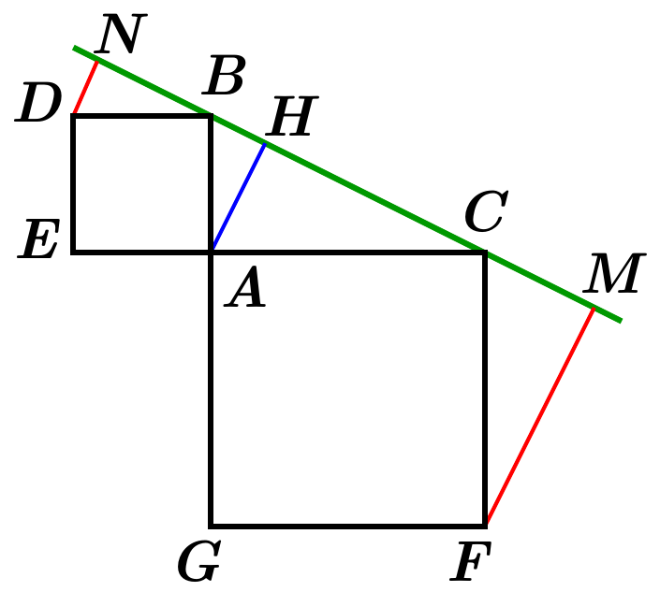

1. Let consider the 2 right triangles *DNB* & *BHA* at points *N* & *H* respectively, with . Then









∴ The 2 triangles are equals, which implies that 

Similar, for the 2 right triangles *CMF* & *AHC* at points *M* & *H* respectively, with . Then









**∴** The 2 triangles are equals, which implies that 



 ***√***

1. 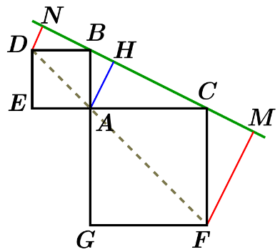Since *ABDE* is a square, then 

And *ACFG* is a square, then 







**∴** The points *D*, *A*, & *F* are on a straight line.

1. Let the point *K* be the intersection of the extension of the sides *DE* and *FG*.

Which will result of *GKEA* is a rectangle with 

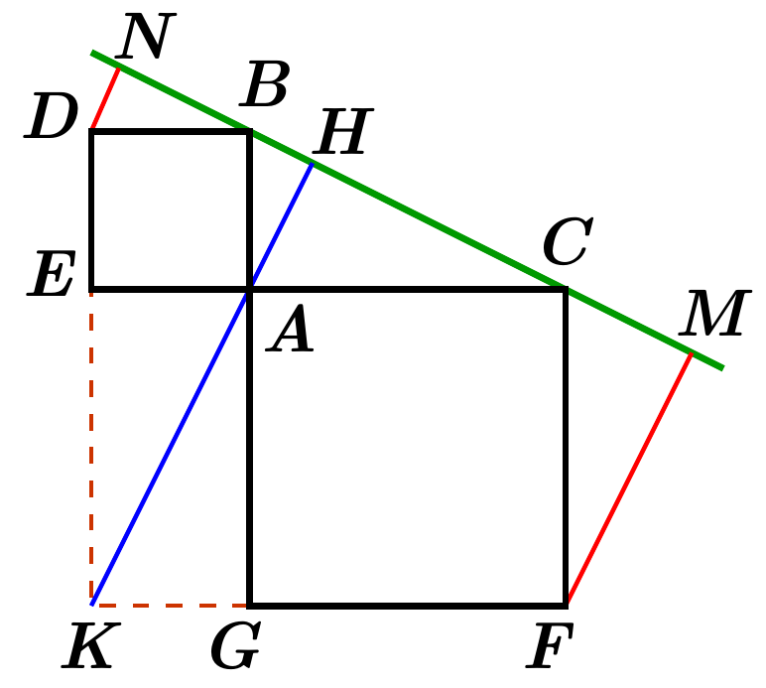

Consider the 2 right triangles *BAC* & *KGA* at points *A* & *G* respectively with 



From the right triangle *AHC*:











**∴** The points *K*, *A*, & *H* are on a straight line.

***Exercise* 18**

Given a diamond *ABCD*; the peak *B* and *D*, the same the perpendiculars *BM, BN, DP, DQ* on opposite sides. These perpendiculars are intersected at *E* and *F*.

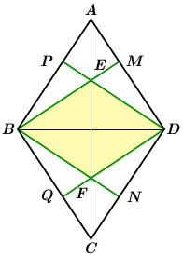Demonstrate that the angles of the quadrilateral *BFDE* are equals to the diamond and which is a diamond itself.

***Solution***

From the right triangles *BPD* & *BMD*, that implies 



Similar, from the right triangles *BND* & *BQD*, that implies 







Since, , then 

The 2 triangles *EBF* & *EDF* have *EF* as a common side and , then





Therefore, the angles of the quadrilateral *BFDE* are equals to the diamond and which is a diamond itself.

***Exercise* 19**

In a triangle *ABC*, we trace the median *AM* and *BN* and from *N* a parallel to *BC*, from *C* a parallel to *BN*; that the two sides intersect at a point *P*. Let *D* be the middle point of the segment *PN*.

Prove that *CD* is parallel to *MN.*

***Solution***

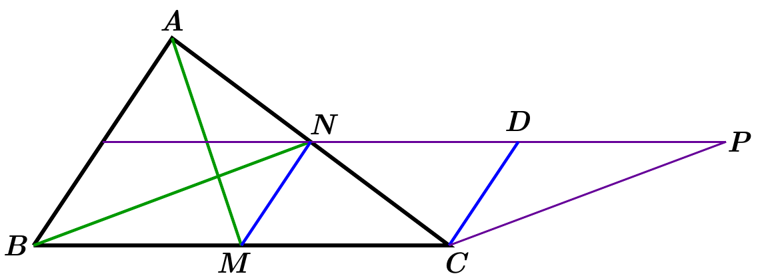

Since the points *M* & *N* are middle of the sides *BC* & *AC* of the triangle *ABC*, then



*Given*: 



Since *M* & *D* are the middle points of the segments *BC* and *NP* respectively, then



Therefore, *BNPC* is a parallelogram, and .

Since 

Therefore, *MCDC* is a parallelogram which implies to *CD* parallel to *MN*

***Exercise* 20**

The median *AD* of a given triangle *ABC* to the side *BC*. The same the median *BE* to the side *AD* which intersect *AC* at a point *F*.

Prove that where 

***Solution***

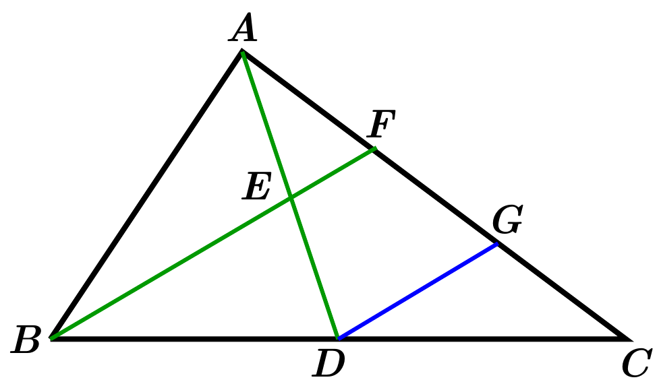

Let *DG* be parallel to segment *BEF*.

***Given***: *E* is the middle point of the segment *AD* 

*D* is the middle point of the segment *BC* 

Since , and , that implies 

Consider the triangles CDG and CBF:

, and , that implies 

That will imply to: 





Therefore; 

***Exercise* 21**

In a parallelogram *ABCD*, from the points peak *A* and *C* joint the middle of opposite sides at *M* and *N* respectively.

Prove that the diagonal *BD* is divided in three equal parts.

***Solution***

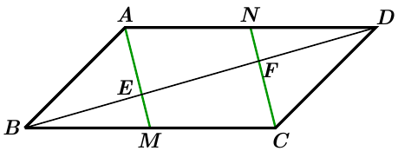

*M* is the middle point of the segment *BC*, then 

*N* is the middle point of the segment *AD*, then 

From these, implies that .

From the triangles *BEM* & *BCF*, and since 

It will give us that 

From the triangles *DFN* & *DEA*, and since 

It will give us that 

Therefore, 





Therefore, the diagonal *BD* is divided in three equal parts

***Exercise* 22**

In a parallelogram *ABCD*, from the point peak *A,* extend to the middle of sides *BC* and *DC* at *M* and *N* respectively.

Prove that the diagonal *BD* is divided in three equal parts.

***Solution***

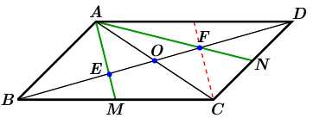

Let a point *E* be the intersection of the segments *AM* & *BD*.

Let a point *F* be the intersection of the segments *AN* & *BD*.

Le *O* be the intersection of both diagonal *AC* & *BD*.

From the triangles *BEM* & *BCF*, and since 



Similar, 





















Therefore, the diagonal *BD* is divided in three equal parts

***Exercise* 23**

Consider a triangle *ABC* with a bisector *AF* of the angle *A*. by *F*, we lead *FE* parallel to *AB*, and by *E* we lead *ED* parallel to *BC*.

Prove that 

***Solution***

***Given***: 

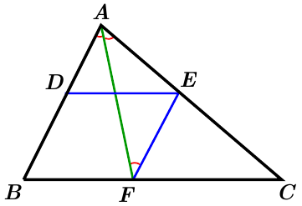Since , then







Consider the triangle *AEF*:









∴ Triangle *AEF* is isosceles



***Given***  & 

*FEDB* is a parallelogram.

Then, 

***Exercise* 24**

Given an isosceles trapezoid *ABCD*  with diagonals *AC* and *BD*. The bisector of angles  and  intersect in *F*, and the bisector of angles  and  intersect in *G*.

Demonstrate that *FG* is parallel to *AB*.

***Solution***

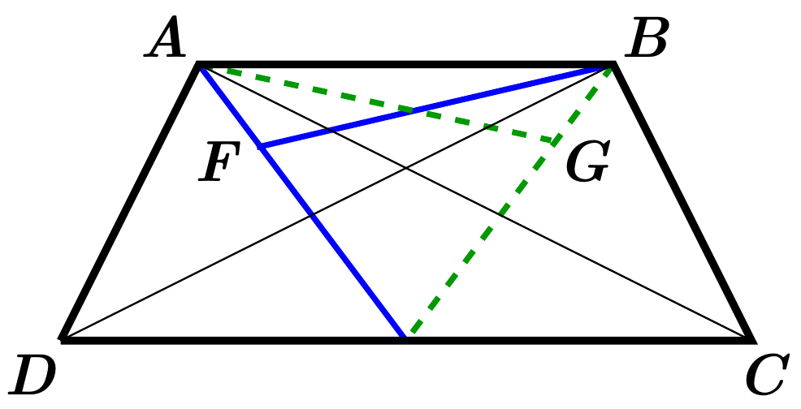

Consider the 2 triangles *ABD* & *ABC*:

* Both has the *AB* as common
* 

That implies to: 

Since *BF* is the bisector of the angle 













From the 2 triangles *AFB* & *AGB*

* Both has the *AB* as common
* 



***Exercise* 25**

Let *M* and *N* be the middle points of the bases *AB* and *CD* of a trapezoid *ABCD*.

Let *P* and *Q* be the middle points of the diagonals *AC* and *BD* respectively.

Demonstrate that the angles  and  of quadrilateral *MNPQ* are equals to the angle formed by extending the sides not parallel to *BC* and *AD*, where intersect at point *E*.

***Solution***

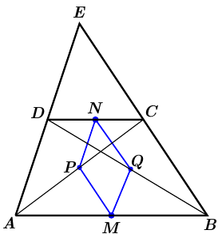Since *N* is the mid-point of the side *DC*, and

*P* is the mid-point of the side *AC*, then



Since *M* is the mid-point of the side *AB*, and

*Q* is the mid-point of the side *DB*, then





Since *N* is the mid-point of the side *DC*, and

*Q* is the mid-point of the side *DB*, then



Since *M* is the mid-point of the side *AB*, and

*P* is the mid-point of the side *AC*, then









***Exercise* 26**

In a triangle *ABC*, the medians segment *BM* and *CN* intersect in right angles and the measurement are 3 and 6 units respectively.

1. Construct a geometrical to the triangle *ABC*.
2. In the trace of third median *AP* which leads *MN* extension such the distance, which lead to the segments *AD* and *PD*. Calculate *AD* and *DP*.
3. What is the natural of the triangle *APD* ?

***Solution***

1. Since *M* and *N* are the middle point of the side’s *AC* & *AB*, then

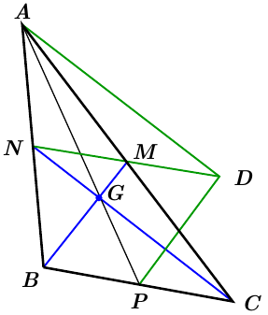



  
Similar,







Wish, we lead to: 

We can construct 2 perpendicular lines intersect at a point *G*, then we use to measure the distance from the point *G* to get the points *B*, *C*, *M*, & *N*.

By extending the segment *BN* and *CM* with equal distance and which it will intersect at point *A*.

1. Since  & 

The parallelogram *BPDM*, 

Then 

 and *M* is the intersection of the diagonals of the parallelogram *ADCN*, then



1. , then 

, then 

Therefore, the triangle *ADP* is right triangle at point *D*.

***Exercise* 27**

Inside the triangle *ABC*, the median *AD*, *BE*, and *CF* intersect at a point *O*. We take *M* the middle point of the segment *OA*, *N* the middle point of segment *OB*.

Show that *DEMN* is a parallelogram.

***Solution***

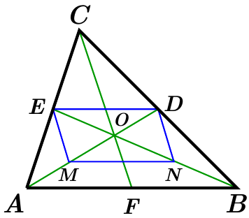

*DE* & *MN* are parallel to *AB* and equals to 

That implies to .

Therefore, *DEMN* is a parallelogram

***Exercise* 28**

Inside the triangle *ABC*, the median *AD*, *BE*, and *CF* intersect at a point *O*. From the point *F*, draw *FG* parallel to *AD* and are equals, then joint *A* to *G*.

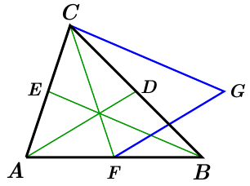

Show that .

***Solution***

***Given***: 

Then, the quadrilateral *AFGD* is a parallelogram which it results to .



Since *F* is the mid-point of the side *AB*, then .

Then, the quadrilateral *BFDG* is a parallelogram which it results to .

So, 

*Given that D & F* are midpoints, then 

And  & , then *BGCE* is a parallelogram.

Therefore, 

***Exercise* 29**

The height of a triangle *ABC* (each of the three lines passing through a vertex of the triangle and perpendicular to the opposite side to this vertex) are *AN*, *BP*, *CM*.

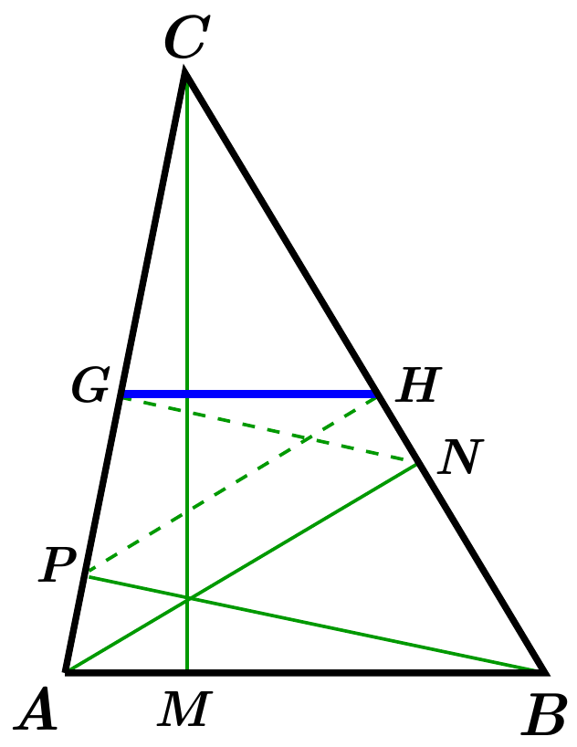

From *P*, let *PH* perpendicular to *BC*, same from *N*, let *NG* perpendicular to *AC*.

Show that *GH* is parallel to *AB*.

***Solution***

Let the point *O* be the middle of the segment *AB*.

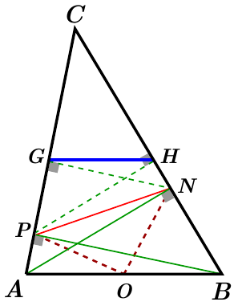Then *O* is the center of the 2 triangles *ANB* & *APB*.

The triangle *OBN* is isosceles, implies to 

The triangle *OPA* is isosceles, implies to 







Consider the triangle *PON* with , then





















From the 2 right triangles *CHP* & *CGN*











Let *Q* be the middle point of the segment *PN*.

Since *PGN* & *PHN* are right triangle with the same hypothesis.

Then, the triangles *HQN* & *GQN* are isosceles.

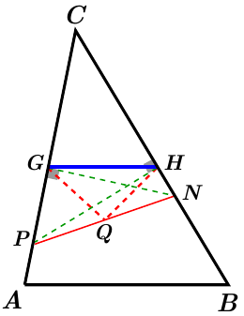





Since 

























Therefore, 

***Exercise* 30**

From the top of a triangle, we lead the external bisectors of angles such that formed an outside triangle such that the top of the first are the feet of the second heights.

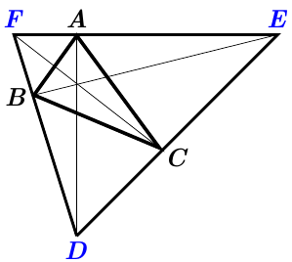

***Solution***

Let the triangle *DEF* where *DA*, *BE*, and *FC* are heights (perpendicular to sides).

Let the point *M* be the middle points of the same hypothenuse of the 2 right triangles *FAD* & *FCD*.

Then, the 2 triangles inscribed the same circle with the center at point *M*.



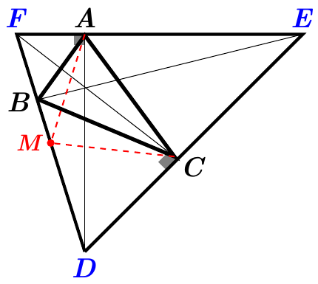

Therefore, the triangle *AMC* is isosceles.























Similar,

Let the point *N* be the middle points of the same hypothenuse of the 2 right triangles *FCE* & *FBE*.

Then, the 2 triangles inscribed the same circle with the center at point *N*.



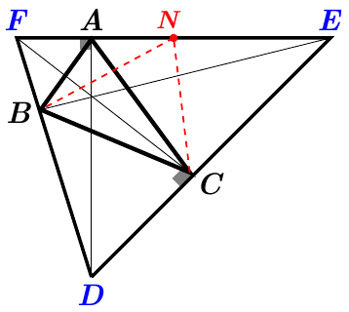

Therefore, the triangle *NBC* is isosceles.























Then, 

Therefore, *CF* is the interior bisector of  and *DCE* is the exterior bisector.















Let the point *P* be the middle points of the same hypothenuse of the 2 right triangles *DAE* & *BDE*.

Then, the 2 triangles inscribed the same circle with the center at point *P*.





Therefore, the triangle *APB* is isosceles.



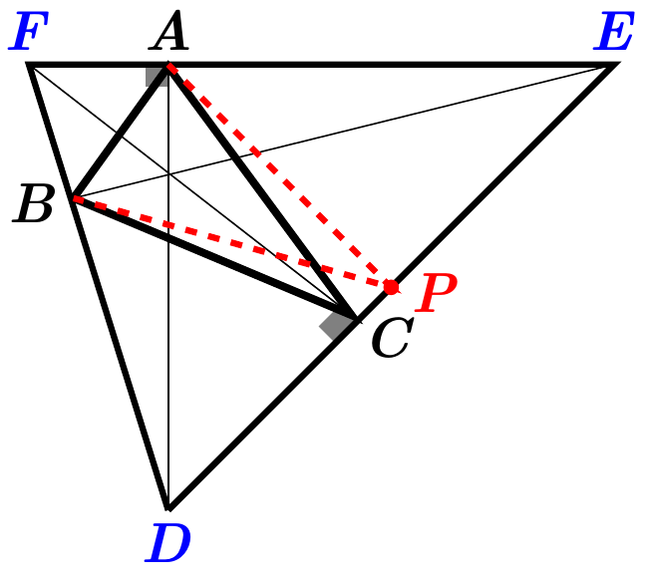 



















Then, 

Therefore, *AD* is the interior bisector of  and *FAE* is the exterior bisector.













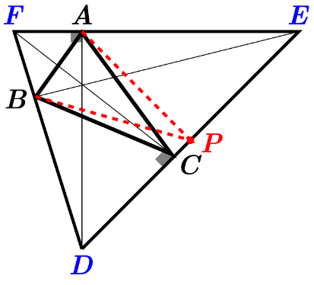















Then, 

Therefore, *BE* is the interior bisector of  and *DBF* is the exterior bisector.

***Exercise* 31**

Consider a point *O* on a vertical line , a point *M* outside the line . We take the symmetries  and  from *M* across the line  and the point *O*, respectively.

Demonstrate that the points  and are symmetries with regard to a line perpendicular to the line  passing through the point *O*.

***Solution***

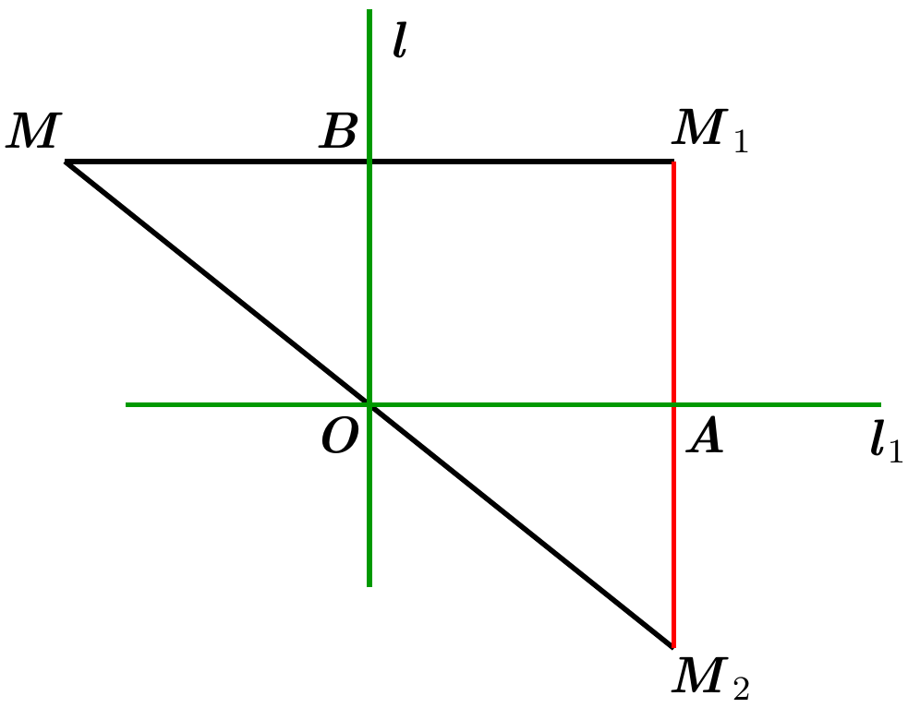

Since  is the symmetry of *M* across the line , let *B* the middle point of the segment .

That implies to: .

Similarly, the point *O* is the middle point of the segment .

That implies to: .

Let *A* be the point intersection of the segment  and line .

Since  and  

From the right triangle Since O is the middle of  and .

Therefore, the point *A* the middle point of the segment 

***Exercise* 32**

In a quadrilateral *ABCD* (*Kite*), the sides , and .

1. Prove the symmetry in the figure.
2. Prove that the middles of the sides are the top of rectangle.
3. Prove there exists an interior of the given quadrilateral a point equidistant of 4 sides; determine these points.
4. On the same exterior bisector of angles *A, B, C, D*; they formed a quadrilateral

***Solution***

1. 



Since , then the side *AC* is the bisector of .

The 2 right triangles *ABC* & *ADC* are rights on *B* and *D* respectively, with same hypothenuse *AC,* therefore the figure is symmetric about the side *AC*.

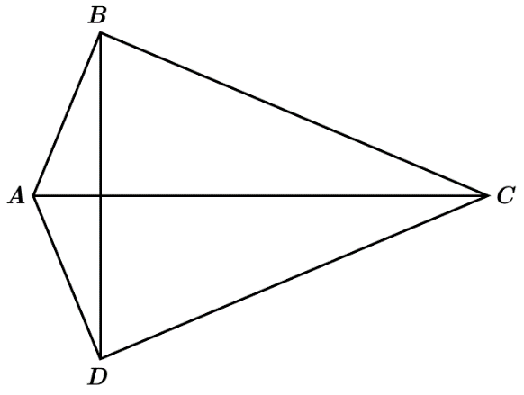















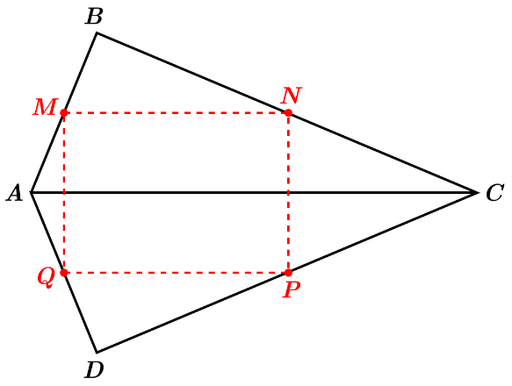 

1. Since , then the triangle *BAD* is isosceles.

Let *M* and *Q* the middle points of the sides *AB* and *AD* respectively.

Therefore, the segment .

Similar, the triangle BCD is isosceles, since .

Let *N* and *P* the middle points of the sides *CA* and *CD* respectively.

Therefore, the segment .

The points *M* and *N* are the middle points of the sides *AB* and *CB* respectively in the right triangle *ABC*.

Therefore, the segment .

The points *P* and *Q* are the middle points of the sides *DC* and *DA* respectively in the right triangle *ADC*.

Therefore, the segment .



That implies to  and , which implies that *MNPQ* is a parallelogram.

From the quadrilateral *ABCD*, 

Therefore, *MNPQ* is rectangular.

1. Let the point *O* be the middle point of the segment *AC*.

Given that the 2 right triangles *ABC* & *ADC* have the same hypothesis segment *AC*.

The 4 point are inscribed in a circle with diameter *AC* where the radius is:



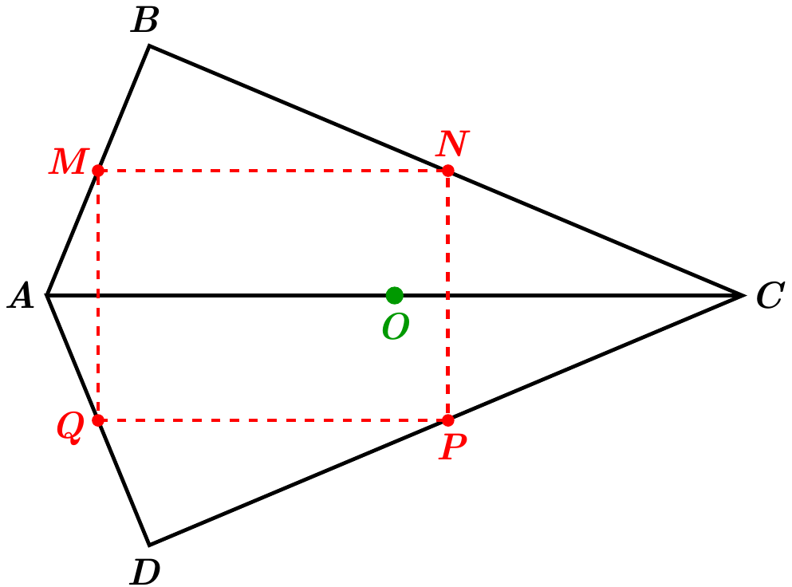

Therefore, the point *O* is an interior of the given quadrilateral which is a point equidistant of 4 sides.

1. Let two segments pass through the points *A* and *C* perpendicular to the segment *AC*, which are parallel to segment *BD*.

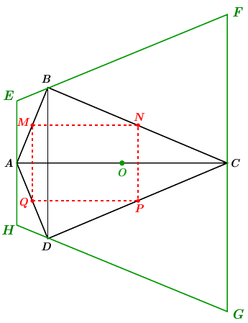

Let the segment *EF* passes through the point *B* such that:































***Exercise* 33**

Given an isosceles triangle *ABC* with a peak at *A* with angle of .

The height of a triangle *ABC* of each of the three lines passing through a vertex of the triangle and perpendicular to the opposite side to this vertex, are *AM*, *BN*, *CP*.

What is the angle of the peak of the isosceles triangle *MNP* ?

***Solution***

The triangle *ABC* is isosceles triangle at *A* then the height *AM* is the bisector. So, the point *M* is the middle point of the side *BC*.

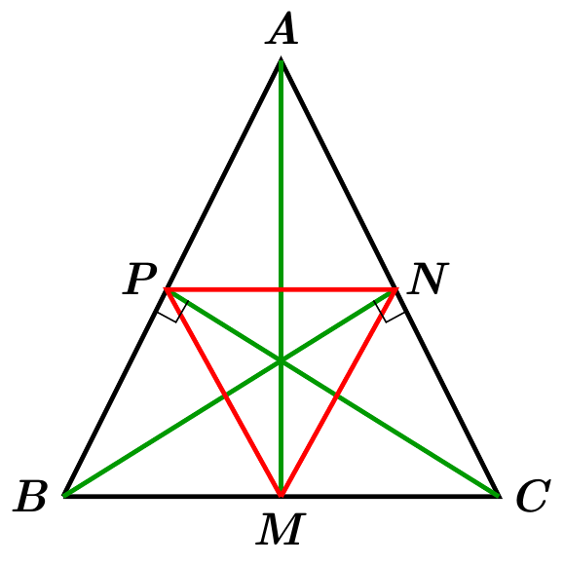

Since the 2 right triangles *BPC* & *BNC* have the same hypothesis segment *BC*.

There are inscribed in a circle with diameter *BC* with the center at point *M*.

Therefore, the triangle *MNP* is isosceles with a peak at the point *M*.





















***Exercise* 34**

The angles *A*, *B*, and *C* of a triangle are:



Let the point *H* be the intersection point of the heights of the triangle *ABC*.

The bisectors inside the triangle *BHC* intersect at a point *O*.

Find the angles: 

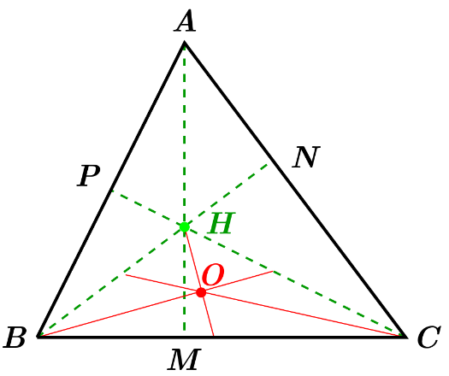***Solution***

Triangle *BNC*:







Triangle *BPC*:







Triangle *BHC*:



















Triangle *BOC*:













Triangle *BHO*:







***Exercise* 35**

On the sides of an angle *A*, where the longest of  is 

1. Prove that 
2. Let a point *I* be the intersection of the sides  and . Prove that  and .
3. Prove that the point *I* is located on the bisector of angle *A*.

***Solution***

1. 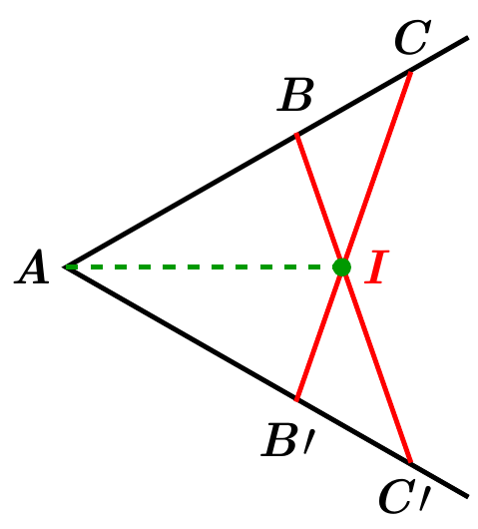From the 2 triangles  and , they have common:

* Common angle *A*.
* 
* 

The 2 triangles are equivalent.

Therefore, that implies to .

1. From the 2 triangles  and .

* 
* 
* 

That implies to the 2 triangles  and  are equivalent

Therefore,  and 

1. Consider the 2 triangles  and 

* 
* 
* Common side

That implies to



Therefore, *AI* is the ***bisector*** of angle *A*.

***Exercise* 36**

Given two adjacent angles of ,  and .

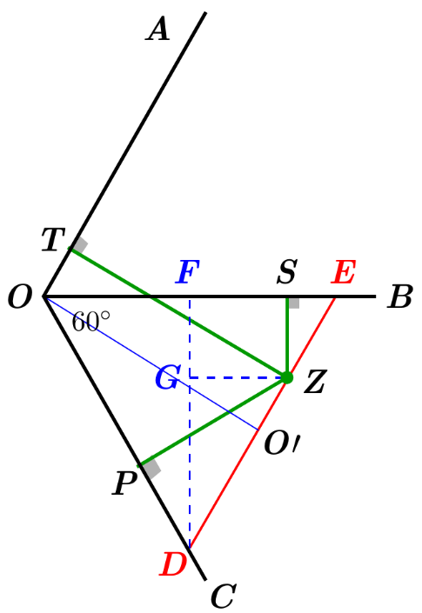A point *Z* is located inside the angle , where leads the perpendicular *ZP, ZT, ZS* on *OC, OA*, and *OB*.

Prove that 

***Solution***

Let the segment *DE* passing through the point *Z* and parallel to *OA*.

So that,







And it is given that



Which implies that the triangle *ODE* is equilateral.

Let *OF* perpendicular to the side *OE*.

And since all the heights in the equilateral *ODE* triangle are equals .

Since side *ZT* is perpendicular to the line *OA*, then the points  is a rectangle with



That implies to 

Let the point *G* on the segment *DF* such that *ZG* perpendicular to *DF* and  from the rectangle *ZSFG*.

From the right triangle *DGZ* at *G*.

 (from the equilateral *ODE* triangle).



Consider the 2 right triangles *DPZ* and *DGZ*, they have

* *ZD* common hypothenuse
* **
* **

That imply to 







***Exercise* 3**

***Solution***