***Lecture Two***

***Section* 2.1 – Real Vectors Spaces**

The vector spaces are denoted by . Each space  consists of a whole collection of vectors.

***Definition***

The space  consists of all column vectors *v* with *n* components.

***Example***



The one-dimensional space  is a line (like the *x*-axis)

The two essential vector operations go on inside the vector space that we can add any vectors in , and we can multiply any vector by any scalar. The ***result*** stays in the space.

A real vector space is a set of “***vectors***” together with rules for vector addition and for multiplication by real numbers. The addition and the multiplication must produce vectors that are in the space.

Here are three other spaces other than :

**M** The vector space of ***all real 2 by 2 matrices***.

**F** The vector space of ***all real functions*** .

**Z** The vector space that consists only of a ***zero vector***.

The zero vector in  is the vector (0, 0, 0).

***Definition***

Let *V* be an arbitrary nonempty set of objects.

If ***u***, ***v***, and ***w*** are vectors in , and if ***k*** and ***m*** are scalars, then

1. If ***u*** and ***v*** are objects in *V*, then  is in *V*.
2. 
3. 
4. There is an object **0** in *V*, called a ***zero vector*** for *V*, such that 
5. For each ***u*** in *V*, there is an object −***u*** in *V*, called a ***negative*** of ***u***, such that 
6. If *k* is any scalar and ***u*** is any object in *V*, then k***u*** is in *V*.
7. 
8. 
9. 
10. 
11. 

**The *Zero* Vector Space**

Let V consist of a single object, which we denote by 0, and define



**Vector Space of Infinite Sequences of Real Numbers**







***Exercises*** ***Section* 2.1 – Real Vectors Spaces**

1. We are given three different vectors . Construct a matrix so that the equations  and  are solvable, but is not solvable.
2. How can you decide if this possible?
3. How could you construct A?
4. For which vectors  do these systems have a solution?
5. 
6. 
7. 
8. Let *V* be the set of all ordered pairs of real numbers, and consider the following addition and scalar multiplication operation on 

 

1. Compute  and  for ***u*** = (0, 4), ***v*** = (1, −3), and *k* = 2.
2. Show that (0, 0) **≠ 0**.
3. Show that (−1, −1) = 0.
4. Show that  for 
5. Find two vector space axioms that fail to hold.

***Section* 2.2 – Subspaces**

***Subspaces***

***Definition***

A subset *W* of a vector space *V* is called a ***subspace*** of *V* if *W* itself a vector space under the addition and scalar multiplication defined in *V*.

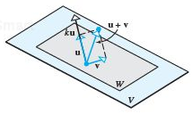

***Theorem***

If *W* is a set of one or more vectors in a vector space *V*, then *W* is a subspace of *V* iff the following conditions holds

1. If ***u*** and ***v*** are vectors in *W*, then ***u*** + ***v*** is in *W*.
2. If *k* is any scalar and ***v*** is any vector in *W*, the  is in the subspace in *W*.

* The most fundamental ideas in linear algebra are that the plane is a subspace of the full vector space .
* Every subspace contains the zero vector. The plane vector in  has to go through (0, 0, 0).

From rule (**2**), if we choose  and the rule requires  to be in the subspace.

The ***axioms*** that are ***not*** inherited by *W* are

Axiom 1 – Closure of *W* under addition

Axiom 4 – Existence of a zero vector in *W*

Axiom 5 – Existence of a negative in *W* for every vector in *W*

Axiom 6 – Closure of *W* under scalar multiplication

***Example***

Keep only the vectors  whose components are positive or zero (first quadrant ***“quarter-plane”***). The vector  is included but  is not. So rule (***2***) is violated when we try . ***The*** ***quarter-plane is not a subspace***.

***Example***

Include also the vectors whose components are both negative. Now we have two quarter-planes. Rule (***ii***) satisfies when we multiply by any *c*. But rule (***i***) fails. The sum of and is  which is outside the quarter-plane. ***Two*** ***quarter-planes don’t make a subspace***.

***Example***

The **Subspace** 

There is a theorem in calculus which states that a sum of continuous functions is continuous and tha a constant times a continuous frunction is continuous. In vector word, the set of continuous functions on  is a subspace of . We dente this subspace by 

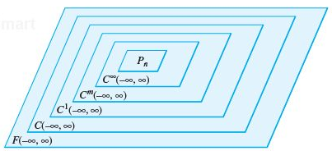

***Theorem***

If  are subspaces of a vector space *V*, then intersection of these subspaces is also a subspace of *V*.

* ***A subspace containing v and w must contain all linear combination*** ***.***

***Example***

Inside the vector space M of all 2 by 2 matrices, given two subspaces:

**U** all upper triangular matrices 

**D** all diagonal matrices 

*Solution*

If we add 2 matrices in **U**:  is in **U**.

If we add 2 matrices in **D**:  is in **D**.

In this case **D** is also a subspace of **U**!. The zero matrix is in these subspaces, when *a*, *b*, and *d* all equal zero.

***Span***

***Definition***

The subspace of a vector space *V* that is formed from all possible linear combinations of the vectors in a nonempty set *S* is called the ***span of S***, and we say that the vectors in *S* *span* that subspace. If , then we denoted the span of S by



***Theorem***

Let  be vectors in vector space *V* and *S* be their span. Then,

1. *S* is a subspace of *V*.

***Proof***: ,  and 





1. *S* is the smallest subspace of *V* that contains . i.e. any other subspace *w* containing  also contains S.

***Proof***: , 

But  ∴ *w closed under scalar multiplication.*

 ∴ *w closed under addition.*



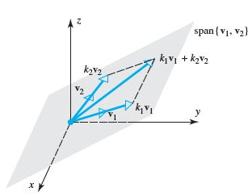

***Example***

1.  span the full two-dimensional space .
2.  span the full space .
3.  only span a line in .

***Definition***

The ***row space*** of a matrix is the subspace of  spanned by the rows.

***Example***

Determine whether  span the vector space 

*Solution*

Let  be the arbitrary vector in  can be expressed as a linear combination









The system is consistent *iff* its coefficient matrix  has a nonzero determinant.

 the  span space 

**Solution Spaces of *Homogeneous* Systems**

***Theorem***

The solution set of a homogeneous linear system *A****x*** = **0** in n unknowns is a subspace of 

***Proof***

Let *W* be the solution set for the system. The set *W* is not empty because it contains at least the trivial solution ***x*** = **0**.

To show that W is a subspace of , we must show that it is closed under addition and scalar multiplication.

Let  and  be vectors in *W* and these vectors are solution of *A****x*** = **0**.



Therefore,



So *W* is closed under addition.



So *W* is closed under scalar multiplication.

***Example***

Consider the linear system 

*Solution*





This is the equation of a plane through the origin that has ***n*** = (1, −2, 3) as a normal.

***Example***

Consider the linear system 

*Solution*



The solution space is {**0**}

***Exercises Section* 2.2 – Subspaces**

1. Suppose *S* and *T* are two subspaces of a vector space **V**.
2. The sum  contains all sums  of a vector *s* in *S* and a vector *t* in *T*. Show that  satisfies the requirements (addition and scalar multiplication) for a vector space.
3. If *S* and *T* are lines in , what is the difference between  and ? That union contains all vectors from *S* and *T* or both. Explain this statement: The span of  is .
4. Determine which of the following are subspaces of ?
5. All vectors of the form (*a*, 0, 0)
6. All vectors of the form (*a*, 1, 1)
7. All vectors of the form (*a*, *b*, *c*), where *b* = *a* + *c*
8. All vectors of the form (*a*, *b*, *c*), where *b* = *a* + *c +* 1
9. All vectors of the form (*a*, *b*, 0)
10. Determine which of the following are subspaces of ?
11. All sequences ***v*** in  of the form ***v*** = (*v*, 0, *v*, 0, …)
12. All sequences ***v*** in  of the form ***v*** = (*v*, 1, *v*, 1, …)
13. All sequences ***v*** in  of the form ***v*** = (*v*, 2v, 4*v*, 8*v*, 16*v*, …)
14. Which of the following are linear combinations of ***u*** = (0, −2, 2) and ***v*** = (1, 3, −1)?
15. (2, 2, 2)
16. (3, 1, 5)
17. (0, 4, 5)
18. (0, 0 ,0)
19. Which of the following are linear combinations of ***u*** = (2, 1, 4), ***v*** = (1, −1, 3) and ***w*** = (3, 2, 5)?
20. (−9, −7, −15)
21. (6, 11, 6)
22. (0, 0 ,0)
23. Which of the following are linear combinations of 
24. 
25. 
26. 
27. Determine whether the given vectors span 
28. 
29. 
30. 
31. Suppose that . Which of the following vectors are in span 
32. (2, 3, −7, 3)
33. (0, 0, 0, 0)
34. (1, 1, 1, 1)
35. (−4, 6, −13, 4)
36. Let  and . Which of the following lie in the space spanned by  and 
37. 
38. 
39. 
40. 

***Section* 2.3 – Linear Independence**

There are *n* columns in an *m* by *n* matrix, and each column has *m* components. But the true ***dimension*** of the column space is not necessarily *m* or *n*. The dimension is measured by counting ***independent columns***.

* **Independent vectors** (*not too many*)
* **Spanning a space** (*not too few*)
* **Basis for a space** (*not too many or too few*)
* **Dimension of a space** (*the right number of vectors*)

**Linear Independence** (**LI**)

The column of A are ***linearly independent*** when the only solution to  is . ***No other combination  of the columns gives the zero vector***.

***Definitions***

* A set of two or more vectors is ***linearly dependent*** if one vector in the set is a linear combination of the others. A set of one vector is ***linearly dependent*** if that one vector is the zero vector.



* The sequence of vectors  is ***linearly independent*** if the only combination that gives the zero vector is . Thus linear independence means that:

 only happens when all *x*’s are zero.

* A (nonempty) set of vectors is ***linearly independent*** if it is not linearly dependent.
* If three vectors  are in the same plane, they are dependent.

***Theorem***

A set S with two or more vectors  is

1. Linearly dependent *iff* at least one of the vectors in *S* is expressible as a linear combination of the other vectors in *S*. There are numbers  at least one of which is nonzero, such that 
2. Linearly independent *iff* no vector in *S* is expressible as a linear combination of the other vectors in *S*.

|  |  |  |
| --- | --- | --- |
|  |  |  |
| Independent vectors |  | Dependent vectors  The combination  is (0, 0, 0) |

***Example***

1. The vectors (1, 0) and (0, 1) are ***independent***.
2. The vectors (1, 1) and (1, 0.0001) are ***independent***.
3. The vectors (1, 1) and (2, 2) are ***dependent***.
4. The vectors (1, 1) and (0, 0) are ***dependent***.

***Example***

The column of *A* are dependent.  has a nonzero solution.



The rank of *A* is only *r* = 2.

Independent columns would give full column rank *r* = *n* = 3.

* The columns of *A* are independent exactly when the rank is *r* = *n*. There are***n*** pivots and no free variables. Only ***x* = 0** is the nullspace.

***Theorem***

1. A finite set that contains **0** is linearly dependent.
2. A set with exactly one vector is linearly independent if and only if that vector is not **0**.
3. A set with exactly two vectors is linearly independent *iff* neither vector is a scalar multiple of the other.

***Theorem***

Let *S* be a set ***k*** vectors in , then if *k* > *n*, *S* is ***linearly dependent***.

***Example***

 are 3 vectors in  ⇒ Linearly dependent.

***Example***

Determine whether the vectors  are linearly independent or linearly independent in 

*Solution*







Solve the system equations: 

This shows that the system has nontrivial solutions and hence that the vectors are linearly dependent.

***2nd method*** to determine the linearly is to compute the determinant of the coefficient matrix



 Which has nontrivial solutions and the vectors are linearly dependent.

***Example***

Determine whether the vectors are linearly independent or linearly independent in 



*Solution*





Which yields the homogeneous linear system



Solve the system equations:  has a trivial solution.

The vectors  are linearly independent.

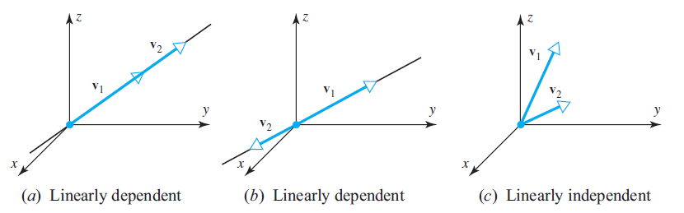

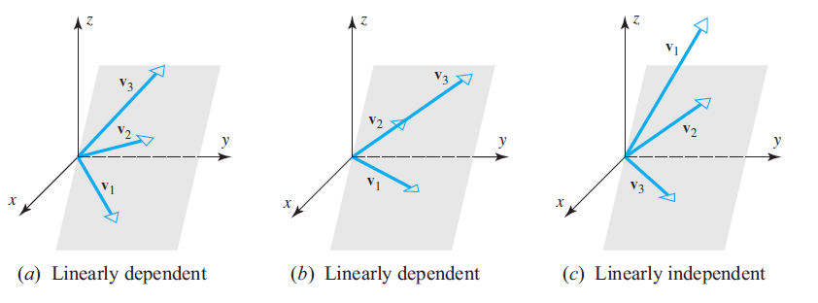

**Linear independence of Functions**

Definition

If  are functions that are *n* - 1 times differentiable on the interval (−∞, ∞), the determinant



is called the ***Wronskian*** of 

***Example***

Use the Wronskian to show that  are linearly independence

*Solution*

The Wronskian is



This function is not identically zero. Thus the functions are linearly independent.

***Example***

Use the Wronskian to show that  are linearly independence

*Solution*

The Wronskian is



Thus the functions are linearly independent.

***Exercises Section* 2.3 – Linear Independence**

1. Given three independent vectors . Take combinations of those vectors to produce . Write the combinations in a matrix form as 

 which is 

What is the test on a matrix **V** to see if its columns are linearly independent?

If  show that  are linearly independent.

If  show that  are linearly *dependent*.

1. Find the largest possible number of independent vectors among



1. Show that are independent but  are dependent:



Solve either . The *v*’s go in the columns of ***A***.

1. Decide the dependence or independence of
2. The vectors (1, 3, 2) and (2, 1, 3) and (3, 2, 1).
3. The vectors  and  and .
4. Find two independent vectors on the plane  in . Then find three independent vectors. Why not four? This plane is the nullspace of what matrix?
5. Determine whether the vectors are linearly independent or linearly independent in 
6. (4, −1, 2), (−4, 10, 2)
7. (−3, 0, 4), (5, −1, 2), (1, 1, 3)
8. (−2, 0, 1), (3, 2, 5), (6, −1, 1), (7, 0, −2)
9. Determine whether the vectors are linearly independent or linearly independent in 
10. (3, 8, 7, −3), (1, 5, 3, −1), (2, −1, 2, 6), (1, 4, 0, 3)
11. (0, 0, 2, 2), (3, 3, 0, 0), (1, 1, 0, −1)
12. (0, 3, −3, −6), (−2, 0, 0, −6), (0, −4, −2, −2), (0, −8, 4, −4)
13. *a* ) Show that the three vectors  form a linearly dependent set in .

*b*) Express each vector in part (*a*) as a linear combination of the other two.

1. For which real values of λ do the following vectors form a linearly dependent set in 



1. Show that if  is a linearly independent set of vectors, then so is every nonempty subset of S.
2. Show that if  is a linearly dependent set of vectors in a vector space *V*, and if  are vectors in *V* that are not in *S*, then  is also linearly dependent.
3. Show that  is linearly independent and  does not lie in span , then  is a linearly independent.
4. By using the appropriate identities, where required, determine  are linearly dependent.
5. 
6. 
7. 
8. 
9.  are linearly independent in  because neither function is a scalar multiple of the other. Confirm the linear independence using Wroński’s test.
10. Use the Wronskian to show that  span a three-dimensional subspace of 

***Section* 2.4 – Coordinates and Basis**

**Coordinate Systems in Linear Algebra**

In ***analytic geometry***, we use rectangular coordinate systems to create a point either in 2-space or 3-space

|  |  |
| --- | --- |
| ***Coordinates of P in a rectangular coordinate system in* 2*-space*** | ***Coordinates of P in a rectangular coordinate system in* 3*-space*** |

|  |  |
| --- | --- |
| ***Coordinates of P in a nonrectangular coordinate system in* 2*-space*** | ***Coordinates of P in a nonrectangular coordinate system in* 3*-space*** |

In ***linear algebra*** coordinate systems are commonly specified using vectors rather than coordinate axes.



***Basis***

***Definition***

If *V* is any vector space and  is a finite set of vectors in *V*, then *S* is called a ***basis*** for *V* if the following two conditions hold:

1. *S* is linearly independent.
2. *S* spans *V*.

***Example***

The columns of  produce the “standard basis” for .

*Solution*

The basis vectors:  are independent. They span .

***Example***

The columns of any invertible *n* by *n* matrix give a basis for .



***Example***

The standard unit vectors  form a basis in .

*Solution*

1.  it follows that . That implies they are linearly independent.
2. Every vector  in  can be expressed as  which is linear combination of  . Thus the standard vector span 

Thus, they form a basis for  that we call the ***standard basis*** for .

***Example***

Show that the vectors  form a basis in 

*Solution*

1. We need to show that the vectors are linearly independent.





Which yields the homogeneous linear system





 has a trivial solution.

The vectors  are linearly independent.

1. Every vectors can be expressed as  which is linear combination of . Thus the standard vector span 

That proves that the vectors  form a basis in 

* The vectors  are a basis for  exactly when they are the ***columns*** of an ***n* by *n* *invertible matrix***. Thus  has infinitely many different bases.
* ***The pivots columns of A are a basis for its column space***. The pivot rows of *A* are a basis for its row space. So are the pivot rows of its echelon form *R*.

***Example***

Find bases for the column and row spaces of a rank two matrix: 

*Solution*

Columns 1 and 3 are the pivot columns. They are a basis for the column space. It is a subspace of .

Column 2 and 3 are a basis for the same column space.

**Coordinates Relative to a Basis**

***Theorem* − Uniqueness of Basis Representation**

If  is a basis for a vector space *V*, then every vector ***v*** in *V* can be expressed in the form  in exactly one way.

***Proof***

Suppose that some vector ***v*** can be written as



Also 

Subtracting the second from the first equation



Since the right side of this equation is a linear combination of vectors in *S*, the linear independence of *S* implies that



That implies 

Thus, the two expressions for ***v*** are the same.

***Definition***

If  is a basis for a vector space *V*, and 

is the expression for a vector ***v*** in terms of the basis **S**, then the scalars  are called coordinates of ***v*** relative to the basis *S*. The vector  in  constructed from these coordinates is called ***coordinate vector of v relative to S***; it is denoted by



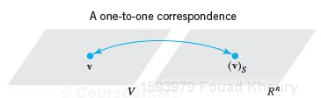

***Example***

1. Given the vectors  form a basis for . Find the coordinate vector of  relative to the basis .
2. Find the coordinate vector of in  whose coordinate relative to S is .

*Solution*

1. To find  we must first express ***v*** as a linear combination of the vectors in *S*;





Which gives:



Solving this system, we obtain . Therefore 

1. 





***Exercises*** ***Section* 2.4 – Coordinates and Basis**

1. Suppose  is a basis for  and the n by n matrix *A* is invertible. Show that  is also a basis for .
2. Consider the matrix 
3. Which vectors  will make the columns of ***A*** linearly dependent?
4. Which vectors  will make the columns of ***A*** a basis for ?
5. For , compute a basis for the four subspaces.
6. Find a basis for  in .

Find a basis for the intersection of that plane with *xy* plane. Then find a basis for all vectors perpendicular to the plane.

1. **U** comes from ***A*** by subtracting row 1 from row 3:



Find the bases for the two column spaces. Find the bases for the two row spaces. Find bases for the two nullspaces.

1. Write a 3 by 3 identity matrix as a combination of the other five permutation matrices. Then show that those five matrices are linearly independent. (Assume a combination gives , and check entries to prove is zero.) The five permutation matrices are a basis for the subspace of 3 by 3 matrices with row and column sums all equal.
2. Choose three independent columns of . Then choose a different three independent columns. Explain whether either of these choices forms a basis for .
3. Which of the following sets of vectors are bases for ?
4. 
5. 
6. Which of the following sets of vectors are bases for ?
7. 
8. 
9. 
10. Let *V* be the space spanned by 
11. Show that  is not a basis for *V*.
12. Find a basis for *V*.
13. Find the coordinate vector of ***w*** relative to the basis  for 
14. 
15. 
16. 
17. 
18. 
19. Find the coordinate vector of ***v*** relative to the basis 
20. 
21. 
22. Show that  is a basis for , and express *A* as a linear combination of the basis vectors
23. 
24. 

***Section* 2.5 – Dimension**

***Dimension***

If  and  are both bases for the same vector space, then *m* = *n*.

***Note***

***V*** may have many different bases, but they all must have the same number of elements.

***Proof***

Let **S** and **W** be bases of **V** can be written as a linear combination of vectors in **S**.



But since **V** is a basis, (to be linearly independent, otherwise to be linearly dependent with at least 1 of t)







∴  linear independent.

Now all bases of **V** have some number of elements, we can define the dimension (is # of vectors in a basis)

***Definition***

The dimension of a finite-dimensional vector space *V* is denoted by dim(*V*) and is defined to be the number of vectors in a basis for *V*. in addition, the zero vector space is defined to have dimension zero.

1. Dim(**V**) = # elements in basis. If **V** is finite.
2. If , then Dim(**V**) = 0, even though there is no basis.
3. Dim(**V**) may be infinite.

*  **The standard basis has *n* vectors**.
*  **The standard basis has *n +* 1 vectors**.
*  **The standard basis has *mn* vectors**.

**Bases for Matrix Spaces *and Function Spaces***

Independence, basis, and dimension are not all restricted to column vectors.

* The dimension of the whole *n* by *n* space is 
* The dimension of the subspace of upper triangular matrices is 
* The dimension of the subspace of diagonal matrices is 
* The dimension of the subspace of symmetric matrices is 

***Function Spaces***

The equations:

 is solved by any linear function 

 is solved by any combination 

 is solved by any combination 

***Example***

Find a basis for and the dimension of the solution space of the homogeneous system



*Solution*



The solution 



The solution space has dimension 2.

**Plus/Minus Theorem**

***Theorem***

Let *S* be a nonempty set of vector space *V*.

1. If *S* is a linearly independent set, and if **v** is a vector in *V* that is outside of span(S), the set  that results by inserting **v** into *S* is still linearly independent.
2. If **v** is a vector in *S* that is expressible as a linear combination of other vectors in *S*, and if  denotes the set obtained by removing **v** from *S*, then *S* and  span the same space; that is,



|  |  |  |
| --- | --- | --- |
| Untitled.png | | |
| The vector outside the plane can be adjoined to the other two without affecting their linear independence | Any of the vectors can be removed, and the remaining two still span the plane | Either of the collinear vectors can be removed, and the remaining two will still span the plane |

***Theorem***

If *W* is a subspace of a finite-dimensional vector space *V*, then

1. *W* is finite-dimensional
2. 
3.  if and only if 

***Exercises Section* 2.5 – Dimension**

1. Consider the eight vectors



1. List all of the one-element. Linearly dependent sets formed from these.
2. What are the two-element, linearly dependent sets?
3. Find a three-element set spanning a subspace of dimension three, and dimension of two? One? Zero?
4. Which four-element sets are linearly dependent? Explain why.
5. Find a basis for the solution space of the homogeneous linear system, and find the dimension of that space
6. 
7. 
8. 
9. 
10. If  for the shift matrix *S*. Show that ***A*** must have this special form:





“The subspace of matrices that commute with the shift *S* has dimension ______.”

1. Find bases for the following subspaces of 
2. All vectors of the form (*a, b, c*, 0)
3. All vectors of the form (*a, b, c*, *d*), where *d* = *a + b* and *c = a – b*.
4. All vectors of the form (*a, b, c*, *d*), where *a = b* = *c = d*.

***Section* 2.6 – Row Space, Column Space, and Null Space**

***Definition***

For an  matrix



The vectors



In  that are formed from the rows of *A* are called the ***row vectors*** of *A*, and the vectors



In  that are formed from the rows of *A* are called the ***column vectors*** of *A*.

***Definition***

If *A* is  matrix, then the subspace of  spanned by the row vectors of *A* is called the ***row space*** of *A*, and the subspace  spanned by the row vectors of *A* is called the ***column space*** of *A*. The solution space of the homogeneous system of equations , which is a subspace of  , is called the null space of *A*.

**The *Column Space* of *A***

The most important subspaces are tied directly to a matrix *A*, to solve .

***Definition***

The column space consists of all linear combinations of the columns. The combination are all possible vectors . They fill the column space .



 

To solve  is to express *b* as a combination of the columns.

The column space  is a plane that containing the two columns.  is solvable when *b* in on that plane.

* The system  is solvable if and only if *b* is in the column space of A.

***Example***

Describe the column spaces (they are subspaces of ) for



*Solution*

The column space of *I* is the whole space . Every vector is a combination of the columns of *I*. In the space language .

The column space of *A* is only a line, the second column (2, 4) is a multiple of the first column (1, 2) and (2, 4) and all other vectors  along that line. The equation  is only solvable when *b* is on the line.

The column space  is all of . Every b is attainable. The vector  is summation of column 1 and 2.

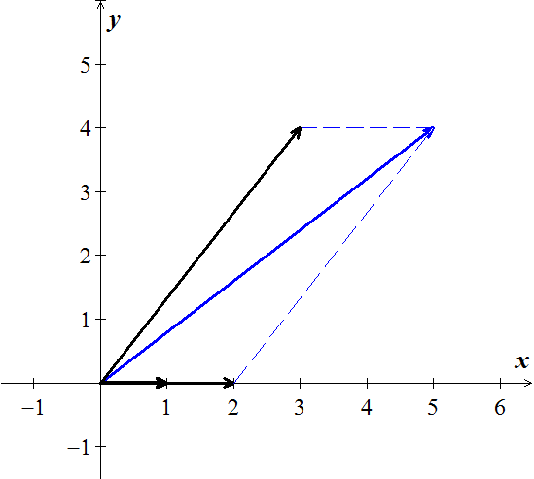









This matrix has the same column as *I* and any *b* is allowed. ***x*** has an extra component (more solutions)

***Complete Solution to ***

To solve , we need to put into an ***augmented*** form where ***b*** is not zero.

  





The augmented matrix is just 





**One *Particular* Solution**

  



The free variable for *R* to be .

Then the equations give the pivot variables 

The particular solution is: 

The two special (nullspace) solutions to :





 

The complete solution:





* ***The particular solution solves:*** 
* ***The***  ***special solutions solve:*** 

***Example***

Suppose *A* is a square invertible matrix, ******. What are and***?***

*Solution*

The particular solution is the one and only solution . There are no special solutions or free variables.  has no zero rows. The only vector in the null space is . The complete solution is 

***Example***

Find the condition on  for  to be solvable, if



*Solution*

The augmented form:





The last equation is 0 = 0 provided .

There are no free variables and no special solutions. The nullspace solution: 

The complete solution:



If , there is no solution to  and  doesn’t exist.

* ***Full column rank*** 
* Every matrix *A* with ***full column rank*** (*r* = *n*) has all these properties:

1. All columns of *A* are pivot columns
2. There are no free variables or special solutions.
3. The nullspace *N*(*A*) contains only the zero vector ***x* = 0**.
4. If  has a solution (might not) then it has only one solution.

**The *General* Solution**

***Example***

There are *n* = 3 unknowns but only two equations. The rank is *r* = *m* = 2.



*Solution*



The particular solution has free variable .  

The special solution has 

 

The complete solution:





* Every matrix *A* with ***full row rank*** (*r* = *m*) has all these properties:

1. All rows have pivots and *R* has no zero rows.
2.  has a solution for every right side ***b***.
3. The column space is the whole space .
4. There are *n – r* = *n – m*. special solutions in the nullspace of *A*.

***Example***

1. Find a subset of the vectors



That forms a basis for the space spanned by these vectors

1. Express each vector not in the basis as a linear combination of the basis vectors

*Solution*

1. Construct the vectors as its column vectors



By using ***rref***:



The leading 1’s occur in columns 1, 2, and 4,  is a basis for the column space, and consequently 

1. 





We call these ***dependency equations***

The corresponding relationships are:





***Exercises*** ***Section* 2.6 – Row Space, Column Space, and Null Space**

1. List the row vectors and column vectors of the matrix



1. Express the product A***x*** as a linear combination of the column vectors of *A*.
2. 
3. 
4. Determine whether ***b*** is in the column space of *A*, and if so, express ***b*** as a linear combination of the column vectors of *A*.
5. 
6. 
7. 
8. Suppose that  is a solution of a nonhomogeneous linear system A***x*** = ***b*** and that the solution set of the homogeneous system A***x*** = **0** is given by the formulas 
9. Find a vector form of the general solution of A***x*** = **0**
10. Find a vector form of the general solution of A***x*** = ***b***
11. Find the vector form of the general solution of the given linear system A***x*** = ***b***; then use that result to find the vector form of the general solution of A***x*** = **0**.
12. 
13. 
14. 
15. Find a basis for the null space of A.
16. 
17. 
18. 
19. Find a basis for the subspace of spanned by the given vectors
20. 
21. 
22. *a*) Let



Show that relative to an *xyz*-coordinate system in 3-space the null space of A consists of all points on the *z*-axis and that the column space consists of all points in the *xy*-plane.

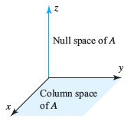

*b*) Find a 3 x 3 matrix whose null space is the *x*-axis and whose column space is the *yz*-plane.

1. Given the vectors  and 
2. Are they linearly independent?
3. Are they a basis for any space?
4. What space **V** do they span?
5. What is the dimension of that space?
6. What matrices ***A*** have **V** as their column space?
7. Which matrices have **V** as their nullspace?
8. Describe all vectors  that complete a basis for .

***The subspace requirements:  and  (and then all linear combinations) must stay in the subspace.***

1. Which of the following subsets of are actually subspaces?
2. The plane of vectors  with 
3. The plane of vectors with .
4. The vectors with .
5. All linear combinations of  and .
6. All vectors that satisfies 
7. All vectors with .
8. True or False (check addition or give a counterexample)
9. The symmetric matrices in *M*  from a subspace.
10. The skew-symmetric matrices in *M*  from a subspace.
11. The un-symmetric matrices in *M*  from a subspace.
12. Invertible matrices
13. Singular matrices
14. If we add an extra column b to a matrix *A*, then the column space gets larger unless _____. Give an example where the column space gets larger and an example where it doesn’t. Why is  solvable exactly when the column space doesn’t get larger – it is the same for *A* and ?
15. For which right sides (find a condition on ) are these solvable. (Use the column space  and the equation )
16. 
17. 
18. Show that the matrices *A* and  (with extra columns) have the same column space. But find a square matrix with  smaller than . Important point: An *n* by *n* matrix has  exactly when A is an ______ matrix.
19. The column of *AB* are combinations of the columns of *A*. This means: The column space of *AB* is contained in (possibly equal to) to the column space of *A*. Give an example where the column spaces *A* and *AB* are not equal.
20. Find a square matrix *A* where  (the column space of  is smaller than .
21. Suppose  and  have the same (complete) solutions for every ***b***. Is true that ?
22. Apply Gauss-Jordan elimination to  and . Reach  and :

 

Solve  to find  (its free variable is ).

Solve  to find  (its free variable is ).

***Section* 2.7 – Rank, Nullity, and the Fundamental Matrix Spaces**

The **R**educed **R**ow **E**chelon **F**orm (***rref***) is a matrix (*R*) with each pivot column has only one nonzero entry (the pivots which is always 1).





***Rank of a Matrix***

The rank of a matrix *A* (***m*** by ***n***) is the number of ***nonzero rows*** in the row-reduced echelon form of *A* (it is the number of pivot). The common dimension of the row space and column space of a matrix *A* is called the ***rank*** of *A* and is denoted by



***Note:***

The rank of a matrix is well defined due to the uniqueness of the row-reduced echelon form. No matter what sequence of elementary row operations is performed to put the given matrix in row-reduced echelon form; there will always be the same number of nonzero rows.

***Theorem***

The row space and column space of a matrix A have the same dimension

The objective is to connect ***rank*** and ***dimension***.

* The ***rank*** of a matrix is the number of pivots.
* The ***dimension*** of a subspace is the number of vectors in a basis.
* ***A has full row rank if every row has a pivot:*** ***. No zero in R.***
* ***A has full column rank if every column has a pivot:*** ***. No free variables.***

***Example***

Find the rank of 

*Solution*

Use the calculator



The matrix *R* has 2 nonzero rows, therefore the 

***Example***

When all rows are multiplies of one pivot row, the rank is :



*Solution*

The row-reduced echelon form :



These matrices have only one pivot.

**Dimension *Theorem* for Matrices**

If A is a matrix with *n* columns, then



***Theorem***

If A is an  matrix, then

* *rank*(A) = the number of leading variables in the general solution of A***x*** = **0**
* *nullity*(A) = the number of parameters in the general solution of A***x*** = **0**

***Theorem***

If A is any matrix, then 

***Definition***

If *W* is a subspace of  that are orthogonal to every vector in *W* is called orthogonal complement of *W* and is denoted nu the symbol 

 is exactly the row space 

***Fundamental Theorem of Linear Algebra***

The nullspace is the orthogonal complement of the row space .

The left nullspace is the orthogonal complement of the column space .

If *W* is a subspace of 

*  is a subspace of 
* The only vector common to *W* and  is 0.
* The orthogonal complement of  is *W*.

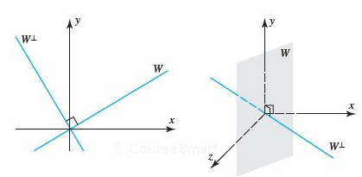

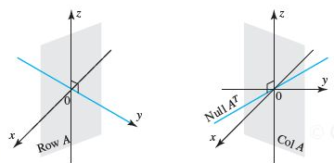



Two pairs of orthogonal subspaces.

**Combining Bases from Subspaces**

* Any *n* linearly independent vectors in  must span . They are basis. Any *n* vectors that span  must be independent. They are a basis.
* If the *n* columns of ***A*** are independent, they span , So ***A****x = b* is solvable,
* If the *n* columns span , they are independent. So ***A****x = b* has only one solution.



* When the orthogonal complement of a subspace *S* is defined to be the subspace whose vectors pairs to zero with the vectors in *S*. The larger the *S* is, the more restriction  has, and hence the smaller  is.

***Theorem*** − ***Equivalent Statements***

If A is an  matrix, then the following statements are equivalent.

1. A is invertible
2. A***x*** = **0** has only the trivial solution
3. The reduced row echelon form of A is 
4. A is expressible as a product of elementary matrices
5. A***x*** = ***b*** is consistent for every  matrix ***b***
6. A***x*** = ***b*** has exactly one solution for every  matrix ***b***
7. 
8. The column vectors of A are linearly independent
9. The row vectors of A are linearly independent
10. The column vectors of A span 
11. The row vectors of A span 
12. The column vectors of A form a basis for 
13. The row vectors of A form a basis for 
14. A has a rank *n*.
15. A has nullity 0.
16. The orthogonal complement of the null space of A is 
17. The orthogonal complement of the row space of A is 

***Pivot Columns***

The pivot columns of *R* have 1’s in the pivots and 0’s everywhere else.

Pivot columns: 

Yields to: 

* ***The pivot columns are not combinations of earlier columns. The free columns are combinations of columns which are the special solutions!***

**Special Solutions**

Each special solution to and  has one free variable equal to1.



The free variables are



1. Set  **(*Column 2*)**

The special solution: 

1. Set  **(*Column 4*)**

The special solution: 

1. Set  **(*Column 5*)**

The special solution: 

The nullspace matrix *N* contains the 3 special solutions in its columns.



The linear combinations of these three columns give all vectors in the nullspace.

*  ***has***  ***free variables and special solutions: n columns minus r pivot columns. The null matrix N has***  ***columns (the special solutions).***

The reduced row echelon form looks like:



The pivot variables in the  special columns come by changing *F* to –*F*:

Nullspace matrix: 

***Example***

The special solutions to  are the columns of N:



***Definition***

The nullspace of *A* consists of all solutins to . These solution vectors *x* are in . The Nullspace containing all solutions is denoted by .

 is the nullspace of *A*, 

(Can also be called ***Kernel*** of *A*)

***Theorem***

Suppose  is a subspace of  for 

* Let *x* and *y* are in the nullspace  then 
* Let  then  

Since we can add and multiply without leaving the Nullspace, it is a subspace.

***Example***

The equation  comes from the 1 by 3 matrix . This equation produces a plane through the origin. The plane is a subspace of . *It is the Nullspace* of *A*.

*Solution*

The solution to  also form a plane, but not a subspace.

***Example***

Describe the nullspace of 

*Solution*

Apply the elimination to the linear equations :



There is only one equation , this line is the Nullspace .

***Example***

Describe the nullspaces of these three matrices *A, B, C*:

  

*Solution*





The equation  has only the zero solution . The nullspace is ***Z***. It is the single point in .

The rectangular matrix *B* has the same nullspace (***Z***). The first two equations (rows) require . The last two  would also force .

The rectangular matrix *C* is different, more columns than rows. The solution vector ***x*** has 4 components.



Column 2 and 4:



Column 2 and 4:



We get 2 special solutions in the Nullspace of *C* (and also in *U*).

**Solving  by elimination**

Matrix *A* is rectangular and we still use the elimination.

1. Forward elimnation from *A* to a triangular *U*.
2. Back substitution in  to find *x*.

Consider the matrix 





***Triangular*** ***U***: 

***P***: The ***pivot*** variables are , since columns 1 and 3 contains pivots.

***F***: The ***free*** variables are , since columns 2 and 4 have no pivots.

Special solutions to:



Complete solution: 

The special solution are in the nullspace , and their combinations fill out the whole Nullspace.

***Definition***

Let *V* and *W* be vector spaces over the field *F* and let *T* be the linear transformation from *V* into *W*. The null space of *T* is the set of all vectors α in *V* such that .

***Example***

Compute  for  given by 

*Solution*

To find , we must solve the equation 



Thus , the set that consists solely of the zero vector.

* If  has more unknowns than equations (more columns than rows) then it has nonzero solutions. There must be free columns, without pivots.

***For an m x n matrix of rank r:***

|  |  |  |
| --- | --- | --- |
| ***Fundamental Space*** | ***Subspace of*** | ***Dimension*** |
| Nullspace |  | *n – r* |
| Column Space |  | *r* |
| Row space |  | *r* |
| Left nullspace |  | *m – r* |

***Exercises*** ***Section* 2.7 – Rank, Nullity, and the Fundamental Matrix Spaces**

1. Verify that 



1. Find the rank and nullity of the matrix; then verify that the values obtained satisfy 
2. 
3. 
4. 
5. If *A* is an  matrix, what is the largest possible value for its rank and the smallest possible value of the nullity of *A*.
6. Discuss how the rank of *A* varies with *t*.

*a*)  b) 

1. Are there values of *r* and *s* for which



Has rank 1? Has rank 2? If so, find those values.

1. Find the row reduced form *R* and the rank *r* of *A* (those depend on *c*).

Which are the pivot columns of *A*? Which variables are free? What are the special solutions and the nullspace matrix *N* (always depending on *c*)?



1. Find the row reduced form *R* and the rank *r* of *A* (those depend on *c*).

Which are the pivot columns of *A*? Which variables are free? What are the special solutions and the nullspace matrix *N* (always depending on *c*)?



1. If *A* has a rank *r*, then it has an *r* by *r* sub-matrix *S* that is invertible. Remove  rows and columns to find an invertible sub-matrix *S* inside each *A* (you could keep the pivot rows and pivot columns of *A*).



1. Suppose that column 3 of 4 x 6 matrix is all zero. Then must be a ______ variable. Give one special solution for this matrix.
2. Fill in the missing numbers to make *A* rank1, rank 2, rank 3.(your solution should be 3 matrices)



1. Fill out these matrices so that they have rank 1:



1. Suppose *A* and *B* are *n* by *n* matrices, and *AB* = *I*. Prove from  that the . So *A* is invertible and *B* must be its two-sided inverse. Therefore *BA* = *I* (which is not so obvious!).
2. Every *m* by *n* matrix of rank *r* reduces to (*m* by *r*) times (*r* by *n*):

*A* = (pivot columns of *A*) (first *r* rows of *R*) 

Write the 3 by 4 matrix  as the product of the 3 by 2 from the pivot columns and the 2 by 4 matrix from *R*.

1. Suppose *R* is *m* by *n* matrix of rank *r,* with pivot columns first: 
2. What are the shapes of those 4 blocks?
3. Find the right-inverse *B* with *RB* = *I* if *r* = *m*.
4. Find the right-inverse *C* with *CR* = *I* if *r* = *n*.
5. What is the reduced row echelon form of  (with shapes)?
6. What is the reduced row echelon form of  (with shapes)?

Prove that  has the same nullspace as R. Then show that  always has the same nullspace as *A* (a value fact).

1. Suppose you allow elementary column operations on ***A*** as well as elementary row operations (which get to ***R***). What is the “row-and-column reduced form” for an *m* by *n* matrix of rank ***r***?
2. Let 
3. Reduce *A* to row-reduced echelon from.
4. What is the rank of *A*?
5. What are the pivots?
6. What are the free variables?
7. Find the special solutions. What is the nullspace ?
8. Exhibit an *r* x *r* submatrix of *A* which is invertible, where . (An *r* x *r* submatrix of *A* is obtained by keeping *r* rows and *r* columns of *A*)
9. Let 
10. Reduce *A* to row-reduced echelon from.
11. What is the rank of *A*?
12. What the pivots?
13. What are the free variables?
14. Find the special solutions. What is the nullspace ?
15. Give the complete solution to 
16. The 3 by 3 matrix *A* has rank 2.



1. Reduce  to , so that  becomes triangular system .
2. Find the condition on  for  to have a solution
3. Describe the column space of *A*. Which plane in ?
4. Describe the nullspace of *A*. Which special solutions in ?
5. Find a particular solution to  and then complete solution.
6. Find the special solutions and describe the complete solution to  for

= 3 by 4 zero matrix  

Which are the pivot columns? Which are the free variables? What is the *R* (Reduced Row Echelon matrix) in each case?

1. Create a 3 by 4 matrix whose special solutions to  are :



You could create the matrix A in row reduced form R. Then describe all possible matrices A with the required Nullspace all combinations of .

1. The plane  is parallel to the plane . One particular point on this plane is . All points on the plane have the form (fill the first components)



1. Construct a matrix whose column space contains (1, 1, 0) and (0, 1, 1) and whose Nullspace contains (1, 0, 1) and (0, 0, 1).
2. Construct a matrix whose column space contains (1, 1, 5) and (0, 3, 1) and whose Nullspace contains .
3. Construct a matrix whose column space contains (1, 1, 1) and whose Nullspace contains .
4. How is the Nullspace N(*C*) related to the spaces N(*A*) and N(*B*), if ?
5. Why does no 3 by 3 matrix have a nullspace that equals its column space?
6. If *AB* = 0 then the column space *B* is contained in the _______ of *A*. Give an example of *A* and *B*.
7. True or false (with reason if true or example to show it is false)
8. A square matrix has no free variables.
9. An invertible matrix has no free variables.
10. An *m* by *n* matrix has no more than***n*** pivot variables.
11. An *m* by *n* matrix has no more than***m*** pivot variables.
12. Suppose an *m* by *n* matrix has *r* pivots. The number of special solutions is ______.

The Nullspace contains only *x* = 0 when *r* = _______.

The column space is all of  when *r* = ______.

1. Find the complete solution in the form  to these full rank system:

*a*)  *b*) 

1. Find the complete solution in the form  to the system:



1. If ***A*** is 3 x 7 matrix, its largest possible rank is ________. In this case, there is a pivot in every ________ of ***U*** and ***R***, the solution to  _________ (always exists or is unique), and the column space of ***A*** is _________. Construct an example of such a matrix ***A***.
2. If ***A*** is 6 x 3 matrix, its largest possible rank is ________. In this case, there is a pivot in every ________ of ***U*** and *R*, the solution to  _________ (always exists or is unique), and the nullspace of ***A*** is _________. Construct an example of such a matrix ***A***.
3. Find the rank of  and  for 
4. Explain why these are all false:
5. The complete solution is any linear combination of .
6. A system  has at most one particular solution.
7. The solution  with all free variables zero is the shortest solution (minimum length ). Find a 2 by 2 counterexample.
8. If *A* is invertible there is no solution  in the null space.
9. Write down all known relation between *r* and *m* and *n* if  has
10. No solution for some ***b***.
11. Infinitely many solutions for every ***b***.
12. Exactly one solution for some ***b***, no solution for other ***b***.
13. Exactly one solution for every ***b***.

***Section* 2.8 – Matrix Transformations from  to **

***Definition***

If *V* and *W* are vector spaces, and if *f* is a function with domain *V* and codomain *W*, then we say that *f* is a transformation from *V* to *W* or that f maps *V* to *W*, which we denote by writing



In the special case where *V* = *W*, the transformation is also called an operator on *V*.

**Matrix Transformation**



Which we can write in matrix formation





Although we could view this as a linear system, we will view it instead as a transformation that maps the column vector ***x*** in  into the column vector w in  by multiplying ***x*** on the left by *A*. We call this a ***matrix transformation*** (or ***matrix operator*** if *m = n*) and we denote it by



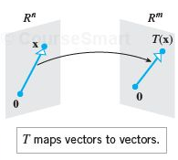 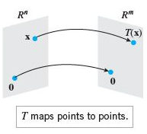

|  |  |  |  |
| --- | --- | --- | --- |
|  |  |  |  |
| Reflection about the *y*-axis |  |  |  |
| Reflection about the *x*-axis |  |  |  |
| Reflection about the line  y = *x* |  |  |  |
| Reflection about the  *xy*-plane |  |  |  |
| Reflection about the  *xy*-plane |  |  |  |
| Reflection about the  *yz*-plane |  |  |  |
| Orthogonal projection on the *x*-axis |  |  |  |
| Orthogonal projection on the *y*-axis |  |  |  |

|  |  |  |  |
| --- | --- | --- | --- |
| Orthogonal projection on the *xy*-Plane |  |  |  |
| Orthogonal projection on the *xz*-Plane |  |  |  |
| Orthogonal projection on the *yz*-Plane |  |  |  |
| ***Rotation Operators*** | | | |
| Rotation through an angle *θ* |  |  |  |
| Counterclockwise rotation about the positive *x*-axis through an angle *θ* |  |  |  |
| Counterclockwise rotation about the positive *y*-axis through an angle *θ* |  |  |  |
| Counterclockwise rotation about the positive *z*-axis through an angle *θ* |  |  |  |

***Dilations and Contractions***

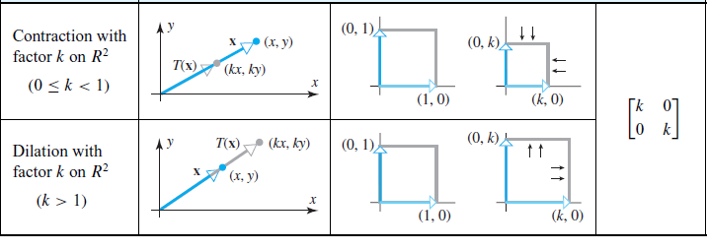

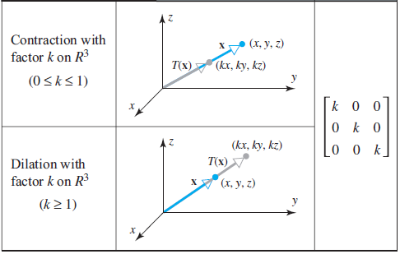

***Expansion or Compression***

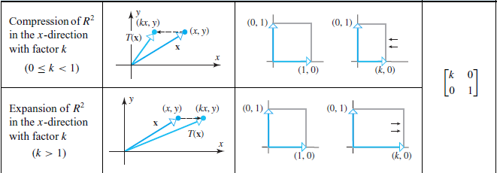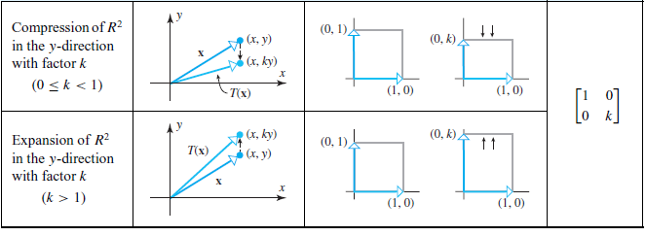

***Shear***

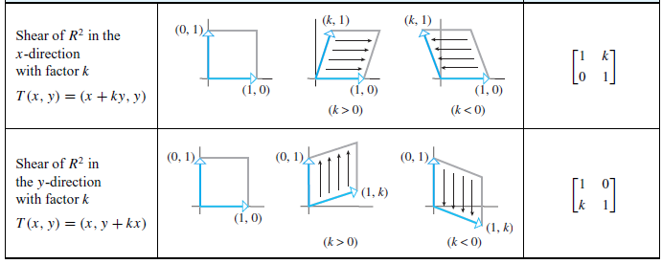

**Orthogonal Projections on Lines through the Origin**





***Example***

Find the orthogonal projection of the vector ***x*** = (1, 5) on the line through the origin that makes an angle of  with the *x*-axis

*Solution*











***Four Fundamental Subspaces***

1. The ***row space*** is , a subspace of .
2. The ***column space*** is , a subspace of .
3. The ***nullspace*** is , a subspace of .
4. The ***left nullspace*** is , a subspace of .

***The Four Subspaces for R***

Consider the matrix 3 by 5:



1. Rows 1 and 2 are a basis. The row space contains combination of all 3 rows.

The ***row space*** of ***R*** has dimension 2 (= ***rank***).

***The dimension of the row space is r***. The nonzero rows of ***R*** form a basis.

1. The ***column space*** of ***R*** has dimension *r* = 2.

The pivot columns 1 and 4 form a basis. They are independent because they start with the *r* by *r* identity matrix.

There are 3 special solutions:



***The dimension of the column space is r***. The pivot columns form a basis.

1. The ***nullspace*** has dimension *n* – *r* = 5 – 2 = 3 (free variables). Here are free (no pivots in those columns). They yield the three special solutions to . Set a free variable to 1, and solve for .



 has the complete solution: 

***The nullspace has dimension*** *n* – *r*. The special solutions form a basis.

1. The ***nullspace*** of  has dimension *m* – *r* = 3 – 2 = 1

The equation : 

The nullspace of  contains all vectors  and it is the line of the basis vector .

***The left nullspace has dimension m – r***. The solutions are 

* In  the row space and nullspace have dimensions *r* and *n* – *r* (adding to *n*)
* In  the column space and left nullspace have dimensions *r* and *m* – *r* (total *m*)



***The Four Subspaces for A***

***The subspace dimensions for A are the same as for R***.

These matrices are connected by an invertible matrix *E*. 

1. ***A*** *has the same row space as* ***R***. Same dimension *r* and same basis

Every row of ***A*** is a combination of the rows of ***R***. Also every row of ***R*** is a combination of the rows of ***A***.

1. *The column space of* ***A*** *has dimension* *r*. The number of independent columns equals the number of independent rows.
2. ***A*** *has the same nullspace as* ***R***. Dimension *n* – *r* and same basis.

**(*dimension of column space*) *+* (*dimension of nullspace*) *= dimension of ***

1. *The left nullspace* ***A*** (the nullspace of) *has dimension m – r*.

**Fundamental Theorem of Linear Algebra**, (Part 1)

The column space and row space both have dimension *r*.

The nullspaces have dimensions *n – r* and *m – r*.

***Example***

Consider 

***A*** has *m* = 1, *n* = 3, and rank: *r* = 1.

The row space is a line in .

The nullspace is the plane . This plane has dimension 2 (which is 3 – 1).

The columns of this is 1 by 3 matrix are in . The column space is all of .

The left nullspace contains only the zero vector.

The only solution to , the only combination of the row that gives the zero row. Thus , the zero space with dimension 0 (*m – r*). In  the dimensions (1 + 0) = 1.

***Example***

Consider 

***A*** has *m* = 2, *n* = 3, and rank: *r* = 1.

The row space is a line in .

The nullspace is the plane . This plane has dimension 3 (1 + 2).

The columns are multiples of the first column (1, 1).

The left nullspace contains more than one zero vector. The solution to  has the solution .

The column space and nullspace are perpendicular lines in . Their dimensions are 1 and 1 = 2.

Column space = line through 

Left nullspace=line through 

***Exercises***  ***Section* 2.8 – Matrix Transformations from  to **

1. Find the standard matrix for the transformation defined by the equations
2. 
3. 
4. 
5. Find the standard matrix for the operator *T* defined by the formula
6. 
7. 
8. 
9. Find the standard matrix for the transformation *T* defined by the formula
10. 
11. 
12. 