***Solution Section* 1.1 – Introduction to System of Linear Equations**

***Exercise***

Find a solution for *x, y, z* to the system of equations



***Solution***





Solution: 

***Exercise***

Draw the two pictures in two planes for the equations: 

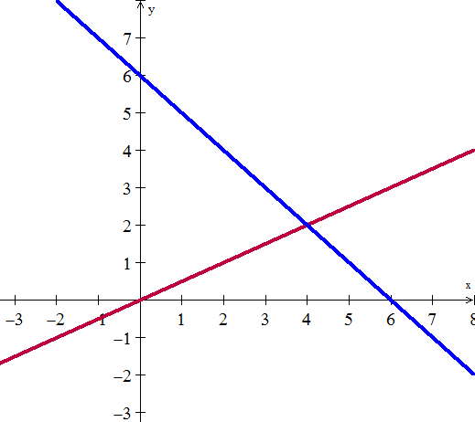***Solution***

The matrix form of the 2 equations:



***Row picture*** is the 2 lines from the given equations and their intersection is the point

(4, 2) which is the solution for the system.

***Column Picture*** is the column vectors  and 

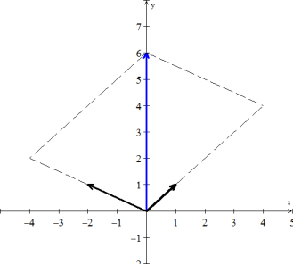



The parallelogram shows how the solution vector  can be written as the linear combination of the column vectors.

***Exercise***

Normally 4 planes in 4-dimensional space meet at a ________. Normally 4 column vectors in 4-deimensional space can combine to produce *b*. what combinations of  produces ?

What 4 equations for  are you solving?

***Solution***

Normally 4 planes in 4-dimensional space meet at a ***point***.

The combination of the vectors producing *b* is:





The system of equations that satisfies the given vectors is:



***Exercise***

What 2 by 2 matrix *A* rotates every vector through 45° ?

The vector (1, 0) goes to . The vector (0, 1) goes to .

Those determine the matrix. Draw these particular vectors is the *xy*-plane and find *A*.

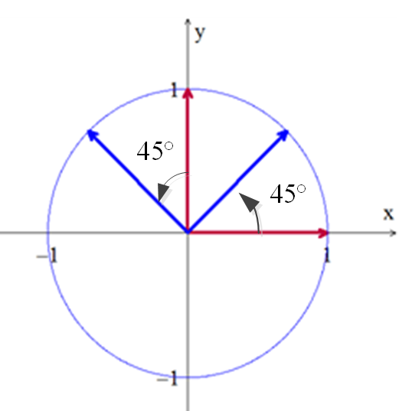***Solution***



***Exercise***

What two vectors are obtained by rotating the plane vectors  and  by 30° (*cw*) ?

Write a matrix *A* such that for every vector *v* in the plane, *Av* is the vector obtained by rotating *v* clockwise by 30°.

Find a matrix *B* such that for every 3-dimensional vector *v*, the vector *Bv* is the reflection of *v* through the plane . 

***Solution***

Rotating the vectors by 30° (*cw*) yields:

For the vector  yields to 

And for the vector  yields to 

 

The desired matrix is: 

To get 1 from  is to multiply by 

The unit vector to the plane  is 























The solution: 

***Exercise***

Find a system of linear equation corresponding to the given augmented matrix



***Solution***



***Exercise***

Find a system of linear equation corresponding to the given augmented matrix



***Solution***



***Exercise***

Find the augmented matrix for the given system of linear equations.



***Solution***



***Exercise***

Find the augmented matrix for the given system of linear equations.



***Solution***



***Exercise***

Find the augmented matrix for the given system of linear equations.



***Solution***

