***Lecture One***

***Section* 1.1 – Introduction to System of Linear Equations**

Given the linear equations



The solution to this system is , which means that 2 lines meeting at a single point.

We can rewrite the system equation as linear combination:









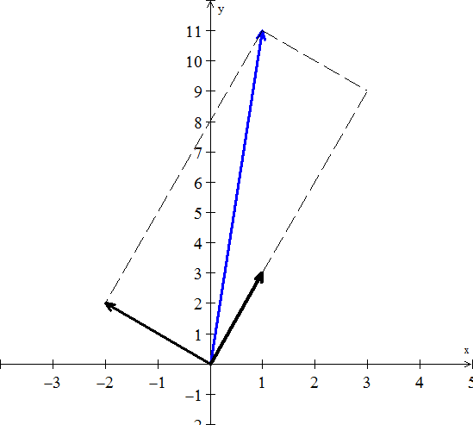 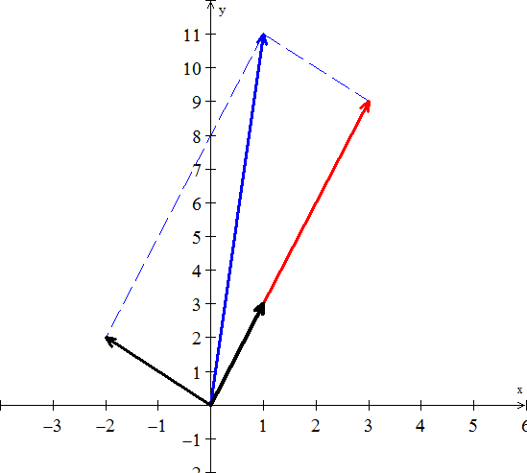

Therefore, the side vectors are

The diagonal sum is 

The linear combination is given by:



Thus, the solution is 

***Note***

is called the “***coefficient matrix***”

The matrix form of the system is written as 



***Graphically***

|  |  |  |
| --- | --- | --- |
|  |  |  |
| ***One solution* (*lines intersect*)**  ***Consistent***  ***Independent*** | ***No Solution* (l*ines //* )**  ***Inconsistent***  ***Independent*** | ***Infinite solution***  ***Consistent***  ***Dependent*** |

***Three* Equations in 3 Unknowns**

Given the system equations



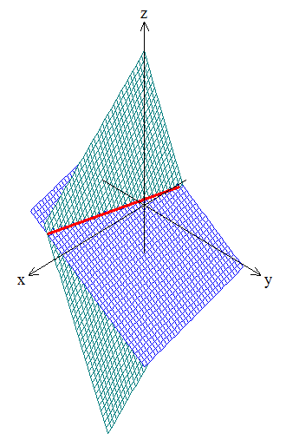 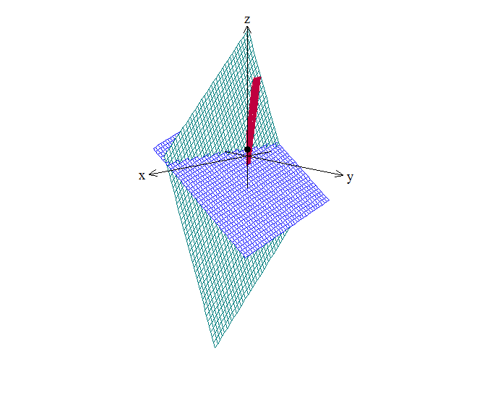

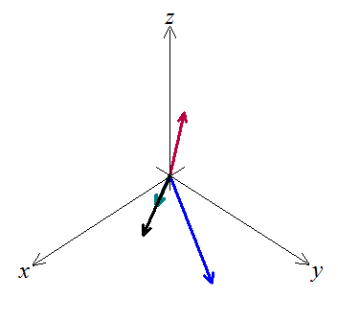

This system can be written as linear combination:



Let 

We want to multiply the three column vectors by  to produce ***b***.

The combination of the three vectors that produces vector *b* is 2 times the third vector.



Therefore, the coefficients that we need are .



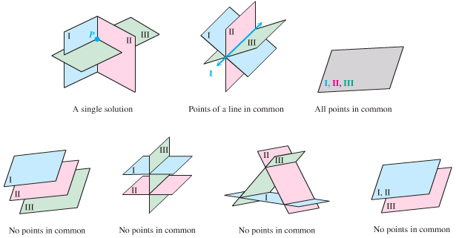

***Exercises Section* 1.1 – Introduction to System of Linear Equations**

1. Find a solution for *x, y, z* to the system of equations



1. Draw the two pictures in two planes for the equations: 
2. Normally 4 planes in 4-dimensional space meet at a ________. Normally 4 column vectors in 4-deimensional space can combine to produce *b*. what combinations of  produces ?

What 4 equations for  are you solving?

1. What 2 by 2 matrix *A* rotates every vector through 45° ?

The vector (1, 0) goes to . The vector (0, 1) goes to .

Those determine the matrix. Draw these particular vectors is the *xy*-plane and find *A*.

1. What two vectors are obtained by rotating the plane vectors  and  by 30° (*cw*) ?

Write a matrix *A* such that for every vector  in the plane,  is the vector obtained by rotating  clockwise by 30°.

Find a matrix *B* such that for every 3-dimensional vector , the vector  is the reflection of through the plane . 

1. In each part, find a system of linear equation corresponding to the given augmented matrix
2. 
3. 
4. Find the augmented matrix for the given system of linear equations.

|  |  |
| --- | --- |
|  |  |