***Solution Section* 1.8 – Applications**

***Exercise***

The flow of traffic, in vehicles per hour, through a network of streets as is shown below

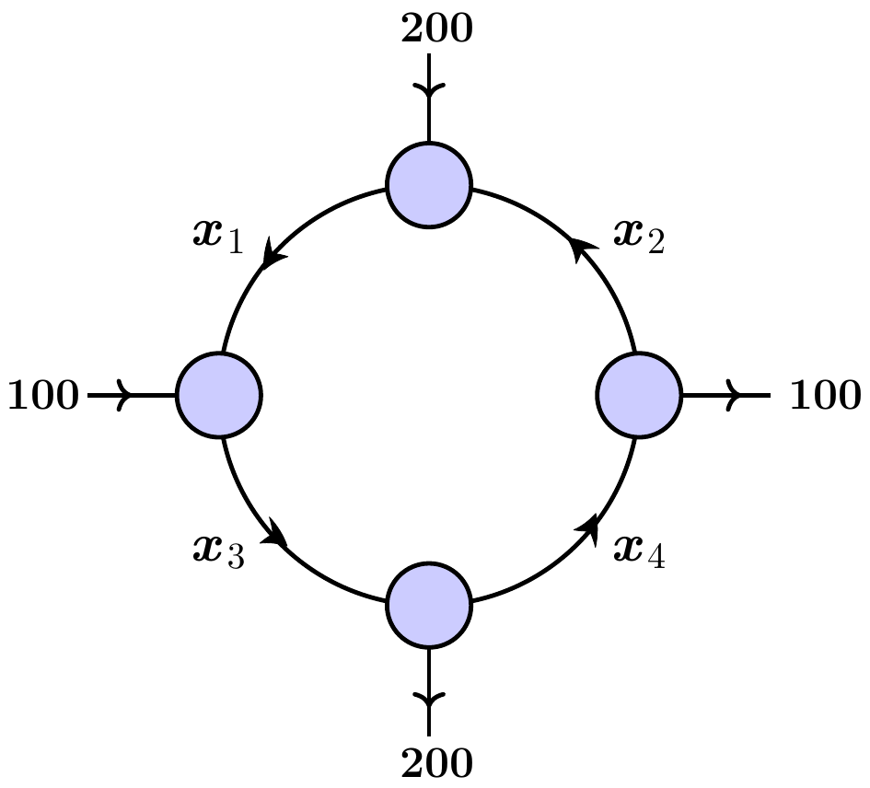

1. Solve this system for 
2. Find the traffic flow when .
3. Find the traffic flow when .
4. Find the traffic flow when .

***Solution***

1. 



 







Let  be the free variable



***Solution***: 

***OR***











1. The traffic flow when  is:

**∴** 

1. The traffic flow when  is:

**∴** 

1. The traffic flow when :







**∴** 

***Exercise***

Through a network, Express  in terms of the parameters ***s*** and ***t***.

***Solution***

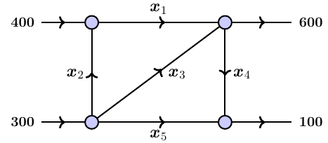











Let 





***Exercise***

Water is flowing through a network of pipes. Express  in terms of the parameters ***s*** and ***t***.

***Solution***

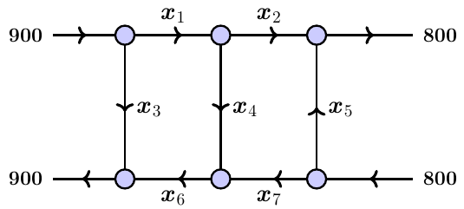























Let 











***Solution***: 

***Exercise***

Determine the currents  for the electrical network shown below

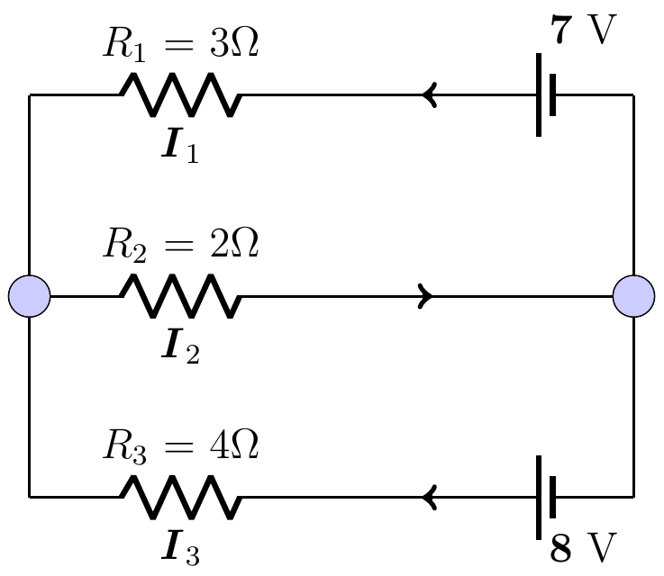

***Solution***









   



***OR***









***Exercise***

Determine the currents  for the electrical network shown below

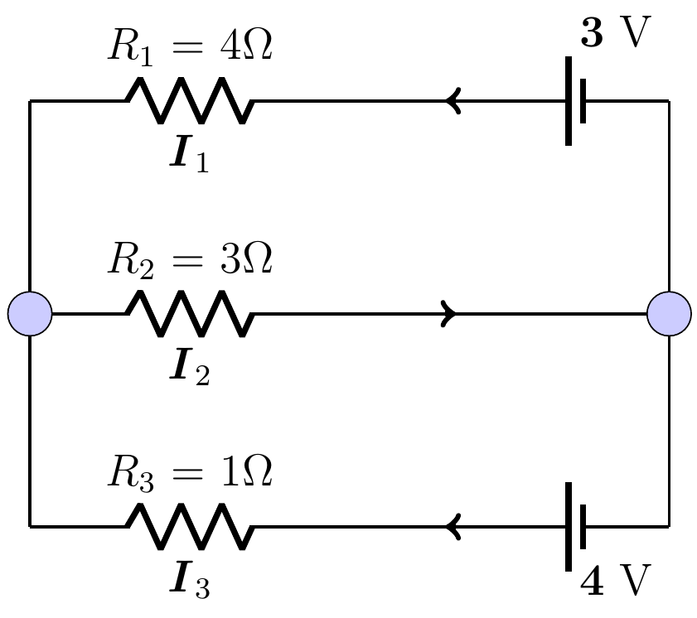

***Solution***









   



***OR***









***Exercise***

Determine the currents  for the electrical network shown below

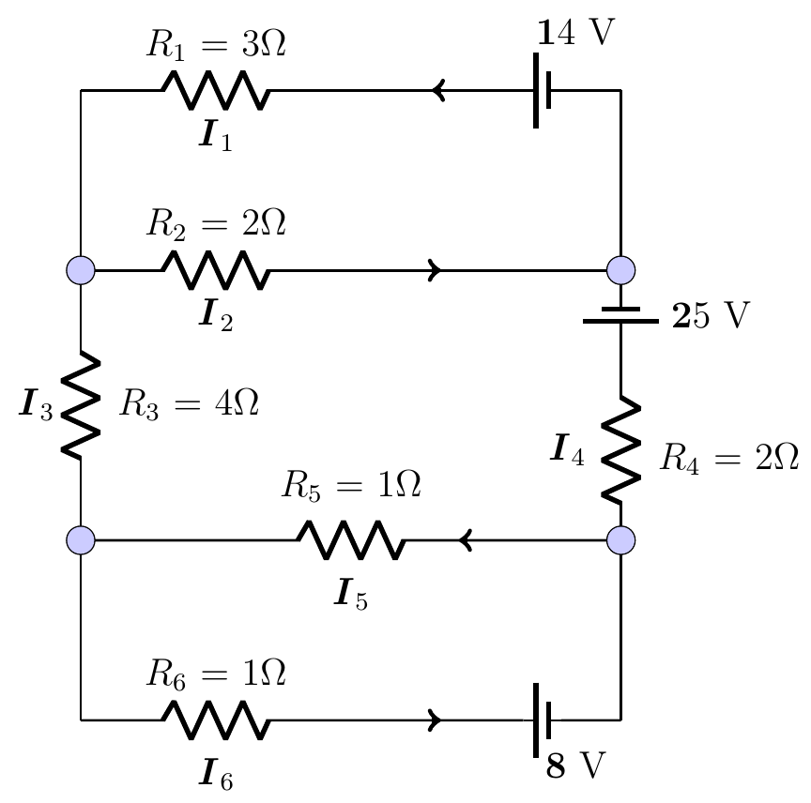

***Solution***























***Exercise***

Determine the currents  for the electrical network shown below

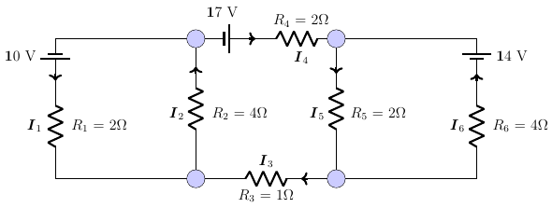

***Solution***



































***Exercise***

Consider the invertible matrix: 

The message: ***ICEBERG DEAD AHEAD***

1. Write the uncoded row matrices  for the message.
2. Use the matrix *A* to encode the message.
3. Decode a message from part *b*) given the matrix *A*.

***Solution***

|  |  |  |  |  |  |  |
| --- | --- | --- | --- | --- | --- | --- |
| 0 = _  1 = A  2 = B  3 = C | 4 = D  5 = E  6 = F  7 = G | 8 = H  9 = I  10 = J  11 = K | 12 = L  13 = M  14 = N  15 = O | 16 = P  17 = Q  18 = R  19 = S | 20 = T  21 = U  22 = V  23 = W | 24 = X  25 = Y  26 = Z |



1. Let encode the message ***ICEBERG DEAD AHEAD***













The sequence of coded row matrices is



The cryptogram:



1. To decode a message given the matrix *A*.





With the cryptogram:















The message is:



***Exercise***

You want to send the message: ***LINEAR ALGEBRA*** with a key word ***MATH***

1. Write the matrix *A*.
2. Write the uncoded row matrices  for the message.
3. Use the matrix *A* to encode the message.
4. Decode a message from part *b*) given the matrix *A*.

***Solution***

|  |  |  |  |  |  |  |
| --- | --- | --- | --- | --- | --- | --- |
| 0 = _  1 = A  2 = B  3 = C | 4 = D  5 = E  6 = F  7 = G | 8 = H  9 = I  10 = J  11 = K | 12 = L  13 = M  14 = N  15 = O | 16 = P  17 = Q  18 = R  19 = S | 20 = T  21 = U  22 = V  23 = W | 24 = X  25 = Y  26 = Z |









1. Encoding the message















The cryptogram:



1. To decode a message given the matrix *A*.







With the cryptogram:



















The message is: *Linear Algebra*

***Exercise***

Write the matrix *A* with a key word ***MATH,*** then decode the cryptogram



***Solution***







With the cryptogram:





























The message is: *I love math*

***Exercise***

Write the matrix *A* with a key word ***MATH,*** then decode the cryptogram



***Solution***







With the cryptogram:







































The message is: *Fred loves math*

***Exercise***

Consider the invertible matrix: 

Decode the cryptogram





***Solution***





With the cryptogram:





















The message is: ***Differential Equation***.

***Exercise***

Determine the key word, then decode the given cryptogram







*Hint*: First row is the key

***Solution***

The key word from the first row is



Since it has 9 numbers, then the matrix is  which is 









With the cryptogram:































The message is: ***math is number one***

***Exercise***

Determine the key word, then decode the given cryptogram



***Solution***

The key word from the first row, because all the numbers are between 0 and 26, alphabetic letter.

Since it has 9 numbers, then the matrix is  which is .

Therefore,



|  |  |  |  |  |  |  |
| --- | --- | --- | --- | --- | --- | --- |
| 0 = _  1 = A  2 = B  3 = C | 4 = D  5 = E  6 = F  7 = G | 8 = H  9 = I  10 = J  11 = K | 12 = L  13 = M  14 = N  15 = O | 16 = P  17 = Q  18 = R  19 = S | 20 = T  21 = U  22 = V  23 = W | 24 = X  25 = Y  26 = Z |

The key word is:









With the cryptogram:



















To decode a message given the matrix *A*.















































































































































