***Section* 1.8 – Applications**

***Network Analysis***

Networks composed of branches and junctions are used as models in such fields as economics, traffic analysis, and electrical engineering.

In a network model, you assume that the total flow into a junction is equal to the total flow out of the junction

***Example***

Set up a system of linear equations to represent the network shown below. Then solve the system for 

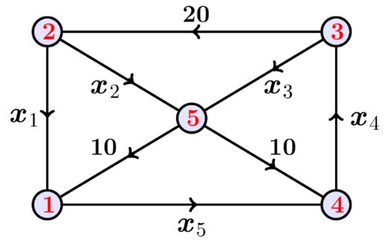

***Solution***





















***Solution***: 

***2nd Method***









Infinite solution:









***Electrical network***

An electrical network is another type of network where analysis is commonly applied. An analysis of such a system uses two properties of electrical networks known as **Kirchhoff’s Laws.**

* All the current flowing into a junction must flow out of it.
* The sum of the products *IR* (*I* is current and *R* is resistance) around a closed path is equal to the total voltage in the path.

***Example***

Determine the currents *I*1, *I*2, and *I*3 for the electrical network

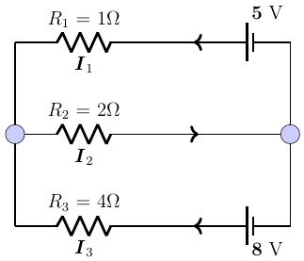

***Solution***









   



***Cryptography***

A ***cryptogram*** is a message written according to a secret code (the Greek word ***kryptos***means “*hidden*”). One method of using matrix multiplication to ***encode*** and ***decode*** messages.

Let assign a number to each letter in the alphabet (with 0 assigned to a blank space), as shown

|  |  |  |  |  |  |  |
| --- | --- | --- | --- | --- | --- | --- |
| 0 = _  1 = A  2 = B  3 = C | 4 = D  5 = E  6 = F  7 = G | 8 = H  9 = I  10 = J  11 = K | 12 = L  13 = M  14 = N  15 = O | 16 = P  17 = Q  18 = R  19 = S | 20 = T  21 = U  22 = V  23 = W | 24 = X  25 = Y  26 = Z |

***Example***

Consider the invertible matrix: 

The message: ***MEET ME MONDAY***

1. Write the uncoded row matrices  for the message.
2. Use the matrix *A* to encode the message.
3. Decode a message from part *b*) given the matrix *A*.

***Solution***



1. Let encode the message ***MEET ME MONDAY***











The sequence of coded row matrices is



The cryptogram:



1. To decode a message given the matrix *A*.





With the cryptogram:













The message is:



***Exercises Section* 1.8 – Applications**

1. The flow of traffic, in vehicles per hour, through a network of streets as is shown below

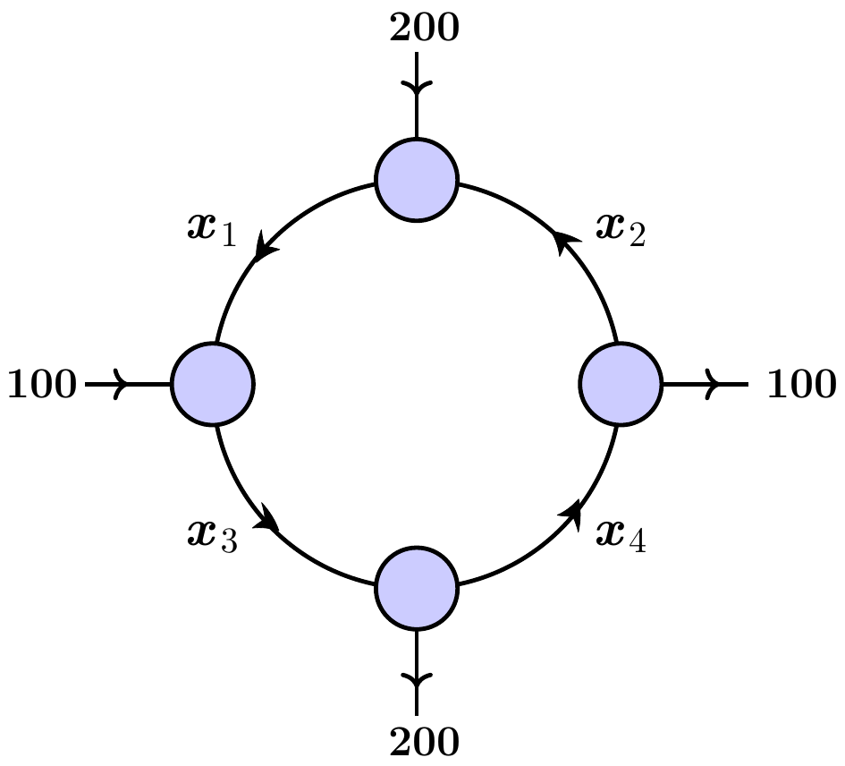

1. Solve this system for 
2. Find the traffic flow when .
3. Find the traffic flow when .
4. Find the traffic flow when .
5. Through a network, Express  in terms of the parameters ***s*** and ***t***.

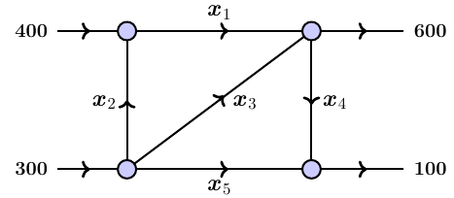

1. Water is flowing through a network of pipes. Express  in terms of the parameters ***s*** and ***t***.

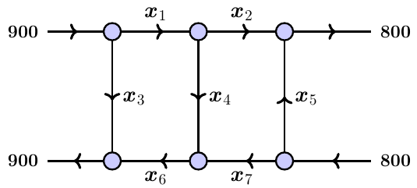

1. Determine the currents  for the electrical network shown below

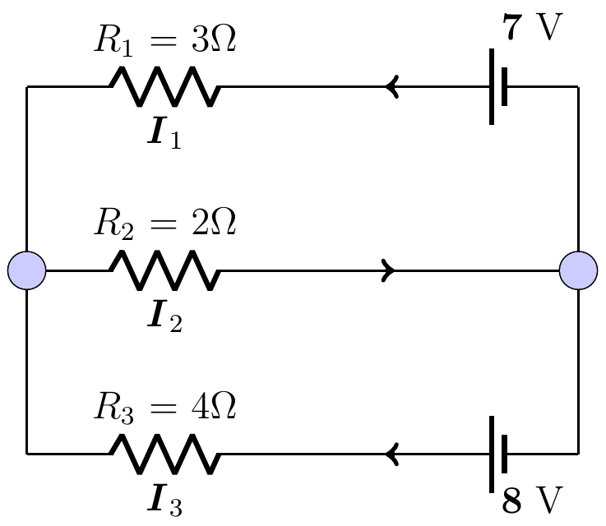

1. Determine the currents  for the electrical network shown below

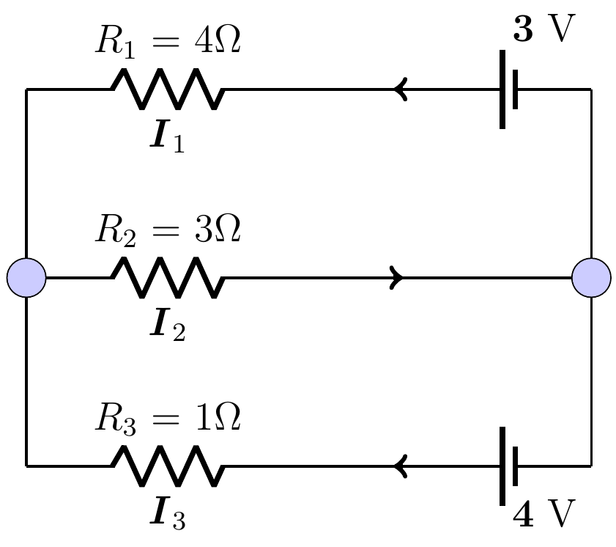

1. Determine the currents  for the electrical network shown below

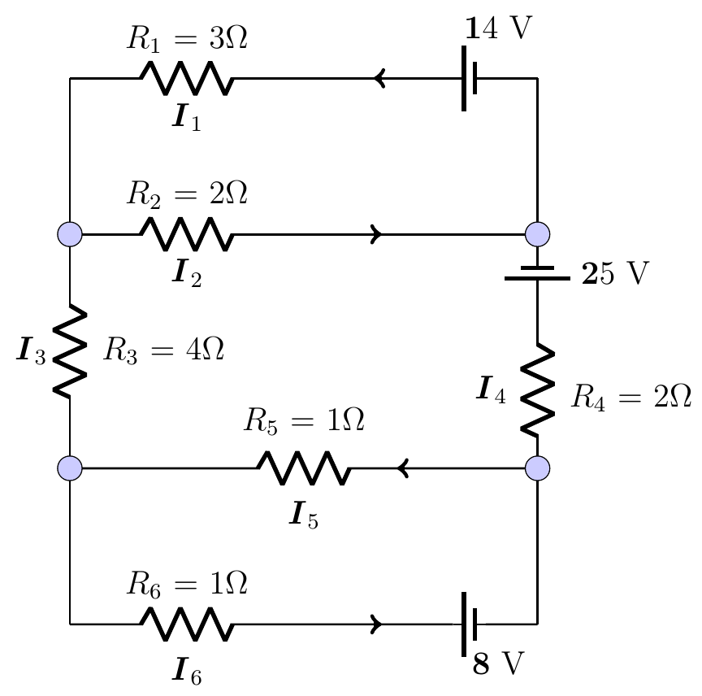

1. Determine the currents  for the electrical network shown below

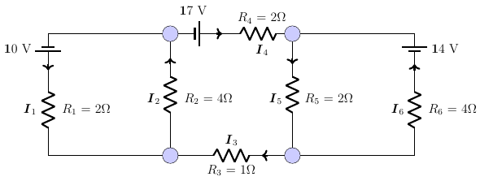

1. Consider the invertible matrix: 

The message: ***ICEBERG DEAD AHEAD***

1. Write the uncoded row matrices  for the message.
2. Use the matrix *A* to encode the message.
3. Decode a message from part *b*) given the matrix *A*.
4. You want to send the message: ***LINEAR ALGEBRA*** with a key word ***MATH***
5. Write the matrix *A*.
6. Write the uncoded row matrices  for the message.
7. Use the matrix *A* to encode the message.
8. Decode a message from part *b*) given the matrix *A*.
9. Consider the invertible matrix: 

Decode the cryptogram



