***Solution Section* 2.1 – Vectors in 2-Space, 3-Space, and *n*-Space**

***Exercise***

Sketch the following vectors with initial points located at the origin

1. 
2. 
3. 

***Solution***

|  |  |
| --- | --- |
|  |  |
|  |  |

***Exercise***

Find the components of the vector 

1. 
2. 
3. 

***Solution***

1. 



1. 



1. 



***Exercise***

Find the terminal point of the vector that is equivalent to = (1, 2) and whose initial point is 

***Solution***

The terminal point: 





The terminal point: 

***Exercise***

Find the initial point of the vector that is equivalent to  = (1, 1, 3) and whose terminal point is 

***Solution***

The initial point: 





The initial point: 

***Exercise***

Find a nonzero vector  with initial point *P* (−1, 3, −5) such that

1.  has the same direction as = (6, 7, −3)
2.  is oppositely directed as = (6, 7, −3)

***Solution***

1.  has the same direction as 

***u*** =  = (6, 7, −3)

The initial point *P*(−1, 3 , −5) then the terminal point:



1.  is oppositely directed as = (6, 7, −3)

 = − = (−6, −7, 3)

The initial point *P*(−1, 3 , −5) then the terminal point:



***Exercise***

Let  = (−3, 1, 2),  = (4, 0, −8), and  = (6, −1, −4). Find the components

|  |  |
| --- | --- |
|  |  |

***Solution***

1. 



1. 



1. 





1. 





1. 





1. 





***Exercise***

Let  = (2, 1, 0, 1, −1) and = (−2, 3, 1, 0, 2). Find scalars *a* and *b* so that 

***Solution***









 ***Unique solution***

***Exercise***

Find all scalars  such that 

***Solution***





















***Exercise***

Find the distance between the given points 

***Solution***







***Exercise***

Let *V* be the set of all ordered pairs of real numbers, and consider the following addition and scalar multiplication operation on 

 

1. Compute  and  for  = (0, 4), = (1, −3), and *k* = 2.
2. Show that (0, 0) **≠** .
3. Show that (−1, −1) = 0.
4. Show that  for 
5. Find two vector space axioms that fail to hold.

***Solution***

1. 









1. 





Therefore (0, 0) is not the zero vector **0** required (by Axiom).

1. 







Therefore (−1, −1) = **0** holds.

1. Let  &









 holds

1. Axiom 7: 









Therefore, ; Axiom 7 fails to hold

Axiom 8: 









Therefore, ; Axiom 8 fails to hold

***Exercise***

Find  given that  , .

***Solution***













***Exercise***

Find  given that  , 

***Solution***













***Exercise***

Find  given that  , 

***Solution***













***Exercise***

Draw , , , and  

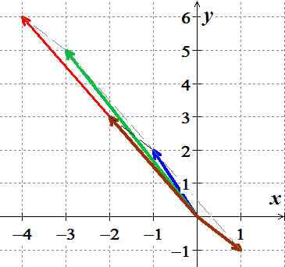***Solution***











***Exercise***

Draw , , , and  

***Solution***

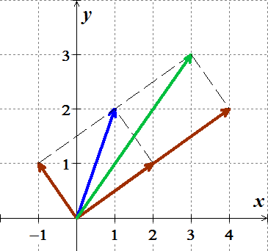









***Exercise***

Draw , , , and  

***Solution***

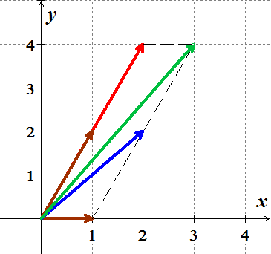









***Exercise***

Draw , , , and  

***Solution***

