***Lecture Two***

***Section* 2.1 – Vectors in 2-Space, 3-Space, and *n*-Space**

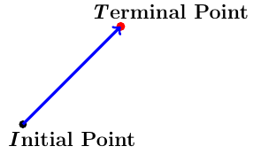Vectors in two dimensions are also called **2**−***space***

Vectors in three dimensions are also called **3**−***space*** by arrow

The direction of the arrowhead specifies the ***direction*** of the vector and the ***length*** of the arrow specifies the *magnitude*.

The tail of the arrow is called the ***initial point*** of the vector and the tip the ***terminal point***.

**Parallelogram Rule for Vector Addition**

If  and  are vectors in 2-space or 3-space that are positioned so their initial points coincides, then the vectors form adjacent sides of a parallelogram, and then the sum  is the vector represented by the arrow from the common initial point of  and  to the opposite vertex of the parallelogram.

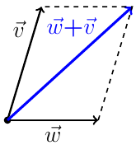

**Triangle Rule for Vector Addition**

If  and  are vectors in 2-space or 3-space that are positioned so the initial point of *w* is at the terminal point of , then the sum  is represented by the arrow from the initial point of  to the terminal point of .

|  |  |  |
| --- | --- | --- |
|  |  |  |

***Example of Sum and Difference of vectors***

Consider the vector  is given by the component  and represented by an arrow. The arrow goes from 4 units to the right and 2 units up.

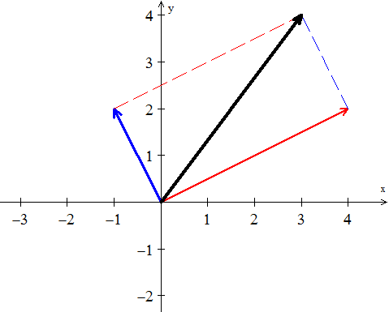

***v + w***

Consider anther vector 

Vector addition (head to tail) at the end of , place the start of .

***w***

***v***

The vector addition and  produces the diagonal of a parallelogram.



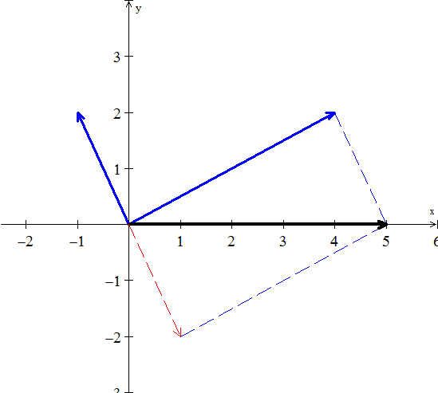

***v − w***

***w***

***v***



In 3-dimensional space, the arrow starts at the origin , where the *xyz* axis meet.

is also written as 

***Notes***:

1. The picture of the combinations  fills a line
2. The picture of the combinations  fills a plane
3. The picture of the combinations  fills a 3-dimensional space.

**Linear Combination**

***Definition***

The sum of  and  is a linear combination of vectors and; *c*, *d* are constants.

4-Special Linear Combinations:









***Vectors in Coordinate Systems***

It is sometimes necessary to consider vectors whose initial are not at the origin. If  denotes the vector with initial point  and terminal point , then the components of this vector are given by the formula



If 



***Example***

The components of the vector  with initial point  and terminal point, find ******?

***Solution***





***n− Space***

The vector spaces are denoted by . Each space  consists of a whole collection of vectors.

***Definition***

The space  consists of all column vectors *v* with *n* components.

***Example***



The one-dimensional space  is a line (like the *x*-axis)

The two essential vector operations go on inside the vector space that we can add any vectors in , and we can multiply any vector by any scalar. The ***result*** stays in the space.

A real vector space is a set of “***vectors***” together with rules for vector addition and for multiplication by real numbers. The addition and the multiplication must produce vectors that are in the space.

Here are three other spaces other than :

**M** The vector space of ***all real 2 by 2 matrices***.

**F** The vector space of ***all real functions*** .

**Z** The vector space that consists only of a ***zero vector***.

The zero vector in  is the vector (0, 0, 0).

**Operation on Vectors in** 

***Definition***

If *n* is a positive integer, then an ordered ***n*-*tuple*** is a sequence of real numbers . The set of all ordered *n*-tuples is called ***n*-*space*** and is denoted by 

***Definition***

Vectors  and  in  are said to be ***equivalent*** (also called ***equal***) if



We indicate this by 

***Example***



***Solution***

*Iff* 

**Vector Space of Infinite Sequences of Real Numbers**

If  and  are vectors in, and if *k* is any scalar, then we defined











**The *Zero* Vector Space**

Let *V* consist of a single object, which we denote by , and define



***Theorem***

If ,  , and  are vectors in , and if *k* and *m* are scalars, then

1. 
2. 
3. 
4. 
5. 
6. 
7. 
8. 
9. 
10. 
11. 

***Proof***: 

Let 

















***Exercises Section* 2.1 – Vectors in 2-Space, 3-Space, and *n*-Space**

1. Sketch the following vectors with initial points located at the origin

|  |  |  |
| --- | --- | --- |
|  |  |  |

1. Find the components of the vector 

|  |  |  |
| --- | --- | --- |
|  |  |  |

1. Find the terminal point of the vector that is equivalent to = (1, 2) and whose initial point is 
2. Find the initial point of the vector that is equivalent to  = (1, 1, 3) and whose terminal point is 
3. Find a nonzero vector  with initial point *P* (−1, 3, −5) such that
4.  has the same direction as = (6, 7, −3)
5.  is oppositely directed as = (6, 7, −3)
6. Let  = (−3, 1, 2),  = (4, 0, −8), and  = (6, −1, −4). Find the components

|  |  |  |
| --- | --- | --- |
|  |  |  |

1. Let  = (2, 1, 0, 1, −1) and = (−2, 3, 1, 0, 2). Find scalars *a* and *b* so that 

1. Find all scalars  such that 
2. Find the distance between the given points 
3. Let *V* be the set of all ordered pairs of real numbers, and consider the following addition and scalar multiplication operation on 

 

1. Compute  and  for  = (0, 4), = (1, −3), and *k* = 2.
2. Show that (0, 0) **≠** .
3. Show that (−1, −1) = 0.
4. Show that  for 
5. Find two vector space axioms that fail to hold.
6. Find  given that  , 
7. Find  given that  , 
8. Find  given that  , 

(**14 – 17**) Draw , , , and 

|  |  |
| --- | --- |
|  |  |