***Solution Section* 2.2 – Norm, Dot product, and distance in *Rn***

***Exercise***

If  and , what are the smallest and largest possible values of  and ?

***Solution***













The minimum value occurs when the dot product is a small as possible,  and  are parallel, but point in opposite directions. Thus, the smallest value is −15.

The maximum value occurs when the dot product is a large as possible, and  are parallel and point in same direction. Thus, the largest value is 15.

***Exercise***

If  and , what are the smallest and largest possible values of  and ?

***Solution***













The minimum value occurs when the dot product is a small as possible,  and  are parallel, but point in opposite directions. Thus, the smallest value is -21.  and 

The maximum value occurs when the dot product is a large as possible,  and  are parallel and point in same direction. Thus, the largest value is 21.  and 

***Exercise***

Given that  and . Similarly, and . The angle  is . Substitute into the trigonometry formula  for  to find 

***Solution***













***Exercise***

Can three vectors in the *xy* plane have  and  and ?

***Solution***

Let consider: , , 















Yes, it is.

***Exercise***

Find the norm of , a unit vector that has the same direction as , and a unit vector that is oppositely directed.

1.  = (4, −3)
2.  = (1, −1, 2)
3.  = (−2, 3, 3, −1)

***Solution***

1. 



***Same direction unit vector***:







***Opposite direction unit vector***:

 



1. 



***Same direction unit vector***:

 



***Opposite direction unit vector***:

 



1. 



***Same direction unit vector***:

 



***Opposite direction unit vector***:

 



***Exercise***

Evaluate the given expression with  = (2, −2, 3),  = (1, −3, 4), and  = (3, 6, −4)

1.  *b)* 

c)  *d)* 

*e)* 

***Solution***

1. 







1. 









1. 







1. 











1. 





***Exercise***

Let  = (1, 1, 2, −3, 1). Find all scalars *k* such that 

***Solution***

















***Exercise***

Find 

1. = (3, 1, 4), = (2, 2, −4)
2. = (1, 1, 4, 6), = (2, −2, 3, −2)
3. = (2, −1, 1, 0, −2), = (1, 2, 2, 2, 1)

***Solution***

1. 

















1. 

















1. 

















***Exercise***

Find the Euclidean distance between  and , then find the angle between them

1.  = (3, 3, 3), ** = (1, 0, 4)
2.  = (1, 2, −3, 0), **= (5, 1, 2, −2)
3.  = (0, 1, 1, 1, 2), **= (2, 1, 0, −1, 3)

***Solution***

1. 















1. 















1. 













***Exercise***

Find a unit vector that has the same direction as the given vector

1. (−4, −3) *b)*  *c)* (1, 2, 3, 4, 5)

***Solution***

1. 





1. 





1. 





***Exercise***

Find a unit vector that is oppositely to the given vector

1. (−12, −5)
2. (3, −3, 3)
3. 

***Solution***

1. 





1. 







1. 





***Exercise***

Verify that the Cauchy-Schwarz inequality holds

1. ,  = (2, −1, 3)
2. = (0, 2, 2, 1),  = (1, 1, 1, 1)
3. = (1, 3, 5, 2, 0, 1),  = (0, 2, 4, 1, 3, 5)

***Solution***

1. 















 ***√***

 Cauchy-Schwarz inequality holds

1. 











 ***√***

 Cauchy-Schwarz inequality holds

1. 













 ***√***

 Cauchy-Schwarz inequality holds

***Exercise***

Find  and then the angle *θ* between  and  

***Solution***



















***Exercise***

Find the norm: ,  for 

***Solution***













***Exercise***

Find all numbers *r* such that: 

***Solution***









***Exercise***

Find the distance between and 

***Solution***









***Exercise***

Given  = (1, −5, 4),  = (3, 3, 3)

1. Find 
2. Find the cosine of the angle *θ* between  and .

***Solution***

1. 



1. 



***Exercise***

Let . Find 

***Solution***

Since, the unit vector equals to a vector  divided by its magnitude.

Therefore,





***Or***

















***Exercise***

Let . Find 

***Solution***





***Or***

















***Exercise***

Let . Find 

***Solution***





















***Exercise***

Let  and  . Calculate the following:

|  |  |  |  |  |  |
| --- | --- | --- | --- | --- | --- |
|  |  |  |  |  |  |

***Solution***

1. 



1. 





1. 









1. 





1. 





1. 





***Exercise***

Let  and  . Calculate the following:

|  |  |  |  |  |
| --- | --- | --- | --- | --- |
|  |  |  |  |  |

***Solution***

1. 



1. 





1. 









1. 





1. 







***Exercise***

Let  and  . Calculate the following:

|  |  |  |  |  |
| --- | --- | --- | --- | --- |
|  |  |  |  |  |

***Solution***

1. 



1. 





1. 







1. 





1. 





***Exercise***

Let ,  and  . Calculate the following:

|  |  |  |  |
| --- | --- | --- | --- |
|  |  |  |  |

***Solution***

1. 





1. 







1. 







1. 







***Exercise***

Let ,  and  . Calculate the following:

|  |  |  |  |
| --- | --- | --- | --- |
|  |  |  |  |

***Solution***

1. 





1. 







1. 







***Or*** 









1. 







***Exercise***

Let ,  and  . Calculate the following:

|  |  |  |  |
| --- | --- | --- | --- |
|  |  |  |  |

***Solution***

1. 





1. 







1. 







1. 







***Exercise***

Suppose , , and  are vectors in  such that , , and . If possible, calculate the following values:

|  |  |  |
| --- | --- | --- |
|  |  |  |

***Solution***

1. 





1. 





1. 







1. 









1. 





1. 









1. 









1. 









***Exercise***

You are in an airplane flying from Chicago to Boston for a job interview. The compass in the cockpit of the plane shows that your plane is pointed due East, and the airspeed indicator on the plane shows that the plane is traveling through the air at 400 *mph*. there is a crosswind that affects your plane however, and the crosswind is blowing due South at 40 *mph*.

Given the crosswind you wonder; relative to the ground, in what direction are you really flying and how fast are you really traveling?

***Solution***

Let the air velocity of the plane be: 

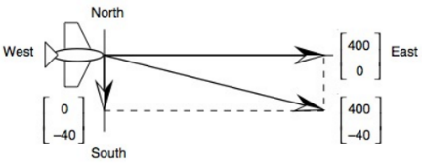The wind velocity be: 

The ground the velocity is:







The *magnitude*: 

The *direction*: 





***Exercise***

A jet airliner, flying due east at 500 *mph* in still air, encounters a 70-*mph* tailwind blowing in the direction 60° north of east. The airplane holds its compass heading due east but, because of the wind, acquires a new ground speed and direction. What speed and direction should the jetliner have in order for the resultant vector to be 500 *mph* due east?

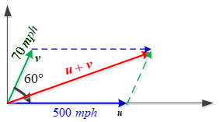***Solution***

: the velocity of the airplane

******: the velocity of the tailwind























∴ The direction is  south of east.

***Example***

A jet airliner, flying due east at 500 *mph* in still air, encounters a 70-*mph* tailwind blowing in the direction 60° north of east. The airplane holds its compass heading due east but, because of the wind, acquires a new ground speed and direction. What are they?

***Solution***

: the velocity of the airplane

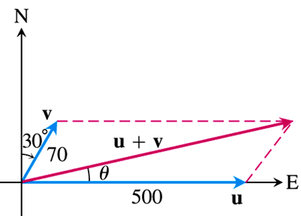: the velocity of the tailwind

***Given***: 



















The ground speed of the airplane is about 538.4 *mph*, and its direction is about 6.5° north of east.

***Exercise***

A bird flies from its nest 5 *km* in the direction 60° north east, where it stops to rest on a tree. It then flies 10 *km* in the direction due southeast and lands atop a telephone pole. Place an *xy*-coordinate system so that the origin is the bird’s nest, the *x*-axis points east, and the *y*-axis points north.

1. At what point is the tree located?
2. At what point is the telephone pole?

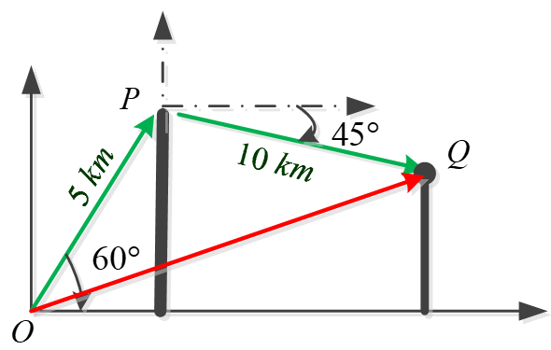***Solution***

1. 



The tree is located at the point



1. 









The pole is located at the point 

***Exercise***

Prove 

***Solution***

Let 











Thus, 

Each , then  for each , thus .

Hence, 

***Exercise***

Prove, for any vectors and  in  and any scalars *c* and *d*, 

***Solution***







 ***√***

***Exercise***

Prove 

***Solution***

Let , , and 













 ***√***

***Exercise***

Prove Minkowski theorem: 

***Solution***











 ***√***