***Section* 2.3 – Orthogonality**

***Definition***

Two nonzero vectors  and  in  are said to be ***orthogonal*** (or ***perpendicular***) if their dot product is zero .

We will also agree that he zero vector in  is orthogonal to every vector in . A nonempty set of vectors  is called an ***orthogonal set*** if all pairs of distinct vectors in the set are orthogonal. An orthogonal set of unit vectors is called an ***orthonormal set***.

***Example***

The floor of your room (extended to infinity) is a subspace ***V***. The line where two walls meet is a subspace ***W*** (one-dimensional). Those subspaces are orthogonal. Every vector up the meeting line is perpendicular to every vector on the floor. The origin (0, 0, 0) is in the corner.

***Example***

Show that   = (−2, 3, 1, 4) and  = (1, 2, 0, −1) are orthogonal in 

***Solution***

  = (−2)(1) + (3)(2) + (1)(0) +(4)( −1)

= −2 + 6 + 0 −4



These vectors are orthogonal in 

***Standard Unit Vectors***



***Proof***





***Normal***

To specify slope and inclination is to use a nonzero vector , called a ***normal***, that is orthogonal to the line or plane.

The line passes through a point  that has a normal  = (*a, b*)

The plane through  that has a normal  = (*a, b, c*).

Both the line and the plane are represented by the vector equation



The line equation: 

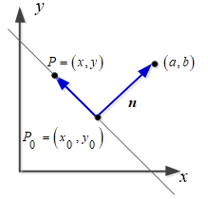

The plane equation: 

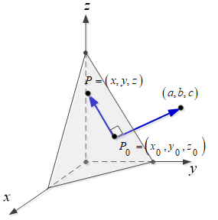

***Projections***

***Theorem* Projection onto a line**

If  and  are vectors in , and if  ≠ 0, then  can be expressed in exactly one way in the form , where  is a scalar multiple of  and  is orthogonal to ******.

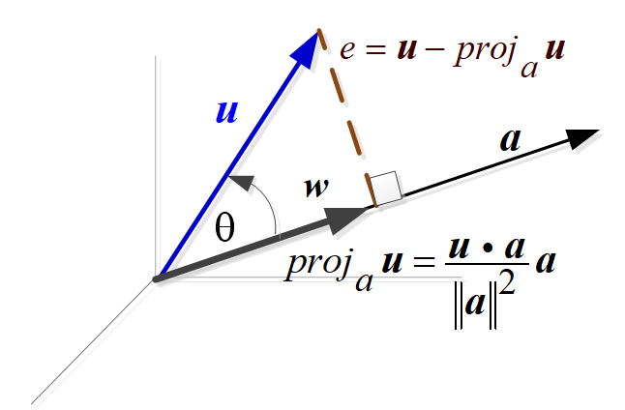

The vector  is called the ***orthogonal projection*** of on  or sometimes ***component*** of  along ******.

The vector  is called the vector ***component*** of  ***orthogonal*** to  (error vector and should be perpendicular to ******)

 (*vector component of* *along*)

 (*vector component of* *orthogonal to* ******)

The length is 



*Special case*: If  then . The projection of  onto  is itself.

*Special case*: If is perpendicular to  then . The projection is .

***Example***

Find the orthogonal projections of the vectors  and  on the line *L* that makes an angle *θ* with the positive *x*-axis in 

***Solution***

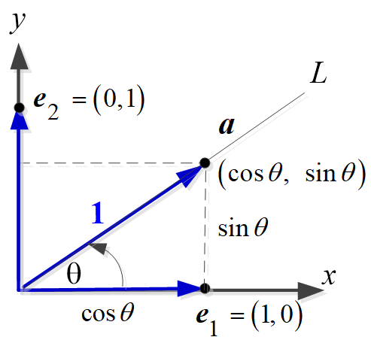

Let ******be the unit vector along the line *L*.

























***Example***

Let  = (2, −1, 3) and  = (4, −1, 2). Find the vector component of  along  and the vector component of  orthogonal to .

***Solution***













The vector component of  orthogonal to  is





***Theorem* of *Pythagoras* in** 

If  and  are orthogonal vectors in  with the Euclidean inner product, then



***Proof***

Since  and  are orthogonal, then 







***Distance***

***Theorem***

In  the distance *D* between the point  and the line  is



In  the distance *D* between the point  and the plane  is



***Exercises Section* 2.3 – Orthogonality**

1. Determine whether  and  are orthogonal

|  |  |
| --- | --- |
|  |  |

1. Determine whether the vectors form an orthogonal set
2. 
3. 
4. 
5. 
6. 
7. 
8. 
9. Find a unit vector that is orthogonal to both  = (1, 0, 1) and  = (0, 1, 1)
10. *a*) Show that  = (*a, b*) and  = (−*b, a*) are orthogonal vectors.

*b*) Use the result to find two vectors that are orthogonal to  = (2, −3).

*c*) Find two unit vectors that are orthogonal to (−3, 4)

1. Find the vector component of  along  and the vector component of  orthogonal to .

|  |  |
| --- | --- |
|  |  |

1. Project the vector  onto the line through , check that is perpendicular to :

|  |  |  |
| --- | --- | --- |
|  |  |  |

1. Find the projection matrix  onto the line through 

(**8 – 9**) Draw the projection of  onto  and also compute it from

|  |  |
| --- | --- |
|  |  |

1. Show that if  is orthogonal to both and , then ***v*** is orthogonal to for all scalars and .
2. *a*) Project the vector  = (3, 4, 4) onto the line through  = (2, 2, 1) and then onto the plane that also contains .
3. Check that the first error vector  is perpendicular to  , and the second error vector  is also perpendicular to  .
4. Compute the projection matrices  onto the lines through  and . Multiply those projection matrices and explain why their product  is what it is. Project  onto the lines , , and also onto .Add up the three projections .
5. If  show that . When *P* projects onto the column space of *A*, *I – P* projects onto the ____.
6. What linear combination of  and  is closest to ?
7. Show that  is orthogonal to  if and only if 
8. Given 
9. Find 
10. Find  and then the angle *θ* between  and  .
11. Given: 
12. Compute the projection  of  on 
13. Find  and show that  is perpendicular to .
14. *a*) Show that  = (*a, b*) and  = (*−b, a*) are orthogonal vectors

*b*) Use the result in part (*a*) to find two vectors that are orthogonal to  = (2, −3)

*c*) Find two unit vectors that are orthogonal to (−3, 4)

1. Show that *A* (3, 0, 2), *B* (4, 3, 0), and *C* (8, 1, −1) are vertices of a right triangle. At which vertex is the right angle?
2. Establish the identity: 
3. Find the Euclidean inner product : 
4. Find the Euclidean distance between  and : 

(*Exercises* **22 − 26**) Find

1. 
2. The cosine of the angle between  and 
3. The scalar component of  in the direction of 
4. The vector 
5. 
6. 
7. 
8. 
9. 
10. Suppose Ted weighs 180 *lb*. and he is sitting on an inclined plane that drops 3 *units* for every 4 horizontal units. The gravitational force vector is .
11. Find the force pushing Ted down the slope.
12. Find the force acting to hold Ted against the slope
13. Prove that is two vectors  and  in  are orthogonal to nonzero vector  in , then  and  are scalar multiples of each other.