***Solution Section* 2.4 – Cross Product**

***Exercise***

Prove when the cross product  is perpendicular to  , then 

***Solution***

Let  and 









***Exercise***

Find , where  and show that  is perpendicular to  and to .

***Solution***









= 2 − 14 + 12





= 6 − 0 − 6



 is orthogonal to both  and .

***Exercise***

Given  Compute the vectors

1. 
2. 
3. 
4. 
5. 

***Solution***

1. 





1. 





1. 







1. 







1. 









***Exercise***

Use the cross product to find a vector that is orthogonal to both

1. 
2. 
3. 

***Solution***

1. 







1. 







1. 







***Exercise***

Find the area of the parallelogram determined by the given vectors

1. 
2. 
3. 

***Solution***

1. 











1. 









1. 











***Exercise***

Find the area of the parallelogram with the given vertices 

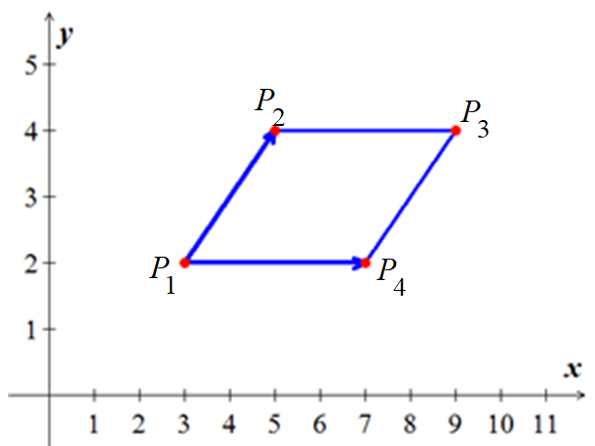***Solution***

















The area of the parallelogram is





***Exercise***

Find the area of the triangle with the given vertices:

1. 
2. 
3. 

***Solution***

1. 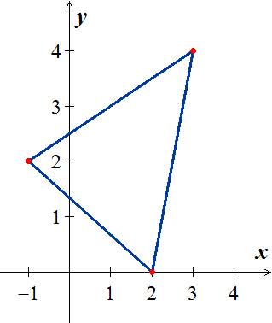 











The area of the triangle is





1.  













The area of the triangle is





1.  



** **







The area of the triangle is



***Exercise***

1. Find the area of the parallelogram with edges  and 
2. Find the area of the triangle with sides , , and  . Draw it.
3. Find the area of the triangle with sides , , and . Draw it.

***Solution***

1. 



which is the parallelogram *OABC*

1. The area of the triangle with sides , , and  is the triangle *OCB* or *OAB* which it is half the parallelogram (by definition).













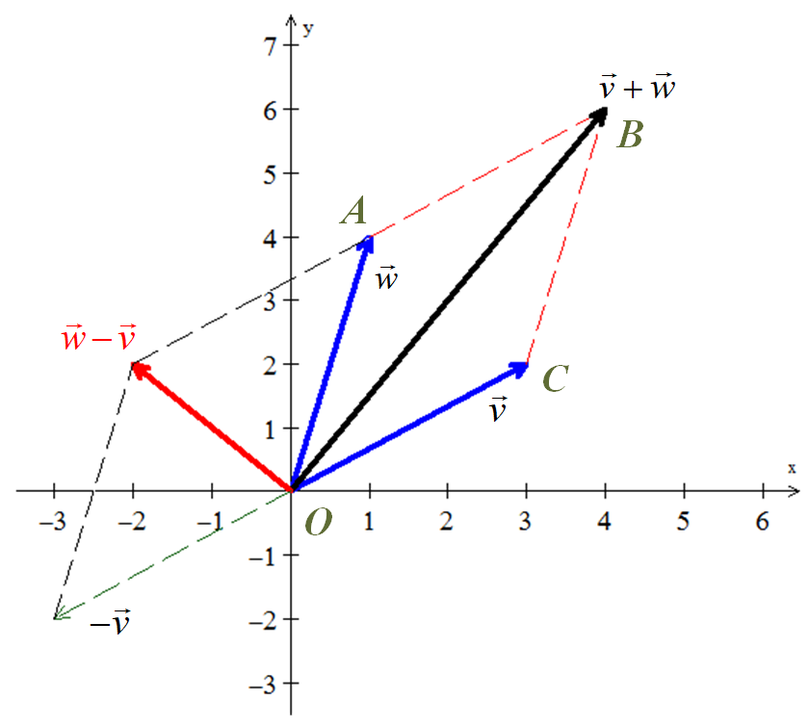

1. The area of the triangle with sides , , and  is equivalent to the triangle *OAC* which it is half the parallelogram (by definition).









***Exercise***

Find the volume of the parallelepiped with sides , , and .

1. 
2. 

***Solution***

1. 



The volume of the parallelepiped is 

1. 



The volume of the parallelepiped is 

***Exercise***

Compute the scalar triple product 

1. 
2. 
3. 
4. 
5. 

***Solution***

1. 



1. 



1. 



1. 



1. 



***Exercise***

Use the cross product to find the sine of the angle between the vectors 

***Solution***























***Exercise***

Simplify 

***Solution***















***Exercise***

Prove Lagrange’s identity: 

***Solution***

Let  and 



















***Exercise***

Polar coordinates satisfy . Polar area  includes *J*:



The two columns are orthogonal. Their lengths are ______. Thus *J* = ______.

***Solution***

The length of the first column is:





The length of the second column is:









So, *J* is the product 1. *r* = *r*.







***Exercise***

Prove that  if and only if  and  are parallel vectors.

***Solution***

If  and  are parallel vectors, then 

Which the two vectors are collinear, which implies that 











 ***√***

***Exercise***

State the following statements as True or False

1. The cross product of two nonzero vectors  and  is a nonzero vector if and only if  and  are not parallel.
2. A normal vector to a plane can be obtained by taking the cross product of two nonzero and noncollinear vectors lying in the plane.
3. The scalar triple product of , , and  determines a vector whose length is equal to the volume of the parallelepiped determined by , , and .
4. If  and  are vectors in 3-space, then  is equal to the area of the parallelogram determine by  and .
5. For all vectors , , and  in , the vectors  and  are the same.
6. If , , and  are vectors in , where  is nonzero and , then 

***Solution***

1. True,

 if  which the two vectors are parallel.

1. True;

The cross product of two nonzero and non collinear vectors will be perpendicular to both vectors, hence normal to the plane containing the vectors.

1. False;

The scalar triple product is a scalar, not a vector.

1. True;
2. False;

Let 













Hence, 

1. False;

Let 









, but 