***Section* 2.4 – Cross Product**

**The *Cross* Product**

To find a vector in 3-space that is perpendicular to two vectors; the type of vector multiplication that facilities this construction is the cross product.

***Definition***

The cross product of  and  is the vector









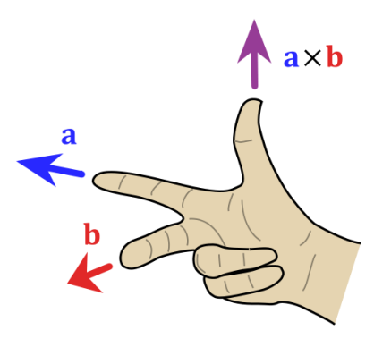 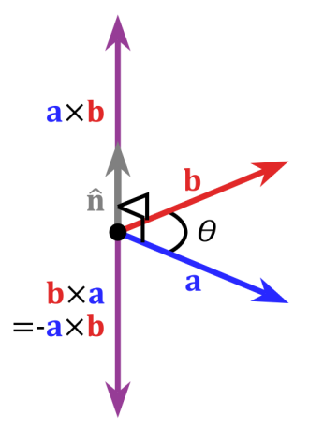 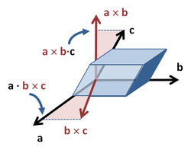

* In 1773, ***Joseph Louis Lagrange*** introduced the component form of both the dot and cross products in order to study the tetrahedron in three dimensions. In 1843 the Irish mathematical physicist Sir ***William Rowan Hamilton*** introduced the quaternion product, and with it the terms "*vector*" and "*scalar*". Given two quaternions [0, ] and [0,  ], where  and  are vectors in  , their quaternion product can be summarized as . ***James Clerk Maxwell*** used Hamilton's quaternion tools to develop his famous ***electromagnetism*** equations, and for this and other reasons quaternions for a time were an essential part of physics education.

***Example***

Find , where  and 

***Solution***







***Example***

Consider the vectors 

These vectors each have length of 1 and lie along the coordinate axes. They are called the ***standard unit vectors*** in 3-space.



For example: 



***Note***:

* 
* 
* 

***Properties***

1.  reverses rows 2 and 3 in the determinant so it is equals 
2. The cross product  is perpendicular to , then 
3. The cross product  is perpendicular to , then 
4. The cross product of any vector with itself (two equal rows) is .
5. Lagrange’s identity: 





***Theorem***

1. 
2. 
3. 
4. 
5. 
6. 

***Definition***

If , and  are vectors in 3-space, then  is called the ***scalar triple product*** of , and .

***Example***

Calculate the scalar triple product  of the vectors:



***Solution***





***Area of a Parallelogram***

***Theorem***

If  and  are vectors in 3-space, then  is equal to the area of the parallelogram determined by  and .

***Example***

Find the area of the triangle determined by the points   .

***Solution***

The area of the triangle is  the area of the parallelogram determined by the vectors  and 













*Area* 





***Volume***

The Volume of the Parallelepiped is





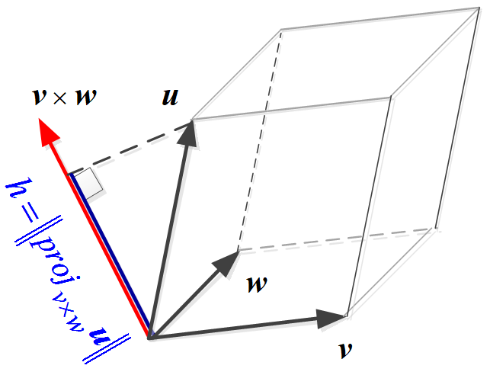

***Theorem***

If the vectors , , and  have the initial point, then they lie in the same plane if and only if



***Example***

Find the volume of the parallelepiped with sides , , and 

***Solution***





***Exercises Section* 2.4 – Cross Product**

1. Prove when the cross product  is perpendicular to  , then 
2. Find , where  and show that  is perpendicular to  and to  .
3. Given  Compute the vectors

|  |  |  |
| --- | --- | --- |
|  |  |  |

1. Use the cross product to find a vector that is orthogonal to both

1. 
2. 
3. 
4. Find the area of the parallelogram determined by the given vectors

1. 
2. 
3. 
4. Find the area of the parallelogram with the given vertices



1. Find the area of the triangle with the given vertices:
2. 
3. 
4. 
5. *a*) Find the area of the parallelogram with edges  and 

*b*) Find the area of the triangle with sides , , and  . Draw it.

*c*) Find the area of the triangle with sides , , and . Draw it.

1. Find the volume of the parallelepiped with sides , , and .

1. 
2. 
3. Compute the scalar triple product 

1. 
2. 
3. 
4. 
5. 
6. Use the cross product to find the sine of the angle between the vectors 
7. Simplify 
8. Prove Lagrange’s identity: 
9. Polar coordinates satisfy . Polar area  includes *J*:



The two columns are orthogonal. Their lengths are ______. Thus *J* = ______.

1. Prove that  if and only if  and  are parallel vectors.
2. State the following statements as True or False
3. The cross product of two nonzero vectors  and  is a nonzero vector if and only if  and  are not parallel.
4. A normal vector to a plane can be obtained by taking the cross product of two nonzero and noncollinear vectors lying in the plane.
5. The scalar triple product of , , and  determines a vector whose length is equal to the volume of the parallelepiped determined by , , and .
6. If  and  are vectors in 3-space, then  is equal to the area of the parallelogram determine by  and .
7. For all vectors , , and  in , the vectors  and  are the same.
8. If , , and  are vectors in , where  is nonzero and , then 