***Section* 2.5 – Subspaces, Span and Null Spaces**

***Subspaces***

***Definition***

A subset *W* of a vector space *V* is called a ***subspace*** of *V* if *W* itself a vector space under the addition and scalar multiplication defined in *V*.



***Theorem***

If *W* is a set of one or more vectors in a vector space *V*, then *W* is a subspace of *V* iff the following conditions holds

1. If  and  are vectors in *W*, then  is in *W*.
2. If *k* is any scalar and  is any vector in *W*, the  is in the subspace in *W*.

* The most fundamental ideas in linear algebra are that the plane is a subspace of the full vector space .
* Every subspace contains the zero vector. The plane vector in  has to go through (0, 0, 0).

From rule (**2**), if we choose  and the rule requires  to be in the subspace.

The ***axioms*** that are ***not*** inherited by *W* are

Axiom 1 – Closure of *W* under addition

Axiom 4 – Existence of a zero vector in *W*

Axiom 5 – Existence of a negative in *W* for every vector in *W*

Axiom 6 – Closure of *W* under scalar multiplication

***Example***

Keep only the vectors  whose components are positive or zero (first quadrant ***“quarter-plane”***). The vector  is included but  is not. So, rule (**2**) is violated when we try . ***The*** ***quarter-plane is not a subspace***.

***Example***

Include also the vectors whose components are both negative. Now we have two quarter-planes. Rule (***ii***) satisfies when we multiply by any *c*. But rule (***i***) fails. The sum of and is  which is outside the quarter-plane. ***Two*** ***quarter-planes don’t make a subspace***.

***Example***

The **Subspace** 

There is a theorem in calculus which states that a sum of continuous functions is continuous and than a constant times a continuous frunction is continuous. In vector word, the set of continuous functions on  is a subspace of . We dente this subspace by 



***Theorem***

If  are subspaces of a vector space *V*, then intersection of these subspaces is also a subspace of *V*.

* ***A subspace containing  and  must contain all linear combination*** ***.***

***Example***

Inside the vector space *M* of all 2 by 2 matrices, given two subspaces:

**U** all upper triangular matrices 

**D** all diagonal matrices 

***Solution***

If we add 2 matrices in **U**:  is in **U**.

If we add 2 matrices in **D**:  is in **D**.

In this case **D** is also a subspace of **U**!. The zero matrix is in these subspaces, when *a*, *b*, and *d* all equal zero.

***Span***

***Definition***

The subspace of a vector space *V* that is formed from all possible linear combinations of the vectors in a nonempty set *S* is called the ***span of S***, and we say that the vectors in *S* *span* that subspace. If , then we denoted the span of S by



***Theorem***

Let  be vectors in vector space *V* and *S* be their span. Then,

1. *S* is a subspace of *V*.

***Proof***: ,  and 





1. *S* is the smallest subspace of *V* that contains . i.e. any other subspace  containing  also contains S.

***Proof***: , 

But  ∴  *closed under scalar multiplication.*

 ∴  *closed under addition.*



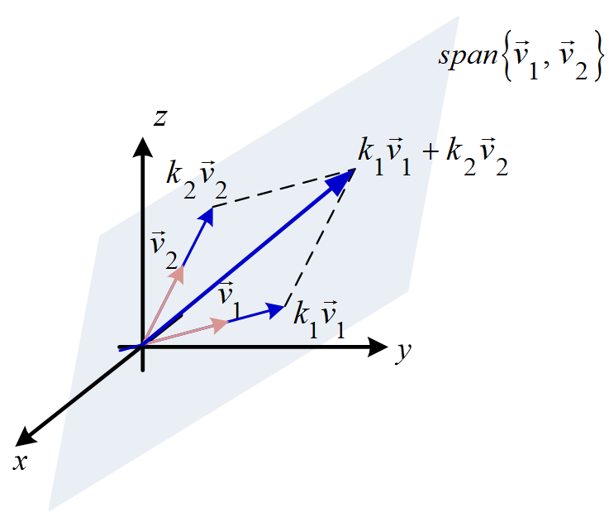

***Example***

1.  span the full two-dimensional space .
2.  span the full space .
3.  only span a line in .

***Definition***

The ***row space*** of a matrix is the subspace of  spanned by the rows.

***Example***

Determine whether  span the vector space 

***Solution***

Let  be the arbitrary vector in  can be expressed as a linear combination













Since the determinant is zero, the ***do not*** span space 

**Solution Spaces of *Homogeneous* (*Null Space*) Systems**

***Theorem***

The solution set of a homogeneous linear system  in *n* unknowns is a subspace of 

***Proof***

Let *W* be the solution set for the system. The set *W* is not empty because it contains at least the trivial solution .

To show that *W* is a subspace of , we must show that it is closed under addition and scalar multiplication.

Let  and  be vectors in *W* and these vectors are solution of  .



Therefore,







So, *W* is closed under addition.



So, *W* is closed under scalar multiplication.

***Null Spaces***

***Definition***

The nullspace of *A* consists of all solutins to . These solution vectors are in . The Nullspace containing all solutions is denoted by .

 is the nullspace of *A*, 

(Can also be called ***Kernel*** of *A*)

***Theorem***

Suppose  is a subspace of  for 

* Let  and are in the nullspace  then







* Let  then 







Since we can add and multiply without leaving the Nullspace, it is a subspace.

***Example***

The equation  comes from the 1 by 3 matrix . This equation produces a plane through the origin. The plane is a subspace of . *It is the Nullspace* of *A*.

***Solution***

The solution to  also form a plane, but not a subspace.

***Example***

Find the null space of

1.  *b)* 

***Solution***

1. 

⇒

So 

1. 



⇒ 

If we let , then

 is in  if and only if



***Example***

Describe the nullspace of 

***Solution***

Apply the elimination to the linear equations :



There is only one equation , this line is the Nullspace .

***Example***

Consider the linear system 

***Solution***





This is the equation of a plane through the origin that has  = (1, −2, 3) as a normal.

***Example***

Consider the linear system 

***Solution***



The solution space is 

***Exercises Section* 2.5 – Subspaces, Span and Null Spaces**

1. Suppose *S* and *T* are two subspaces of a vector space **V**.
2. The sum  contains all sums  of a vector  in *S* and a vector  in *T*. Show that  satisfies the requirements (addition and scalar multiplication) for a vector space.
3. If *S* and *T* are lines in , what is the difference between  and ? That union contains all vectors from *S* and *T* or both. Explain this statement: The span of  is .
4. Determine which of the following are subspaces of ?
5. All vectors of the form (*a*, 0, 0)
6. All vectors of the form (*a*, 1, 1)
7. All vectors of the form (*a*, *b*, *c*), where *b* = *a* + *c*
8. All vectors of the form (*a*, *b*, *c*), where *b* = *a* + *c +* 1
9. All vectors of the form (*a*, *b*, 0)
10. Determine which of the following are subspaces of ?
11. All sequences  in  of the form  = (*v*, 0, *v*, 0, …)
12. All sequences  in  of the form  = (*v*, 1, *v*, 1, …)
13. All sequences  in  of the form 
14. Which of the following are linear combinations of  = (0, −2, 2) and  = (1, 3, −1)?

|  |  |  |  |
| --- | --- | --- | --- |
| 1. (2, 2, 2) | 1. (3, 1, 5) | 1. (0, 4, 5) | 1. (0, 0 ,0) |

1. Which of the following are linear combinations of  = (2, 1, 4),  = (1, −1, 3) and  = (3, 2, 5)?

|  |  |  |
| --- | --- | --- |
| 1. (−9, −7, −15) | 1. (6, 11, 6) | 1. (0, 0 ,0) |

1. Determine whether the given vectors span 
2. 
3. 
4. 
5. Which of the following are linear combinations of 

|  |  |  |
| --- | --- | --- |
|  |  |  |

1. Suppose that . Which of the following vectors are in span 

|  |  |  |  |
| --- | --- | --- | --- |
| 1. (2, 3, −7, 3) | 1. (0, 0, 0, 0) | 1. (1, 1, 1, 1) | 1. (−4, 6, −13, 4) |

1. Let  and . Which of the following lie in the space spanned by  and 

|  |  |  |  |
| --- | --- | --- | --- |
|  |  |  |  |

1. Let, Determine:
2. Is *S* closed under addition?
3. Is *S* closed under scalar multiplication?
4. Is *S* a subspace of ?
5. Let , Determine:
6. Is *S* closed under addition?
7. Is *S* closed under scalar multiplication?
8. Is *S* a subspace of ?
9. Let , Determine:
10. Is *S* closed under addition?
11. Is *S* closed under scalar multiplication?
12. Is *S* a subspace of ?
13. Let , Determine:
14. Is *S* closed under addition?
15. Is *S* closed under scalar multiplication?
16. Is *S* a subspace of ?
17. Let , Determine:
18. Is *S* closed under addition?
19. Is *S* closed under scalar multiplication?
20. Is *S* a subspace of ?
21.  where *V* is a vector space and *S* is subset of *V*
22. Is *S* closed under addition?
23. Is *S* closed under scalar multiplication?
24. Is *S* a subspace of *V*?
25.  where *V* is a vector space and *S* is subset of *V*
26. Is *S* closed under addition?
27. Is *S* closed under scalar multiplication?
28. Is *S* a subspace of *V*?
29.  where *V* is a vector space and *S* is subset of *V*
30. Is *S* closed under addition?
31. Is *S* closed under scalar multiplication?
32. Is *S* a subspace of *V*?
33. Let , Determine:
34. Is *S* closed under addition?
35. Is *S* closed under scalar multiplication?
36. Is *S* a subspace of ?
37. Let , Determine:
38. Is *S* closed under addition?
39. Is *S* closed under scalar multiplication?
40. Is *S* a subspace of ?
41. Let , Determine:
42. Is *S* closed under addition?
43. Is *S* closed under scalar multiplication?
44. Is *S* a subspace of ?
45. Let , Determine:
46. Is *S* closed under addition?
47. Is *S* closed under scalar multiplication?
48. Is *S* a subspace of ?
49. Let , Determine:
50. Is *S* closed under addition?
51. Is *S* closed under scalar multiplication?
52. Is *S* a subspace of ?
53. Let , Determine:
54. Is *S* closed under addition?
55. Is *S* closed under scalar multiplication?
56. Is *S* a subspace of ?
57. Let , Determine:
58. Is *S* closed under addition?
59. Is *S* closed under scalar multiplication?
60. Is *S* a subspace of ?
61. Let , Determine:
62. Is *S* closed under addition?
63. Is *S* closed under scalar multiplication?
64. Is *S* a subspace of ?
65. Let , Determine:
66. Is *S* closed under addition?
67. Is *S* closed under scalar multiplication?
68. Is *S* a subspace of ?
69. , Determine:
70. Is *S* closed under addition?
71. Is *S* closed under scalar multiplication?
72. Is *S* a subspace of ?
73. , Determine:
74. Is *S* closed under addition?
75. Is *S* closed under scalar multiplication?
76. Is *S* a subspace of ?
77.  and , Determine:
78. Is *S* closed under addition?
79. Is *S* closed under scalar multiplication?
80. Is *S* a subspace of ?
81.  and  , Determine:
82. Is *S* closed under addition?
83. Is *S* closed under scalar multiplication?
84. Is *S* a subspace of ?
85. Let  and , Determine:
86. Is *S* closed under addition?
87. Is *S* closed under scalar multiplication?
88. Is *S* a subspace of ?
89.  where *V* is a vector space and *S* is subset of *V*
90. Is *S* closed under addition?
91. Is *S* closed under scalar multiplication?
92. Is *S* a subspace of *V*?
93. Let  and , Determine:
94. Is *S* closed under addition?
95. Is *S* closed under scalar multiplication?
96. Is *S* a subspace of ?
97. Let , Determine:
98. Is *S* closed under addition?
99. Is *S* closed under scalar multiplication?
100. Is *S* a subspace of?
101. Let , Determine:
102. Is *S* closed under addition?
103. Is *S* closed under scalar multiplication?
104. Is *S* a subspace of?
105. Given: 
106. Find 
107. For which *n* is  a subspace of 
108. Sketch  in  or 
109. Determine which of the following are subspaces of 
110. All 2 × 2 matrices with integer entries
111. All matrices  where 
112. Let . Is *V* a vector space?
113. Let . Define addition and scalar multiplication as follows:



Is *V* a vector space?

1. Construct a matrix whose column space contains  and  and whose nullspace contains  and 
2. How is the nullspace  related to the spaces  and , is  ?
3. True or False (check addition or give a counterexample)
4. If *V* is a vector space and *W* is a subset of *V* that is a vector space, then *W* is s subspace of *V*.
5. The empty set is a subspace of every vector space.
6. If *V* is a vector space other than the zero vector space, then *V* contains a subspace *W* such that .
7. The intersection of any two subsets of *V* is a subspace of *V*.
8. Let *W* be the *xy-*plane in; that is, . Then 
9. Let  be a homogeneous system of *n* linear equations in *n* unknowns that has only the trivial solution. Show that of *k* is any positive integer, then the system  also has only trivial solution.
10. Let  be a homogeneous system of *n* linear equations in *n* unknowns and let *Q* be an invertible  matrix. Show that of  has just trivial solution if and only if  has just trivial solution.
11. Let  be a consistent system of linear equations and let  be a fixed solution. Show that every solution to the system can be written in the form  where  is a solution to . Show also that every matrix of this form is a solution.