***Section* 2.6 – Linear Independence**

There are *n* columns in an *m* by *n* matrix, and each column has *m* components. But the true ***dimension*** of the column space is not necessarily *m* or *n*. The dimension is measured by counting ***independent columns***.

* **Independent vectors** (*not too many*)
* **Spanning a space** (*not too few*)

**Linear Independence** (**LI**)

The columns of *A* are ***linearly independent*** when the only solution to  is . ***No other combination***  ***of the columns gives the zero vector***.

***Definitions***

* A set of two or more vectors is ***linearly dependent*** if one vector in the set is a linear combination of the others. A set of one vector is ***linearly dependent*** if that one vector is the zero vector.



* The sequence of vectors  is ***linearly independent*** if the only combination that gives the zero vector is . Thus, linear independence means that:

 only happens when all *x*’s are zero.

* A (nonempty) set of vectors is ***linearly independent*** if it is not linearly dependent.
* If three vectors  are in the same plane, they are dependent.
* The empty set is linearly independent, for linearly dependent sets must be nonempty.
* A set consisting of a single nonzero vector is linearly independent. For if  is linearly dependent, then  for some nonzero scalar *a*. Thus,



***Theorem***

A set *S* with two or more vectors  is

1. Linearly dependent *iff* at least one of the vectors in *S* is expressible as a linear combination of the other vectors in *S*. There are numbers  at least one of which is nonzero, such that 
2. Linearly independent *iff* no vector in *S* is expressible as a linear combination of the other vectors in *S*.

|  |  |  |
| --- | --- | --- |
|  |  |  |
| Independent vectors |  | Dependent vectors  The combination  is (0, 0, 0) |

***Example***

1. The vectors (1, 0) and (0, 1) are ***independent***.
2. The vectors (1, 1) and (1, 0.0001) are ***independent***.
3. The vectors (1, 1) and (2, 2) are ***dependent***.
4. The vectors (1, 1) and (0, 0) are ***dependent***.

***Theorem***

1. A finite set that contains  is linearly dependent.
2. A set with exactly one vector is linearly independent if and only if that vector is not .
3. A set with exactly two vectors is linearly independent *iff* neither vector is a scalar multiple of the other.

***Theorem***

Let *S* be a set ***k*** vectors in , then if *k* > *n*, *S* is ***linearly dependent***.

***Example***

 are 3 vectors in  ⇒ *Linearly dependent*.

***Example***

Determine whether the vectors  are linearly dependent or linearly independent in 

***Solution***

















Solve the system equations: 

This shows that the system has nontrivial solutions and hence that the vectors are linearly dependent.

***2nd method*** to determine the linearly is to compute the determinant of the coefficient matrix



 Which has nontrivial solutions and the vectors are *linearly dependent*.

***Example***

Determine whether the vectors are linearly dependent or linearly independent in 



***Solution***





Which yields the homogeneous linear system











Solve the system equations:  has a trivial solution.

The vectors  are *linearly independent*.

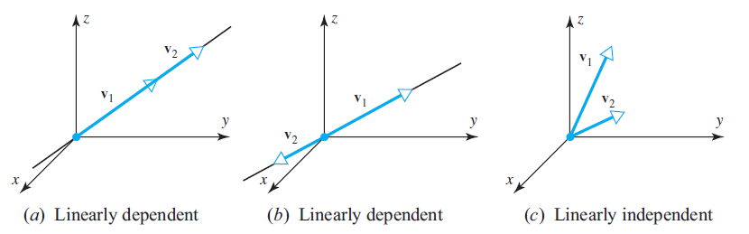

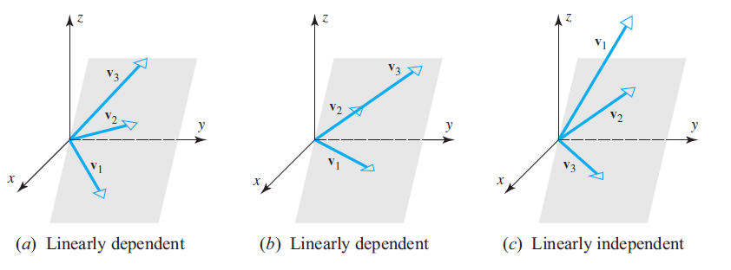

**Linear independence of Functions**

***Definition***

If  are functions that are *n* − 1 times differentiable on the interval (−∞, ∞), the determinant



is called the ***Wronskian*** of 



***Example***

Use the Wronskian to show that  are linearly independence

***Solution***

The Wronskian is





This function is not identically zero. Thus, the functions are linearly independent.

***Example***

Use the Wronskian to show that  are linearly independence

***Solution***

The Wronskian is







Thus, the functions are linearly independent.

***Theorem***

Let *S* be a linearly independent subset of a vector space *V*, and let  be a vector in *V* that is not in *S*. Then

 is linearly dependent if and only if 

***Proof***

If  is linearly dependent, then there are vectors  in such that  for some nonzero scalars .

Because *S* is linearly independent, one of the  say , equal . Thus , and so







Since  is linear combination of , which are in *S*, we have .

Conversely, let .

Then there exist vectors  in *S* and scalars  such that . Hence,



Since  for , the coefficient of  in this linear combination is nonzero, and so the set  is linearly dependent.

Therefore  is *linearly dependent*.

***Exercises Section* 2.6 – Linear Independence**

1. State the following statements as ***true*** or ***false***
2. If *S* is a linearly dependent set, then each vector in *S* is a linear combination of other vectors in *S*.
3. Any set containing the zero vector is linearly dependent.
4. The empty set is linearly dependent.
5. Subsets of linearly dependent sets are linearly dependent.
6. Subsets of linearly independent sets are linearly independent.
7. If  and  are linearly independent, the null the scalars  are zero
8. Given three independent vectors . Take combinations of those vectors to produce . Write the combinations in a matrix form as 



which is 

What is the test on a matrix **V** to see if its columns are linearly independent?

If  show that  are linearly independent.

If  show that  are linearly *dependent*.

1. Find the largest possible number of independent vectors among



1. Show that are independent but  are dependent:



Solve either . The *v*’s go in the columns of ***A***.

1. Decide the dependence or independence of
2. The vectors (1, 3, 2), (2, 1, 3), and (3, 2, 1).
3. The vectors , , and .
4. Find two independent vectors on the plane  in . Then find three independent vectors. Why not four? This plane is the nullspace of what matrix?
5. Determine whether the vectors are linearly dependent or linearly independent in 

|  |  |
| --- | --- |
| 1. (4, −1, 2), (−4, 10, 2) 2. (8, −1, 3), (4, 0, 1) | 1. (−3, 0, 4), (5, −1, 2), (1, 1, 3) 2. (−2, 0, 1), (3, 2, 5), (6, −1, 1), (7, 0, −2) |

1. Determine whether the vectors are linearly dependent or linearly independent in 
2. 
3. 
4. 
5. 
6. 
7. 
8. 
9. *a* ) Show that the three vectors  form a linearly dependent set in .

*b*) Express each vector in part (*a*) as a linear combination of the other two.

1. For which real values of λ do the following vectors form a linearly dependent set in 



1. Show that if  is a linearly independent set of vectors, then so is every nonempty subset of S.
2. Show that if  is a linearly dependent set of vectors in a vector space *V*, and if  are vectors in *V* that are not in *S*, then  is also linearly dependent.
3. Show that  is linearly independent and  does not lie in span , then  is a linearly independent.
4. By using the appropriate identities, where required, determine  are linearly dependent.

|  |  |  |
| --- | --- | --- |
|  |  |  |

1.  are linearly independent in  because neither function is a scalar multiple of the other. Confirm the linear independence using Wrońskian’s test.
2. Show  are linearly independent in .
3. Use the Wronskian to show that  span a three-dimensional subspace of 
4. Show by inspection that the vectors are linearly dependent.



(**19 – 37**) Determine if the given vectors are linearly dependent or independent, (any method)

1. 
2. 
3. 
4.  in 
5.  in 
6.  in 
7. 
8. 
9. 
10. 
11. 
12. 
13. 
14. 
15. 
16. 
17. 
18. 
19. 
20. Suppose that the vectors  are linearly dependent. Are the vectors , , and  also linearly dependent?

(***Hint***: Assume that , and see what the  can be.)

1. Show that the set  is a linearly independent subset of 
2. Suppose that *A* is linearly dependent set of vectors and *B* is any set containing *A*. Show that *B* must be linearly dependent.
3. Show that  is a linearly independent, subset of . Does it span 
4. Show that the set  is linearly dependent on 
5. Show that if  are linearly independent and  are linearly dependent, then  can be uniquely expressed as a linear combination of .
6. Show that if  are linearly dependent with  if and only if there exists an integer , such that  is a linear combination of 