***Section* 2.8 – Row and Column Spaces**

***Definition***

For an  matrix



The vectors



In  that are formed from the rows of *A* are called the ***row vectors*** of *A*, and the vectors



In  that are formed from the rows of *A* are called the ***column vectors*** of *A*.

***Definition***

If *A* is  matrix, then the subspace of  spanned by the row vectors of *A* is called the ***row space*** of *A* and is denoted by , and the subspace  spanned by the row vectors of *A* is called the ***column space*** of *A* and is denoted by . The solution space of the homogeneous system of equations , which is a subspace of  , is called the null space of *A*.

**The *Column Space* of *A***

The most important subspaces are tied directly to a matrix *A*, to solve .

***Definition***

The column space consists of all linear combinations of the columns. The combination are all possible vectors . They fill the column space .

|  |  |
| --- | --- |
|  |  |

To solve  is to express *b* as a combination of the columns.

The column space  is a plane that containing the two columns.  is solvable when *b* in on that plane.

***Theorem***

The system  is solvable if and only if *b* is in the column space of *A*.

***Example***

Let  be the linear system



Show that ***b*** is in the column space of *A* by expressing it as a linear combination of the column vectors of *A*.

***Solution***











That implies to 

It follows that

 `

***Example***

Describe the column spaces (they are subspaces of ) for



***Solution***

The column space of *I* is the whole space . Every vector is a combination of the columns of *I*. In the space language .

The column space of *A* is only a line, the second column (2, 4) is a multiple of the first column

(1, 2) and (2, 4) and all other vectors  along that line. The equation  is only solvable when is on the line.

The column space  is all of . Every *b* is attainable. The vector  is summation of column 1 and 2.

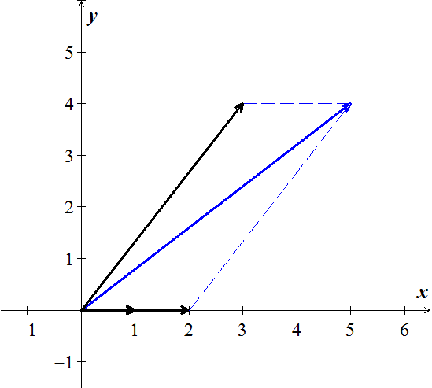









This matrix has the same column as *I* and any is allowed.  has an extra component (more solutions).

***Pivot Columns***

The pivot columns of *R* have 1’s in the pivots and 0’s everywhere else.

Pivot columns: 

Yields to: 

* ***The pivot columns are not combinations of earlier columns. The free columns are combinations of columns which are the special solutions!***

***Complete Solution to*** 

To solve , we need to put into an ***augmented*** form where  is not zero.

 







The augmented matrix is just 



***Special Solutions***

Each special solution to and  has one free variable equal to1.



The ***free variables*** are



1. Set  **(*Column 2*)**

The special solution: 

1. Set  **(*Column 4*)**

The special solution: 

1. Set  **(*Column 5*)**

The special solution: 

The nullspace matrix *N* contains the 3 special solutions in its columns.



The linear combinations of these three columns give all vectors in the nullspace.

**One *Particular* Solution**

  



The ***free variables*** for *R* to be .

Then the equations give the ***pivot variables*** 

The ***particular solution*** is: 

The two special (nullspace) solutions to :







 



 

The ***complete solution***:





***Example***

Find the condition on  for  to be solvable, if



***Solution***

The augmented form:







The last equation is 0 = 0 provided .

There are ***no*** *free variables* and ***no*** *special solutions*.

The nullspace solution: 

The complete solution:





If , there is no solution to  and  doesn’t exist.

***Example***

1. Find a subset of the vectors



That forms a basis for the space spanned by these vectors

1. Express each vector not in the basis as a linear combination of the basis vectors

***Solution***

1. Construct the vectors as its column vectors









The leading 1’s occurs in columns 1, 2, and 4.

 is a basis for the column space, and consequently 

1. 







We call these ***dependency equations***

The corresponding relationships are:





**Solving**  **by *elimination***

Matrix *A* is rectangular and we still use the elimination.

1. Forward elimnation from *A* to a triangular *U*.
2. Back substitution in  to find *x*.

Consider the matrix 





***Triangular*** ***U***: 

***P***: The ***pivot*** variables are , since columns 1 and 3 contains pivots.

***F***: The ***free*** variables are , since columns 2 and 4 have no pivots.

Special solutions to:



Complete solution: 

The special solution are in the nullspace , and their combinations fill out the whole Nullspace.

***Exercises*** ***Section* 2.8 – Row and Column Spaces**

1. List the row vectors and column vectors of the matrix



(**2 – 4**) Express the product  as a linear combination of the column vectors of *A*.

|  |  |
| --- | --- |
|  |  |

**(5 – 8**) Determine whether  is in the column space of *A*, and if so, express as a linear combination of the column vectors of *A*.

|  |  |
| --- | --- |
|  |  |

1. Suppose that  is a solution of a nonhomogeneous linear system  and that the solution set of the homogeneous system  is given by the formulas 
2. Find a vector form of the general solution of 
3. Find a vector form of the general solution of 

**(10 – 13**) Find the vector form of the general solution of the given linear system ; then use that result to find the vector form of the general solution of .

1. 
2. 
3. 
4. 
5. Given the vectors  and 
6. Are they linearly independent?
7. Are they a basis for any space?
8. What space **V** do they span?
9. What is the dimension of that space?
10. What matrices ***A*** have **V** as their column space?
11. Which matrices have **V** as their nullspace?
12. Describe all vectors  that complete a basis for .
13. *a*) Let 

Show that relative to an *xyz*-coordinate system in 3-space the null space of *A* consists of all points on the *z*-axis and that the column space consists of all points in the *xy*-plane.

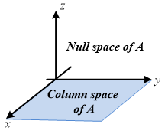

*b*) Find a 3 x 3 matrix whose null space is the *x*-axis and whose column space is the *yz*-plane.

1. If we add an extra column  to a matrix *A*, then the column space gets larger unless _____. Give an example where the column space gets larger and an example where it doesn’t. Why is  solvable exactly when the column space doesn’t get larger – it is the same for *A* and ?
2. For which right sides (find a condition on ) are these solvable. (Use the column space  and the equation )
3. 
4. 
5. Show that the matrices *A* and  (with extra columns) have the same column space. But find a square matrix with  smaller than . Important point: An *n* by *n* matrix has  exactly when *A* is an ______ matrix.
6. The column of *AB* are combinations of the columns of *A*. This means: The column space of *AB* is contained in (possibly equal to) to the column space of *A*. Give an example where the column spaces *A* and *AB* are not equal.
7. Find a square matrix *A* where  (the column space of  is smaller than .
8. Suppose  and  have the same (complete) solutions for every  . Is true that ?
9. Apply Gauss-Jordan elimination to  and . Reach  and :

 

Solve  to find  (its free variable is ).

Solve  to find  (its free variable is ).

***The subspace requirements:***  ***and***  ***(and then all linear combinations******) must stay in the subspace.***

1. Which of the following subsets of are actually subspaces?
2. The plane of vectors  with 
3. The plane of vectors with .
4. The vectors with .
5. All linear combinations of  and .
6. All vectors that satisfies 
7. All vectors with .
8. We are given three different vectors . Construct a matrix so that the equations  and  are solvable, but is not solvable.
9. How can you decide if this possible?
10. How could you construct *A*?
11. For which vectors  do these systems have a solution?

|  |  |
| --- | --- |
|  |  |

1. Find a basis for the null space of *A*. 
2. Is it true that is  then the row space of *A* equals the column space.
3. If the row space equals the column space the 
4. If , then the row space of *A* equals the column space.
5. Does the matrices *A* and  share the same 4 subspaces?
6. Is *A* and *B* share the same 4 subspaces then *A* is multiple of *B*.
7. Suppose  have the same (complete) solutions for every  . Is it true that 
8. *A* and  have the same left nullspace?