***Section* 2.9 – Rank and the Fundamental Matrix Spaces**

The **R**educed **R**ow **E**chelon **F**orm (***rref***) is a matrix (*R*) with each pivot column has only one nonzero entry (the pivots which is always 1).





***Rank of a Matrix***

The rank of a matrix *A* (***m*** by ***n***) is the number of ***nonzero rows*** in the row-reduced echelon form of *A* (it is the number of pivot). The common dimension of the row space and column space of a matrix *A* is called the ***rank*** of *A* and is denoted by



***Note:***

The rank of a matrix is well defined due to the uniqueness of the row-reduced echelon form. No matter what sequence of elementary row operations is performed to put the given matrix in row-reduced echelon form; there will always be the same number of nonzero rows.

***Theorem***

The row space and column space of a matrix *A* have the same dimension

The objective is to connect ***rank*** and ***dimension***.

* The ***rank*** of a matrix is the number of pivots.
* The ***dimension*** of a subspace is the number of vectors in a basis.
* ***A has full row rank if every row has a pivot:*** ***. No zero in R.***
* ***A has full column rank if every column has a pivot:*** ***. No free variables.***

***Example***

Find the rank of 

***Solution***







The matrix *R* has 2 nonzero rows, therefore the 

***Example***

The columns of *A* are dependent.  has a nonzero solution.





The rank of *A* is only *r* = 2.

Independent columns would give full column rank *r* = *n* = 3.

* The columns of *A* are independent exactly when the rank is *r* = *n*. There are***n*** pivots and no free variables. Only  is the nullspace.

***Example***

When all rows are multiplying of one pivot row, the rank is :



***Solution***











 

The row-reduced echelon form :



These matrices have only one pivot.

**Dimension *Theorem* for Matrices**

If *A* is a matrix with *n* columns, then 

***Theorem***

If *A* is an  matrix, then

* *rank*(*A*) = the number of leading variables in the general solution of 
* *nullity*(*A*) = the number of parameters in the general solution of 

***Theorem***

If *A* is any matrix, then 

*  ***has***  ***free variables and special solutions: n columns minus r pivot columns. The null matrix N has***  ***columns (the special solutions).***
* ***The particular solution solves:*** 
* ***Full column rank*** 

The reduced row echelon form looks like:



The pivot variables in the  special columns come by changing *F* to –*F*:

Nullspace matrix: 

* Every matrix *A* with ***full column rank*** (*r* = *n*) has all these properties:

1. All columns of *A* are pivot columns
2. There are no free variables or special solutions.
3. The nullspace *NS*(*A*) contains only the zero vector 
4. If  has a solution (might not) then it has only one solution.

***Example***

Suppose *A* is a square invertible matrix, . What are and***?***

***Solution***

The particular solution is the one and only solution .

There are no special solutions or free variables.  has no zero rows.

The only vector in the null space is .

The complete solution is







***Example***

Compute  for  given by 

***Solution***

To find , we must solve the equation 



Thus , the set that consists solely of the zero vector.

* If  has more unknowns than equations (more columns than rows) then it has nonzero solutions. There must be free columns, without pivots.

***Definition***

If *W* is a subspace of  that are orthogonal to every vector in *W* is called orthogonal complement of *W* and is denoted nu the symbol .  is exactly the row space 

***Fundamental Theorem of Linear Algebra***

The nullspace is the orthogonal complement of the row space .

The left nullspace is the orthogonal complement of the column space .

If *W* is a subspace of 

*  is a subspace of `
* The only vector common to *W* and  is 0.
* The orthogonal complement of  is *W*.

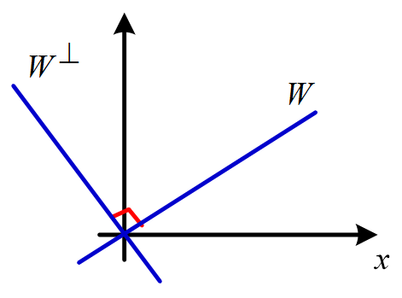 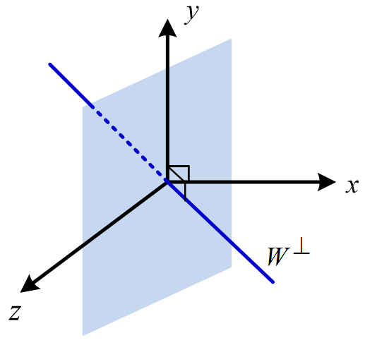

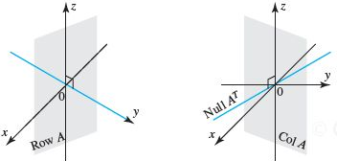

**Left Nullspace**

A matrix  has *m* columns and has *r* ranks, so the number of free columns of  must be .



The left nullspace is the collection of vectors  for which . Equivalently, , where and  are row vectors. We can call “***left nullspace***” because  is on the left of matrix *A* in that equation.

To find a basis for the left nullspace we reduce an augmented type of *A*.



Where matrix *E* can be found from .

If matrix *A* is a square matrix, then .

**The Four Fundamental Subspaces**

1. The ***row space*** is , a subspace of .
2. The ***column space*** is , a subspace of .
3. The ***null space*** is , a subspace of .
4. The ***left null space*** is , a subspace of.

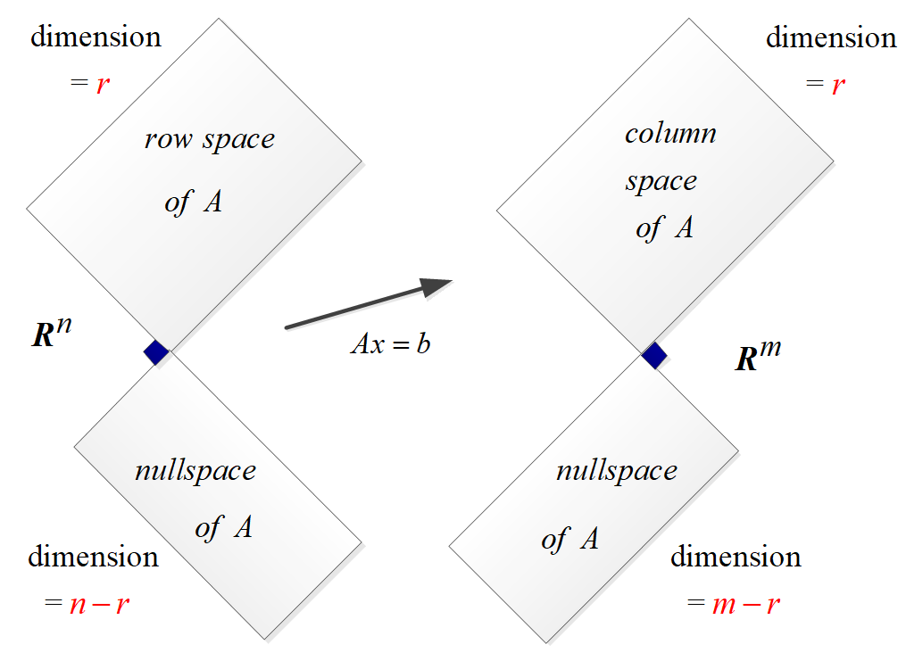

Two pairs of orthogonal subspaces.

***For an m x n matrix of rank r*:**

|  |  |  |
| --- | --- | --- |
| ***Fundamental Space*** | ***Subspace of*** | ***Dimension*** |
| Nullspace |  | *n – r* |
| Column Space |  | *r* |
| Row space |  | *r* |
| Left nullspace |  | *m – r* |

***Example***

Find a basis for each of the four subspaces associated with matrix *A*:



***Solution***





1. Basis for ***row space***: 
2. Basis of the **column spaces**: 

Rank(***A***) = 1

Dimension of *A* = 1

The pivots variables are: 

The free variables are: 

Set 

The special solution: 

Set 

The special solution: 

1. Basis of the **Null space**: 







Set  

1. Basis of the **Left** **Nullspace**: 

**Combining Bases from Subspaces**

* Any *n* linearly independent vectors in  must span . They are basis. Any *n* vectors that span  must be independent. They are a basis.
* If the *n* columns of ***A*** are independent, they span , So  is solvable,
* If the *n* columns span , they are independent. So  has only one solution.

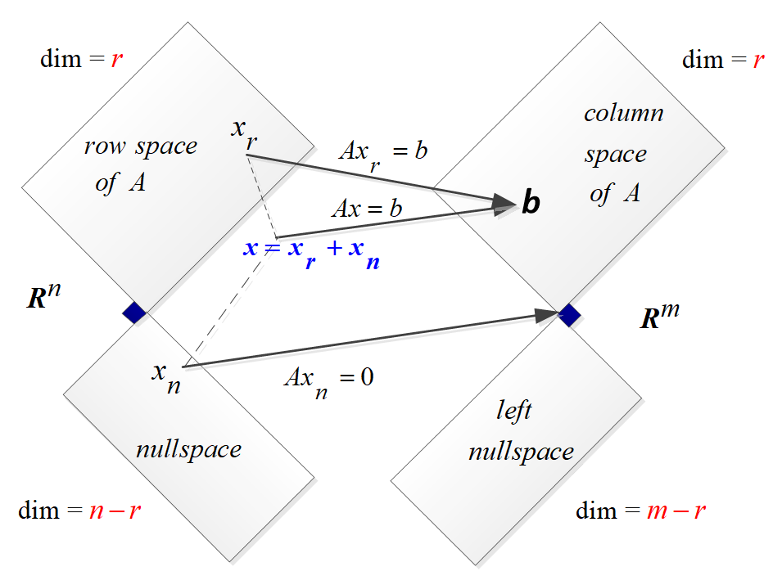

* When the orthogonal complement of a subspace *S* is defined to be the subspace whose vectors pairs to zero with the vectors in *S*. The larger the *S* is, the more restriction  has, and hence the smaller  is.

***Theorem*** − ***Equivalent Statements***

If *A* is an  matrix, then the following statements are equivalent.

1. *A* is invertible
2.  has only the trivial solution
3. The reduced row echelon form of *A* is 
4. A is expressible as a product of elementary matrices
5.  is consistent for every  matrix 
6.  has exactly one solution for every  matrix 
7. 
8. The column vectors of *A* are linearly independent
9. The row vectors of *A* are linearly independent
10. The column vectors of *A* span 
11. The row vectors of *A* span 
12. The column vectors of *A* form a basis for 
13. The row vectors of *A* form a basis for 
14. *A* has a rank *n*.
15. *A* has nullity 0.
16. The orthogonal complement of the null space of *A* is 
17. The orthogonal complement of the row space of *A* is 

***Exercises*** ***Section* 2.9 – Rank and the Fundamental Matrix Spaces**

1. Verify that 



1. Find the rank and nullity of the matrix; then verify that the values obtained satisfy 

|  |  |
| --- | --- |
|  |  |

1. If *A* is an  matrix, what is the largest possible value for its rank and the smallest possible value of the nullity of *A*.
2. Discuss how the rank of *A* varies with *t*.

*a*)  b) 

1. Are there values of *r* and *s* for which



Has rank 1? Has rank 2? If so, find those values.

1. Find the row reduced form *R* and the rank *r* of *A* (those depend on *c*).

Which are the pivot columns of *A*? Which variables are free? What are the special solutions and the nullspace matrix *N* (always depending on *c*)?



1. Find the row reduced form *R* and the rank *r* of *A* (those depend on *c*).

Which are the pivot columns of *A*? Which variables are free? What are the special solutions and the nullspace matrix *N* (always depending on *c*)?



1. If *A* has a rank *r*, then it has an *r* by *r* sub-matrix *S* that is invertible. Remove  rows and columns to find an invertible sub-matrix *S* inside each *A* (you could keep the pivot rows and pivot columns of *A*).



1. Suppose that column 3 of 4 x 6 matrix is all zero. Then must be a ______ variable. Give one special solution for this matrix.
2. Fill in the missing numbers to make *A* rank 1, rank 2, rank 3. (your solution should be 3 matrices)



1. Fill out these matrices so that they have rank 1:



1. Suppose *A* and *B* are *n* by *n* matrices, and *AB* = *I*. Prove from  that the . So *A* is invertible and *B* must be its two-sided inverse. Therefore *BA* = *I* (which is not so obvious!).
2. Every *m* by *n* matrix of rank *r* reduces to (*m* by *r*) times (*r* by *n*):

*A* = (pivot columns of *A*) (first *r* rows of *R*) 

Write the 3 by 4 matrix  as the product of the 3 by 2 from the pivot columns and the 2 by 4 matrix from *R*.

1. Suppose *R* is *m* by *n* matrix of rank *r,* with pivot columns first: 
2. What are the shapes of those 4 blocks?
3. Find the right-inverse *B* with *RB* = *I* if *r* = *m*.
4. Find the right-inverse *C* with *CR* = *I* if *r* = *n*.
5. What is the reduced row echelon form of  (with shapes)?
6. What is the reduced row echelon form of  (with shapes)?

Prove that  has the same nullspace as R. Then show that  always has the same nullspace as *A* (a value fact).

1. Suppose you allow elementary column operations on ***A*** as well as elementary row operations (which get to *R*). What is the “row-and-column reduced form” for an *m* by *n* matrix of rank ***r***?
2. True or False (check addition or give a counterexample)
3. The symmetric matrices in *M*  from a subspace.
4. The skew-symmetric matrices in *M*  from a subspace.
5. The un-symmetric matrices in *M*  from a subspace.
6. Invertible matrices
7. Singular matrices
8. Let 
9. Reduce *A* to row-reduced echelon form.
10. What is the rank of *A*?
11. What are the pivots?
12. What are the free variables?
13. Find the special solutions. What is the nullspace ?
14. Exhibit an *r* x *r* submatrix of *A* which is invertible, where . (An *r* x *r* submatrix of *A* is obtained by keeping *r* rows and *r* columns of *A*)
15. Let 
16. Reduce *A* to row-reduced echelon form.
17. What is the rank of *A*?
18. What the pivots?
19. What are the free variables?
20. Find the special solutions. What is the nullspace ?
21. Give the complete solution to 
22. Let 
23. Reduce *A* to row-reduced echelon form.
24. What is the rank of *A*?
25. What the pivots?
26. What are the free variables?
27. Find the special solutions.
28. What is the nullspace ?
29. Let 
30. Reduce *A* to row-reduced echelon form.
31. What is the rank of *A*?
32. What the pivots?
33. What are the free variables?
34. Find the special solutions.
35. What is the nullspace ?
36. The 3 by 3 matrix *A* has rank 2.



1. Reduce  to , so that  becomes triangular system .
2. Find the condition on  for  to have a solution
3. Describe the column space of *A*. Which plane in ?
4. Describe the nullspace of *A*. Which special solutions in ?
5. Find a particular solution to  and then complete solution.
6. Find the special solutions and describe the complete solution to  for

= 3 by 4 zero matrix  

Which are the pivot columns? Which are the free variables? What is the *R* (Reduced Row Echelon matrix) in each case?

1. Create a 3 by 4 matrix whose special solutions to  are :



You could create the matrix *A* in row reduced form *R*. Then describe all possible matrices *A* with the required Nullspace all combinations of .

1. The plane  is parallel to the plane . One particular point on this plane is . All points on the plane have the form (fill the first components)



1. Construct a matrix whose column space contains (1, 1, 5) and (0, 3, 1) and whose Nullspace contains .
2. Construct a matrix whose column space contains (1, 1, 0) and (0, 1, 1) and whose Nullspace contains (1, 0, 1) and (0, 0, 1).
3. Construct a matrix whose column space contains (1, 1, 1) and whose Nullspace contains .
4. How is the Nullspace N(*C*) related to the spaces N(*A*) and N(*B*), if ?
5. Why does no 3 by 3 matrix have a nullspace that equals its column space?
6. If *AB* = 0 then the column space *B* is contained in the _______ of *A*. Give an example of *A* and *B*.
7. True or false (with reason if true or example to show it is false)
8. A square matrix has no free variables.
9. An invertible matrix has no free variables.
10. An *m* by *n* matrix has no more than***n*** pivot variables.
11. An *m* by *n* matrix has no more than***m*** pivot variables.
12. Suppose an *m* by *n* matrix has *r* pivots. The number of special solutions is ______.

The Nullspace contains only *x* = 0 when *r* = _______.

The column space is all of  when *r* = ______.

1. Find the complete solution in the form  to these full rank system:

*a*)  *b*) 

1. Find the complete solution in the form  to the system:



1. If ***A*** is 3 x 7 matrix, its largest possible rank is ________. In this case, there is a pivot in every ________ of ***U*** and ***R***, the solution to  _________ (always exists or is unique), and the column space of ***A*** is _________. Construct an example of such a matrix ***A***.
2. If ***A*** is 6 x 3 matrix, its largest possible rank is ________. In this case, there is a pivot in every ________ of ***U*** and *R*, the solution to  _________ (always exists or is unique), and the nullspace of ***A*** is _________. Construct an example of such a matrix ***A***.
3. Find the rank of  and  for 
4. Explain why these are all false:
5. The complete solution is any linear combination of .
6. A system  has at most one particular solution.
7. The solution  with all free variables zero is the shortest solution (minimum length ). Find a 2 by 2 counterexample.
8. If *A* is invertible there is no solution  in the null space.
9. Write down all known relation between *r* and *m* and *n* if  has
10. No solution for some .
11. Infinitely many solutions for every.
12. Exactly one solution for some, no solution for other.
13. Exactly one solution for every.
14. Find a basis for its row space, find a basis for its column space, and determine its rank

 

1. Find a basis for the row space, find a basis for the null space, find , find , and verify 



1. Determine if  lies in the column space of the given matrix. If it does, express  as linear combination of the column.



1. Find the transition matrix from *B* to *C* and find 
2. 
3. 



1. Does *A* and  have the same number of pivots.

(**44 – 49**) For the given matrix *A*, which is given in row reduction echelon form

1. What is the rank of *A*?
2. What is the dimension of *A*?
3. What are the pivots?
4. What are the free variables?
5. Find the special (homogeneous) solutions.
6. What is the nullspace ?
7. Find the particular solution 
8. Give the complete solution.
9.  
10.  
11.  
12.  
13.  
14.  

(**50 – 55**) Find a basis for each of the four subspaces associated with each given matrix

|  |  |
| --- | --- |
|  |  |