***Section* 3.4 – Orthogonal Matrices**

***Definition***

A square matrix *A* is said to be orthogonal if its transpose is the same as its inverse, that is, if



or, equivalently, if



***Example***

The matrix 

***Solution***





***Example***

The matrix 

***Solution***





***Theorem***

The following are equivalent for  matrix *A*.

1. *A* is orthogonal.
2. The row vectors of *A* form an orthonormal set in  with the Euclidean inner product.
3. The column vectors of *A* form an orthonormal set in  with the Euclidean inner product.

***Theorem***

1. The inverse of an orthogonal matrix is orthogonal
2. A product of orthogonal matrices is orthogonal
3. If *A* is orthogonal, then  or 

***Theorem***

If *A* is an  matrix, then the following are equivalent

1. *A* is orthogonal.
2.  for all ***x*** in .
3.  for all  and  in .

Let  and  be the unit vectors along the *x*- and *y*-axes and unit vectors  and  along the *x′*- and *y*′-axes.

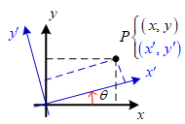 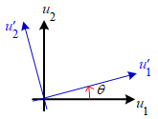

The new coordinates  and the old coordinates  of a point *P* will be related by

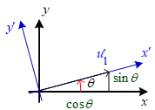









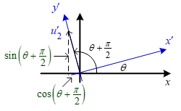

These are sometimes called the ***rotation equations***.

***Example***

Use the form  to find the new coordinates of the point  if the coordinate axes of a rectangular coordinate system are rotated through an angle of .

***Solution***







The new coordinates of *Q* are 

***Exercises Section* 3.4 – Orthogonal Matrices**

(**1 – 2**) Show that the matrix is orthogonal

|  |  |
| --- | --- |
|  |  |

(**3 – 12**) Determine if the matrix is orthogonal. For those that is orthogonal find the inverse.

|  |  |  |
| --- | --- | --- |
|  |  |  |

1. Find a last column so that the resulting matrix is orthogonal



1. Determine if the given matrix is orthogonal. If it is, find its inverse



1. Prove that if *A* is orthogonal, then  is orthogonal.
2. Prove that if *A* is orthogonal, then  is orthogonal.
3. Prove that if *A* and *B* are orthogonal, then  is orthogonal.
4. Let *Q* be an  orthogonal matrix, and let *A* be an  matrix. Show that 
5. Let 
6. Is matrix *A* an orthogonal matrix?
7. Let *B* be the matrix obtained by normalizing each row of *A*, find *B*.
8. Is *B* an orthogonal matrix?
9. Are the columns of *B* orthogonal?